Student name: Kazi Hossain Jakaria
Student ID: 2223467
Programme: International hotel management
Module: Hospitality and Guest services - Module code: BMIH4003
Lecturer name: Luciana Suardi
Assignment title: Assessment 2:
Report title: Hotel Standards, reputation, management and service culture

Executive Summary
The hotel and hospitality sector is a cutthroat one that is always evolving. In this rapidly shifting climate, hotels absolutely have to make maintaining brand consistency, managing their reputations, and cultivating a culture of excellent service their top priorities. Monitoring and responding to the comments and suggestions of guests is an important part of reputation management. Brand consistency requirements ensure that guests have the same experience no matter where they stay. Service culture, unlike corporate culture, prioritises exceptional service to provide memorable guest experiences. To keep up with the times, hotels need to implement personalization, sustainability, and technological advances. It is necessary to engage in strategic planning, investment, and continuous development in order to prevail against one's competitors and meet the expectations of one's guests.

Table of Contents
Executive Summary 2
Introduction 4
Hotel Standards 5
Brand consistency standards 5
The use of the same standards 5
Reputation monument 6
Managing reputation 6
Guest review management 6
Impact of negative reviews 6
Service culture 8
What is service culture? 8
Difference from corporate culture 8
Importance of service culture to the hotel industry 9
Recommendations 10
Conclusion 11
References 12

Introduction
There is a great deal of competition between hotels in order to get new clients and retain the ones they already have. The researcher will go into the issues of hotel standards, the art of managing one's reputation, and the tradition of providing service. The researcher will have a deeper comprehension of these concepts, as well as the significance of those ideas if the researcher applies them to specific examples and scenarios drawn from the hospitality industry. The development of the market as well as the challenges that businesses must overcome will serve as the basis for the researcher's suggestions on the practical industry.

Hotel Standards

Brand consistency standards
Maintaining the integrity of the hotel brand is essential. They work to guarantee that guests enjoy a similar experience across all of a brand's properties (Wood, 2015). These requirements involve design, service, amenities, and guest experience. Maintaining a consistent brand image is essential to gaining the trust of hotel guests, which in turn increases income. The world's largest hotel company, Marriott International, maintains brand consistency throughout all of its properties by following certain rules. At each of its 7,600 hotels throughout the world, Marriott makes an effort to give clients consistent service and quality (Chan, Gao and McGinley, 2021). This creates familiarity with the brand and ensures that guests have the same experience at each location. The constancy of the hotel brand is backed by the data. According to research conducted by the School of Hotel Administration at Cornell University, maintaining brand consistency can enhance customer satisfaction by 23%, a guest's willingness to recommend the establishment by 15%, and the average daily rate by 9% (González-Rodríguez et al., 2019).

The use of the same standards
Hotel standards differ. In contrast to branded hotel firms, independent hotels have more flexibility when it comes to adapting their standards to the specific needs of their target audience and positioning (Wood, 2015). Independent hotels have the potential to stand out by providing guests with one-of-a-kind experiences. Independent hotels of a high level can be found at The Level Hotels. The identities, architectural styles, and overall guest experiences of The Standard properties are all unique. The Standard Miami is a trendy hotel that frequently plays host to well-attended events, while The Standard High Line in New York City is an up-to-date and urban establishment (Christensen and Laegreid, 2020). These independent hotels target clients seeking unique experiences.
Hotel chains require brand consistency criteria to develop trust and recognition, whereas independent hotels can define their standards to cater to the preferences of their guests and differentiate themselves in the industry (Mate, Trupp and Pratt, 2019). When establishing criteria, hotels should first consider how they position themselves in the market and who their ideal guests are.

Reputation monument
To draw customers, hotels need to manage their reputation well. Basics of hotel reputation management:

Managing reputation
Hotels should have an active online presence on travel portals, social media platforms, and reviews sites (Vallen and Vallen, 2014). This includes keeping track of visitor ratings, responding quickly and competently to feedback, and resolving issues. Hotels may improve their reputation by interacting with visitors online. The Peninsula Hotels take good care of its standing. An upscale hotel chain reads reviews and responds right away. They address visitor issues and find solutions. This proactive approach improves reputation and guest trust. Control of one's online reputation is important. 96% of tourists read hotel reviews on TripAdvisor before making a reservation, and 77% of them pick establishments with higher review scores. According to research from Gössling et al. (2018), a 1-point increase in a hotel's 5-point review score can raise rates by 1.4% and occupancy by 1.1%.

Guest review management
Reviews from past visitors have a big impact on prospective visitors' choices. Guest evaluations and opinions should be solicited via post-stay surveys and in-room cards (Tesone, 2014). By studying customer reviews and determining their strengths and flaws, hotels may enhance the experiences of their visitors Ovolo Hotels demonstrates the value of customer reviews. Customer reviews are requested by this boutique hotel chain, and they use them in their marketing. On their website, in their social media posts, and their promotional materials, they leverage actual guest reviews for authenticity.

Impact of negative reviews
Unfavourable reviews can harm a property. Guests appear to be more affected by unfavourable reviews than by pleasant ones. A positive management response to a negative review, according to 87% of TripAdvisor users, improves the property's reputation. The Langham in London manages negative reviews well (Tejayadi, Laba and Pradana, 2019). They promptly and expertly respond to complaints. The hotel acknowledges problems, apologises and provides solutions to demonstrate its commitment to client satisfaction. This can mitigate poor reviews and demonstrate the hotel's dedication to guest satisfaction.
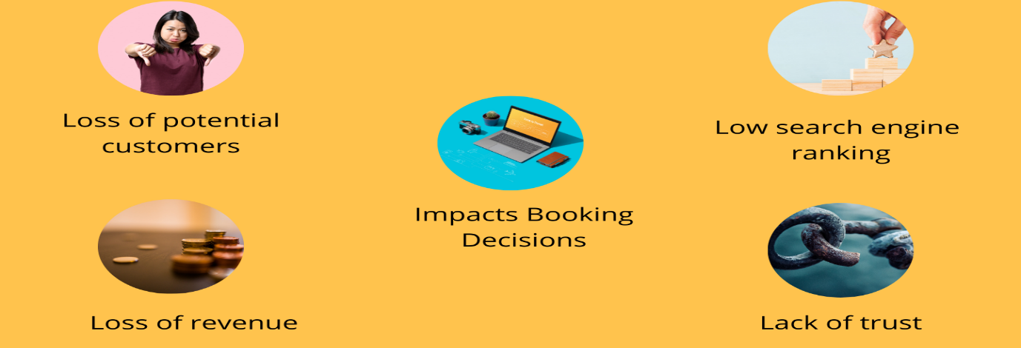
Figure: Impact of negative reviews
Source: (Tejayadi, Laba and Pradana, 2019)
Hotels may control their reputation by keeping an eye on online evaluations, responding to them, encouraging visitor feedback, and resolving any flaws. Potential guests' decisions are greatly influenced by guest feedback. In response to tourist concerns, hotels can enhance their reputation by proving their commitment to the comfort of their guests.

Service culture

What is service culture?
Customer satisfaction is prioritised by an organization's shared ideas, values, and behaviours, which are referred to as its service culture (O’gorman and Cousins, 2010). Included are the employee mind-set, training, and practices needed to live up to guest expectations. The service at The Ritz-Carlton is legendary. "Gold Standards" supports individualised care, close attention to detail, and going above and above for customers. The curriculum places a focus on distinctive experiences, gives workers decision-making authority, and offers in-depth training. The Ritz-Carlton normally receives good marks for both service and guest satisfaction. Statistics are affected by hotel service culture. According to Saban et al. (2020), premium hotels with excellent staff and service may charge four times as much per night as those with subpar service. Hotels with top-notch service cultures enjoy higher rates of occupancy, ADR, and guest satisfaction.
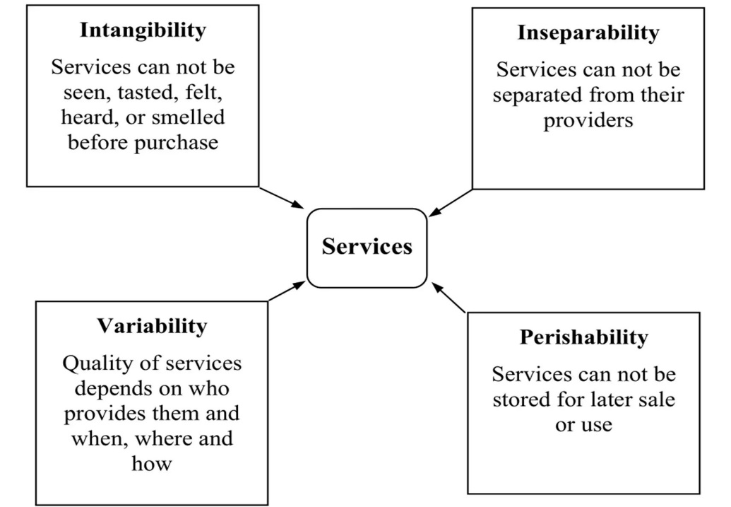
Figure: Service culture
Source: (O’gorman and Cousins, 2010)

Difference from corporate culture
Customer service is emphasised in service culture, which is different from corporate culture. Corporate culture informs decisions and defines the organisation (O’fallon and Rutherford, 2010). The focus of service culture is on the attitudes, actions, and education required to deliver superior service. Marriott International stands for the business culture of hotels. Efficiency, profitability, and operational excellence are valued in the company culture. Within its corporate culture, Marriott fosters customer-focused service, individualised interactions, and attention to detail.

Importance of service culture to the hotel industry
Because clients form long-lasting impressions based on service, service culture is crucial in the hotel industry (Johnston, Clark and Shulver, 2012). Excellent customer service can increase hotel bookings, customer retention, and word-of-mouth. Success at The Four Seasons demonstrates the importance of service culture. The business values service. Exceptional client loyalty and high guest satisfaction ratings are the results of excellent service. Engaged hotel guests who are exceptionally satisfied with the service, according to Gallup, create significantly more revenue and profitability than less engaged guests (Tejayadi, Laba and Pradana, 2019). In a cutthroat industry, service culture sets apart hotels and produces unique visitor experiences.
The culture of hotel service is crucial. It outlines the attitudes, values, and behaviours required to deliver first-rate service and enjoyable experiences for customers. Service culture sets hotels apart, enhances customer satisfaction, and increases revenue.

Recommendations
Personalization: To customise guests' experiences, hotels should make use of guest data and technology (Horner and Swarbrooke, 2011). Utilise customer relationship management software to collect feedback from guests and tailor your services. Examples include personalised greetings and amenities, as well as recommendations and special offers. Hotels can foster customer loyalty by attempting to anticipate and fulfil the needs of their guests. The challenges involve protecting users' data privacy and providing non-invasive personalization options.
Enhance Sustainability Practices: The hospitality industry is becoming increasingly environmentally conscious (Heppell, 2015). The management of energy, water, waste, and responsible sourcing has to be given the top priority at hotels. Sustainability can be demonstrated through environmentally friendly activities such as obtaining a LEED or Green Key designation. The introduction of environmentally friendly technology can be pricey and requires employee training, but it can save money, increase a business's brand, and attract environmentally conscious tourists.
Embrace Technology and Digital Transformation: Both the experience of the guests and the efficiency of the operations are improved by technology and digital transformation. To better understand the preferences of guests and make better decisions, mobile check-in, keyless entry, guest-facing apps, and data analytics should be implemented. Instead of trying to replace human interaction with technology, hotels should focus on enhancing it (Mate, Trupp and Pratt, 2019). Data security, protecting individuals' privacy, and choosing the appropriate technology are all difficult tasks.

Conclusion
Standards for hospitality, strategies for managing one's reputation, and a culture of service are all extremely important. Hotels have the potential to differentiate themselves, attract clients, and achieve success by adhering to the standards of brand consistency, maintaining a reputation, and developing a robust service culture. Additionally, market trends like technology and sustainability need to be included in the sector. By adhering to these guidelines, hotels may be able to solve difficulties, meet the ever-evolving expectations of visitors, and compete successfully.

References
Chan, J., Gao, Y. (Lisa) and McGinley, S. (2021). Updates in service standards in hotels: how COVID-19 changed operations. International Journal of Contemporary Hospitality Management, 33(5), pp.1668–1687. doi:https://doi.org/10.1108/ijchm-09-2020-1013.
Christensen, T. and Laegreid, P. (2020). The coronavirus crisis—crisis communication, meaning-making, and reputation management. International Public Management Journal, 23(5), pp.1–17. doi:https://doi.org/10.1080/10967494.2020.1812455.
González-Rodríguez, M.R., Martín-Samper, R.C., Köseoglu, M.A. and Okumus, F. (2019). Hotels’ corporate social responsibility practices, organizational culture, firm reputation, and performance. Journal of Sustainable Tourism, 27(3), pp.398–419. doi:https://doi.org/10.1080/09669582.2019.1585441.
Gössling, S., Zeiss, H., Hall, C.M., Martin-Rios, C., Ram, Y. and Grøtte, I.-P. (2018). A cross-country comparison of accommodation manager perspectives on online review manipulation. Current Issues in Tourism, 22(14), pp.1744–1763. doi:https://doi.org/10.1080/13683500.2018.1455171.
Heppell, M. (2015). 5 Star Service : How To Deliver Exceptional Customer Service. Boston: Pearson.
Horner, S. and Swarbrooke, J. (2011). Consumer Behaviour in Tourism. Routledge.
Johnston, R., Clark, G. and Shulver, M. (2012). Service operations management : improving service delivery. 5th ed. Harlow: Pearson.
Mate, M.J., Trupp, A. and Pratt, S. (2019). Managing negative online accommodation reviews: evidence from the Cook Islands. Journal of Travel & Tourism Marketing, 36(5), pp.627–644. doi:https://doi.org/10.1080/10548408.2019.1612823.
O’fallon, M.J. and Rutherford, D.G. (2010). Hotel management and operations. 5th ed. Hoboken, N.J.: Wiley.
O’gorman, K.D. and Cousins, J.A. (2010). The origins of hospitality and tourism. Oxford: Goodfellow Publishers Ltd.
Saban, D., Basalamah, S., Gani, A. and Rahman, Z. (2020). Impact Of Islamic Work Ethics, Competencies, Compensation, Work Culture On Job Satisfaction And Employee Performance: The Case Of Four Star Hotels. European Journal of Business and Management Research, 5(1). doi:https://doi.org/10.24018/ejbmr.2020.5.1.181.
Tejayadi, I.P.W., Laba, I.N. and Pradana, G.Y.K. (2019). The effect of organizational culture on employee satisfaction in Mercure Resort Sanur. International Journal of Green Tourism Research and Applications, [online] 1(1). Available at: https://ojs.pnb.ac.id/index.php/IJOGTRA/article/view/1631 [Accessed 26 Oct. 2022].
Tesone, D.V. (2014). Principles of Management for the Hospitality Industry. Routledge.
Vallen, G.K. and Vallen, J.J. (2014). Check-in check-out : managing hotel operations. Upper Saddle River, N.J.: Pearson/Prentice Hall.
Walker, J.R. (2013). Introduction to hospitality management. Boston: Pearson.
Wood, R.C. (2015). Hospitality Management. London: SAGE.

