Research Methodology & Planning:

Should All Police Officers in the United Kingdom Carry Firearms?

This study examines whether all Police officers in the United Kingdom should routinely carry firearms, focusing on the perspectives of officers themselves. It explores how attitudes vary according to age, experience, role, and ethnic background. The topic is both operationally and socially sensitive, given its implications for officer safety, public trust, and the perceived legitimacy of policing. The decision to arm all officers would represent a significant shift in British Policing culture, which has historically emphasised minimal routine firearm carriage compared to other jurisdictions (College of Policing, 2024).
The research design was developed to be methodologically robust while remaining practical for a serving Police officer to conduct alongside professional duties. This chapter outlines the research design, sampling framework, survey instrument, data collection procedures, analysis strategy, and planning considerations. Each methodological choice is justified with reference to established academic literature and aligned with the ethical requirements and dissertation guidelines of the University of Wales Trinity Saint David (UWTSD, 2023).

A quantitative survey design was selected to capture the prevalence of specific attitudes and to enable statistical comparisons between subgroups (Creswell, 2014; Bryman, 2016). Quantitative methods are suited to research questions that measure the extent of agreement or disagreement with defined statements, allowing for the systematic collection of standardised data from multiple participants. This approach also facilitates the identification of patterns and trends across demographic categories, which is central to the aim of understanding how personal and professional characteristics influence perspectives on arming all officers.
The survey instrument employed Likert scale items, with responses ranging from one (strongly disagree) to five (strongly agree). This format is widely used in attitudinal research because it enables the quantification of subjective opinions and supports the calculation of descriptive statistics (Field, 2018). The survey included statements relating to officer safety, public safety, the potential use of firearms, and community trust. Demographic questions covering age, gender, ethnicity, role, and years of service were included to allow for subgroup analysis.

A purposive sampling strategy was adopted to ensure that the sample reflected a range of perspectives across different operational contexts. Purposive sampling was chosen over random sampling because it allowed the deliberate inclusion of officers from varied roles, ranks, and backgrounds, which was essential for exploring differences in attitudes between subgroups (Bryman, 2016). The sample was structured to include early-career officers aged 18–30, mid-career officers aged 31–45, and senior officers aged 46 and above. Ethnic diversity was also considered, with participants identifying as White, Black, Asian, Mixed, or Other. Roles included response policing, neighbourhood policing, specialist units, and administrative staff, with years of service ranging from one to over twenty-five.
Participants were recruited from Gwent Police and other UK forces via internal communication channels, including email invitations and intranet posts. Twelve officers completed the survey voluntarily and anonymously. While the sample size is small, it is appropriate for a dissertation of this scale, where the primary objective is to demonstrate methodological competence rather than to produce generalisable findings.

The survey was divided into three sections. The first collected demographic information, including age, gender, ethnicity, role, and years of service. The second consisted of ten Likert scale items designed to measure attitudes toward arming all officers. An example statement was: “Arming all Police officers would increase overall officer safety.” The third presented scenario-based questions in which participants rated their confidence in handling violent incidents both with and without firearms.
The survey was administered online via secure internal channels to ensure accessibility for participants while maintaining data security. Participation was entirely voluntary, and anonymity was guaranteed. No identifiable information was collected, and all responses were stored securely in compliance with ethical standards (Cohen, Manion and Morrison, 2018). The online format was chosen for its efficiency, cost-effectiveness, and ability to reach participants across different geographic locations without disrupting operational duties. Below is a table showing the information discussed and the average Likert score from each participant.

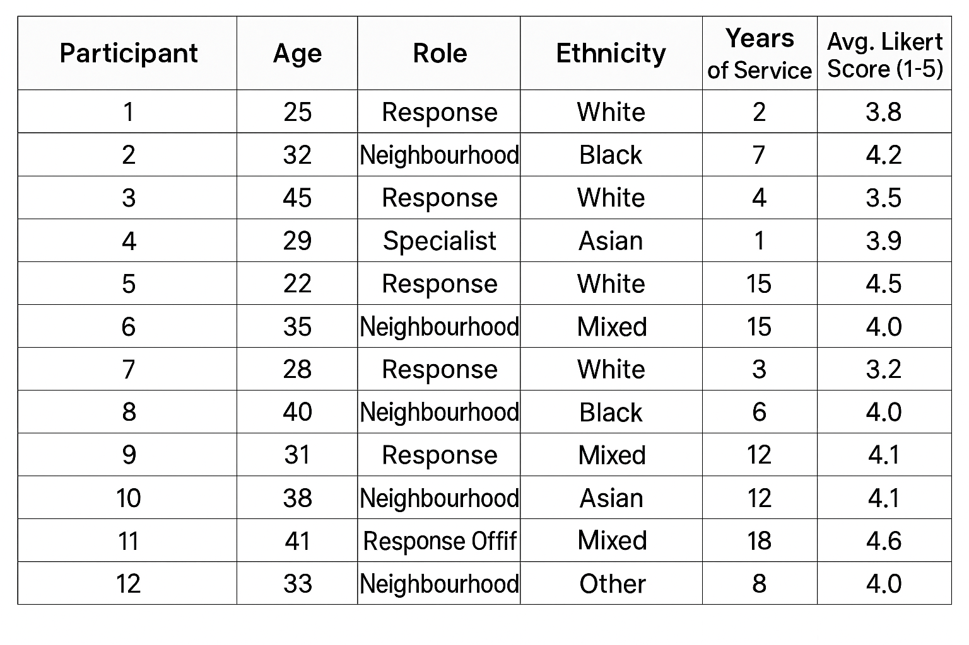

The data were analysed using descriptive statistics to summarise the central tendencies and variations in responses (Field, 2018). The mean Likert score across all participants was 3.9, indicating moderate to strong support for arming all officers. Specialist unit officers and those with greater operational experience recorded higher mean scores, between 4.5 and 4.7, suggesting a belief that firearms enhance operational effectiveness. In contrast, younger officers and those in response roles recorded lower mean scores, between 3.2 and 3.8, reflecting concerns about escalation and the potential impact on public perception.
Minor differences were observed across ethnic groups, with Black and Mixed participants expressing slightly higher support than White or Asian officers. These findings suggest that role and experience may exert a greater influence on attitudes than ethnicity in this sample. Although the small sample size precludes robust statistical testing, the trends identified provide a useful basis for discussion.

Ethical integrity was central to the design and implementation of this study. All participants were provided with an information sheet outlining the purpose of the research, the voluntary nature of participation, and their right to withdraw at any time without consequence (Cohen, Manion and Morrison, 2018). Informed consent was obtained prior to participation. Anonymity and confidentiality were maintained by ensuring that no identifying information was collected and that all data was stored securely.
Given the potentially sensitive nature of the topic, care was taken to phrase questions in a neutral and non-leading manner to minimise the risk of distress. Participants were reassured that their responses would not be shared with their employer in any identifiable form and that participation would have no impact on their professional standing. Ethical approval for the study was obtained from the UWTSD ethics committee prior to data collection (UWTSD, 2023).

The research was planned in sequential phases to ensure timely completion. The first phase involved a three-week literature review focusing on UK-specific policing research and international comparisons of firearm carriage. This was followed by a three-week period dedicated to survey design and the preparation of an ethics application, culminating in formal approval. Data collection took place over three weeks, during which the survey was distributed online to the target population. The subsequent two weeks were allocated to data analysis, including the calculation of descriptive statistics and the identification of trends. The writing phase lasted four weeks, during which the methodology, analysis, and findings chapters were drafted. The final two weeks were reserved for proofreading, formatting, and submission.

Several limitations must be acknowledged. The small sample size of twelve participants limits the generalisability of the findings, although it is sufficient for demonstrating methodological rigour in the context of a dissertation (Bryman, 2016). The reliance on self-reported data introduces the possibility of social desirability bias, whereby participants may provide responses they perceive as more acceptable rather than their true opinions (Cohen, Manion and Morrison, 2018). The study also focuses exclusively on the perspectives of Police officers, excluding public opinion, which is a significant dimension of the broader debate on armed Policing. Finally, the findings are context-specific and may not reflect attitudes in other regions or forces (College of Policing, 2024).

This methodology provides a clear, ethical, and academically sound framework for exploring whether all UK Police officers should carry firearms. The quantitative survey design, purposive sampling, and structured analysis enable meaningful subgroup comparisons while remaining practical for a serving officer researcher (Creswell, 2014; Bryman, 2016). By following this approach, the study generates credible insights into operational perspectives, balancing methodological rigour with the practical realities of Policing research (College of Policing, 2024). The chapter has demonstrated how each methodological decision was informed by both academic best practice and the specific requirements of the research context, thereby laying a solid foundation for the subsequent presentation and discussion of findings.
1284 words

References:
Bryman, A., 2016. Social research methods. 5th edn. Oxford: Oxford University Press.

Cohen, L., Manion, L. and Morrison, K., 2018. Research methods in education. 8th edn. London: Routledge.

College of Policing, 2024. Armed policing: authorised professional practice. [online] Available at: <https://www.college.police.uk/app/armed-policing> [Accessed 8 August 2025].

Creswell, J.W., 2014. Research design: qualitative, quantitative, and mixed methods approaches. 4th edn. Thousand Oaks, CA: SAGE Publications.

Field, A.P., 2018. Discovering statistics using IBM SPSS statistics. 5th edn. London: SAGE Publications.

University of Wales Trinity Saint David (UWTSD), 2023. Referencing handbook: Harvard. Version 1.3. [online] Available at: <https://intranet.uwtsd.ac.uk/sites/intranet/files/2023-10/Harvard%20en_v.1.3%20%28V6%29.pdf> [Accessed 20th August 2025].

