

Internet Technology and Security (Please note that this is a resit of my previous report from this year)
HTML and CSS Web Developments
Shaun Holborow (1704229)
Course: Computer Networks and Cyber Security
Faculty name: SOAC
Student Number: 1704229
Date of Submission: 12th July 2019

Contents

2. Introduction: 3
3. Requirements: 4
4. Implementation: 5
3.1. Screen Shots: 5
3.2. Validation: 7
5. Evaluation: 9
6. References 11

Figure 1 - Home Page 5
Figure 2 - History Page 5
Figure 3 - Governance Page 6
Figure 4 - Geology Page 6
Figure 5 - Education Page 7
Figure 6 - Contact Page 7
Figure 7 - Markup Validation Service 8
Figure 8 - CSS Validation Service 8
Figure 9 - Contrast Checker 9

Introduction:

This report was created to demonstrate an understanding of the standards, concepts, principles and practise required in the implementation of websites and to select and deploy web languages to implement websites.
As such it contains various sections to present in text information regarding the website created and designed. The "Requirements" section provides a brief intro to the website which describes its purpose and subject matter, the target audience and its relevance.
"Implementation" refers to screenshots provided to give a quick glance at the design of the website but not the code and validation via "validators" which are used commonly by web designers to find errors more efficiently, brief descriptions of how these were handled or corrected.
"Evaluation" which discusses the accessibility of the website in question referencing to WCAG 2.1 with respect to the four principles that provide the foundation applicable to the website which is done using various tools, as well as things like its design, usability, content and even recommendations for any future improvements.
And lastly the "References" section which displays all information sources utilised for this report and website.

Requirements:

Upon entering the website you will be greeted with a home page that presents information regarding the purpose of the website as well as an image of Gorseinon in the centre of the page and links to other pages that each talk about separate aspects regarding town (history, geology etc.).
The purpose of the website is to provide information regarding the town to people visiting it for the first time such as tourists to make a less stressful and more fun experience exploring said area.

Implementation:

3.1. Screen Shots:

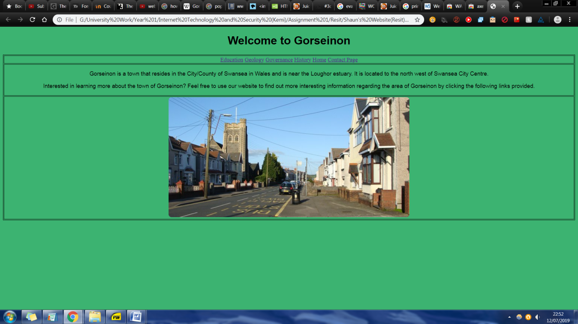
Figure 1 - Home Page
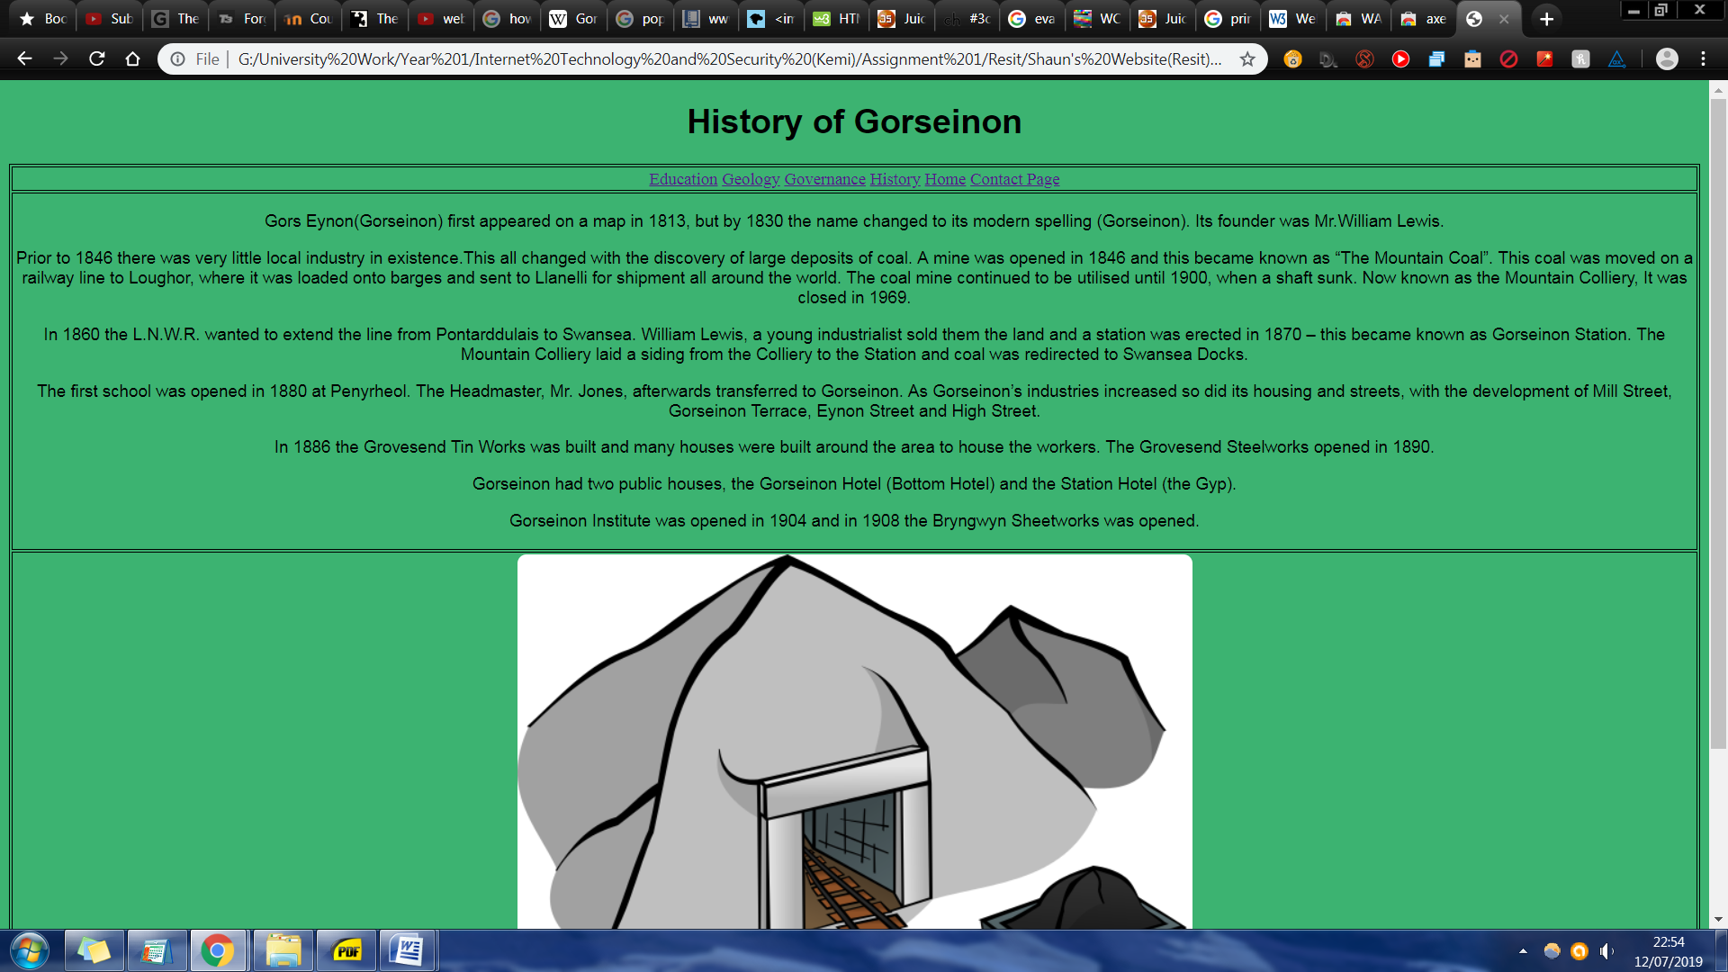
Figure 2 - History Page
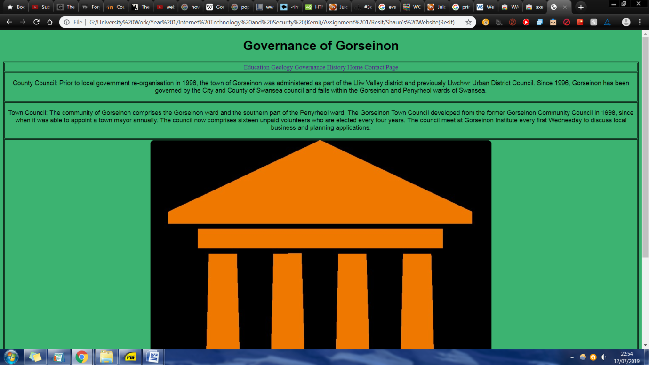
Figure 3 - Governance Page
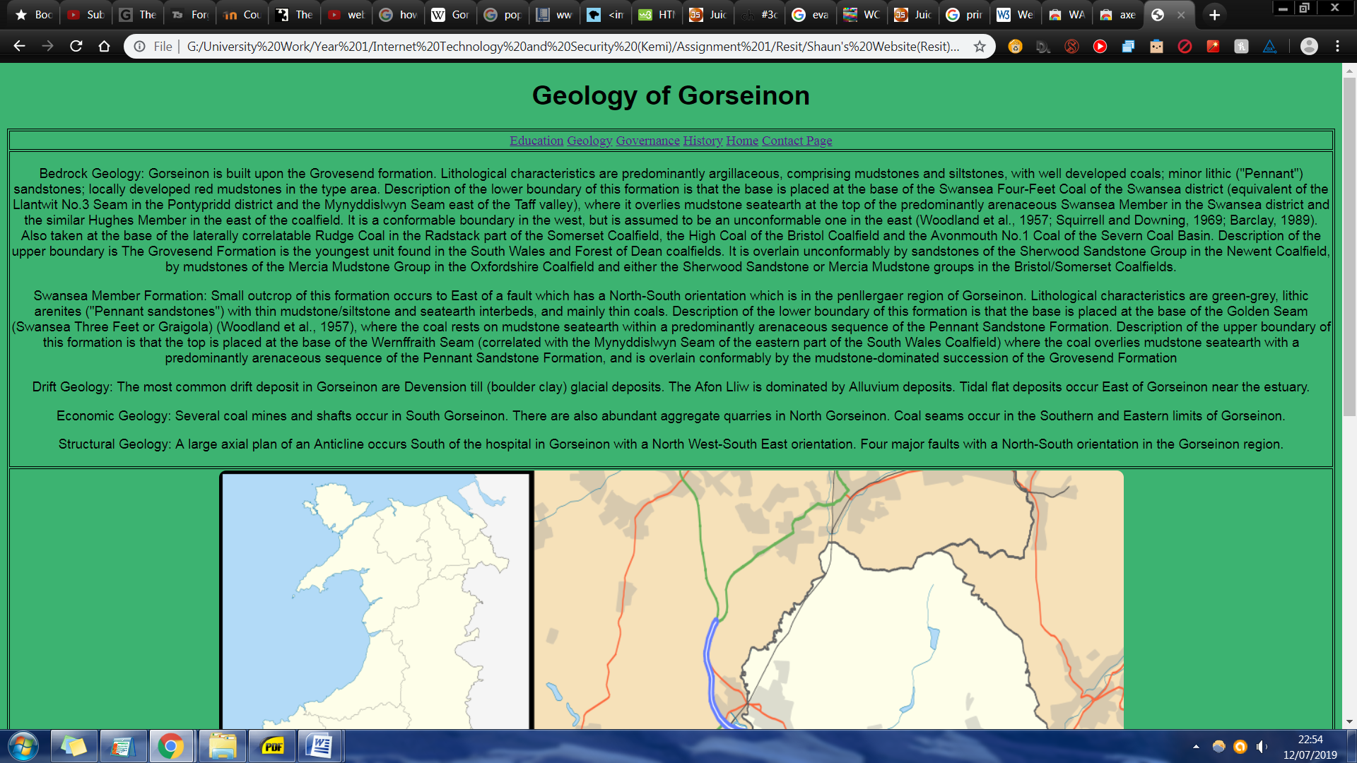
Figure 4 - Geology Page
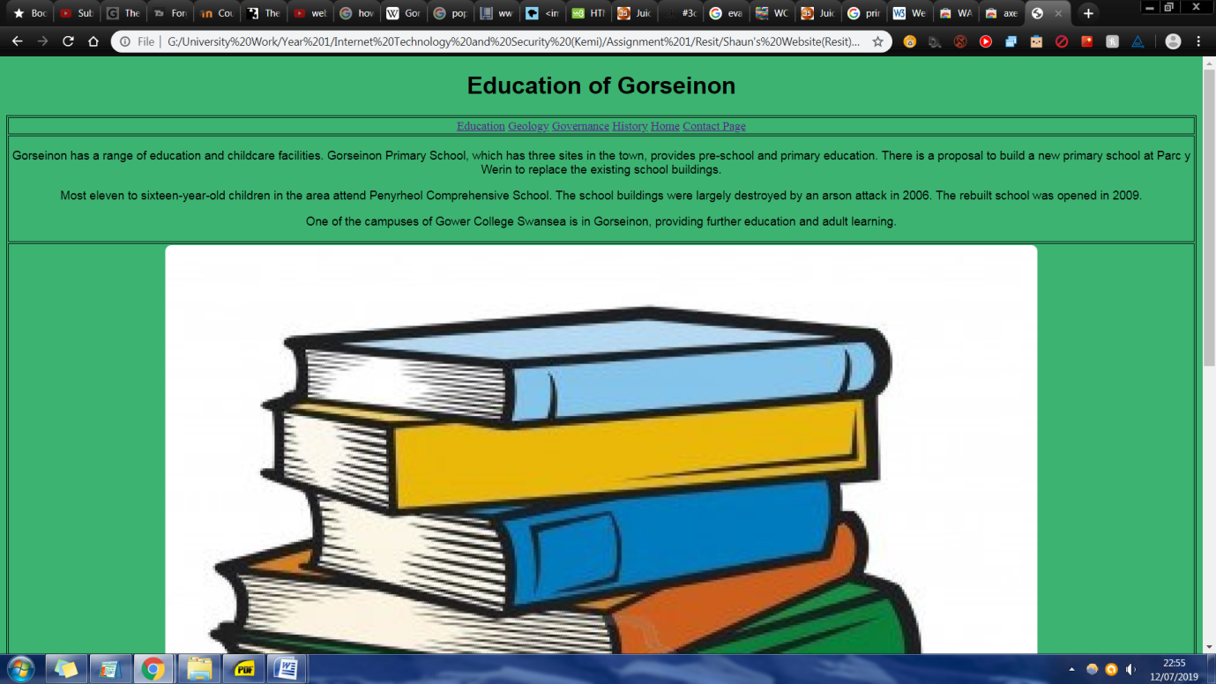
Figure 5 - Education Page
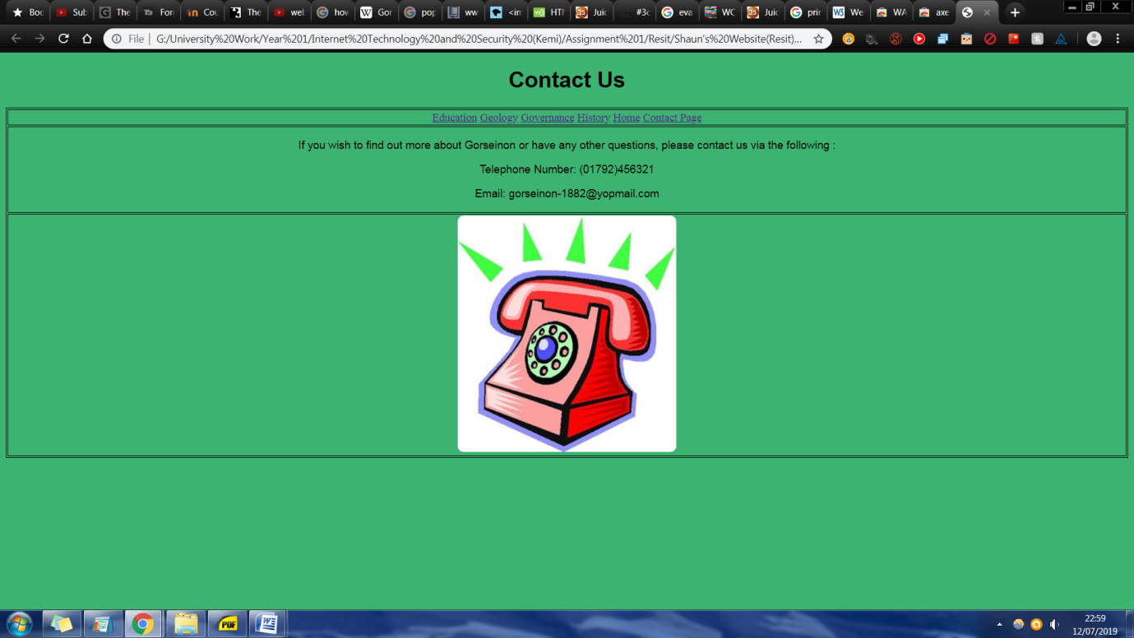
Figure 6 - Contact Page

3.2. Validation:

To insure the validity of the website when it came to designing the code, Online forms of validation tools from w3.org were used to find any errors contained within the code of said website, even if everything seemed to work correctly as code can also be implemented unethically or in a form that goes against the guidelines created for creating basic websites correctly.
When an error was found however, the fix was simple in that you would go back into the code of the website and correct the error based on where it was found.
The two used for this report for validation with the website were "Markup Validation Service" and "CSS Validation Service" with evidence of use provided below as the following.
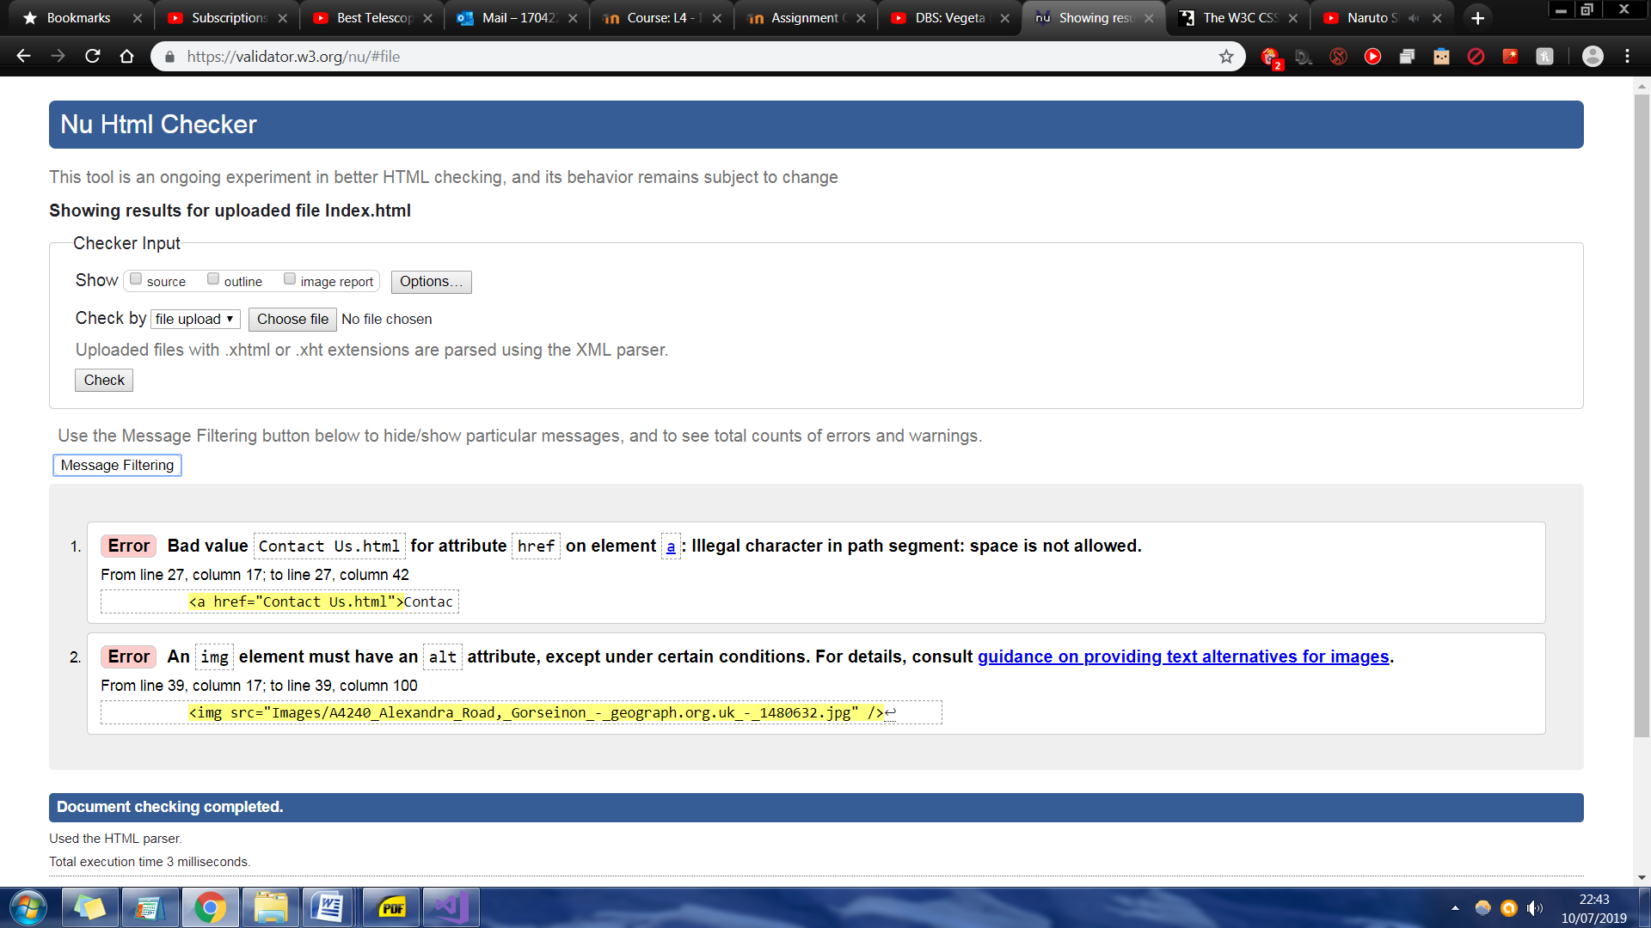
Figure 7 - Markup Validation Service
An example of error correction discovered via the Markup Checker was an apparent illegal character discovered which basically stated that a space was used between the word "contact" and "us" but is not allowed, so it was corrected by inserting a underscore or "_" between both words instead.

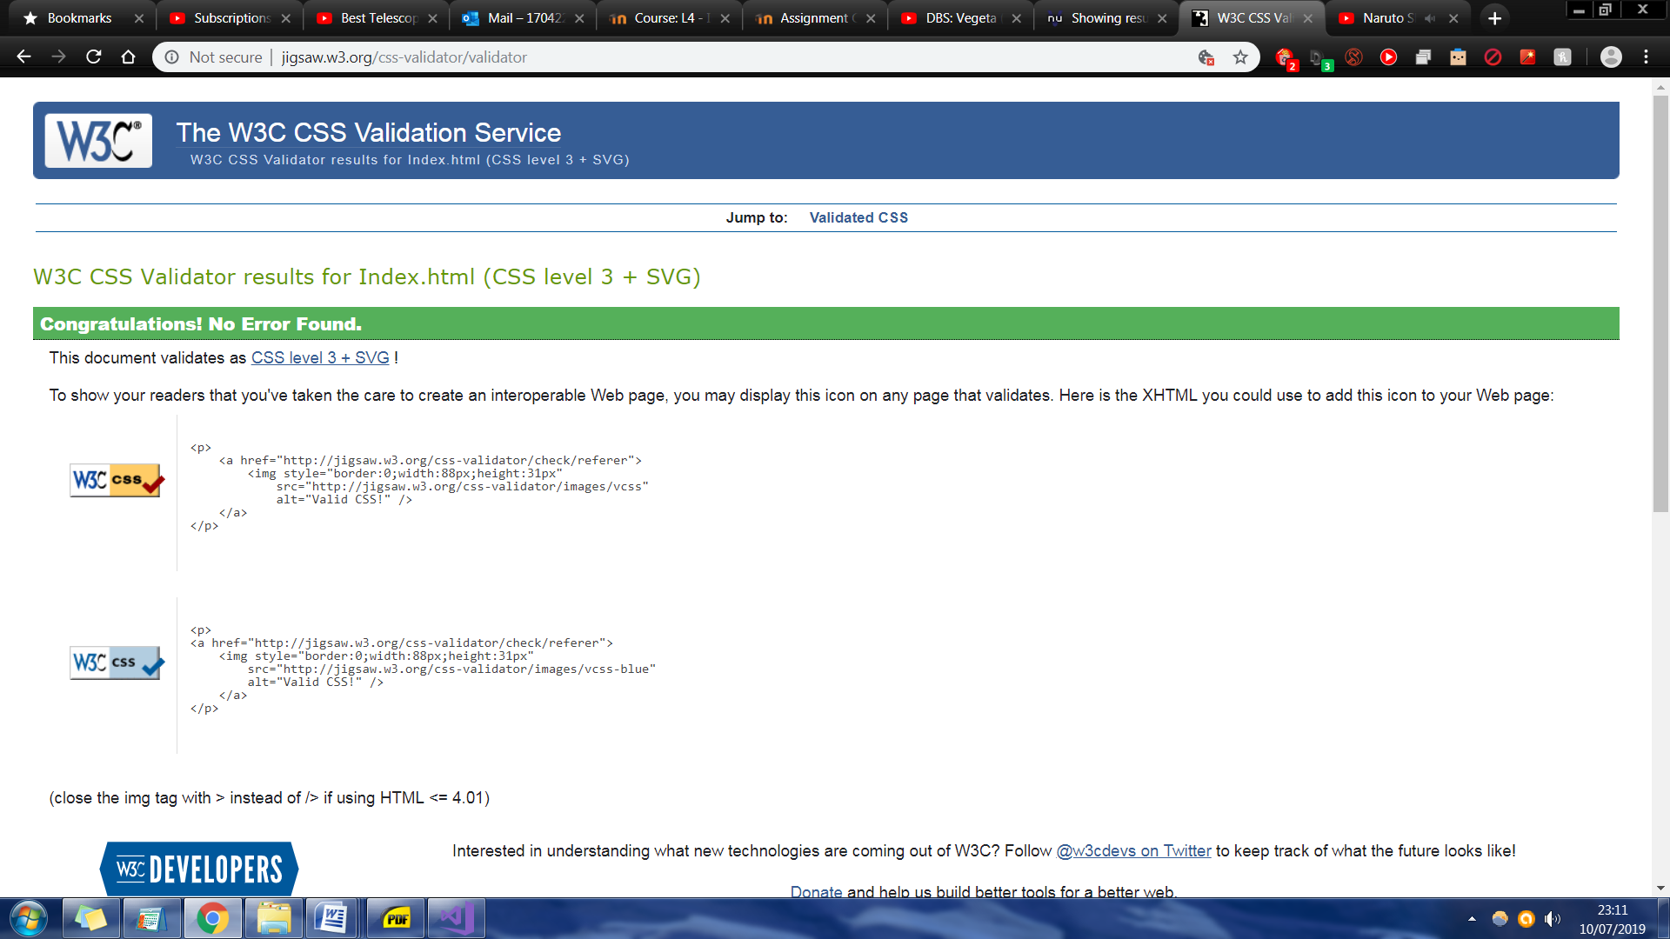
Figure 8 - CSS Validation Service

Evaluation:

In regards to the accessibility of the website, all four principles of WCAG 2.1(Perceivable, Operable, Understandable, Robust) were taken into consideration and as such various tools (Contrast Checker, Luminosity Colour Contrast Ratio Analyser, aXe extension, WAVE Evaluation Tool etc.) were utilised to insure all of these principles were followed or upheld with the creation of the website.
The results of these tests are presented below in the following screenshots.
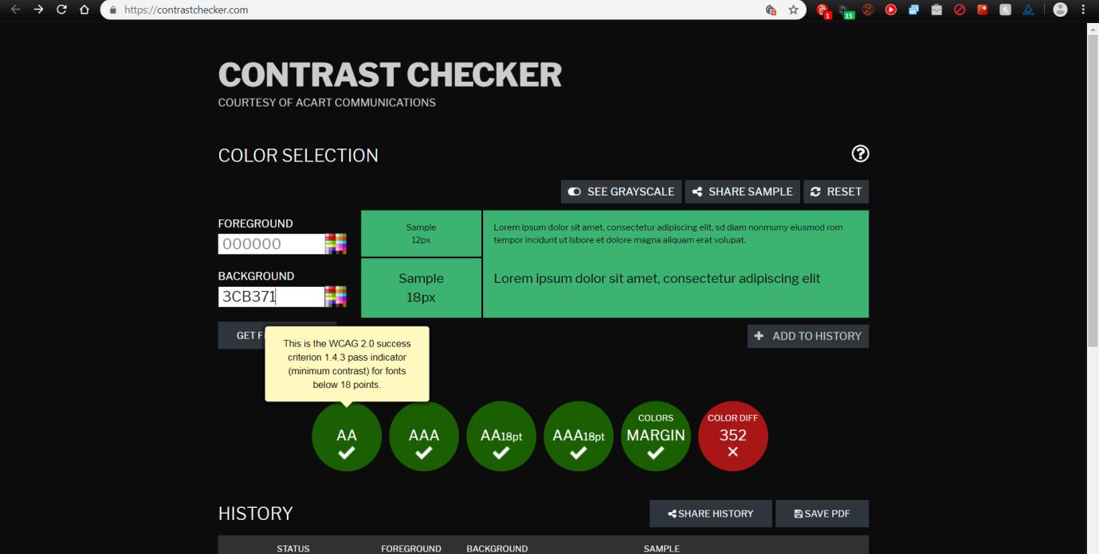
Figure 9 - Contrast Checker
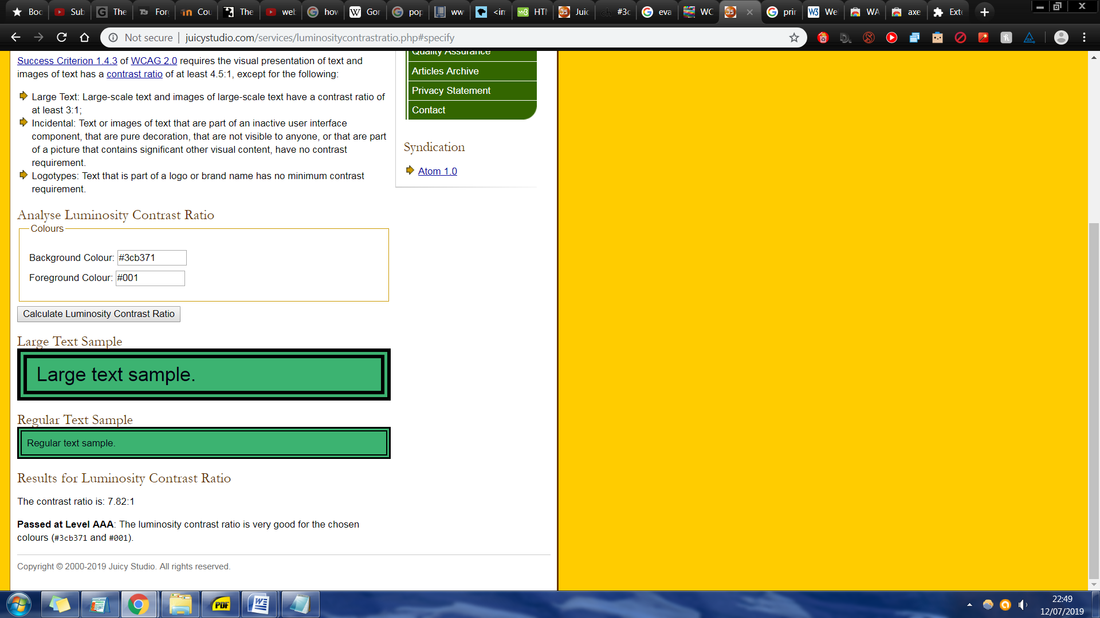
Figure 10 - Luminosity Colour Contrast Ratio Analyser
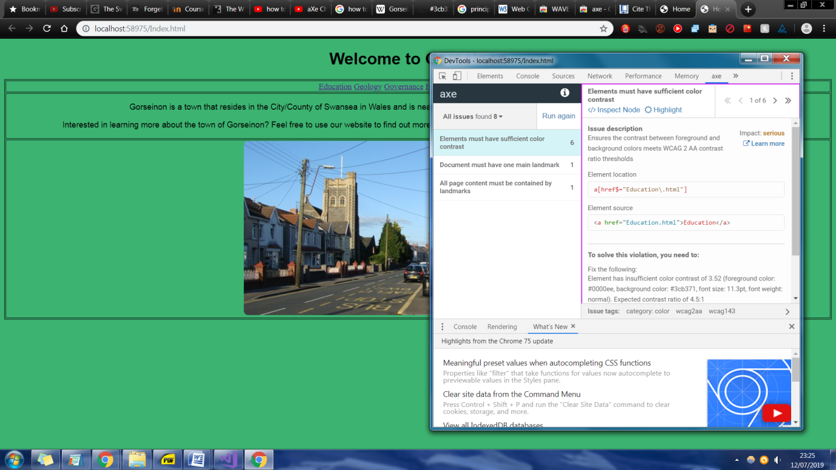
Figure 11 - aXe Google Chrome Extension
Overall the methods used to follow the four principles were deemed sufficient based on each of their basic required or descriptions provided for each principle.
However future changes can be made to improve it such as the following proposals:
- Allow user to listen to text via sound
- Animations
- Allow user to change colour to background.
An evaluation of the website's on SEO (Search Engine Optimisation) was done using SEO checker tools and was overall determined to be sufficient and in working order thus ensuring that anyone wishing to find a site using the keyword used could find it more easily for the information/content they wish to see.

References

[1]"2011 Census - Nomis - Official Labour Market Statistics", Nomisweb.co.uk, 2019. [Online]. Available: http://www.nomisweb.co.uk/census/2011. [Accessed: 12- Jul- 2019].
[2]"Quick Map - Nomis - Official Labour Market Statistics", Nomisweb.co.uk, 2019. [Online]. Available: http://www.nomisweb.co.uk/keystats/sqmap.aspx?kv=1367344941&type=-1&title=. [Accessed: 12- Jul- 2019].
[3]"Mountain colliery Gorseinon", Welshcoalmines.co.uk, 2019. [Online]. Available: http://www.welshcoalmines.co.uk/GlamWest/Mountain.htm. [Accessed: 12- Jul- 2019].
[4]"UK Twin Towns", Web.archive.org, 2019. [Online]. Available: https://web.archive.org/web/20070624184158/http://www.twinning.org.uk/uk_twinnings.htm. [Accessed: 12- Jul- 2019].
[5]"Swansea - Gorseinon Primary School project", Swansea.gov.uk, 2019. [Online]. Available: https://www.swansea.gov.uk/gorseinonprimaryproject. [Accessed: 12- Jul- 2019].
[6]"BBC NEWS | Wales | South West Wales | Rebuilt school opens after arson", News.bbc.co.uk, 2019. [Online]. Available: http://news.bbc.co.uk/1/hi/wales/south_west/8235755.stm. [Accessed: 12- Jul- 2019].
[7]"WCAG - Contrast Checker", Contrast Checker, 2019. [Online]. Available: https://contrastchecker.com/. [Accessed: 12- Jul- 2019].
[8]"Juicy Studio: Luminosity Colour Contrast Ratio Analyser", Juicystudio.com, 2019. [Online]. Available: http://juicystudio.com/services/luminositycontrastratio.php. [Accessed: 12- Jul- 2019].
[9]"axe", Chrome.google.com, 2019. [Online]. Available: https://chrome.google.com/webstore/detail/axe/lhdoppojpmngadmnindnejefpokejbdd/related. [Accessed: 12- Jul- 2019].
[10]"WAVE Evaluation Tool", Chrome.google.com, 2019. [Online]. Available: https://chrome.google.com/webstore/detail/wave-evaluation-tool/jbbplnpkjmmeebjpijfedlgcdilocofh. [Accessed: 12- Jul- 2019].

marking criteria and Student FEEDBACK

This section details the extent to which the assessment criteria are demonstrated by you, which in turn determines your mark. The marks available for each category of skill are shown. Lecturers will use the space provided to comment on the achievement of the task(s), including those areas in which you have performed well and areas that would benefit from development/improvement.

Common Assessment Criteria Applied (Assignment 1) | Marks available | Marks  awarded
1. Engagement with Literature Skills

The reference list only includes references of assets used in the website. It is expected that you would consult academic reference sources to assist you in your assignment work. Expand the scope of references consulted to further improve your work. (Grade mark: 20.00%) | 5 | 1
2. Knowledge and Understanding Skills

Demonstrates satisfactory understanding of the standards used to design and implement a website. The main area for improvement is your understanding of HTML and CSS to layout and structure website content. (Grade mark: 30.00%) | 20 | 6
3. Cognitive and Intellectual Skills

A fair evaluation of the website has been provided. Generally, this section could be improved as your evaluation is too brief and does not consider all of the elements you have been asked to evaluate. Satisfactory recommendations for further improvements have been made. (Grade mark: 43.33%) | 30 | 13
4. Practical Application Skills

A satisfactory attempt featuring a simple website. There is, however, room for improvement e.g. in the layout and organisation of content and the choice of colours to improve accessibility. See your report for additional comments. (Grade mark: 55.00%) | 40 | 22
5. Transferable Skills for Life and Professional Practice

The report is of a good standard. (Grade mark: 60.00%) | 5 | 3

Assignment Mark (Assessment marks are subject to ratification at the Exam Board. These comments and marks are to give feedback on module work and are for guidance only until they are confirmed. ) | Late Submission Penalties (tick if appropriate) |  | 45%
 | Up to 1 week late (40% Max) |  | 45%
 | Over 1 week late (0%) |  | 45%

Note that as this is a RESIT attempt, the mark is capped at 40%.

