Critical Reflection

‘Torn from Home’ is the theme of the Copper Coast International Film Festival of 2019. With this in mind we all set to work on creating 3 idents and 3 trailers as well as creating ideas for new logos for the coming festivals. Currently in the planning stages of the event trailers and Idents, however these need to wait until logos have been created and agreed upon. I have had very few ideas that relate to the theme and am finding it difficult, however, the right music seems like it is going to be the most difficult thing to find that stays to the theme.

Film selection was a long and tedious prosses as there was so many films to watch. Firstly, the films were split between the class individually, before grouping up again with two groups, one group of maybes and one group of yes’. Everyone involved would then begin voting on films that should go through. The voting prosses was difficult in such a large group as some felt unheard and others were loud about biases against genres. This had caused heavy discourse between the years over films that were and weren’t put through.
My own prosses was simple, first watching the quality of the plot, characters and the camera. I would look for continuities between shots and characters motivations, as well as watching for actor performances. I would also keep an eye out for weather there was any impressive or interesting cinematography, music or acting that fit the scenes perfectly. I would pay special attention to the categories each film was entered into, nevertheless, as films started to fly past we would be able to tell a bad film from the first 3-5 minutes in.

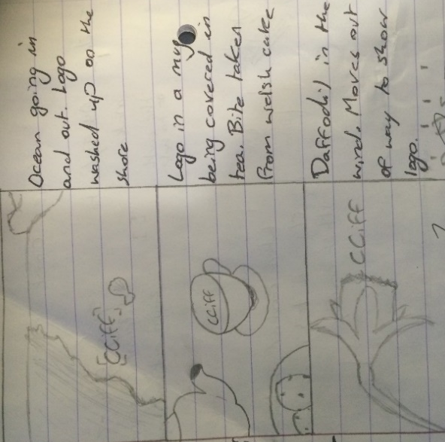
I had high hopes for creating the idents for this years festival, however some of the ideas hadn’t planned out the way I was hoping. All were for different reasons. My first idea was to have a Daffodil blowing in the wind and as it moves one of the logos would appear behind it as the Daffodil carries on blowing; after searching for a Daffodil I realised that they aren’t in season for a few more weeks and only tiny ones from Super markets were being sold. This idea was from thinking about generically Welsh things, along with tea and Welsh cakes that I was planning to use in my last idea. My second idea was to film the tides on Swansea beach, but after becoming ill I had no time to do this. Lastly was the idea to add powder to the top of a hot drink in the shape of CCIFF new logo. Three attempts were made to film this, first time I knocked the drink over when I dropped the camera, second and third attempts were also unsuccessful as the powder would immediately sink or disperse the foam at the top of the mug.
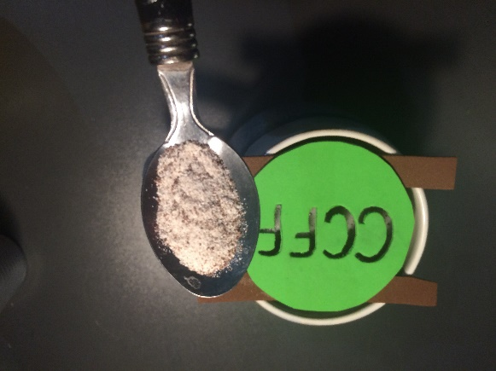
Instead of these I used clips from the interviews held with the class, one word to describe the Festival was turned into a short ident. My trailer ident was also used as an ident as there wasn’t enough films from different countries to keep the attention for 45 seconds.

The first trailer idea I had was to draw around the countries of earth and create a cartoon spinning globe; this was taking too long to draw with limited illustrator knowledge so this was scrapped in exchange for the next idea. This was for a spinning globe to have films from different countries coming from them on the globe. I had managed to create the globe in After Effects, even though it had taken longer than expected as I had missed an early step that halted progress for a while. The idea came from the films being forwarded from all over the world, people all over the world are coming together for this event in a small Welsh city.
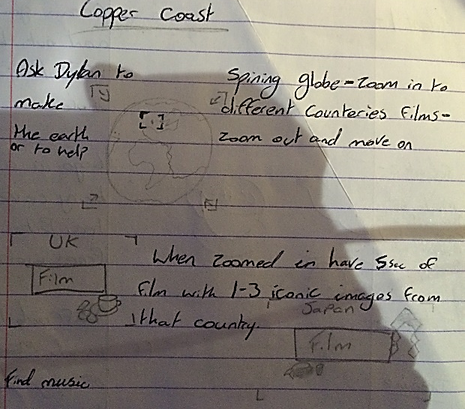
The two other trailers were about bringing people together. One is about being alone in this world before seeing the light at the end of the tunnel, having family and friends around for you when they are needed most. The next is very similar but starts with Grief and running from this before seeing the light in life. Films like these were common place in many film festivals that I had seen, having inspirational and happy messages to them and the festivals. Mine are both about seeing the light after tragedy hits, like being torn away from home or having someone being torn away from the family.


I personally had very little to do with creating and designing the new logo for CCIFF as I have little knowledge of Photoshop and Illustrator as well as very few ideas. However, I still threw my hat into the ring with creating two ideas. The first idea was having a film reel flickering with CCIFF inside like it was being played, it would then quickly move up with short clips flickering on the gaps to follow. My second idea was similar, however instead of using the reel its self it was the reel tin spinning with information in them; showing one section at a time. If given more time I would have created the tin and reel with more details, but with better ideas going around I never improving on these. Although neither fits into this years theme both still stick with the theme of film, especially the classic way of making films. Others in the class had come up with similar ideas that were executed better than my own ever could.

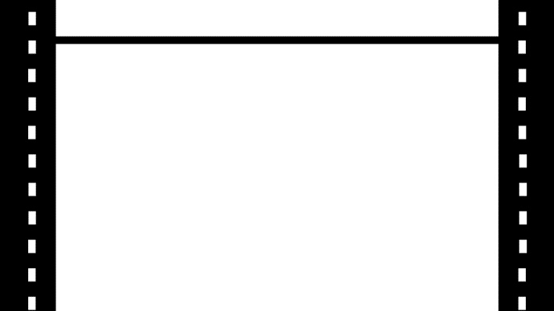

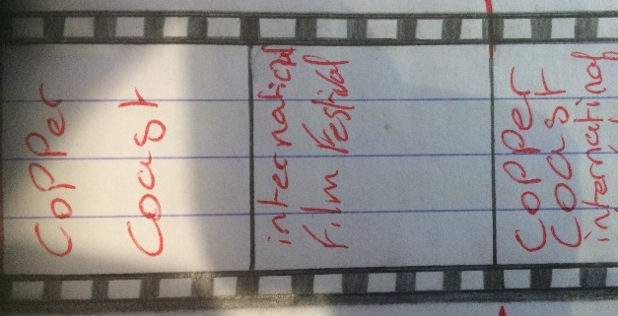
Two more ideas were also conceptualized and put to paper, however were never created due to time restraints. The first would have been a clap bored with the information about CCIFF and the festival (this one I was going to use at the beginning of trailers). The second idea was a drawn image of the fountains in the centre of Swansea with CCIFF written next to it, but due to not being a strong artist I would have had to find someone from the art course. The Clap bored was the better of the lot, however was still out of my own reach.
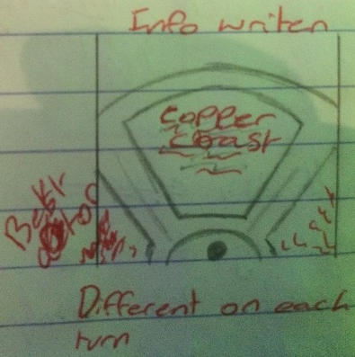
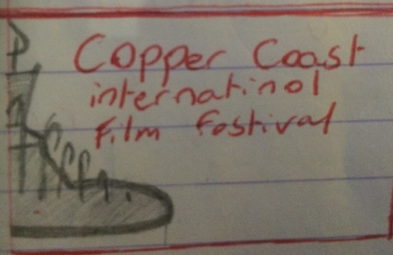
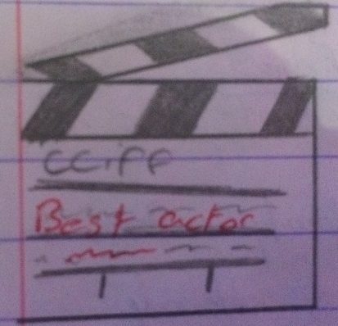

In the end too many of my ideas had fallen through or had been changed drastically as the deadline was approaching fast; some of these due to time restraints, being over enthusiastic or from lack of props. In theory this was going to be easy, but with so much footage to work with there was still not enough for some ideas. Music was also a large problem that everyone had run into, online there are plenty of places to find Royalty free music but finding the good stuff that suited thee film and was the right length was a large task. I had tried my best to find as much as possible. Next year hopefully we can get the music tech course to lend a hand by suppling anything they are able to.

