Production Diary
Aday Cejas Torres
P150999
CCGD
ELM TEAM
1,3,5 and 6th February
Today I started with the Main Boss retopology. Since this is the first time I make a retopology for my tam project I had to do some research to remember some basics and the most efficient way to retopology each part of the body.
I stated placing the main loops in the neck, shoulder, stomach, etc. Put big squares at the beginning to make sure it stays low poly. After hat I started to connect the main loops and then I started to fill them with more squares.
I started to fill some zones before connecting the main loops which caused that in the end the loops had different number of polys, so I had to figure out how to make them connect properly.

Ç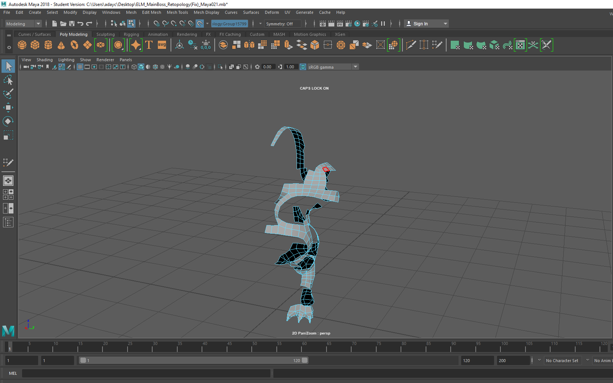
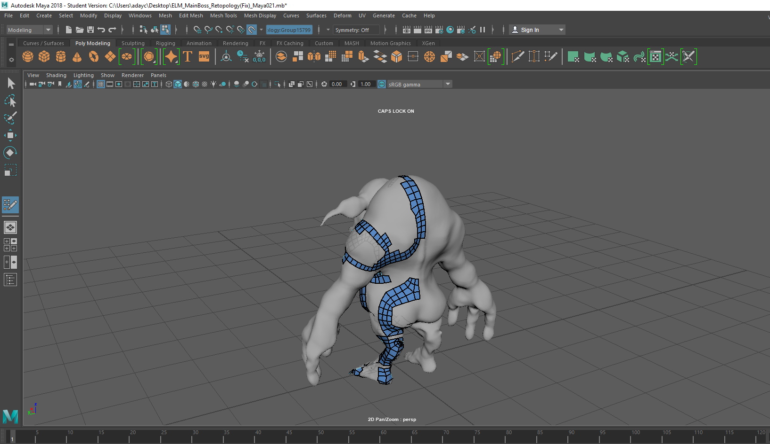

7 and 8th February
After connecting all the main loops on the body, I started with the fingers. First a small square on the fingertip and then I just added more squares all the way up to the wrist. Once the hand was done I went through the head. Started with some loops in the eyes and the mouth. The face was the hardest part to retopology so far since my character has exaggerated expression and elf ears but at the end I managed to finish it, not as clean as the body but still decent. I also started with the top head retopology and the feet.

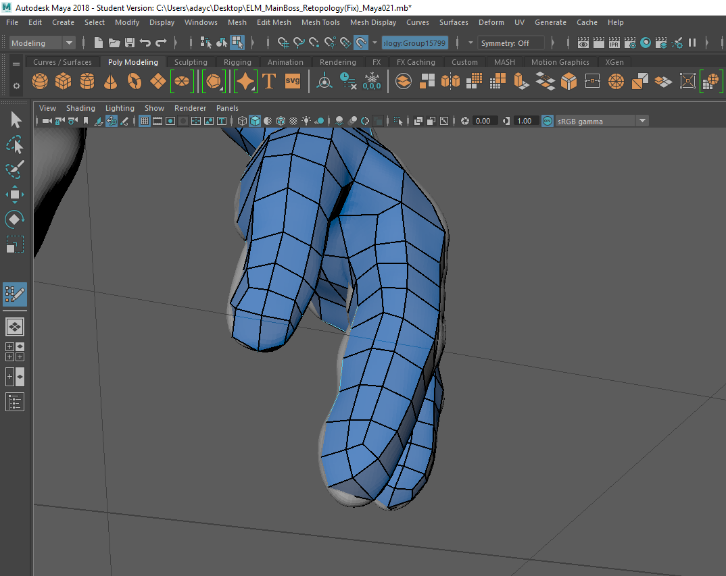
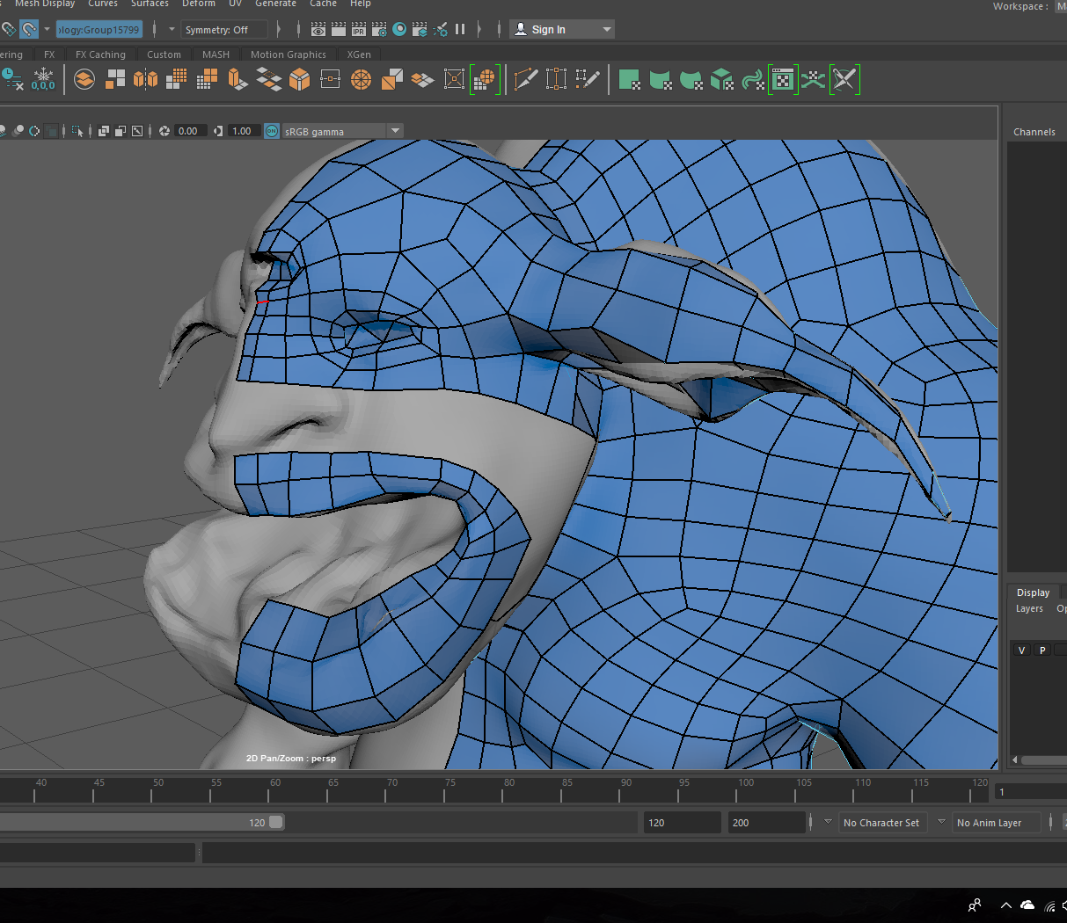

9 and 10th February
Today I just had to fill the mouth and the eyes to finally finish the retopology, so I started to connect the main loops through the inside and finished it. While doing research about it I saw some people taking the topology in the mouth and eyes really deep within the model, but I just did it on the surface. I had some problems connecting some loops and fixing some triangles and Ngons but was finally able to do it.

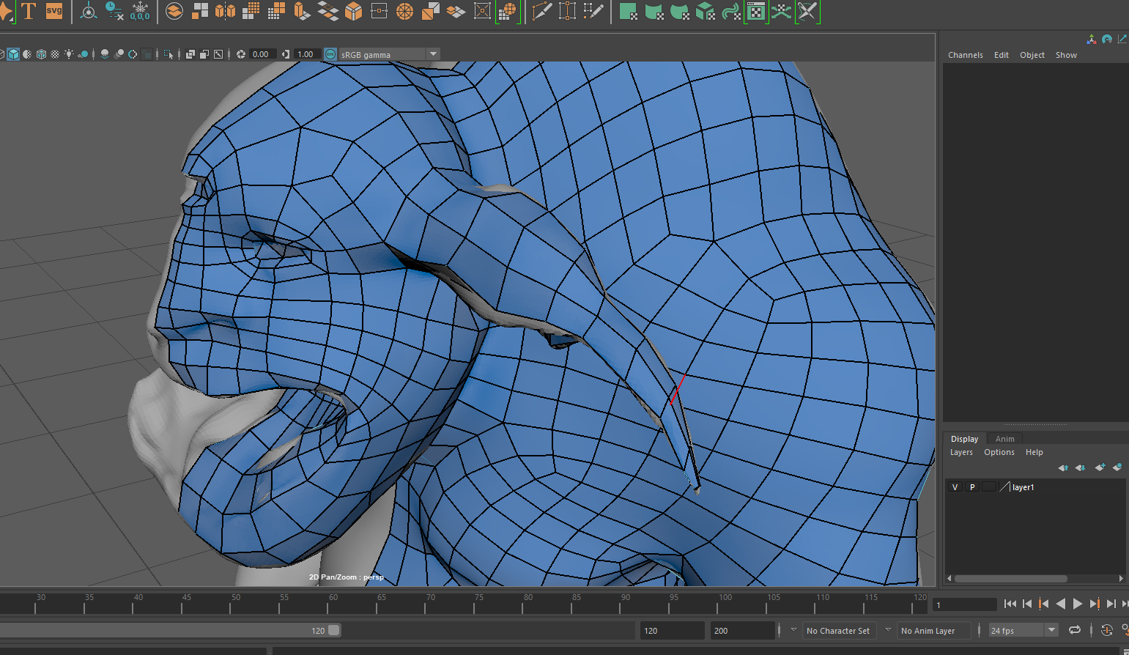
12^{s} February
I imported the teeth of the main boss in Maya and retopologies them as well, I follow the same process I used with the fingers. Placed a square on the bottom and top of the teeth, connected both and then I just added more loops to soft the shape.
14 and 15th February
Today I started to retopology the other enemy model. I followed the exact same process I used in the first enemy. Started with the main loops and the in tried to connect them and fill them

16 and 17th February
Before continuing with the second enemy’s model I went back to the first one to mirror it and checked for any mistakes or ngons left. I found a few, some of the squares weren’t attached and I had some infinite loops.
19 and 20th February
Fixed Ngons, the infinite loops and made sure every square was attached to the others. Finally, I smoothed the whole retopology to achieve a higher quality shape closer to the actual model.

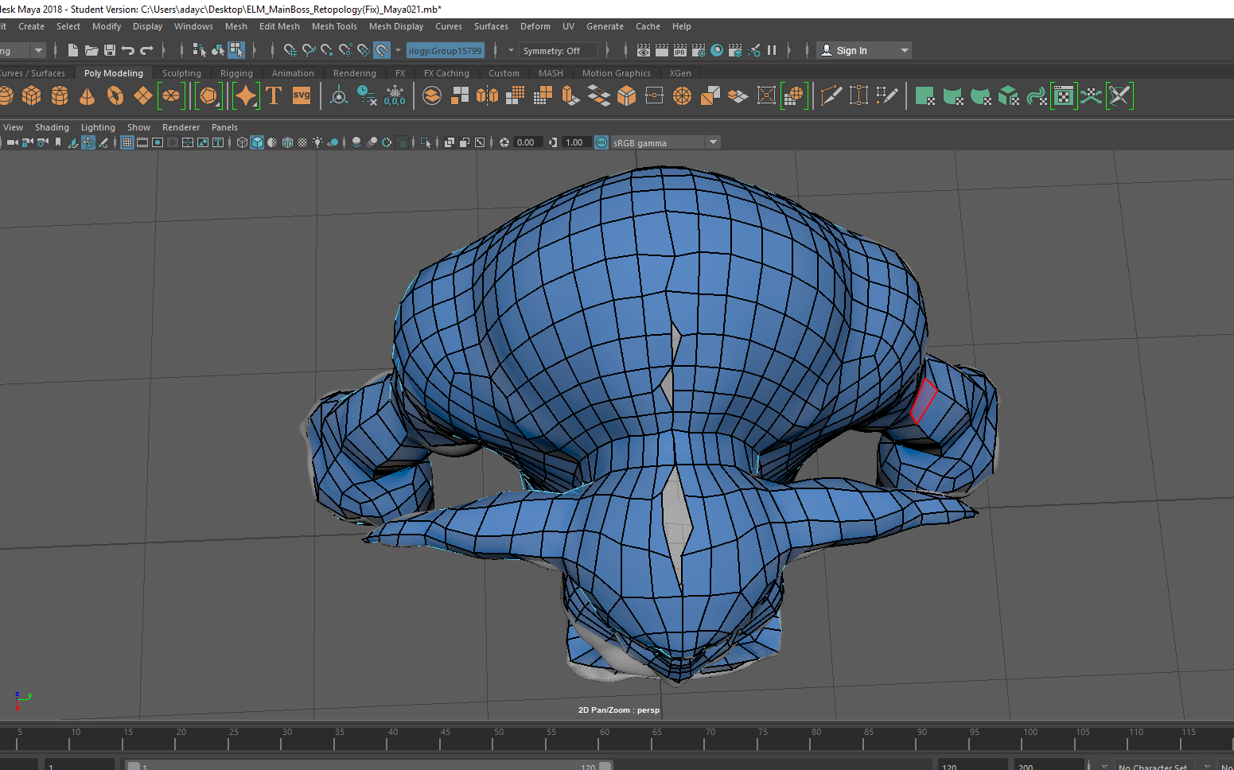

21st and 22nd February
I UV Unwrapped the main boss without much trouble, I separated the head, the arms and the legs from the main body structure and then I split in a half each section. Now the main Boss is ready to be textured.

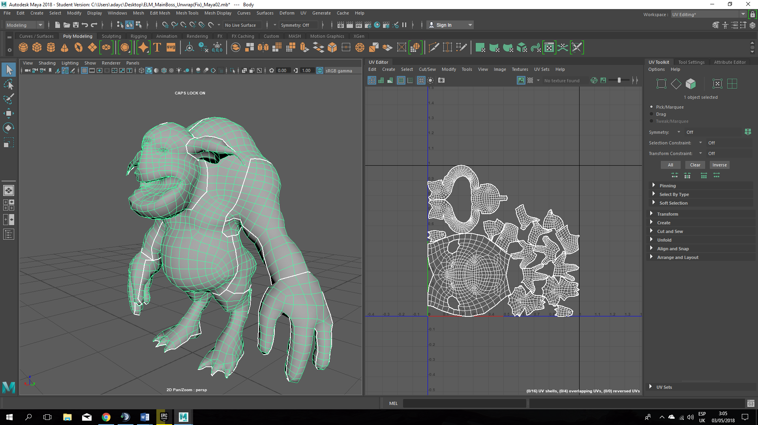
23, 26 and 27th February
These three days I tried to find a palette of purple and pink colours that fit into the world clearly representing the corrupted state of the planet and the alive being in it. I chose some pastel purple as a basic colour and then I just used different tones of that purple for the shadows. For the bright (belly, head, shoulders and hump I used a pastel pink and then blurred it to make a smooth transition between the purple and pink. For the eyes I used a dark orange to give it a scary and hungry look. After that, I used the opacity value to texture the small teeth upon a transparent mat. For the big fangs I just added some yellow and orange for the dirt Finally I put some detail such dirt and dust on it’s feet, belly and back using some particle brushes.
March
1st 2nd 5th 6th and 7th
I expended these days researching trees and different ways to model them as a low poly asset and yet a bit realistic. What I did was to make a hexagon and use it as the main structure of the tree. Once I got a rough shape for the main structure I started with the roots. This process shouldn’t have taken me so long but since it was the first try I went through it slower than I expected. As I was saying for the roots I just extrude squares form the base of the main structure, then I separated them from the whole piece, scale down the squares and reoriented to make curves, the I combine them back with the main structure and then I just used the “bridge “tool to fill the space between the squares and the main body. I repeated this process many times with each root until I have three of them with different shapes. I used the same process on the brunches but this time it took me a bit longer since every brunch has another brunch or two in it and the brunches are longer than the roots, so they have more divisions.
Finally, I changed a bit more the make structure to make it look more like an actual tree and gave it more details. Since this is going to be the main tree I made it big to make clear that to protect it is the main objective of the level.
8th March
I placed the asset in the centre of the world, made sure the scale was the one I needed and UV Unwrapped it.
10th, 11st, 12nd and 13rd March
I designed and modelled the normal and the dead trees. They have the same structure, but I will make different textures for them and I’ll add some leaves to the normal tree.
For this tree I used the same method as in the main tree, but I tried to make it look simpler since these trees won’t have the same importance in the level. Although the process was the same and the design w\as simple I changed the design couple of times.
After finished it I UV unwrapped it to leave it ready for the texturing.
15th and 16th March
I modelled a really basic bush for the normal trees. I used a low poly style because I didn’t want to expend too much time on this tree since they don’t need to be as detailed as the main tree. I Used some spheres and squares and tried different shapes. Then I just UV Unwrapped it.
19th and 20th March
Connor asked me for a bridge to connect two parts of the maps. We needed a bridge that would be able to open and close but at the same time to had to fit with the environment so u modelled a really simple trunk bridge and placed the rotation at the on of it so it would look like it was open and closing

21st to 24th March
We needed another trunk to use in the platform section at the beginning of the level so this time I made it more detailed since it would be more visible. I took a cylinder and follow the same process as with the normal trees but instead extruding roots I just opened the bottom side and made it look like broken wood. This asset took me longer than expected because I have some issues with the UV Unwrap. Some faces were too stretched and others where overlapping so it took me a while to find out which faces were affected.
26th to 27th March
I modelled a bouncy shroom that we needed to have on the platform section and some other spots around the level. It wasn’t a big deal since I have modelled shrooms many times before like on the main tree. UV Unwrapped it

1st to 2nd April
I modelled a more complex and detailed bush for the main tree. I used three half spheres on top of each other to give it some depth. I will use the Alpha option on substance painter to texture the leaves on it and me it looks better and more striking than the normal trees.
3rd April
At this point I started with the texturing. Today u textured the trunk bridge. I just added some cartoony wood textures. I also did a small variation on the fallen trunk we will use on the platform section just to be able to choose or spam different versions in the level.

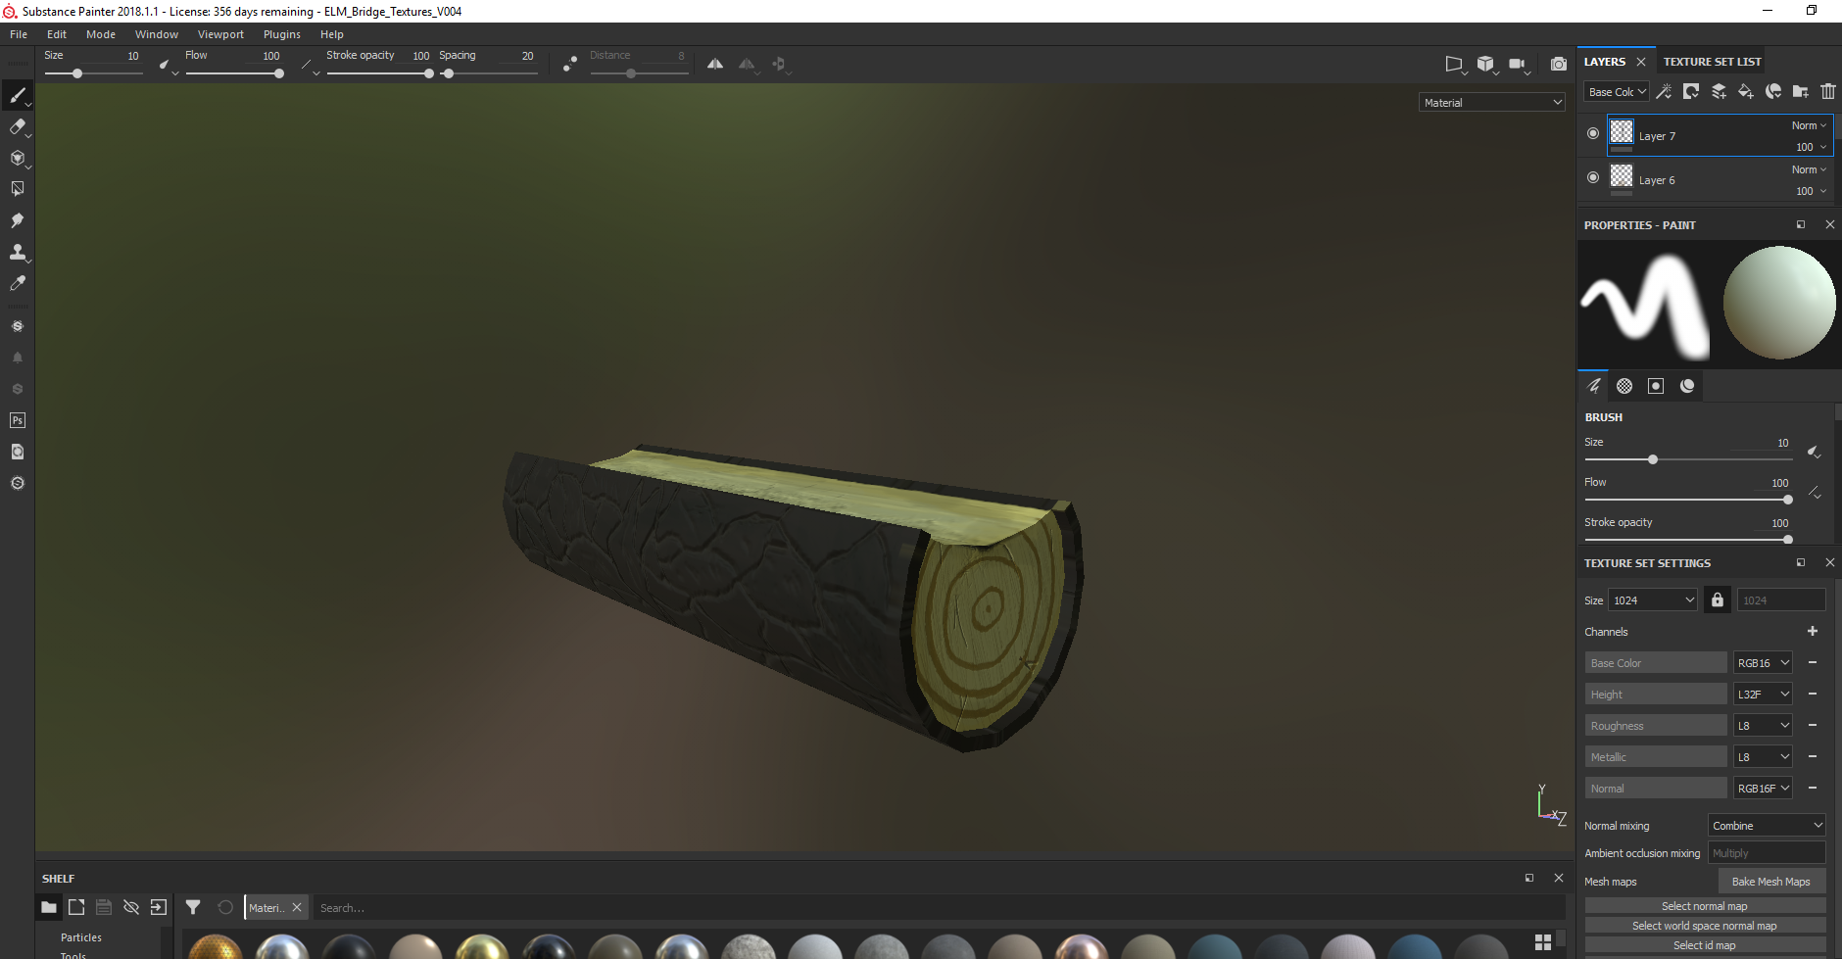
4th to 5th April
Import the dead (corrupted) tree into substance. I gave it a dark and corrupted look by adding dark colours and some sort of dark blue magic within the tree. Since this tree I supposed to be dying I won’t add any sort of leaves to it.
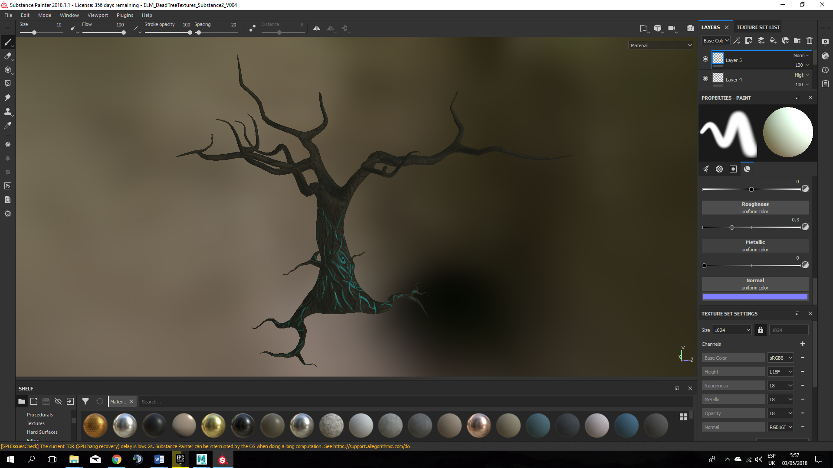
7th April
I just did simple textures on this one. Used some brown on the whole tree and then just added some wood textures by hand.

9th to 11st April
For the main tree I did a more detailed and striking textures to catch the player’s attention. I did two different versions of it, a green one with green leaves and a yellow/brown one with pink leaves. I t looked like an ancient tree with both textures so we all decided to add a green one to make it look more “alive”. I used some yellow and orange tones for the shrooms growing form the tree. 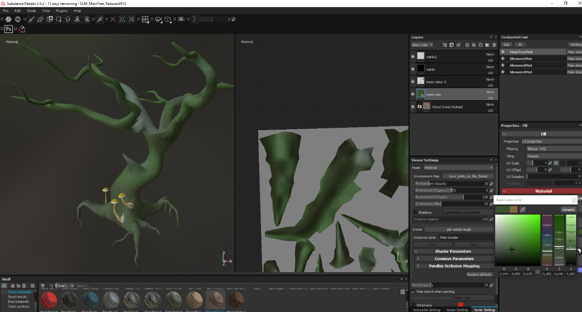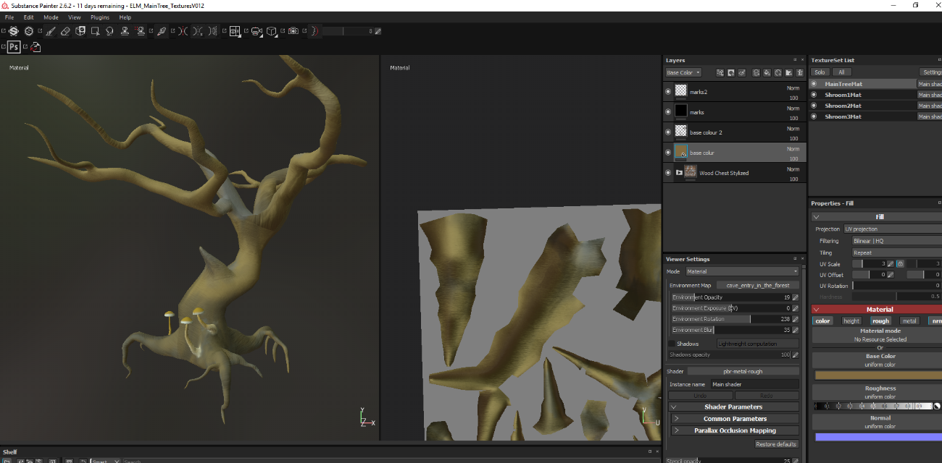

15th to 16th April
I textured this trunk as I did with the bridge. Simple textures

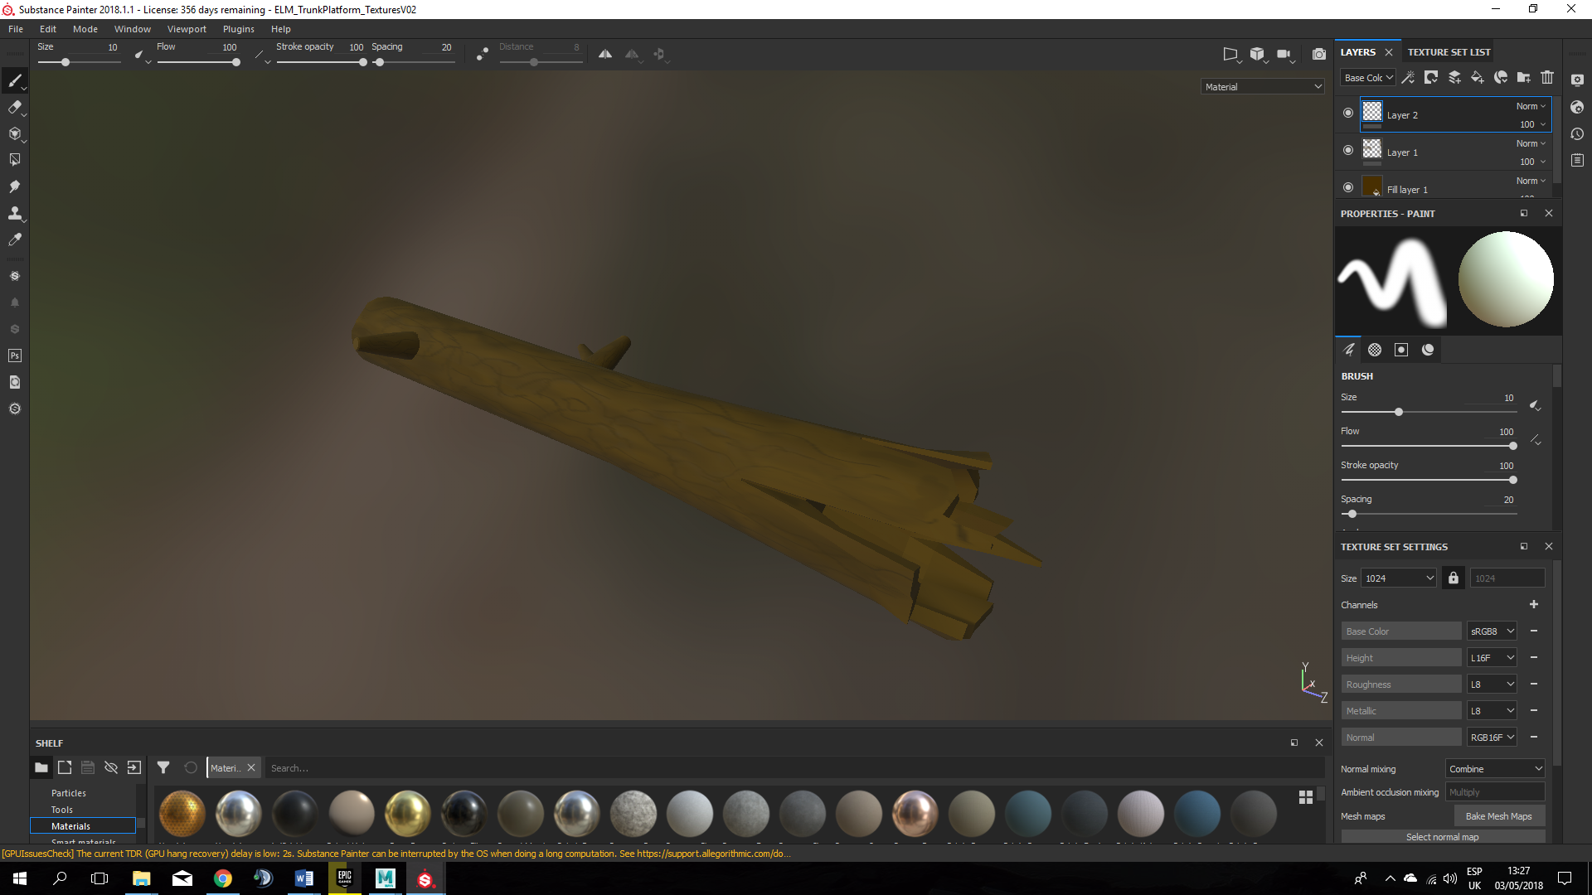
18th April
We needed a potion model for the collectibles, so I model a classic potion and combined it with an acorn to make it fill in the forest.

19th April
I gave a really basic colour for the basic leaves. I wanted simple and low poly. I also textured the toadstool. Put some orange tones to it and some shroom textures. 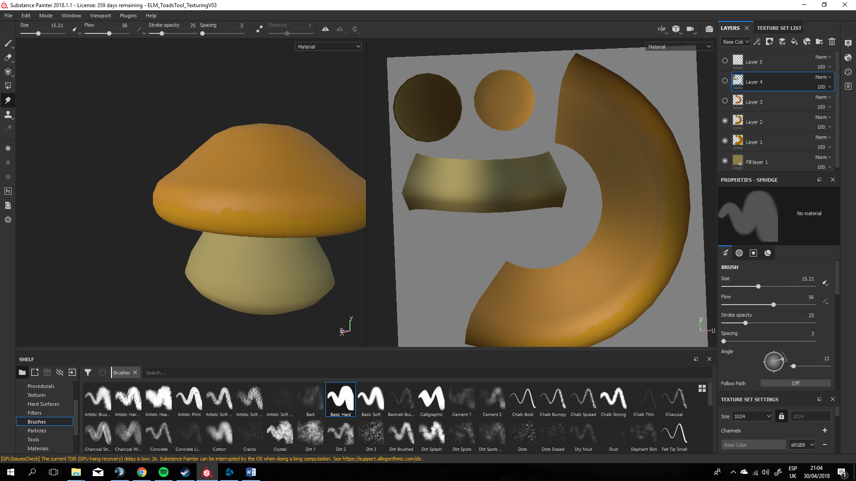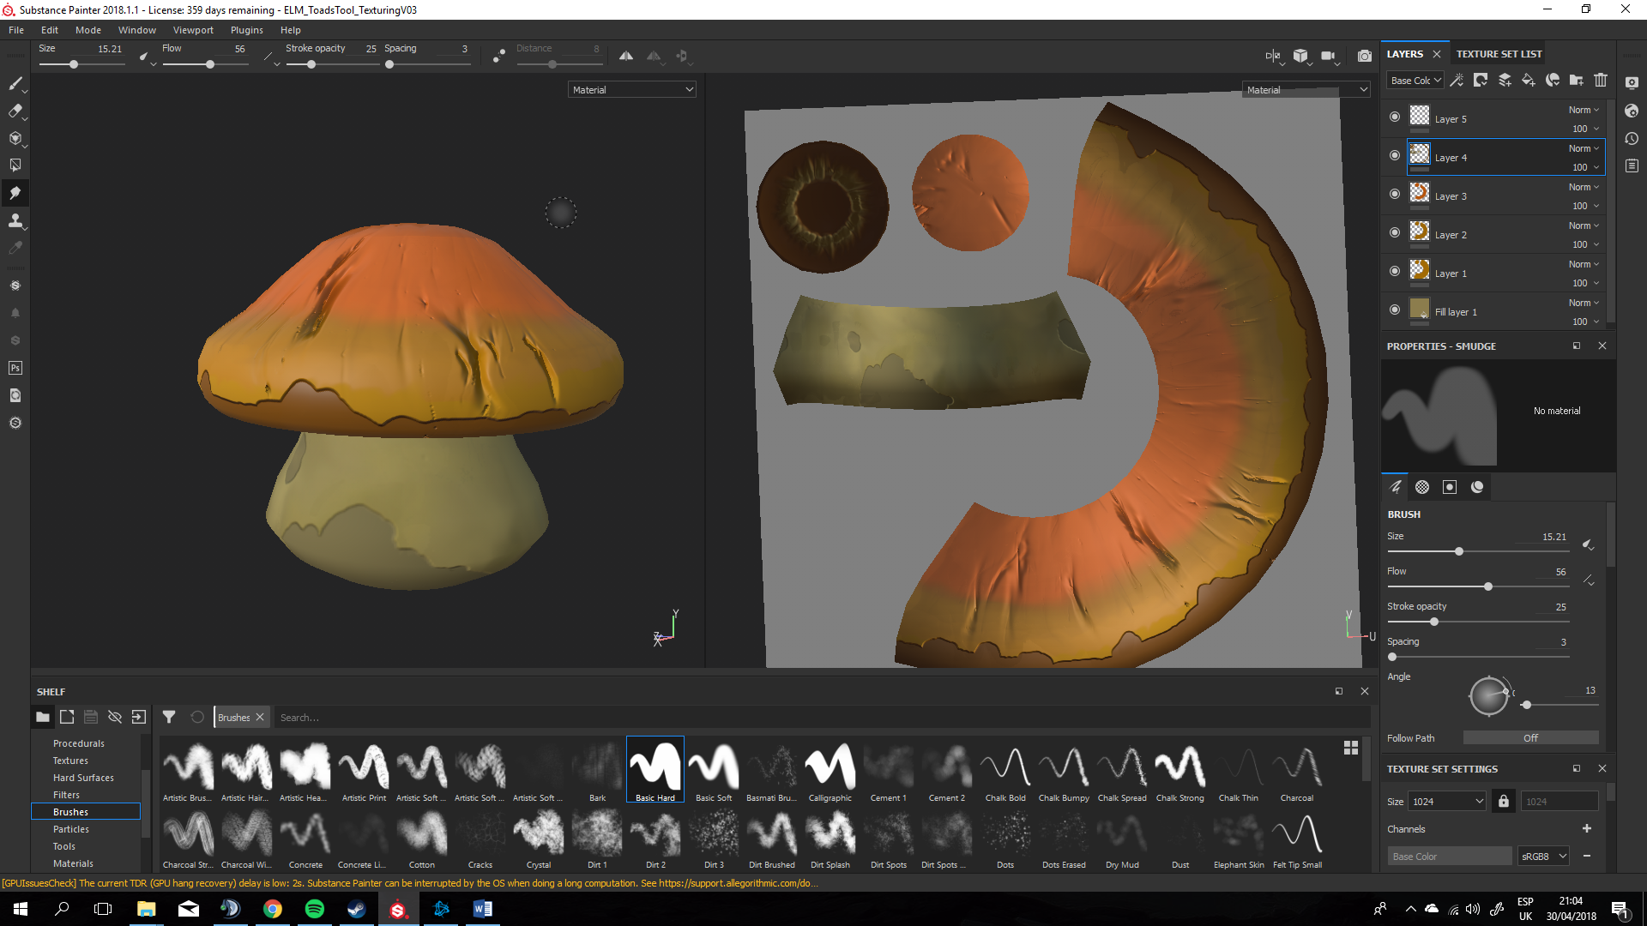
20th to 21st April
Textured the main tree’s leaves. I added Alpha value, so I could make it more detailed. Put some green and yellow colours.

22nd to 23rd April
We needed some grass, snow, etc for the world so in order to be able to pain the world I made a square structure in Maya composed by six squares uv unwrapped in the same way and overlapping each other, in that way I will be able if the textures look too similar from the far.

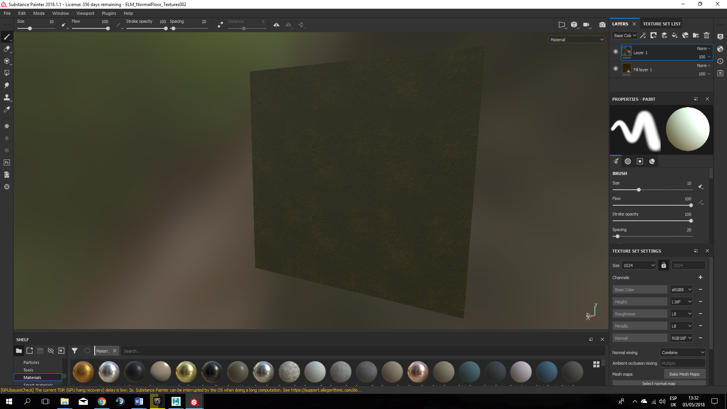

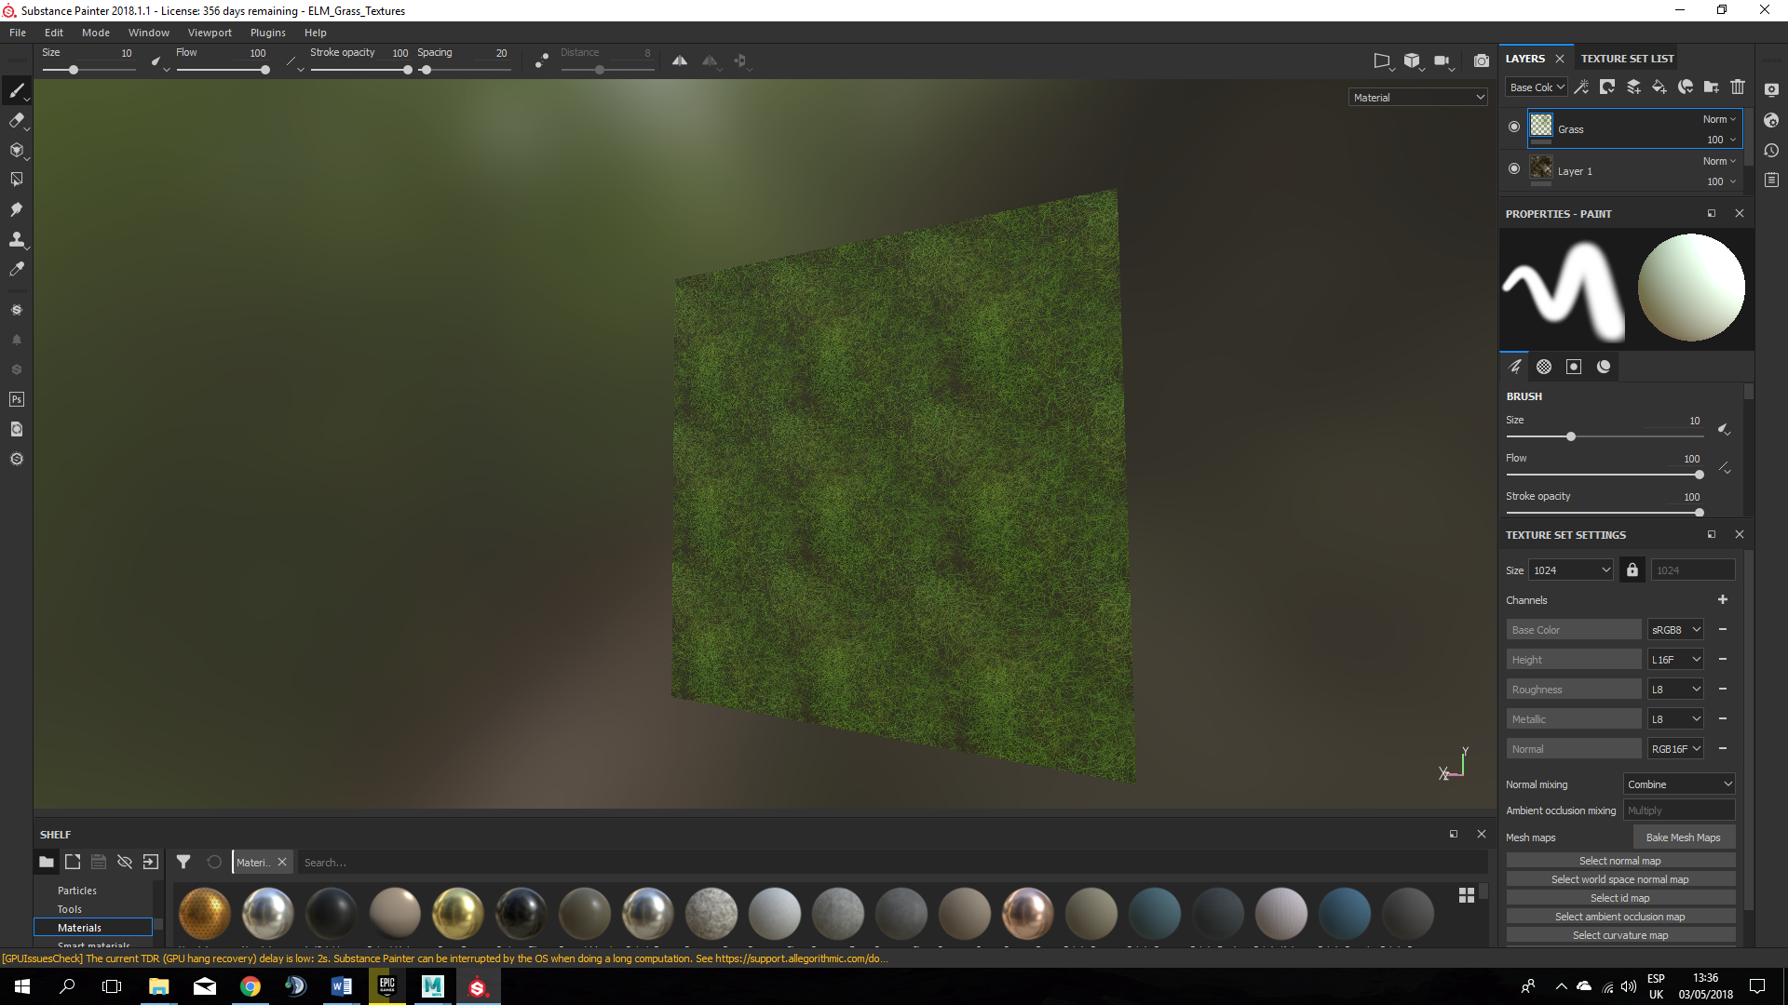

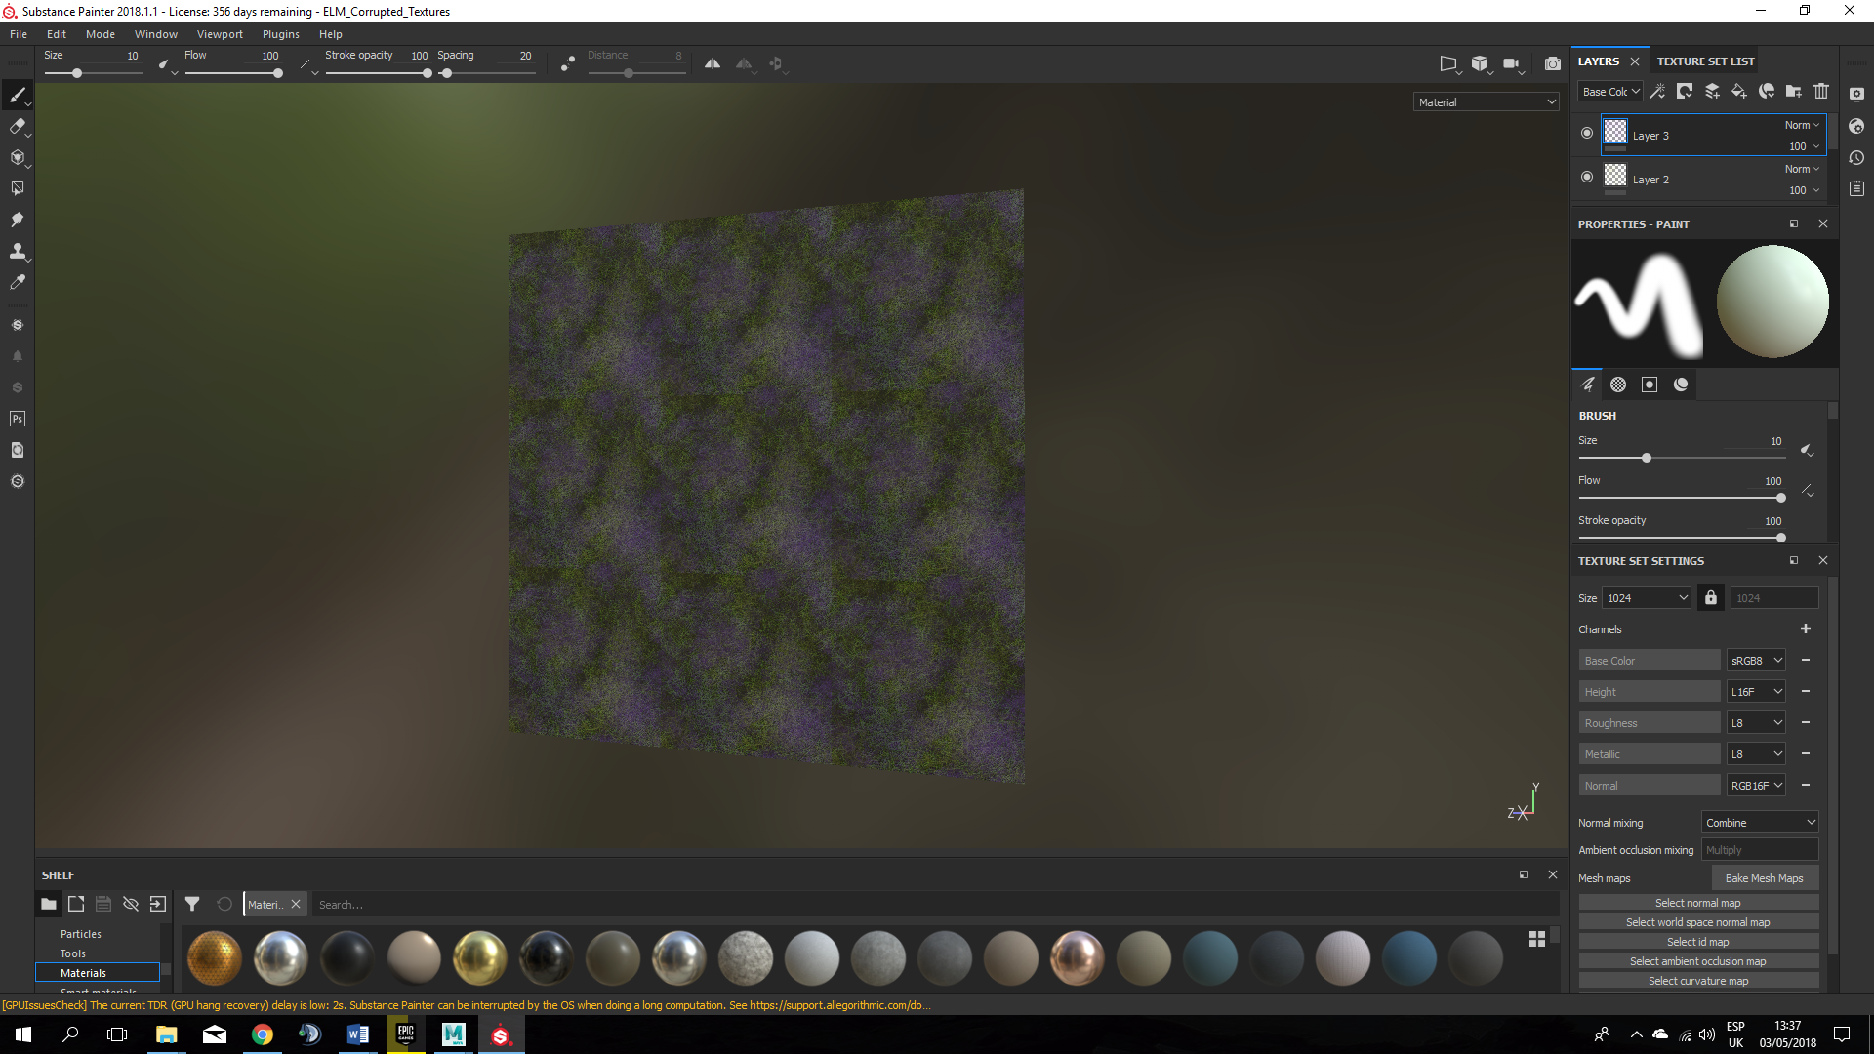

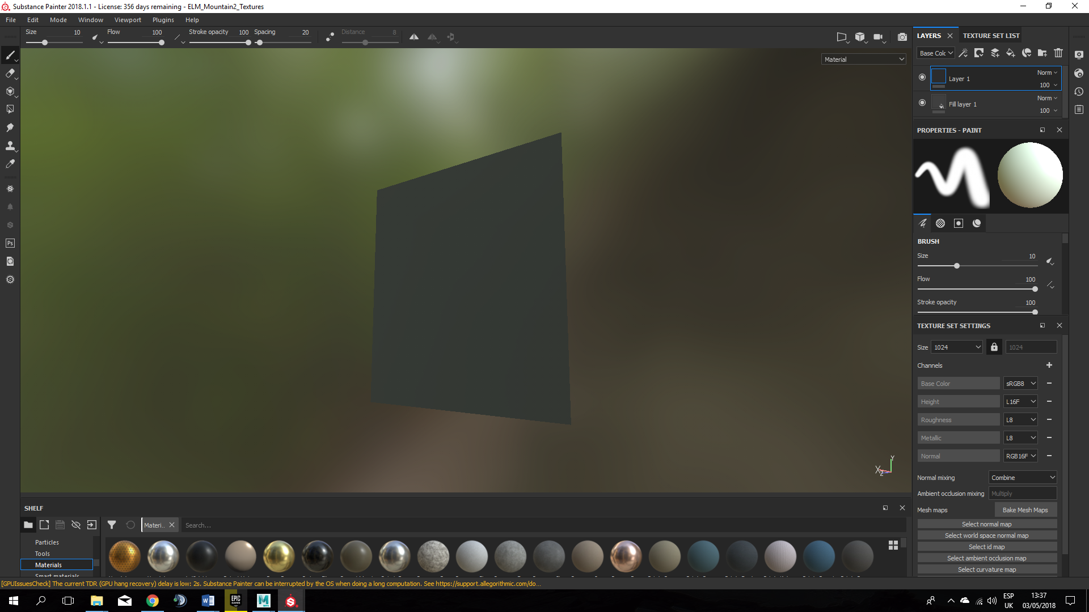

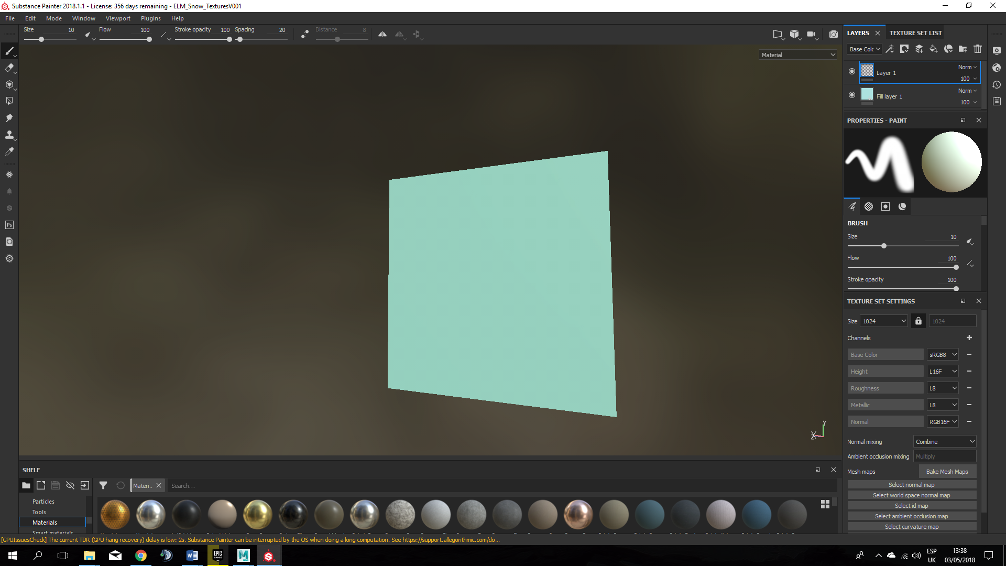
24th to 25th April
For the potions I made one of them red and the other one blue in case we add some stamina potions. I also textured a simple bonfire Aled gave me. We will place it around the world near to the enemies

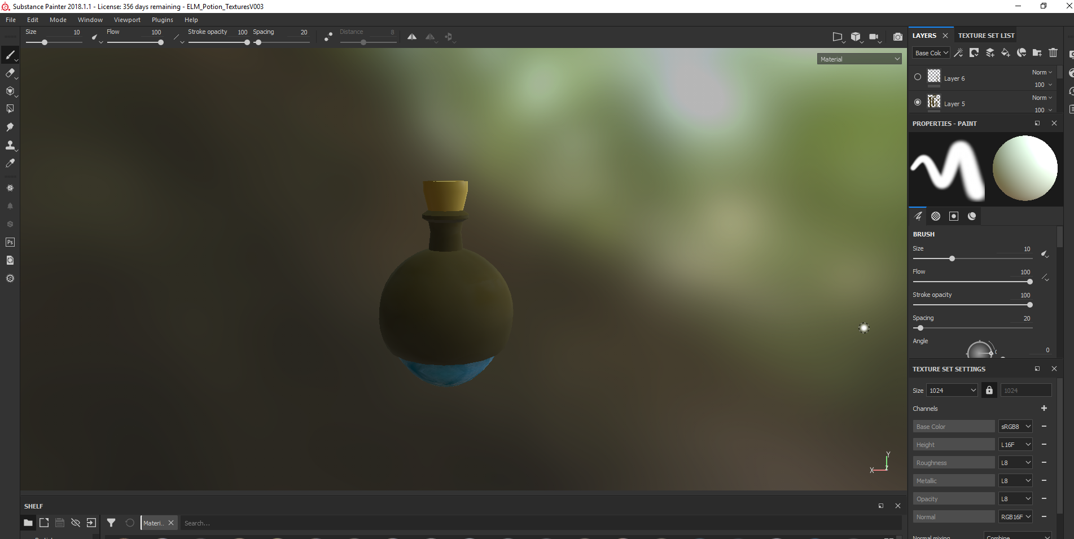
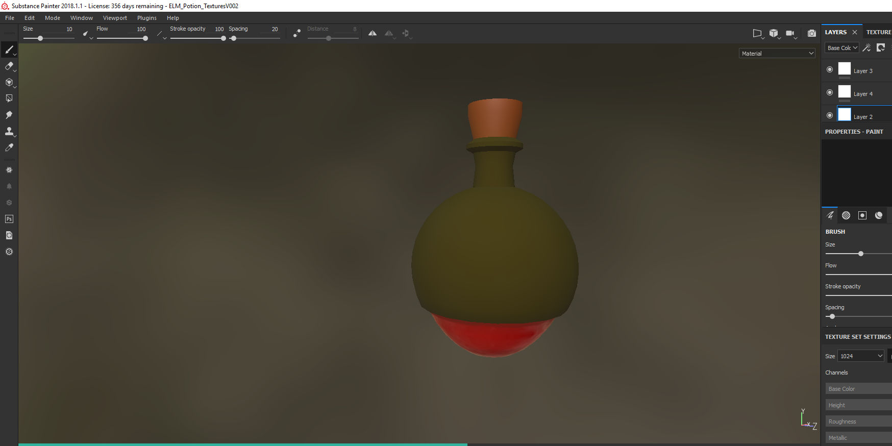

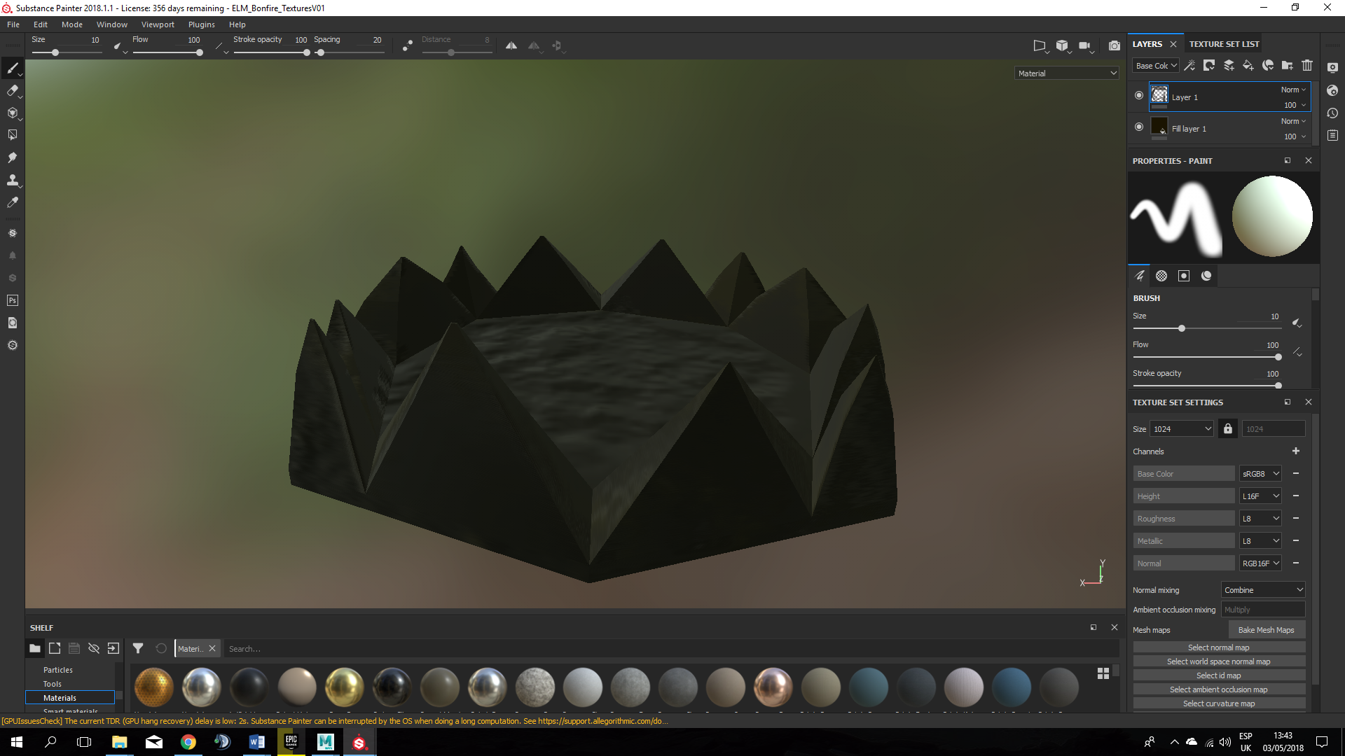
28th to 29th April
We wanted to make the last enemy look stronger so what I did was to add some magic corruption to the normal enemy textures we already had. We will apply this texture just to the last enemy of the game to make it look different and more challenging.

Gantt Chart



