

Module Title: Social Epidemiology and Public Health Development
Module Code: LCHS7000
Assignment Title: Component 2: Analytical Report
Report Title: Age and Health Inequalities: A Social and Epidemiological Analysis of Cardiovascular Disease in Older Adults

Student Name: TUFEL TAJUDDIN ARAB
Student ID: 2530247

Table of Contents
TASK 1: SOCIAL EPIDEMIOLOGICAL ANALYSIS 2
Introduction 2
A. Health Disparities: Contextual Background and Underlying Factors 3
1. Increased Burden of Cardiovascular Diseases 3
2. Rising Rates of Dementia and Cognitive Decline 3
3. Increased Multimorbidity and Deaths 4
B. Social Issues Affecting Older Adults 4
4. Social isolation and loneliness 4
5. Economic and Poverty Status 5
6. Inadequate Housing and Living Environment 5
Government strategies to address health inequalities 5
Organisation Supporting Older Adults 6
Conclusion 6
TASK 2: EPIDEMIOLOGICAL ANALYSIS (Cardiovascular Disease in Older Adults) 7
Introduction 7
Public Health Interventions: 3 Ps (Prevention, Protection, Promotion) 8
Determinants and Risk Factors 9
Epidemiological Studies and At-Risk Population 10
Monitoring and Surveillance Systems 10
Public Health burden (Short- and Long- term) 11
Evaluation of Intervention Programme 11
Advantages and Disadvantages of Epidemiological Approach 12
Conclusion and Recommendations 13
REFERENCE LIST 14

TASK 1: SOCIAL EPIDEMIOLOGICAL ANALYSIS

Title: Age and Health Inequalities in Older Adults

Introduction
Age is a key social determinant of health, affecting risk factor exposure, access to health care and health status. Inequalities in health are systematic and preventable differences in health, well-being and health determinants between populations (Case and Kraftman, 2024). Health inequalities disproportionately impact older adults, especially those aged 65 or older, due to natural age-related changes, lifelong exposure to health risks and social vulnerabilities.
Worldwide, the population aged 60+ will double by 2050, placing healthcare demands (Khan et al., 2024). In the UK, 65+ year olds bear the majority of the health-care burden and suffer from most chronic diseases (Conrad et al., 2024). Social epidemiology tells us that these differences are not merely biological and are also influenced by social determinants of health, such as socioeconomic, environmental and health care access (Perez et al., 2022). Thus, to understand health disparities due to age, it's important to examine both diseases and social determinants.
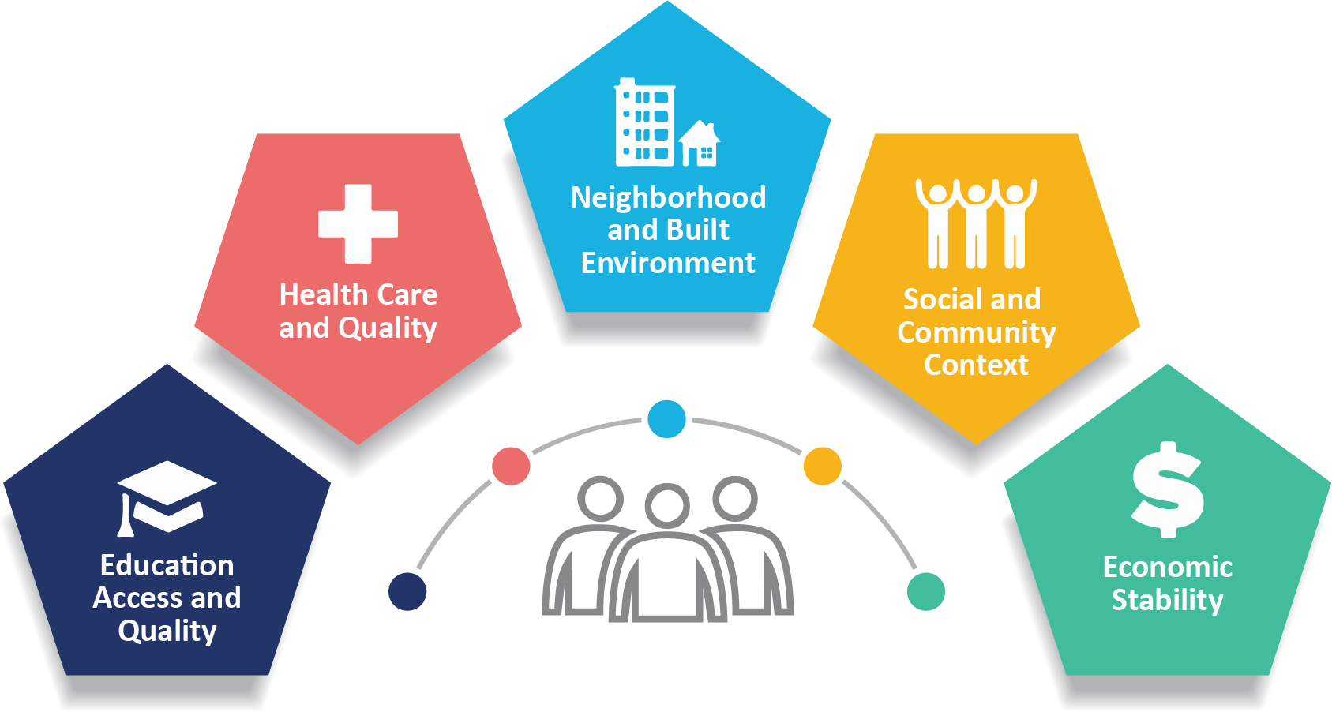
Source: (Conrad et al., 2024)

A. Health Disparities: Contextual Background and Underlying Factors

1. Increased Burden of Cardiovascular Diseases
Cardiovascular disease (CVD) is the most common cause of death worldwide: 17.9 million people die from CVD each year (Timmis et al., 2022). In the UK, CVD rates have not decreased, especially in older people, with long-term inequalities showing a trend towards increased multimorbidity (Conrad et al., 2024). Ageing, natural decline, and exposure to unhealthy conditions (such as poor diet, smoking, and physical inactivity) increase the risk (Tian et al., 2023).
But disparities exist because vulnerable and older populations are more vulnerable to these risks and lack preventive health measures. For instance, the low socioeconomic population often receive a late diagnosis and has suboptimal management of CVD (Petermann-Rocha et al., 2023). To address this, more screening and lifestyle programs are needed for high-risk older people (Syed et al., 2022).
Cardiovascular disease is more prevalent in older people, resulting in 17.9 million deaths a year. This is caused by ageing, lifestyle and disparities in early detection and treatment. It disproportionately affects lower-socioeconomic-status populations due to limited access. Prevention through screening programmes is the key.

2. Rising Rates of Dementia and Cognitive Decline
Cognitive decline and dementia are major health issues for older people. Currently, more than 900,000 people in the UK have dementia, more common as people get older (Corbett et al., 2023). Worldwide, the number of dementia cases is set to triple by 2050, due to an ageing population (Amuthavalli Thiyagarajan et al., 2022).
Inequalities in health outcomes are related to education, income, and health care. Those living in conditions of disadvantage have higher rates of delayed diagnosis and barriers to accessing services (Tan et al., 2022). Moreover, lack of social interaction increases cognitive impairment, especially in vulnerable populations (Hussain et al., 2023). Screening and community-based mental health programmes can help minimise these inequities (Deng et al., 2023).
In the UK, the number of individuals living with dementia is more than 900,000, with an overwhelming percentage being older adults. Inequalities are based on disparities in education, income, and services. Disparities can be minimised by early detection and interventions in communities.

3. Increased Multimorbidity and Deaths
Chronic illness and multimorbidity lead to higher mortality in older adults. Research suggests older adults (65+) are at higher risks of multiple chronic diseases, thus higher risks of health care use and death (Boonpor et al., 2024). A rise in non-communicable diseases is linked with older people globally (Khan et al., 2024).
Health disparities are since groups of disadvantage accumulate health risks over the life course. Early biomedical disadvantage is related to frailty and bad health outcomes at older ages (Tampubolon, 2025). This is why a life course perspective on health and policy making needs to be taken to prioritise prevention and early intervention.
Elderly persons have a higher chance of experiencing various long-term diseases, which elevate risk of death. It is associated with lifetime cumulative disadvantage. Integrated care systems and preventive measures are needed.

B. Social Issues Affecting Older Adults

4. Social isolation and loneliness
Social isolation is an important health determinant in older adults. In the UK, for instance, many older people report feelings of loneliness, which are associated with poor health (Irvine et al., 2022). Internationally, loneliness is emerging as an important public health concern, particularly among the elderly (Hussain et al., 2023).
Inequalities exist as socially disadvantaged people are at greater risk of living alone, having smaller social networks and being excluded from social activities. It is also a risk factor for depression, cognitive impairment and death (Lee et al., 2022). Interventions at the community level, such as social support groups and community-based activities, lower feelings of loneliness and enhance health and well-being.
Loneliness is a significant problem among many older adults that heightens the chances of depression and death. The socially disadvantaged people are more affected. This can be minimized by community engagement programmes.

5. Economic and Poverty Status
Health inequalities among older adults are related to poverty. In the United Kingdom, there are high levels of pensioner poverty, which reduces access to health care, food, and housing (Tampubolon, 2025). Worldwide, social inequalities still impact health over the lifespan (Perez et al., 2022).
A lack of financial resources perpetuates unhealthy lifestyles, barriers to accessing health care, stress and chronic disease. Moreover, poverty is intertwined with other issues like poor housing and isolation (Tan et al., 2022). Health policy responses, such as pension and welfare changes, are needed to curb inequalities.
Access to healthcare, nutrition, and housing is limited by poverty among the pensioners. Poor health has a financial insecurity element. Welfare support, as well as other policy interventions, is needed.

6. Inadequate Housing and Living Environment
Older adults' health is affected by housing quality. Older adults in the UK often live in poor quality housing, which is associated with higher risks of respiratory illness, accident and mental illness (Zahiri and Gupta, 2023). Worldwide, adverse housing conditions increase morbidity and decrease well-being (Alidoust and Huang, 2023).
Health disparities are seen when older adults with low incomes are more likely to experience unsafe housing conditions. Overcrowding, inadequate insulation, and inaccessibility are among the factors that negatively impact health (Mnea and Zairul, 2023). Better quality housing and the creation of age-friendly residential environments can improve health and quality of life in the older population (McClatchey et al., 2025).
The substandard and deteriorating conditions of housing contribute to the risks of older adults experiencing sickness and accidents. The poor people are more susceptible. Health outcomes can be improved by improving the quality of housing.

Government strategies to address health inequalities
There are several policies and strategies in place in the UK to tackle ageing-related health inequalities. The NHS Long Term Plan aims to enhance services for older people, including integrated and preventative care. Historically, strategies to address health inequalities in England have shown some improvement, but have not eliminated inequalities (Holdroyd et al., 2022).
Public health measures, including taxation and prevention strategies, have also helped to reduce inequalities. For instance, whole population strategies such as the soft drinks industry levy show the impact of policy on health, and reducing age disparities (Cobiac et al., 2024). But there is still work to be done to ensure older adults have access to healthcare and social care.

Organisation Supporting Older Adults
Age UK is a key organisation for older adults in the UK. It aims to enhance the lives of those in later life through the delivery of services, research and policy advocacy. Its community initiatives and services focus on tackling problems such as loneliness, poverty and health care.
Age UK is vital for increasing awareness of health inequalities and of healthy ageing. It works with policymakers and the health sector to provide solutions to enhance the lives of older people. As well as funding research in support of global initiatives such as the UN Decade of Healthy Ageing (Keating, 2022).

Conclusion
The health inequalities affecting older people are impacted by the interaction between biological, social and economic determinants. Increased vulnerability to chronic illness, cognitive impairment and death, coupled with social problems including loneliness, poverty and inadequate housing, affects older people. Although government policies and national organisations have begun to tackle these issues, inequalities persist.
Health, social and policy interventions, in an integrated manner, are required to address inequalities. A focus on prevention, timely intervention and community involvement can enhance health and foster healthy ageing.

TASK 2: EPIDEMIOLOGICAL ANALYSIS (Cardiovascular Disease in Older Adults)

Introduction
CVD is a significant global health burden and a leading cause of disease and death. This includes coronary heart disease, stroke and heart failure. It contributes to 17.9 million annual deaths worldwide, or almost 32% of global deaths (Timmis et al., 2022). In the UK, CVD remains a major cause of death, with more than 7 million diagnosed with the condition, and it particularly affects the elderly (Conrad et al., 2024).
Age is a significant risk factor for CVD due to the physiological changes and risk factor accumulation over time (Tian et al., 2023). The social and cultural impact includes decreased quality of life, dependency and healthcare expenditures. Crucially, CVD disparities reflect social determinants including disadvantage, access to health care and behaviours (Perez et al., 2022). As such, it is important to consider the epidemiology of CVD in older adults when developing public health strategies. The report narrows down to consider older adults (65 years or older) in the UK, especially socioeconomically deprived older adults, who are more prone to cardiovascular disease (CVD).
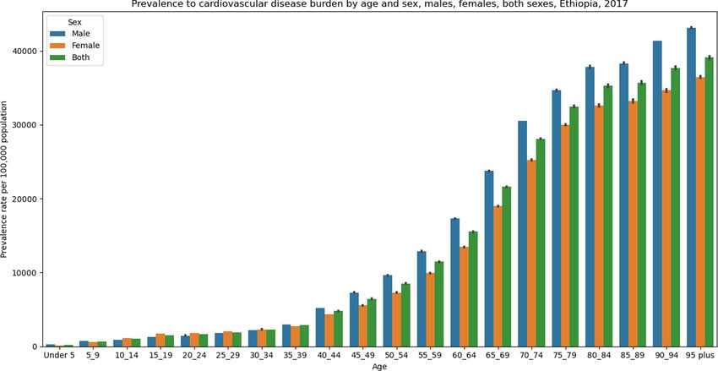
Source: (Tian et al., 2023)

Public Health Interventions: 3 Ps (Prevention, Protection, Promotion)
Public health measures to reduce the burden of CVD among older adults are frequently divided into the 3 Ps: prevention, protection, and promotion.
Prevention involves strategies to address risk factors, including smoking, obesity and lack of physical activity. There is clear evidence that lifestyle-related risk factors play a major role in the development of CVD and that changing lifestyle factors can reduce this burden (Petermann-Rocha et al., 2023). For instance, "population-based" interventions to promote diet and physical activity have been successful in lowering the risk of CVD. CVD is more likely to occur with lifestyle risk factors like tobacco use, poor diet; yet, since elderly people living in deprived regions frequently lack access to nutritious foods and safe environments to exercise, behaviour change becomes a challenge.
Interventions to prevent in older adults aged 65 years and above: Lifestyle interventions to prevent the occurrence of intense depression in older adults include smoking cessation and physical activity programmes in line with mobility.
Protection comes in the form of screening and early treatment of disease. In the UK, the National Health Service (NHS) offers screening and management for at-risk individuals for CVD. But there are issues of inequality, with the poor accessing services less frequently (Maddock et al., 2022). This reveals health service inequalities and the need for better engagement. Screening programmes like NHS Health Checks may also be used to protect vulnerable older adults with deprived backgrounds, but there is lower uptake in these groups.
Promotion involves the promotion of health awareness and behaviours through campaigns and policies. The UK soft drinks levy policy illustrates the effectiveness of structural measures to reduce risk factors such as obesity, especially in kids, which in turn has long-term benefits on cardiovascular health (Cobiac et al., 2024). Health literacy and access to information impact health outcomes, contributing to inequalities. Health promotion among older adults works well in creating awareness, but this is low due to low health literacy and a lack of digital literacy among the older population.
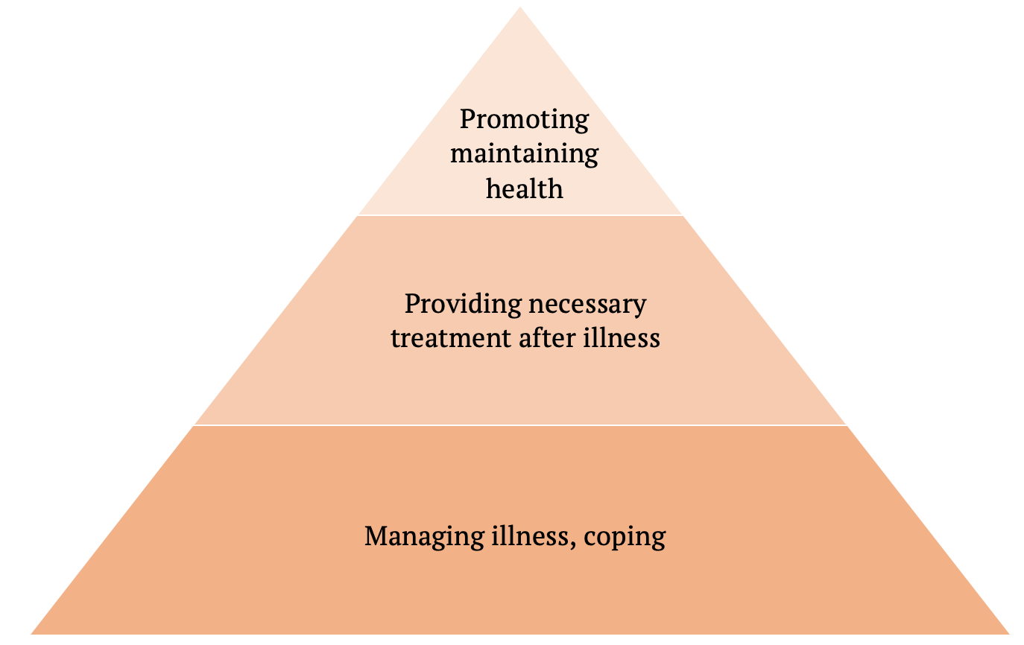
Source: (Cobiac et al., 2024)

Determinants and Risk Factors
Biological, behavioural and social factors impact CVD. The strongest non-modifiable risk factor is age, with a dramatic rise in the incidence of disease with increasing age (Tian et al., 2023). But lifestyle factors, including inadequate diet, smoking, alcohol abuse, and a lack of physical activity, are key in the development of CVD.
Socioeconomic factors influence the impact of these risk factors. People living in disadvantaged circumstances are more likely to have poor living conditions, limited access to healthy food, and poor access to health services (Tan et al., 2022). Moreover, digital determinants of health, including access to health information and digital services, are becoming increasingly prominent and important in inequalities (Chidambaram et al., 2024).
Health is also influenced by urban-rural health inequalities, with rural areas often experiencing limited access to health services and preventive programs (Li et al., 2022). These factors are interconnected across the life course, exacerbating inequalities and contributing to the burden of CVD in later life.

Epidemiological Studies and At-Risk Population
Epidemiological research is essential in targeting at-risk populations and guiding intervention strategies. Whilst large cohort studies (such as the UK Biobank) have shown strong associations between lifestyle and the risk of CVD in older adults (Boonpor et al., 2024).
In the UK, older adults from deprived backgrounds are more likely to die from CVD than those from wealthier backgrounds (Perez et al, 2022). This is due to the past exposure to poor social determinants of health and lack of access to preventive healthcare services (Perez et al., 2022). Imbalances in access to health care were also evident during the COVID-19 pandemic, where inequalities took a toll on the most vulnerable in society (Maddock et al., 2022).
And similarly, international studies show that low- and middle-income countries have increasing CVD burdens due to urbanisation and lifestyle changes (Khan et al., 2024). This highlights that CVD is a health, social and economic problem.

Monitoring and Surveillance Systems
Surveillance and monitoring play a crucial role in the control of CVD. In the UK, the NHS Digital and the Office for National Statistics (ONS) gather information on incidence, mortality and risk factors. These allow policymakers to monitor trends and assess interventions (Watkinson et al., 2022).
Internationally, bodies like the World Health Organization (WHO) have surveillance systems to track CVD prevalence and inform global initiatives (Amuthavalli Thiyagarajan et al., 2022). Improvements in digital health technologies have also improved data gathering and analysis, aiding in risk assessment (Chidambaram et al., 2024).
But there are gaps, such as under-recording and missing data, especially among vulnerable populations. These can prevent evaluation of health disparities and the impact of interventions (Cesari et al., 2022).
Intelligence surveillance tools like NHS Digital and ONS are vital perspectives in tracking the trends of CVDs among the elderly. Their accuracy is, however, low due to underreporting in populations that are deprived, where there is low healthcare access. This introduces inaccuracies in data and can underestimate the actual burden of disease. Further, the use of routine data collection might not measure behavioural and social determinants and limit the capacity to develop specific interventions.
There are two surveillance types employed:
- Passive surveillance: Routinely collected data (e.g., NHS Digital) in hospitals and GP records, which is economical but likely to be underreported.
- Active surveillance: Surveys or screenings (e.g. NHS Health Checks) are comparatively more precise, but less resource-intensive.

Public Health burden (Short- and Long- term)
CVD can have a significant impact on older adults. It causes short-term things like hospitalisation, decreased functionality and greater use of health and social services. Over the long term, it leads to disability, decreased quality of life and death (Boonpor et al., 2024).
CVD also has hefty healthcare costs. In the UK, the burden of CVD is estimated in billions of pounds each year, taking into account not only direct costs (to patients and the healthcare system) but also indirect costs (to employers and society). Around the world, the cost is even greater if we consider countries with low healthcare capacity (Timmis et al., 2022).
Health inequalities compound these effects, since the disadvantaged are disproportionately affected by serious disease and have limited access to health care.

Evaluation of Intervention Programme
CVD risk reduction interventions utilise both individual and community-based approaches. UK-based NHS Health Checks are a planned and systematic way of assessing and monitoring risk factors in adults 40-74 years of age. These have been successful in helping to detect, prevent and halt disease progression (Abud et al., 2022).
Community initiatives such as exercise programs and nutrition education are also important for promoting risk reduction (Lee et al., 2022). Also, international campaigns like the UN Decade of Healthy Ageing highlight the importance of integrated and prevention-based care (Keating, 2022).
But these interventions' success rates differ. Although some initiatives are successful, others face barriers to access and participation. For instance, people from disadvantaged backgrounds are less likely to access preventive services, decreasing their effectiveness (Holdroyd et al., 2022). As such, we need to develop strategies to combat these inequalities.

Advantages and Disadvantages of the Epidemiological Approach
The epidemiological study of CVD offers insights into its prevalence, determinants and impacts. The ability to leverage large datasets, like UK Biobank, and sophisticated statistical techniques to provide accurate estimates of associations and trends is a key advantage (Boonpor et al., 2024).
Although the epidemiological evidence is strong, interventions can be hampered in practice because older people have low participation rates, digital exclusion and healthcare inequalities. These contribute to the inefficiency of public health measures. What's more, a lack of representation of certain population subgroups, such as ethnic minorities and those from socially disadvantaged backgrounds, can contribute to a lack of comprehensive knowledge about inequalities (Goodwin et al., 2023).
Also, disease surveillance measures might underestimate the contribution of social determinants and need to be further included in monitoring approaches.

Conclusion and Recommendations
Cardiovascular disease (CVD) continues to pose a significant burden, especially in older people, where age-related risks are compounded by inequalities in social and economic factors. Although great strides have been made in prevention, management and surveillance, inequalities remain.
For equitable outcomes, public health approaches need to be multifaceted and include prevention, early diagnosis and social support. Key strategies include strengthening healthcare services, currently in the community, and tackling social factors such as low education, housing and poverty. Finally, enhancing surveillance and ensuring equitable data collection will enhance epidemiological strategies.
In short, to reduce inequality related to CVD, there needs to be a concerted effort between health systems, policy makers and communities that prioritise healthy ageing and ensure better health outcomes for all.

REFERENCE LIST

Abud, T., Kounidas, G., Martin, K.R., Werth, M., Cooper, K. and Myint, P.K. (2022) ‘Determinants of healthy ageing: a systematic review of contemporary literature’, Aging Clinical and Experimental Research, 34(6), pp. 1215–1223. Available at: https://link.springer.com/content/pdf/10.1007/s40520-021-02049-w.pdf
Alidoust, S. and Huang, W. (2023) ‘A decade of research on housing and health: A systematic literature review’, Reviews on Environmental Health, 38(1), pp. 45–64. Available at: https://espace.library.uq.edu.au/view/UQ:7f11bf9/UQ7f11bf9_OA.pdf
Amuthavalli Thiyagarajan, J. et al. (2022) ‘The UN Decade of healthy ageing: Strengthening measurement for monitoring health and wellbeing of older people’, Age and Ageing, 51(7), p. afac147. Available at: https://academic.oup.com/ageing/article-pdf/51/7/afac147/44372034/afac147.pdf
Boonpor, J., Pell, J.P., Ho, F.K., Celis-Morales, C. and Gray, S.R. (2024) ‘In people with type 2 diabetes, sarcopenia is associated with the incidence of cardiovascular disease: A prospective cohort study from the UK Biobank’, Diabetes, Obesity and Metabolism, 26(2), pp. 524–531. Available at: https://dom-pubs.onlinelibrary.wiley.com/doi/pdfdirect/10.1111/dom.15338
Case, A. and Kraftman, L. (2024) ‘Health inequalities’, Oxford Open Economics, 3(Supplement_1), pp. i499–i528. Available at: https://academic.oup.com/ooec/article-pdf/3/Supplement_1/i499/58618494/odad060.pdf
Cesari, M., Sumi, Y., Han, Z.A., Perracini, M., Jang, H., Briggs, A., Amuthavalli Thiyagarajan, J., Sadana, R. and Banerjee, A. (2022) ‘Implementing care for healthy ageing’, BMJ Global Health, 7(2), p. E007778. Available at: https://gh.bmj.com/content/bmjgh/7/2/e007778.full.pdf
Chidambaram, S., Jain, B., Jain, U., Mwavu, R., Baru, R., Thomas, B., Greaves, F., Jayakumar, S., Jain, P. and Battaglino, M.R. (2024) ‘An introduction to digital determinants of health’, PLOS Digital Health, 3(1), p. e0000346. Available at: https://journals.plos.org/digitalhealth/article/file?id=10.1371/journal.pdig.0000346&type=printable
Cobiac, L.J., Rogers, N.T., Adams, J., Cummins, S., Smith, R., Mytton, O., White, M. and Scarborough, P. (2024) ‘Impact of the UK soft drinks industry levy on health and health inequalities in children and adolescents in England: An interrupted time series analysis and population health modelling study’, PLoS Medicine, 21(3), p. e1004371. Available at: https://journals.plos.org/plosmedicine/article/file?id=10.1371/journal.pmed.1004371&type=printable
Conrad, N., Molenberghs, G., Verbeke, G., Zaccardi, F., Lawson, C., Friday, J.M., Su, H., Jhund, P.S., Sattar, N., Ra himi, K. and Cleland, J.G. (2024) ‘Trends in cardiovascular disease incidence among 22 million people in the UK over 20 years: Population-based study’, BMJ, 385. Available at: https://www.bmj.com/content/bmj/385/bmj-2023-078523.full.pdf
Corbett, A., Williams, G., Creese, B., Hampshire, A., Hayman, V., Palmer, A., Filakovszky, A., Mills, K., Cummings, J., Aarsland, D. and Khan, Z. (2023) ‘Cognitive decline in older adults in the UK during and after the COVID-19 pandemic: a longitudinal analysis of PROTECT study data’, The Lancet Healthy Longevity, 4(11), pp. e591–e599. Available at: https://www.thelancet.com/pdfs/journals/lanhl/PIIS2666-7568(23)00187-3.pdf
Deng, Y., Zhang, K., Zhu, J., Hu, X. and Liao, R. (2023) ‘Healthy aging, early screening, and interventions for frailty in the elderly’, Bioscience Trends, 17(4), pp. 252–261. Available at: https://www.jstage.jst.go.jp/article/bst/17/4/17_2023.01204/_pdf
Goodwin, V.A., Low, M.S., Quinn, T.J., Cockcroft, E.J., Shepherd, V., Evans, P.H., Henderson, E.J., Mahmood, F., Ni Lochlainn, M., Needham, C. and Underwood, B.R. (2023) ‘Including older people in health and social care research: best practice recommendations based on the INCLUDE framework’, Age and Ageing, 52(6), p. afad082. Available at: https://academic.oup.com/ageing/article-pdf/52/6/afad082/50495201/afad082.pdf
Holdroyd, I., Vodden, A., Srinivasan, A., Kuhn, I., Bambra, C. and Ford, J.A. (2022) ‘Systematic review of the effectiveness of the health inequalities strategy in England between 1999 and 2010’, BMJ Open, 12(9), p. e063137. Available at: https://bmjopen.bmj.com/content/bmjopen/12/9/e063137.full.pdf
Hussain, B., Mirza, M., Baines, R., Burns, L., Stevens, S., Asthana, S. and Chatterjee, A. (2023) ‘Loneliness and social networks of older adults in rural communities: a narrative synthesis systematic review’, Frontiers in Public Health, 11, p. 1113864. Available at: https://www.frontiersin.org/journals/public-health/articles/10.3389/fpubh.2023.1113864/pdf
Irvine, K.N., Fisher, D., Marselle, M.R., Currie, M., Colley, K. and Warber, S.L. (2022) ‘Social isolation in older adults: a qualitative study on the social dimensions of group outdoor health walks’, International Journal of Environmental Research and Public Health, 19(9), p. 5353. Available at: https://www.mdpi.com/1660-4601/19/9/5353
Keating, N. (2022) ‘A research framework for the United Nations Decade of Healthy Ageing (2021–2030)’, European Journal of Ageing, 19(3), pp. 775–787. Available at: https://link.springer.com/content/pdf/10.1007/s10433-021-00679-7.pdf
Khan, H.T., Addo, K.M. and Findlay, H. (2024) ‘Public health challenges and responses to the growing ageing populations’, Public Health Challenges, 3(3), p. e213. Available at: https://onlinelibrary.wiley.com/doi/pdf/10.1002/puh2.213
Lee, C., Kuhn, I., McGrath, M., Remes, O., Cowan, A., Duncan, F., Baskin, C., Oliver, E.J., Osborn, D.P.J., Dykxhoorn, J., Kaner, E., Walters, K., Kirkbride, J., Gnani, S., Lafortune, L. and the NIHR SPHR Public Mental Health Programme (2022) ‘Community-based interventions for the prevention of mental ill-health in older adults in the UK’, Health & Social Care in the Community, 30(1), pp. 27–57. Available at: https://onlinelibrary.wiley.com/doi/pdfdirect/10.1111/hsc.13413
Li, H., Zeng, Y., Gan, L., Tuersun, Y., Yang, J., Liu, J. and Chen, J. (2022) ‘Urban-rural disparities in the healthy ageing trajectory in China: A population-based study’, BMC Public Health, 22(1), p. 1406. Available at: https://link.springer.com/content/pdf/10.1186/s12889-022-13757-x.pdf
Maddock, J., Parsons, S., Di Gessa, G., Green, M.J., Thompson, E.J., Stevenson, A.J., Kwong, A.S., McElroy, E., Santorelli, G., Silverwood, R.J. and Captur, G. (2022) ‘Inequalities in healthcare disruptions during the COVID-19 pandemic: Evidence from 12 UK population-based longitudinal studies’, BMJ Open, 12(10), p. e064981. Available at: https://bmjopen.bmj.com/content/bmjopen/12/10/e064981.full.pdf
McClatchey, R., McClymont, K., Griffin, E. and Carmichael, L. (2025) ‘Community-led housing, health and wellbeing: A comprehensive literature review’, International Journal of Housing Policy, 25(1), pp. 18–55. Available at: https://www.tandfonline.com/doi/pdf/10.1080/19491247.2023.2232200
Mnea, A. and Zairul, M. (2023) ‘Evaluating the impact of housing interior design on elderly independence and activity: A thematic review’, Buildings, 13(4), p. 1099. Available at: https://www.mdpi.com/2075-5309/13/4/1099
Perez, F.P., Perez, C.A. and Chumbiauca, M.N. (2022) ‘Insights into the social determinants of health in older adults’, Journal of Biomedical Science and Engineering, 15(11), p. 261. Available at: https://pmc.ncbi.nlm.nih.gov/articles/PMC9681180/pdf/nihms-1850883.pdf
Petermann-Rocha, F., Deo, S., Celis-Morales, C., Ho, F.K., Bahuguna, P., McAllister, D., Sattar, N. and Pell, J.P. (2023) ‘An opportunity for prevention: Associations between the Life’s Essential 8 score and cardiovascular incidence using prospective data from UK Biobank’, Current Problems in Cardiology, 48(4), p. 101540. Available at: https://eprints.gla.ac.uk/288868/2/288868.pdf
Syed, M.A., Aiyegbusi, O.L., Marston, E., Lord, J.M., Teare, H. and Calvert, M. (2022) ‘Optimising the selection of outcomes for healthy ageing trials: a mixed methods study’, Geroscience, 44(6), pp. 2585–2609. Available at: https://link.springer.com/content/pdf/10.1007/s11357-022-00690-5.pdf
Tampubolon, G. (2025) ‘Growing up in poverty, growing old in frailty: The life course shaping of health in the United States, England and Europe’, Scientific Reports, 15(1), p. 15510. Available at: https://www.nature.com/articles/s41598-025-99929-2.pdf
Tan, V., Chen, C. and Merchant, R.A. (2022) ‘Association of social determinants of health with frailty, cognitive impairment, and self-rated health among older adults’, PLoS One, 17(11), p. e0277290. Available at: https://journals.plos.org/plosone/article/file?id=10.1371/journal.pone.0277290&type=printable
Tian, F., Chen, L., Qian, Z.M., Xia, H., Zhang, Z., Zhang, J., Wang, C., Vaughn, M.G., Tabet, M. and Lin, H. (2023) ‘Ranking age-specific modifiable risk factors for cardiovascular disease and mortality: Evidence from a population-based longitudinal study’, EClinicalMedicine, 64. Available at: https://www.thelancet.com/pdfs/journals/eclinm/PIIS2589-5370(23)00407-8.pdf
Timmis, A., Vardas, P., Townsend, N., Torbica, A., Katus, H., De Smedt, D., Gale, C.P., Maggioni, A.P., Petersen, S.E., Huculeci, R. and Kazakiewicz, D. (2022) ‘European Society of Cardiology: Cardiovascular disease statistics 2021’, European Heart Journal, 43(8), pp. 716–799. Available at: https://orbi.uliege.be/bitstream/2268/290879/1/ehab892.pdf
Watkinson, R.E., Williams, R., Gillibrand, S., Sanders, C. and Sutton, M. (2022) ‘Ethnic inequalities in COVID-19 vaccine uptake and comparison to seasonal influenza vaccine uptake in Greater Manchester, UK: A cohort study’, PLoS Medicine, 19(3), p. e1003932. Available at: https://journals.plos.org/plosmedicine/article/file?id=10.1371/journal.pmed.1003932&type=printable
Zahiri, S. and Gupta, R. (2023) ‘Examining the risk of summertime overheating in UK social housing dwellings retrofitted with heat pumps’, Atmosphere, 14(11), p. 1617. Available at: https://www.mdpi.com/2073-4433/14/11/1617

