
Approaches to innovation and Organisational change
Rhys O’Shea

April 25, 2025
University of Wales Trinity Saint David
Student Number - 2415783

Executive Summary
The purpose of this report is to analyse the recent organisational change carried out by Renishaw, which is a global engineering company that focuses on precision measurement technology. The change in question, was based within the Encoder’s division, which saw technician’s move from a single day shift into a two-shift pattern on day and afternoon shifts. The aim of the change was to align engineering hours with production hours, to ensure that continuous engineering support is provided during all manufacturing times and not just in the day. The intent/impact was to therefore operate much more efficiently, and most importantly, reduce the cost of poor quality.
The change was prompted by several repeat issues, such as machine failures/breakdowns and quality defects, which occurred outside of engineering hours, this contributed to significant downtime, wasted materials, and additional costs. The report looks at how Lewin’s Forcefield analysis was used by the company, to establish both driving and resisting forces involved in the change process. Driving forces were those that prompted the change, such as the need for operational continuity, quality improvement, and reduced downtime. Restraining forces included concerns over technician work-life balance, shift disruption, and increased operational costs. Although, due to early communication via team meetings, and feedback sessions, management successfully engaged with technicians in the process, which reduced resistance and ensured that they bought-into the change.
The report also demonstrates how the change process was guided by Kotter’s 8 Step Change Model. This model was highly effective, as it provided the proper structure to deal with organisational change. The report also further indicates the significance of data-driven evidence when justifying and establishing a change in a company. As previously stated, Technicians were involved throughout the change process and helped to develop credibility and acceptance. Additionally, job-specific training and financial rewards such as shift allowances also contributed to successful transition.
An evaluation of the impact on employees was conducted using Herzberg's Two-Factor Theory. The report shows how the organisation was able to control hygiene factors, such as shift allowances and flexible working hours, and promote motivation, including factors such as recognition and increasing responsibility. Overall, the report outlines that the change was implemented successfully because of strong leadership, factual evidence-based justification, and engagement with staff.
The change produced measurable improvements including production output consistency, quality incidents reduction, and reduced breakdown times. One lesson learned however was the need for better cross-shift training, as skill disparities were revealed post implementation of the shift model. More structured cross shift training would bridge this gap and provide technicians more confidence and a better skillset, as well as make the shift structure more robust and flexible.
Overall, the shift change was a strategic, well-executed transformation that demonstrated the importance of planning, communication, flexibility, and data-driven decision-making in delivering successful organisational change.

Table of Contents
Executive Summary 1
Introduction 3
Main Findings 4
Understanding organisational change 4
Lewin’s Forcefield Analysis 4
Driving Forces 5
Resisting Factors 5
Kotter’s 8 Step Change Model 6
What is Kotter’s 8 Step Change Model? 6
Advantages and Disadvantages of Kotter’s 8 Step Change Model 8
Impact on Employees and Motivation 8
Lessons learnt 9
Conclusion 10
Bibliography 11

Introduction

Organisational change is often required in fast-paced engineering and manufacturing environments, because operational efficiency and product quality are a priority for these types of businesses (Duro, 2023). Renishaw is a global engineering company that specialises in precision measurement technology. Founded in 1973 by Sir David McMurtry and John Deer, Renishaw now serves a wide range of industries such as aerospace, automotive, electronics, and medical devices, helping customers improve efficiency, accuracy, and quality in production and research (Renishaw, 2025). The company changed some departments from operating a regular day shift to a system with a day and afternoon shift pattern. This change was implemented to align with production hours which would allow continual engineering support.
The organisational structural change was prompted by repetitive issues on the production line related to mechanical/jig failures and product quality issues during non-engineering hours. With no one to troubleshoot, or fix any reactive issues during this time, several breakdowns could occur that would mean production was on stop. Additionally, the engineering team would be unable to prevent continued output of defective components. It is crucial having engineering support during these periods, as it mitigates cost due to increased defective components made, as well as increases efficiency by reducing potential production down time.
Organisational Change Management is a structured approach to navigating change within an organisation. Models such as, Lewin’s Force Field Analysis, are used to identify driving forces that support change and restraining forces that resist it. Kotter’s 8 Step change model is also used to guide organisations through change by providing detailed steps regarding how to approach organisational change, whereas the impact on employee motivation due to change is evaluated using Herzberg’s Two Factor Theory.

Main Findings

Understanding organisational change
In an organisational context, change is viewed as the result of significant adjustments to a company's processes, procedures, culture or strategies due to pressures from both internal and external environments (Indeed, 2025). The nature of these changes can range from simple procedural changes to large-scale changes in leadership, technology or workforce structure.
According to Mullins (Mullins, 2023), Change will be interpreted differently by individuals or groups. Some view change positively, as an opportunity for growth, innovation or improved efficiency. Others view change negatively, as a potential threat to stability, employment or established patterns of behaviour. The employees' past experiences, the level of communication from the leadership, and their level of support from managers will shape these interpretations. When undertaking significant changes in an organisation, it is vital to acknowledge the various interpretations and mitigate concerns through communication, planning, and proper leadership (Stobierski, 2020).
The change at Renishaw was in the Encoders group, which focus on high-precision encoder products. These products are assembled on a production line that contains a mix of manual assembly methods and automated processes requiring constant oversight and maintenance to ensure quality products and continuity of operations. The role of the technicians is crucial to the production process as they respond to equipment failure, operational issues with the process and assist in ensuring that the products are built to quality standards. They are essential to reducing downtime and limiting the throughput of non-conforming products, which in turn has a cost benefit to the company.
Before the implementation of a shift structure, engineering support was only available on the daytime shift. As a result, the afternoon production shift was vulnerable to both equipment and jig failures causing significant downtimes and key quality issues being missed. This led to operator inefficiencies, an increase in poor products as well as increased cost of quality. Due to these issues, it was clear engineering hours needed to be aligned with production, and it could be justified. Management acknowledged the operational and financial damage caused, and as a result needed to intervene by increasing efficiency and decreasing poor cost of quality, by introducing a shift structure. Therefore, this change was a top-down approach, where decision-making processes, strategies and changes are initiated by senior management and then communicated down through the organisation (Asana, 2025).

Lewin’s Forcefield Analysis

Lewin’s Forcefield Analysis is a decision-making tool developed by Kurt Lewin, a German American social psychologist from the early 20th century, to evaluate the factors that influence organisational change (Raza, 2024). The analysis categorises these factors into two different groups namely Driving forces, and Restraining forces. Driving forces are factors that push towards change, whereas restraining forces are factors that resist change (Channell, 2021).
Lewin's change model argues that restraining forces are the prime obstacles that prevent both organisations and individuals from changing, which ultimately determines the fate of the change. Driving forces motivate and guide employees and organisations into the new state., Therefore driving forces must always be greater than restraining forces and change is accomplished by either increasing a driving force or decreasing a restraining force (Connelly, 2023). Lewin suggests that it is crucial to balance these forces through effective change communication and employee involvement (Malik, 2025). According to Change Management Insight (Tahir, 2019), the model is user friendly and serves as a practical tool for companies to gain a clearer understanding of their situation. However, according to Sixsigma.us (2024), critics argue that participants may focus too narrowly on forces within their immediate control, potentially overlooking broader influencing factors.
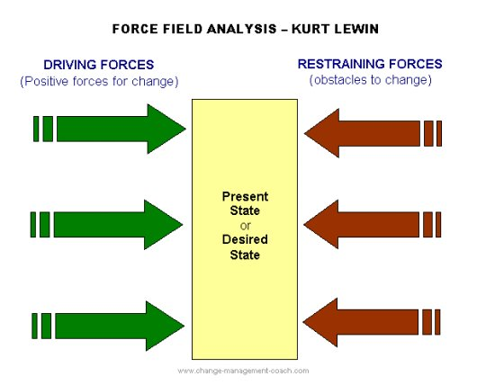
Figure 1 – Lewin’s Forcefield Analysis (Connelly, 2023)

The simplicity of this model is powerful and valuable, prior to the change at Renishaw, the driving forces and restraining forces were meticulously laid out and evaluated, allowing a clear case for change to be made.

Driving Forces
The primary forces of change were continual breakdowns of the production line, which caused anywhere from twenty-five hours of downtime per week (80% without engineering support). This not only resulted in lost production, but in the operator often being unutilised, and ordered product being missed. The important point was that with the shift change, the technician could continue to support whereas with unresolved problems from the prior night shift, added pressure dramatically increased the day shift workload. The second important force was the poor-quality control, without engineering support, rejected defects often went unnoticed. In 2024, it was reported that £70,000 of the £600,000 quality cost related to encoder product defects came from shifts without engineering support. These inefficiencies were a clear driving force that demonstrated that a two-shift system was needed.

Resisting Factors
Management also had to consider possible resisting forces, which were obstacles in implementing the change. Some factors included that technicians would be concerned about work-life balance due to the new shift structure, which brings unfamiliar working hours. Additionally, the proposed shift change could break team cohesion and strategy, as the team would have to deviate against current working practices. While these are resisting forces from a technician’s perspective, from a management perspective, it is an increased cost to the company to change the shift structure.
The forcefield analysis indicated the driving forces were strong and connected to clear operational issues which had resulted in poor performance, quality and cost impacts. The need for change was clear. Restraining forces were more about human and cost issues, such as unwillingness of employees to work a shift structure and hesitation from management about shift pay costs. For the change to be successful, in line with Lewin’s model. Renishaw’s management needed to limit the resistance from employee’s by creating clear communication channels so that they can voice their concerns, while justifying the cost to senior management by production gains in the driving forces. There was however little resistance to the change from the technicians, due to a combination of the support and communication put in place by managers, which confirms Lewin’s conclusions that it is crucial to balance these changes through effective communication. It was also evident to senior management that the change was extremely cost beneficial overall (Malik, 2025).

Kotter’s 8 Step Change Model

What is Kotter’s 8 Step Change Model?
Kotter's 8-Step Change Model, developed by Dr. John Kotter, a Professor at Harvard Business School, is a structured method to help organisations deal with change in a successful and sustainable manner (Watts, 2023). The model outlines eight vital stages (shown in figure 2 below), from creating a sense of urgency to implementing new behaviours into the culture of the company, which help leaders facilitate transformation. Kotter's specific steps are designed to provide leaders with a clear approach to managing change in an organisation ensuring organisational buy-in, strong leadership, communication, employee engagement, and continuous improvement (Lucidity, n.d.; NHSElect,n.d.)

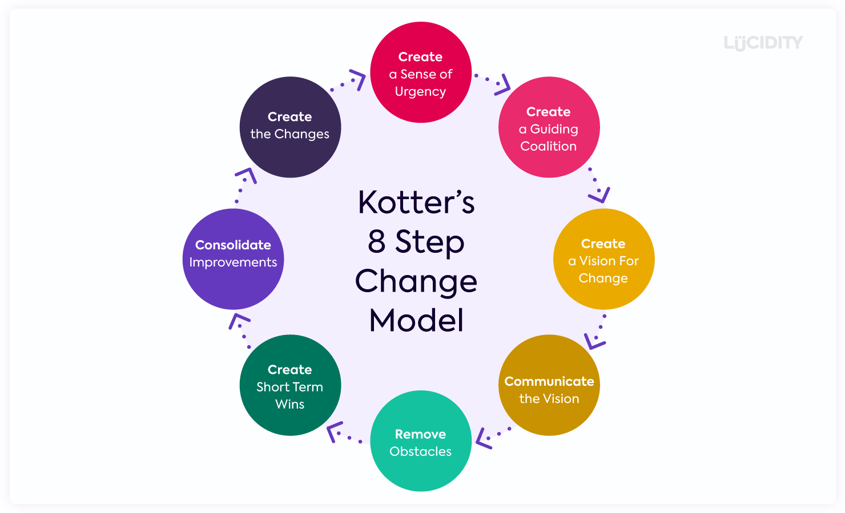
Figure 2- Kotter’s 8 Step Change Model (Lucidity, n.d.)

The transition to the new shift structure at Renishaw was guided by a structured, staged approach aligned with Kotter’s 8-Step Change Model. To begin the change process, urgency was established using operational data and Lewin’s Force Field Analysis to highlight key driving forces and restraining forces identified above. The Force Field Analysis highlighted the need for urgency to all stakeholders at Renishaw, through operational performance data. Kotter’s first step, creating a sense of urgency, is crucial to create momentum and commitment across the organisation so that everyone understood the impact of inaction and the need for change (Lucidity, n.d.).
When preparing for the change, Renishaw formed a guiding coalition (Kotter’s next step), by establishing early involvement with key stakeholders. Technicians, operators, and managers from both production and engineering were invited to share their thoughts on the current situation and the effect the change would have. Building this credibility and trust improved shared commitment to change, which is essential for sustaining momentum and overcoming resistance throughout the change process (Lucidity, n.d.).
Management developed a clear vision for change by developing goals related to reducing downtime, improving quality, and increasing production support. Management openly communicated this vision in team meetings and one-on-one meetings to help technicians understand the value and impact of the proposed change to the shift system. According to Kotter’s model (Prosci, 2025), a clear, well-communicated vision is vital as it guides decision-making, aligns efforts, and inspires engagement.
The next stage of Kotter’s model, removing obstacles, is an important step in lowering resistance (Watts, 2023). The new shift structure allowed an incentivised shift allowance to be offered, so employee concerns such as work-life balance are softened as they will earn more money. Management also presented the projected cost savings to senior managers, helping secure approval by justifying the long-term value of the change.
With the introduction of the shift structure, several short-term wins were celebrated which were vital for sustaining momentum and morale, as suggested by Kotter (Watts, 2023). Metrics such as a decrease in downtime and scrap, and an increase in overall efficiency were discussed and celebrated through regular meetings, which provided a clear message to all that the new system was working well.
To reinforce the change, feedback sessions enabled regular conversations between the teams. One meaningful outcome was the addition of a structured shift handover, so that all work is noted and there is an easy transition between shifts. Most importantly, Renishaw anchored the change by embedding processes into day-to-day work. The technicians were trained with job specific knowledge to enhance their more independent role on shifts. Regular team meetings allowed feedback and problems to be discussed and actioned, whilst supporting the new way of working as new norms developed under the division's culture. Renishaw was able to implement the shift structure successfully using Kotter's model with consistent communication, data-backed justification, and employee involvement, as well as seeing operational improvements and positive employee engagement (Prosci, 2025).

Advantages and Disadvantages of Kotter’s 8 Step Change Model
Kotter’s 8-Step Change Model has several advantages that make it a good approach to managing organisational change. It offers a straightforward, step by step process that people can identify with, understand and easily follow as both a leader or a team member (Prosci, 2025). The model is based on research and encompasses both cultural and operational dimensions of change (Lucidity, n.d.). It emphasises steps that require employee engagement and communication leading to buy-in rather than resistance from employees (Lucidity, n.d.). There is also a lot of documentation available to help organisations carry out the steps. The disadvantages are that while the model can assist in managing change, it does not help sustain the change (Lucidity, n.d.). The model assumes a linear top-down approach that does not often occur in real-world organisational change because it can be more unpredictable and dynamic (Prosci, 2025). While the steps may look easy, implementing them requires a lot of planning and communication. The lack of early involvement of the team could lead to disengagement or resistance.

Impact on Employees and Motivation

Herzberg’s Two-Factor Theory is a motivational theory created by psychologist Frederick Herzberg in 1959 (Wrike, 2024). It describes how two different sets of factors affect employee satisfaction and performance. The first set, hygiene factors such as salary; work conditions; and company policy do not necessarily motivate employees and while they do not lead to satisfaction, if they are absent, can lead to dissatisfaction (Wrike, 2024). The second set, motivators, includes factors such as achievement; recognition; responsibility and personal development, which truly motivate and inspire employee satisfaction (Wrike, 2024). Herzberg believed that satisfaction and dissatisfaction do not oppose each other, but are two different states, based on different factors. Using hygiene factors to address employee dissatisfaction, and motivators to inspire employee performance, will improve employee morale, engagement, and productivity (Mullins, 2023).
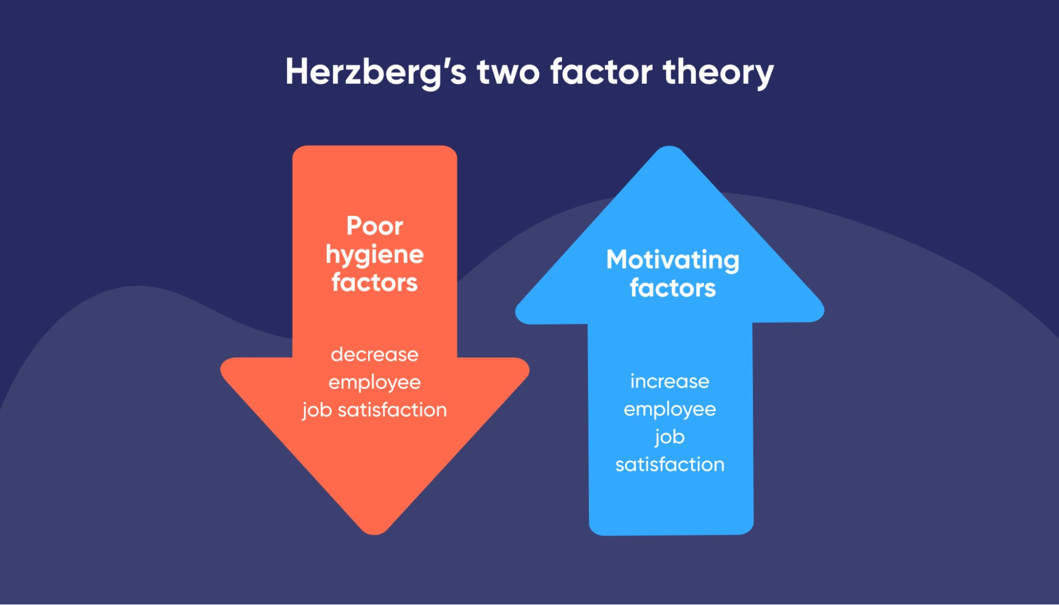
Figure 3 - Herzberg's Two-Factor Theory (Bluedonkey, n.d.)
The key hygiene factors for the shift change at Renishaw were identified and carefully managed, such as the work-life balance issue referenced above. To ease this transition, Renishaw’s approach was to have a more relaxed managerial standpoint, that enabled technicians to request a shift change on occasion if needed. By doing so, it reduced employee dissatisfaction by offering flexibility when required. Another key hygiene factor was pay, by introducing shift allowance, employee dissatisfaction was reduced as they were compensated for the inconvenience (Nickerson, 2025).
In contrast, Motivators included recognition and achievement, with technicians resolving issues that previously caused long downtime or significant cost implications (Nickerson, 2025). Positive feedback from managers can hugely motivate them (Nickerson, 2025). It also provided a better development opportunity, with responsibility given for overseeing the production line.

Lessons learnt

The shift change roll out was a success, which resolved many significant operational issues. The main lesson learnt from the change, was the effectiveness of clear, early and continuous communication. By involving the technicians throughout the process, they bought into the decisions and accepted the change. Also, the success of this change reinforces the benefit of making decisions based on data. By quantifying data such as downtime, inefficiencies and the cost of poor quality, they persuaded senior management to buy into the change. Another positive takeaway was flexibility. By allowing occasional shift swaps and providing financial incentives through shift allowances, this addressed hygiene factors and helped maintain morale within the team throughout the change.

Conclusion

The organisational change implemented within Renishaw’s Encoder division, transitioning from a single day shift to a dual shift structure, has proven to be a well-justified and effectively managed solution to significant operational challenges. The shift change addressed ongoing issues with production downtime and quality defects during non-engineering hours, ultimately leading to increased efficiency, reduced cost of poor quality, and enhanced technician engagement. The application of established change management models, including Lewin’s Forcefield Analysis and Kotter’s 8-Step Change Model, demonstrates that the change was underpinned by structured planning, communication, and stakeholder involvement (Culture Partners, 2024).
Employee motivation and morale were supported through the careful balancing the hygiene factors outlined above. This approach was consistent with Herzberg’s Two-Factor Theory and proved effective in gaining technician buy-in and sustaining performance during and after the change. The process also highlighted the importance of data-driven decision-making and the value of continuous feedback and review.
Overall, the change at Renishaw serves as a strong example of successful organisational transformation in a manufacturing environment. By aligning engineering support with production needs and maintaining open communication throughout the process, the company achieved a smoother transition and operational gains, while fostering a more motivated and capable workforce (Oliveira, 2023).
A suggestion for future improvement would be to develop more structured cross-training across both shifts. While the shift system had a positive effect on production support, it has also highlighted disparities between technician skill levels. Some technicians have had limited exposure to lone working, therefore better training would help them be more confident. More consistent cross-shift training improves a technician's upskilling and builds confidence in their ability to perform their full technical role, thereby fostering a robust shift structure and increased flexibility and reliability.

Bibliography
Asana, (2025). Top-down approach vs. bottom-up approach: What’s the difference?. [Online]
Available at: https://asana.com/resources/top-down-approach
[Accessed 2 April 2025].
Bluedonkey,(n.d). Herzberg two-factor theory and Lead generation marketing. [Online]
Available at: https://www.bluedonkey.co.uk/herzberg-two-factor-theory-lead-generation/
[Accessed 15 April 2025].
Channell, M., (2021). Lewin’s Change Management Model: How To Implement Organisational Change. [Online]
Available at: https://www.tsw.co.uk/blog/leadership-and-management/lewins-change-model/
[Accessed 6 April 2025].
Connelly, M., (2023). Force Field Analysis - Kurt Lewin. [Online]
Available at: https://www.change-management-coach.com/force-field-analysis.html
[Accessed 6 April 2025].
Creately, (2024). The Easy Guide to Kotter’s 8 Step Change Model. [Online]
Available at: https://creately.com/blog/strategy-and-planning/kotters-8-step-change-model/
[Accessed 2 May 2025].
Culture Partners, (2024). Kotter’s Change Model Explained. [Online]
Available at: https://culturepartners.com/insights/kotters-change-model-explained/?utm_source=chatgpt.com
[Accessed 7 May 2025].
Duro, (2023). Navigating the Process of Change: A guide to Engineering Change Management. [Online]
Available at: https://durolabs.co/blog/engineering-change-management/
[Accessed 15 April 2025].
Indeed, (2025). What Is Organisational Change: Benefits, Types And Reasons. [Online]
Available at: https://in.indeed.com/career-advice/career-development/what-is-organisational-change#:~:text=Organisational%20change%20is%20the%20process,because%20of%20unanticipated%20external%20factors.
[Accessed 2 April 2025].
Kotter, J. P., (2012). Leading Change. Boston, Massachusetts: Harvard Business Review Press.
Lucidity, (n.d). How to Successfully Implement Kotter’s 8 Step Change Model. [Online]
Available at: https://getlucidity.com/strategy-resources/guide-to-kotters-8-step-change-model/#What_is_Kotters_8_Step_Change_Model
[Accessed 8 April 2025].
Malik, P., (2025). [Online]
Available at: https://whatfix.com/blog/lewins-change-model/
[Accessed 6 April 2025].
Mullins, L. J., (2023). Management and Organisational Behaviour. Thirteenth Edition ed. s.l.:Pearson Education.
NHSElect, (n.d). Quality Improvement - Kotter's 8 Step Change Model. [Online]
Available at: https://www.nhselect.nhs.uk/uploads/files/1/Kotter%27s%208%20steps%20of%20change.pdf
[Accessed 8 April 2025].
Nickerson, C., (2025). Herzberg’s Two-Factor Theory Of Motivation-Hygiene. [Online]
Available at: https://www.simplypsychology.org/herzbergs-two-factor-theory.html
[Accessed 15 April 2025].
Oliveira, A. d., (2023). Change Management Strategies for Manufacturers. [Online]
Available at: https://blog.proactioninternational.com/en/change-management-strategies-for-manufacturing
[Accessed 7 May 2025].
Paton, R. A. & McCalman, J., (2008). Change management : A guide to effective implementation. 3rd Edition ed. Los Angeles: SAGE.
Prosci, 2025. Kotter’s Change Management Theory Explanation and Applications. [Online]
Available at: https://www.prosci.com/blog/kotters-change-management-theory
[Accessed 8 April 2025].
Raza, M., (2024). Lewin’s 3 Stage Model of Change Explained. [Online]
Available at: https://www.bmc.com/blogs/lewin-three-stage-model-change/
[Accessed 6 April 2025].
Renishaw,(2025). About Renishaw. [Online]
Available at: https://www.renishaw.com/en/about-renishaw--6432
[Accessed 2 April 2025].
SixSigma.us, (2024). Lewin’s Force Field Analysis in Change Management. What, Why, and How. [Online]
Available at: https://www.6sigma.us/six-sigma-in-focus/lewin-force-field-analysis-in-change-management/
[Accessed 5 May 2025].
Stobierski, T., (2020). WHAT IS ORGANIZATIONAL CHANGE MANAGEMENT?. [Online]
Available at: https://online.hbs.edu/blog/post/organizational-change-management
[Accessed 2 April 2025].
Tahir, U., (2019). Lewin’s Force Field Analysis (Change Management). [Online]
Available at: https://changemanagementinsight.com/lewins-force-field-analysis-change-management/
[Accessed 5 May 2025].
The World of Work Project, (2024). Herzberg’s Two Factor Theory of Motivation: A Simple Summary. [Online]
Available at: https://worldofwork.io/2019/02/herzbergs-two-factor-theory-of-motivation/
[Accessed 2 May 2025].
Watts, S., (2023). Kotter’s 8 Steps for Leading Change in Organizations. [Online]
Available at: https://www.splunk.com/en_us/blog/learn/kotter-8-steps-change.html
[Accessed 12 April 2025].
Wrike, (2024). Herzberg’s two-factor theory in project management. [Online]
Available at: https://www.wrike.com/blog/what-is-herzbergs-two-factor-theory/
[Accessed 15 April 2025].

