

Management and quality management in construction
NAME: Thomas Sion Griffiths
STUDENT NUMBER: 2007491
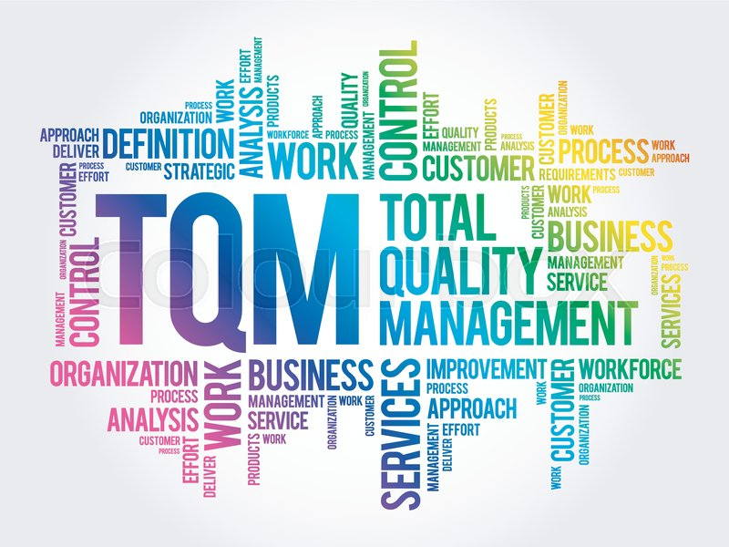

Contents
1.0 Introduction 2
2.0 What is quality? 2
2.1 Definition of quality in construction 2
3.0 Quality management 2
3.1 how is quality management used in construction? 2
3.2 Objectives of quality management. 3
3.3 why is quality management important in construction? 3
4.0 Quality control and quality assurance 4
4.1 What is quality control and how does it work? 4
4.2 what is quality assurance and how does it works? 5
5.0 Total quality management and how it works. 5
6.0 Conclusion 6
7.0 References 7
Appendices 10
Appendix 1 10

1.0 Introduction

This report aims to define the concepts and effectiveness of quality and of its management systems within a construction project by giving explanations on what these concepts are and how they are used within the construction industry effectively within a project, while also summarising what quality is. This report will then go on to summarise whether total quality management is an effective and suitable solution for construction projects to use to improve the overall quality of a project.

2.0 What is quality?

The word quality can mean different things to different people, some take it to be the characteristics of a service or product that can bear its ability to satisfy a need. Whilst others take it as the degree to which a product exceeds the customer’s expectations and requirements. (Dale, Van der Wiele and Van Iwaarden, 2007b, pp.4–5)
Quality is formally defined by the international organisation for standardisation (ISO DIS 9000:2000), as “the degree to which a set of inherent characteristics fulfils the requirements.” (ISO - International Organization for Standardization, 2015)

2.1 Definition of quality in construction

Quality within the “construction industry can be defined as the attainment of acceptable levels of performance from construction activities. This performance would be attained when the activity meets or exceeds the requirement of the client or the owner. The quality of any product or service is achieved when it conforms to the desired specifications.” (Gopal Mishra, 2018)

3.0 Quality management

Quality management is a system that companies use to ensure they can make, produce and deliver a product or scope of works to the desired specifications and cost of the clients brief, it also helps companies ensure that their services are consistent.
A quality management system focuses on both it’s service and product, it is made up of 4 main components which are quality planning, quality assurance, quality control and quality improvement. (Singer, 2018)

3.1 how is quality management used in construction?

Quality Management is used by companies through quality management plans, quality procedures and quality management documentation.
Quality management plans are put in place by a company to suit the product or project that they are working on, it works by having a defined standard in place that will be required to be met by the company for it to be successful and it will provide evidence on how those standards will be achieved. Within the quality management plan, you will find the projects quality policies, quality objectives, requirement standards and any other legal and statutory requirements.
Quality management procedures are put in place once the quality management plan is finalised. Quality management procedures have 4 main areas of focus which are Control of documents and records, internal quality audits, control of non-conformities and corrective and preventative actions also abbreviated as CAPA. These procedures form a system of how work progresses through the project from site capture with documents and records to corrective and preventative actions from what was seen on site.
Quality management forms and documentation are documents that companies put in place inline with the clients brief to ensure that they keep to the set standards. Quality documentation and forms range from quality hold points, punch lists, inspection test plans and specialty quality forms for skilled works such as welding control forms. These forms are typically used by management to ensure the quality is being met, these forms are and documents are usually word or pdf documents. (Hodgson, 2018)

3.2 Objectives of quality management.

Quality management can be different for each company, but the general objectives of quality management are the continuous improvement of the production process, increased productivity, decrease in production costs and improved competitiveness.
Continuous improvements to the production processes, which are to comply with the specifications and standards that are set out by the client at the beginning of the project. This is achieved through quality control inspections by identifying areas that need improvement and take actions to improve them.
Increase the productivity by reducing the waste, mistakes and the waiting time that can be created through the production system.
Decrease production costs by detecting the processes that are generating the most waste and simplifying processes.
Improve the companies competitiveness by ensuring their services and production meets the needs and standards of the clients expectations. (cyzotech.com, 2022)

3.3 why is quality management important in construction?

Quality management is important within construction as it allows a company to be more effective by reducing the time and cost of the project while keeping standards high and improving the consistency of work activities that are involved within the project. (Gray, 2020) Quality management also helps meet the needs and expectations of the client and also helps with the companies reputation as they are delivering work to high standards, which in turn gives the company a good name. Having quality management also provides less waste, whether it be time through poor management or through material. Quality management enables a company to continuously improve its services and systems to continually provide client satisfaction. (Corporate Finance Institute, 2022)

4.0 Quality control and quality assurance

Quality control and quality assurance are quality management systems that can work interchangeably in a project, but they are not the same. Both help a company provide a client with confidence that they can carry out the works to the specification.

4.1 What is quality control and how does it work?

Quality control can is defined as “Part of quality management focused on fulfilling quality requirements.” (Dale, Van der Wiele and Van Iwaarden, 2007, p.25)
Quality control is a process that companies use to ensure that their product quality is preserved or improved in line with the criteria and specification that is briefed by the client at the beginning of the construction process. This gives the employees a benchmark for the quality that the product needs to be, which in turn places an onus on the company and its employees to strive for perfection.
In quality control the implementation of well specified controls is a major part of quality control. These measures help the standardising of both production and responses to problems with quality. By limiting the margin for error and designating which production tasks are to be carried out by which people, employers can lessen the possibility that employees will be assigned to jobs for which they are not properly qualified. (Hayes, 2021)
Quality control works through having the correct procedures in place, for example carrying out regular inspections at different stages of the project or inspections on different elements of the project. Before any inspections are carried out there should be a plan put in place that shows what is to be inspected and what the end product should look like. All works that are carried out should meet the client’s criteria and specification. Having a quality checklist with the standardised criteria set out when carry out an inspection helps identify where there maybe a cause for concern and identifies which team is responsible.

Quality control comes with a number of benefits for companies that apply the process and these are the following:
- Customer satisfaction.
- Creates quality consciousness in employees.
- Reduced waste/ more effective use of resources.
- Improved production methods.
- Lower inspection costs.
- Product Uniform.
(TechnologyHQ, 2021)
See appendix 1 for an example of a quality control document from the company I work for inspecting foundations from the excavations to oversite of a house.

4.2 what is quality assurance and how does it works?

Quality Assurance is defined as “focused on providing confidence that quality requirements will be fulfilled.” (Dale, Van der Wiele and Van Iwaarden, 2007, p.27)
Quality assurance is a process that is implemented within a construction organisation in order to maintain and improve the standards of quality of work consistently that is to the specification and needs of the client. “Quality assurance forms the integral management system in a construction company”. Companies tend to have a quality assurance chart that specifies different checks at various time frames within the project’s life cycle.
The quality assurance process aims to ensure that the quality procedures that are implemented during the design phase of the construction project effectively comply with the companies and clients established standards for quality, services, production, and performance. The core specifications focus on the following points:
- Qualifications established for architects, engineers, and designers

- Mark-up rules pertaining to plans and drawings from preparation thru revision and into final approval
- And the assurance that specified materials comply with company-established quality standards and the clients design brief. (www.assignar.com, 2017)
Quality assurance like control also comes with a number of benefits and they are the following:

5.0 Total quality management and how it works.

Total quality management is a system that aims to improve the competitiveness, effectiveness and flexibility of an organisation. Total quality management is essentially a way of organising, planning and understanding each activity that is to be carried out, but it rests on each individual at each level. For total quality management to be effective within an organisation, each part of it needs to work together towards the same target, recognizing that each individual and activity can affect and be affected. Total quality management is also a way of lowering waste whether it be someone’s time or material by bringing everyone into the process of improvement, so that desired results can be achieved quicker. (Oakland, 1993, pp.22–23)
Total quality management is implemented into the construction industry by the following procedures:
- Obtain the client’s commitment to quality
- Develop project quality assurance plans for all levels of work
- Increase staff awareness, education, and attitude change
- Develop a procedural approach to TQM
- Begin the process of continuous improvement.
- Use quality control circles and motivation programs to encourage employee participation and contribution.
- Evaluate quality plans and track results.

Total quality management has 6 points known at the 6 C’s that are important for the successful implementation of total quality management in an organisation. (Admin, 2022)
Below is a diagram depicting the 6 C’s:
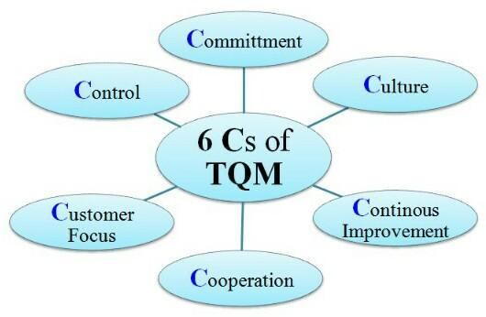
(Operations Management Notes (MBA), 2014)
Add benefits of TQM

6.0 Conclusion

To conclude this report, I believe that Total quality management is an improved solution to project effectiveness in certain projects. I believe it would work effectively for large companies that undertake higher valued projects where profit margins are greater. This is because larger scale companies generate more profit than smaller companies making it an effective tool for them to use. This is due to larger projects involving more works which require standards to be kept to the clients brief whereas smaller companies wouldn’t require total quality management as it would not be a feasible or cost-effective option due them possibly only carrying out a small amount of work which can be controlled at by using quality control and assurance but not the full system as it is time consuming, which makes it not cost-effective for the works that are being carried out.
The reason I support total quality management for effectiveness in larger scale projects is due to the standard of quality that is produced by the company within the works that are carried out, the continuous improvement it gives a project and the improvement it gives a project within the workforce as it promotes cooperation and development within employees. Total quality management doesn’t just make the project successful it also can promote a competitiveness and reputation for a company that provides quality.

7.0 References

Admin (2022). Total Quality Management-TQM in Construction Industry. [online] ConstructionPlacements. Available at: https://www.constructionplacements.com/tqm-in-construction/#gsc.tab=0 [Accessed 9 Dec. 2022].
Corporate Finance Institute. (2022). Quality Management. [online] Available at: https://corporatefinanceinstitute.com/resources/management/quality-management/ [Accessed 6 Dec. 2022].
cyzotech.com. (2022). Quality Management: Functions, Objectives and Importance. [online] Available at: https://cyzotech.com/quality-management/ [Accessed 8 Dec. 2022].
Dale, B.G., Van der Wiele, T. and Van Iwaarden, J. (2007a). Managing Quality. Fifth ed. Oxford: Blackwell Publishing, p.27.
Dale, B.G., Van der Wiele, T. and Van Iwaarden, J. (2007b). Managing Quality. Fifth ed. Oxford: Blackwell Publishing, pp.4–5.
Gopal Mishra (2018). Quality in Construction Industry -Objectives, Factors Affecting Quality. [online] The Constructor. Available at: https://theconstructor.org/construction/quality-construction-objectives-factors-affecting/707/ [Accessed 24 Nov. 2022].
Gray, T. (2020). Why is quality important in construction projects? [online] Thomson Gray. Available at: https://www.thomsongray.com/why-is-quality-important-in-construction-projects/ [Accessed 6 Dec. 2022].
Hayes, A. (2021). Quality Control. [online] Investopedia. Available at: https://www.investopedia.com/terms/q/quality-control.asp [Accessed 7 Dec. 2022].
Hodgson, L. (2018). Quality management in construction: Here’s what you need to know. [online] Sitemate. Available at: https://sitemate.com/uk/resources/articles/quality/quality-management-construction/ [Accessed 24 Nov. 2022].
ISO - International Organization for Standardization (2015). ISO 9000:2005. [online] ISO. Available at: https://www.iso.org/standard/42180.html.
Oakland, J.S. (1993). Total Quality Management. Second edition ed. Oxford: Butterworth-Heinemann, pp.22–23.
Operations Management Notes (MBA). (2014). Operations Management Notes (MBA): Total Quality Management. [online] Available at: http://operations11.blogspot.com/2014/10/total-quality-management.html [Accessed 9 Dec. 2022].
Singer, M. (2018). What is quality management? Definition and... [online] Market Business News. Available at: https://marketbusinessnews.com/financial-glossary/quality-management/ [Accessed 7 Dec. 2022].
TechnologyHQ (2021). Important Benefits of Quality Control - TechnologyHQ. [online] TechnologyHQ - All about Technology, AI, blockchain, Cybersecurity, Business. Available at: https://www.technologyhq.org/important-benefits-of-quality-control/#:~:text=Important%20Benefits%20of%20Quality%20Control%201%20It%20Fosters [Accessed 13 Dec. 2022].
www.assignar.com. (2017). Quality Assurance (QA) And Quality Control (QC) On Construction Projects – Assignar. [online] Available at: https://www.assignar.com/articles/quality-assurance-qa-quality-control-qc-construction-projects/ [Accessed 9 Dec. 2022].

Appendices

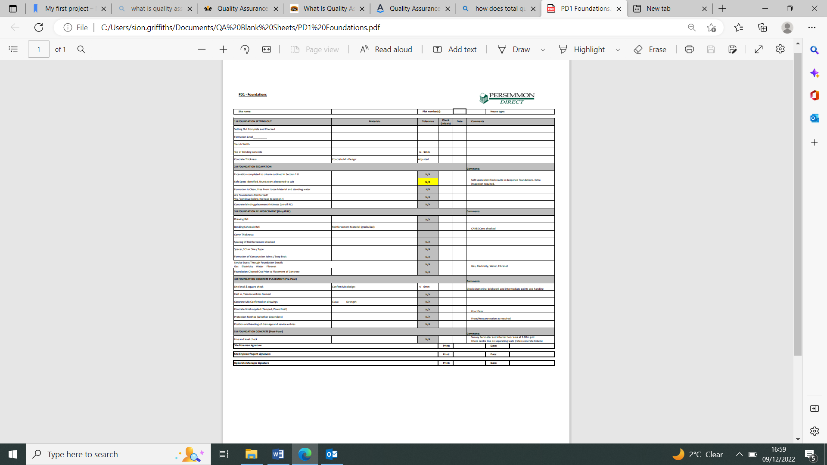
Appendix 1
(Persimmon Direct Groundworks, 2022)

