Program of study:BA Business Management
Module name:ENTREPRENEURSHIP
Module code:LCBB5001

Assignment title: Business Plan
Lecturer's name:David Jenkins

Name:Muscinschi Elena

Executive Summary
Star Car Wash is expected to operate in major UK cities, headquartered in Cardiff. It will mainly focus on company employees and individuals who must clean their cars. Some customers have to wait until the weekend to wash their car, so the car wash is mainly concentrated in the working group and female drivers. This will allow them to professionally clean their cars at the entrance on their way to work. Star Car Wash's main focus is a strategic location, accessible in places without car washes. Most Cardiff customers prefer to have their cars washed nearby, so Star Car Wash is their ideal choice. We will provide them with the best expert service experience in comfort. Our Star Car Wash comprises a dedicated and skilled team that handles business even after hours and on weekends. Natural gas, diesel and fuel are also available at our various outlets. We aim to focus on quality, make the best decisions, exercise great judgment, and show loyalty to our most valued customers. Star Car Wash Associates is strategically positioned in the industry as it solves its customers' problems more completely and cost-effectively.

Table of Contents
Executive Summary 2
Company Description 4
Industry, Target Customer and Competitor Analysis 4
Product/Service Plan 5
Sales Process 5
Sales Tactics 5
Marketing Plan 5
Operations and Development Plan 6
Development Status and Tasks 6
Marketing Team 7
Management team with a skills profile 7
Critical Risks 7
Offering/ Exit Strategy 8
Financial Plan 9
Assumptions 9
References 11

Company Description
Undergraduate students in Cardiff, UK, founded the business. I have always had a passion for innovation and customer experience. I will use these interests to achieve our goal of providing truly useful and environmentally friendly car care across the city. Customers can schedule, track, and pay for car washes through the newly launched mobile app. The well-trained professionals will provide you with the necessary equipment to keep your car shiny and new. However, the entire structure of our government is determined by the surrounding biological systems. This business will use environmentally friendly water sources to replace the bulk of conventional car wash water that goes to waste. The innovations safely recycle and reuse used water and oil (Harakh, 2019). The staff will call or text upon arrival and hand over the car keys to us with instructions on how to wash/repair the car. As usual, you can rate and pay directly from your phone. Whether a person is at home or work, this business will take care of their car so that they can get on with life.
Star Car Wash Association's mission is to provide high-quality cleaning services to luxury car owners throughout Cardiff. Most importantly, it will strive to provide better service by providing employees with the good and friendly work environment they deserve. Along these lines, people's insurance caters to mishaps caused by broken gears or careless workers. Second, they maintain a clear and pleasant office (Chaudhry, 2015).

Industry, Target Customer and Competitor Analysis
There are not many rivals in the market who give home car wash expert assistance. In addition, single people do it for specific individuals without working under any organisation. Regardless, it is not concentrating on the customers who search for master and quality cleaning. Likewise, even their range is incredibly low.
The business will confront direct rivalry from suppliers offering home car cleaning administration (Bui, 2015). Yet, car wash organisations generally have contenders who have the vehicle cleaning stations, not the home cleaning decision, to spare their time. As they have the weakness of poor marking, helpless client assistance, undeveloped staff, lack of centre, targets everybody the business thought can start to lead the pack separated from giving doorstep administration.
Traffic circle contention will radiate from elective sources so customers can clean their cars. A couple of clients like to clean their vehicles at home – this will outline some of the deviant competition that Star Car Wash Administrations will stand up to. Distorted contention will moreover radiate from generous fundraisers, colossal settled-in car organisation associations, ‘Do it without anybody’s assistance’ car wash organisations and other nearby substances. Mushrooming easygoing car wash associations will similarly introduce abnormal competition for the business (Albert Jab et al., 2015).

Product/Service Plan
The evaluation plan is exclusively designed by looking at discrete car washes in Cardiff. Star Car Wash, at that point, featured the best attributes of each pack and created our exceptional assessing scale, which the business acknowledges sensibly balances offering quality help at home and at the expense (Jirachaisingh, 2007). The three administrations will be given on the under-cost, and administration will be disseminated on the doorstep through online appointments.
• Full-wash: $10
• Exterior Wash: $7
• Interior was: $5

Sales Process
Clients can reserve a spot through the application or site; as per the accessible openings, they can pick the best time and day for their benefit. We will likewise give them the alternative to benefit week after week or month-to-month memberships (Thind & Alexander, 2017).

Sales Tactics
Arrangements methodologies are an organised reason. Our clients are to be served equally with attractive discounts so that they feel welcomed more often. Star Car Wash employees are fully responsible for giving the clients the best service to their cars by maintaining trust and integrity.

Marketing Plan
A significant thought is the driving binding together power behind a brand showcasing exertion. It builds accentuation on finding incredible, mid blowing innovative ideas to fuel an advertising effort. We talk about the "Star Car wash", it will draw in its clients through their online life showcasing methodologies; we will spend more via the web-based networking media promoting instead of the announcement of pen flex (Ibrahim, 2022).
The active primary strategy behind Star car clean association is centred on Targeting and division. It will be easy to get more clients on weekdays, like Monday to Friday, because, as it may, particularly in the winter, people will not consider having their vehicles cleaned. Hence, the Star car clean association will concentrate on people who are typically served across the week without preference for specific days (TƯỜNG, 2021).
- Visionaries have all the earmarks of being amazingly unique individuals, yet are as often as possible prepared to make their own time.
- Resigned individuals (more settled high-class motorists) would prefer to clean their cars after every couple of days, say maybe after every 3 to four days.
- Vendors will require vehicles to be express and cleaned to pay little notice to the time and day in and day out days. This wills a consistent course of traffic deftly.
- During typical affiliation time, the organisation will require their maritime power vehicles cleaned for two or three days.

Operations and Development Plan
Star Car Wash Inc. permits clients to plan a wash using their site or versatile application within minutes. When a splash is reserved, a prepared expert group shows up, places the car on a restrictive tangle, and plays out the chosen administration. As the professional plays out the administration, they utilise a specialist application to refresh clients on its status. Clients are alarmed when the administration is finished and keys are returned (McLoughlin & Kemp, 2010). When keys are returned to the car proprietor, clients are incited to rate, audit, pay, and tip all through the application. Star Car Wash Inc. washes every vehicle utilising their Cardiff Green framework, an ecologically protected procedure where 100% of the water is reused, with zero run-offs.

Development Status and Tasks
By examining this QR code, the clients will have the option to download the application and begin by following advances:
1. Scan the QR code with the camera on your phone.
2. Download the Star car wash application.
3. Create an account and start availing services at your doorstep today or visit the website.
The QR code is also available on the social media account of the Star car wash app.

Marketing Team
This organisation has been very much organised to have association owners. The bosses will segregate the commitments essential to keep up the business, join specialist enlisting; building, property and rigging upkeep; exhibiting; publicising; organise relations; fiscal issues; agent pay and focal points; charges; payables; and receivables (John, 2012).

Management team with a skills profile
From the start, the association is set to be fully managed by its owners. In any case, in the second quarter, the partner manager can be engaged in assisting with the ordinary day-to-day errands of the business. Additionally, the methodology of utilising the individual potential existing from inside the management team gives us an approach to see different work execution being well undertaken.

Board of Directors and advisors
The top managerial staff and the leading group of consultants at first might be the proprietors of the organisation. When the organisation arrive at the development stage through development, the organisation may recruit a leading body of guides.

Company structure
We work in divisions as our work is, for the most part, to go around, so we have isolated divisions (territory savvy). In this way, we manage clients and their questions inside these territories, as these are the primary regions we work under. Other works like employing, promoting deals, and funds are managed together. As consumer loyalty is our primary goal, so is all other work we do together. However, we partitioned the regions among us explicitly with the goal that we work appropriately, and if there are any questions, we bargain them right off the bat.

Critical Risks
One of the fundamental dangers with this business is that when we carry out our responsibilities well, the customer will not need our administrations for broadened timeframes; this implies we are continually systems administration to discover more customers to proceed with productivity. Car wash traders are viewed as self-employed entities under law, so we should defend ourselves concerning making sure about instalments. An extra risk would be the expert risk; if a slip-up is made or if something is neglected, a displeased customer could guarantee not to pay for the administration delivered. Intending to meet the customer's quick needs and satisfy them, we have to reveal any expected future needs of the customer. On the other hand, the customer's immediate need is to select and recruit ability; at that point, the next requirement for the customer would be executing the board. If the customer needs performance on the board, at that point, a follow-up would be remuneration and advantages of not charging them to keep up their dependability on our car wash.
In the matter of washing cars, we vigorously depend on each other to meet the finish of the deal by addressing the customer's needs and inclinations. It is to their most significant advantage to band together with one another to manufacture their systems and guarantee the customer goes to them and not another specialist. Concerning securing ourselves and making sure about instalments will ensure the customer pays through-composed pay terms in the agreements while demanding in advance instalments, particularly from customers.

Offering/ Exit Strategy
During the period for the dissolution of our business, there are strategies already laid out that will enable the smooth transition of the terminating of the market and ensure that every stakeholder gets their fair share of what is left and available in the company finances and assets. Some of these measures are outlined below;
a. Excellent and well-developed accounts are already in place with all necessary authentications
b. Getting guided advice on the accounting/ financing option about the most preferred way and choice of an exit strategy that our business from our Business consultant
c. Having a good, close, and professional relationship with our investors, we are free to convene a meeting and share the various strategies that we deem fit so that they can share their insights
d. Our business has hardworking leaders who can receive the responsibilities in case one may choose to exit. This is to ensure that the company goes on as usual and that no disruptions
e. From our newly developed applications, our employees will be notified as soon as one decides to exit the business
f. Last but not least, with the well-stored list of our customer contacts, they will be notified through an official letter or short message about the exit of a partner to avoid creating the chain of command confusion when dealing with other new management staff.

Financial Plan
The execution of the course of action plots the definite accounting improvement of this business for the three years outlined. The possible areas for generating starting capital are from an individual endeavour by owners and financially created through pay. Thus, the business will grow more progressively in a short period while also ensuring that we hold leverage the business orientation. In the third quarter, chances are high of the business having an alternative open resulting zone.
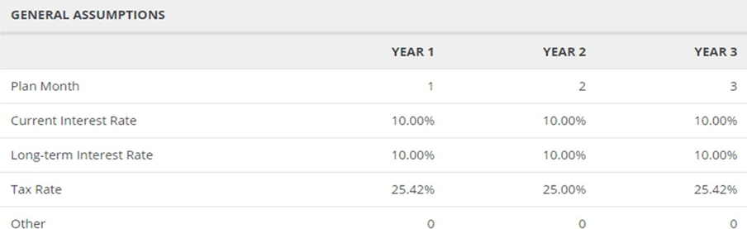
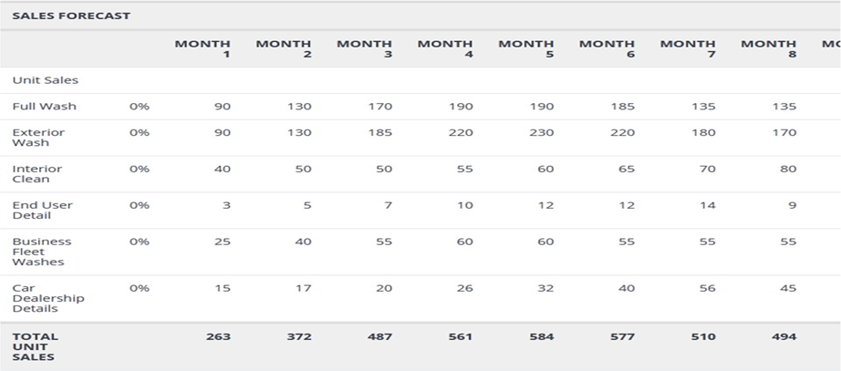

Assumptions
This business acknowledged that financing costs applied to the securing of our points of interest would be 10 per cent. Additionally, this business anticipated the significant presence of the organisation equipment and office apparatus for ten years and the structure and grounds for fifteen years. The execution of the system portrays the money-related headway of the Star Car clean affiliation.

References
Albert Jab, A., Fabian, M., Gordon, N. A., Hashim, S., Sakius, S., & Dommy, S. (2015). The Flash Car Wash.
Bui, H. (2015). Business plan for establishing an auto car-washing service in Hanoi, Vietnam.
Chaudhry, Z. (2015). Business Plan For XYZ Hand Car Wash.
Harakh, D. (2019). Dream Klean Car Wash business plan (Doctoral dissertation).
Ibrahim, I. M. E. (2022). An Assessment of Authorized Car Wash Site Suitability Using a GIS-Based Modeling in Khartoum City, Sudan. Journal of Geographic Information System, 14(2), 134-152.
Jirachaisingh, W. (2007). A feasibility study of launching car wash business in Bangkok.
John, S. (2012). Geo Car Wash-A Planet Friendly Enterprise. Asia Pacific Journal of Management & Entrepreneurship Research, 1(3), 274.
McLoughlin, P., & Kemp, M. (2010). IMO Car Wash Group Restructuring, The. Insolvency & Restructuring Int'l, 4, 18.
Thind, D., & Alexander, P. (2017). Methods to attract customers In Car wash.
TƯỜNG, R. T. (2021). Market entry strategy to Sweden Case: Finland hand carwash.

