When developing my keywords, I chose to focus in on the themes of Cadbury, beauty and movement. Alongside researching into these keywords, I was influenced by a variety of theorists and artists where I based my development of Cadbury on the creative director of Bulletproof, Jamie Gandee, based in the company who redesigned the branding. Noami Wolf, a feminist author of ‘The Beauty Myth’ that influenced the theme of beauty and the profound meaning behind its history. The three German psychologists, Max Wertheimer, Wolfgang Kohler and Kurt Koffka who founded the Gestalt principles were the influence behind the subject of movement as it reflects how design can be manipulated by the theory of illusion.

Branding is the face and personality of your company, Cadbury embraces this and embodies a trustworthy and giving, globally known brand. The company didn’t start as the British multi-national confectionary company it is today and we can see how branding provided the building blocks that boosted the brand to boom as it does to this day. Established by John Cadbury in 1924, based in Birmingham, England, the renowned Dairy Milk Bar was launched in 1905 with a charming original serif typeface logo (see fig. 1) that was certainly reflective of its era, featuring the pale lilac primary colour alongside a red type. This initial design would be vastly contrasting to the adaptation of the primary colour to the iconic purple used in the early 1900s when the company saw a rise in sales. Cadbury continues to use the Pantone 2658 C using unregistered rights despite losing them in 2013, demonstrating its branding continuity through the key elements remaining firmly set since the 1900s such as the colour as well as the logo which was later developed and stayed from 1921. The closeness of the family-based company that engages the trust of its consumers is reflected and ingrained as early as its packaging design from 1951, where the script type placed on the major branding is based on William Cadbury’s signature (grandson of John Cadbury). Cadbury demonstrates how consistency within a brand, alongside an aim to remain current can be key to growing and building a successful brand identity as a “brand must also respond to shifts in social trends to remain in tune with audience” (Davis, 2009, p. 13). In order to remain relevant to the target audience, this would refer to something along the lines of advocating the importance of sustainability due to the very relevant and growing threat of climate change as well as the maintenance to the factor of developing technology and to cover social media platforms that would reach and engage with a growing global audience.

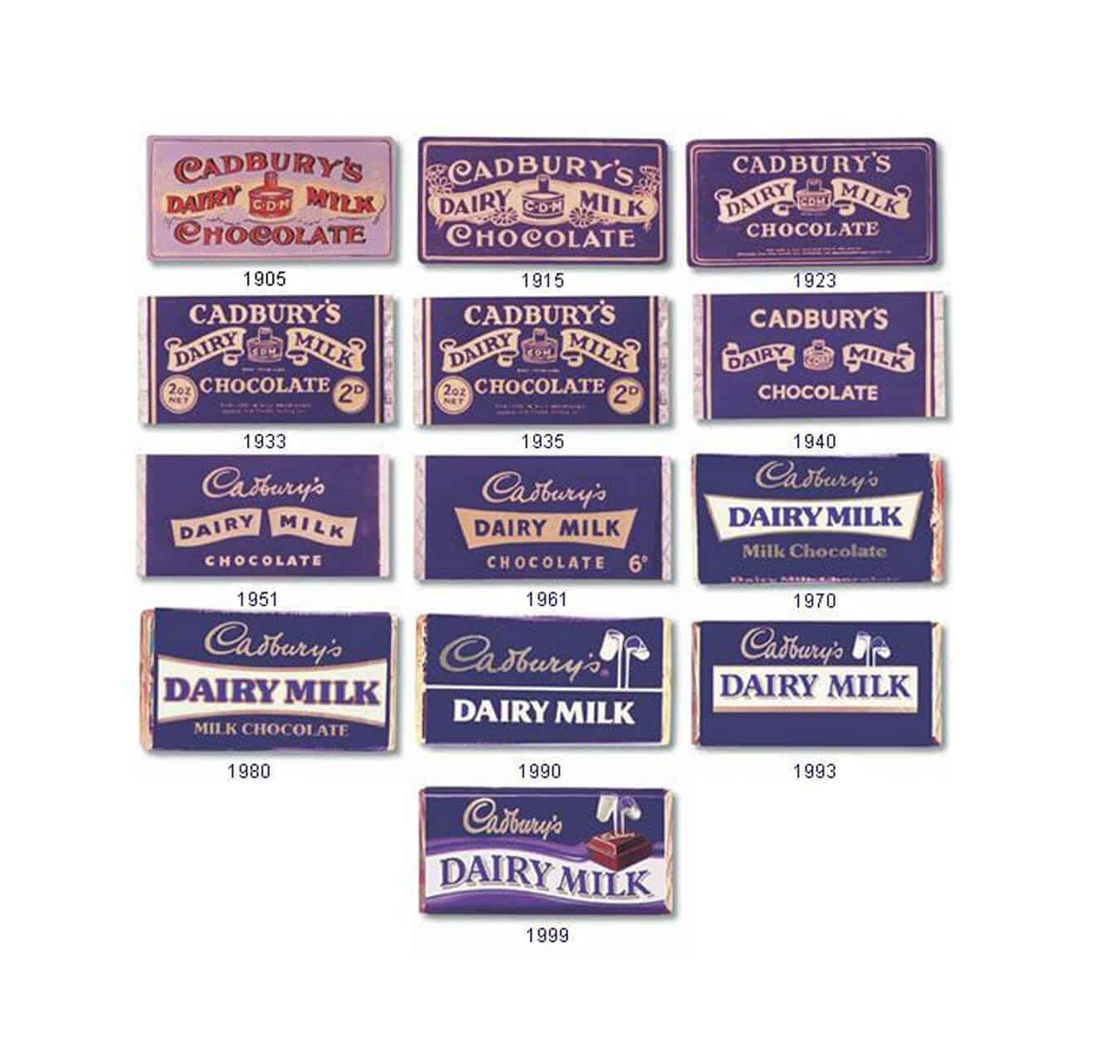
Fig. 1. The Evolution of Cadbury’s Dairy Milk Branding over the 1900s (2021)
The globally recognised phrase carrying connotations of generosity and sharing ‘there’s a glass and a half in everyone’ first originated in 1928, encouraging the consumers to associate “the chocolate brand with the friendly connotations of kindness and giving” (Kille, 2021) with the example of connecting to the idea of giving and receiving Easter eggs or a Roses box during celebrations.
Through the new branding in the beginning of 2021 (see fig. 2), Cadbury took a step backwards with their branding to the original concept where the phrase would trigger a familiarity and almost reminiscence about the personality of the brand. By wearing the basic concept down to its realistic, raw history beginning as a family-owned brand, encouraging a resemblance to the realism and authenticity of the brand identity, therefore, prompting the consumer to distance the idea of its identity as one of the largest multi-national confectionary businesses.

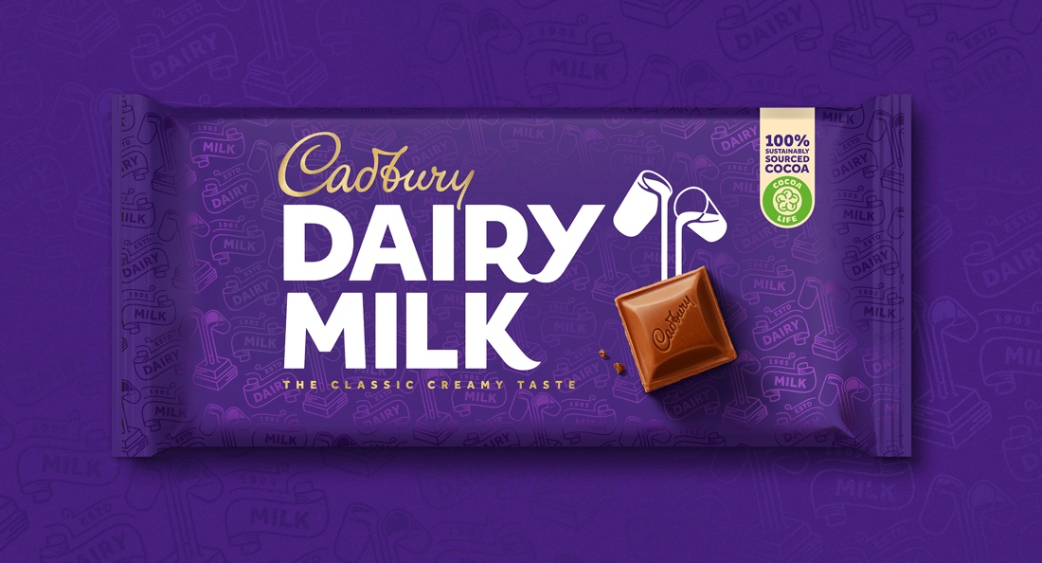
Fig. 2. Bulletproof’s Cadbury Redesign (2021)
Supported by “A brand analysis may include an internal review of the brand image, its heritage, its strengths and how they fit with the company’s values.” (Davis, 2009, p. 48), implying that people seek originality and something they haven’t seen before, on the other hand, people are also drawn to familiarity and through recognition. Due to branding requiring constant attention and to be developed as the world develops, Bulletproof revamped Cadbury. The rebranding was based upon the idea of enforcing the history behind the company and bringing a sense of togetherness and closeness, therefore, intrusting the target audience as they can appreciate the well-developed brand through the element of familiarity as the 1905 packaging designs are featured in the background pattern highlighting the banner style (see fig. 3).

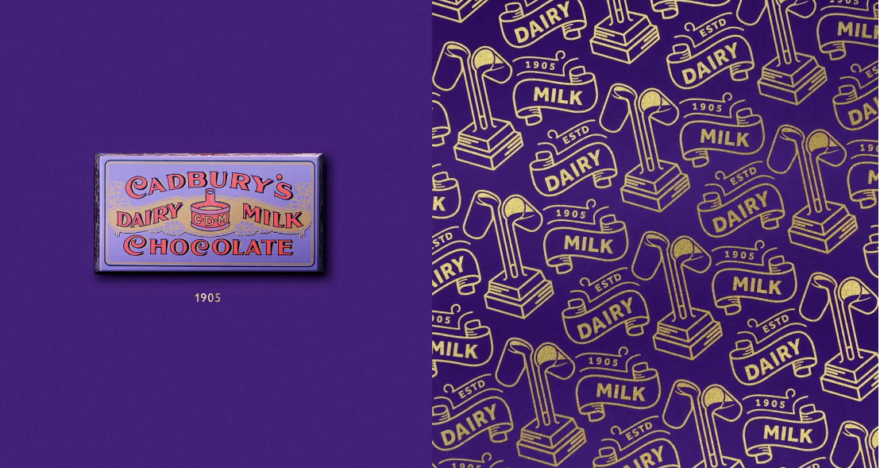
Fig. 3. Bulletproof’s Cadbury Redesign (2021)
Cadbury’s Mum’s Birthday Advert was a centre point for the idea behind the rebrand as “The advertising was making people cry. It was pulling on heartstrings… But when the corner shop owner hands the pack to her, the pack looks really out of context. And actually, that was our brief and what we wanted to do. Create a brand world that was as emotive as the advertising.” (Johnson, 2021). This seems out of the ordinary to base a rebrand on the concept of moving backwards, although by turning to the brand’s past, it was evident that one of the main values held dear to the company was the idea of spreading generosity whether it was through maintaining improved working conditions for employees to campaigning for the rights of animal welfare. Supporting this idea to reflect the core values of the company on the face of the packaging, when visiting the Cadbury’s archives, “There’s a whole floor with all these filing cabinets and showcases and boxes. It’s got an amazing energy.” “It’s like having your childhood all in one room, but also your parents’ and their parents’ childhood.” (Johnson, 2021) quoted by Jamie Gandee, the creative director at Bulletproof. There is something wholesome and humbling about the deep history of Cadbury that is presented through the rebrand as it focuses and highlights on the depth of the iconic brand with such a wide global appeal. Cadbury has demonstrated that when “Developing a brand that is sustainable requires a deep understanding of how that business, operation or person operates” (Davis, 2009, p. 12), as you cannot develop an accurate and authentic brand personality without a profuse amount of knowledge on the brand values and visions.

The fundamental definition behind the noun ‘beauty’ drastically alters alongside trends through the decades, officially based upon “a combination of qualities, such as shape, colour, or form, that pleases the aesthetic senses, especially the sight” (Huynh, 2017).
The ever-expanding world of social media and its’ omnipresence in women’s everyday life stimulates the highly damaging mental and physical consequences that come alongside the freedom to express yourself in any manner, whether a fake persona or accurately reflecting.

Toxic beauty standards often prioritise thinness, facial symmetry, perfect hair, clear skin, and the idolised list continues to the extent of normalising potentially dangerous cosmetic procedures. The reinforced pressure to attain these unrealistic and harmful expectations can lead to consequences such as low self-esteem, eating disorders and body dysmorphia.
These conditions work hand-in-hand, accelerating how “these latter conditions characterise individuals who are unhappy with something about themselves, typically their body shape or weight or appearance.” (Richards, 2003, p. 11), of which are all heightened by the pressures of social media promoting impractical body shapes as the desired body type according to the decade, where body trends should never be the case as it only encourages self-hatred in the younger generation. Nevertheless, with an increasing awareness to the unattainable beauty standards, the personal care brand Dove focuses on campaigns that shine a light on the depth of the damage to young women’s health that the toxic beauty industry promotes. The Self-Esteem Project launched in 2004 with the aim to promote positive body image and self-esteem by working through educational programs and workshops. Dove states that “8 out of 10 girls are so concerned with the way they look that they opt out of important activities” (Dove, 2023), highlighting the severity of the impact that negative factors such as beauty stereotypes and trends has on the youth mind, supported by Naomi Wolf’s observation on how “women have breached the power structure; meanwhile, eating disorders rose exponentially and cosmetic surgery became the fastest growing medical speciality” (Wolf, 1990, p. 1). This implies that although women have progressed drastically in terms of our role in society, our legal and social rights, acceptance into education and a diverse range of professions and trades; the self-hatred, fear of ageing and physical obsession with ourselves has taken over and exceedingly become more relevant.
Essentially the illusion of beauty is boosted by the fairly new trend that is filters, of which are featured across the majority of social media platforms. “What is taking it to the next level with these filters is it’s not just seeing an image of a celebrity who is unrealistic and measuring yourself against that person, it’s measuring your real self against a pretend image of yourself.” (Haines, 2021). Not only are you influenced to compare yourself to others but you are comparing yourself to a false and unattainable version of yourself through the easily accessible feature, leading young girls to feel pressured and self-conscious that they are not good enough without a filter or using a retouching app as this has become the accepted standard across a social media presence, set by widely admired influencers.
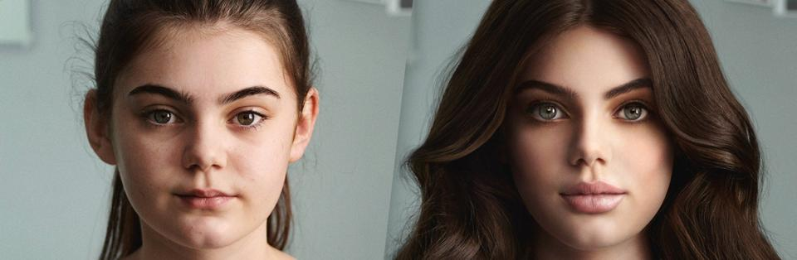
Fig. 4. Dove’s ‘Reverse Selfie’ film aims to raise awareness about the negative effects of facial editing on social media as part of their new ‘Selfie Talk’ Campaign (2021)
Referring to Dove’s work to spread awareness on celebrating real beauty, the company created a powerful advertisement campaign named ‘Reverse Selfie’ with the tag ‘Have #TheSelfieTalk’, beginning with a young girl sharing a heavily edited selfie, receiving countless likes and comments. You are then taken back through the augmentation process to her facial features, fuller hair and smoother skin in order to fit the unrealistic beauty standards perpetuated (see fig. 4). Even going so far as to removing background objects where the photo frame displays how you disconnect from yourself. The sense of innocence at the end of the advertisement featuring the girl in front of the mirror, encourages the audience to not feel obligated to conform to the pressures of today’s standards and to instead remind themselves of self-acceptance.

The idea of illusion is based off of misinterpreted perception and the illusion of movement includes elements such as lines, shapes, colours, typography and images to bring a sense of motion and energy to a design. The Gestalt grouping principles are a set of concepts that interpret how people perceive visual elements and organises them into meaningful patterns. The patterns work as a visual illusion to the audience’s eye, whether they guide the eye to a certain area of the design, or it creates an appealing and legible layout for the eye through a sense of movement.
The principles were founded around the 1920s by German psychologists Max Wertheimer, Wolfgang Kohler and Kurt Koffka and as clarified by Emilia Negoescu, a growth designer, “The 7 Gestalt principles are fundamental in the design world; thus, they influence the user’s experience. If I had to explain them in one sentence, they help the human eyes fill in the ‘gaps’ and perceive separate elements as a whole” (Berry, 2022), resulting in an organised manner of eye movement across the screen for example.
The closure principle encourages the most possibilities and intrigue due to how the human mind naturally fills in the blanks of an object even if the shape is not complete in order to see something that is familiar to us. As it is most common for the principle to be used as a logo rather than within UX and UI design, take the World Wildlife Fund logo as an example (see fig. 5). Referring to our ability to perceive incomplete objects as a whole with no need to think twice, where the basic black outline of the panda is cut off before it is connected to create a whole animal although it is natural for our minds to fill in the missing sections as even with the most basic of shapes, it is instinct to attempt to make something familiar out from the incomplete and unfamiliar. The idea of being able to create an extremely basic outline and the human eye would be able to decipher the whole image would allow more creative freedom when designing a logo as such.
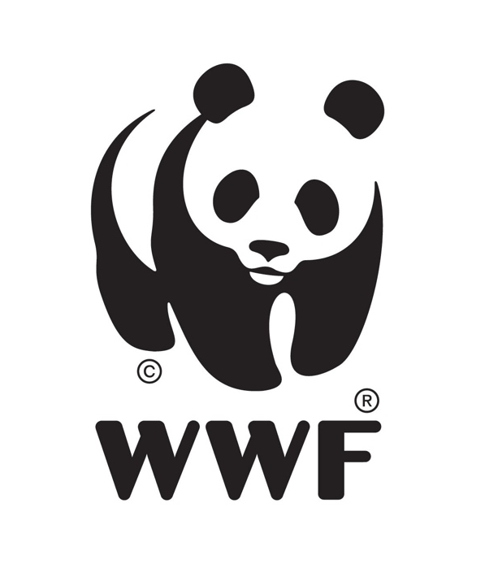
Fig. 5. WWF World Wildlife Fund Logo (2023)
An additional concept within design is the figure-ground principle which focuses on which area of the image the brain interprets as the foreground and the background based on the negative space. The “figure-ground object perception can be influenced by colour, focus and contrast” (Berry 2022), based upon the more prominent figure of the image. Danish psychologist Edgar Rubin developed the iconic optical illusion, Rubin Vase around 1915 (see in fig. 6) where the black feature of the image is typically processed initially, due to being the most prominent against the white but depending on how you perceive this image, your focal point is altered and you can see two completely different interpretations.
As a more practical use for this principle, website pop-up notifications would discourage the audience to interact with the background until you have made contact with the pop-up message. The element of movement creates the reaction of the eye to focus solely on the bolder box whilst the background is usually dimmed and blurred, supporting the theory that perception can be influenced by contrast and focus.


Fig. 6. The Rubin Vase Illusion (2023)
The focal point principle determines the hierarchy of perception focusing on the area or object that grabs the attention foremostly. The visual hierarchy can be influenced by its size, shape, colour, contrast or location, taking colour for example where each colour would display various levels of impact with some drawing more attention than others in terms of contrast or size. A method that would transfer into practical design work is the bold button on an app for example, enticing the user to proceed to the next step or purchase an item quickly, by using a prominent colour that stands out of the colour scheme and using visual hierarchy to encourage the movement and direction of attention.

Researching each keyword brought me to certain areas of work within the theme, where the concept behind the rebranding of Cadbury demonstrates how it used the brand’s deep history to influence the new personality face with the aim to develop an authentic representation and a sense of familiarity whilst remaining relevant. Through the keyword beauty, I explored the damage caused by the beauty industry’s unattainable, accepted beauty standard and the influence and consequences targeting young girls that are encouraged to compare themselves to others and even themselves against a false version through the heavy influence of social media filters and unrealistic body images. The Gestalt principles explore the theory of illusion that influences the movement within design and how they can be used practically along with a purpose.
Looking into how the topics could relate, the illusion created by movement could relate to the illusion that beauty has become widely accepted in today’s society due to both topics encouraging a version of misinterpreted perception. In terms of Cadbury linking in with the theory of movement, the rebranding would incorporate techniques that influence the user’s experience, prompting the audience to admire the packaging closer as the more you look, the more features you notice; playing along with the idea of visual hierarchy with the principle of focal point.
To summarise, the question proposed that I would want to advance with is ‘How does branding appeal to the illusion of beauty?’. This would interest me to researching the methods that are used to engage with the beauty industry’s toxic standards and continues to entertain the idea of the delusion. With regards to the proposal, a potential practice-based projects could lead me to rebranding a brand that notoriously appeals to the toxic industry to encourage self-confidence and defying the normalised heavy self-editing as such.

Figure List

Figure. 1. Kille, Robert. (2021) The Evolution of Cadbury’s Dairy Milk Branding over the 1900s. [Photograph] At: https://soak.co/unwrapping-the-history-of-cadbury-branding/ (Accessed 19/03/23)

Figure. 2. Johnson, Theresa. (2021) Bulletproof’s Cadbury Redesign. [Photograph] At: https://thedieline.com/blog/2021/2/1/behind-bulletproofs-redesign-for-cadburys-iconic-dairy-milk-chocolate? (Accessed 19/03/23)

Figure. 3. Johnson, Theresa. (2021) Bulletproof’s Cadbury Redesign. [Photograph] At: https://thedieline.com/blog/2021/2/1/behind-bulletproofs-redesign-for-cadburys-iconic-dairy-milk-chocolate? (Accessed 19/03/23)

Figure. 4. Haines, Anna. (2021) Dove’s ‘Reverse Selfie’ film aims to raise awareness about the negative effects of facial editing on social media as part of their new ‘Selfie Talk’ Campaign. [Photograph] At: https://www.forbes.com/sites/annahaines/2021/04/27/from-instagram-face-to-snapchat-dysmorphia-how-beauty-filters-are-changing-the-way-we-see-ourselves/?sh=61de0bf44eff (Accessed 24/03/23)

Figure. 5. Logowik. (2023) WWF World Wildlife Fund Logo. [Photograph] At: https://logowik.com/wwf-world-wildlife-fund-vector-logo-130.html (Accessed 22/03/23)

Figure. 6. Haasakker, Isard. (2023) The Rubin Vase Illusion. [Photograph] At: https://www.linkedin.com/pulse/rubin-vase-optical-illusion-shows-versatility-human-brain-haasakker?trk=pulse-article (Accessed 2/04/23)

Bibliography

Berry, R. (2022) Gestalt grouping principles: A guide to the psychology behind stellar UX. Available at: https://maze.co/blog/gestalt-grouping-principles/ (Accessed: (10 April 2023)

Davis, M. (2009) The Fundamentals of Branding. Switzerland: AVA Publishing SA

Deakin, W. (2023) Why it pays to play it unsafe. Available at: https://www.creativereview.co.uk/brandingdesign-risk-wayne-deakin/ (Accessed: 09 March 2023)

Dove (2023) Our Mission – The Dove Self-Esteem Project. Available at: https://www.dove.com/uk/dove-self-esteem-project/our-mission.html (Accessed: 04 April 2023)

Haines, A. (2021) From ‘Instagram Face’ to ‘Snapchat Dysmorphia’: How Beauty Filters Are Changing The Way We See Ourselves. Available at: https://www.forbes.com/sites/annahaines/2021/04/27/from-instagram-face-to-snapchat-dysmorphia-how-beauty-filters-are-changing-the-way-we-see-ourselves/?sh=165b17ff4eff (Accessed: 05 April 2023)

Huynh, A. (2017) Beauty and its Boundaries. Available at: https://medium.com/@annehuynhh/beauty-defined-by-the-oxford-dictionary-noun-is-as-a-combination-of-qualities-such-as-shape-f3077f001ec (Accessed: 04 April 2023)

Johnson, T. (2021) Behind Bulletproof’s Redesign for Cadbury’s Iconic Dairy Milk Chocolate. Available at: https://thedieline.com/blog/2021/2/1/behind-bulletproofs-redesign-for-cadburys-iconic-dairy-milk-chocolate? (Accessed: 20 March 2023)

Kille, R. (2021) Unwrapping the History of Cadbury Branding. Available at: https://soak.co/unwrapping-the-history-of-cadbury-branding/ (Accessed: 20 March 2023)

Luckiesh, M. (1965) Visual Illusions Their Causes, Characteristics & Applications. Dover edn. London: Constable and Company, Ltd.

Newark, Q. (2007) What is Graphic Design?. Switzerland: RotoVision SA

Parsons, G. and Carlson, A. (2008) functional beauty. United States: Oxford University Press Inc.

Poynor, R. (2003) No More Rules Graphic Design and Postmodernism. London: Laurence King Publishing Ltd.

Press, G. (2013) Branding Typography. United States: Sandu Publishing Co, Ltd.

Richards, K. (2003) Self-esteem and Youth Development. Ambleside. Brathay Hall Trust.

Robinson, J. (1972) The Psychology of Visual Illusion. London: Hutchinson & Co Ltd.

Wade, N. (1982) The Art and Science of Visual Illusions. London: Routledge & Kegan Paul Ltd.

Wheeler, A. (2013) Designing Brand Identity. 4th edn. New Jersey: John Wiley & Sons, Inc.

Wolf, N. (1990) The Beauty Myth. London: Chatto & Windus Ltd.

