

Student Name: Nethi Vishwa Prudhvi Raj
Student ID: 2105235

Name of the Module: International Marketing
Code of the Module: LCMB7006
Name of the Lecturer: Tushara Balendran

Contents
1. Introduction & Background information about the company. 3
2. Mission Statement: 4
3. PESTLE: 4
3.1 Hofstede Cultural Model 6
Advantages and disadvantages 9
Conclusion: 9
4. Porter’s Five Force Model 9
4.1 Similarities and Dissimilarities 11
5. SWOT Analysis 12
5.1 Advantages and Disadvantages of SWOT analysis: 13
6. Segmentation, Targeting, Positioning 13
6.1 Perceptual Map 14
7. Marketing Mix: 15
7.1 Market Entry Methods in India 17
8. Directional Development Strategy 18
8.1 Product life cycle. 19
9. Ansoff Matrix 20
10. Recommendations 21
10.1 TOWS Matrix: 21
11. Conclusion 22
12. References 23

Introduction & Background information about the company.
Dyson's past is unique. It's one of those stories that happened by chance! The company's founder, James Dyson, is famed for designing the Dual Cyclone, a bagless vacuum cleaner that uses cyclonic separation.
On July 8, 1991, James Dyson founded Dyson in Britain. It designs and produces vacuum cleaners. The organization has grown to thousands of clients in over 100 countries.
Sir James Dyson, was born in Norfolk, England on May 2, 1947. And Gresham's School in 1956. Following his studies at the Royal College of Art, he attended an engineering school. (Joegraham, 2015)
A single man's vision grew into a multinational technical enterprise employing over 1000 engineers. Dyson machines are now available in 65 countries. James Dyson and his company also invented bladeless fans, hairdryers, and heaters. Because his wheelbarrow got stuck in the mud while fixing his house!
The organization and its ever-expanding team of scientists and engineers are continually working on new products and technology. (The Editors of Encyclopaedia Britannica, 2021)
Prince Phillip Designers Prize 1997, Lord Lloyd of Kilgerran Award 2000. That year he also got his D. Eng. at Bath University.2007 he was made a Fellow of the Royal Academy of Engineering. Since 2011, Royal College of Art Provost He was elected a Royal Society of London Fellow in 2015.
His proposal was deemed a danger by big vacuum manufacturing businesses, which made obtaining a license in the UK and the USA difficult. Apex, a Japanese firm, licensed James' idea in 1993. So, Apex created the G-force, a vacuum cleaner that turns into a table, conserving space in Japan's tiny apartments. It started at $2000 in Japan. In 1993, Dyson founded the Dyson Company and a research facility in the UK.
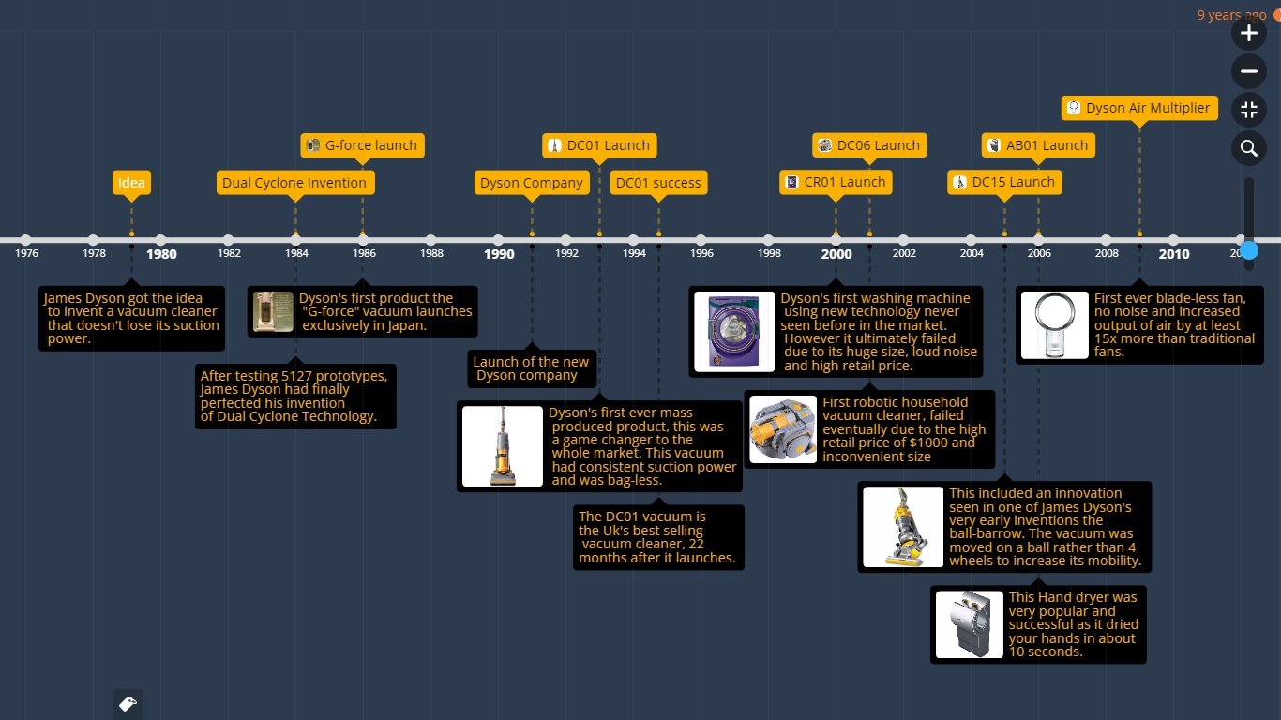
Source: (Farahat, 2018)

James' invention took ten years to catch on in Britain. This happened when a TV commercial implied Dyson vacuum cleaners were different from other vacuums because they didn't need bags. "Say goodbye to the bag" worked. The Dyson Dual Cyclone vacuum is one of the most popular ever! When other companies tried to sell cyclonic cleaners, Dyson sued and won $5 million. (Anonymus, history-of-the-dyson-company, 2021)
Throughout this assessment, you will learn about the company's critical analysis, which includes the Macro environment model, the SWOT analysis, Porter's 5 force model, as well as the Market mix and segmentation, targeting, and positioning of the company in two different countries, all of which will help us better understand the company's approach and behavior, as well as the company's favorable and unfavorable aspects. As part of the expansion into one of the countries, we will also address the market entry strategies used by the company, as well as their pros and disadvantages, as well as an idea of what would be the ideal approach to enter the market if the existing market entry strategy is not appropriate. In the end, we will explore the directed method for the company about the Ansoff Matrix, and we will conclude with recommendations based on the TOWS Matrix.

2. Mission Statement:
As one of the top British technology businesses, Dyson believes in its tagline that states engineers are the world’s problem solvers. To handle 21st-century concerns like air pollution, we need more of them. Dyson’s goal statement is “To inspire a new generation of engineers. It gives money, equipment, and mentorship so that young people can get hands-on with issues – and learn how to solve them.”

3. PESTLE:
A PESTEL study is an acronym that refers to a technique that is used to detect the macro (external) factors that are affecting a company. Political, economic, social, technological, environmental, and legal are represented by the letters PESTL. We will discuss what a PESTEL analysis is, how it is used, as well as the pros and downsides of employing it.
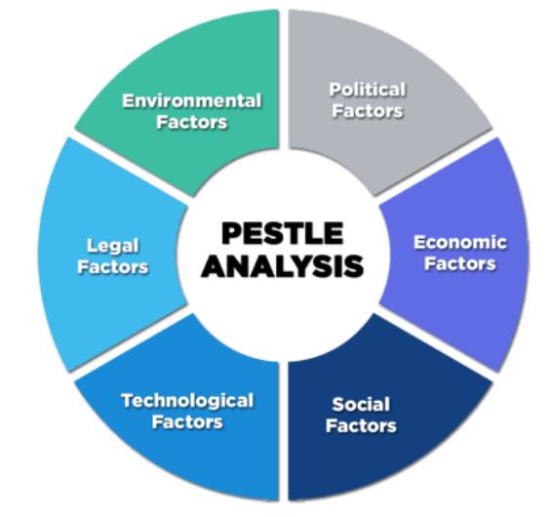Source: (Gandhi, 2020)

Political factors -Favorable in UK and INDIA
It could be possible for the UK and India to have an impact on the Dyson case. There are a lot of political laws in the UK because it is Dyson's home market. Dyson or any company can easily make recommendations about them, and the laws don't have an impact on Dyson business in the UK. However, in the current times, the administration has to deal with a lot of different things that can have an impact on Dyson's business, such as a high conversion standard, a shaky government, changes in exchange rules, and import business in any country, which can all have an impact on their business. (Dyson, 2014) Although Dyson was launched in 2018 in India it had not faced any difficulties in terms of the laws and political factors, before launching the new vacuum cleaner in India, Dyson tied up with FICCI Research and Analysis Centre (FRAC) to understand the issue of hidden dust in the country. The two entities jointly work with as many as 100 households across Bengaluru, Delhi, and Mumbai, and their initial research discovered that on average, 125 grams of dust is collected from just four key areas, including carpets, mattresses, sofas, and cars.

Economic Factors - Favorable in UK and INDIA
In some markets, things like how much it costs to get a loan or how quickly Dyson grows can change how people think about the company. For example, if the growth rate in a country is high, Dyson is likely to get a lot of business from that country because its sales are likely to go up. While on the other hand, if the growth rate in a certain economy is very high, it can make people less likely to buy and thus less likely to make a deal for Dyson. India is a country where Dyson is an early high-quality product that people buy a lot. This can either help or hurt their business in a certain market.
Technological Factors- Favorable in UK and INDIA
Dyson is all about innovative technology and giving creative solutions to very creative customers. It is important for their sales and growth that Dyson keeps up with the latest mechanical trends and stays ahead of their competitors. Putting more effort into their innovative work and always coming up with new ideas will help Dyson become a well-known brand and get them a lot of deals in the long run.. (Abbas, 2019) As there is no manufacturing unit in India, any product is first launched in the UK tested, and released in India as per their market research with changes made if required.
Legal Factors- Favorable in UK and INDIA
Since Dyson works internationally, it has to comply with the rules and regulations of these countries to sell its products legally in all these markets. These laws include trademark registration requirements, employment laws, safety laws, and other patent requirements. Following these laws will not only help them conduct their business in a certain country but also built their brand image in a certain country and increase their sales and business due to the favorable political factors it was easy and favorable for the UK and India in terms of Legal factors as well.
Environmental Factors- Favorable in UK and INDIA
In both countries with people being more aware of their environment, Dyson can provide products involved in cleaning. But by providing more information regarding their products, and investing in projects involving ecological investments, they will be able to increase their sales as people are more aware than ever and they expect the companies to also play their roles in saving the environment.
(Jha, 2009)

Socio-cultural Factors- Favorable in UK and INDIA

In the UK and India, customers are very aware of what they want, so it's important for businesses to make sure their products and customer service meet their needs. Dyson has always come up with new ideas that take into account the needs of their clients. Globally, if people don't know about the new technology Dyson has, they won't buy as many things, and that market isn't good for their business. So, in a country where people's way of life fits with what Dyson gives, Dyson's sales will keep going up.

3.1 Hofstede Cultural Model

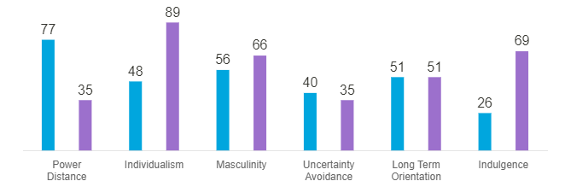
Source: (Compare countries, 2017)
Power Distance
The fact that not all people in society are the same shows how the culture feels about inequality. Power Distance is how much less powerful people in a country's institutions and organizations think about and accept power imbalances.
India scored 77 out of 100 in this category, which suggests that India likes top-down social and organizational hierarchy. Dependent on the boss or powerholder for direction, Indians accept that power-privileged people have more rights than those who are lower down in the pecking order, and they have less access to their immediate superiors than those who are above them. Despite how it looks, real power is concentrated, and managers rely on the loyalty of their team members. Employees want to know everything they need to know about their jobs and responsibilities. Control is familiar, even psychologically safe, and even if supervisors know your name, they still act like they don't know you. There is a lot of top-down communication, but negative feedback isn't usually sent up the ladder. With a PDI of 35, Britain is a country that wants to make things better for everyone. The PD index in Britain is lower in the upper class than in the working class. This is a surprise. It seems at first that the PDI score is against the long-standing British class structure. This shows one of the big problems in British society: the importance of birth rank and the idea that where you are born should not affect your life chances. A sense of justice leads people to think that everyone should be treated equally.
INDIVIDUALISM
A lot of attention is paid to how interdependent a society's members are in this dimension. It's about whether people say "I" or "We" when they talk about their own lives. Individualist cultures expect people to take care of themselves. They are part of "in groups" that look after them in exchange for being loyal to them.
People in India, who have a 48, live in a society that is both a group and an individual. Individuals are supposed to do what is best for the group they belong to (s). A person's actions are influenced by ideas like family, extended family, neighbors, and workgroups. Collectivists feel empty and rudderless when they aren't accepted by their peers or aren't liked by their immediate and extended in-groups. There are expectations for the employee to be loyal and for the employer to treat them almost like family. Relationships are often used to make hiring and promotion decisions in a society where people work together. There are only a few countries in the Commonwealth that are more Individualist than the UK (89). (Australia and the USA). Individualistic and private: Britain is a very private country. From a very young age, children are encouraged to think for themselves and figure out what they want to do in life and how they can help the world. Happiness comes from being satisfied with yourself. As Britain's income has grown over the last decade, many people have talked about the rise of uncontrolled materialism and the strengthening of the "me" culture.
Hinduism, the main religion and philosophy in India, is thought of as a very individualistic culture. Hindus believe that there is a cycle of death and rebirth, and each new life is determined by what you did in the previous one. Then, each person is responsible for their own life and how it affects their rebirth. Individualism and collectivism work together in Indian society, so this dimension has a medium score.
MASCULINITY
In a culture that values competition, achievement, and success, the winner / best in the field is seen as a success - a value system that starts in school and lasts through work.
This means that society places a high value on caring for others and having a good life. Women in a Feminine culture value quality of life more than making a big deal out of themselves. Because they want to be the best (male) or because they enjoy what they do (Feminine).
People in India are Masculine because they get a 56 on this scale. India is very masculine when it comes to wealth and power. The sparkle and glitz that comes with promoting one's success are used a lot. But India is a spiritual country with a lot of deities and different ideas. It is also a very old country, and it has one of the oldest civilizations. This teaches it a lot about humility and restraint, which it can use. This usually stops people from overindulging in Masculine displays. Success and accomplishments are more important in more masculine countries. When someone is working, it is important to show that they have done well. At 66, Britain is a Masculine culture that is driven by success. Foreigners have a hard time understanding the British culture of humility and understatement because of the way the country's values are based on success. You need to know the British by reading between the lines. Often, what is said is not what is meant. Unlike women in Scandinavia, Britons live for work and have a specific goal in mind.
UNCERTAINTY AVOIDANCE
How should society deal with the fact that the future is unknown? Should we try to stop it, or should we just let it happen? This uncertainty makes people nervous, which different cultures have learned how to deal with. People in a culture's Uncertainty Avoidance score show how scared they are when things aren't clear or ambiguous.
India has a score of 40 on this dimension, which means it doesn't like to be sure. In India, everything doesn't have to be perfect or go as planned. India is a long-suffering country that enjoys the unexpected as a break from everyday life. People don't feel like they have to act or settle into established roles and routines without questioning them first. Rules are usually set up to be broken, and clever ways are used to "get around the system." The word "adjust" is used a lot, and it can mean anything from not paying attention to rules to coming up with a new way to solve a problem that seems impossible. When the country thinks this way, it is both hurting and strong, but it is also the source of both. Indians say that "nothing is impossible" if you know how to "adapt." When it comes to Uncertainty Avoidance, the UK has a score of 35. This means that they are willing to start the day not knowing what it will be like and change their plans as new information comes to light. The British are used to ambiguity, and "muddling through" is a very British phrase. People in British society don't follow a lot of rules, but they do, and people do (the most famous of which of course is the British love of queuing which has also to do with the values of fair play)
The goal is to have a high MAS, but the details of how we get there aren't very detailed, and the process itself is flexible and adaptable to different situations. Shorter plans will also be made. Most importantly, a country that is very individualistic and curious needs a lot of invention and innovation. What is different is interesting! Advertising, marketing, and financial engineering are all very creative fields that thrive in this fast-paced world.
LONG TERM ORIENTATION
This dimension shows how every society needs to keep some ties to its past while also taking care of the present and the future. It also shows how different civilizations prioritize these two important goals. Normative cultures, for example, try to keep old traditions and conventions alive, but they don't trust social change. On the other hand, people with a high culture score say that people should be thrifty and get modern education to be ready for the future, which they think is the best way to do this.
With a 51 in this dimension, it's impossible to figure out what Indian and British cultures like the most. In India, "karma" is a big part of religious and academic ideas. Time doesn't move in a straight line, and so it isn't as important as it is in Western societies. India, for example, lets people from all over the world practice their religions. Hinduism is usually thought of as a philosophy, a group of ideas, attitudes, practices, and esoteric beliefs. There are many different truths in India, depending on who you ask. Societies with a high pragmatism score usually don't care about being late, changing plans when things change, or being happy with fate rather than following a predetermined path.
INDULGENCE
Very young children have a lot of socialization. This is both a current and historical issue. We are not "human" if we don't talk to each other. This dimension talks about how people try to control their desires and impulses based on how they were raised. An indulgence is a weak form of control, while restraint is a strong form of control. Culturally, this means that they could be a lot of fun or a lot of work.
India has a score of 26 in this area, which means it has a culture of restraint. People are skeptical and pessimistic in this part of the world. In contrast to Indulgent cultures, Restrained societies don't care about having fun and don't eat as much. People who have this point of view think that society's rules keep them from doing what they want to do and that indulging is bad. A score of 69 suggests that British culture is a lot of fun. People who live in communities with a lot of Indulgences are more likely to be able to live their dreams of having fun and having fun. In other words, they are positive and have a positive outlook on life. They also value their time off more, act how they want, and spend money how they want.

Advantages and disadvantages
Pros include Hofstede's description of culture and how culture may be assessed. His study found that culture matters. Also, Hofstede's model helps managers understand cultural differences in value systems and behavior. Hofstede's concept helps individuals comprehend diverse cultures in everyday life. The Hofstede model also confirms that there are numerous methods of constructing organizations and institutions.
Many researchers questioned Hofstede's original findings. As a simple organizational change control, culture is just too complicated and multidimensional. Also, some claim it's outdated, while others say four dimensions didn't provide enough information. (Anonymus, The Advantages And Pros And Cons Of Hofstede's Model, 2020)
One of the first things that people say about Hofstede's research is that it is based on "disciplinal power." He only thought about the world in one way and didn't think about other ways. This is what he thinks about the world. Two groups are made by Hofstede: one group is made up of nations that are well-developed, while the other group is made up of countries that are old and not very developed. Hofstede's work cut down on how the world can be seen. He treated the whole world in the same way that he did. According to Hofstede, it is important for societies to have different values in order to be different. In his book, Hofstede says that culture isn't about what people do, but how they think about things. He only talked about cultural values. The "dimensions of culture" that Hofstede talks about as internal motivational mechanisms not only reproduce one A version of disciplinary power, but they also encourage divisions and unwarranted evaluations of societies that aren't really true.
(Moulettes, 2007)

Conclusion:
There are many models for understanding the national culture including Hofstede’s cultural dimensions. Culture is a very complex term and it is not as simple as Hofstede takes in his study. There are many dimensions that other scholars had given. Among the extra aspects are assertiveness, performance orientation, gender equality, degree of formality, pragmatism/rationalism, and gender equality. These factors may assist in developing a more critical understanding of the culture. It is possible to transform the culture of any company by using this technique. By using this concept, a business may enhance its working environment while simultaneously increasing the talents of its employees.

4. Porter’s Five Force Model
Porter's Five Force Model is comprised of five variables that influence a company's performance. Existing competition, supplier negotiating strength, prospective Entrants, the danger of alternatives, and the bargaining power of the consumer are all factors to consider. We will go over each factor one by one to see how Dyson is influenced by each kind of factor. (Adamkasi, 2020)
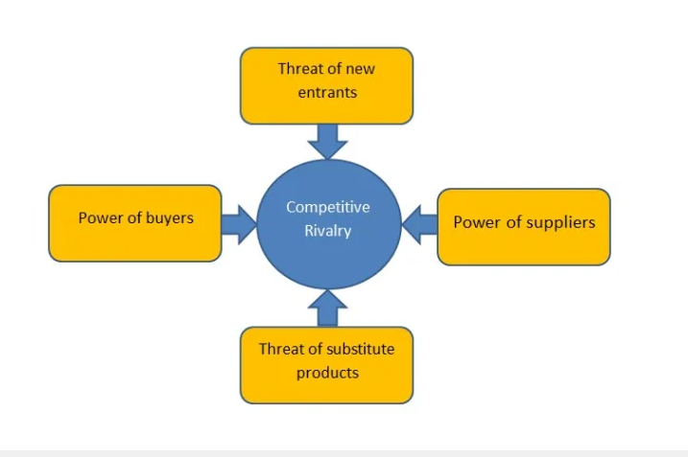
Source: (TFLIU90, 2020)

Competitive Rivalry – High in UK and India
There are a plethora of firms competing in the vacuum cleaner industry, including Philips, Hoover, and others in both India and the UK. When it comes to electricity, Philips is one of the most successful firms in the world. They have a strong brand image, and they have a significant market share in the vacuum cleaner business around the globe. In addition to this, Philips must be disregarded at all times since they can beat you at any moment, even when you are performing below par. In contrast to Philips, which concentrated its efforts on all aspects of electricity, Hoover concentrated its efforts on the vacuum field. They are one of the most established businesses in the cleaner’s industry in the region. Hoover was formed in 1908, and the company has been Dyson's primary opponent over the years. Aside from these two major corporations, there are a plethora of other businesses that pose a challenge to Dyson on its path to development. (Market Watch, 2019)

Bargaining Power of Supplier – Low in UK and India
Not only in India or UK, but this company in this industry also covers the global level and it is the reason suppliers are dependent on the company. Dependency is high due to the quality of the product and technology they use in R&D to stay ahead in the market considering the technology used. Because they are doing a large number of studies, they need a variety of various types of materials. In addition, some of them are quite tough to locate. The supplier, therefore, has the benefit of being able to set the price for the material. Dyson, on the other hand, needs to broaden the range of providers available to them. (Haucap, Heimeshoff, Klein, Rickert, & Wey, 2013)

The threat of New Entry - Low in the UK and India
The number of hurdles decides the threat of new entry in the industry, considering the technology the company has invested in R&D to be updated and provide the best it is difficult for the new entry to invest so much in the R&D. Hence the threat of new entry is low in both India and UK through the manufacturing unit is in the UK and not in India. Cleaning companies earned $5 billion per year in profits throughout the late 1980s. After 30 years, the figure has to be significantly raised. For such a massive cake, all of the firms who have the potential to share it are eager to do so. There are indeed several firms wishing to join the market and participate in the profits. Dyson should also consider the amount of electricity that may be obtained from possible competitors. (David Atkin, 2015)

The threat of Substitutes - High in the UK and India
Although the approach utilized in Dyson goods is quite distinctive in both the countries UK and India, the majority of other items are designed differently. If the vacuum cleaner with bags can overcome the supply shortfall while maintaining a cheaper price, it will be able to compete with the Dyson vacuum cleaner with two cyclones for market share. Another new style of cleaner is on its way, and this one does not need the user to transfer it from one location to another to be effective. They have excellent performance while operating in automated mode. They will take care of cleaning the room themselves. If this kind of design takes the place of Dyson's design, Dyson will face a significant challenge in the marketplace.

Bargaining Power of Buyer - Medium in UK and India
It is creating a balance between the bargaining power of the buyers and the companies as this company provides the most recent or latest innovation product which other companies are taking time to launch in both UK and India. When compared to other items, Dyson's pricing is consistently among the most expensive on the market. As a result of the pricing, they must confront the reality that they will lose the majority of their customers in the long run. However, they have adopted a high-price approach to ensure that their items are the best available, which serves as a kind of guarantee to their customers. Customers pay a premium amount for the items, but in exchange, they get high-quality service from the firm. Furthermore, if consumers discontinue usage of Dyson's product, they will have forfeited a valuable service. (Cowan, 2018)

4.1 Similarities and Dissimilarities
Competitive Rivalry - High in UK and India, Philips vs. Hoover, Hoover vs. Dyson. Bargaining Power of Supplier - Dependency is high due to the quality of the product they use in R&D to stay ahead in the market considering the technology used. The threat of new entry is low in India and UK through the manufacturing unit is in the UK. Dyson should also consider the amount of electricity that may be obtained from possible competitors.
Dyson's pricing is consistently among the most expensive in both the market. However, they have adopted a high-price approach to ensure that their items are the best available. Customers pay a premium amount for the items, but in exchange, they get high-quality service.

5. SWOT Analysis
SWOT analysis is a way to figure out what internal strengths and weaknesses and outside opportunities and threats shape current and future operations and help you set strategic goals. In both the UK and India, we will be able to analyze them. (KENTON, 2021)
Strength | Weakness
Strong Focus on R&D Activities (the UK, IN) | Overdependence on Europe (IN)
Strong Market Position. (UK) | Operational Issues (UK)
Strong business models (the UK, IN) | Lack of expertise in operating (IN)
Large Customer base and Geographical Outreach (UK)
Opportunity | Threat
Recovery of Global Steel Demand (UK) | Market Competition (the UK, IN)
Positive Outlook for Automotive Industry (the UK, IN) | Raw Material Risks (the UK, IN)
High Internet penetration (IN) | Regulatory Environment (the UK, IN)
Source: Learner

Strength:
- The company develops new materials through its Research and Development Laboratory (RDL) in Sheffield to ensure that its products are of the highest quality, competitively priced, and satisfy customers’ present and future requirements in both the countries UK and India.
- Dyson selects materials concerning an extensive application database, which, in conjunction with close liaison with end-users, provides materials that offer optimum performance in terms of cost and operation.
- Dyson also obtained an anISO9001 quality management certification from BSI Audit for its manufacturing unit while maintaining consistent standards in quality.
- The diverse end-user market provides the company with a broad customer base, a strong brand presence, and growth opportunities across emerging markets.
- Dyson caters to the needs of a diversified end-user market through its advanced zirconia ceramics, high-performance industrial refractory, and ceramics bodies. (GlobalData, 2021)
Weakness:
- Dyson's excessive dependence on Europe to generate revenue exposes it to associated risks and drawbacks.
- A strong regional focus could affect the business when the economy is in a downturn in India.
- Though the company has a wide presence in Europe, Asia Pacific, Africa, and America, it generates a major portion of its revenue from Europe. (GlobalData, 2021)
- Dyson is involved in several legal proceedings related to its ordinary course of business.
- These legal actions, regardless of the outcome, could drain the company's financial resources and divert the time and effort of its management.
Opportunity:
- The recovery of demand for steel and steel products will enable the company to record growth in its operations in both UK and India.
- According to the World Steel Association's (WSA's) June 2020 Short Range Outlook report, the global steel demand is expected to drop 6.4% in 2020 due to the CO LithiumVID-19 crisis.
- The steel demand in the emerging and developing economies (excluding China) is expected to rebound by 15% in 2021.
- In developed economies, the steel demand is projected to rebound by 7.8% in 2021. A positive outlook for the global automotive industry provides growth opportunities for Dyson in its operating markets. (GlobalData, 2021)
- It could benefit from the growing demand for eco-friendly vehicles such as hybrid vehicles as UK and India strive to become eco-friendly and have nonfuel vehicles in coming years.
- Such a positive outlook for the automotive industry could translate into an increase in demand for the company's products in both the countries UK and India.
Threats:
- Dyson operates in a highly competitive industry, in the UK and India.
- Raw material prices constitute a significant part of the production cost of the company to sell in the UK and export to India.
- Volatility in the price of raw materials could increase the financial burden on the company.
- Thus, price fluctuations and the non-availability of raw materials may hurt production costs and the operations of the company.
- Dyson could be affected by the regulations governing the European ceramics industry.
- The industry is regulated by directives on emissions trading, industrial emissions (IED), REACH, and ceramic articles intended to come into contact with foodstuffs on packaging and packaging waste.
- REACH (Registration Evaluation and Authorization of Chemicals), in Europe, is an example of the stringent environmental regulation that affects chemical producers.
- Complying with these regulations increases the cost to the company, which could affect its operational performance in both the countries UK and India. (GlobalData, 2021)

5.1 Advantages and Disadvantages of SWOT analysis:
A SWOT analysis is an excellent tool for guiding business-strategic planning discussions. It is common for a pre-planned SWOT analysis to modify throughout the session to reflect variables that were previously unknown to you and that you would have missed had it not been for the group's involvement. SWOT analysis may be used by a corporation for general business strategy sessions as well as for specialized segments such as marketing, manufacturing, or sales strategy sessions.
SWOT analysis is a powerful planning technique, but it has several drawbacks. Rather than being employed in isolation, it should be seen as one of various business planning approaches to take into consideration. The SWOT analysis does not take into consideration the disparities in weight.
SWOT is the best guide to plan and discuss for the company to use in both UK and India but alone will not be sufficient for critical decision making.

6. Segmentation, Targeting, Positioning

Segmentation: Similar Segmentation in UK and India
Market segmentation has been similar in both the countries in terms of demographic focusing on the major cities and the same age group as well as the affordability of the product by the consumers by occupation or other status factors, though it was launched in 2018 in India. European and American established markets continue to be the most lucrative for vacuum cleaner manufacturers. A constant CAGR growth rate of 4 percent per year will be maintained in these locations. The Asia-Pacific region, on the other hand, is seeing the most significant development and is anticipated to maintain its position as the leader for the foreseeable far future. Latin America and the Middle East, for example, have shown signs of rapid development. Canister-based vacuums have the biggest market share of all the different kinds of vacuums, accounting for 40% of the total. In terms of sales, upright vacuums account for around 4% of total sales. It is projected that the market share of cordless vacuums would grow steadily over the next several years. Nevertheless, sales of robotic cleaners have already surpassed $1 billion per year, and the industry expects sales to continue to expand at an exponential rate. (Preeti Wadhwani, 2020)
Targeting: Similar Targeting in UK and India
Since Dyson is a company that is always coming up with new ideas, its main customers are people who like products that are technologically advanced and meet their high standards for quality. Then, they will pay the high price point for the high level of performance and ease of use they get. There is a big group of people who would like the new product because it is environmentally friendly. Dyson products have a high-performance suction system, a bagless storage system, and less energy consumption. All of these things may make it more appealing to market the product for commercial use because it will be seen as a long-term investment in high-efficiency equipment that will save money in the long run. (Preeti Wadhwani, 2020)

Positioning:
In both the countries UK and India, to position a product in marketing, it must be differentiated from the competitors. Dyson will introduce a long-lasting, durable, and multi-functional cordless vacuum cleaner to target various market groups and demographics. The startup will overcome technical barriers to cordless vacuums and give the finest consumer alternative available. The firm will maintain and increase its market leadership by focusing on the new vacuum cleaner and ensuring that the investment pays off. Derived from revolutionary technology advances, each Dyson product has its own set of attributes. Other than vacuum cleaners, several technologies are widely employed. Thus, Dyson has improved its goods' capabilities and design, setting it apart from competitors. (Sidhu, 2017)
James Dyson's ambition for the firm is to become a large technological corporation, not just a consumer appliance manufacturer. As a result, billions have been invested in different battery-related research activities. As the market converts to cordless vacuum cleaners, Dyson and many other renowned technology experts say batteries will be important for powering equipment. This will also help Dyson become a leader in consumer electronics and appliances since incremental advancements make it tough to overturn the status quo. Dyson wants to be seen as inventive, clever, and superior in quality and practicality to its rivals. (KUANG, 2015)

6.1 Perceptual Map
Dyson now has the best levels of customer loyalty and brand success in the industry. Samsung and LG, along with Dyson, have a high level of brand success, but they have a lesser level of consumer loyalty. Dyson has been successful in attracting clients because of the innovative designs and features it offers. Hoover and Electrolux, who sell goods similar to Dyson but at cheaper pricing, could catch up in the long term. (merrickfernandes, 2018)
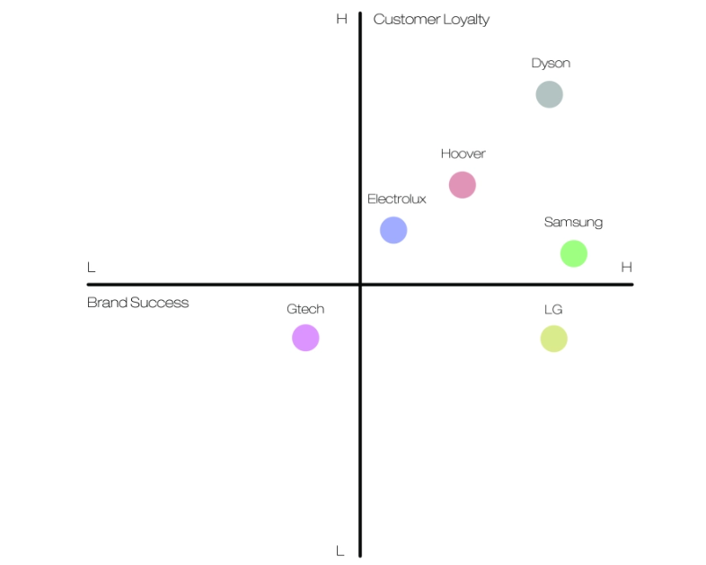
Source: (merrickfernandes, 2018)

7. Marketing Mix:

Product:
When Dyson develops product branding for its new eco-friendly vacuum cleaners, it must take current trends in the home appliances market and industry into mind. First and foremost, manufacturing methods must comply with the ISO 14020 and ISO 14024 guidelines issued by the International Organization for Standardization to ensure that the environment is not harmed to a significant degree. vacuum cleaners are categorized as energy-intensive technologies, and their design must gradually fit the requirements of contemporary sustainability models as they become available. Marketing in the future will be affected by sustainability requirements and models that are pushed for global consistency in the progression towards 'green' goods, argued Atherton in a paper published in 2013 (Atherton, 2013). Dyson will design a campaign based on the firm's exceptional customer care service to distinguish between its multipurpose and portable ventures and its original upright and cylinder vacuum cleaners, according to the company. Another point of distinction will be the provision of a warranty on the sub-branded items that are longer than one year. Customers will be able to expose their difficulties via the use of an online expert program, which will then be analyzed and suitable solutions will be identified. This program will serve as a step in ensuring client satisfaction. Putting the customer service number on the equipment, rather than on the user instructions, is another successful method of increasing customer happiness. A company's ability to provide complete customer satisfaction is critical to its overall success (Meyer, 2014). The techniques outlined above may be quite beneficial to the organization as it attempts to establish dominance in new categories. This is because the corporation will place a strong emphasis on cutting the cost of manufacturing by foregoing fashionable designs and high-performance capabilities. As a result, exceptional customer service is the component that will add value to the business. Many of the policies, the majority of which were devised by James Dyson and backed by the other CEOs, are concerned with broad concerns that concern both gender equality and scientific advancement. These topics, according to (Cuneo, 2003), include universities, education, culture, and research and development, among other things. In the large number of policies that have been produced, including pure science in the educational system is an inclusive policy. Aside from that, policies that will assist increase innovation include tax responsibilities that will benefit beginning enterprises, improving the quality of learning and teaching, and integrating adaptable courses that are based on the present condition and plans for the industrial system.
Pricing:
Dyson is already regarded as a high-end manufacturing enterprise. As a result, the corporation is unable to adopt competitive priorities, which are accomplished by rising prices to make the pricing more competitive. Dyson, on the other hand, may pursue a low-price approach while expanding into new product categories such as multifunctional and portable. The corporation, on the other hand, needs a sub-brand to pursue a low-price strategy. The sub-brand contributes to the preservation of the high-end association that has been the foundation of the firm since its inception. The sub-brand should be positioned in such a manner that the parent company, Dyson, is prominently shown. The Dyson vibe will be conveyed via the sub-brand, and the company's heritage will be preserved as a result of this approach. At the same time, the corporation should continue to emphasize the upright and cylinder categories of products. The carryover impact will assist the organization in reaping the benefits of the two categories after the recession. (UKEssays, 2018)
Promotion:
Because of the rise of social media platforms, Dyson now has more effective tools for managing communications among its constituents and partners. The firm communicates with its large consumer base in numerous areas across the globe by using social media platforms such as Facebook, Twitter, and Instagram. Employing social media platforms to facilitate the flow of information, consultation, and feedback-giving amongst workers, suppliers, and other stakeholders across a variety of industries have also shown to be more effective. When it comes to multinational corporations, communication is an important operational aspect and a competitive advantage.

People:
At Dyson, they look for people who are creative and have a passion for engineering and problem-solving when they hire them. This helps them build a team that is all about customer service. All the machines are lined up so that when customers call to talk to Dyson employees about the problems they are having, the staff can understand what they say. Most of the time, this works, but if it doesn't, Dyson engineers will come to the customer to fix their machines. (UKEssays, 2018)
Processes:
At DYSON, all of the things they do are in line with the Dyson formula. There are many ways to solve problems at a company, from drawing up the machine's design to testing it at home, to giving employees the chance to invent. All of these have the same goal: solving problems through continuous innovation and perfection. (UKEssays, 2018)
Physical Evidence:
Physical evidence shows a company's experience quality. So, it's particularly useful when a customer has never bought from the firm before or when a service is expected to be paid in advance. The setting, staff uniform, and online reviews all contribute to the whole experience. Clients want to see testimonials, case studies, and contracts on a company's website. (Assemblo, 2021)

Place:
When it comes to channel planning, the forces of globalization have positioned e-commerce as a viable option for global companies. When digital marketing tactics are integrated, it becomes simpler to discover target markets, assess levels and patterns of demand for particular items in specific markets, and provide the appropriate quantities of products in specific markets. E-commerce combines e-warehousing, which simplifies the administration of items that are en route to multiple markets or that have already arrived. Dyson should implement an e-commerce-based producer-consumer distribution channel to achieve greater market performance.

7.1 Market Entry Methods in India
Dyson has decided to enter the Indian market through social media Marketing and Export instead of setting up a manufacturing unit. However, they have set up a store cum experience center in Delhi first as they believe in word of mouth. (Bhatia, 2017). This was a niche brand. So it didn't need to spend money on mass advertising. Instead, they used social media influencers, the digital form of word of mouth. It has been clicked with Mira Rajput, Masaba Gupta, and Sagarika Ghatge. Instagram lifestyle influencers have also been seen sporting the Dyson cordless vacuum and hair products. This is a brand that consumers want to show off, not only because it works so well. Using social media effectively, Dyson was able to announce its foray into the Indian market without jeopardizing its premium brand image. (grocurv, 2019) Currently, Retail stores have traditionally been where people buy consumer appliances. Selective distribution: The company has chosen to sell its products only in certain places and department stores. The company sells things on its website, and it also works with other websites that sell consumer appliances or general goods. However, with the huge rise in e-commerce, Dyson needs to focus on platforms that allow direct delivery to the customer. The strategy may cost more at first because there may be a loss in economies of scale and the company may need to build new online or shipping infrastructure at the beginning. As a result, this strategy should save money by not having to pay for a brick-and-mortar location. It also ensures that the company will not be left out of a new market segment. Allows for collaboration with the new supply chain system that has been changed so that it's built-to-order. (StudyCorgi, 2022)
Influences on Market entry Method:
Now is the right time (to come to India). Dyson said that they think they will be able to solve problems that will make a big difference in the lives of Indians, like cleaning their homes, making the air they breathe cleaner, and also making their hair supersonic. A Dyson vacuum cleaner has changed the way people clean their homes because it has a unique design and is very efficient. He said that in China, they are changing the way they measure air quality because their air-purifiers clean the whole room, not just around the device. He also said the company was investing in filter technology. To improve filter technology and fight pollution, we are spending a lot of money on R&D. The Indian market will play a big role in this, he said. (Rajan, 2018)
In addition to China, Dyson has been dealing with other markets. Now it's time for India. Also, India wasn't ready for vacuums. "India is an intriguing market, but it may take time to grow, unlike China, which has become Dyson's third-biggest market after the US and Japan," Dyson added. It will also sell via other merchants and online shopping sites in India. “Online helps us. We sell on Amazon in several countries and may do so in India," he said. Dyson products will be priced between £300 and £500, in line with worldwide pricing. “Technology is expensive, and our items are patented. "We don't discount and won't play pricing games," Dyson added.
The firm will import goods from Malaysia, Singapore, and the Philippines. Depending on demand, Dyson may consider manufacturing in India. (Mitra, 2016)

Advantages and Disadvantages of Exporting:
There are a variety of advantages to exporting. On a worldwide basis, it is currently being marketed, as well. Profits have increased as a consequence of this. Precautions can be taken at this time. As a consequence, the company's competitiveness and market share have both increased. This capability of realizing economies of scale is critical. The aid by the government is much appreciated for Exporting. Exporting has both good and bad things about it. Supply chain problems, for example. There are too many fees, licenses, and paperwork that need to be paid upfront before you can export. When it comes to making changes to a product, the term "product adaption" is used to describe the process. It can be hard to keep the legislative and executive processes running smoothly. Obstacles that happen because of cultural differences Currency changes and multi-currency payments happen all the time. (Thuri, 2022)

8. Directional Development Strategy
In business, directional strategy refers to the game plan that a firm agrees on and then executes to expand the company, boost earnings, and achieve goals and objectives. Small firms and huge corporations alike may develop their forms of directed strategies that are tailored to the specific emphasis and scope of their organizations. (Tushara, 2022)
Dyson is in the growth stage in both countries UK and India as they are focused continuously on R&D to launch new products, and the latest technology and diversified into Vacuum cleaners, hairdryers, air purifiers, etc.
Similarities and Differences:
The company is similar in the direction of growth in both the UK and India. The only difference is that the products are launched late in India compared to the UK due to the technology stage in India as well as the customer response in the UK as the presence in the UK is higher than in India for Dyson.
Though few products have reached the maturity stage in the UK due to the technology up-gradation in the market as well as the company they have been remodeled and relaunched in the other countries which keeps the company in the growth stage overall.

8.1 Product life cycle.

Essentially, the product life cycle describes the process that a product goes through from the time it is initially brought into the market until it is no longer viable or is withdrawn from the market entirely. The life cycle is divided into four stages: initiation, growth, maturity, and decomposition.

However, although certain items may be able to maintain a protracted maturity stage for an extended period, all products ultimately phase out of the market owing to a variety of causes such as saturation, greater competition, lower demand, and declining sales. (S, 2021)

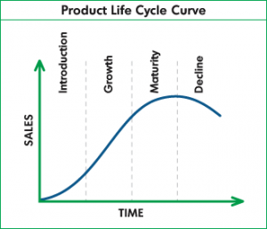
Source: (Flekel, 2013)
Dyson is experiencing rapid growth in both the United Kingdom and India, owing to the company's ongoing investment in research and development to introduce new products and the latest technology, as well as its diversification into vacuum cleaners, hairdryers, air purifiers, and other household appliances. Dyson is headquartered in the United Kingdom. Though it was launched late in India compared to UK few products have reached the maturity stage but the technology development helps in bringing them modified and keeping them in the growth stage.
The product life cycle must be established as part of the product development cycle to track the progress of the timetable. Management's use of controls in the product development lifecycle helps create quality control and oversee financial expenses. The management of product development streamlines the design to the commercial sales process. Strategic management may be done in several ways. Usually, deadlines are set for project phases as a motivating and time-management tool. Expenses incurred throughout the development stage must be offset until the product is delivered and sales begin to generate profit. It is also possible to refocus the development plan before the next significant flood of resources by using a milestone review. This will allow for a more thorough assessment of the project's effects and obstacles. Strategic monitoring may be used to establish which small-scale goals are crucial to the product's success. Thus, proper management of these milestone moments would avoid long-term setbacks. (Stark, 2020)

9. Ansoff Matrix
Ansoff's Model helps marketers figure out how to make more money for a business by developing new products and services or "tapping into" new markets. So it's called the 'Product-Market Matrix' instead of the 'Ansoff Matrix' sometimes.
The Ansoff Model is one of the most commonly used marketing models because it focuses on growth, which makes it a very popular model to use. It is used to see if there are ways for businesses to sell more products and services to new customers and in new places. For example, it compares products and services that offer four different strategies with those that don't. (Hanlon, 2021)

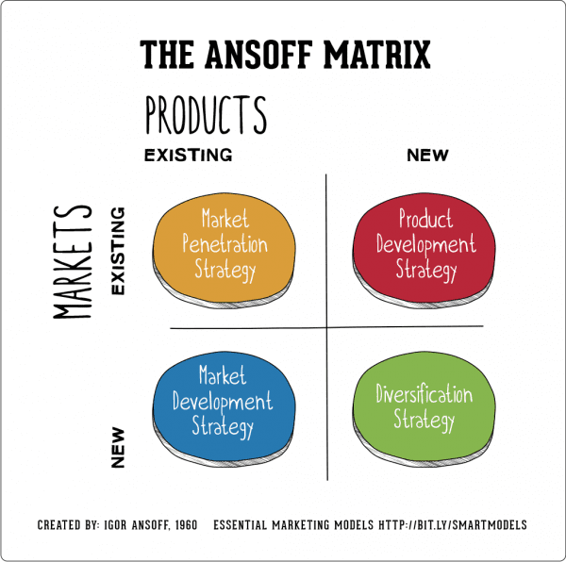
Source: (Hanlon, 2021)
Market Expansion
Utilize the marketing department to generate promotions targeted at certain customer categories. 'Full Nest III', 'Married Couples', 'Older Singles', and 'Empty Nest I' are all categories worth considering for increasing sales, and vacuum advertising should be customized to these groups.
Create loyalty programs for present and prospective consumers, such as promotions or discounts on internet portals or at retail locations. Attractive programs would increase online or foot traffic, hence boosting sales and benefiting the business in the long term. (merrickfernandes, 2018)
Development of New Products
The introduction of a new vacuum cleaner or upgrades or additions to existing models would be an effective strategy for differentiating oneself from competitors and increasing brand recognition. Competitor manufacturers provide goods with comparable characteristics to Dyson's at a cheaper price range. Such a method would ensure that earnings are maintained and increased.
'Married Couples,' 'Older Singles,' and 'Empty Nest I' are all customer categories that are likely to invest in a new product. Promotions targeting these populations should be conducted across several platforms, including television, print media, and the internet. (merrickfernandes, 2018)
Market Expansion
Brand recognition should also be raised across non-targeted customer categories. The marketing team should devise a campaign that is both appropriate and appealing to the other customer categories.
The research and development team may want to investigate developing and using less expensive materials for product packaging. It would contribute to a marginal reduction in total product costs, hence increasing product sales and profits. (merrickfernandes, 2018)
Diversification
Other consumer appliance categories, such as culinary appliances, garden equipment, and irons, are served by competitor brands. Utilize the research and development team to focus on these product sectors, to introduce a new one in the future years. (merrickfernandes, 2018)

10. Recommendations
As per the complete study, It is observed that the company has always been on top of R&D to diversify and launch new products or enhance the existing products. They have already tried and failed in launching the washing machines as well as the electric vehicles due to the cost of the outcome product. However, they have not stopped research on creating new products and product lines. I would like to recommend Dyson to also get into the telecom industry as well as the kitchen appliances which have a huge market through there are numerous players, their technology would help in taking the edge of others. Let us try to use the TOWS Matrix to understand better.

10.1 TOWS Matrix:
The TOWS matrix is used to identify numerous elements, which are then linked together, for example, an opportunity with strength, to inspire the development of a new strategic initiative. The TOWS matrix represents the organization's endeavor to link internal and external influences to spark new strategic initiatives. (Dyson R. G., 2002)
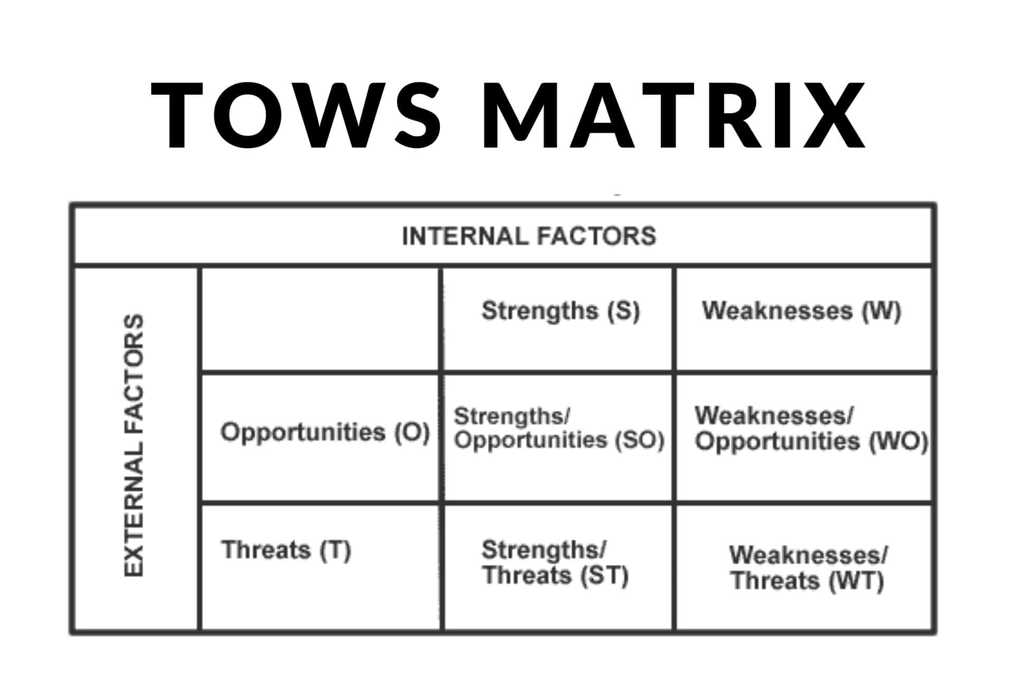
Source: (Chowdhury, 2019)
Strength Opportunity: Maxi-Maxi Strategy
Dyson to use internal strengths to make the best use of the outside opportunities that the company has available. In other words, the company needs to make the most of its strengths by using its resources to take advantage of possible changes. Dyson as a company has built up a good brand name in the market and has won the hearts of its customers, there is a great chance to look into new markets or come up with new products and services for the same people. That move could be the best for the company.
Dyson has always been on top of R&D to introduce new goods or improve old ones. Due to the high cost of the end product, they have previously attempted to introduce washing machines and electric automobiles and failed. They haven't given up on developing new items and lines. I would advise Dyson to enter the telecom business as well since their technology would help them gain a competitive advantage.

11. Conclusion
To keep Dyson's products and brand-strong, they need to keep coming up with new ideas. The company comes up with a simple but effective way to get people to recognize their brand and help them promote it in a new and different way. However, Dyson's strategy is risky because they have always been the first to try new things. Dyson doesn't know how well its products will do until they hit the market. If you look at James Dyson's work, you will see that he can use technologies in many different ways.
In addition to the above, it's also important to think about what could happen to Dyson and how this could affect their position as the market leader, like how they protect their intellectual property. As a market leader in innovative products, Dyson needs to look to the future and see how technologies it has made can be used in other businesses. This way, Dyson can stay on top. The company needs to keep coming up with new ideas to be able to do this in today's competitive industry; failure can also be used to achieve this goal.

12. References
Abbas. (2019). Pestle-Analysis-Dyson-is-an-organization-situated-in-the-United-Kingdom. Course Hero, 12.
Adamkasi. (2020, January 31). porters-five-forces-for-Dyson. Retrieved from www.porteranalysis.com: https://www.porteranalysis.com/porters-five-forces-for-dyson/
Anonymus. (2018). commercial-aspects-of-product-design. online: Merrick Fernandes.
Anonymus. (2020). The Advantages And Pros And Cons Of Hofstede's Model. ipl, 5.
Anonymus. (2021, September 24). history-of-the-dyson-company. Retrieved from www.phcvacuumservice.co.uk: https://www.phcvacuumservice.co.uk/history-of-the-dyson-company/
Assemblo. (2021, february 18). what are 7ps of marketing? Retrieved from assemblo.com: https://assemblo.com/guides/what-are-the-7-ps-of-marketing/
Atherton, J. (2013). Dyson recruits 650 skilled workers as 2012 profits grow to £364m. UK: Metro.
Bhatia, A. (2017). Dyson is to enter India in January 2018 and plans to store in Delhi. New Delhi: indianexpress.
Chowdhury, O. (2019, December 4). tows-matrix. Retrieved from https://tradebrains.in: https://tradebrains.in/tows-matrix/
Compare countries. (2017, September 04). Retrieved from www.hofstede-insights.com: https://www.hofstede-insights.com/fi/product/compare-countries/
Cowan, R. S. (2018). The “Industrial Revolution” in the Home. In R. S. Cowan, The Routledge Companion to Modernity, Space, and Gender (p. 412). New York: Routledge.
Cuneo, A. Z. (2003). DYSON TAKES ON VACUUM GIANTS. London: Adage.
David Atkin, B. F.-N. (2015). RETAIL GLOBALIZATION AND HOUSEHOLD WELFARE. Massachusetts: NBER.
Dyson, J. (2014, November 22). Why we must quit the EU, by tycoon Sir James Dyson. (A. LITTLE, Interviewer)
Dyson, R. G. (2002). Strategic development and SWOT analysis. European Journal of Operational Research 152 (2004) 631–640, 10.
Farahat, k. (2018, November 5). line/172610. Retrieved from https://time.graphics: https://time.graphics/line/172610
Flekel, A. (2013, April 24). Understanding the Product Life Cycle. Retrieved from https://www.business2community.com/: https://www.business2community.com/product-management/understanding-the-product-life-cycle-0475909
Gandhi, R. (2020, May 29). pestle-analysis-a-mechanism-for-analysis-of-businesses. Retrieved from enterslice.com: https://enterslice.com/learning/pestle-analysis-a-mechanism-for-analysis-of-businesses/
GlobalData. (2021). Dyson Group Plc. London: GlobalData plc.
grocurv. (2019, November 28). how-Dyson-nails-its-marketing-strategy. Retrieved from grocurv.com: https://grocurv.com/blog/2019/11/28/how-dyson-nails-its-marketing-strategy/
Hanlon, A. (2021, August 12). The Ansoff Model. Retrieved from www.smartinsights.com: https://www.smartinsights.com/marketing-planning/create-a-marketing-plan/ansoff-model/
Haucap, J., Heimeshoff, U., Klein, G. J., Rickert, D., & Wey. (2013). Bargaining power in manufacturer-retailer relationships. econstor, 40.
Jha, A. (2009). Dyson Engineering. London: The Guardian.
Joegraham. (2015, May 30). history-of-the-dyson-company. Retrieved from www.joegraham.co.uk: https://www.joegraham.co.uk/blog/tag/history-of-the-dyson-company#:~:text=Dyson%20Ltd%20is%20a%20British,in%20over%20100%20countries%20worldwide.
KENTON, W. (2021, March 29). SWOT. Retrieved from www.investopedia.com: https://www.investopedia.com/terms/s/swot.asp
KUANG, C. (2015). James Dyson on His Company's High-Powered, Portable Future. London: WIRED.
Market Watch. (2019, November 26). household-vacuum-cleaners-market-share-industry-analysis-size-growth-trends-top-key-players-and-forecast. Retrieved from https://www.marketwatch.com/: https://www.marketwatch.com/press-release/household-vacuum-cleaners-market-share-industry-analysis-size-growth-trends-top-key-players-and-forecast-2019-2024-2019-11-26
merrickfernandes. (2018). Commercial Aspects of Product Design: The Plan. online: merrickfernandes.
Meyer, K. E. (2014). Local Context and Global Strategy: Extending the Integration Responsiveness Framework to Subsidiary Strategy. Global Strategy Journal, 32.
Mitra, S. (2016). Dyson eyes India entry next year with its retail stores. New Delhi: Mint.
Moulettes, F. &. (2007). Commentary From Cognitive Dichotomies to Cultural Discourses: Hofstede, Fougere, and Moulettes in Conversation. Journal of Multicultural Discourses, Carbaugh, Journal of Multicultural Discourses Vol. 2 (1)., 6.
Preeti Wadhwani, P. S. (2020). Household Vacuum Cleaners Market Size By Product (Cordless/Stick, Upright, Canister, Central, Drum, Wet/Dry, Robotic), By Sales Channel (Offline, Online), Industry Analysis Report, Regional Outlook, Growth Potential, Competitive Market Share & Forecast, 2. online: Global Market Insights.
Rajan, N. (2018). Dyson comes to India with high-performance vacuum cleaners, and air purifiers; to invest £150 million. New Delhi: indianexpress.
S, A. (2021, October 29). What Is the Product Life Cycle? The street. online, online, online: The Arena Group.
Sidhu, I. (2017, December 6). Profiles in Doing Both: How Dyson Blew Away the Vacuum Market. Retrieved from www.huffpost.com: https://www.huffpost.com/entry/profiles-in-doing-both-ho_b_613827
Stark, J. (2020). Product Lifecycle Management (Volume 1). Geneva, Switzerland: 21st Century Paradigm for Product Realisation.
StudyCorgi. (2022, March 10). Dyson Company: Cordless Vacuum Cleaner Marketing Plan'. Retrieved from studycorgi.com: https://studycorgi.com/dyson-company-cordless-vacuum-cleaner-marketing-plan/
TFLIU90. (2020, June 17). industries. Retrieved from toughnickel.com: https://toughnickel.com/industries/Porters-five-forces-analysis-of-Netflix-Inc
The Editors of Encyclopaedia Britannica. (2021, April 28). James Dyson. Retrieved from https://www.britannica.com/: https://www.britannica.com/biography/James-Dyson/additional-info#contributors
Thurs, V. (2022, March 27). advantages-of-exporting. Retrieved from wise.com: https://wise.com/us/blog/advantages-of-exporting
Tushara. (2022). International Marketing (LCMB7006). London: UWTSD. Retrieved from moodle.used.ac.UK: https://moodle.uwtsd.ac.uk/course/view.php?id=4120
UKEssays. (2018, November 23). Dyson Marketing Analysis. Retrieved from www.ukessays.com: https://www.ukessays.com/essays/marketing/marketing-analysis-of-dyson-marketing-essay.php
UKEssays. (2018, November 24). Product and company analysis of Dyson. Retrieved from www.ukessays.com: https://www.ukessays.com/essays/marketing/product-and-company-analysis-of-dyson-marketing-essay.php?vref=1

