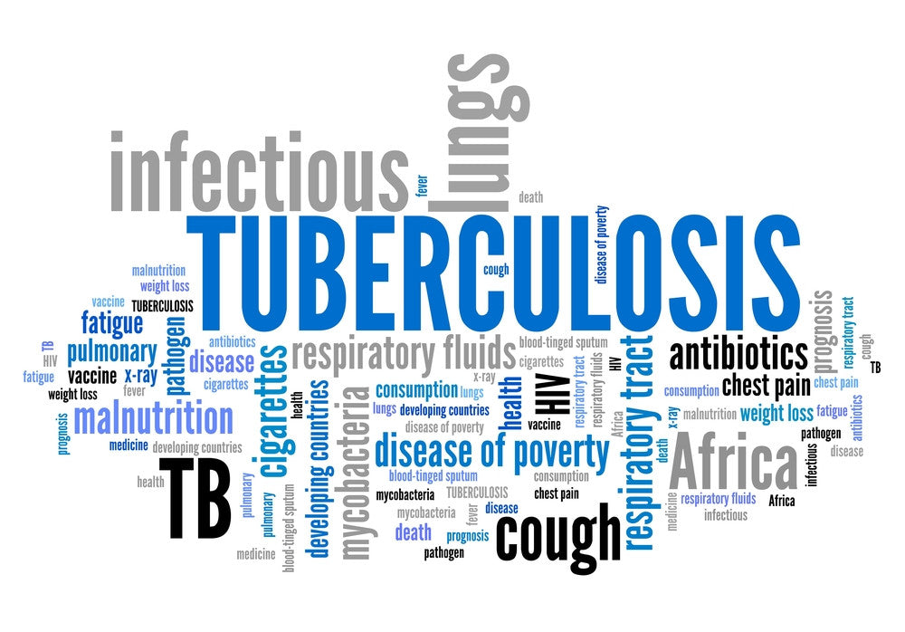  PUBLIC HEALTH  LCHS4004 | Student Name: Janna Saif  Lecturer Name: Mohammed Hussain  Janna Bint-E Saif (2129742)  Student ID:2129742

Content page

Introduction…………………………………………………………. ………. Page2
Measure………………………………………………………………………. Page2
Monitor…………………………………………………………………………Page 3
Control………………………………………………………………………… Page 3
Policy…………………………………………………………………………. Page 4
Recommendation………………………………………………………..........Page4
Conclusion……………………………………………………………………...page 5
References……………………………………………………………………Page 6

Tuberculosis TB
Tuberculosis (TB) is a bacterial infection which is contracted by inhaling tiny droplets from an infected person's cough or sneeze. Even though the lung is the main organ that are harmed, any organ, including the stomach (abdomen), glands, bones, and nervous system, may also be damaged. According to estimates from the World Health Organization (WHO), about one-fourth of the world's population has latent mycobacterium TB infection (WHO, 2019).
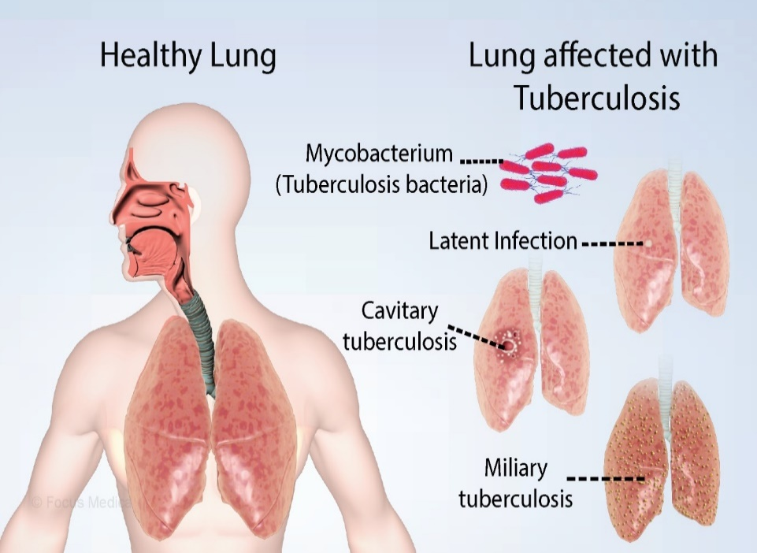
The most contagious form of tuberculosis (TB) is pulmonary TB, which affects the lungs, but it typically spreads only after prolonged contact with a person who has the condition. While tuberculosis (TB) has the potential to be extremely destructive, it is treatable when taken care of with the right drugs.
Figure 1: Focus Medical

DR. Robert Koch reported the discovery of Mycobacterium tuberculosis, the germ that causes tuberculosis (TB), on March 24, 1882. One in seven persons in the United States and Europe died from TB during this time. The most significant step toward the control and eradication of this fatal disease was made thanks to DR. Koch's discovery. A century later, March 24 was declared World TB Day, an occasion to inform the public about the effects of TB all over the world (CDC, 2016).

In 2018, there were 4,655 cases of TB in England, or 8.3 cases per 100,000 people. The rate of TB is six times higher among the poorest 10% of the population than among the least poor. People born outside of the UK are 14 times more likely to get TB (10%) than people born inside the UK (BBC, 2012).

Measure-
It is vitally critical to fully understand the situation, measure the epidemic, and track its spread through the population.
The TB outbreak can be measured using a variety of indicators, each with advantages and disadvantages. Daily cases, hospitalisation, and mortality were frequently employed as tracking metrics for any disease outbreak. These are the most crucial metrics and looking at them independently can help us understand how widely the sickness has spread throughout the neighbourhood or whether the staff or hospitals are understaffed.
Daily Cases- Using the "R," or reproduction number, epidemiologist calculate the prevalence of infection in a population daily. For DS TB and MDR TB, the estimated basic reproduction numbers were 1.14 and 0.54, respectively. This is a statistic that represents the typical number of infectious illness cases that spread from one afflicted person. When the R0 is less than 1, it indicates that the epidemic is under control; when it is greater than 1, it is still expanding.
Hospital capacity - It's critical that every patient receives specialised care in a hospital. Since TB cases require specialised care, the size of the TB outbreak can be estimated by analysing hospital capacity. Hospitals can better prepare for surges by knowing how many beds are available.
Death - The goal of any outbreak response is to save lives, so monitoring death counts due to TB is important. There are tests that may be performed to measure TB, and these procedures include: a biopsy, which involves taking a tiny sample of tissue or fluid from the affected area and testing it for tuberculosis, as well as a CT scan, MRI scan, or ultrasound scan of the affected part of the body.

Monitor-
"Maps" is one of the most effective methods to track any outbreak. We can generate a map that shows exactly where the infection is and how it is spreading by combining data from all hospitals and the community. GIS is one of the most effective techniques used by epidemiologists. For epidemiologists who study epidemics, (Geographic Information System) is a useful tool. As a result, they can map disease outbreaks and track them through time and geography. These techniques can pinpoint the exact origin of the disease and reveal the most vulnerable demographic types.
According to World Health Organisation (WHO) Over 10 million people are still affected by tuberculosis each year, a disease that has been around for 70,000 years. 2020 saw 1.5 million deaths from tuberculosis, a disease that is both detectable and treatable.
Through TB detection and treatment, an estimated 66 million lives have been saved since 2000.

Control-
Although it has been around for a long time, tuberculosis (TB) is still one of the deadliest infectious illnesses, second only to COVID-19, and claimed more lives in 2020 than HIV and malaria put together (WHO, 2021).
To control TB, infected person doesn’t need to separate but still need to take a few easy precautions to stop TB from spreading to others. One must abstain from attending job, school, or college until TB treatment team advises it is okay for you to do so. Always cover your mouth, ideally with a disposable tissue, when sneezing, coughing, or laughing. Use a sealed plastic bag to dispose of any used tissues with care.
Administrative control- The most important component of TB infection control is the implementation of administrative measures to reduce the risk of exposure to individuals who may have TB disease. Important activities that should be implemented include diagnosing TB symptoms quickly, separating infected patients, restricting the spread of germs, and minimising the amount of time spent in medical facilities.
Environmental Control-Another crucial component of TB infection management is environmental measures. Environmental controls work to prevent and lower the number of infectious droplets in the air. There are two sorts of environmental controls.
The primary environmental controls involve reducing the infection source by using local exhaust ventilation.
Secondary environmental controls include regulating airflow to stop polluted air from settling in locations near the airborne source.

Policy
The Department of Health's Stopping tuberculosis in England: An Action Plan from the Chief Medical Officer, published in 2004, contains the primary policy framework for combating the disease. It outlines the program's objectives, including the long-term reduction and eventual eradication of tuberculosis from England, with the immediate goals of lowering the risk of people contracting the disease for the first time, providing high-quality treatment, and promoting healthy lifestyles (DoH, 2004). This framework has prescribed how medical practitioners should handle instances of tuberculosis, but it hasn't stemmed the disease's sharp increase in England. To prevent TB, a vaccination called BCG (bacilli Calmette-Guerin) is administered. It works better on kids, and it works inconsistently on adults

Recommendation
If a family member is known to be infected at home, use a mask, keep separate utensils and rooms, and keep the most vulnerable persons, such as young children or the elderly, away from the infected person.
- Always wash your hands before leaving the house or use hand sanitizer.
- Make sure the home is properly ventilated.
- Frequently clean the air dusts in your automobile and house.
- Obey and teach proper sneeze and cough techniques.
- Reduced turnaround times for sputum testing and culture,
- The use of quick diagnostic tests, and the prompt start of treatment are also further recommendations.

Conclusion
To prevent TB, a vaccination called BCG (bacilli Calmette-Guerin) is administered. It works better on kids, and it works inconsistently on adults.
Accountability is crucial in the effort to eradicate TB because it helps to guarantee that regional, international, and national commitments to do so are kept.
Within 100 days of a declared health emergency, the government has promised to provide vaccines for newly identified infectious diseases. If we are to fulfil our global duties and end needless deaths, we must also battle existing neglected diseases like TB and ensure that we never have to wait 100 years for another vaccine.

Referencess:

BBC news, (2012), the changing NHS. Available https://www.bbc.uk/news/health-19721977

BBC (2006) Sharp rise in tuberculosis cases. [Accessed 20th October] http://news.bbc.co.uk/2/hi/health/6109228.stm
DOH (2004) Stopping tuberculosis in England: An Action Plan from the Chief Medical Officer. Department of Health.
Public Health Disease Management of Tuberculosis (ukessays.com) [Accessed 24th October]
https://tbfacts.org/tb-infection control/- :~:text=TB%20infection%20control%20in%20health%20care%20settings%201,in%20areas%20adjacent%20to%20the%20airborne%20source.%2
Tuberculosis (TB) - NHS (www.nhs.uk) [ Accessed 24th October 2022]
Tackling tuberculosis (local.gov.uk) [Accessed 20th October 2022]
Suárez, I. et al (2019). The diagnosis and treatment of tuberculosis. Deutsches Aerzteblatt International, 116(43).
Shah, M. and Dorman, S.E., 2021. Latent tuberculosis infection. New England Journal of Medicine, 385(24), pp.2271-2280.
World Health Organisation (2022) Infectious Diseases Available at: https://www.who.int/ [Accessed 20th October 2022]

