Problem solving and decision making in project management of Unilever
Submitted By: Noor Ahmed
Student ID:1707321

Table of Contents
Introduction 4
Project management problem, its scope and impact 5
Objectives of the problem solving 6
Brainstorming, problem solving and creative thinking techniques 6
Information on the problem that help in decision making process 8
Difference between information and data 8
Interpretation of charts and diagrams 9
How to evaluate options 10
Importance of the adequate and relevant information for decision making 10
Alternative solution to the problem 11
Decision making techniques 11
Plan to implement to solution 13
Case presentation 14
Communicate the plan to shareholder 15
Appropriate monitoring and review technique 15
Organisational change 15
Reason for organisation change 16
Environment analysis technique 16
Organisational analysis 17
Change management principles 18
Methods for planning for change and its use 18
Feasibility and viability of change to shareholder 19
Human and financial factor in consideration of hindrance to change 19
Communication of change and importance of involving with people 19
Techniques of monitoring and evaluating outcome of change 20
Conclusion 21
Reference 22

Introduction
An organisation starts a project for the purpose of achieving organisational objectives. Unilever is a UK based multinational organisation which runs its business operation around the world. Unilever has its business operation in all seven continents. But when Unilever wanted to expand its business operation in Pakistan the organisation faces some problem. That is why the organisation takes a project solve those problem and takes decision regarding the problem. This report will discuss about how this problem of Unilever can be can be solved and the organisation can take decision regarding this. For doing this, this report will first define the problem what was faced by the organisation and the scope and impact of the problem, analysing the information regarding this problem for the purpose of helping in decision making process. Then this assignment will discuss about the different types of alternative solution that can be taken by Unilever to solve the problem and various technique for the purpose of decision making. And finally, this report will discuss about the plan by using which the organisation implement the decision, communicate it to the shareholder and monitor and controls so that the solution is properly implemented.

Project management problem, its scope and impact
`Problem solving is reactive skill for an organisation. It is one for the major activity for an organisation because organisation try to solve the problem in that area in which the organisation objectives is not fulfilled and by problem solving a decision-making organisation try to achieve those objectives. There are various ways to recognise a problem (Chu and MacGregor, 2011). Some of these are:
- Finding out what prevent an organisation to achieve its goal and objectives.
- Not only identify the problem but also identify it’s and scope and impact.
- Problem recognition needs to be based on data and information.
After recognising a problem an organisation needs to define the problem carefully so that it can provide the implication of the problem. Here the problem is how Unilever can increase the organisation performance efficiency in Pakistan. Problem solving is the process of defining a situation which is problematic (where there is gap between what the organisation wants and what really happened) and the organisation saw an opportunity in that problem.
There are various scopes in Unilever for these problems solving. Unilever is a multinational organisation which operates in most of the country in world and for doing this the organisation needs to deal with various factor like culture religion, behaviours etc. if the organisation successfully understand what the customer want form the organisation then it will be easy for the organisation to achieve its goal (Del Missier, Mäntylä and Bruin, 2011). Problem solving help the organisation to understand what the customer of Pakistan wants form the organisation and if the organisation solves the problem regarding this then it will be easy for Unilever to achieve its objectives in Pakistan.
Unilever plans to invest $120 million in Pakistan. After doing this the organisation face problem on that region regarding the customer really want in that region. It is because of the fact that what the customer wants in a European country is not the same for Asian country. That is why if Unilever do not solve the problem then the impact of the problem will be huge for the organisation. So, the amount of investment in Pakistan is huge for the organisation. If the organisation fails to solve the problem then it will have a negative impact on the organisation profitability.

Objectives of the problem solving
Unilever start this project for the purpose of expanding the organisation business in Pakistan. While doing the organisation face some problem regarding what the organisation really wants and what the organisation found form the project. Unilever saw a difference in expectation and actual result. That is the reason the organisation identifies this problem to solve and taking decision on how to achieve organisation goal (Funke, 2013). The objective behind this problem solving includes:
- Identifying different style of problem solving so that the organisation can use it to solve the problem.
- Finding out the methods which appropriate to solve this problem.
- Apply different types of method which is suitable to a specific situation.
- Apply different types of problem solving skill in the time of working in a team.
These are the objectives for what the organisation starts this problem solving and this will help the organisation to achieve its organisation objectives.

Brainstorming, problem solving and creative thinking techniques
The process of creativity techniques of s group by using an organisation try solve a problem form taking or generating ideas form the member of the group. For an organisations success the group which are existing in the organisation is very important. In other word it can be said that group played a vital role to an organisation goal achievement. That is why every organisation focuses on effective team work (Greiff, Holt and Funke, 2013). When an organisation identify problem to solve then the organisation needs to find out various solution to that problem. One man may not be able to do this. That is forming a team is important. The member of the team came up with unique ideas spontaneously for purpose of solving the problem. Brainstorming techniques include brain writing, figuring storming, brain-netting, rapid ideation, round robin brainstorming, star bursting and stepladder technique.

Figure: Brainstorming
Source: PTO (2016)
Problem solving is the process of identifying problematic situation and the opportunity of that problem. There are various techniques that an organisation can use to solve a problem. Some of this technique includes:
Problem identification: This is the most important stage of problem solving where the organisation needs to find a problem that can help the organisation to eliminate the gap between organisation expectation and actual result.
Option generation: After deciding which problem to solve an organisation needs to evaluate various option that can be used by the organisation to solve the problem? This is very important as the option which will determine the successful completion pf a problem solving (Jäkel and Schreiber, 2013).
Select most appropriate technique: Which technique to use for solving this particular problem is very important for the organisation to decide? There are various techniques which are available for an organisation to solve a problem. But the organisation management need to find out the most appropriate technique which is fit to solve the problem.

Create plan of action and implement: The technique of problem solving is to create a plan of action and implement the action. The solution what were found in previous stage need to be implemented and for that organisation need to create a plan of action so that the solution can be implemented successfully?
Monitor performance: After implementing the plan the organisation needs to monitor the performance to find out whether the action plan worked as per plan or not. If not then the organisation needs to act so that the problem can be eliminated (Kwisthout, 2012)?
The intellectual disciplined way of active and skilful conceptualisation, analysation, apply, synthesising and evaluation of information which gathered by means of observation, experience, reflection, communication and reasoning as a guide of action is known as critical thinking. Critical thinking is playing a vital role to an organisation goal achievement because of the reason that it helps the organisation to bring out the best way to solve a problem. The technique involved to critical thinking includes ask the basic question, fix the basic assumption, be aware of the team mental process, try to reverse thing, evaluate existing evidence, need to understand the fact that no can think 100% critically all the time etc.

Information on the problem that help in decision making process
This is era of digital technology where information is the key to success. Without using information properly an organisation can’t achieve its goal. The information which is used by an organisation need to right without this the organisation can lead to a path that may be harmful for the information (Rao, 2013). Anything about something is known as information. But there is difference between data and information which is discussed below:

Difference between information and data
Data | Information
The raw facts which are gathered about a condition, idea, entity or event is called data. | The facts gathered about a particular event and which is refined by means of processing is known as information.
Data are simple number and text. | Information is interpreted data.
Data is unorganised form which collects randomly to draw conclusion. | When data is organised then it is called information.
It is generally based on simple records and observation. | Information is reliable than data as it organised and processed.

Interpretation of charts and diagrams
The project which is taken by Unilever for the purpose of expanding its business operation in Pakistan faces many problems. The first problem regarding this matter is to finish the project in time. To solve this method the organisation can use critical path method.
Tasks | Precedence | Time
a | - | 4 days
b | - | 6 days
c | a | 6 days
d | b | 2 days
e | b | 5 days
f | c | 8 days

Critical path
4 10 10 12
D
2 Days

B
6 Days

10 15
E
5 Days
A
4 Days

4 10
C
6 Days

10 18
F
8 Days

The days require to complete the project = 18 and critical path a - c - f.
The problem that faced by Unilever is to finish the project in time. Completing project in a specific time is very important for an organisation. Because if the organisation unable to finish the project within specific time then the project cost and other related cost may be increased. That is to solve the problem of finishing the project in time the organisation uses critical path method (Reed and Learning, 2014). For this the organisation at first divides the project in task and allocates maximum number of days to each task and crate a task precedence which is shown in the table. For this information the project manager creates a CPM. And it is found out that the critical path for the project is a-c-f and maximum number of days requires to finish the project is 18.

How to evaluate options
Unilever have different option by using which the organisation can solve the problem. But which option the organisation use of the purpose of solving the problem is very important. To do this the organisation needs to evaluate every option on the basis of following matter:
Suitability: The option which is used by the organisation to solve the problem, need to find out is the option is suitable for the organisation or not (Sprankle and Hubbard, 2012). For checking suitability organisation need to check is the option fit to the organisation internal and to external environment? Does the option match with organisation culture? Does it help the organisation overcome weakness etc.?
Feasibility: To evaluate option organisation need to check feasibility. To check this organisation, need to find out that the organisation has the necessary resource and skill or not to accomplish the option.
Acceptability: Is the option what is taken to solve the problem accepted by the stakeholder, is it bring positive impact to the organisation or not etc.

Importance of the adequate and relevant information for decision making
Information is key to success. Without using proper information in an organisation business process no organisation can achieve success. To take an effective information an organisation need effective decision. Organisation use information to understand what the customer want, how to provide the customer with best customer service, how to reach the customer with service that the organisation offer (Brunell and Buelow, 2015). If the organisation does not have this type of information then the organisation cannot serve the customer with right product. The products which are suitable for a European country, is not suitable for the people of Pakistan. As a Muslim country pigs and its fat contain product is strongly prohibited in Islam. If the organisation provides the product which contain this type of element then it will create a negative impact for the organisation. That is why organisation needs to serve the product which is suitable for the country culture. In this way adequate and relevant information helps in decision making process of Unilever.

Alternative solution to the problem
For accomplishing a project or solving a project management Unilever need to find some alternative solution to solve the problem of project management (Whimbey, Lochhead and Narode, 2013). The alternative ways of project management include:
- Clearly defined goal by arranging a meeting that the organisation wants to accomplish.
- Set a deadline which can be meet.
- Avoid scope-creep by proper planning.
- Increased the skills of the team member.
- Establish an effective communication channel.
- Construct team based on situation.
- Manage risk of the project.
- Conflict resolution among the team member.
These are the alternative solution that can be used by the organisation for the purpose solving the problem of project management.

Decision making techniques
An organisation’s success mostly depends on the organisation management decision making. If the decision of the management is wrong then the objectives of the organisation may not be achieved. There are various types of decision making techniques. Some of those are discussed here:
Multiple criteria decision analysis: This technique of decision making helps the organisation to take decision by defining various set of success criteria with this criteria risk. By using this the organisation able to define various criteria that can lead to a perfect decision with the risk associated with it (Bray, 2015).
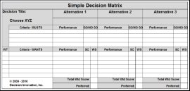
Figure: Multiple Criteria Decision Analysis
Source: RTS (2015)
Paired comparison: In this analysis the options which are available to solve the problem is being compared to each other in order to find out the most important one.
Decision making tree: This technique of decision making helps an organisation to find out problem related to each stage and by addressing uncertain outcome of the solution.
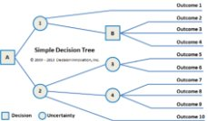
Figure: Decision making tree
Source: ResearchG (2014)
Besides this pro/con, influence diagrams, game thirty etc. can be used as decision making technique. For this report multiple criteria decision analysis is used for the purpose of making decision to which solution to use. It is because of the reason that it takes into consideration all alternative and evaluates success criteria with risk.

Plan to implement to solution
The solutions which are drawn by using various decision-making technique need to be implemented by making proper plan. What will be done in the future deciding it now is called plan. Making a proper plan determines the successful implementation of a solution.
Action plan: The plan which outline the action which is needed to reach goal. This will help the organisation to outline the plan for the purpose of achieving the organisational goal. In other word it can be said that action plan helps the organisation to schedule the activity one after another to reach the solution. Unilever use this planning technique. At first the organisation determines the problem that hinders the organisation objectives, than propose some alternative suggestion to solve the problem, in other word to reach the organisation goal (Pit, 2015).

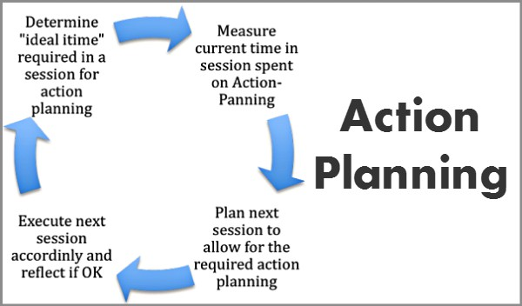
Figure: Action Plan
Source: Tries (2017)

Gantt chart: Gantt chart is pretty useful planning tools. For a project management it is essential to finish the project in time. In many cases organisational goal achievement depends on finishing the project in time. The Gantt chart of this project is shown below according to the information used in CPM method:
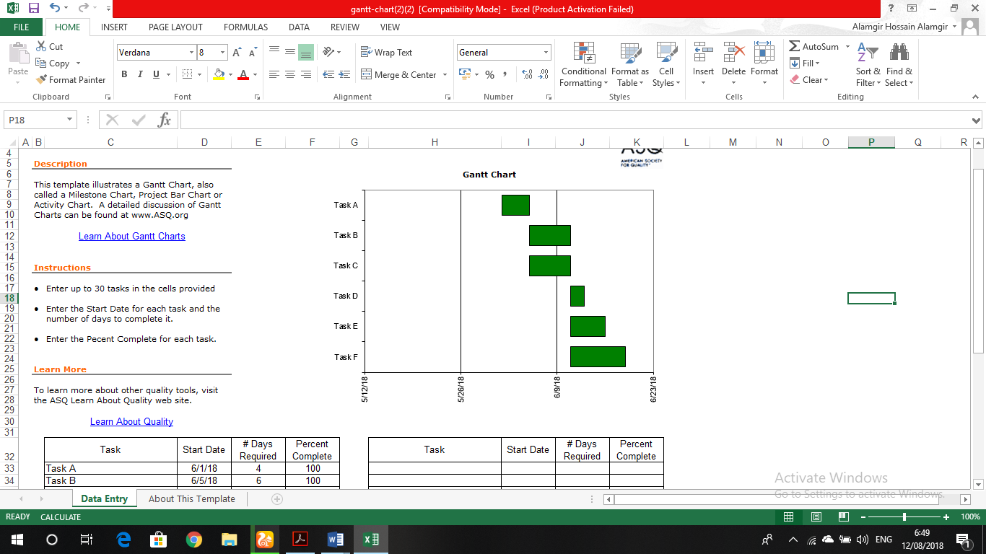
Figure: Gantt chart
Source: Author

Case presentation
Unilever is a UK based multinational organisation. The organisation wants to expand its business operation in Pakistan and for it the organisation will invest $120 million (11 billion Rs). This is a welcome sign for the country as the country face low FDI recent year. The organisation aims to invest in Pakistan is to make the Unilever Pakistan a billion-euro revenue firm in 2019, now the organisation revenue in that country is around 800-810 million euros. But for fulfilling the organisation objectives the organisation now faces some problem. The problems include strong competitors present in the market of the country, terrorist activity religion etc. one problem is that Pakistan is a Muslim country, that is why pigs fat cannot be used in any product or other elements that hurts religion feelings. These are the reason why Unilever feel some problem to accomplish the organisational objectives in Pakistan. To solve the problem the organisation, start a project in order finds out the solution of this type of problem.

Communicate the plan to shareholder
Shareholders are real owner of an organisation. That is why an organisation always needs to make sure of the fact that the solution which made to solve the problem is properly communicated with the shareholders. The ways by using which organisation can effectively communicate with shareholder includes:
Understand shareholder: Organisation at first need to understand what the shareholder wants form the organisation (Kim et al, 2011).
Tailoring communications: Every shareholder of an organisation attracted to that organisation a reason. Organisation needs to find out the reason and tailored communication.
Formal communication plan: Organisation needs to find a way to formally communicate with shareholder.
These are some the ways by which an organisation can communicate its plan with its shareholder.

Appropriate monitoring and review technique
Organisation needs to use appropriate monitoring and review technique so that the organisation can ensure that solution which was made for the purpose of solving the problem is successfully implemented. For solving the problem of Unilever, the project manager of the organisation takes some step so that by using the organisation can achieve its objectives. In monitoring the manager of the project will see whether the plan is effectively implemented or not. Monitoring techniques includes Gage blocks, surface plates, non-destructive technique, force measurement technique etc. Among this technique Gage block is used to measure the performance of the project problem solving (Chen and Liu, 2012).

Organisational change
For solving a problem organisation needs to make change in various segments of the organisation. In this part of the report, why the organisation needs to make organisational change? It will be discussed.

Reason for organisation change
There are various reasons for what an organisation needs to force to change. For archiving organisational goal organisation make change in various matter like:
Leadership: Leadership is one of the key elements for every organisation to achieve its goal. If an organisation detects problem or unable to achieve its goal that means that the organisation leaders are failed. In this situations organisation need to change leadership to achieve goal (Burns, 2012).
Technology: Now this is the era of digital technology where new technology is developed every day. In order to up to date with latest technology organisation needs to change.
Business strategy: Not every strategy will applicable to everywhere. That is why organisation needs to adopt new strategy based on new business environment.

Environment analysis technique
Environment plays a big role to an organisation. That is why organisation needs to analyse environment. Some of the environment analysis techniques are:
PESTLE: PESTLE stands for political, economic, social, technological, legal and environment. This is a business analysis tools which helps an organisation to determine the external factor which have impact on the organisation. When an organisation makes a goal or objectives then organisation needs to keep these factors in mind (Leybourne et al, 2014).
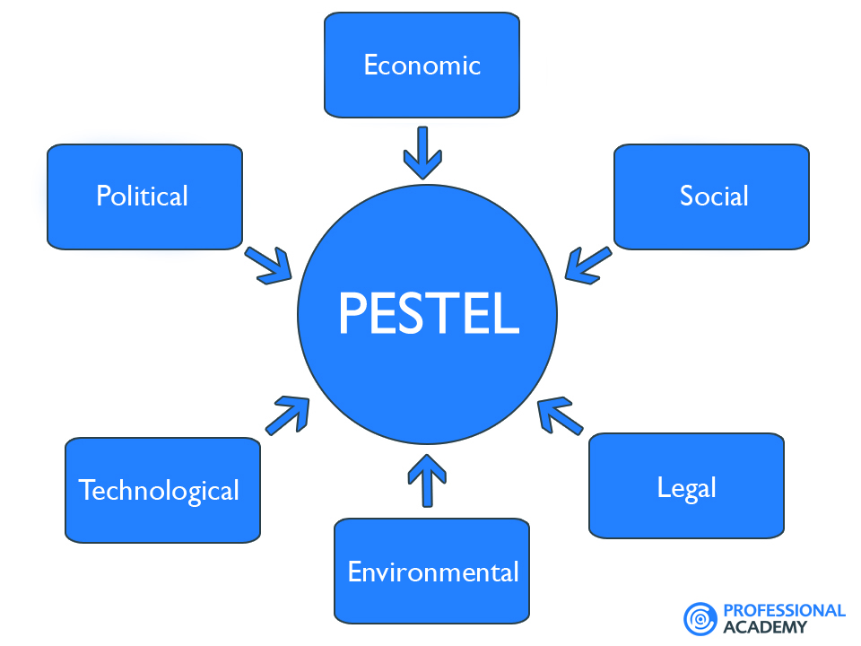
Figure: PESTLE
Source: PA (2012)
Porter five force analysis: This is another technique that can be used to analysis. The component of Porter’s Five Force includes: competitive rivalry, supplier power, buyer power, new entry threat, substitution threats.

Organisational analysis
For solving a problem and implementing the solution properly an organisation needs to do its organisational analysis. Organisational analysis technique includes:
SWOT: SWOT stands foe strength, weakness, opportunity and threats. This is very important for an organisation as it help the organisation to understand its: strength: worldwide operation, huge loyal customer, almost every household product etc. weakness: inefficient management, unskilled workforce (Ljungblom and Lennerfors, 2018). Opportunity: Growing consumer market of Pakistan and threats includes huge competitors, terrorist activity etc.
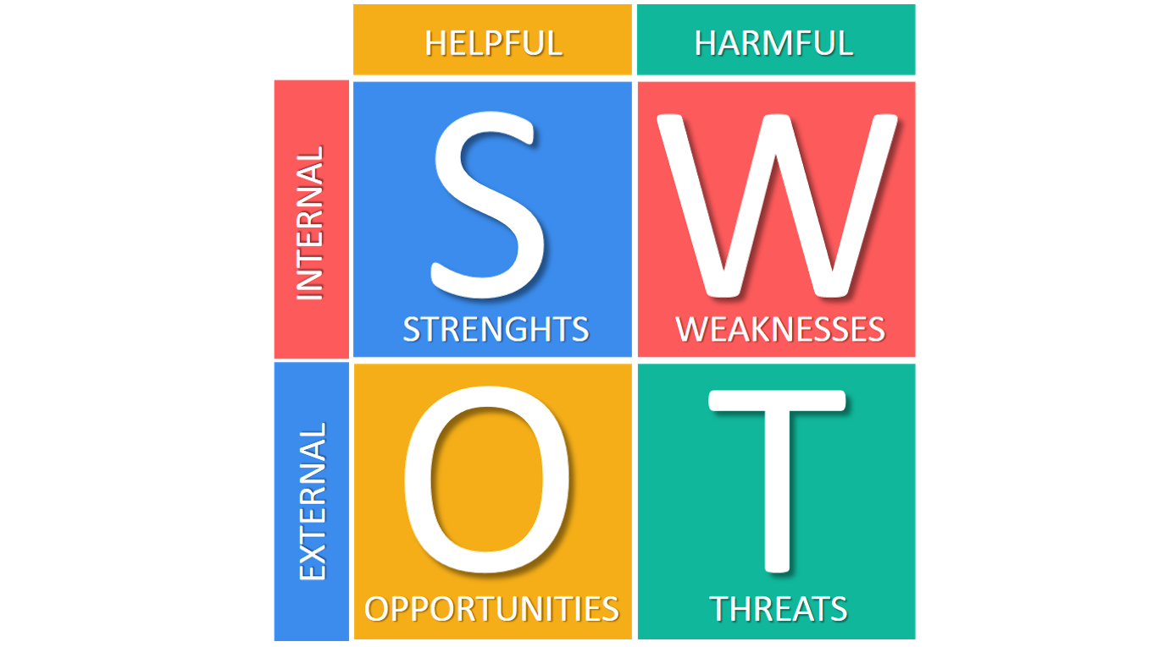
Figure: SWOT
Source: BR (2016)
Forecasting: The process by using an organisation predicts a future event is known as forecasting. In other word it can be said that it is the process of imagining of what will going to happen in the future of the organisation. Forecasting is using in sales, technological development etc.

Change management principles
Change is obvious for an organisation in order to keep space with the current worlds. There are various benefits of change and as well it has also various implication. Based on the benefits and implication of change the principle of change includes:
- Address human side systematically
- Start form the top
- Involve every layer
- Make formal case
- Create ownership
- Communicate message
- Assess cultural landscape#
- Prepare for unexpected situation
- Speak to individual

Methods for planning for change and its use
When an organisation takes the decision of making change then the organisation needs to make plan for change. The methods that can be used by the organisation to plan for change and its use include:
Flowcharting: Flowcharting is a simple process by using which an organisation can determine the current position of the organisation and the position where the organisation wants to go. It can be used by organisation to predict future (Mastrofini, 2015).
Data collection: Data collection is one of the major tools for palming change. By this the organisation can collect data about what the customer wants and make according to the customer expectation.
Culture mapping: This is another tool of planning for change. Every organisation has its own culture, values. When the organisation wants to plan for change the keep in mind the organisational cultural factors.

Feasibility and viability of change to shareholder
Shareholder is the real owner of an organisation. That is when an organisation maker plan to change then the organisation needs to keep in mind the fact whether the change will feasible and viable to the shareholder or not. For ensuring shareholder feasibility and viability the organisation needs to:
- Makes changes which will maximise the shareholder value.
- Take strategic decision that will maximise shareholder expected value.
- Make acquisition that will maximise shareholder expected value.
- Carry only those assets which will maximise shareholder value.
- Clearly communicate the change with shareholder.

Human and financial factor in consideration of hindrance to change
In an organisation there are many human and financial factor which may hinder the change. HR is one of the main components of an organisation which the organisation needs to manage effectively for the purpose of achieving organisational success. Finance is the life-blood of an organisation. When an organisation wants to make change then the organisation needs consider this important factor (Mir and Pinnington, 2014). The hindrance while making change from human factors includes: whether the employees are ready to change, the effect of change on the organisation human factor, are the human factor of the organisation have the ability to accomplish the change. The financial factors include: do the organisation have enough financial support to accomplish the change, do the shareholder agree etc.

Communication of change and importance of involving with people
Communication is one of the one of the key elements of success. To do change effectively the organisation needs establish a clear communication with the related party of the change. For clear communication the organisation needs to make sure:
Understand shareholder: Organisation at first need to understand what the shareholder want form the organisation. It is important if the organisation knows what the shareholder wants then it can communicate according to that.
Tailoring communications: Every shareholder of an organisation attracted to that organisation a reason. Organisation needs to find out the reason and tailored communication (Ponnappa, 2014).
Formal communication plan: Organisation needs to find a way to formally communicate with shareholder.

Techniques of monitoring and evaluating outcome of change
The change which the organisation was it brings benefit to the organisation or the change is successfully implemented or not, in order to find out this the organisation needs to use various monitoring and evaluating technique of change. In monitoring the manager of the project will see whether the plan is effectively implemented or not. Monitoring techniques includes Gage blocks, surface plates, non-destructive technique, force measurement technique etc. Among this technique Gage block is used to measure the performance of the project problem solving.

Conclusion
An organisation detect problem when the organisation saw that the result which is expected from a project and the result which actually found is different. Then the organisation tries to solve the problem and take decision according to the problem. Unilever a multinational organisation makes a huge investment costing $120 million in Pakistan for the purpose of making the organisation revenue in Pakistan 1 billion euro in 2019 which is 800-810 at this moment. That’s why the organisation takes project to eliminate the problem. The project manager of the project at first define the project and why it is important for the organisation and then takes various step to solve the problem that can help the organisation to take decision. Then manager use some decision-making technique to make proper decision among the solution what is suggested. Then the organisation communicates the decision with related party. At last this report discussed about organisation change, its reason, techniques, factors that hinder it and how to monitor it.

Reference
Bray, R. (2015). Developing a participative multi criteria decision making technique: a case study. International Journal of Management and Decision Making, 14(1), p.66.
Brunell, A. and Buelow, M. (2015). Narcissism and Performance on Behavioral Decision-making Tasks. Journal of Behavioral Decision Making, 30(1), pp.3-14.
Burns, J. (2012). Leadership. New York, NY: Open Road Integrated Media. Chen, J. and Liu, Y. (2012). Research on Control Strategy and Control Plan of Highway Monitor System. Applied Mechanics and Materials, 229-231, pp.2182-2187.
Chu, Y. and MacGregor, J. (2011). Human Performance on Insight Problem Solving: A Review. The Journal of Problem Solving, 3(2).
Del Missier, F., Mäntylä, T. and Bruin, W. (2011). Decision-making Competence, Executive Functioning, and General Cognitive Abilities. Journal of Behavioral Decision Making, 25(4), pp.331-351.
Funke, J. (2013). Human Problem Solving in 2012. The Journal of Problem Solving, 6(1).
Greiff, S., Holt, D. and Funke, J. (2013). Perspectives on Problem Solving in Educational Assessment: Analytical, Interactive, and Collaborative Problem Solving. The Journal of Problem Solving, 5(2).
Jäkel, F. and Schreiber, C. (2013). Introspection in Problem Solving. The Journal of Problem Solving, 6(1).
Kwisthout, J. (2012). Relevancy in Problem Solving: A Computational Framework. The Journal of Problem Solving, 5(1).
Lee, T., Kim, D. and Lee, D. (2011). A competency model for project construction team and project control team. KSCE Journal of Civil Engineering, 15(5), pp.781-792.
Leybourne, S., Warburton, R. and Kanabar, V. (2014). Is project management the new management 2.0?. Organisational Project Management, 1(1), p.16.
Ljungblom, M. and Lennerfors, T. (2018). Virtues and Vices in Project Management Ethics. Project Management Journal, 49(3), pp.5-16.
Mastrofini, E. (2015). In biblioteca. Project life cycle economics. PROJECT MANAGER (IL), (24), pp.47-47.
Mir, F. and Pinnington, A. (2014). Exploring the value of project management: Linking Project Management Performance and Project Success. International Journal of Project Management, 32(2), pp.202-217.
Pit, N. (2015). Plan-do-study-act to implement change. OR Nurse, 9(3), p.6.
Ponnappa, G. (2014). Project Stakeholder Management. Project Management Journal, 45(2), pp.e3-e3.
Rao, R. (2013). Decision making in manufacturing environment using graph theory and fuzzy multiple attribute decision making methods. London: Springer.
Reed, C. and Learning, B. (2014). Problem Solving. Chicago: Britannica Digital Learning.
Sprankle, M. and Hubbard, J. (2012). Problem solving & programming concepts. Harlow: Pearson Education.
Whimbey, A., Lochhead, J. and Narode, R. (2013). Problem solving and comprehension. New York: Routledge.

