

RESULT

ASSIGNMENT DETAILS AND FEEDBACK

SOUTH WEST WALES CENTRE OF TEACHER EDUCATION

Sections marked with * should be completed by module lead
Student name: | Matthew Foster | Student number: | 1502096
Programme: | BA Primary Education with QTS
Module: * | Enterprising and Creative Teaching and Learning | Module Level (4, 5, 6): | 6
Module code: * | ECAD6004/C | Contribution to Overall  Module Assessment (%): * | 50%
Module Lead:* | Mr T. Cox
Start date:* | 3/10/17 | Assignment No (x of x):* | 1 of 1
Submission deadline:* | 15/12/17 | Return date of provisional marks & written feedback:* | 26/1/18
Assignment Title:* | Critically evaluate your creativity and enterprise dispositions in terms of the Entrecomp frame work and how you might develop these to the next level and demonstrate progression.

Referencing: | In the main body of your submission you must give credit to authors on whose research your work is based. Append to your submission a reference list that indicates the books, articles, etc. that you have read or quoted in order to complete this assignment (e.g. for books: surname of author and initials, year of publication, title of book, edition, publisher: place of publication).
Submission: | All assignments must be submitted to Turnitin unless otherwise instructed by the Lecturer.  Note: the Turnitin version is the primary submission and acts as a receipt for the student. Late submission of the electronic version of the assignment will result in a late penalty. Penalties for late submission: Up to one week late, maximum 40%. Over one week late will be recorded as a non-submission. Late submission penalties may be lifted only with the approval of the Extenuating Circumstances Panel. | Date: | 15/12/17

Module lead to tick to indicate if a hard copy version of the assignment must be submitted.* | YES
 | NO | X

Learning Outcomes tested*  (from module syllabus) | Assessment Criteria: To achieve each outcome a student must demonstrate the ability to:*
Upon the successful completion of this module, the student should be able to:  - Recognise, identify and select learning environments that support the development of creative learning and teaching.  - Critically reflect on strategies that impact on the distinctive role of the educator when developing creative and innovative pedagogies and environments.  - Critically reflect upon the educational potential of developing enterprise and creativity in the primary school.  - Demonstrate a critical awareness of the contribution of creativity and enterprise to educational practice. | In this assignment, markers will be looking for:  - The writing to include critical analysis and evaluation of wide, deep and appropriate background reading. Relevant synthesis of research and government documentation should be utilised to demonstrate knowledge and understanding of Creativity and Enterprise skills.  - A clear understanding of the importance of Creativity and Enterprise skills in education and the wider world.  - Appropriate knowledge and use of the Entrecomp Framework.  - Critical evaluation of personal creativity and Enterprise dispositions, linked to the Entrecomp Framework. Including examples and evidence of current level.  - Clear recommendations for future personal development with regards to identified areas.  - Critical reflection of reading and experience.  - Accurate referencing and academic writing skills  - Allocated word count.

TASK DESCRIPTION

Assessment Title

Critically evaluate your creativity and enterprise dispositions in terms of the Entrecomp frame work and how you might develop these to the next level and demonstrate progression.

Word Count - 2500 words

The essay should demonstrate critical self-evaluation. Also, analysis and evaluation of wide and appropriate background reading. Relevant reference to research, current pedagogy where appropriate, government documentation and school-based experience should be synthesised in the response.

So what might you include in your essay response?

- An outline of ‘why we should be developing creativity and enterprise skills within education’ (Highlighting benefits/ NC links/ initiatives/ current thinking/ Donaldson etc.)
- The importance of creativity and enterprise skills for the teacher.
- Knowledge of the Entrecomp Framework, the benefits/ uses/ limitations.
- Appropriate background research and knowledge for the competences identified. Supporting principles/ theories that underpin the discussion/ reflection and strategies proposed.
- Range of evidence to support the identification of competences discussed. Who agrees with the competency identified? What are the specific benefits/ challenges/ research base/ models or methods of progression? (Educational writers, case studies, wide research)
- Reference to key ‘Creativity’ and Enterprise skills researchers.
- Reference to, and understanding of, the fifteen competences of the Entrecomp Framework, with a clear focussed discussion on a limited number most appropriate to the development of teacher creativity and enterprise skills.
- A good understanding of not only the principles and theory but also the practical issues when implementing strategies to promote personal progression.
- A clear understanding and ability to identify where current level and awareness of proposed progression and continuity of personal development.
- Examples of proposed recommendations.
- Evidence of wide and deep background reading to support the reflection. Case studies, research, journals etc.
- A high level of professionalism in dialogue.
- Clear evidence of very good understanding of creativity and enterprise skills, no glaring errors.
- Critical analysis and evaluation of current performance and clearly identified reasons for recommendations, supported with a variety of data.

GUIDANCE FOR Students IN THE COMPLETION OF TASKS

NOTE: The guidance offered below is linked to the common assessment criteria overleaf.

- Subject Knowledge and Understanding (which includes using research-informed literature and knowledge and understanding of the subject)

Your work must be informed and supported by scholarly material that is relevant to and focused on the task(s) set. You should provide evidence that you have accessed a wide range of sources, which may be academic and/or governmental; these sources may include academic journal articles, textbooks, current news articles, organisational documents, and websites. You should consider the credibility of your sources; academic journals are normally highly credible sources while websites require careful consideration/selection and should be used sparingly. Any sources you use should be current and up-to-date, mostly published within the last five years or so, though seminal/important works in the field may be older. You must provide evidence of your research/own reading throughout your work, using in-text citations in the main body of your work and a reference list that is alphabetical at the end of your work. Please use the Harvard referencing system.

Your work must demonstrate the growing extent of your knowledge and understanding of concepts and underlying principles associated with the subject area. Knowledge relates to the facts, information and skills you have acquired through your learning. You demonstrate your understanding by interpreting the meaning of the facts and information (knowledge). This means that you need to select and include in your work the concepts, techniques, models, theories, etc. appropriate to the task(s) set. You should be able to explain the theories, concepts, etc. meaningfully to show your understanding. Your mark/grade will also depend upon the extent to which you demonstrate your knowledge and understanding; ideally each should be complete and detailed, with comprehensive coverage.

- Intellectual Skills (Analysis)

Your work must contain evidence of logical, analytical thinking, evaluation and synthesis. For example, to examine and break information down into parts, make inferences, compile, compare and contrast information. This means not just describing what! But also justifying: Why? How? When? Who? Where? At all times, you must provide justification for your arguments and judgements. Evidence that you have reflected upon the ideas of others within the subject area is crucial to you providing a reasoned and informed debate within your work. Furthermore, you should provide evidence that you are able to make sound judgements and convincing arguments using data and concepts. Sound, valid conclusions are necessary and must be derived from the content of your work. There should be no new information presented within your conclusion. Where relevant, alternative solutions and recommendations may be proposed.

- Pedagogic and Professional Applications (Practical Application and Deployment)

You should be able to demonstrate how the subject-related concepts and ideas relate to pedagogic situations or a particular education context. How do they work in practice? You will deploy models, methods, techniques, and/or theories, in that context, to assess current situations, perhaps to formulate plans or solutions to solve problems, some of which may be innovative and creative. This is likely to involve, for instance, the use of pedagogic examples and cases, the application of a model within relevant educational context. You should show awareness of the limitations of concepts and theories when applied in particular educational contexts. Your work must provide evidence of the attributes expected in professional practice. This includes demonstrating your individual initiative and/or collaborative working. Where relevant, you should show awareness of any ethical issues that relate to your discussion.

- Key Transferable Skills (Skills for Professional Practice)

You must communicate effectively in a suitable format, which includes written and oral presentation. Work should be coherent and well structured in presentation and organisation.

marking criteria and Student FEEDBACK

This section details the assessment criteria. The extent to which these are demonstrated by you determines your mark. The marks available for each criterion are shown. Lecturers will use the space provided to comment on the achievement of the task(s), including those areas in which you have performed well and areas that would benefit from development/improvement.

Common Assessment Criteria Applied | Marks available | Marks  awarded
1. Subject Knowledge and Understanding (which includes using research-informed literature and knowledge and understanding of the subject)  Extent of research and/or own reading, selection of credible sources, application of appropriate referencing conventions. Extent of knowledge and understanding of concepts and underlying principles associated with the discipline. | 30
2. Intellectual Skills (Analysis)  Analysis, evaluation and synthesis; logic, argument and judgement; analytical reflection; organisation of ideas and evidence | 30
3. Pedagogic and Professional Applications (Practical Application and Deployment)  Deployment of pedagogic methods, materials, tools and techniques; application of concepts; formulation of innovative and creative solutions to solve problems. Attributes in professional practice: individual and collaborative working | 30
4. Key Transferable Skills  Deployment of appropriate media; presentation and organisation. | 10

Assignment Mark (Assessment marks are subject to ratification at the Exam Board. These comments and marks are to give feedback on module work and are for guidance only until they are confirmed. ) | Late Submission Penalties (tick if appropriate) |  | %
 | Up to 1 week late | 40% Max | %
 | Over 1 week late | 0% | %
ASSESSMENT AND MARKING CRITERIA FOR ECAD5001/C ASSIGNMENT
Level 5 | Assessment Criteria Descriptors for BA Primary Education with QTS  This format emphasizes the holistic nature of judgements to be made by markers. Criteria weighting is adjusted for each module.
 | 0-39 (F) | 40-49 (P) | 50-59 (P) | 60-69 (P) | 70-79 (P) | 80-100 (P)
 | Poor / Weak F | Satisfactory 3rd | Good 2:2 | Very good 2:1 | Excellent 1st
Assessment Criteria | Poor, superficial, unsystematic, incomplete and/or inaccurate | Satisfactory understanding of main issues demonstrated | Good understanding demonstrated with some analysis | Very good understanding of basic principles and relevant evidence, with a coherent and logical argument | Thoughtful answer informed by wider reading, showing clarity of thought and personal insight | Outstanding answer, well written, highly structured and informed, showing striking personal insight and originality
Module Learning Outcomes matched to: | 0-11 | 12-14 | 15-17 | 18-20 | 21-23 | 24-30
Subject Knowledge and Understanding  (Conceptual)  (Reading) | Basic misunderstanding, misconceptions, misinterpretations and/or superficial knowledge in places | Outline knowledge of few key issues with evidence of understanding and application | Defined knowledge of some key issues and wider implications | Wider knowledge of most key issues, concepts and arguments | Clear understanding of the key issues under discussion with logical discussion | Excellent knowledge of key issues, concepts and arguments clearly discussed
Subject Knowledge and Understanding  (Conceptual)  (Reading) | Some inappropriate literature/material with limited reading range and lack of accuracy | Satisfactory range of reading drawn from the recommended list and other sources | Good range of reading drawn from the recommended list and other sources | Very good range of relevant literature from a variety of sources beyond recommended list | Evidence of well-considered thinking from a wide reading base using a variety of sources | Clear evidence of independent thinking informed by an excellent range of reading from a variety of sources
 | 0-11 | 12-14 | 15-17 | 18-20 | 21-23 | 24-30
Intellectual skills  (argument)  (presentation of findings/analysis)  (critical /reflective evaluation) | Argument is weak, little attempt to present differing viewpoints.  Generally too descriptive | The argument is beginning to be balanced with a growing awareness of other viewpoints | A balanced argument is presented while attempting to justify other viewpoints | A balanced argument is presented showing an understanding of different viewpoints and the reasoning behind them | A thoughtful argument is presented with appropriate consideration of viewpoints | A well- structured critical argument is presented with insightful consideration of viewpoints
 | Findings presented within incomplete descriptive framework and few or inaccurate conclusions are drawn | Findings are beginning to be presented in a developing framework with some analysis and reasonable conclusions | Findings are presented in a framework with some analysis and interpretation of data to form reasonable conclusions | Findings are presented in a framework with some analysis, interpretation and evaluation of data to form reasonable conclusions | Findings presented with some analysis and justified conclusions | Findings presented in a critical and analytical framework. Thoughtful conclusions, firmly based upon the evidence presented
 | Lack of evidence of evaluation and/or critical reflection | Evaluation and/or reflection are present but lacks depth | Good engagement with evaluation and reflection | Very good evidence of beginning to evaluate and critically reflect | Evidence of thoughtful critical engagement with evaluation and reflection | Effective and more in-depth critical engagement with evaluation and reflection
 | 0-11 | 12-14 | 15-17 | 18-20 | 21-23 | 24-30
Pedagogic and Professional applications  (linking theory to practice)  (professional reflection)  (ethical conduct where appropriate) | Superficial or lack of understanding of pedagogic and professional context(s) | Relates principles and concepts to underlying theoretical frameworks and approaches with respect to the pedagogic and professional context(s) | Identifies principles/ concepts underlying theoretical frameworks and begins to identify their strengths and weaknesses with respect to the pedagogic and professional context(s) | Evidence of the use of relevant research or developments to inform actions with respect to the pedagogic and professional context(s) | Clear evidence of integration of theory and practice with respect to the pedagogic and professional context(s) | Effective integration of theory and practice with respect to the pedagogic and professional context(s)
 | Little or no evidence of reflection | Reflection is evident | Evidence of good reflection | Beginning to critically reflect | Critical reflection is evident | Effective and in-depth logical and critical reflection is evident
 | Little or no awareness of ethical issues | Awareness of ethical issues | Awareness of ethical issues and able to discuss these in relation to personal beliefs and values | Ethical issues have been discussed showing an awareness of personal responsibility and professional codes of conduct | Ethical issues have been clearly discussed in the context of personal responsibility and professional codes of conduct | Ethical issues have been effectively addressed especially in the context of personal responsibility and professional codes of conduct
 | 0-3 | 4 | 5 | 6 | 7 | 8-10
Key/Transferable Skills  (Referencing techniques) | Weak presentation of written work | Satisfactory presentation of written work | Good presentation of written work | Very good presentation of written work | Effective presentation of written work | Outstanding presentation of written work
Key/Transferable Skills  (Referencing techniques) | A number of basic errors in spelling, punctuation or grammar | Some errors in spelling, punctuation or grammar | Few errors in spelling, punctuation or grammar | Very few errors in written language | Minor errors in written language | No errors in written language
Key/Transferable Skills  (Referencing techniques) | Weak structure with unclear writing style in parts | Satisfactory structure with a mostly coherent writing style | Good structure with a coherent writing style | Very good structure which supports the reader | Effective structure which supports the reader | Highly coherent and mature writing style which fully engages the reader
Key/Transferable Skills  (Referencing techniques) | Little or no use of protocols and conventions of Harvard referencing | Satisfactory use of Harvard referencing protocols and conventions | Good use of Harvard referencing protocols and conventions | Harvard system mainly used accurately, with some secondary sources | Harvard system used accurately including secondary sources | Harvard system used accurately, consistently and effectively with all sources

Student Self Evaluation Form

This section repeats in brief the common assessment criteria detailed on previous pages. The extent to which these are demonstrated by you determines your mark. Using these criteria, tick the box that best indicates the level of achievement you feel you have achieved with regard to each of them.

Common Assessment Criteria Applied | Level of Achievement
Common Assessment Criteria Applied | REFER |  | 3rd | 2:2 | 2:1 | 1st | 1st
 | OUTRIGHT FAIL | UNSATISFACTORY | SATISFACTORY | GOOD | VERY GOOD | EXCELLENT | EXCEPTIONAL
1. Subject Knowledge and Understanding (which includes using research-informed literature and knowledge and understanding of the subject) | 0-29% | 30-39% | 40-49% | 50-59% | 60-69% | 70-79% | 80-100%
2. Intellectual Skills (Analysis) | 0-29% | 30-39% | 40-49% | 50-59% | 60-69% | 70-79% | 80-100%
3. Pedagogic and Professional Applications  (Practical Application and Deployment) | 0-29% | 30-39% | 40-49% | 50-59% | 60-69% | 70-79% | 80-100%
4. Key Transferable Skills | 0-29% | 30-39% | 40-49% | 50-59% | 60-69% | 70-79% | 80-100%

PLEASE COMMENT ON AREAS IN WHICH YOU FEEL THAT YOU HAVE PERFORMED WELL | PLEASE COMMENT ON AREAS you feel that you need TO DEVELOP
I feel that I have read a vast variety of publications surround the subject area and have become more knowledgeable about the pedological practical and theoretical problems surrounding creativity and enterprise. I also feel that in this assignment I felt I development my argumentative skills and maturity of writing. | I feel that I need to be more concise when answer a question. Feel that I lead myself down one direction of travel and instead of returning and focusing on the main core of the discussion I stayed on the other track.  I also felt that when having to reflect on my personal experience and link that the theory I was limited in my ability to translate my thoughts into coherent text.

Student’s Name | Matthew Foster | Date | 10/12/17
Student’s Signature | M Foster

The next generation will need to have confidence, business acumen and practical skills to thrive. Young children are creative and free-thinking, more so than adults and they are refreshingly honest, fearless and see things without boundaries. However entrepreneurial instincts are often tempered as they grow up and as society conditions and constrains their thinking. (Peter Jones CBE as cited by New CPD Standard, 2016, Robinson, 2013; Robinson, 2010) With a shift in the country’s economy and the move from knowledge based activities and business to a creativity, innovation, enterprise and imagination society (van den Broeck et al. 2008; Oke et al. 2009 as cited by Fillis & Rentschler, 2010) and which is also recognised in Successful Futures (2015) where, as part of the four key purposes of a new curriculum for Wales; one is to ‘encourage enterprising, creative contributors who are ready to play a full part in life and work.’ (Donladson, 2015)
It could be considered that education has started to change to better suit the needs of society for tomorrow, (WG, 2017), that the education in Wales is being reconstructed to deliver education that offers learning experiences that are broad and extensive, enabling children to be armed with skills that will help them to be adaptable in an ever-shifting multifaceted environment. Although, some argue that as education moves further to the left it becomes more liberal, with more emphasis being put on the skills rather than the knowledge, children become academically inept lacking the intellectual aptitude to deploy that knowledge in various contexts (lol Education forum, 2010). Nonetheless, the consensus remains that the landscape of tomorrow is going to be different from today and therefore we need to ensure the children have the skills and knowledge to be adaptive to survive (NACCCE, 1999; Robinson, 2010; Wegerif, 2010).
These skills are said to be those that can be encompassed under entrepreneurship, they are the skills needed to be resilient, self-efficient, reflective, risk taking and empathetic. Throughout the EU there have been many attempts to find best practice as to what is felt will enhance creativity and enterprise in education, (Likar, et al., 2015). This suggests that creativity can be taught. That is, if a teacher were to put the right pedological strategies in place, such as the use of De Bono’s Six Thinking Hats (1985); cultivation and fostering an ethos of risk taking and mistake making, children could learn to be creative (Robinson, 2013; Hallman, 1964). However many argue that it cannot be taught and that creativity is an innate ability that we are born with and thus creativity can only be developed, that the use of various pedological approaches encourages the use of inherent ability opposed to learning the ability , supporting the enhancement of the creative mind. (Best, 1982; Likar et al 2015, Foster, 1969). However, if we are all born with an innate ability, we can all be for example artists and musicians, but this suggests that what could be a common misconception that creativity is limited to the arts, when this is actually not the case. If we consider entrepreneurs such as Peter Jones CBE, he built his empire on new communication technologies, he used his entrepreneurial skills to think originally and find alternative original ways. He didn’t design and build the products, but he did use his resilience, risk taking, dialogical, and divergent thinking to conceive alternative solutions to existing situations.
Although there is case from both sides of the nature / nurture debate, both would have to concede that creativity and enterprise (entrepreneurship) are subjective, because what one person may view as a unique idea, another may perceive as commonplace for them. One persons art can be seen as thought provoking but may be considered plain and boring to another person. Taking this into account we should consider how, as a teacher, do we to assess creativity and enterprise in the class room? Do we use our own preconceived ideas that are built from many years of experience and influence from social inhibition as to what is creative? Or do we set boundaries and success criteria that boxes as to where a child’s thoughts may go? Because if we do, does it not become paradoxical, as restrictions inhibit divergent thought and to be creative, to be enterprising, to think originally there needs to be removal of the confines of right and wrong? (Robinson 2013; Fillis & Rentschler, 2010; Wegerif, 2010)
If we continue to consider the view that creativity and enterprise can be taught we must then also consider that for all things taught, there must be some form of assessment, whether summative or formative, there must be some criteria to measure those assessments against. This can become difficult when defining what actually is creative enterprise. Barbot et al., (2011) suggests that to assess creative we must first realise that ’… creativity is viewed as a continuous and unidimensional construct…’ and that it can be assessed only when the contributing factors are taken into account, that is,‘…cognitive (information processing), conative (personality traits, motivational aspects), and emotional factors (affective state, trait) that are interacting dynamically with the environment (which stimulates or inhibits the expression of creative potential)’ (Barbot et al., 2011: 61) and that if you measure against these you can judge the potential creativity of a child. There are also various other methods that have been suggested as measures of creativity such as the Wallach and Kogan tests which are standardized tasks that evaluate the competency of the individual to produce many ideas from a starting point, in a limited amount of time or the divergent thinking tests such as the Torrance Tests of Creative Thinking which measures against four scales Fluency, Flexibility, Originality and Elaboration.
Although these examples do not offer opportunity for formative assessment to be made against a measure that considers the capability of more than just creativity and neither do they offer direction toward improvement which is fundamental in all education. There are however several frameworks such as the SKECM and Entrecomp that offer flexible sources of inspiration for setting boundaries, assessable measures of skills and attributes that can be considered creative and enterprising.
Although both are frameworks that support the assessment of entrepreneurial competencies, Entrecomp has been specifically designed to bridge the gap between the education and work based environments and therefore it potentially provides a more beneficial tool to be used for assessment in education. The Entrecomp conceptual framework is composed of three competency areas; into action, resources, ideas and opportunities. Within each of these there are five competency areas. All fifteen competencies are interconnected and interrelated and are all part of the whole. It also provides a descriptor for each of the competencies, which could be used to set tasks when planning, having that as a desired outcome. The main tool that would be used in terms of assessment would be that of the Entrecomp progression framework model. This part of model segments each of the competencies into a triad of proficiencies and by doing this it enables a teacher and/or a student to assess what level of the proficiency they are currently working at within the competence and identify what is required to become more proficient.
If we refer to the idea that creativity and enterprise can be taught, then it must be concluded that teachers themselves must be creative and that they will have the skills knowledge and attributes to teach creativity. Being a creative teacher is the essence of being a great teacher to use pedagogy in an unique individual engaging manner. (Donaldson, 2015; Grigg, 2010; Wilson et al., 2009). Though this does not show that the teacher has the knowledge and understanding of how to teach creativity. (Wilson et al., 2009) describes the difference between the two as
‘Creative teaching is seen to involve teachers in making learning more interesting and effective and using imaginative approaches in the classroom. Teaching for creativity by contrast is seen to involve teachers in identifying creative strengths and fostering their creativity’ (Wilson et al., 2009 :49)
To nurture and develop the creativity and enterprise of children a practitioner should be able to identify their own proficiency and what measures can be taken to move forward in that area. This will support the teacher in developing their confidence and enthusiasm and show commitment through reflection and improvement. (Beetleston, 1998; Jones and Wyse 2004; Grainger et al., 2004; as cited by Wilson et al., 2009).
Using the Entrecomp framework as a foundation and as an assessment tool, I have identified two componentises that I consider to be valuable in the ability to foster an ethos with creativity and enterprise in mind in professional practise, and that are both strengths and weaknesses in my character.
Creativity
The Entrecomp framework describes creativity as the ability to, ‘develop several ideas and opportunities to create value including better solutions to existing and new challenges. To be able to explore and experiment with innovative approaches and combine knowledge and resources to achieve valuable effect.’ (Bacigalupo, et al., 2016)
As well as this descriptor, the framework provides statements that enables levelling against five threads within creativity. It is from these which I base my argument and provide evidence as to why I consider myself to assert a specific level of creativity and how perceive that I need to further develop my abilities.
Through personal analysis I have concluded that I consider myself to be on average at level five. I feel that this is the case because I consider I have the ability to be curious and open and that I actively search for new solutions that meet my needs. For example, when I taught teaching a lesson about ‘pattern’ to children in the reception class, I followed my lesson plan throughout the first day. However, as the lesson progressed I felt that children were struggling and finding it difficult to understand the concept of repetition in pattern. The resources being used for the introduction included an Interactive White Board (IWB) and a programme from HWB that gave a variety of different patterns. The children’s task was to have to identify the missing item in the pattern and explain why it was missing. However, I felt it was evident through their responses that they needed an alternative more physical experience to gain deeper understanding as, ‘learning is the process whereby knowledge is created through the transformation of experience” (Kolb, 1984: 38).
Therefore, I decided that throughout he remainders of that day I would use a free play session to test some ideas I had formulated based on the responses I had observed. This included games that required physical movement. After considering a range of movement activities, I decided that the following day I would change my lesson introduction and use a marching to music game and thereby adding a variety or repeating steps formulating and example of a pattern. Over the remainder of the day the children used the marching game during their playtimes and free play time which helped to reinforce their understanding. Brown et al., (1989) who developed situated learning theory suggests’…. Learning, both outside and inside school, advances through collaborative social interaction and the social construction of knowledge.” (Brown et al., as cited by David, 2007) and on listening to their discussions they evidently started to use the technical language that describes pattern, this also showed through when completing other related tasks throughout the week.
Furthermore, I believe that this example also provides evidence of my ability and potential to search for innovative ideas in light of an existing enterprise, (level 7) ; I can set up process involving stake holders in finding developing and testing ideas ( Level 6) and finally I can create products that solve my problem (Level 4).
After this example lesson having taken place on professional teaching practice two I feel that I have further progressed by for example, when working in a different school some 18 months later I was able to take the knowledge and ideas I had acquired previously and develop them in a different context. In this case, if we take the marching game used with the reception class in the previous example I was able to use the simplicity of the active learning model and transfer and combine that with a theory talk on writing to enable children to produce a play about a story they had written. I consider this to demonstrate proficiency in the ‘open curious’ thread of creativity taking myself to level six. This does not, however, prove that I have increased in proficiency in the entity of creativity but does show that I have made progression. I feel that to further engage and develop my proficiency I would need to identify opportunities in the future that will enable me to work with stakeholders to create value which I believe in the context of education would be to increase the opportunity for learning for the children.

Self-awareness and Self-efficacy
The Entrecomp framework describes self-awareness and self-efficacy as the ability to ‘reflect on your needs and aspirations and wants in the short medium and long term. Identify and assess your individual and group strengths and weaknesses. Believe in your ability to influence the course of events, despite uncertainty setbacks and temporary failures.’ (Bacigalupo, et al., 2016) I chose this competency as it combines what could be some of the most important aspects of being a great teacher. Firstly, that of the reflective practitioner; the person who can and does at every opportunity review what has happened, identify how it can be improved and can implement the change. (Grigg, 2010; Lindey, 2008) Secondly, you are a role model to the children that you teach and therefore if you can set your sights high and that your able to believe in your ability to achieve your goals the children will encode this behaviour and will imitate the behaviour at another time, as observed with Banduras Bobo doll experiment (1961).
If this is the case I consider myself to be proficient to level five in most elements of this competency, as it shows in appendix 1 through to appendix 4. I believe that I am able to reflect on my professional practice and adapt my skills and abilities to better provide a quality of professional practice. A comment in appendix 2 exemplifies that I am aware of my own progress and can identify areas that need improvement and my training needs. There is also evidence throughout that I have further developed these skills from being told where I need development as seen in appendix 1. Also in support of my personal assessment with regards the thread; shape your future, the fact that through current experience of changing my own career path to engage in a new opportunity to train as a primary school teacher provides evidence of this. (Level 7) Furthermore, the experience of following the degree course has enabled me to develop my skills in working as a team and to be able to compensate for other weaknesses that can be clearly identified in year one and year two of the present course when carrying out a group assignment. However, to further develop my skills and proficiency in this area, I feel that I will need to develop my skills by working closely with my peers.
Conclusion
Creativity and enterprise cannot be in their own domain, they are not subject specific and therefore can be taught and integrated throughout the curriculum, in a variety of different education, social and cultural contexts. Although it should be remembered that some subject areas lend themselves naturally to the development and teaching of the skills associated directly with skills associated with creativity and enterprise, such as Design and Technology and Science where a creative and enterprising process is an intrinsic element of the subject.
To become a teacher that fosters an ethos that is creative and enterprising one must develop pedagogical techniques that enhance learning using original and innovative methods that on occasion some may consider none orthodox, which with the combination of research and deep reflection and the use of other enterprising attributes can develop an atmosphere or ethos within a school that will ensure that those children’s creative and enterprising abilities are identified, developed and rewarded (NACCCE, 1999). As suggested by Wilson et al.,(2009) ‘Developing your awareness of yourself as a creative being is therefore an important first step, for which a flexible creative mindset will be able to teach creatively and foster creativity in the young.’ (Wilson et al., 2009:42)

Word Count: 2753

References
Bacigalupo, M., Kampylis, P., Punie, Y. & Van den Brande, G., 2016. EntreComp: The Entrepreneurship Competance Framework., Luxembourg: Pulication Office of the European Union.
Barbot, B., Besancon, M. & Lubart, T. I., 2011. Assessing Creativity in the Classsroom. The Open Education Journal, 4(1), pp. 58-66.
Best, D., 1982. Can creativity be taught?. British Journal of Educational Studies, 30(2), pp. 280-294 .
Donladson, G., 2015. Successful Futures, Cardiff: Welsh Government.
Fillis, I. & Rentschler, R., 2010. The Role of Creativity in Entrepreneurship. Journal of Enterprising Culture (JEC)., 18(10), pp. 49-81.
Finlay, L. (2008). Reflecting on ‘reflective practice’. A discussion paper prepared for Practice-based Professional Learning Centre (PBPL CETL). The Open University, 52, 1-27. Retrieved from http://www8.open.ac.uk/opencetl/files/opencetl/file/ecms/web-content/Fin...
Foster, D. l., 1969. Can creativity be taught. Music Journal, 27(3), p. 36.
HANSEN, Marit Engum; SNOEN, Else. Educational entrepreneurship in learning tasks. Scandinavian Journal of Vocations in Development , [Sl], v. 1, Nov. 2016. ISSN 2464-4153. Available: < https://journals.hioa.no/index.php/yrke/article/view/1849 >. Download date: 13th of December 2017 doi: http://dx.doi.org/10.7577/sjvd.1849 .
Hallman, R. J., 1964. Can creativity be taught?. Educational Theory, 14(1), pp. 15-23.
Kolb, D. A., t, E. C. N. J. & Prentice-Hall., L., 1984. Experiential learning : experience as the source of learning and developmen. London: Englewood Cliffs.
Likar, B., Cnaker, F. & Zupan, B., 2015. EducationalModel for Promoting Creativityand Innovation in Priamary Schools. Systems Research and Behavioural Science, 32(1), pp. 205-213.
lol Education forum, 2010. A defence of edcuation reform. Institute of Ideas’ annual, unkown November.
NACCCE, 1999. All Our Futures: Creativity, Culture and Education, London: National Advisory Committee on Creative and Cultural Education (NACCCE).
New CPD Standard, 2016. Entrepreneurship in primary school. Education Journal, 277(1), p. 6.
Robinson, S. K., 2006. Do Skills Kill Creativity?, Las Vegas: TEDTALKS.com.
Robinson, S. K., 2010. Changing Educational Paradigms, NewYork: TEDTALKS.com.
Robinson, S. K., 2013. How to escape education’s death valley. New York City: TEDTALKS.com.
Sowden, P. T., Clements, L., Chrishelle, R. & Lewis, C., 2015. Improvisation Facilitates Divergent Thinking and Creativity: Realizing a Benefit of Primary School Art Education. Phychology of Aesthetics, Creativity, and the Arts, 9(2), pp. 128-138.
Studdard, N. I., Dawson, M. & Jackson, N. I., 2016. Fostering Entrepreneurship and Building Entrepreneurial Self-Efficacy in Primary and Secondayr Education, Alabama: Versita.
Wegerif, R., 2010. Mind Expanding: Teaching for thinking and creativty in primary education. 1st ed. Maidenhead: Open University Press.
WG, 2017. Education in Wales: Our national mission, Cardiff: Welsh Government.

Appendix

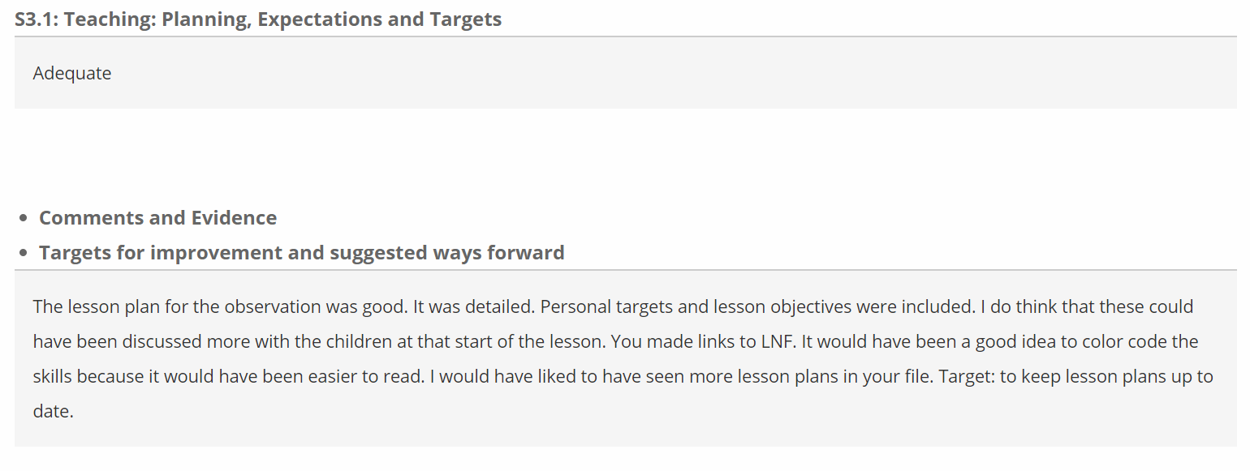
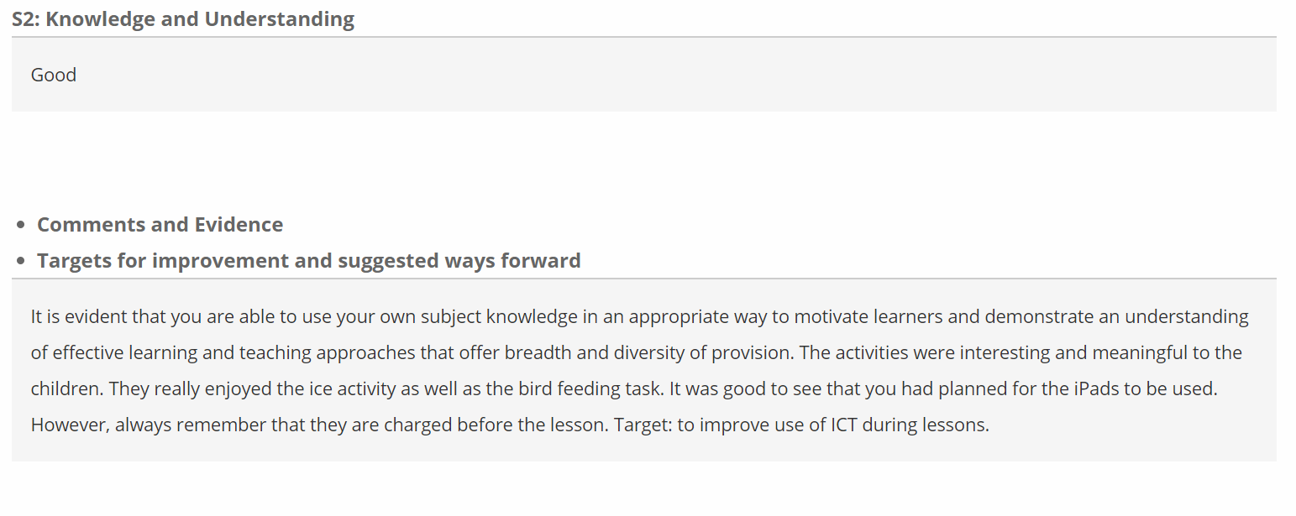
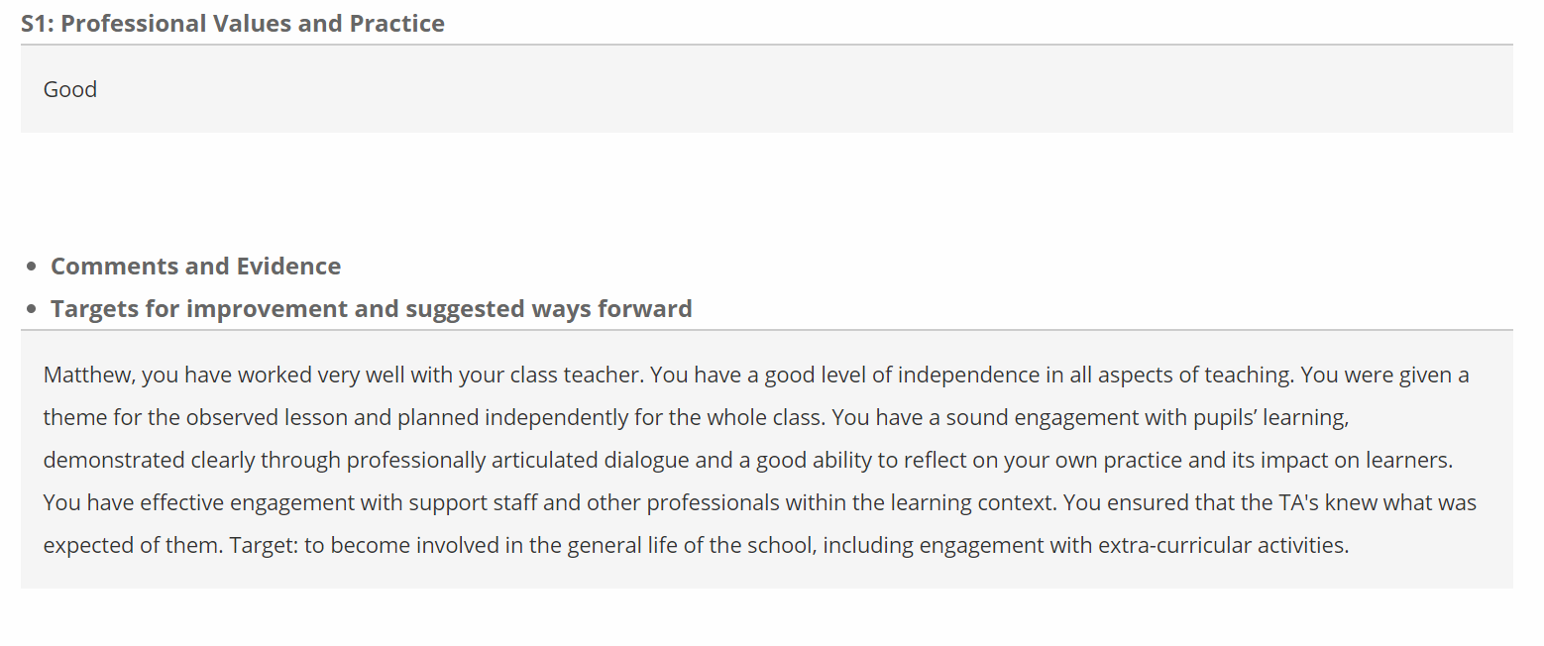
Apendix 1
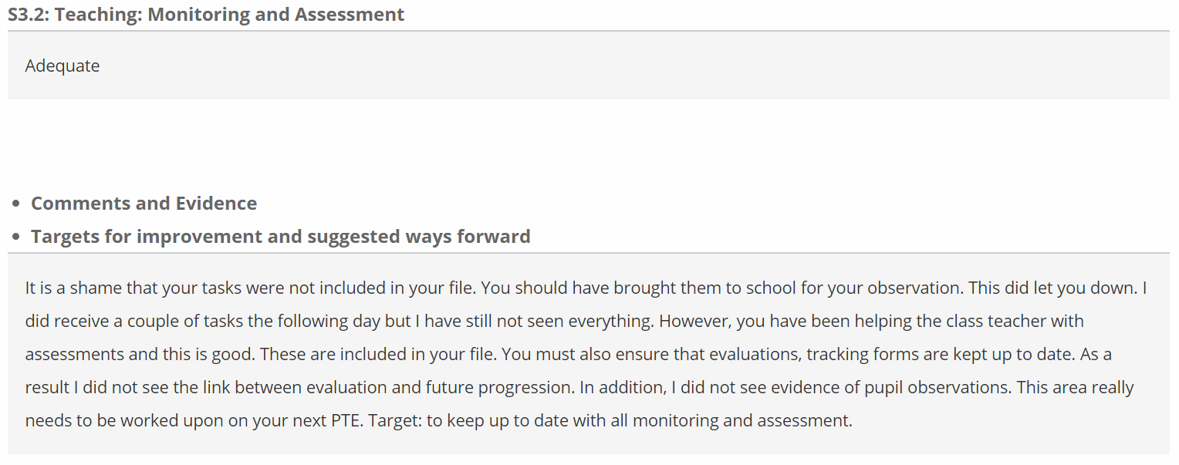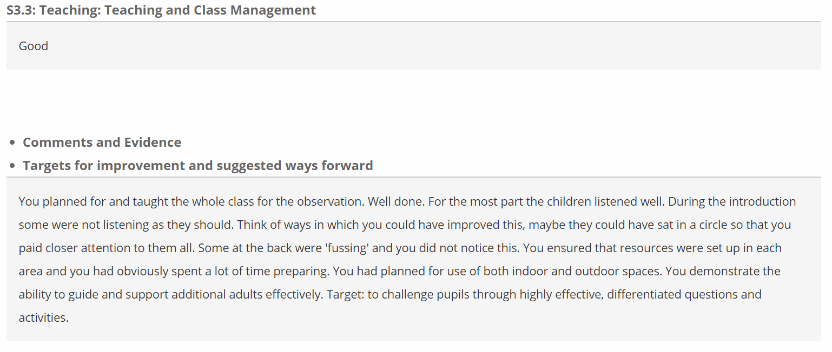
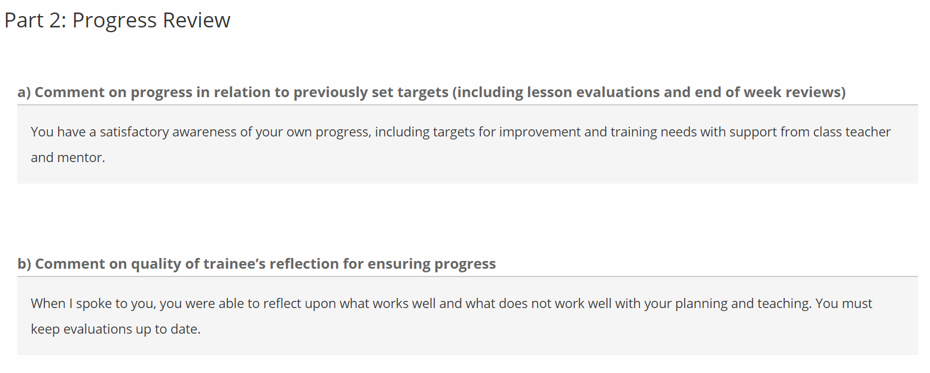
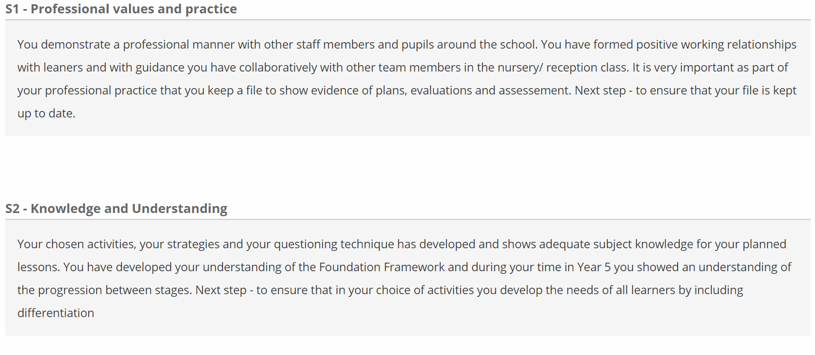
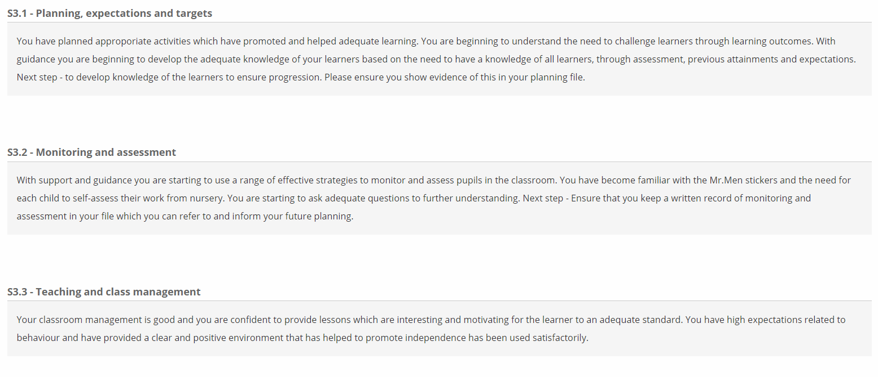

Appendix 2
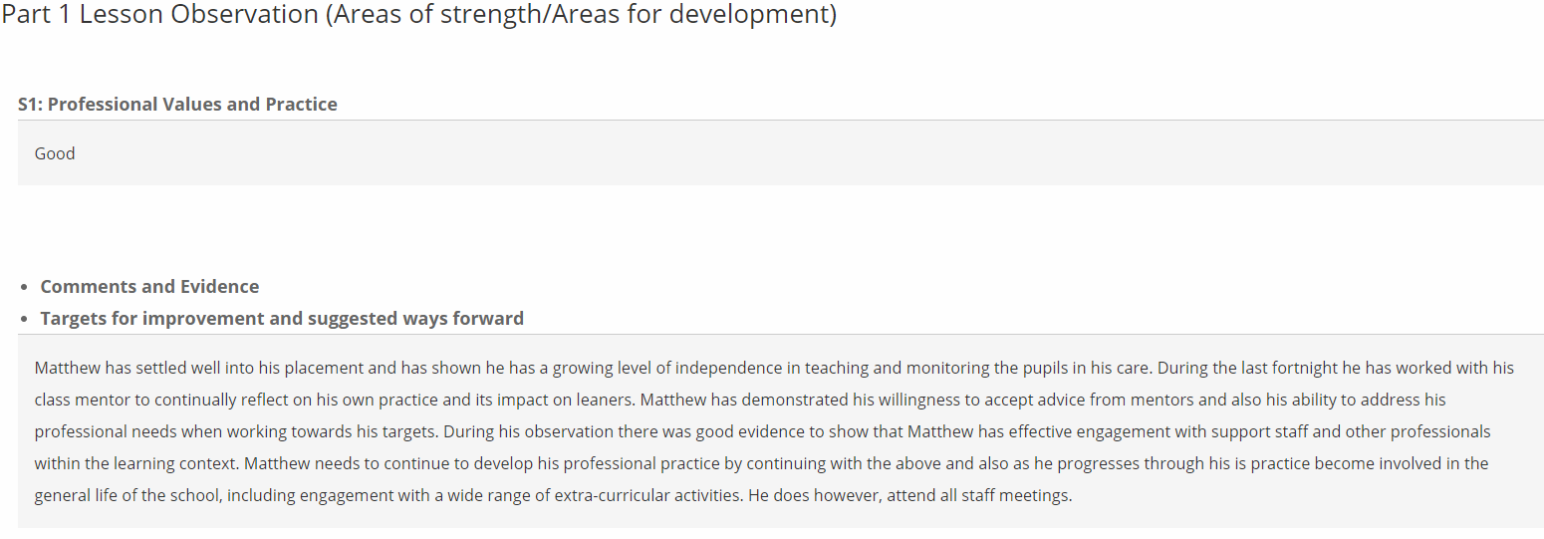
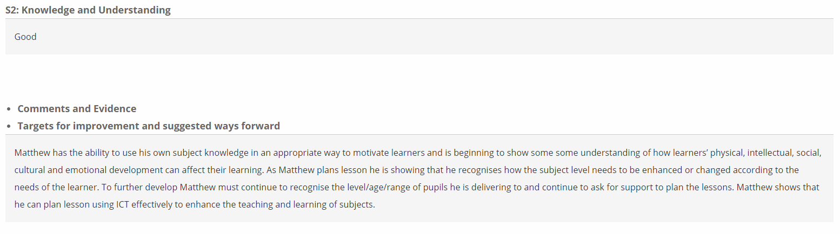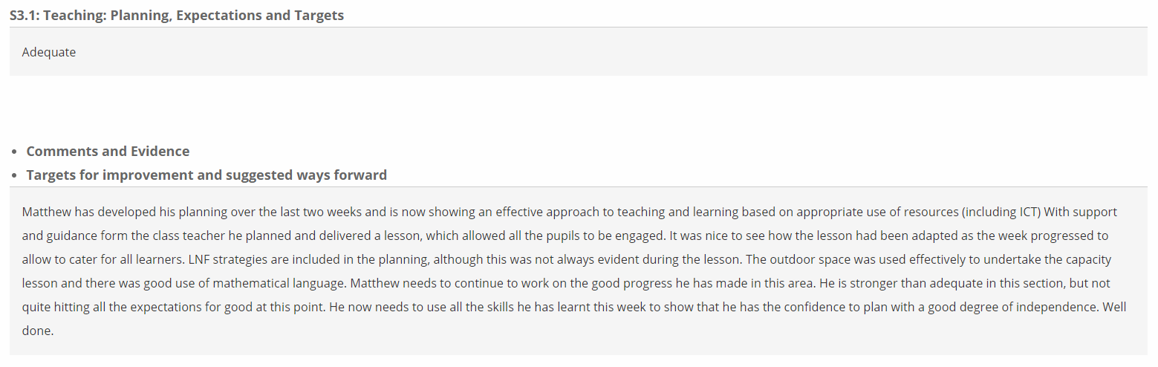
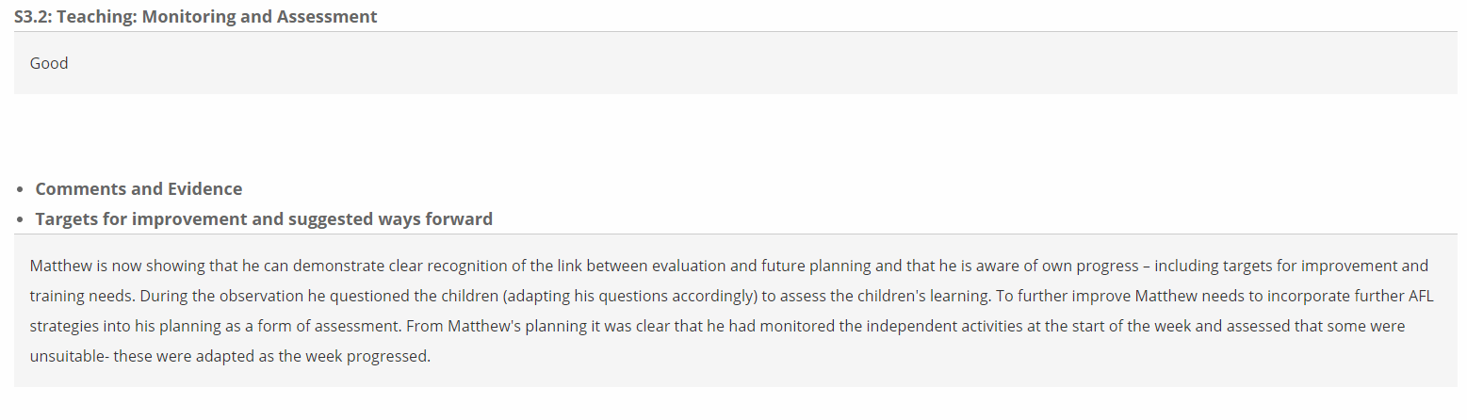

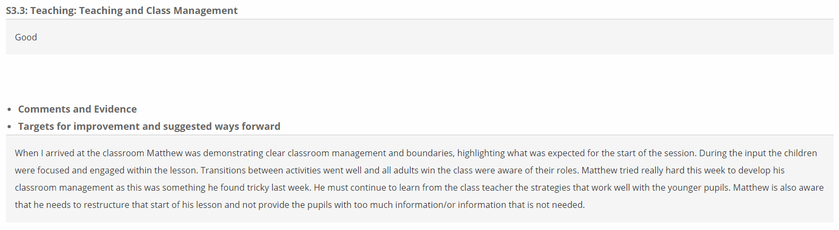

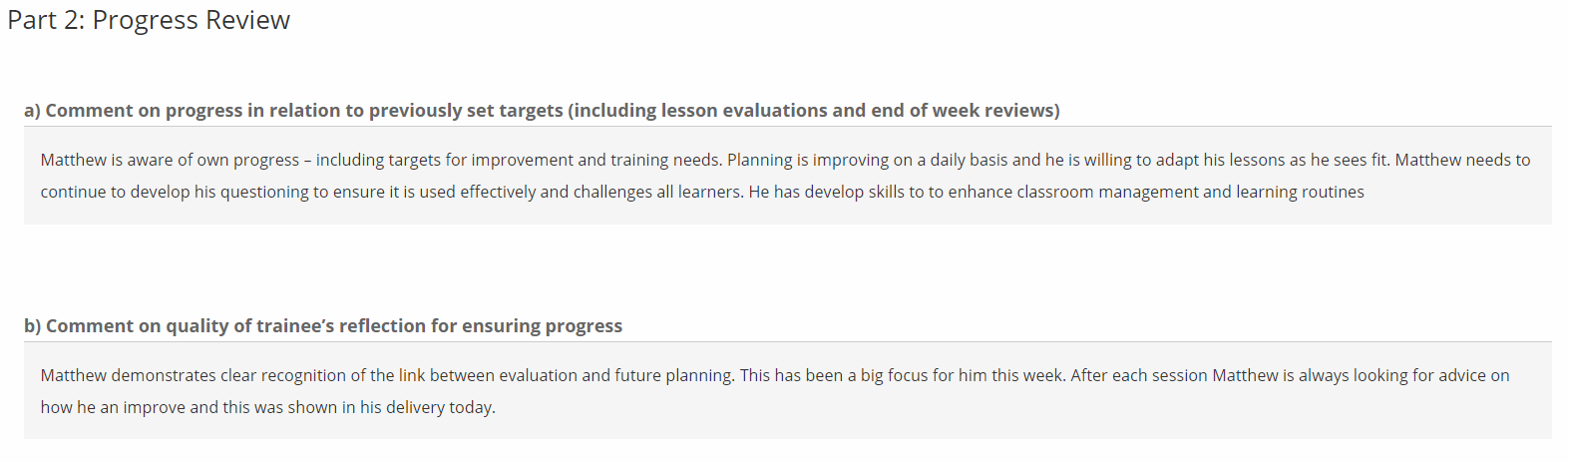

Appendix 3
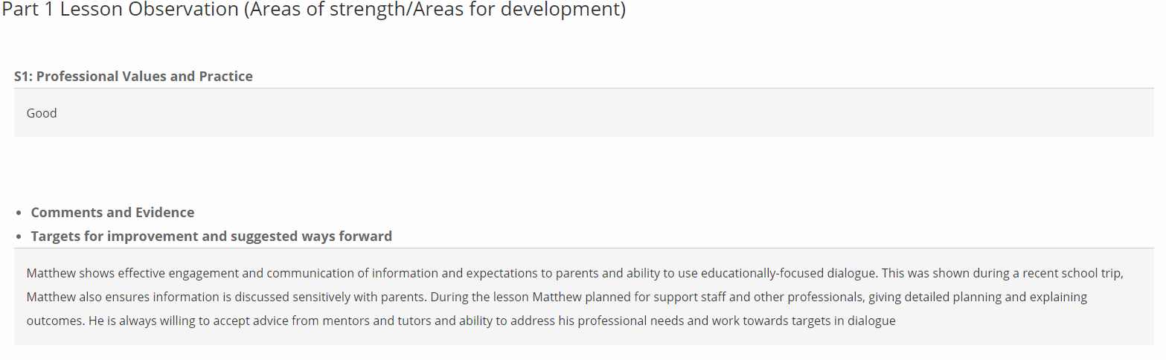
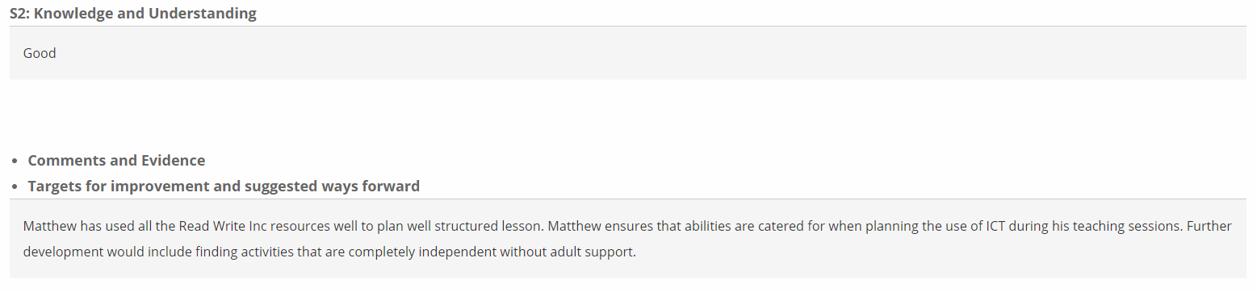

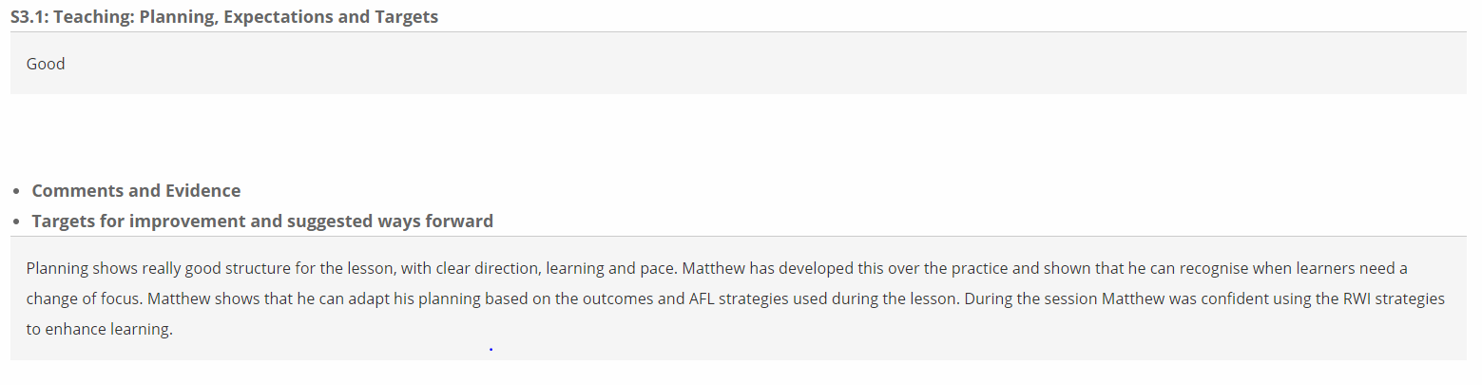
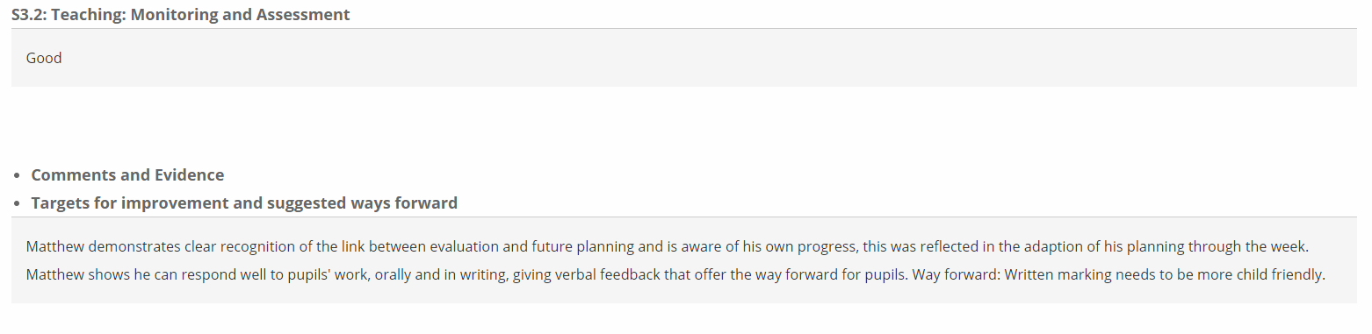

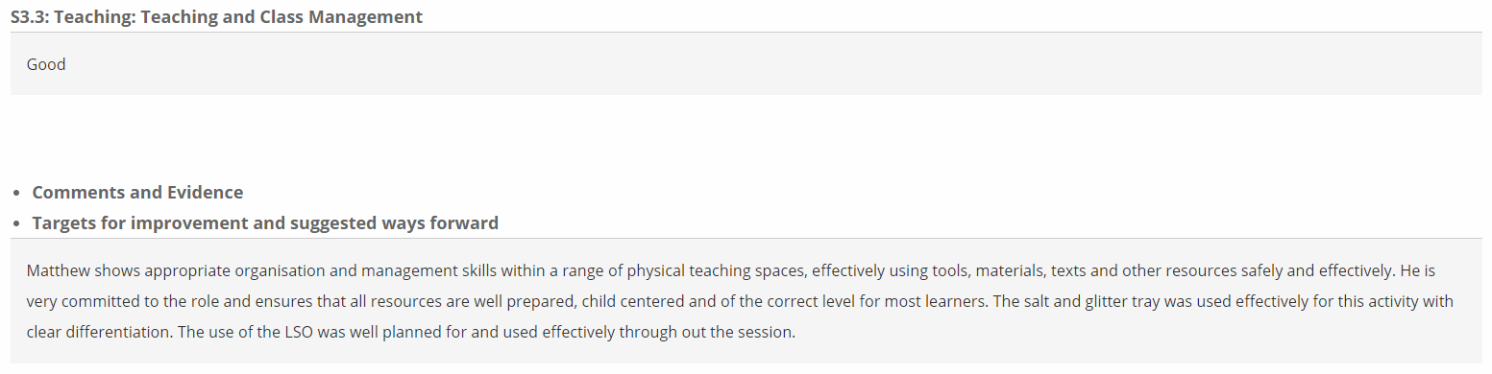
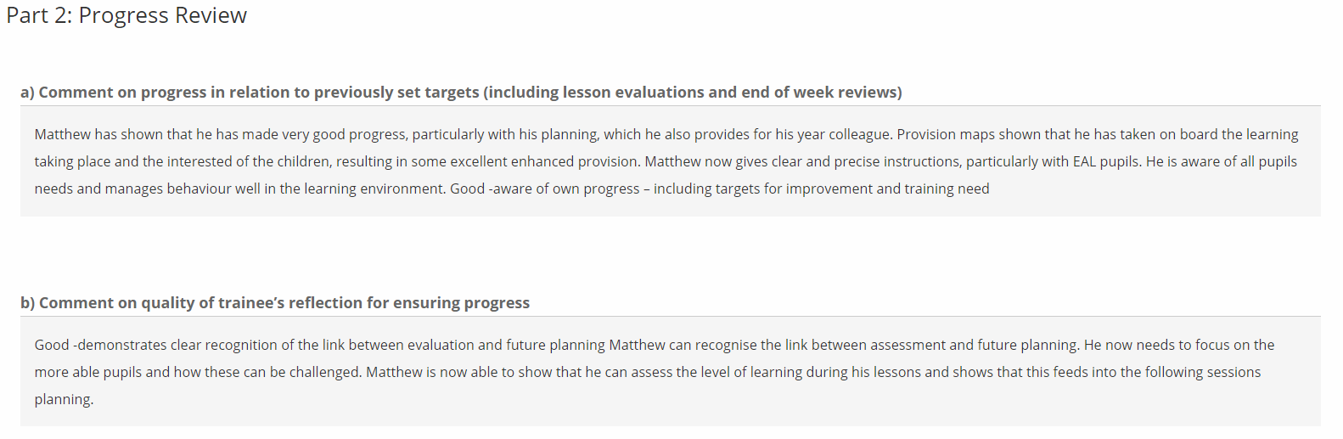

Appendix 4



