Database Management Systems
A report on
“Security and Data manipulation triggers”

Submitted in the partial fulfilment for the award degree of
BSC CLOUD COMPUTING
to
University of Wales Trinity Saint David, London

Submitted by:

1805315
Giuseppe Ventimiglia

Under the guidance of:
Joy Botu
Academic Year 2019/2020



Abstract
This report aims to give a knowledgeable overview of auditing triggers and database concurrency problems to enhance security at the ”Venti property management” estate agency.

Contents

1 Introduction 3
1.1 Data at risk 3
1.2 Insiders 3
2 Mitigating approach 4
2.1 Auditing Triggers 4
2.2 Implementation 4
3 Concurrency Transactions 7
3.1 Definition and use 7
3.2 Concurrency problems 8
3.3 Concurrency control protocols 9
3.4 Transaction ACID 10
4 Conclusion 10
5 References 10

1 Introduction
The creation of a database for the “Venti property management Estate agency” has led the company to a fantastic economic growth resulting in a higher demand for its services and increased productivity.
However, after some months of the implementation, the company that realized the database has been contacted to provide a solution to a possible security issue regarding the staff: employees are indeed suspected by the management to perform fraudulent activities by creating tables to hide their actual sales and by deleting records to eliminate tracks of the sales.
This type of activity highlights a critical issue in the security posture of the company that it could bring to even more harmful situations, therefore a new strategy is needed to determine and tackle the issue also identifying the responsible staff.

Data at risk

According to Sobers (2019) data in companies is constantly at risk and in the research conducted by the Varonis company on 785 organizations operating in different industries, over 54 billion files have been examined in data risk assessments and the results were surprising:
- 53% of all data in a company is stale data, not needed for daily operations.
- 58% of the companies were found to have folders with uncertain user permissions.
- 17% of all sensitive and private files were accessible to all employees.
- 50 % of active user accounts were unutilized.
These findings could have different negative consequences on companies that include fines for not respecting data protection regulations or loss of customers, investors, and reputation in case of attack from hackers or insider threats.

Threat

Collins (2016, p.3) defines insider threats as employees or stakeholders that have authorised access to the organization’s system, network and data that voluntary or involuntary exploit their privileges and permissions in a way that negatively affect the company
Insider threats, such as the suspected member of the staff, are more difficult to identify because of their ability to hide among other users with same privileges and permissions and therefore a different approach must be used to investigate the fraudulent activity, identify the responsible staff and take necessary actions to prevent future attacks.

2 Mitigating approach

2.1 Auditing Triggers
To detect suspicious activity is necessary to start tracking activities in the database to analyse all operations performed and one of the most effective solutions is represented by the implementation of “auditing triggers”, a system that combines auditing with triggers.

Auditing  Auditing is a systematic examination performed activities or events to make sure they are performed, managed, and tracked in conformity of the settled policies, procedures and guidelines. (Majid, 2017) |  | Trigger  A trigger is an operation that is performed whenever a certain condition on the database server takes place.

Triggers are divided into two categories: DDL and DML triggers.

DML triggers are performed when the user attempts to edit data using data manipulation language events such as “INSERT, “DELETE” and ”UPDATE”. This type of trigger is particularly used to respond to table modifications.

DDL triggers instead, are executed in reaction to data definition language events such as Transact-SQL CREATE, ALTER and DROP statements. This type of trigger is particularly used for server or database changes (Rabeler, 2009).

2.2 Implementation
Auditing triggers allow users to capture relevant information within the tables, databases, servers affected, such as changes performed, login username, type of action performed, timestamps and objects affected.

Trigger analysis
Advantages | - Log of events is the main benefits  - Increased integrity as triggers can enforce integrity constraints  - Useful in error catching  - Prevent invalid transactions from occurring  - Eliminates redundant code, as triggers are stored once  - Triggers can be nested inside other triggers, up to 32 levels.  - Procedures and functions can also be called from a trigger  - Simpler modification, as triggers require to be changed only in one place affecting the whole database
Disadvantages | - Create a higher workload on database servers  - Slow down the process of accessing, editing data  - Can cause cascading effects, firing other triggers  - Triggers are not visible to the client  - Nested triggers might cause troubleshooting and debug to be hard
Connolly and Begg (2015, p. 286)
The solution provided to the estate agency company includes the creation of a DDL trigger and three DML triggers able to log activity on the Sale.

1) The DDL Trigger shown in Figure 1, uses XML language to store information such as database name, table name, login name, SQL command and timestamp whenever a table is created, altered or deleted in the server. The trigger’s output is saved in the table “PRGDatabase_audit”, figure 2.
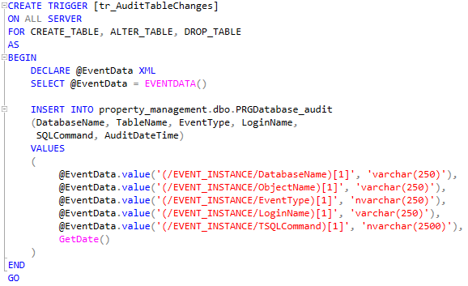
Figure 1 Trigger “tr_auditTableChange” (Author, 2020).

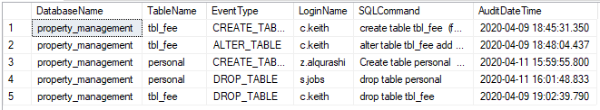
Figure 2 Table PRGDatabase_audit (Author, 2020).
2) The three DML triggers manage the insert, delete and update operation of the “Sales table”.

- The insert and delete trigger (Figure 3-4) log any insert and delete activity on the “PRGSalesAudit” table, stating the username, the ID of the property affected and the timestamp. (Figure 5)
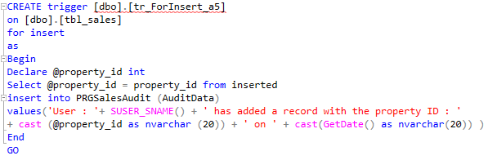
Figure 3 Update trigger (Author, 2020).
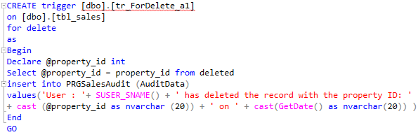
Figure 4 Delete trigger (Author, 2020).

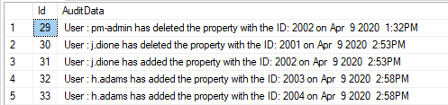
Figure 5 Table PRGSalesAudit (Author, 2020).

The update trigger shown in figures 6 and 7 is a group of conditional statements that compares two types of variables (named old and new) that have been created for each column of the Sales table, printing any changes in the “PRGSalesAudit” (figure 8).

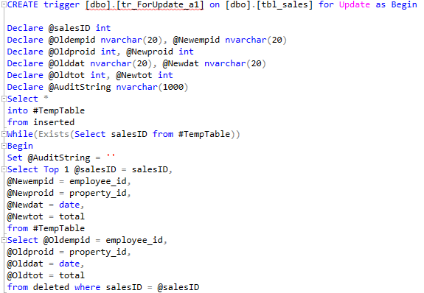
Figure 6 Update trigger (1/2) (Author, 2020).
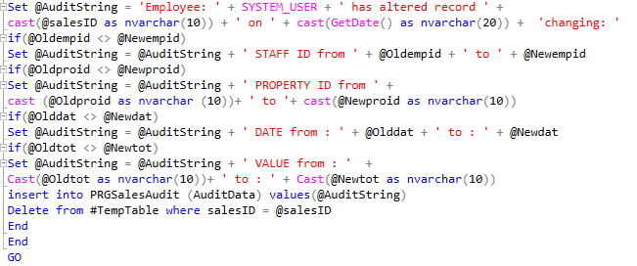
Figure 7 Update trigger (2/2) (Author, 2020).
Figure 8 Output Update triggers (Author, 2020).

Security has also been enhanced on the two auditing tables by limiting the staff’s permission to only view its content.  (Figure9 )  The Admin has full control over the tables, having also the ability to create queries for more detailed information such as activity within a time frame, searching all logs related to a specific property and comparing records. | 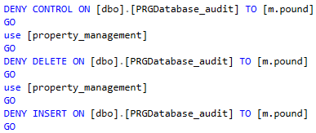  Figure 9 Example of user’s permission on the auditing tables (Author, 2020).

- Comparing records  The query in figure 10 compares the properties’ value stored in the property tables with the sales price recorder recorded in the Sales tables  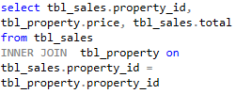  Figure 10 Query for comparing records (Author, 2020). | 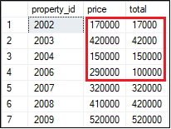  Figure 11 Output query (Author, 2020).
The output in figure 11 shows differences between the list price, called “price” and the actual sales price, called “total” highlighting possible user mistakes or intentional fraudulent activity.

- Searching through sales logs.  The query in figure 12 selects all logs associated with a specific property to determine its chronology (figure 13) | 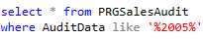  Figure 12 Sales log query (Author, 2020).
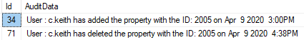
Figure 13 Output sales query (Author, 2020).

- Searching through time frames  The query in figure 14 searches all tables logs activity in a time frame as shown in figure 15 | 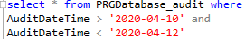  Figure 14 Time frame query (Author, 2020).
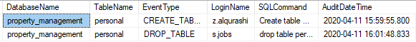
Figure 15 Output (Author, 2020).

3 Concurrency Transactions

3.1 Definition and use
Another important concept that needs to be considered for the security of the database and integrity of data is the concurrency control problem associated with transactions.
Database transactions are defined by Elmasri and Navathe (2010, p. 743) as a sequence or series of operations such as Insert, update, delete and retrieve that is defined between the “Begin transaction” and “End transaction” statements and is executed by a single user as a program. A basic example will be managing the bank accounts of two users where the sum of £100 is moved from one account to the other, as shown in the table alongside.
  Begin transaction
  Open bank account A
  Retrieve account balance
  Update balance by removing 100
  Close account
  Open bank account B
  Retrieve account balance
  Update balance by adding 100
  Close account
  End Transaction

3.2 Concurrency problems
Transactions can also be categorized in Read-only, if the operations that contain inside do not alter the database but just fetch data, or in Read-write, if data is updated. Transactions are used in both single-user systems and multi-user systems, but the type of database can represent a problem. Indeed, according to Elmasri and Navathe (2010, pp. 748-750), multi-user systems users can execute different transactions concurrently but with no management of the transactions there is a high risk to generate problems such as Lost update, Dirty read, and Unrepeatable read.

The lost update problem takes place when two transactions are executed at the same time affecting the same data returning incorrect data for one of the transactions because of the concurrency.  As shown in figure 9 the two transactions occur at the same time accessing the same value, but the Write_Item (A) for Transaction 2 is incorrect, because its value is overwritten by Transaction 1. | 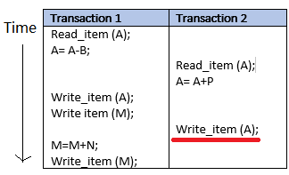  Figure 16 Lost Update problem (Author, 2020).

The dirty read problem takes place when a transaction in the progress of its execution, updates a value in the database that is being used by another transaction for its operation, but in the meanwhile the first transaction fails, causing the other transaction to use an incorrect value.  In the example of figure 10, Transaction 1 that had accessed the value of X, fails and must rollback to its original value, but Transaction 2 has read the value and is operating with the incorrect value | 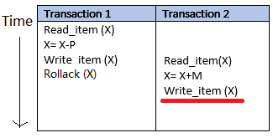  Figure 17 Dirty Read problem (Author, 2020).

The unrepeatable read problem takes place when a transaction reads the same item twice, but the item is altered by another transaction between the two reads.  As shown in the example in figure 11, Transaction 1 reads the value of X, but before reading it again, its value is changed | 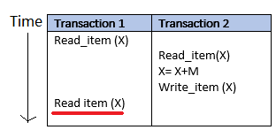  Figure 18 Unrepeatable read problem (Author, 2020).

3.3 Concurrency control protocols
To address the different problems caused by the transactions executed on a multiprogramming environment, Connolly and Begg (2014) state that a special mechanism is used to control and coordinate simultaneous operations without creating any conflicts among them.
Concurrency control protocols are a vital part of transaction management that manages concurrency through locking and timestamp protocols.  Lock-based protocols apply a technique by which a special lock is applied on the data used by a transaction, denying temporary access to other transactions that want to access it Instead, Timestamp- based | 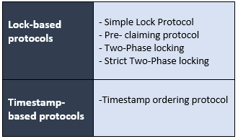
protocols manage transactions based on their time of request following a “First in, First out” approach.

One of the most used and know protocols is the Two-phase locking protocol, often referred to as 2PL.
Elmasri and Navathe (2010, p. 782) state: ” A transaction is said to follow the two-phase locking protocol if all locking operations precede the first unlock operations in the transactions”. The protocol indeed, as suggested from its name, it is composed of two phases; a primary phase called “Growing” in which the protocol acquires new locks on the item but cannot release any lock and the second phase called “Shrinking” in which previous locks can be released but new locks cannot be acquired.
Returning at the previous example of figure 17, the following figures show and compare how 2PL prevents the Dirty Read problem from occurring.
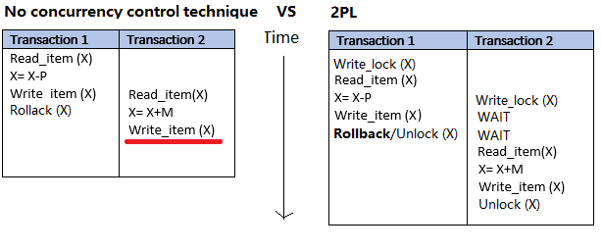
Figure 19 Comparison “No concurrency control vs 2PL” (Author, 2020).
Without any concurrent control techniques in place, Transactions can access values that need to be rolled back because of failures.
With Two-phase locking the transactions are managed differently:
-Transaction 1 requests a lock on X to execute operations, but when it fails, values are
rolled-back and the lock is released.

- Transaction 2, even if it has requested a lock during Transaction 1 processing, is put on hold until the previous lock associated with X is released.

3.4 Transaction ACID

Chikale and Dhande (2014) also state that in order to reduce and avoid failures for concurrency control protocols, transactions must respect different requirements that are grouped under the acronym of “ACID”.

Requirement | Description
Atomicity | This requirement is based on the concept that it is impossible to separate an atom. Therefore, transactions need to be executed completely or not executed at all. Users are responsible to comply with this requirement and in case of failed transactions, the database recovery subsystem is responsible for rollback transactions.
Consistency | This requirement indicates that a transaction must be consistency preserving, meaning that if it is executed without any interferences, the state of the database should remain consistently the same. The preservation of this requirement is usually associated with the programmer’s responsibility.
Isolation | This requirement implies the ability for each transaction to be executed independently, so in case of an incomplete transaction, it is not visible from other transactions. Isolation is measured on different levels that rank from 0 to 3 depending the ability to overwrite dirty-reads (Level 0), to not have lost updates (level 1), to not have dirty reads (Level 2) and to not have repeatable reads (Level 3).
Durability | This requirement determines the duration of a transaction’s effects, precising that must be permanently stored in the database and should not be lost in the event of failure. Durability is also the responsibility of the Database recovery subsystem.

4 Conclusion
The solution created for the “Venti Property Management” can effectively track any traces of the suspected fraudulent activity in the company’s DBMS, contributing to raise its security. Auditing triggers could also be expanded to all database’s tables in the event of stricter control.
The analysis of the concurrency transactions, has also highlighted the importance of concurrency control protocols in databases to reduce the different problems associated with concurrency and determine the ACID properties that all transaction must respect.

5 References
Collins, M. (2016). Common Sense Guide to Mitigating Insider Threats, Fifth Edition. [online] Available at: https://resources.sei.cmu.edu/asset_files/TechnicalReport/2016_005_001_484758.pdf.
Connolly, T. and Begg, C. (2015). Global Edition Database Systems A Practical Approach to Design, Implementation, and Management Sixth Edition. [online] 2015: Pearson. Available at: http://vumultan.com/Books/CS713-Database-System-A-Practical-Approach-to-Design-Implementation-and-Management-by-T-Connoly-C-Begg.pdf.
Elmasri, R. and Navathe, S.B. (2010). Fundamentals of Database Systems. Sixth Edition ed. [online] Pearson, pp.754–755. Available at: http://www.cvauni.edu.vn/imgupload_dinhkem/file/CSDL/Fundamentals_of_Database_Systems,_6th_Edition.pdf [Accessed 11 Apr. 2020].
Majid, A. (2017). WHAT IS AUDITING A Brief Overview LAHORE SCHOOL OF ECONOMICS.
Rabeler, C. (2019). CREATE TRIGGER (Transact-SQL) - SQL Server. [online] Microsoft.com. Available at: https://docs.microsoft.com/en-us/sql/t-sql/statements/create-trigger-transact-sql?view=sql-server-ver15 [Accessed 11 Apr. 2020].
Singh Lodhi, M. and Kaul, R. (2016). Detecting Unknown Insider Threat Scenarios. International Journal on Computational Science & Applications, 6(5/6), pp.15–21.
Sobers, R. (2020). 2019 Data Risk Report Stats. [online] Varonis.com. Available at: https://www.varonis.com/blog/data-risk-report-highlights-2019/ [Accessed 11 Apr. 2020].

