Appendix 1:



ECAD5010 Consent Form

Student teachers must gain the following written consent of the head teacher before trialling their research tools.

To be completed by the school:

I agree to ____________________________________ as a representative of Yr Athrofa to:

-Take photographs (Tick accordingly)

-Interview

-Take video

-Observe

-Quote school policy documents

-Questionnaires

Name of Head teacher ________________________ Signed _____________________

Name of school _______________________________

To be completed by the student teacher:

If I am granted such permission, I agree to abide by the ethics embodied within the EWC Code of Conduct and BERA Ethical Guidelines (2018) and will not distribute any such material to audiences beyond the University authorities without their permission.

Name of student teacher: Signed:

Student teacher UWTSD e-mail address:

Programme (e.g. BA Ed/PGCE Primary):

Date:

Appendix 2:
SECTION A: About You (Principal Researcher)
Full Name: |  | Megan Lawley
Tick all boxes which apply: |  | Member of staff: | ☐ | Honorary research fellow: | ☐
Undergraduate Student | ☒ | Taught Postgraduate Student | ☐ | Postgraduate Research Student | ☐

Faculty/School/Centre: | Initial Teacher Education, Yr Athrofa
Campus: | Carmarthen
E-mail address: | 1800303@student.uwtsd.ac.uk
Contact Telephone Number: | 07534649007
For students:
Student Number: | 1800303
Programme of Study: | BA Primary Education with QTS
Director of Studies/Supervisor: | Dr. Sioned V. Hughes

SECTION B: Approval for Research Activity
Has the research activity received approval in principle?  (please check the Guidance Notes as to the appropriate approval process for different levels of research by different categories of individual) |  | YES | ☒ | NO | ☐
 |  |  |  | Date
If Yes, please indicate source of approval (and date where known): Approval in principle must be obtained from the relevant source prior to seeking ethical approval | Research Degrees Committee |  | ☐
 | Faculty Research Committee |  | ☐
 | Other (write in) ECAD5010 Module Lead |  | ☒ | 27.02.20

SECTION C: Internal and External Ethical Guidance Materials
Please list the core ethical guidance documents that have been referred to during the completion of this form (including any discipline-specific codes of research ethics, and also any specific ethical guidance relating to the proposed methodology). Please tick to confirm that your research proposal adheres to these codes and guidelines.
UWTSD Research Ethics & Integrity Code of Practice | ☐
UWTSD Research Data Management Policy | ☐
BERA Guidelines | ☒
 | ☐

SECTION D: External Collaborative Research Activity
Does the research activity involve collaborators outside of the University? |  | YES | ☐ | NO | ☒
If Yes, please provide the name of the external organisation and name and contact details for the main contact person and confirmation this person has consented to their personal data being shared.as part of this collaboration.
Institution
Contact person name
Contact person e-mail address

Has this individual consented to sharing their details on this form? |  | YES | ☐ | NO |  |  | ☐
Are you in receipt of a KESS scholarship? |  | YES | ☐ | NO |  |  | ☐
Is your research externally funded |  | YES | ☐ | NO |  |  | ☐
Are you specifically employed to undertake this research in either a paid or voluntary capacity? | Voluntary | YES | ☐ | NO |  | ☐
 | Employed | YES | ☐ | NO |  | ☐
Is the research being undertaken within an existing UWTSD Athrofa Professional Learning Partnership (APLP) | If YES then the permission question below does not need to be answered. | YES | ☒ | NO |  |  | ☐
Permission to undertake the research has been provided by the partner organisation | (If YES attach copy)  If NO the application cannot continue | YES | ☐ | NO |  |  | ☐

Where research activity is carried out in collaboration with an external organisation
Does this organisation have its own ethics approval system? | YES | ☐ | NO | ☒
If Yes, please attach a copy of any final approval (or interim approval) from the organisation

SECTION E: Details of Research Activity
Indicative title: | What are the pupil’s and staff’s perceptions of feedback within the classroom?
Proposed start date: | 02.03.20 | Proposed end date: | 01.04.20
Introduction to the Research (maximum 300 words)
Ensure that you write for a Non-Specialist Audience when outlining your response to the three points below:
- Purpose of Research Activity
- Proposed Research Question
- Aims of Research Activity
- Objectives of Research Activity
Demonstrate, briefly, how Existing Research has informed the proposed activity and explain
- What the research activity will add to the body of knowledge
- How it addresses an area of importance.

Purpose of Research Activity

- To explore how feedback is given
- To identify the effectiveness of giving and receiving feedback
- To trial different research tools in practice, including observations, interviews and questionnaires

(this box should expand as you type)
Research Question

What are the pupil’s and staff’s perceptions of feedback within the classroom?

(this box should expand as you type)
Aims of Research Activity

- To explore staff and learners’ perceptions of AfL, main focus being on feedback
- To critically evaluate the different research tools
- To further develop personal knowledge and understanding of feedback strategies and their benefits to improve professional practice

(this box should expand as you type)
Objectives of Research Activity

- To explore the AfL strategies within feedback and approaches used by staff to support and develop pupils’ learning using a questionnaire.
- To interview Year 2 learners, Year 5 learners and their teachers to capture their views about the use of feedback and its benefits/ limitations.
- To observe a select few children and identify how effective the use of feedback is within their learning
- To critically reflect on the process of using different research tools to collect data

(this box should expand as you type)
Proposed methods (maximum 600 words)
Provide a brief summary of all the methods that may be used in the research activity, making it clear what specific techniques may be used. If methods other than those listed in this section are deemed appropriate later, additional ethical approval for those methods will be needed.
Interviews – Small groups of children from different classes will be involved in a semi-structured interview where they will be invited to respond to key questions and bring their own work to allow for a discussion. Some of the questions that will be asked will relate to the feedback within their books and asking what they do in certain sessions. As well as focusing on their time to respond to feedback. These interviews will be conducted in an informal setting and I will make notes of and audio record their responses, these will be destroyed afterwards with the presence of the class teacher. The children will not be forced to participate, will be made aware that they do not have to answer any questions and that they can stop at any time. All children will be asked if they wish to be involved. I will check on the children’s feelings regularly. No names will be recorded.

Questionnaire – A small group of children will be taken into a room and sat around a table. They will be given an iPad or laptop to complete a questionnaire (differentiated around age and knowledge). I will be sat with the children to read any questions or help them with any answers if needed. The children will be able to opt out of a question by not completing it or ticking the ‘prefer not to say’ box. Pupils and staff are made aware that the questionnaire is anonymous and the purpose of it is to gather information regarding their perceptions of feedback as an AfL strategy within their work.

Observations- Observations will take place in the Year 2 and Year 5 classrooms where a select few pupils will be focused on and their responses towards the feedback given. This information will be noted into a table using a tally chart to help notice when the feedback is given and who it is directed at. No names will be recorded and all data will be used to gather information regarding perceptions on feedback.

(this box should expand as you type)

Location of research activity
Identify all locations where research activity will take place.
The research task will take place in an urban school with around 550 pupils. The main focus will be around the Year 2 and Year 5 classrooms with the use of the hall to complete the questionnaires.

(this box should expand as you type)
Research activity outside of the UK
If research activity will take place overseas, you are responsible for ensuring that local ethical considerations are complied with and that the relevant permissions are sought. Specify any local guidelines (e.g. from local professional associations/learned societies/universities) that exist and whether these involve any ethical stipulations beyond those usual in the UK (provide details of any licenses or permissions required). Also specify whether there are any specific ethical issues raised by the local context in which the research activity is taking place, for example, particular cultural and/or legal sensitivities or vulnerabilities of participants.
N/A

(this box should expand as you type)
Use of documentation not in the public domain: Are any documents NOT publicly available? | NO | ☒
 | YES | ☐
If Yes, please provide details here of how you will gain access to specific documentation that is not in the public domain and that this is in accordance with prevailing data protection law of the country in question and England and Wales.

(this box should expand as you type)

SECTION F: Scope of Research Activity
Will the research activity include: | YES | NO
Use of a questionnaire or similar research instrument? | ☒ | ☐
Use of interviews? | ☒ | ☐
Use of diaries? | ☐ | ☒
Participant observation with their knowledge? | ☒ | ☐
Participant observation without their knowledge? | ☐ | ☒
Use of video or audio recording? | ☒ | ☐
Access to personal or confidential information without the participants’ specific consent? | ☐ | ☒
Administration of any questions, test stimuli, presentation that may be experienced as physically, mentally or emotionally harmful / offensive? | ☐ | ☒
Performance of any acts which may cause embarrassment or affect self-esteem? | ☐ | ☒
Investigation of participants involved in illegal activities? | ☐ | ☒
Use of procedures that involve deception? | ☐ | ☒
Administration of any substance, agent or placebo? | ☐ | ☒
Working with live vertebrate animals? | ☐ | ☒
Other primary data collection methods, please explain in this box  For example, ‘focus groups’. Please indicate the type of data collection method(s) in this box and tick the accompany box. | ☐ | ☒
Details of any other primary data collection method:  (this box should expand as you type) | ☐ | ☒
If NO to every question, then the research activity is (ethically) low risk and may be exempt from some of the following sections (please refer to Guidance Notes).

If YES to any question, then no research activity should be undertaken until full ethical approval has been obtained.

SECTION G: Intended Participants
Who are the intended participants: | YES | NO
Students or staff at the University? | ☐ | ☒
Adults (over the age of 18 and competent to give consent)? | ☒ | ☐
Vulnerable adults? | ☐ | ☒
Children and Young People under the age of 8? (Consent from Parent, Carer or Guardian will be required) | ☒ | ☐
Prisoners? | ☐ | ☒
Young offenders? | ☐ | ☒
Those who could be considered to have a particularly dependent relationship with the investigator or a gatekeeper? | ☐ | ☒
People engaged in illegal activities? | ☐ | ☒
Others (please identify specifically any group who may be unable to give consent) please indicate here and tick the appropriate box. | ☒ | ☐
Other – please indicate here:  5 pupils (Year 5, aged 9-10)  (this box should expand as you type) | ☒ | ☐

Participant numbers and source
How will you identify participants and how will they be recruited?
How many participants are expected? | 13 participants (staff and pupils)  (this box should expand as you type)
Who will the participants be? | 3 teachers, 10 pupils (5 pupils – Year 2; 5 pupils – Year 5)  (this box should expand as you type)
How will you identify the participants? | Previous PTE2 experience in the school  (this box should expand as you type)

Information for participants: | YES | NO | N/A
Will you describe the main research procedures to participants in advance, so that they are informed about what to expect? | ☒ | ☐ | ☐
Will you tell participants that their participation is voluntary? | ☒ | ☐ | ☐
Will you obtain written consent for participation? | ☐ | ☐ | ☒
Will you explain to participants that refusal to participate in the research will not affect their treatment or education (if relevant)? | ☒ | ☐ | ☐
If the research is observational, will you ask participants for their consent to being observed? | ☒ | ☐ | ☐
Will you tell participants that they may withdraw from the research at any time and for any reason? | ☒ | ☐ | ☐
With questionnaires, will you give participants the option of omitting questions they do not want to answer? | ☒ | ☐ | ☐
Will you tell participants that their data will be treated with full confidentiality and that, if published, it will not be identifiable as theirs? | ☒ | ☐ | ☐
Will you debrief participants at the end of their participation, in a way appropriate to the type of research undertaken? | ☐ | ☐ | ☒
If NO to any of above questions, please give an explanation
(this box should expand as you type)

Information for participants: | YES | NO | N/A
Will participants be paid? | ☐ | ☒ | ☐
Is specialist electrical or other equipment to be used with participants? | ☐ | ☒ | ☐
Are there any financial or other interests to the investigator or University arising from this study? | ☐ | ☒ | ☐
Will the research activity involve deliberately misleading participants in any way, or the partial or full concealment of the specific study aims? | ☐ | ☒ | ☐
If YES to any question, please provide full details
(this box should expand as you type)

SECTION H: Anticipated Risks

Outline any anticipated risks that may adversely affect any of the participants, the researchers and/or the University, and the steps that will be taken to address them.

If you have completed a full risk assessment (for example as required by a laboratory, or external research collaborator) you may append that to this form.
Full risk assessment completed and appended? |  | Yes | ☐
 |  | No | ☒
Risks to participants
For example: emotional distress, financial disclosure, physical harm, transfer of personal data, sensitive organisational information
Risk to Participant:  Pupils may feel under pressure to give the correct answer to the questions.  (this box should expand as you type) | How will you mitigate the Risk to Participant  Pupils will be told that there is no consequence for anything they say. I will make it clear that I want open and honest answers. I will make it clear that the answers they give will affect their education in no way and there will be no repercussions for their actions and answers in regard to the research  (this box should expand as you type)
If research activity may include sensitive, embarrassing or upsetting topics (e.g. sexual activity, drug use) or issues likely to disclose information requiring further action (e.g. criminal activity), give details of the procedures to deal with these issues, including any support/advice (e.g. helpline numbers) to be offered to participants. Note that where applicable, consent procedures should make it clear that if something potentially or actually illegal is discovered in the course of a project, it may need to be disclosed to the proper authorities
N/A
(this box should expand as you type)
Risks to investigator
For example: personal safety, physical harm, emotional distress, risk of accusation of harm/impropriety, conflict of interest
Risk to Investigator:  Allegations from pupils in the classroom while completing the research.  (this box should expand as you type) | How will you mitigate the Risk to Investigator?  The majority of the research will be during a normal activity in the classroom. There will be another researcher present while interviewing is taking place.  (this box should expand as you type)
University/institutional risks
For example: adverse publicity, financial loss, data protection
Risk to University:  Not behaving in a way that could impact the relationship between school and university.  (this box should expand as you type) | How will you mitigate the Risk to University?  I will behave in a professional manner, at all times.  (this box should expand as you type)

Disclosure and Barring Service
If the research activity involves children or vulnerable adults, a Disclosure and Barring Service (DBS) certificate must be obtained before any contact with such participants. | YES | NO | N/A
Does your research require you to hold a current DBS Certificate? | ☒ | ☐ | ☐

SECTION I: Feedback, Consent and Confidentiality
Feedback
What de-briefing and feedback will be provided to participants, how will this be done and when?
N/A

(this box should expand as you type)
Informed consent
Describe the arrangements to inform potential participants, before providing consent, of what is involved in participating. Describe the arrangements for participants to provide full consent before data collection begins. If gaining consent in this way is inappropriate, explain how consent will be obtained and recorded in accordance with prevailing data protection legislation.
I will converse with my class teacher and senior mentor and inform them of the research I will be undertaking, providing reason and rationale behind the research. However, I will verbally ask children identified to participate whether they wish to participate. Children will also be informed they can approach me at any time to ask questions and discuss their contribution to the project.

(this box should expand as you type)
Confidentiality / Anonymity
Set out how anonymity of participants and confidentiality will be ensured in any outputs. If anonymity is not being offered, explain why this is the case.
No names will be recorded or disclosed and I will ensure that no individual data (raw scores, individual identifiable performance outcomes) are made available to schools/parents etc.

(this box should expand as you type)

SECTION J: Data Protection and Storage
In completing this section refer to the University’s Research Data Management Policy and the extensive resources on the University’s Research Data Management web pages (http://uwtsd.ac.uk/library/research-data-management/).
Does the research activity involve personal data (as defined by the General Data Protection Regulation 2016 “GDPR” and the Data Protection Act 2018 “DPA”)? | YES | NO
“Personal data” means any information relating to an identified or identifiable natural person (‘data subject’). An identifiable natural person is one who can be identified, directly or indirectly, in particular by reference to an identifier such as a name, an identification number, location data, an online identifier or to one or more factors specific to the physical, physiological, genetic, mental, economic, cultural or social identity of that natural person. | ☐ | ☐
If YES, provide a description of the data and explain why this data needs to be collected:
(this box should expand as you type)
Does it involve special category data (as defined by the GDPR)? | YES | NO
“Special category data” means sensitive personal data consisting of information as to the data subjects’ –  (a) racial or ethnic origin,  (b) political opinions,  (c ) religious beliefs or other beliefs of a similar nature,  (d) membership of a trade union (within the meaning of the Trade Union and Labour Relations (Consolidation) Act 1992),  (e) physical or mental health or condition,  (f) sexual life,  (g) genetics,  (h) biometric data (as used for ID purposes), | ☐ | ☐
If YES, provide a description of the special category data and explain why this data needs to be collected:
(this box should expand as you type)
Will the research activity involve storing personal data and/or special category data on one of the following: | YES | NO
Manual files (i.e. in paper form)? | ☐ | ☐
University computers? | ☐ | ☐
Private company computers? | ☐ | ☐
Home or other personal computers? | ☐ | ☐
Laptop computers/ CDs/ Portable disk-drives/ memory sticks? | ☐ | ☐
“Cloud” storage or websites? | ☐ | ☐
Other – specify: | ☐ | ☐
For all stored data, explain the measures in place to ensure the security of the data collected, data confidentiality, including details of password protection, encryption, anonymisation and pseudonymisation:
(this box should expand as you type)
All Data Storage
Will the research activity involve any of the following activities: | YES | NO
Electronic transfer of data in any form? | ☐ | ☐
Sharing of data with others at the University? | ☐ | ☐
Sharing of data with other organisations? | ☐ | ☐
Export of data outside the European Union or importing of data from outside the UK? | ☐ | ☐
Use of personal addresses, postcodes, faxes, emails or telephone numbers? | ☐ | ☐
Publication of data that might allow identification of individuals? | ☐ | ☐
Use of data management system? | ☐ | ☐
Data archiving? | ☐ | ☐
If YES to any question, please provide full details, explaining how this will be conducted in accordance with the GDPR and DPA (and/or any international equivalent):
(this box should expand as you type)
List all who will have access to the data generated by the research activity:
(this box should expand as you type)
List who will have control of, and act as custodian(s) for, data generated by the research activity:
(this box should expand as you type)
Give details of data storage arrangements, including security measures in place to protect the data, where data will be stored, how long for, and in what form. Will data be archived – if so how and if not why not.
(this box should expand as you type)
Please indicate if your data will be stored in the UWTSD Research Data Repository (see https://researchdata.uwtsd.ac.uk/ ). If so please explain. (Most relevant to academic staff)
(this box should expand as you type)
Confirm that you have read the UWTSD guidance on data management (see https://www.uwtsd.ac.uk/library/research-data-management/) | YES | ☐
 | NO | ☐
Confirm that you are aware that you need to keep all data until after your research has completed or the end of your funding | YES | ☐
 | NO | ☐

SECTION K: Declaration
The information which I have provided is correct and complete to the best of my knowledge. I have attempted to identify any risks and issues related to the research activity and acknowledge my obligations and the rights of the participants.

In submitting this application I hereby confirm that I undertake to ensure that the above named research activity will meet the University’s Research Ethics and Integrity Code of Practice
Signature of applicant: | m.lawley | Date:  27.02.20

For STUDENT Submissions:
Director of Studies/Supervisor: | Dr. Sioned V. Hughes | Date:
Signature: |  | Date:

For STAFF Submissions:
Head of School/Assistant Dean: |  | Date:
Signature: |  | Date:

Checklist: Please complete the checklist below to ensure that you have completed the form according to the guidelines and attached any required documentation:
☐ | I have read the guidance notes supplied before completing the form.
☐ | I have completed ALL RELEVANT sections of the form in full.
☐ | I confirm that the research activity has received approval in principle
☐ | I have attached a copy of final/interim approval from external organisation (where appropriate)
☐ | I have attached a full risk assessment (and have NOT completed Section H of this form) (where appropriate) ONLY TICK IF YOU HAVE ATTACHED A FULL RISK ASSESSMENT
☐ | I understand that it is my responsibility to ensure that the above named research activity will meet the University’s Research Ethics and Integrity Code of Practice.
☐ | I understand that before commencing data collection all documents aimed at respondents (including information sheets, consent forms, questionnaires, interview schedules etc.) must be confirmed by the DoS/Supervisor, module tutor or Head of School.
☐ | I have deleted the guidance notes before submitting the PG2 for consideration

RESEARCH STUDENTS AND STAFF ONLY
All communications relating to this application during its processing must be in writing and emailed to pgresearch@uwtsd.ac.uk , with the title ‘Ethical Approval’ followed by your name.
You will be informed of the outcome of your claim by email; therefore it is important that you check your University and personal email accounts regularly.

STUDENTS ON UNDERGRADUATE OR TAUGHT MASTERS PROGRAMMES should submit this form (and receive the outcome) via systems explained to you by the supervisor/module leader.

This form is available electronically from the Academic Office web pages: http://www.uwtsd.ac.uk/academic-office/

Application Process

All staff research projects and all research students must submit the Ethical Approval Form to the University Ethics Committee via the Academic Office (pgresearch@uwtsd.ac.uk). Staff research directly in relation to personal study for taught undergraduate or Masters programmes should be submitted via the Faculty procedures explained below.

Taught masters and taught undergraduate research Ethical Approval Forms are considered within Faculties. Faculties will provide details of the specific processes for this. Where the Ethical issues within any single ethical application are of particular concern the Faculty will refer these to the University Ethics Committee. Any student activity that involves the collection of primary data needs to undergo Ethical approval, this includes assignment work as well as dissertations.

Appendix 3:

Strategy | Class | Group | Individual | Effectiveness
Traffic Lights
Time to answer feedback
Verbal feedback
Mini Whiteboards
Self- assessment
Peer- assessment

Appendix 4:
https://forms.office.com/Pages/DesignPage.aspx?origin=shell#FormId=-REPTm4EBUWcuNshUjEeIVM7EU-MMuJArp-qU_mosB1UMUM5WVBHR1VJQ0ZQTTVUSjA2UzhOWDNMMi4u

Appendix 5:
https://forms.office.com/Pages/DesignPage.aspx?origin=shell#FormId=-REPTm4EBUWcuNshUjEeIVM7EU-MMuJArp-qU_mosB1UQThHTlVPNUlBRlVHNjg0QVZUSllRREMzUi4u

Appendix 6:
Transcript 2:
Researcher: Who can tell me what feedback is?
T: Questions? Like using questions?
Researcher: Feedback is when somebody tells you what you have done good and what you can do better. So, do you think feedback is helpful?
R: Yes
Researcher: Okay, why? What is helpful about feedback.
M: It helps us learn
ML: Does it make your work better or not?
C: Better!
Researcher: Can you look at the page you have open and tell me if you can see any feedback on it
R: Yes, my teacher has written in here
Researcher: how does that writing help you?
T: it helps me to get it right and do it right next time.
Researcher: Do you use traffic lights? Where you colour in your book?
T: Yes, we have it so we colour green if we had no help, orange if you had a little help and red if you had loads of help.

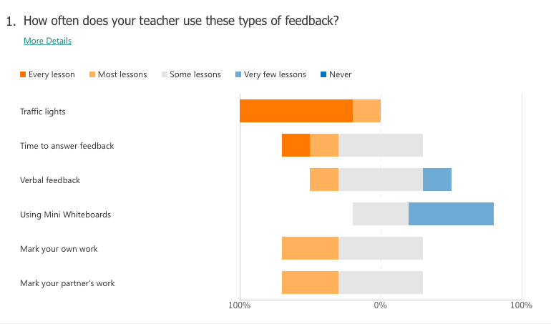
Appendix 7:

Appendix 8:
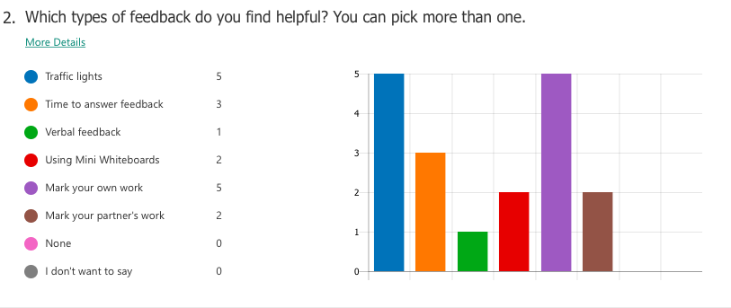

Appendix 9:
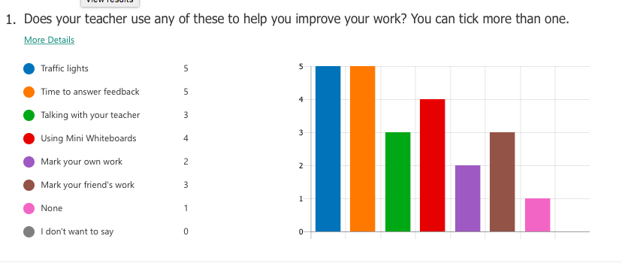

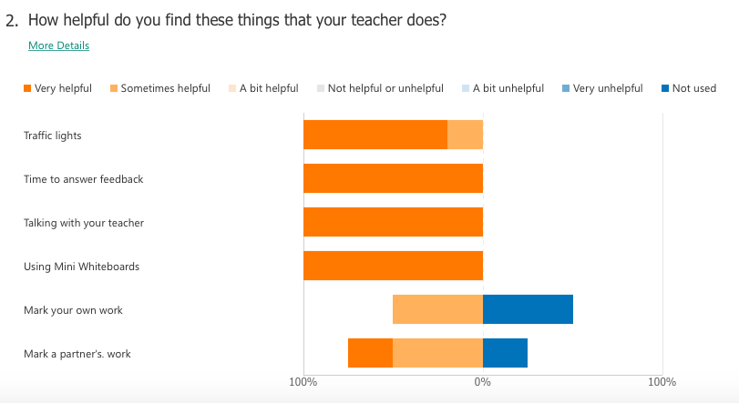
Appendix 10:

Appendix 11:
Transcript 4:
Researcher: My first question is, do you think that feedback is beneficial for youself as a teacher?
EE: Yes, I do
Researcher: Why?
EE: It informs me, rather than just looking into books. I don’t see any value in that. It lets me really focus on the Learning Objectives and to notice if they have achieved it. I think giving feedback, writing or orally, is the way forward because it is the way that they learn.
Researcher: You said that it is beneficial for the children, which technique do you think is the most beneficial for the class you have currently?
EE: At the moment, they can do with the written. But some children, I feedback orally. This is because they pay more attention to that then going back. Even though I give them time to go back and look in their books to see what the teacher has written, some of them won’t do it. So then, what I like to do, while they are working, is call them out and mark the book with them to give them pointers from there. That way it isn’t left until the end.

Appendix 12:
Transcript 1:
Researcher: What do you think feedback is?
M: Feedback is an explanation you give back to your teacher
E: Or if a teacher marks your work. They can say if you have achieved the LO or Success Criteria
Researcher: Okay, so do you think that feedback is helpful?
M: yeah it is, because you get to express about your work and see if you can improve
Researcher: Anything else?
E: We can see what we did well and what we could do better
Researcher: I’m looking at the books you brought with you and I can see there is some writing from your teacher. What kind of things does your teacher normally write here?
E: Basically, how you have done
M: Or if you have had an excellent understanding
Researcher: Okay, so what is this, here, by your Learning Objectives?
M: It’s called traffic lights
Researcher: Traffic lights? Can you tell me what they mean?
E: To see how we felt
M: Yeah, it’s like Miss is asking if you thought the work was hard or easy
E: And she can see if you need help
Researcher: Why do you think these traffic lights are helpful?
E: We can see what we have done in our work and what we found easy or hard
Researcher: What happens if you put an orange or red traffic light
M: Yellow is like you struggled a little bit
E: Or if you need a bit more support
Researcher: What does your teacher do if you put yellow or red?
M: They try to help you understand more.
Researcher: Okay, I saw the RAP board in your class, can you tell me about it?
M: It explains what you have done through the week and what you want to learn.
Researcher: Do you think your teachers use this information to plan your lessons?
BOTH: YES!
M: Once, someone asked to learn about Victorian Art and to do a project and we did it.
Researcher: With the questionnaires you have completed, it says that you don’t use a lot of whiteboards. Do you think using whiteboards would be helpful?
M: In some ways
Researcher: What ways?
E: To help us with our working out, instead of using our books
Researcher: From the questionnaire, which was your favourite type of feedback?
M: The traffic lights or when we write in blue
Researcher: What does writing in blue mean?
M: You’ve looked at your work and you correct your answers
E: I prefer when other people mark my book in purple pen
Researcher: What if they don’t understand the work they are marking?
E: Miss usually writes the answers on the board so we can check with her.

Appendix 13:
Transcript 3:
Researcher: Do you find feedback helpful
G: Yes, it is helpful for you and your teacher
Researcher: Do you have a favourite feedback method?
E: Traffic lights because you can say if you understand the work
Researcher: okay
GE: My favourite way is writing down because if I write it, I can express my feelings
Researcher: Looking at your pages, I can see the traffic lights. What do they mean?
GE: You colour a box. Red means you need loads of practise. Orange means you need some practise and green means you don’t need practise
Researcher: Does your teacher look at this?
GE: Yes, the teacher writes a comment about the colour we chose
Researcher: Are there any strategies you don’t like to use?
GE: Mini whiteboards
Researcher: Okay, why?
GE: It is a waste of time having to wipe the board
Researcher: Okay, would you say the RAP board in your class is helpful
GE: Not really because we don’t use it enough
Researcher: how would you improve this?
E: we could do it every week or after every task so we can add to it and reflect.
Researcher: What would be the benefits of this?
G: We can update it and add to more topics if we want to learn more.

