Eco Glide

My Name
My Student Id
Alex Bell
Technological change and innovation
(BMSP5019)

Introduction 2
Research and Analysis 3
Justification 7
Stakeholders 10
Conclusion 12
Index 12
Reference List 15

Introduction
In order to address the transportation issues in Llanelli, this paper offers a creative proposal for the introduction of Eco Glide, a sustainable electric scooter service. The town's urgent problems of ineffective public transportation, emissions, congestion, and parking shortages will be addressed environmentally with EcoGlide. Using the town's current bike routes, the service will be available to anyone 13 years of age and up. Solar-powered battery vending machines will be installed to further improve the project's sustainability by providing consumers with an easy and eco-friendly way to recharge their scooters. In addition to enhancing the local transportation infrastructure, Eco Glide's promotion of clean mobility options advances larger sustainability objectives and helps Llanelli's citizens live more sustainably and independently in the future.

Research and Analysis
Eco Glide is a sustainable eco-friendly scooter that can be used on cycle pathways around the Llanelli area. The cycle pathways will be fitted with solar panel rechargeable battery vending machines allowing users to get around town efficiently and sustainably without the fear of running out of battery.
Emissions and sustainability
Air pollution is a problem in big cities, and specific laws are being implemented to address it. Due primarily to national laws in EU member states, the number of low emission zones in Europe increased by 40% between 2019 and 2022, from 228 to 320, with an additional 500 or so anticipated by 2025. Electric mopeds and scooters are becoming more popular in these places due to the demand for zero-emission alternatives (Ghotge. 2024).
Public transport within Llanelli.
According to (Noticeboard, 2024) the bus service in Llanelli is in need of a significant update, at present their public transport is not conveniently accessible to the members of the public with two of its main bus routes only operating four times a day between the hours of 8.15am until 3.15pm. These operating times are not convenient for pupils or working people, with the average school hours being between 8.15am to 3.10pm and the average working day being between 9am to 5pm. There is no direct bus route from Llanelli bus station to Llanelli train station, with e nearest bus stop being a five-minute walk away at Copperworks Social Club with bus routes running between the hours of 8.20am and 5.20pm (Rome2Rio, 2025). According to (Carmarthenshire County Council, 2025) 62% of workers in Carmarthenshire travel to work by car, 3% use public transport, 1.1% cycle and 7.1% of Carmarthenshire workers walk to work.

The use of e-scooters.
We are all aware that internal combustion engines contribute significantly to pollution today, and nations everywhere are banding together to lessen their carbon footprint and protect the environment. electric vehicles becoming popular around the world few people can afford them with the average cost for a family size electric car in the United Kingdom range from £26,500 to £33,000 on average (Yurday, 2024). According to (Electric Bike Scooter Car, 2024) electric scooters start from £239.99, which is a fraction of the price of an electric car, making them more cost effective for people in the UK. They are more energy efficient, affordable, and eco-friendly for people living and commuting in towns and cities.
Not all electricity comes from renewable sources – in the UK, only about 42% is from renewables, on average. With a solar scooter, you can be sure 100% of the electricity you use comes from renewable solar energy (Lebreton,2024).
Many countries around the world have already embraced e-scooters as a form of sustainable transportation, countries like Belgium, France, Germany, Austria, Singapore and most states in the USA have legalized the use of private e-scooters for people on average aged 13 years old and above on public roads and cycle paths (Ridder Guide, 2024).
Country | Are private  e-scooters legal? | Public roads | Cycle paths | Sidewalk | Age restriction
Belgium | Yes | Yes | Yes | No | 16
France | Yes | Yes | Yes | No | 8
Germany | Yes | Yes | Yes | No | 14
Austria | Yes | Yes | Yes | No | 12
Singapore | Yes | No | Yes | No | 16
USA | Yes | Most states | Yes | No | 12-17

(Rider Guide, 2024).
how a public e-scooters are charged
Public e-scooters in the United States of America are equipped with GPS and battery monitoring systems, once the battery levels become low enough a worker also known as a juicer will collect the scooter and take it home or to a workplace to recharge it. Once fully charged the juicer will then drop the scooter off at a designated drop off point within the city and upload an image of it to their app to let users know it is available (Levy. 2025).
Battery charging vending machines
According to (Ghotge. 2024) Battery shifting is an innovative technology that is emerging as a solution. Just take out the mopeds about 10 kg of batteries, put them in a station that resembles a vending machine, and then swap them out for a fully charged battery from the station before you ride away. It only takes a minute or so to complete the entire process. These battery-swapping stations are gaining popularity in the major two-wheeler markets throughout the world due to their speed, convenience, and significantly longer driving range. There are already more places in Taiwan, home to Gogoro, the industry pioneer, that sell more batteries than gasoline. In Kenya, Rwanda, Indonesia, India, and other places, these switching stations are rapidly gaining popularity. One important element is the subscription-based business strategy, which charges a monthly cost for the battery and allows for limitless exchanges. That makes switching to electric far more inexpensive and cuts the moped's initial price in half.
Currently, Gogoro operates in nine countries and has about 13,000 smart battery swapping stations spread across 3,000 locations. Additionally, its AI-managed, cloud-connected stations can predict customer demand, monitor the condition of each battery in the system, and schedule charging for off-peak hours when energy costs are lower. To ensure that batteries are full when and where they are needed, or can charge down when they are not, its algorithms learn from rider habits (Honan. 2023).
Gogoro acquired $150 million in funding. Each battery station, which stores eight batteries, will cost less than $10,000. Each is roughly the size of an ATM, so installation should not be a significant bother, and stations can be added as demand develops.
It would cost less than $100 million to install 100 battery stations in 100 cities. Additionally, they ought to be able to get locations like supermarkets and convenience stores to host them or franchise the vending machines. Eight 20-pound batteries can be stored in each battery change station, which you can pull up to. After removing the dead battery from the scooter and replacing it with a new one in the battery bank, you can continue riding in as little as six seconds (Wang, 2015).
The future of batteries
Deregallera is a company based in Wales that is working on a new development for sodium-ion batteries. This pilot aims to establish a connection between Deregallera's lab-scale material discovery research and commercial battery manufacturing. The company wants to show that its innovative materials can be assembled into huge, commercially useful battery cells that meet industry standards. This should demonstrate that sodium-ion batteries from the company are a good substitute for lithium (Hathway, 2020).
The future of solar powered vending machines
Vending machines that run on solar electricity have several advantages. Most importantly, they lower carbon emissions by producing renewable energy, which promotes sustainability. Financially speaking, these devices may be economical. Although the solar panels and setup need an initial expenditure, over the course of the machine's life, the savings from lower energy prices may exceed the initial costs.
Additionally, solar-powered vending machines are ideal for distant or outdoor sites because they may run off the grid. Because they are not dependent on the electrical grid, they can continue to function even in the event of a power outage, guaranteeing continuous service (Solgen Power, 2025).

Justification
EcoGlide is an innovation plan starting in Llanelli with the vision to expand across the region, county and country by teaming up with the Welsh Government and Carmarthenshire County Council to tackle the transportation sector with a new innovation of sustainable transport with e-scooters by installing rechargeable battery station along the cycle paths throughout llanelli cutting down congestion issues, emmision levels and parking helping Wales hit its sustainable development goals.

To lessen traffic, encourage active travel, and lessen Wales' carbon imprint, the Welsh government set out to finance and build roads with the initiative is to promote the transition from private vehicles to active transportation and improve the accessibility, safety, and health of Wales' urban roads. One of Wales’ sustainable development goals is to have sustainable cities and communities (Cummins, 2024).
As you can see by the research above Llanelli has a public transportation problem. Leaving many members of the local community with little to no transport available, leaving many people to rely on cars or to travel on foot, which is not ideal, especially after a long day at work or school.
I believe EcoGlide is a fantastic opportunity for the town of Llanelli as it has extensive cycle tracks throughout the region with many more schemes in Wales like Safe Routes.

As you can see by the map below of the (Carmarthenshire County Council, 2024) Llanelli has already got vast cycle path in place,

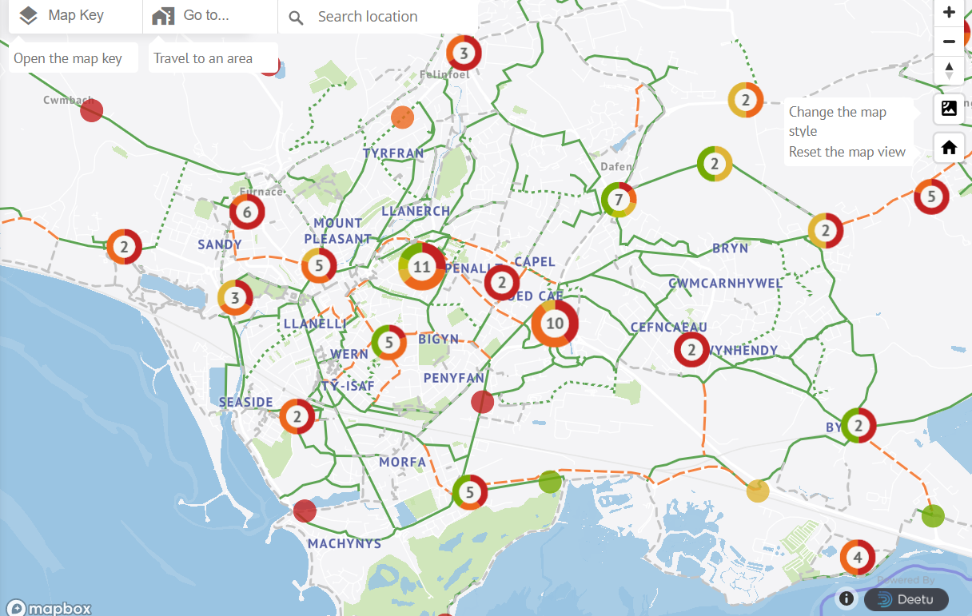
The Welsh government has promised to spend £75 million in their new transport policy to get more people to use alternative methods of transportation, with other schemes like the Active Travel Fund and Safe Routes in the community grants which is worth £6.4 million will help create safe walking and cycling routes around schools allowing pupils to get around safely ( Know Your Parking Rights, 2021). The pathways are already available just waiting to be utilized giving members of the community sustainable independence.
In 2022, there were approximately 2.6 million e-scooter sharing users in the UK. By 2025, Statista Market Insights predicts that the user base will have doubled. It is anticipated to have grown by 164% by 2027, reaching approximately 6.9 million e-scooter sharing users (Statista, 2024).
With e-scooters becoming increasently popular in recent years with the popularity set to rise further by 2027. This is the perfect time to utilize their popularity by putting a safe sustainable structure in place

According to (Compared to vehicles and e-bikes, e-scooters have numerous advantages, such as: They are convenient to store and move: Although e-bikes require more room, their slim frame makes them ideal for an office or apartment. Improved security: Since scooters do not need to be left outside, there is a lower chance of theft. Affordability: Most e-bikes and vehicles are more expensive than standard commuter scooters. Accessibility: E-bikes are not as small as scooters, but scooters are still svelte enough to handle traffic. Easy to use: Since e-scooters do not require pedaling, they are ideal for a sweat-free trip.
With the innovation developments of sodium-ion batteries and the invention of solar powered rechargeable vending machines the future of sustainable energy efficient transport is only going to become ever more assessable
With the help from the Welsh Government and funding from the Smart Cymru Scheme, Llanelli can join the other European countries and become the newest member of their e-scooter revolution helping keep Wales on track as one of the top sustainable countries in the world. With the likley possibility of expanding Eco Glide across the country.

Stakeholders

Investers - (The Smart Cymru Program,2025) offers guidance on innovation and financial assistance. We help you make connections and link you with experts. In other words, we share the risk with you. All stages of a research and development project, from initial feasibility to market exploitation, can receive support.
Scooter manufacturer – TIRE-Dott are the largest e-scooter micromobility fleet in Europe with 250,000 vehicles. By working with their manufacturers, we could supply top quality eco-friendly e-scooters for our customers (West of England, 2025).
Battery developer – "The push for low carbon technologies has led to an explosion in demand for lithium-ion batteries (LIBs)," said Chris Kavanagh, materials scientist and project lead at Deregallera. But the lack of lithium precursors and the rising environmental and financial difficulties of procuring cobalt are fueling the need for safer, greener battery chemistries. The substance sodium ion is widely available. It functions and is made similarly to lithium batteries, but it has the added benefit of being able to discharge to zero volts, which makes it much safer to transport (Hathway, 2020). Sodium ion batteries have double the cyclability, higher safety are less costly, have lower temperature performance, are not flammable, has faster charging and discharging time and are easier to recycle compared to lithium batteries and to top it off sodium ion batteries have no need for critical raw materials (Iberdrola, 2025).
Battery charging vending machines – working with Gogoro to install smart battery swapping stations throughout Llanelli so riders can swap out their dead batteries for fully charged one as often as they need when subscribing to our low-cost subscription at £18 a month. (Honan, 2023).
Local authority = working with Carmarthenshire County Council to follow the lead of the West Of England trial that allows e-scooters from TIRE-Dott to be ridden on any public land where bicycles are permitted.
Police – working with Dyfed Powes Police to enforce the rules and regulations such as riders must wear a helmet and safety pads, sticking to the speed limits and making sure riders have passed their safety training.
Cycle scheme – following the cycle safety scheme e- scooter riders must pass a e-scooter safety scheme, so they can ride safely
Insurance Brooker – partner up with an insurance company to offer third party insurance.
Website and app developers – by working with the top engineers and developers from Tire. Tom Wallroth -, principal engineer and Tilman Borner, software developer we can have a smoothly run website and app, so our customers have a pleasant experience with our company (TIRE, 2022). Offering a monthly prescription to have unlimited use of battery charging stations.
Customers – anyone over the age of thirteen that has completed their e-scooter safety scheme providing them sustainable independence.

Conclusion
To sum up, the Eco Glide innovation plan provides a prompt and environmentally friendly response to Llanelli's transportation issues. With the introduction of electric scooters and solar-powered battery vending stations, Eco Glide will offer a convenient, affordable, and eco-friendly substitute for conventional modes of transportation. In addition to addressing the shortcomings of the current public transportation options, such as their restricted schedules and accessibility problems, this project would lessen traffic and pollutants. Eco Glide is well-positioned for success thanks to its integration with Llanelli's current infrastructure and the backing of important players including local government agencies and digital companies. With the government supporting active travel and the growing need for environmentally friendly transportation options, Eco Glide offers a thrilling chance to build a more autonomous, accessible, and sustainable future for the community. The adoption of this proposal would not only help Llanelli but also act as a template for other areas of Wales and abroad, given the growing popularity of e-scooters.

Index

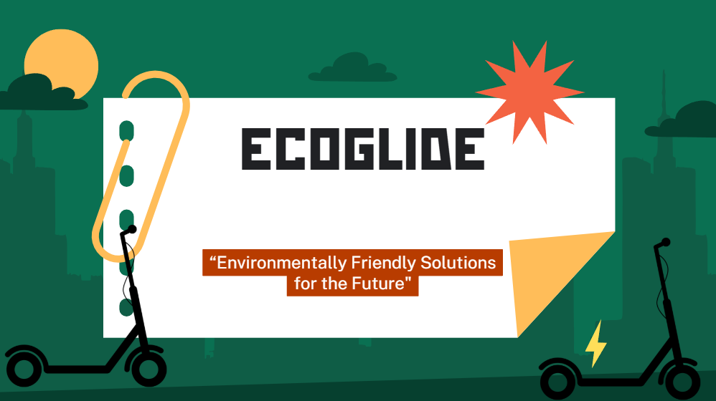

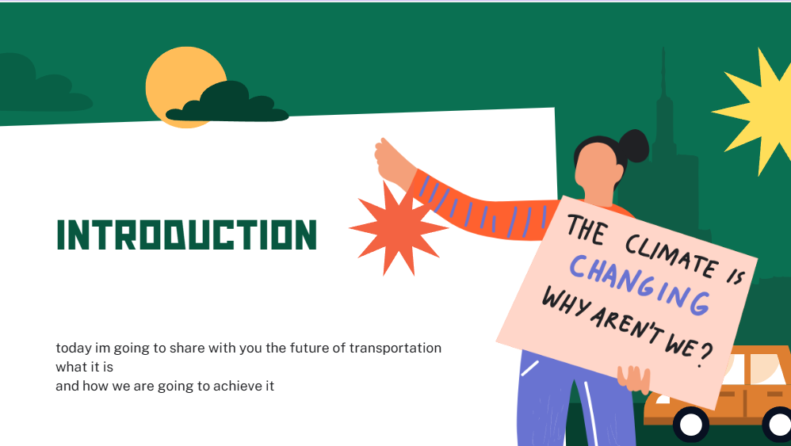

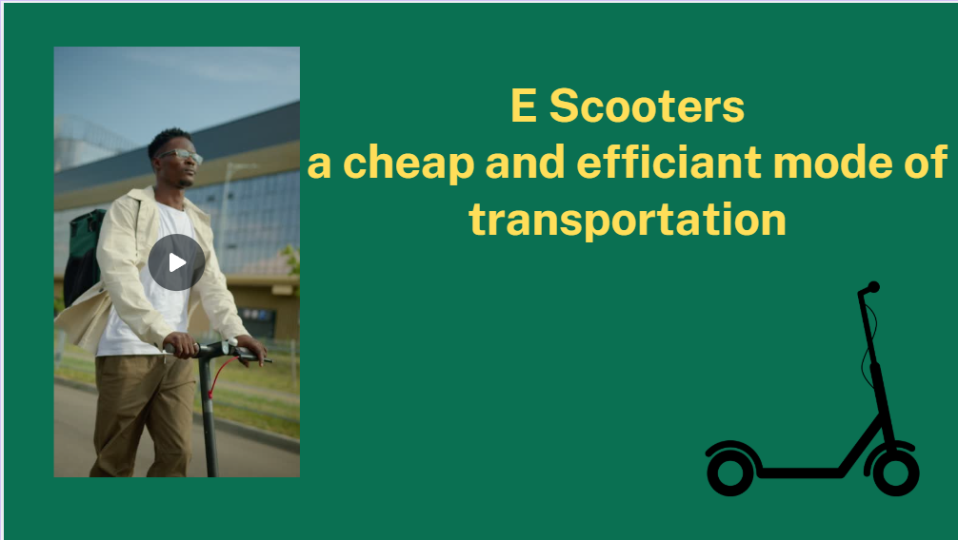

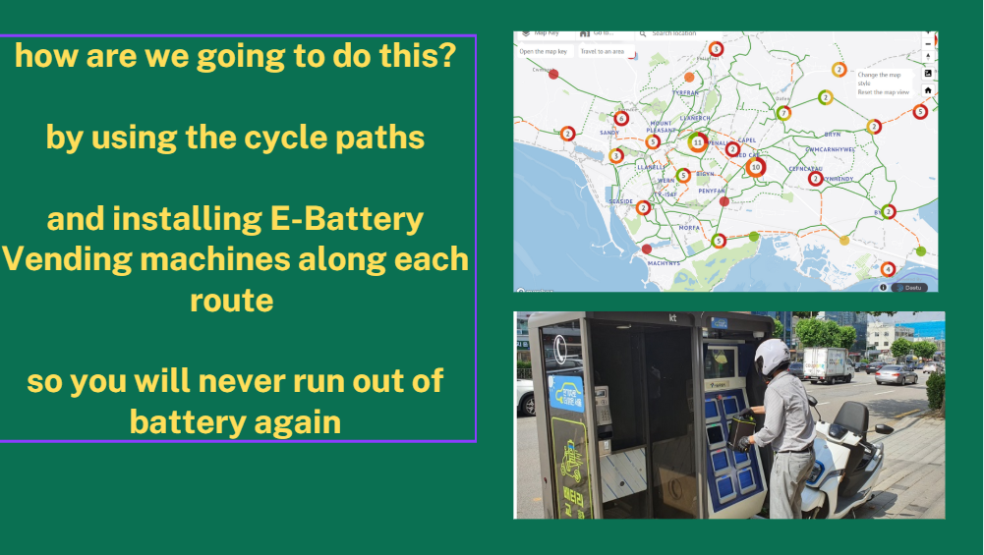
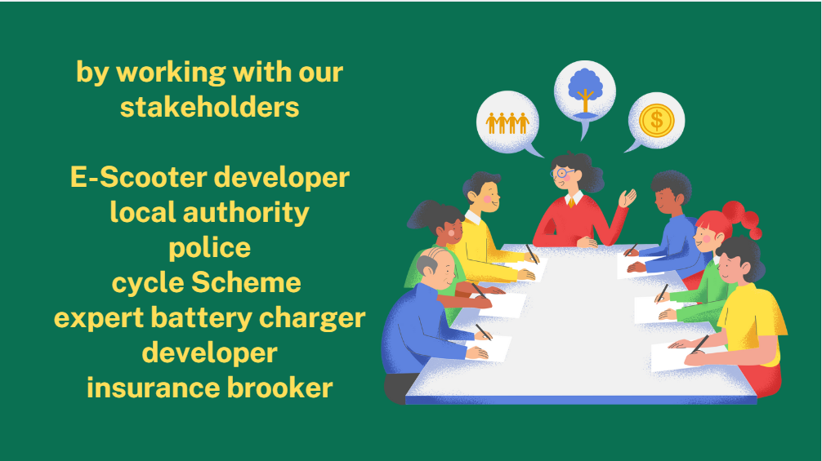
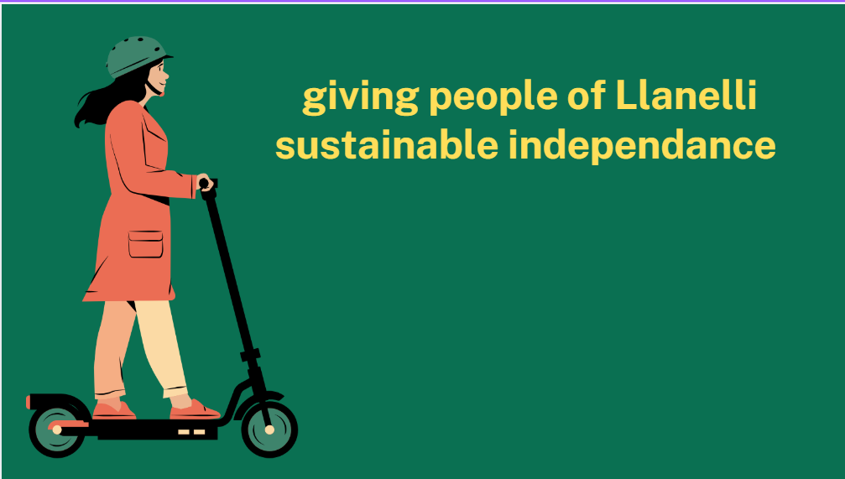

Reference List

Carmarthenshire County Council. (2024). Welcome to Carmarthenshire’s Active Travel Map. Carmarthenshire County Council's Active Travel Map

Carmarthenshire County Council. (2025). 2021 Census Data for Carmarthenshire – methods of travel to work. https://www.carmarthenshire.gov.wales/media/1230516/method-of-travel-to-work.pdf

Cummings, A. (2024). How Wales uses the UN SDG,s to support long-term infrastructure planning. https://www.ice.org.uk/news-views-insights/inside-infrastructure/wales-uses-un-sdgs-support-long-term-infra-plans#:~:text=In%202015%2C%20Wales%20became%20the,now%20and%20in%20the%20future.

Electric Bike Scooter Car. (2024). Electric Moped & Scooters. https://electricbikescootercar.co.uk/electric-scooter/#:~:text=The%20price%20of%20electric%20mopeds,for%20individuals%20living%20in%20cities.

Ghotge, R. (2024). Battery Swapping for E-Mopeds: A Gamechanger for Urban Last Mile Travel?. https://www.cenex.co.uk/blog/battery-swapping-for-e-mopeds-a-gamechanger-for-urban-last-mile-travel/#:~:text=New%20technology%20is%20emerging%20as,takes%20only%20about%20a%20minute.
Hathway, C. (2020). Deregallera looks to spearhead the future of battery development in Wales. https://www.newelectronics.co.uk/content/news/deregallera-looks-to-spearhead-the-future-of-battery-development-in-wales/

Honan, M. (2023). 2023 Climate Tech Companies to Watch: Gogoro and its scooter and battery pack network. https://www.technologyreview.com/2023/10/04/1080115/2023-climate-tech-companies-gogoro-electric-vehicles-scooter-battery-pack-network/

Iberdrola. (2025). Sodium-ion batteries: the revolution in renewable energy storage. https://www.iberdrola.com/sustainability/environment/energy-efficiency/sodium-ion-batteries

Know Your Parking Rights. (2021). Llwybr Newydd The Wales Transport Strategy 2021. https://www.knowyourparkingrights.org/news/welsh-government-to-spend-75m-on-active-travel#:~:text=Selected%20schemes&text=The%20Cardiff%20Cycleways%20project%20will,and%20new%20and%20improved%20paths.

Lebreton, T. (2024). The Complete Guide to Solar Scooters. https://www.theecoexperts.co.uk/solar-panels/solar-scooters

Levy. (2025). Charging Public Electric Scooters: The Process Explained. https://www.levyelectric.com/resources/charging-public-electric-scooters%3A-the-process-explained#:~:text=These%20scooters%20typically%20have%20GPS,locate%20and%20collect%20the%20scooter.

Noticeboard. (2024). Boost to Llanelli town bus service planned for January 2025. https://www.inyourarea.co.uk/news/boost-to-llanelli-town-bus-service-planned-for-january-2025

Rider Guide. (2024). The changing electric vehicle market & how e-scooters fit in. https://riderguide.com/guides/best-countries-for-electric-scooter-ownership/

Rome2Rio. (2025). My trips. https://www.rome2rio.com/map/Llanelli/Llanelli-Station#trips/transport/Llanelli/Llanelli-Station/r/Bus/s/0
Solgen Power. (2025). Solar-Powered Vending Machine. https://solgenpower.com/about-us/faqs/solar-terms/solar-powered-vending-machine/#:~:text=A%20solar%2Dpowered%20vending%20machine%20harnesses%20the%20power%20of%20the,a%20cooling%20or%20heating%20system.

Statista. (2024). User forecast of the e-scooter sharing market in the United Kingdom from 2022 to 2027. https://www.statista.com/statistics/1405476/e-scooter-sharing-market-user-forecast-united-kingdom/#:~:text=In%202022%2C%20the%20number%20of,million%20e%2Dscooter%20share%20users.

TIRE. (2022). Nerd Overflow: the engineering ceremony at TIRE. https://tier.engineering/Nerd-Overflow-the-enginering-ceremony-at-TIER

Wang, B. (2015). Electric Scooter with vending machine like battery swaps in 6 seconds would be great for Asian Cities. https://www.nextbigfuture.com/2015/01/electric-scooter-with-vending-machine.html

Welsh Government. (2025). SMART Cymru Research, Development and Innovation Driving Innovation. https://businesswales.gov.wales/sites/business-wales/files/documents/Growing%20a%20business/SMARTCymru%20Brochure%20Eng_growing.pdf

West of England. (2025). Frequently Asked Questions. https://www.westofengland-ca.gov.uk/what-we-do/transport/future-transport-zone/public-e-scooters-trial/

Yurday, E. (2024). Average Cost of an Electric Car UK 2024. https://www.nimblefins.co.uk/average-cost-electric-car-uk

Image of cycle routes
https://cyclewalkcarms.engaged.space/

Battery vending machines
http://koreabizwire.com/seoul-to-install-1000-electric-bike-charging-stations-using-public-phone-booths/221794

https://en.yna.co.kr/view/AEN20210628006200315

https://www.youtube.com/watch?v=C2zh5f71O8o


Laws on e bikes in the UK
https://www.sustrans.org.uk/our-blog/get-active/where-to-start-with-electric-bikes-all-you-need-to-know/#:~:text=Electric%20bikes%20are%20also%20subject,e%2Dbike%20on%20the%20pavement.

