Database Design (Dylan’s Book Store)

Beverly Holland

Joshua Batchelor – 1802076

Contents
Abstract 3
Introduction 4
ERD Diagram 6
Database Tables, Forms, Reports, Query’s 7
Menu 7
Forms 7
Book Order Form 7
Book Orders Placed Form 8
Customer Form 8
Staff Form 8
Suppliers Form 9
Reports 10
Newsletter Report 10
Staff Report 10
Books Placed Report 11
Query from One Table 12
SQL to create a Query 12
AutoExec Macro 12
Documentation 13

Abstract
I have to create a database for a set scenario. Firstly, I must look at the different requirements that I need to include into the database. Then I will plan how I am going to create the database with the set requirements by creating an ERD diagram which will have all the requirements to start the build of the database. Once I had the basics completed, I will then start on the forms, queries and reports that need to be created to extract certain data from the tables. I then have to produce a report with a user documentation on how to use the database.

Introduction
This is my report that I have made showing the different sections of my database that I have created. The database must have some requirements that needs to be added into the database. Once the requirements are added into the database I then started to create a range of different forms, queries and reports showing the data from the tables. I finally must create a user documentation manual, so the users will have a walkthrough guide of my database with the different sections.

ERD Diagram

This is my ERD diagram that I had created before making my database. I created this before starting my database because as this will plan the different tables I needed to create and what data type is needed for each of the fields. This diagram will also show me what keys are needed on each of the tables to make the one too many relationships.

Database Tables, Forms, Reports, Query’s

Menu
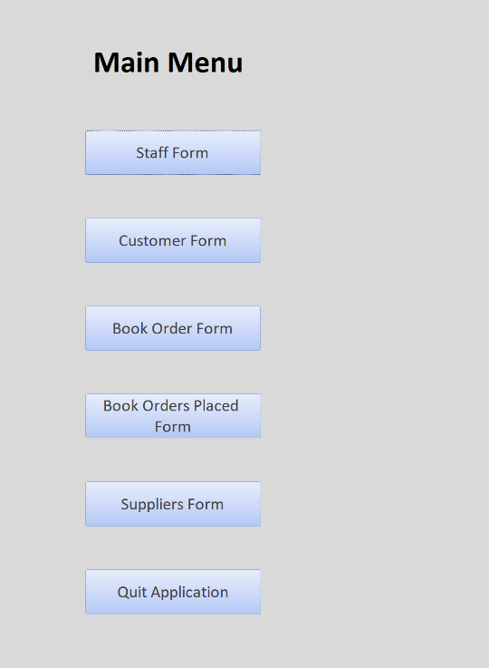

This is my main menu that I had created, so the users can navigate to the different forms. This is more user friendly as the users can navigate from one area to another. This will make the database more usable and will give the users a friendlier service. I have also added a quit application button, so the users can close the database by clicking the button.

Forms

Book Order Form
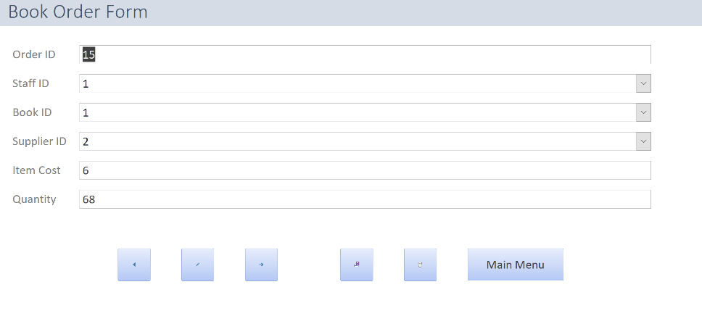
This is the book order form that shows all of the books that have been ordered by which staff member and the quantity that they want to order.

Book Orders Placed Form
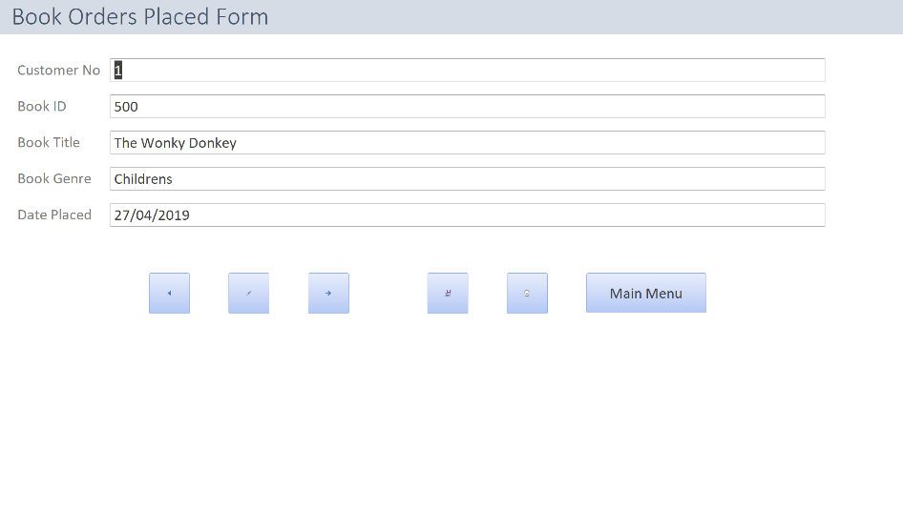
This is the books orders placed form that record the customer no and what book they have ordered and what date they placed the order.

Customer Form

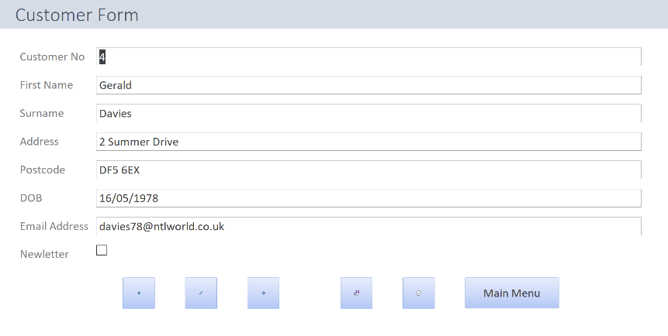
This is my customer form where all the customers details will be stored. This form will also record if they want a newsletter with a Boolean field (yes or no).

Staff Form
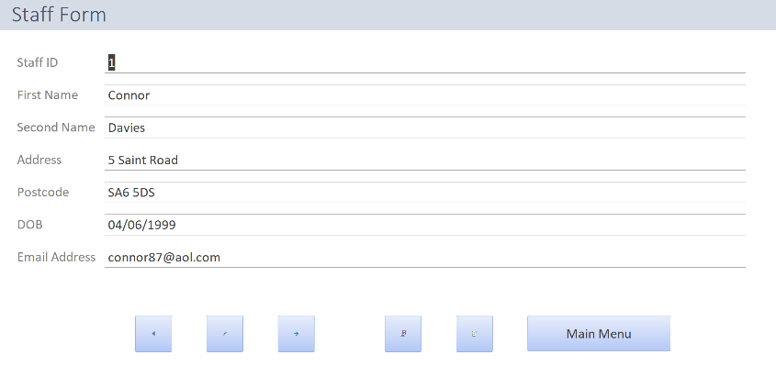
This is the staff form that shows all the staff members and the user can add new staff members into the form if needed.

Suppliers Form
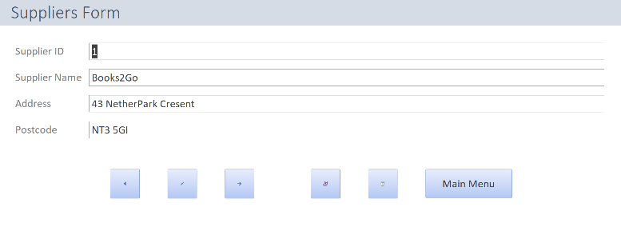
This is my supplies form where all the book suppliers are stored for reference in the different forms where the data is needed.

Reports

Newsletter Report

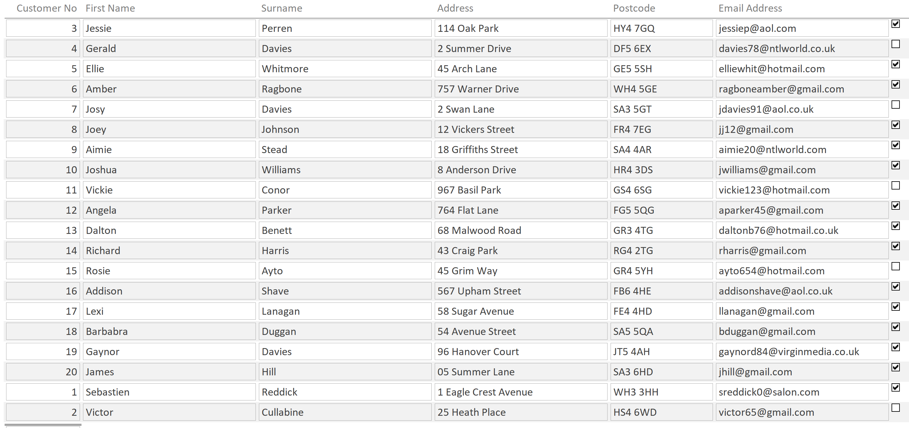

This is the newsletter report that has been generated by the newsletter query. This will show which customers want the newsletter and which customer don’t. Without this report the staff members won’t know which customer want the newsletter.

Staff Report

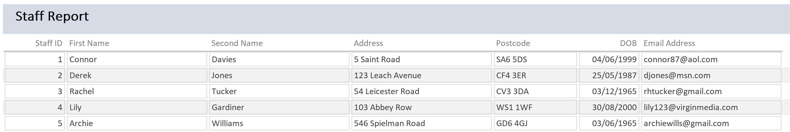

This is a report showing the staff members that work for the book company.

Books Placed Report

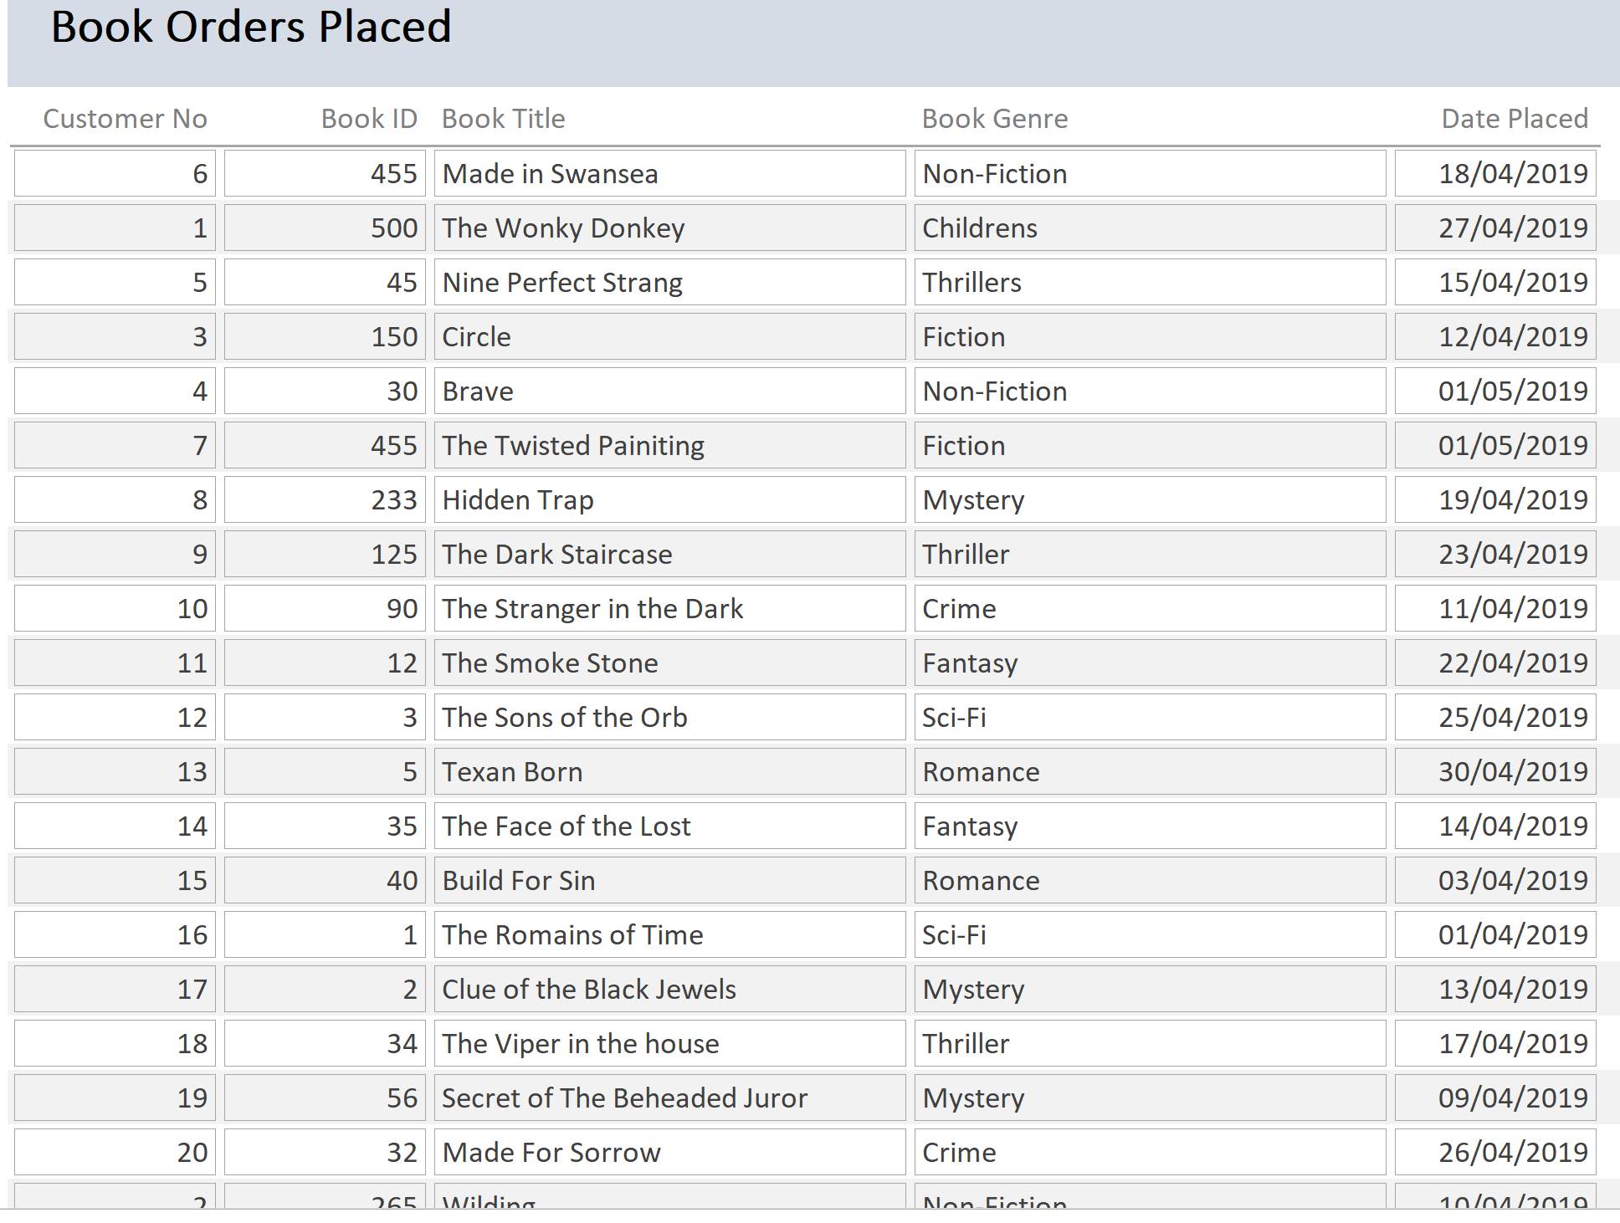

This is the report that shows what books have been requested by the different customers and what date the request was submitted.

Query from One Table

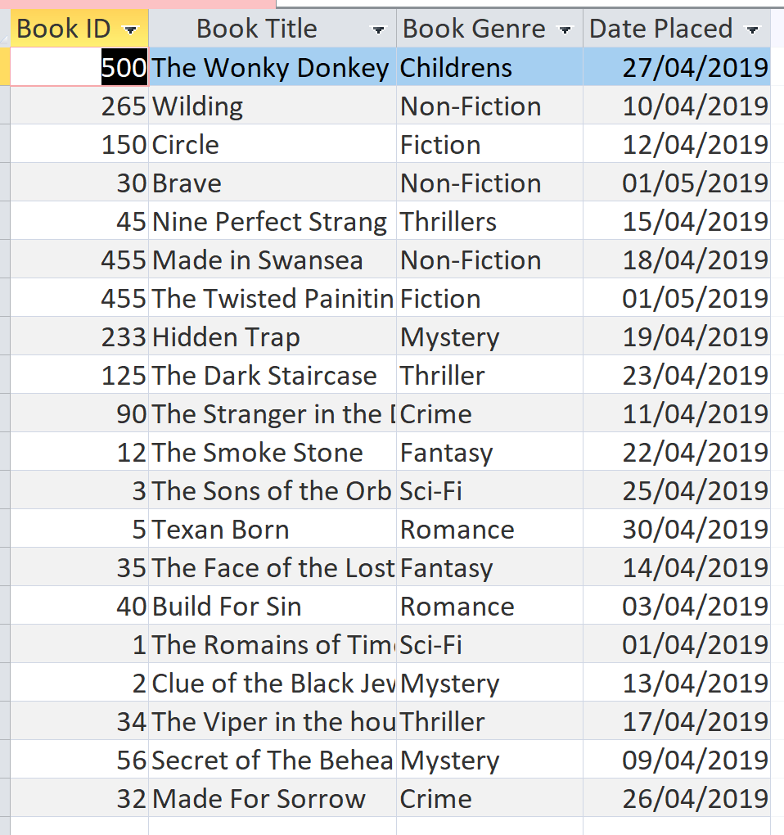
This is a query from one table showing the different books customers have ordered from the book store.

SQL to create a Query

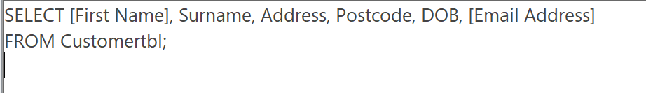
I used sql to create a query to retrieve all the customers with certain fields showing not all fields. This query queries from the customer table with the above fields.

AutoExec Macro

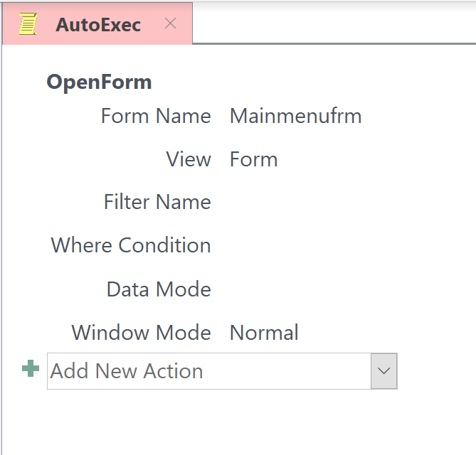
This is my Auto Exec macro that I had implemented into my database. I had implemented this macro because when the user opens the database it will take them to the main menu form which is more user friendly as they can navigate easier though the different forms.

Documentation

The function of this database is to record all the data that maybe want to be recorded within the book business such as customer data and the different orders that take place within the book store. With the data that is recorded it will let the staff to analyse the different tables that hold the information that has been gathered overtime. It will also help the business save space because all the data will be held in one central place which means its all saved as a computerized format rather than using a paper format. The book company can produce reports which they can use rather than using paper based notes/reports.

User Guide
Once you have opened the database file you will come to this main menu screen. This will allow you to navigate to the different forms to enter and view the data which are in the separate tables.
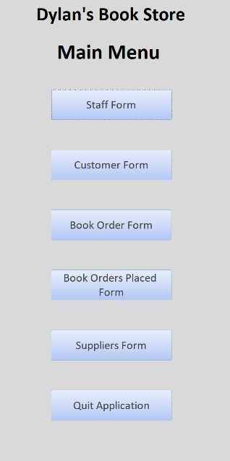

To create these reports, queries or forms you will need to create a table firstly. Once you have made the table you will need to select the create tab at the top of the program and then select what option you want to choose.
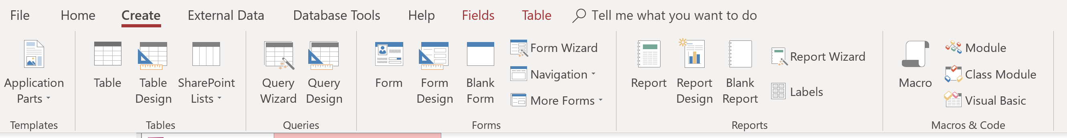

Queries
There are three different queries that have been made to pull the important data. To view each of these queries use the side panel and pick the query you want to run within the queries section of the panel.
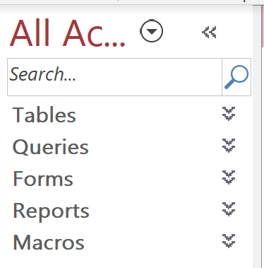

These are the different queries that you can choose to run to gather certain data.
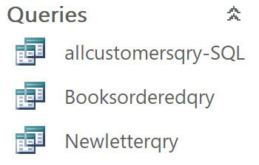

Reports
If you want to view the reports, you will have to use the side bar to view the report that have been made.

Then click onto the reports tab and all the reports will be available to click onto.


