- Understand the purpose and value of the people profession.
Q: With reference to the CIPD Profession Map, appraise what it means to be a people professional. (AC 1.1)

The CIPD Profession Map establishes the global benchmark for people professionals, detailing the purpose, values, essential knowledge, and behaviours needed to create a meaningful impact in the workplace (CIPD, 2024a). According to the CIPD, being a people professional means embodying the principles and standards set out in the CIPD Profession Map, this process is designed to enhance work and working lives, centered around the core purpose (CIPD, 2024a). It is supported by three fundamental values: evidence-based, principles-led, and outcomes-driven, which collectively enable this approach. To layer the professional map the CIPD, (2024a) illustrate three people profession areas required to facilitate this process, core knowledge, core behaviour and specialist knowledge.

According to the CIPD (2024b) being a people professional involves managing and developing an organisation's workforce, these responsibilities include recruitment, training, employee relations, performance management, and ensuring compliance with employment laws. People professionals are essential in cultivating a positive work environment, enhancing employee engagement, and aligning with the organisation's strategic goals (CIPD, 2024b). They must have excellent interpersonal skills, a deep understanding of human behaviour and the ability to manage complex organisational dynamics (CIPD, 2024b). For organisations to implement effective changes, people professionals are essential to the success or failure of the organisation's reputation (O’Malley, 2022). Therefore, professional integrity is vital for maintaining the credibility and effectiveness of both individuals and organisations. It cultivates a work environment where ethical behaviour is valued and encouraged (O’Malley, 2022).

- Know own personal and ethical values and apply these consistently in their (people practice) work.
Q: Discuss your personal and ethical values (one of each), with examples of how these are evident in your work. (If you have yet to work in people practice, explore how you believe your values would inform your work.) (AC 1.2)

The CIPD (2024c) describes ethical values as the guiding principles for effective decision making and actions by highlighting the importance of fostering a shared ethical culture within organisations, where employees are encouraged to behave ethically and make the right choices, rather than just adhering to a set of rules. This approach can foster an inclusive supportive workplace where people can collectively demonstrate healthy ethical practices in an organisation. To support ethical decision making in the workplace the CIPD advocate for organisations to consider appropriate frameworks and guidelines to uphold ethical standards, this can support employers to make sound judgements and help navigate through complex decisions (CIPD, 2024d). For example, deontology is an ethical framework that focuses on the significance of duty following moral rules or principles, irrespective of the outcomes, thus if a manager makes a mistake on a finance report which could potentially lead to negative consequences but demonstrates openness and honesty illustrates how deontological ethics prioritise duty and adherence to moral principles over the consequences of action.

Compassion is a personal value I believe I practice at the workplace through interaction, meetings and 1:1’s with colleagues and employers. By demonstrating compassion, I feel it creates a safe psychological space where employers feel empowered to speak up about challenges and with my support to consider what alternative solutions or options may be appropriate to address their concerns. Applying compassion demonstrates a deeper understanding to the persons thinking and I feel it illustrates an authentic approach to communication where the person feels heard and understood. Thus, this has created a culture of openness and trustworthy relationships which is reflected in good teamwork and collaboration amongst directorates.

An ethical value I believe is vitally important within my role is fairness, which is indicative of our organisational values. I feel I must demonstrate fairness and equitability amongst employers to mitigate the potential for discrimination and illustrate an un-bias and approachable inclusive workplace for everyone. This can foster a healthy workplace environment where everyone feels valued and appreciated minimising the potential for workplace conflict and unhealthy working relationships.

- Know the importance of people professionals contributing to discussions in an informed, clear and confident way to influence others.
Q: Discuss reasons why this is important and the consequences of people practitioners not being willing or able to influence others. (AC 1.3)

People professionals play a crucial role in shaping organisational policies and practices that affect the workforce, therefore, it's essential for them to participate in discussions with clarity, confidence, and a well-informed perspective to effectively influence others (Hall et al, 2017). Being well-informed allows people professionals to provide accurate and relevant information that supports decision-making processes, clear communication ensures that employees understand and value the context of communication, while confidence helps build credibility and trust (Armstrong & Taylor, 2023). This process enables them to effectively champion initiatives that cultivate a positive work environment, boost employee engagement, and align with the organisation's strategic goals (Armstrong & Taylor, 2023).

According to Armstrong & Taylor (2023) people practitioners not contributing to discussions in a professional manner can negatively affect an organisation and its employees. In-accurate or lack of information can lead to poor decision making which can foster ineffective policies and practices if miss-informed which can overlook the needs of the workforce (Armstrong & Taylor, 2023). Inadequate information can also lead to non-compliance to employment laws and regulations potentially causing legal issues to arise thus damaging to the organisation’s reputation. Hall et al, (2017) state if people professionals lack clarity and confidence in their communication, they might find it difficult to earn the trust and respect of employees which can weaken their ability to influence and advocate for essential changes (Armstrong & Taylor 2023). This can result in reduced employee engagement reducing morale and potentially contribute to higher employee turnover rates. CIPD (2024d) state people professionals lacking the ability to effectively influence is likely to overlook opportunities to implement initiatives which can improve the work environment, support employee development, and drive organisational success. CIPD (2024d) suggests that the ability to contribute effectively to discussions is crucial for the well-being of the workforce and the achievement of the organisation's strategic goals.

According to CIPD (2024e) to overcome the potential for poor communication, people professionals should demonstrate good interpersonal communication skills and the ability to show emotional intelligence and empathy to navigate through complex queries. Aligned with the ability to deliver clear and concise communication to establish credibility and trust with a strategic focus encompassing HR and L&D initiatives. With these key skills this supports people professionals to communicate effectively in making meaningful evidence-based changes benefiting both employee and organisational culture (Hall et al, 2017).

- Know when and how to raise matters that might be unethical or illegal.
Q: Discuss, with examples, when and how you would react to both unethical and illegal matters (one of each). (AC 1.4)

It's crucial for organisations to adopt optional platforms that allow employees to raise concerns. Implementing "Speak Up Safely" initiatives and a robust whistleblowing policy can significantly enhance trust and transparency within the workplace (Young, 2023). Young (2023) states there are four forces which can foster an effective whistleblowing policy. These include Legal Compliance: adhering to laws and regulations to protect whistleblowers from retaliation, Organisational Culture: promoting transparency and trust to encourage employees to speak up. Clear Procedures: Implementing accessible and anonymous reporting options. Leadership Support: Ensuring senior leaders commit to supporting and acting on whistleblowing reports.

Unethical

If an employee is perceived to be a victim of unethical behavior, such as recruitment discrimination based on race, gender, age, or sex, policies and procedures (Equality Act, 2010) should be followed to manage and mitigate such discrimination (Gifford et al., 2023). These behaviors can negatively impact both individuals and the workplace environment, affecting overall well-being. HR has a duty to recognize and address these issues in line with operational guidance. Employees are more likely to act unethically if they perceive their organization as unfair, especially if rewards are not distributed equitably or policies are inconsistently applied (Gifford et al., 2023). Adhering to the CIPD Code of Professional Conduct ensures trust and upholds the standards of the HR profession (CIPD, 2023). Employees should be encouraged to share their concerns formally to ensure proper processes are followed and improvements can be made (Gifford et al., 2019).

Illegal

An example might be workplace sexual harassment, which is not only unethical but also violates laws designed to protect employees from discrimination and harassment. A formal investigation would be necessary to ascertain accounts to understand legitimacy which could be used in a formal hearing. As HR professionals we have a duty to ensure the well-being of those involved and sufficient support is offered to aid unavoidable harm during the process. Immediate action or intervention may need to be applied depending upon the circumstances for example, an employee may need to be moved to a different directorate. All key stakeholders should be informed on a need-to-know basis with strict confidentiality and the consideration of referrals to other governing bodies such as safeguarding should be made if deemed appropriate.

- Be able to make use of related theory and thinking, to argue the human and business benefits of people feeling included, valued, and fairly treated at work.
Q: Demonstrate your ability to do this with a written argument, which poses different theoretical perspectives, as well as your own. (AC 2.1)

Maslow’s hierarchy

According to Maslow’s hierarchy of needs, individuals strive to fulfil their needs in a hierarchical order, starting from the most basic needs like food and shelter, progressing to safety, social needs such as love and belonging, esteem, and ultimately self-actualisation (Channel, 2023). Maslow's perspective suggests that people address lower-level needs before moving on to higher-level ones.

Business benefits

Promoting and implementing EDI in the workplace is a crucial element of effective people management. It involves creating environments and cultures where everyone feels safe, experiences a sense of belonging, and is empowered to reach their full potential (Frost and Kalman, (2016). CIPD, (2024f). state an effective EDI strategy should go beyond legal compliance, adopting an intersectional approach that adds value to the organisation, enhances well-being, and ensures equality for all employees.

Human benefits

When Maslow’s social and personal esteem is reached in the workplace employees feel valued and appreciated in the workplace, they will reach a higher sense of engagement and motivation which will promote better performance and productivity for the organisation.

Daniel Pink's theory of motivation

This theory focuses on three key elements that drive intrinsic motivation: autonomy, mastery and purpose. This theory enables control over work and decisions, boosts engagement and creativity, supported by skill development opportunities. Thus, creates purposeful, meaningful work that contributes to larger goals enhances motivation and commitment. Pink argues that these intrinsic motivators are more effective and sustainable than extrinsic rewards like money or punishments (Penpoin, nd).

Business benefits
An employer's inclusive and considerate attitude, coupled with a policy of fair dealings, grants workers the independence they need and the chance to express themselves and participate in decision-making. When employees' contributions are recognised as opportunities for skill development, they feel valued and move closer to mastery. This results in better time management and increased efficiency and effectiveness in performing tasks (Exon, 2023).

Human benefits

Additionally, the theory suggests that fulfilling extrinsic needs—such as being accepted, treated fairly, and respected—enhances workplace motivation. This leads to higher job satisfaction, improved psychophysical wellness, and greater inner contentment in professional life (Choi, 2022). When individuals gain the ability to make their own decisions, further develop their skills, and significantly contribute to the business, their situation changes. These employees understand the reality of higher motivation and engagement. Human dignity is a central component of both Maslow’s Hierarchy of Needs and Daniel Pink’s Three Essential Elements of Motivation. These principles are used to promote business growth and enhance people's lives. When team members feel their contributions are recognised and valued, and they are treated justly, they experience greater happiness, satisfaction, and competitiveness. This leads to positive outcomes for the entire organisation and fosters a generally positive work environment.

- Know how to design people practice initiatives to be inclusive and how to check inclusivity after an initiative has been implemented.
Q: Discuss, with examples, how you have, or would, achieve both of these (AC 2.2)

A nurse retention group has been set up as part of our recommendations to address high employee turnover and retention across the health board. This was implemented through a task and finish group involving appropriate stakeholders from HR, recruitment, and nurse managers. Turnover data rates and the predicted retirement figures over the next five years indicate a reduction in experienced, skilled nurses leaving the organisation within this period. However, it is evident that fewer British nurses are entering the system to replace them, which has implications for succession planning and retention (RCN, 2024).

To enhance retention and manage turnover rates, additional support for employee sickness has been provided to line managers to ensure adherence to the sickness policy and support for staff. Staff benefit roadshows have been conducted across various sites to outline available incentives and well-being schemes. Well-being days are being organized at hospital sites to showcase local community support, focusing on health and nutrition. Education and development, identified as a key priority by staff, are now being addressed through accessible training programs available both online and face-to-face in partnership with the Learning & Development team.

For a retention strategy to be successful and engaging for employees, feedback mechanisms must be integrated to gather ongoing data and assess the impact of the initiatives. This can be implemented through various methods, such as regular surveys, focus groups, or feedback sessions, where employees are encouraged to complete questionnaires to share their experiences and suggestions regarding the retention efforts (Hart, 2021). It is crucial for a company to continuously track metrics like employee engagement, satisfaction, and retention rates to assess the effectiveness of its retention plan. Data can be collected by analysing turnover rates, conducting surveys, and reviewing exit interview information. This helps HR identify areas for improvement and make necessary adjustments (Romansky et al., 2021). Regular monitoring ensures that the retention strategy stays aligned with the workforce’s changing needs and preferences, fostering a more inclusive and supportive workplace (Frost and Kalman, 2016).

- Be able to work inclusively with others and build positive working relationships.
Q: Using a combination of your own reflections and feedback from at least one other person, discuss your ability to work inclusively and positively with others. (AC 2.3)

There is no requirement to include evidence of the use of references to wider reading for AC 2.3

My ability to work inclusively and positively within my organisation is a fundamental part of my role. As a relations manager I endeavour to build trusting positive relationships with my colleagues which creates an effective work environment. With use of interpersonal skills and effective communication I can actively listen and contribute which supports the development of healthy working relationships.

As part of my role, I am responsible for acting as a conduit for the rest of OD by supporting teams both operationally and strategically to enhance a positive working culture across the organisation. This involves gaining trust and demonstrating knowledge and empathy to the strains and stresses within the system which can act as barriers and challenges. I am often asked to support with difficult conversations evolving from conflict in the workplace which requires a calm, inclusive and un-bias approach to facilitate a safe psychological space whereby employers feel comfortable to positively contribute. I have recently been working with a team of district nurses with high sickness, accounts of bullying and described toxic culture. When I met with this team it was it was evident relationships and communication had broken down after two days of meeting with managers and facilitating an OD session to the team, I received this feedback from the line manager:

“Thanks Rea, you seem to have achieved more in 2 days with this team than I have in 6 months”. – Jo Lewin DN lead

- Understand how the people practitioner role is evolving and the implications this has for your ongoing professional development.
Q: Demonstrate your understanding of this with a written response and related entries in your CPD Plan. (AC 3.1)

CIPD (2023a) state the role of people practitioners is transforming to address the evolving needs of both the workforce and the business landscape. As organisations encounter new challenges and opportunities, people practitioners are expected to take on a more strategic and comprehensive approach to human resources and learning and development (CIPD, 2023a). To achieve this there needs to be an understanding of the organisation’s strategic direction and long-term goals to align appropriate working projects to support the achievement of the organisations vision for success. Without this understanding work may not be effective for the outcomes needed which can have consequences for the employers and the overall productivity and performance of the organisation. To positively contribute to the alignment of strategic strategies practitioners should embrace and utilise resources such as data and analytics to help inform decision making which is evidence based. This is achieved through collaborative working across the organisation and understanding the importance of the detail of the data when contributing or informing organisational change to policies, guidelines, or initiatives.

My CPD plan (Table 1) outlines the actions I consider necessary to effectively fulfil my role and responsibilities within the organisation. My role is integral in promoting and fostering an inclusive and diverse culture. Therefore, acting as an advocate and sharing knowledge to support necessary changes to policies and practices is essential for creating an equitable and inclusive work environment. This involves working collaboratively with WOD to address areas such as recruitment panels, BAME nurse development, and the retention of our IENs. My role has positively influenced the organisational culture by bringing culture to the forefront of the work environment. From recruitment to retirement employee experience is a crucial part for employee development and job satisfaction which can affect the well-being and morale of the workplace. Ensuring that we are providing employees with the resources to enable them to feel valued and appreciated in the workplace helps support retention of the workforce. Thus, educating my own knowledge and developing retention groups and informing staff of flexible/agile working toolkits has been a positive contributing factor to promote strategic goals within the health board.

To remain an effective practitioner, continuous development is fundamental to ensure my knowledge and skills remain up to date to support the organisations strategic vision for the future of health care in Hywel Dda. This is achieved through wider learning, meaningful PADR; s, and utilising educational resources externally and internally to layer existing experience.

- Be able to assess (own) strengths, weaknesses and development areas, based on own considerations and feedback from others.
Using a combination of your own conclusions and feedback from at least one other person, assess yourself against a specification of your choice (such as a role/job description or any two of the core behaviour areas of the CIPD Profession Map (associate level). Briefly explain the outcome of your assessment (strengths, weaknesses and development areas) and the information that informed your conclusions. (AC 3.2)

Strengths

Feedback and managerial 1:1’s and self-reflection have informed me of strengths I have demonstrated in my delivery of work. The CIPD emphasises the importance of multiple feedback sources to ensure the validity and reliability of performance evaluations (Cioca and Gifford, 2023). I have been thanked for inclusive teamworking across different OD pillars by supporting leadership development for a clinical management team. This involved communication across different directorates including HR, L&D and OD to collaboratively work together to produce a bespoke learning intervention day. I have also demonstrated professional courage and influence to support HR with facilitated conversations to overcome conflict in the workplace. The feedback from the employers stated I was able to make an uncomfortable situation supportive and made to feel at ease without judgement, it was a success and both persons felt they could work on improving their communication skills.

Weaknesses

My solutions are driven by practicality and interventions however I am learning not every request needs an action. Embracing coaching techniques to support managers to come to their own conclusions and solutions is something I feel I need to work towards as opposed to offering practical interventions as a “quick fix”. Supporting the development of employees is crucial for upskilling the organisation and empowering employees to make decisions and take accountability and ownership for their leadership skills. To support my own development with this I feel I would benefit from practicing my coaching skills to help understand the process and experience different problem-solving techniques.

- Be able to formulate a range of appropriate CPD options to support ongoing learning.

Completing the self-assessment has identified areas I would like to further my knowledge and has signposted me to resources to support my learning. Table 1 illustrates my development plan with key areas I have prioritised. I consider they key areas relevant for my role and my development plan which aligns to the work I am delivering. I have included attending a course “coming to senses” within my organisation as I feel this course will give me key skills to help inform and support organisational challenges such as high sickness and burnout amongst employees within my directorate. I feel the knowledge gained will be valuable to feedback and share with my colleagues across WOD to deepen their understanding of stress and burnout in high functioning teams. I have also included CIPD supportive resources to help build my knowledge on employment law and employee relation cases as this is relevant in supporting some of the areas, I work within to ensure I am providing effective support in alignment to policies and guidance.
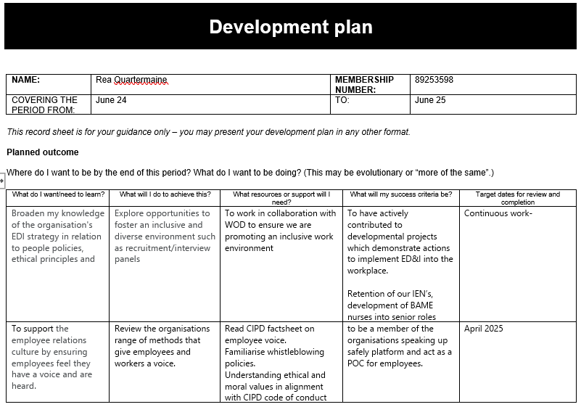
Table 1: Development plan
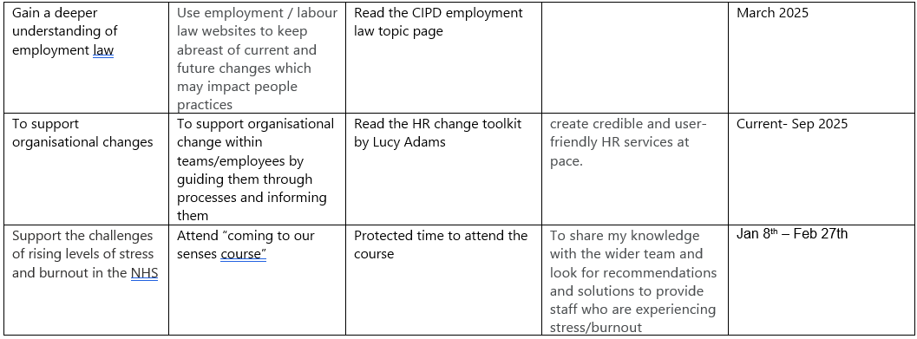
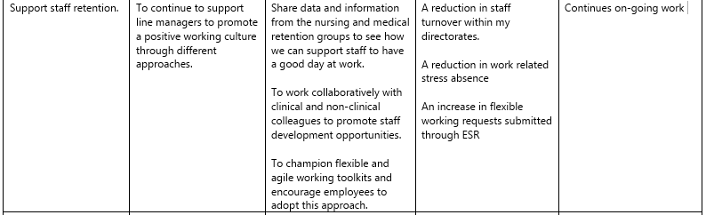

- Be able to reflect on and draw conclusions about the effectiveness of development activities.


