WADITA CATO
250498 INTRODUCTION TO HEALTH AND SOCIAL CARE WAFA NASIR
LCHS4003

Residential care homes 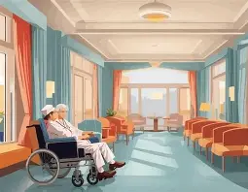
Care home services provide housing and personal support for one another who cannot live alone due to age, disability or illness. These services form a big impact on the adult social care system. Care homes are divided into residential homes and nursing homes
Residential homes assist with daily activities such as but also employ registered nurses to provide clinical care to residents with washing, dressing, eating and help administer medications. Nursing homes provide similar support medical needs.

Care homes may also perhaps focus on dementia care or support for people with learning or physical disabilities. These Services are regulated by the Care Quality Commission, which monitors and asses providers to ensure standards of safety, effectiveness and quality are being met.
Care Quality Commission (CQC) (2023)

Brief history
Sine the 17th century the UK residential care homes has evolved from poorhouses and Victorian workhouses into a regulated private and public sector system.
In the 20th century more formalised facilities and increasing regulation had been introduced to ensure safety, human rights, and care standards due to government laws

Now in the 2000s–present in Person centered care emphasises integration with health and social care systems, use of technology (electronic records, monitoring), to keep track of who is in the facility or keep records of patients.

Care homes now focus on a family orientated environment to make the patients feel safe and have a sense of comfort

Services of Care Home
1. Personal care (help with bathing, dressing, grooming)
2.Medication administration oversight
3.Timely nursing or health oversight (often through visiting nurses or on-site staff)
4, Domestic services (cooking, cleaning, laundry)
5.Social and recreational activities
6.Safeguarding and safeguarding procedures
7.Basic emergency response (alarms, call systems)

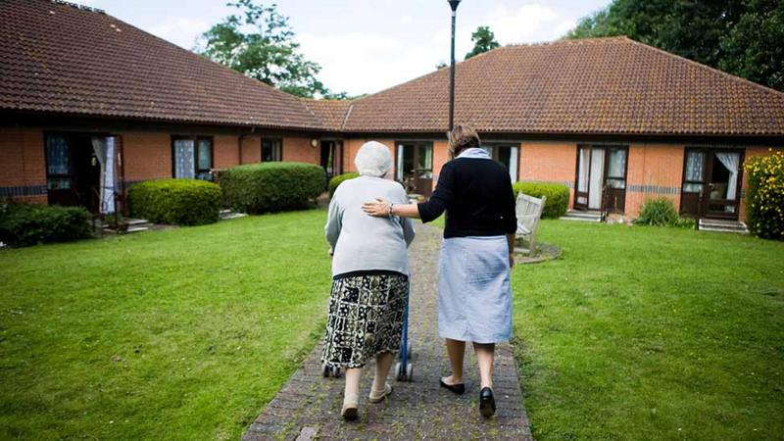
Two challenges faced by care homes

Care homes currently face severe operational pressures, primarily driven by a persistent crisis in workforce recruitment and retention, where high staff turnover and burnout levels disrupt the continuity of care essential for residents with complex needs (POST, 2025)
Furthermore, the financial sustainability of these institutions is increasingly threatened by a widening gap between rising operational costs such as energy prices and the National Living Wage and the insufficient funding provided by local authorities and councils, which significantly increases the risk of facility closures (Moore Kingston Smith, 2026).

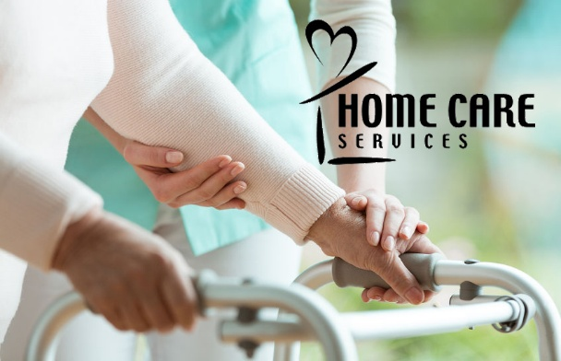

Current functioning of care homes
Care homes serve as "step-down" units to help residents regain independence after a stroke or surgery. Research shows that structured physical therapy in these settings significantly improves functional recovery and reduces permanent disability (McArthur et al., 2023).
Facilities provide a regulated environment to protect vulnerable adults from falls, neglect, or medication errors. Systematic oversight ensures a balance between resident safety and personal autonomy (SCIE, 2024).
Beyond treating illness, care homes focus on preventative health through nutrition, vaccinations, and cognitive stimulation. This proactive approach reduces emergency hospital admissions and manages chronic disease progression (Watson & Tilford, 2022).

Ambulances

Ambulance services use their origins to the need for organised patient transport in times of war and rapid urbanisation. Early forms of ambulance provision emerged from European battlefield innovations in the late 18th century, where systems were developed to get rid of wounded soldiers quickly and provide basic care before hospital admission. This laid the groundwork for more formal services in civilian contexts during the 19th century, with horse-drawn ambulances deployed in response to industrial accidents and public health crises (Sanjay and Abhilash, 2019).
Throughout the 20th and 21st centuries, ambulance services turned into structured emergency medical services (EMS) systems, putting together trained personnel protocols and advanced cars to deliver prehospital care. Contemporary histories emphasise this transformation from simple transport to complex care delivery, reflecting broader developments in emergency medicine and public health (Meadley, B 2025)

The historical development of ambulance services was shaped by warfare, urbanisation, and evolving medical knowledge. Organised casualty evacuation first emerged prominently during the Napoleonic Wars, when Dominique Jean Larrey introduced systematic battlefield transport to reduce delays in surgical treatment. His approach demonstrated that rapid removal of the wounded could significantly improve survival, making a principle that later influenced civilian practice (Porter, 2016).
During the 19th century, rapid industrialisation and growth in Europe and North America made new public health challenges, including workplace injuries, traffic accidents, and epidemics. authorities and voluntary hospitals began carrying structured transport systems to bring patients to medical facilities. In Britain, the late Victorian period saw the growth of hospital-based ambulance services, often supported by charitable organisations and local government capabilities (Woollard, 2019).
The 20th century further transformed ambulance provision through the experience of the World Wars, which sky rocketed advances in triage, communication, and mobile medical technology. Post-war health system reforms, particularly the establishment of national health services, accept ambulance services as essential components of public healthcare infrastructure. accordingly, ambulance services evolved from simple transport mechanisms into integrated prehospital care systems grounded in professional training and coordinated emergency response.
Today’s ambulance services play a big role in urgent and emergency care, but their use and effectiveness are the key to ongoing evaluation. Modern ambulances respond to life-threatening 999 calls and provide prehospital treatment, making patients at the scene or en route to hospital, with skilled paramedics and technicians equipped for care. Ambulance services also increasingly support telephone triage and see and treat models to reduce unnecessary hospital transport and improve system efficiency.
However, high demand and pressure on emergency departments have put pressure on services, leading to cuts in policy reforms. Response time and integrating care in primary and community settings. Despite investment in new vehicles and targeted improvements,

concerns remain over response delays and public trust, emphasizing the need for continued adaptation to workforce capacity and service delivery.
Ambulance services are reliable in showing the quality of care experienced by service users through the timely delivery of skilled prehospital involvement.
By providing rapid assessment, stabilization and appropriate triage, paramedics reduce medication and mortality rates and ensure patients are directed to the most appropriate care pathway. Current models emphasize patient-centred practice, clinical decision making, and community-based alternatives to the hospital visit, thereby promoting safety, continuity of care, and improved health outcomes.
References:
Meadley, B. (2025) ‘History of ambulance services, paramedics, and research’, in History of Ambulance Services, Paramedics, and Research in Paramedicine. Wiley.
Porter, R. (2016) The greatest benefit to mankind: A medical history of humanity. London: HarperCollins.
Sanjay, M. and Abhilash, K.P.P. (2019) ‘History of prehospital care’, Current Medical Issues, 17(2), pp. 42–43.
Woollard, M. (2019) Emergency care: A practical guide. Oxford: Wiley-Blackwell.
https://www.england.nhs.uk/urgent-emergency-care/improving-ambulance-services/
https://www.gov.uk/government/news/new-ambulances-deployed-to-boost-nhs-winter-response
https://nhsproviders.org/resources/nhs-activity-tracker-202425/february-2025/ambulance-sector

Moore Kingston Smith (2026) How can care homes respond to the financial challenges they face?. Available at: https://mooreks.co.uk/insights/how-can-care-homes-respond-to-the-financial-challenges-they-face/ (Accessed: 22 February 2026).
POST (Parliamentary Office of Science and Technology) (2025) Sustaining the health and adult social care workforce. Available at: https://post.parliament.uk/sustaining-the-health-and-adult-social-care-workforce/ (Accessed: 22 February 2026).

Care Quality Commission (CQC) (2023) : https://www.cqc.org.uk (Accessed: 20 February )
McArthur, C., Alizadehsaravi, N., Affoo, R., Cooke, K., Douglas, N., Earl, M., Flynn, T., Ghanouni, P., Hunter, S., Kalu, M., Middleton, L., Moody, E., Smith, C., Verlinden, L. and Weeks, L. (2023) 'Effectiveness of physical rehabilitation for physical functioning and quality of life in long-term care residents with dementia: a systematic review and meta-analysis', JBI Evidence Synthesis, 22(8), pp. 1460–1535. doi: 10.11124/JBIES-22-00407.

how care homes currently function
through Licensure and inspection by regulatory authorities to ensure safety, staffing levels, and quality of care.
Compliance with care standards, safeguarding, and rights-based care principles.
Staffing and care delivery:
24-hour coverage with care aides/assistants, shift-based scheduling, and on-call nursing support.
Individual assessment plans (care plans) developed with residents and families, updated regularly.
Medication management protocols, including administration, reviews, and allergy checks.
Resident experience:
Private or shared rooms; communal dining; social and therapeutic activities.
  - Programs designed to support physical health (mobility, nutrition), mental well-being (stimulating activities, socialization), and independence where possible.
- Health integration:
  - Regular health assessments, visiting healthcare professionals (GPs, physiotherapists, pharmacists), and coordination with hospitals when needed.
- Safeguarding and rights:
  - Clear safeguarding policies, patient rights, consent processes, and complaint mechanisms.
- Quality and improvement:
  - Monitoring outcomes (falls, infections, weight changes, satisfaction), staff training, and quality improvement initiatives.

SCIE (2024) Creating a safeguarding culture. Available at: https://www.scie.org.uk/app/uploads/2024/09/Creating-a-safeguarding-culture.pdf (Accessed: 22 February 2026).

Watson, M.C. and Tilford, S. (2022) 'Maintaining and promoting health in care homes', BMJ, 376, o183. doi: 10.1136/bmj.o183.

