

Network Attached Storage as a secure storage solution for 2 separate Offices on 2 separate Networks.

by
Shaun Davies

Supervisor: Dr Munyaradzi Nicholas Murira

Project submitted as part of the requirements for the award of
BSc (Hons) Computing (Computer Networks & Cybersecurity)

April 2023

DECLARATION

I, Shaun Davies declare that I am the sole author of this Project; that all references cited have been consulted; that I have conducted all work of which this is a record, and that the finished work lies within the prescribed word limits.

This work has not previously been accepted as part of any other degree submission.

Date : 25.04.2023

FORM OF CONSENT

I, Shaun Davies hereby consent that my Project, submitted in candidature for the B.Sc.(Hons) Computing (stream) degree, if successful, may be made available for inter-library loan or photocopying (subject to the law of copyright), and that the title and abstract may be made available to outside organisations.

Date : 25.04.2023

Table of Contents
Abstract 4
1. Chapter 1 - Introduction 5
1.2 Objectives 6
2. Chapter 2 – Research & Review of Literature 7
2.1 Benefits of NAS Solutions 13
2.2 Types of NAS Solutions 13
2.3 Factors Influencing NAS Performance 13
Chapter 3. Methodology & Implementation 14
3.1 Hardware and Software 14
3.2 Configuration of the NAS Devices 15
3.3 Network Topology 16
3.4 Creation of User Accounts and Shared Folders 16
3.5 Implementation 17
3.6 Conclusion 19
3.7 Virtual Machine 20
Chapter 4. Analysis & Evaluation 24
Chapter 5. Conclusions 25
5.1 Conclusions 25
Chapter 6. Reflection 27
Chapter 7. References 28
Appendix A. 29
Appendix. B 58

Abstract

This report presents the implementation of a Network-Attached Storage (NAS) solution to provide shared storage for two separate offices using two separate networks. The NAS was configured to create shared folders that would allow Office 1 to save, edit and delete data, while Office 2 could only copy the data to their shared folder and edit it without being able to save it in Office 1's folder or delete/edit data in it. The aim of this project was to provide a centralised and easily accessible storage solution for both offices, while maintaining the necessary level of security and control over the data and in turn enhance productivity. The objectives were to set up the NAS, configure the shared folder, and test the solution to ensure that it met the requirements. The research and literature review were conducted to gather information on the NAS technology and its applications, including its benefits, challenges, and best practices. The literature review covered the works of various authors who have researched and written about NAS and its usage, and the findings were used to inform the implementation of the solution. The report covers the implementation process, configuration, and testing of the NAS, as well as the creation of a shared folder for access to the stored data. The NAS was successfully implemented, providing a reliable and secure storage solution for both offices to share data.

1. Chapter 1 - Introduction

The need for a centralised and efficient storage solution for departments / businesses has become increasingly important with the rapid growth of data storage requirements. Small businesses or niche departments, require a reliable and cost-effective storage solution that can meet their growing data storage needs. A Network-Attached Storage (NAS) system provides an ideal solution for small businesses to store and share data without the need or reliance of a third-party provider.
The growth of digital data and the need to store, manage and access it easily and securely have led to the development of various data storage technologies. Network-Attached Storage (NAS) is one such technology that provides a centralised storage solution accessible by multiple users over a network. NAS offers several benefits over other storage solutions such as Direct-Attached Storage (DAS) and Storage Area Network (SAN). NAS is cost-effective, scalable, and easily expandable, making it an ideal solution for businesses of all sizes.
The problem facing the department in question is data is being stored using a combination of external hard drives, for the initial production and then CD/DVD’s for access and longer term storage. The problem rising from this is the need to physically store the CD/DVDs in secure storage at both locations and then the eventual archiving or destruction of those discs when no longer relevant. The other problem is that there is a delay between the production of the data and the access to the data between the offices.
The aim of this project is to implement a NAS solution for two separate offices on different networks to provide a centralised storage solution for the offices to share data. This will allow both offices to increase their productivity with faster access to the data and, reduce their physical storage such as CD/DVDs stored in secure cabinets. The objective of this project is to configure and test the NAS to ensure it is reliable, secure, and can meet the data storage needs of both offices. To also analyse the success of the NAS by clarifying if the system has allowed faster information dissemination as a result of the easier access and centralised storage.

1.2 Objectives

- To increase productivity by creating a NAS storage solution which has ease of access for staff.
- Backup data in a way that maintains its integrity and reduces risk of loss/damage.
- Create a virtual replication which can be used for testing and design experimentation.
- Carry out cyber security analysis testing the security of the NAS and Network.
- Provide recommendations to provide security for any cyber risks identified.
- Provide recommendations on how to improve NAS system and analysis of impact.

By carrying out this project this will allow both offices to archive all previous physical storage as it will no longer be required. All future archiving or destruction of material can be completed at ease and can potentially be automated. The 2 offices will have better access to the data which will allow staff to disseminate relevant information more effectively.
During the following chapters of the report the author will go on to explain their research around similar projects / research which is relevant to this project and or NAS used as a storage solution. This will detail any literature referenced within the report and how it is relevant to the project.
The author will detail the methodology used in order to successfully implement the NAS and shared folder used by the 2 offices. This will detail the products / software used and the technical details of how this was installed / used in order to create the storage location and allow secure access and file sharing between staff at both locations. The report will be as follows,

Chapter 2 provides a comprehensive review of the literature relevant to this project. The literature review includes an overview of NAS and its applications, previous studies on NAS, and network-attached storage architecture, among others.

Chapter 3 covers the methodology used in the implementation of the NAS solution. This chapter includes a detailed description of the hardware and software used, the configuration of the NAS devices, the network topology, and the creation of user accounts and shared folders.

Chapter 4 presents the results of the implementation process, including network connectivity tests, productivity analysis, and other performance tests.

Chapter 5 provides a discussion of the findings, including an analysis of the performance tests, security measures, and potential improvements.

Finally, Chapter 6 summarises the report's findings and conclusions, outlining the key points and highlighting the success of the project.

Overall, this report provides a detailed account of the implementation of a NAS solution for two separate offices using two separate networks. The report demonstrates how the project's objectives were successfully met and how the implementation process provided a reliable and efficient data storage solution for the two offices.

2. Chapter 2 – Research & Review of Literature

The idea of network-attached storage can be traced back to the early 1980s when file servers were used to store data and provide access to it over a network. However, the first true NAS device was developed in the early 1990s by Auspex Systems, which used a dedicated operating system to provide file-level access to storage devices over a network. Since then, NAS has evolved significantly, with improvements in performance, capacity, and reliability.
NAS is widely used in businesses, from small offices to large enterprises, as a cost-effective and efficient way to store data. It is commonly used for file sharing, backup and disaster recovery, virtualisation, and video surveillance. The use of NAS has also expanded to home users, where it is used to store and share personal files, photos, and videos.
Recent developments in NAS include improvements in performance and capacity, with some NAS devices now offering capacities of up to several petabytes. There have also been developments in the use of cloud-based NAS, providing a cost-effective and scalable solution for businesses.
The article "Network-Attached Storage: Data Storage Applications" by M.G.R. Kumar et al, published in the Turkish Journal of Computer and Mathematics Education in 2021, explores the various applications of Network-Attached Storage (NAS) in the field of data storage. The study aims to provide a comprehensive understanding of NAS technology, its benefits, and its role in data storage applications. The article defines NAS and its architecture, highlighting its key features such as its ability to provide easy access and efficient storage management. The article further discusses the different types of NAS devices available in the market, their features and limitations, and their suitability for specific applications.

The article elaborates on the various applications of NAS in the field of data storage. They explain how NAS technology can be used to store large amounts of data securely and efficiently. The study explores how NAS can be used for backup and recovery, file sharing, multimedia streaming, and data archiving. This is relevant to the authors report as the aim of their NAS project is utilising the NAS in a similar way by storing data securely and with ease of access. The article explains how NAS can provide a centralized data storage system that can be accessed by multiple users and devices, thereby enabling collaboration and enhancing productivity, again this is one of the aims of the authors projects and enhanced productivity will be a method of analysis during the project. [1]

The article also highlights the benefits of using NAS over traditional storage solutions, highlighting how NAS can provide better performance, scalability, and reliability compared to traditional storage solution. It shows that NAS can improve data access times, reduce data transfer times, and provide better data protection through features such as RAID (redundant array of independent disks) and snapshot backups. This was also an initial intention of the author who aims to set the NAS as a RAID in order for backup security.

Furthermore, the study provides a comprehensive overview of the key factors that need to be considered when selecting a NAS device. The authors emphasize the importance of considering factors such as performance, scalability, security, and ease of use when making a selection. This was key in the authors decision as they had to take into account not only the requirements necessary for the project but the finances available. The author found this article to be a valid reference for understanding the role of NAS technology in data storage applications and relevant to their project.

The author continued their research in this area and identified further literature that was relevant to their project and research into NAS and storage solutions. "What is NAS (network-attached storage) and how does it work?" discusses the concept of NAS and its increasing importance in the storage of unstructured data workloads. The authors, A. Bednarz and J. Fruhlinger, explain how a NAS server operates, how it differs from a SAN, and the key features that IT buyers seek in file-level storage.

They define NAS as a type of storage that allows multiple users and devices to access and share data over a network. Unlike a storage area network (SAN), which is a high-speed network of storage devices connected to servers, NAS connects directly to the network, allowing users to access data using standard protocols like Network File System (NFS).

NAS has evolved over the years, from early models with limited storage capacity to modern NAS servers that can store multiple terabytes of data. There is an increasing importance for NAS in the storage of unstructured data workloads, which include media files, virtual machine images, and other data types that do not fit neatly into a database.
In terms of performance, NAS can be optimised for various workloads using techniques like tiering and caching. More modern NAS servers often include fast connectivity options to deliver faster performance. Again, this is an important factor when considering the objectives of the project. [2]

Two similar articles that discuss network-attached storage (NAS) solutions, the first article being, "G-Technology releases new network attached storage solution," discusses the introduction of a new NAS solution by G-Technology in 2016 and the second article, "Optimization of NAS Performance for Multi-User and Multi-File Environment using Cache and Tiering," by Tirta and Shidik, discusses how to optimise NAS performance for multi-user and multi-file environments using cache and tiering.
G-Technology has introduced a new NAS solution, called the G-RACK 12, which is designed for media and entertainment workflows. The article describes the G-RACK 12 as a high-performance NAS solution that can support up to 120 terabytes of storage and provide up to 1,000 MB/s of throughput. The G-RACK 12 also includes a web-based interface for easy management and supports various protocols like NFS, SMB, and AFP.
The article highlights the importance of NAS in the media and entertainment industry, where large amounts of data need to be stored and accessed quickly. The G-RACK 12 is designed to meet the demands of this industry by providing fast, reliable, and scalable storage solutions. Although this is not the method the author aims to use, it demonstrates the scalability of NAS and the other areas it used in whereby there is a need for secure storage and fast access to data. [3]

The second article by Tirta and Shidik discusses how to optimize NAS performance for multi-user and multi-file environments using cache and tiering. The article explains that caching and tiering are two techniques that can be used to improve NAS performance in these environments.

Caching involves storing frequently accessed data in a fast, local cache to reduce the time required to access the data. Tiering involves using different types of storage devices, such as solid-state drives (SSDs) and hard disk drives (HDDs), to store data based on its importance and frequency of access. Whilst this is not yet a consideration of the authors for this project it is something to consider in the future in the ongoing development of the system.

In the article they describe a system they developed that uses both caching and tiering to improve NAS performance. The system uses an SSD cache to store frequently accessed data and a tiered storage system that includes high-performance SSDs and slower but larger HDDs.

They tested their system using various file sizes and numbers of users, and they found that caching and tiering improved NAS performance significantly. The authors concluded that caching and tiering are effective techniques for optimising NAS performance in multi-user and multi-file environments. As stated this would be something that the author may consider for their system in the future. [4]
Both articles highlight the importance of NAS solutions in different industries and discuss ways to optimise NAS performance.
NAS was initially developed as a low-cost alternative to storage area networks (SANs) for small to medium-sized businesses. However, as NAS technology improved, it began to gain traction in larger enterprises due to its scalability, ease of management, and cost-effectiveness as previously mentioned, this was a key factor in the authors decision to progress with NAS.

Like many other businesses as their amounts of data storage needs increase regularly such as multimedia files, word/PDF documents, organisations are turning to NAS solutions to store and manage this data as well as personal use, such as using a NAS system for storage of multimedia at home, for example a person with a keen interest in photography might collate a large amount of data and would not want to risk losing the images/videos they create, a NAS system can ensure regular backups and large storage capacities. [5]
The author was very aware that there were alternative options such as cloud storage, however, it was made clear that at this time, NAS was the preferred method as this meant it could be solely managed within the department and there would be no reliance on any third party. The author is aware that this project may only be as an interim solution to a longer term plan involving cloud storage being purchased and utilised across the whole organisation, however this will serve as a good solution in the interim as well as assist with productivity.
The main benefit for the author at this time is the fact that NAS is flexible and should there be a need to add storage, this is possible, should there be a need to add a further NAS at a separate location, again this can also be achieved. There is also the possibility of the NAS being deployed across virtual machines in order to allow further locations to access should this become a necessity. [6]
The continued growth of data and the increasing importance of data security and privacy are likely to drive further innovation in the storage industry. Cloud based storage is highly likely to play a key role in the future of storage systems for the department and already do so in modern society. [7]
NAS has previously been utilised in a similar manner to that of the authors project in relation to medical images, at a veterinary practice. This was seen as a cost-effective solution and again one that could be maintained by the practice themselves. To further reduce the cost, open-source software was used as well as commercial NAS.
Their system was designed to be easy to install and use, with a user-friendly interface that allowed the veterinarians to quickly and easily access and manage medical images. Much like the objectives of the authors project which will allow staff to quickly access the data they need utilising a simple shared folder. The veterinaries found that it was highly effective at managing medical images. The system was easy to use and highly reliable, and provided significant cost savings compared to traditional other considered options. [8]
Cybersecurity threats to SMBs' file-sharing systems can have devastating consequences, leading to financial loss, damage to reputation, and potential legal issues. Therefore, it is critical for SMBs to take appropriate cybersecurity measures to protect their file-sharing systems from cyberattacks. In this report, we will examine some of the most significant cybersecurity risks to SMBs' file-sharing systems and provide recommendations for cybersecurity tools that can help prevent these risks.
One of the most significant cybersecurity risks to SMBs' file-sharing systems are data breaches. Data breaches occur when cybercriminals gain unauthorised access to the SMBs' file-sharing systems and steal sensitive data. SMBs are at an increased risk of data breaches as they may not have the resources to implement advanced cybersecurity measures. Cybercriminals have previously exploited SMBs' cybersecurity infrastructure to steal sensitive data, when not secured sufficiently. This can lead to financial loss, damage to reputation, and potential legal issues. [9]

Malware is another significant cybersecurity risk to SMBs' file-sharing systems. Malware refers to malicious software that cybercriminals use to gain unauthorised access to SMBs'. Malware can be delivered through various methods, including email attachments, malicious websites, or social engineering attacks. Once installed on the SMBs' file-sharing systems, malware can steal sensitive data, damage files, and disrupt the SMBs' operations. [10]

Phishing attacks are a prevalent cybersecurity risk to SMBs. Phishing attacks refer to social engineering attacks in which cybercriminals trick SMB employees into revealing sensitive information, such as login credentials, through email or other forms of communication. Phishing attacks can also be used to gain unauthorised access to steal sensitive data or worse. There are already systems in place that are well advertised within the department to assist staff from avoiding these types of attacks as well as the use of Microsoft 365 which scans attachments and notifies the user if the sender is not within their organisation or, someone who they do not receive emails from frequently.

Ransomware is a type of malware that is also popularly used to gain unauthorised access to SMBs' file-sharing systems and encrypt files, making them inaccessible to the SMBs. Cybercriminals then demand a ransom payment in exchange for the decryption key. Ransomware attacks can be devastating for SMBs, as they can lead to the loss of critical data and significant financial loss, even if the company comply with the criminals’ demand as there is no guarantee they will be given the correct method to decrypt the malware.

2.1 Benefits of NAS Solutions

NAS solutions offer several benefits to organisations. One of the primary benefits is centralised data storage. NAS solutions provide a centralised location for storing data, which makes it easier for users to access and share data. Additionally, NAS solutions are easy to manage and maintain, which helps to reduce the overall cost of ownership.

2.2 Types of NAS Solutions

There are several types of NAS solutions, including hardware-based NAS solutions and software-based NAS solutions. Hardware-based NAS solutions are standalone devices that are designed specifically for storing data. They are typically more expensive than software-based solutions, but they offer better performance and more features. Software-based NAS solutions, on the other hand, are installed on existing hardware, such as servers or personal computers. They are typically less expensive than hardware-based solutions, but they offer lower performance and fewer features.

2.3 Factors Influencing NAS Performance

Several factors can influence the performance of NAS solutions, including network bandwidth, disk speed, and RAID configuration. Network bandwidth is a critical factor in determining the performance of NAS solutions since it determines the speed at which data can be transmitted over the network. Disk speed is also essential since it determines how quickly data can be read and written to the disk. The RAID configuration can also affect the performance of NAS solutions since it determines how data is stored and protected on the disks.

Chapter 3. Methodology & Implementation

In this chapter, the author details the methodology used in the implementation of a 32TB QNAP Network Attached Storage (NAS) solution for two offices across two separate networks. The author covers the hardware and software used, the configuration of the NAS devices, the network topology, and the creation of user accounts and shared folders. The implementation of this solution was crucial for the efficient sharing of data between the two offices to ensure the availability and security of the data.

3.1 Hardware and Software

The implementation of the NAS solution involved the use of QNAP TR - 004 NAS devices, which have a total capacity of 32TB across 4 bays. The devices were selected because they offered high-performance, scalability, and flexibility. The NAS devices were configured with 128GB RAM, Intel Xeon D-1531 6-core 2.2GHz processors, and ten Gigabit Ethernet ports. These specifications were critical in ensuring the devices could handle the high volume of data shared between the two offices.

In addition to the hardware, the software used included the QTS operating system, which is a web-based platform for managing the NAS devices. The QTS operating system provides features such as file sharing, backup and recovery, security management, and cloud integration. This software was essential in managing the devices and ensuring that the data was available and secure.

3.2 Configuration of the NAS Devices

The NAS devices were configured using the QTS operating system, which provided an easy-to-use web-based interface. The first step in the configuration was to set up the RAID configuration. The RAID configuration involved the grouping of the hard drives in the NAS devices into a logical unit to ensure data redundancy and availability. In this implementation, the author opted for a RAID 6, which provided redundancy for up to two hard drives.

The next step in the configuration was to set up the network settings for the devices. The NAS devices were connected to two separate networks, and each device was assigned a static IP address. This configuration was crucial in ensuring that the devices could communicate with each other and with the devices on their respective networks.

To ensure that the NAS devices were accessible to the users, the author configured the shared folder settings. The shared folder settings allowed the users to access the data stored in the NAS devices through the network. The author created a shared folder on each device and set permissions to allow access to specific users to have specific permissions/access. The shared folder settings also allowed the author to ensure data was not accidentally deleted by someone who did not have the relevant permissions to do so.

3.3 Network Topology

The network topology used in this implementation involved two separate networks connected via a router. Each network had its own internet connection and a separate subnet. The NAS devices were connected to the router using Gigabit Ethernet ports, and each device was assigned a static IP address on its respective network.

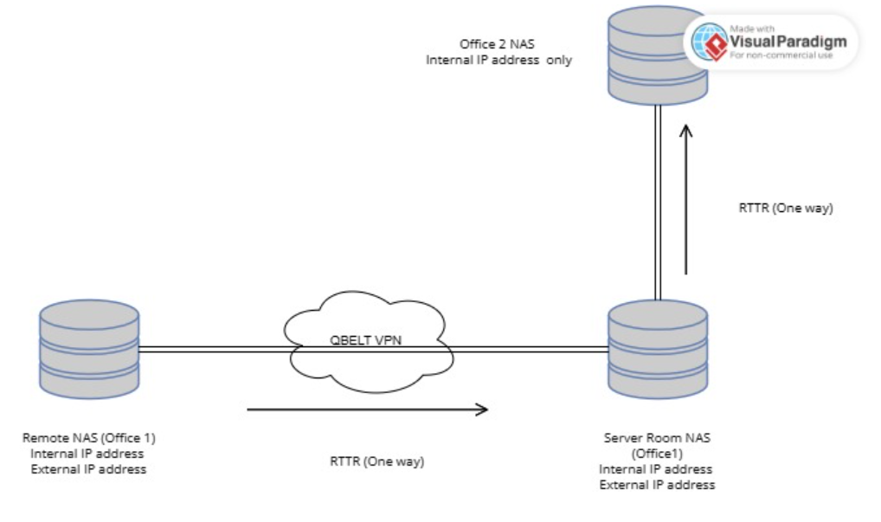 [11]

The network topology allowed the devices on each network to communicate with the devices on their respective network and the devices on the other network. The router provided the necessary routing and firewall rules to ensure that the data traffic was secure and that the devices were protected from external threats.

3.4 Creation of User Accounts and Shared Folders

The final step in the implementation of the NAS solution was the creation of user accounts and shared folders. The author created user accounts for each user in both offices, and each user was assigned a username and password. The user accounts were configured with the necessary permissions to access the shared folders. The user account for Office 1 was assigned permissions to read, write, save, and delete data (Full control) in Office 1’s shared folder and read and copy in Office 2’s shared folder. Office 2 were then assigned the reverse of this in relation to their respective shared folders. The shared folders on each NAS device were created and were named after the respective offices.

3.5 Implementation

After careful research into NAS providers as well as advice from peers, the decision was made by the author to purchase QNAP devices. A requisition was made and authorised for 3 x 32TB QNAP NAS devices (TR-004). 2 x Laptops were already available for use as well as the necessary network cables. This maintained the low-cost scope of the project. Once the devices arrived, they were unpacked and checked for any damage and to ensure all the component parts were there prior to the setup.
The author then began the initial setup process which first involved powering up the NAS device and connecting it to the server. The author had been granted authorisation to access the server for this purpose. A web browser was opened on the server device and the IP address of the NAS was entered. From there you are required to access the NAS web interface being QNAP QTS. This is where the administrator account is setup along with the network settings and configuration of the RAID setup required.
The author decided to use a RAID 6 configuration (Redundant Array of Independent Disks), this is recommended for best data protection and performance. This is because RAID lends itself to the NAS system as it is likely to run for 24 hours a day, 7 days a week. The fact that the NAS will be run for an extensive period of time it is crucial that safeguarding of data loss due to a malfunction to one of the drives such as a complete breakdown, is crucial. The RAID setup creates a redundancy portion with the hard drives which stores an exact copy of the data, this then allows the data to be fully recovered should one of the drives break down.
The RAID level 6 gives the optimum level of capacity against redundancy overall. Like most other RAID types, a RAID 6 distributes data among the drives, but on each sweep, one of the drives is given a tiny bit of information known as parity data. The foundation of the remaining data on the other discs is made up of a set of checksums. The next drive along is then chosen for the parity data during the subsequent sweep of data writing. In the case that a single disc fails, you can do this to recover all of the data. This is the option that prioritises safety over the best pricing per GB.
Once this was completed the author conducted PING tests via the command line in order to confirm connectivity. The next step was to then access File Station 5 in order to begin creating the shared folders. File Station 5 is an easy to use file management system allowing the user to access NAS file systems via a web browser. This allows the user greater flexibility and remote access to carry out any administrative actions when required and not have to physically attend each individual location for the NAS itself.
The next task for the author was to create the shared folders, this was conducted by accessing the File Station 5 app in the NAS web interface. The author created 2 folders, one folder was for the sole access of Office 2, this folder contained information for staff at this location only and office 1 were not required to access. The purpose of this folder was for storage and security purposes as opposed to ease of access and sharing, permissions were then set so that office 1 had full control over the folder. This was necessary so that in the long term the folder could be maintained by the staff and the content within in it. The type of shared folder was SMB share, (Server Message Block). SMB share is a type of network share that allows multiple users and computers to access and share files and folders on a Windows-based computer or server. This would then allow the author to map the drives on the devices used to access the folders and test permissions.
The author then created a second folder, this folder was for use by both offices in order to share access to data for productivity and ease of access. The author set permissions for office 1 to have full control as they will ultimately have overall responsibility for the data and how/when it is shared. Office 2 were given read and execute, read, write and list folder contents. These permissions allow office 2 access to the data as required for their role but deny them the ability to delete. This avoids any accidental deletion of data. To properly allow access, permissions were needed to allow the relevant offices to connect to the folders. This meant having to map the network drive so that the path to the shared drive was set, for example Z:\Device_Name\shared_folder, once this was completed the folder was accessible. The IP addresses of office 2 and the server were added to the privilege settings of the SMB share so that these IP addresses were the only ones allowed to access the folders. This gave a layer of protection to the NAS and its data so that the risk of unauthorised access is limited. Office 1 however was located at a separate location on a separate network. This required port forwarding to be enabled and a VPN tunnel to be created.
The author confirmed that the connection was accessible by creating a file within the shared folder and checking access from the server room and office 2 then, ensuring the permissions were set and working correctly.
Once the author had confirmed the connection between the first 2 NAS devices, the next task would be then to connect the third device located in Office one. This would require port forwarding to be enabled, this had to be sought from the ICT team and a full explanation as to why. There was a delay in achieving this as there were higher priority requests that needed ICT attention but, it was eventually configured.
The third device was then setup at the office 1 location. To enable the VPN tunnel to be created, the author had to initiate the VPN connection via QNAPs QBELT VPN service, there were other options in relation to the VPN tunnel as QNAP devices offer PPTP which is one of the oldest point to point tunnelling protocols by Microsoft and one of the fastest, however, QBELT was designed around security and offers lower chances of the connection detection as a VPN, this further reduces the possibility of network traffic interception.
The author accessed the router and configured the QBELT VPN server settings, allocating the IP addresses allowed and creating the admin account for the username and created an appropriate password. The author then had to access the VPN server attached to the NAS located at the server room / office 2 and configure the VPN client via the QVPN service and setting the VPN client with the IP address of the remote NAS located at office 1. Once configured correctly this was then connected to initiate the VPN connection. Once the connection is created you will see a status message in green stating “Connected”. On the first attempt this was not the case for the author and troubleshooting commenced. It was quickly identified that the wrong IP address for office 1 had been entered and this was the fault preventing connection, once this was rectified the connection was confirmed.
The author then mapped the network drive for access to the shared folder for office 1 as previously conducted in earlier in the report and confirmed connection by placing a file within the folder and checking access and permissions.
The final stage for the author was to ensure a regular backup was being conducted. The author began by enabling backup services through QTS interface and selecting remote replication.
The preferred backup period was daily due to the important nature of the data and need for regular access. Within the remote replication the schedule section is offered, within this area you can then select the necessary schedule, the author then set this to daily. Compression was enabled as many of the files themselves would be relatively small, therefore having compression meant that the system would be able to access compressed files quicker than it would uncompressed files. Using RTTR (Real-Time Traffic Redirection) allowed network traffic to be redirected from one path to another in real-time. This can be helpful in situations where it is necessary to balance network traffic across multiple paths or to reroute traffic in the event of a failure. The backups would be from the remote NAS to the server NAS (one way) and then from the server NAS to the Office 1 NAS (One way), this was configured by inputting the IP address, username and password of the destination NAS unit.

This meant that the data being backed up to the NAS device over a network connection had the failsafe that should the primary network interface fail, RTTR can automatically redirect traffic to a backup network interface to ensure that the backup process can continue without interruption. This helps to ensure that the data is backed up reliably and without interruption, even in the event of a network failure.

3.6 Conclusion
In conclusion, the implementation of a 32TB QNAP NAS solution for two offices required careful planning, configuration, and testing. The hardware and software used were selected based on their scalability, flexibility, and high-performance capabilities. The configuration of the devices involved the setup of the RAID configuration, network settings, and shared folder settings. The network topology used ensured that the devices on each network could communicate with the devices on the other network, and the creation of user accounts and shared folders ensured that only the authorised users could access the data stored in the NAS devices. The implementation of this solution has enabled efficient sharing of data between the two offices, ensured the availability and security of data, and provided a scalable and flexible solution for future growth. Redacted screen captures of the process have been provided in Appendix A.

3.7 Virtual Machine

In order for the author to demonstrate their work it was necessary to create the same NAS setup or as similar to, in a virtual setting. This was to protect the integrity of the actual NAS system and its data which could not be shared. The author did so by creating virtual machines using free virtual machine software - Oracle VM Virtualbox. This was due to the fact that the author has previously used this software on a number of occasions.
The author began by creating the virtual machines to replicate what was in place physically, they created a windows server using windows server 2019 (64-bit) ISO. Once the install was complete the author created the user account details as follows,

User – Admin
Password – Net123!
They then created 2 windows 10 PCs, one for Office 1 and another for Office 2. Both were created using the Windows 10 ISO and following installation were given the following user details,

User – OffPC1
Password – Net123!
User – OffPC2
Password – Net123!
The author used the same password for simplicity but would not to do this in any other circumstances as this would present a risk to the integrity of the system and its data.

Following the successful installation of the devices it was then necessary to create a NAS using free online software which was compatible with virtualbox. One such software was TrueNas (Previously Freenas). TrueNAS is an open-source network-attached storage (NAS) solution that offers a number of benefits over other similar software.

TrueNAS offers a range of data protection features, including built-in ZFS support, snapshotting, and replication. These features help ensure that the users data is protected against corruption and loss. TrueNas is highly scalable and can be easily expanded to meet the needs of growing businesses. This makes it an ideal solution for companies that need to store large amounts of data.
The author found that TrueNas offers a simple and intuitive user interface that makes it easy for users to configure and manage their storage systems. This means that even non-technical users can get up and running quickly with TrueNAS.
Overall, TrueNAS is a powerful and versatile NAS solution that offers a range of benefits over other similar software. Its data protection, scalability, ease of use, high performance, and cost-effectiveness make it an ideal choice for businesses of all sizes and making it the most applicable choice for the author. [12]
The author then began to install TrueNas, first, the author created a new virtual machine (VM) with the name NAS. The machine was assigned 2 virtual drives, this was so one could be utilised for the installation process of TrueNas and the other could then be used as the storage in which shared folders could be created.
Once the VM is created the author then added the ISO for TrueNas version 13 and ensured that the right ISO type was selected, being FreeBSD (64-bit). The VM was then powered on and the TrueNas ISO booted, this brings the user to the installation guide. The user should then follow the on-screen installation guidance which prompts the user as it goes. The author selected the relevant disk (ada0) where the system should be installed, leaving the other disk (ada1) free, the user is also prompted to enter a password for the root, doing so will allow you access to the interface on completion of the installation.
Once the installation process is complete the author ejected the ISO image from the VM as prompted by the installer. Once this was done the VM is then rebooted, again the install guide is displayed however, once it automatically boots it will begin by finishing some post installation tasks and on completion will present the console setup. There the IP address of the TrueNas interface is listed, the user then uses this IP address in a web browser to access the interface using the username of “Root” and the password created on installation.
Upon accessing the interface, the user should complete the Network interfaces. The first interface em0 is automatically set with DHCP (Dynamic Host Configuration Protocol) which is used to automatically assign IP addresses. This needs to be changed and the IP address given from the installation should be entered, this means that on loading the TrueNas, the IP address is now static and will not change. The second interface is then set with DHCP.
Setting up one interface with a static IP address and the other with DHCP for TrueNAS is necessary for a few reasons. By setting one interface with a static IP address and the other with DHCP, you can easily manage the network connections. The interface with the static IP address will always have the same IP address, which makes it easier to configure other devices to communicate with the TrueNAS server. The interface with DHCP will automatically obtain an IP address from your network's DHCP server, which allows it to connect to other devices on the network without manual configuration.
Configuring two network interfaces on the TrueNAS server, provides redundancy for the network connections. If one interface fails or loses connectivity, the other interface can continue to provide network access to the TrueNAS server.
Overall, configuring one interface with a static IP address and the other with DHCP provides flexibility and ease of management for the TrueNAS server's network connections.

The authors next step was to create a new dataset using the spare disk mentioned previously (ada1). Within the TrueNas interface this is carried out by creating a new “Pool”. The user selects the disk required to be used as a pool, and assigns a name, in this instance the author named the pool “OpsPool” and selected encryption, this meant that TrueNAS will encrypt all data on the pool using the ZFS encryption feature. This means that data on the pool will be protected against unauthorised access if the drives are removed from the system. Full disk encryption is designed to protect against physical theft of the drives. Once the pool is created the user is provided with an encryption recovery key giving the ability to unlock the pool, without the key this cannot be done. AES – 256 encryption is used as standard but there are other options available to the user, AES-256 encryption is a widely used symmetric encryption algorithm that uses a 256-bit key to encrypt and decrypt data. It is a secure and robust encryption standard that is used to protect sensitive data and communications and is widely adopted by industries and organisations around the world. The AES-256 algorithm uses multiple rounds of substitution and permutation operations to create a ciphertext that is difficult to decipher without the correct key. It is considered to be one of the strongest encryption algorithms available today and is used in a variety of applications, including secure messaging, online transactions, and data storage.
The data compression level is pre-set by TrueNas at LZ4, this is due to the fact that LZ4 maximises performance by dynamically identifying the best files to compress. The RAID layout is also pre-selected based on the device being used, the STRIPED layout is selected in this instance as there is no other choice for the type of disk. This means that RAID 0 is implemented meaning that data is evenly distributed across all disks in the pool, with no redundancy. This layout provides the highest performance but offers no protection against disk failures. This is in contrast to the RAID 6 setup for the physical NAS in place.
The authors next process was to begin creating a folder within the pool which could then be shared as a WebDav folder. WebDAV (Web Distributed Authoring and Versioning) folder is a type of shared folder that allows users to access and manage files stored on a remote server using the HTTP or HTTPS protocol. It provides a standardised way for users to collaborate on and edit files over the internet, similar to using a local file system. With WebDAV, users can create, delete, edit, and move files and folders on the remote server, and changes are automatically synchronised across all devices and users with access to the folder. WebDAV folders are commonly used for remote file access, content management systems, and collaborative document editing. Due to the fact this was now a virtual environment, the author wanted to explore the different options available as opposed to going straight to the same setup.
To begin the creation of the folder the author accessed the Shell and listed the directories and navigated to the Pool that had been created, OpsPool. They then created a folder within the pool called OpsShare. To test that this had been successful, the author navigated (cd OpsShare/) to the folder and created another folder called “Test”. In order to make the folder a WebDav folder then the author had to do so by adding it in the WebDav folder section of Truenas. The author did so by giving it the same name as had been created in Shell and then confirmed the path (/mnt/OpsPool/OpsShare). The change user & group ownership box was selected, this meant that the user and ownership would automatically be changed from root and wheel to WebDav for both.
The author then set a password for the WebDav folder which would be required in order to access and have use of the folder, this is done via the services section, the author then assigned a strong password. Following this the author then began to test connection, this was carried out by entering the IP address of the folder along with the port number (8080) and the location of the folder. When entering this into a web browser the user is then asked for the username and password, the username is webdav and the password is the one created by the author.
However, on reflection the author then decided that this may not be the most appropriate type of shared folder due to the outdated format. Instead the author opted to create a Windows Share or SMB share (Server Message Block). Windows share or SMB share is a type of network share that allows multiple users and computers to access and share files and folders on a Windows-based computer or server. When a folder or drive is shared, it becomes accessible to other devices on the network, allowing users to read, write, and modify files as necessary.
Windows shares allow administrators to control which users or groups can access a particular shared folder or drive, and what type of access they have (read-only, read/write, etc.). When a user accesses a Windows share, they are typically prompted to enter their username and password to authenticate their identity before they can access the shared folder or drive. SMB is a widely used protocol that is supported by most modern operating systems, including Windows, macOS, and Linux, making it an ideal choice for sharing files across networks.
The author created 2 users Off1 (Office 1) and Off2 (Office 2) and created 2 separate Groups Office1 and Office 2. Off1 was assigned Office 1 as their primary group with Office 2 being their auxiliary group, the opposite was then applied for Off2. The author then created the dataset within the OpsPool named TeamShare, they then edited the permissions of the dataset by selecting Off1 as the user and applying the Office1 group and set the ACL (Access Control List) to restricted. A task was then created in order to periodically take Snapshots of the dataset, this was to assist in identifying any changes to the dataset and would assist in troubleshooting. This was set to every minute for this instance and set so that if there were no changes to the dataset then there will be no Snapshot, this will make it clear that there have been changes when checking.
The Windows Share to OpsPool/TeamShare was then created and the service was enabled. The next step was to then mount the share to a windows device. The author then accessed the NAS device located on the Network, from there they were able locate the TeamShare folder, by right clicking on the folder you can then assign a letter to the drive and select the “Reconnect at sign-in option” for convenience.
Once mapped the author then created a word document within the folder named “TEST” and edited the document to show that read and write permissions were correct. This then gave the user a folder for use as in any other folder on any of the devices drives, this then matched the physical NAS setup and provided the same usage and ease of access, it is far more suitable and user friendly than the WebDav Folder. Screen captures are listed within Appendix A.

Chapter 4. Analysis & Evaluation

In order for the author to properly evaluate the NAS system that was now in place, they wanted to test its security using cyber security methods gathered during the research process. The safest way to do this and in order not to risk the integrity of the actual system, was to carry this out in a virtual environment. That way any accidental deletion of data or corruption data could be rectified by reverting to a previous snapshot of the VM.
The author started by creating a Kali Linux VM, a prebuilt machine can be downloaded from the Kali Linux website which comes pre-built with all the necessary tools you require in order to begin pen testing and carrying out vital assessments of your system. However, the author decided to install from ISO in order to install the tools that they would prefer.
Once the installation was completed the author was able to login and begin pen testing the SMB. The author began by opening a command line and utilising the NMAP tool. Nmap (Network Mapper) is a powerful open-source tool used for network exploration, management, and security auditing. It is designed to scan networks and identify hosts and their services, as well as provide information about the operating system, open ports, and potential vulnerabilities. Nmap can be used for a wide range of tasks, including network inventory, network mapping, service enumeration, OS detection, and vulnerability scanning.
In this instance the IP address is known, there is many ways this can be found if not known, such as Ping scan. The ping command can be used to scan the local network and find live hosts. For example, "ping -c 1 [network address]/[subnet mask]". This will send a ping request to all hosts in the specified network address range and show the hosts that respond.

An ARP scan can be used to discover hosts on the local network that are not responding to ping requests. To perform an ARP scan, run the following command: "arp-scan [network address]/[subnet mask]". This will send ARP requests to all hosts in the specified network address range and show the MAC addresses and IP addresses of the hosts that respond.
These were just 2 examples the author has listed however for the purpose of this testing the IP address was used. The author proceeded to enter the following command “nmap -p 139,445 –script smb-enum-shares.nse [SMB IP ADDRESS]”. Once this command was completed, if the shares are not secure it will list the along with their names, paths, and permissions.
Another tool available to the author was enum4linux. The enum4linux tool can be used to enumerate information about an SMB share, including usernames and shares. The command the author used for running enum4linux was “enum4linux -a [target-IP]”.

The author then utilised another Kali tool called smbclient, using the command smbclient //[IP ADDRESS]/[Share_Name] the tool attempts to gain access to the share and its contents.
It is quite clear that not properly securing an SMB share can be devastating for the owner/business it is associated to. As there are many ways SMB shares can be exploited if they are not carefully configured to protect against unauthorised access.
In order to attempt to combat the cyber security risks identified, the author has made the following suggestions,
Ensuring that strong authentication mechanisms are implemented to control access to the SMB share. This includes using complex and unique passwords, multi-factor authentication, and disabling anonymous access.
Using encryption to protect data in transit between clients and the SMB share. You can configure SMB encryption on the server-side by enabling the "EncryptData" registry value, or on the client-side by setting the "Encrypt data" option in the Windows file sharing settings.
Using a firewall to block unauthorised access to the SMB share from outside the network. Configure the firewall to only allow traffic on the necessary ports and from trusted hosts. Further to this there are a number of routers that have firewalls built in such as those provided by Draytek, Cisco, Asus, TP-Link etc. A firewall in the router provides protection against unauthorised access to the network from the Internet. The firewall can be configured to block traffic based on various criteria such as IP address, port number, protocol, and application. The firewall can filter out unwanted traffic such as spam, viruses, and malware, which can help prevent them from reaching the network.
VPN connectivity, which allows secure remote access to the network from remote locations. VPN connections are encrypted and authenticated, which adds an additional layer of security. QoS management, which allows you to prioritise network traffic based on application, user, or device. This can improve network performance and ensure that important applications or services have sufficient bandwidth.

As well as the above steps, the author states that regular updates of the client and SMB server software will keep them up to date with the latest security patches. Access control lists should also be created to only allow specific users and groups.

Chapter 5. Conclusions

5.1 Conclusions

In order to establish if the project had achieved its objectives, the author aimed to gather feedback in relation to the NAS system that was put in place, directly from the staff that were utilising it. An example of the questions asked are as follows,

What impact has the NAS system had on your day-to-day role?
Compared to the previous process, on average how much time does the NAS system save you?
Has the NAS system improved your productivity?

The full set of questions can be found in Appendix B. however the response was overwhelmingly positive. The main factors that returned positive feedback was the ease of access to data and the increased productivity. This was due to the fact that there was instant access to the data instead of having to sift through physical discs etc. This allowed the staff more time to concentrate on their report and in turn assisted in the office output being significantly improved. On average most staff members stated they saved over 30 minutes from use of the NAS.

The author also concluded that to ensure that the SMB remain a success then efficient upkeep of the share and its security is key. A share security policy would have to drafted in order for those users to agree to the terms set out in the policy, for example not sharing usernames or passwords, having effective password policies to prevent lazy password configuration. Limiting the IP addresses that have access by creating an access list and installing a more secure router.

Chapter 6. Reflection

The NAS solution implemented by the author is a secure short-term solution to a specific issue for the associated department. In the longer-term the author foresees there may be a greater reliance on cloud storage which can offer further security along with additional features. There may also be a requirement for a niche system to be built in order to assist in data assurance. For example, the system could actively monitor the data and perform archiving tasks. The date would have to be assigned to a category which would determine how long the data is retained before being archived or deleted entirely, once the data is within 30 days of its expiry a warning could be sent to the user to review with an option of extending or recategorizing.
However, this comes at a cost, such a system would likely have a significant financial cost as opposed to the NAS solution, however this may be achieved by implementing the software across a range of departments in order to share the cost and to provide a more fluid service.
At the current time the author believes that the NAS solution has completed its objectives by providing a secure area for ease of access, allowing for increased productivity at a relatively low cost and low maintenance.

Chapter 7. References

[1] | M. G. R. K. e. al, ""Network-Attached Storage: Data Storage Applications"," Turkish Journal of Computer and Mathematics Education, vol. 12, no. 12, pp. 2385-2396, 2021.
[2] | A. B. a. J. Fruhlinger, "What is NAS (network-attached storage)," Network World (Online), 2021.
[3] | Coventry: Normans Media Ltd., "G-Technology releases new network attached storage solution.," Telecomworldwire, 2016.
[4] | M. B. W. Tirta and G. F. Shidik, "Evaluation performance of cloud computing with network attached storage for video render," in International Seminar on Application for Technology of Information and Communication (iSemantic), Semarang, 2017.
[5] | J. Zyskowski, "Net storage gets serious," Federal Computer Week, vol. 15, no. 1, p. 42, 2001.
[6] | "Review: Software-based NAS offers free/low-cost storage: Software-based network attached storage (NAS) allows for deployment on your hardware of choice, on a virtual machineor in the cloud," Network World (Online), 2013.
[7] | R. J. M. &. B. Truskowski, "The evolution of storage systems," IBM Systems Journal, vol. 42, no. 2, pp. 205-217, 2003.
[8] | P. C. E. C. A. G. a. L. M. D. Costanza, "Description of a low‐cost picture archiving and communication system based on network‐attached storage," Veterinary radiology & ultrasound, vol. 63, no. 3, pp. 249-253, 2022.
[9] | Verizon Business, "Data Breach Investigations Report 2021," 2021. [Online]. Available: https://www.verizon.com/business/resources/reports/dbir/. [Accessed 10 Mar 2023].
[10] | Cisco, "What Is Malware," Cisco, [Online]. Available: https://www.cisco.com/site/us/en/products/security/what-is-malware.html. [Accessed 10 Mar 2023].
[11] | Visual Paradigm Online, "Free Network Diagram Software," [Online]. Available: https://online.visual-paradigm.com/diagrams/solutions/free-network-diagram-software/.
[12] | TrueNas, "TrueNas," TrueNas, 2023. [Online]. Available: https://www.truenas.com/truenas-enterprise/. [Accessed 2 Apr 2023].
[13] | Survey Monkey, "Surevy Monkey," [Online]. Available: www.surveymonkey.com. [Accessed 01 Apr 2023].

Appendix A.

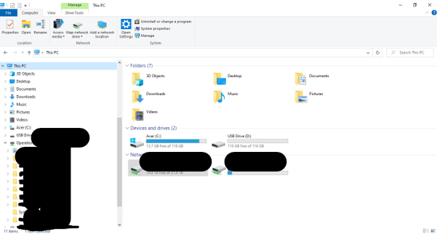

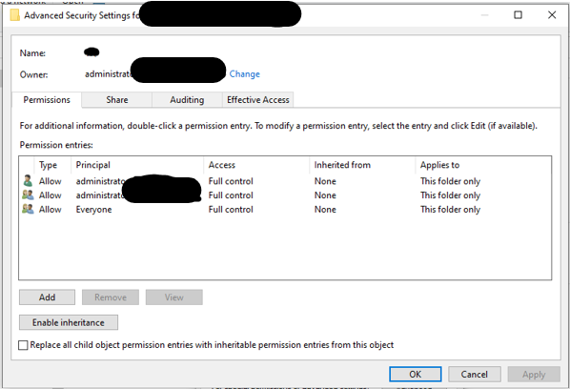

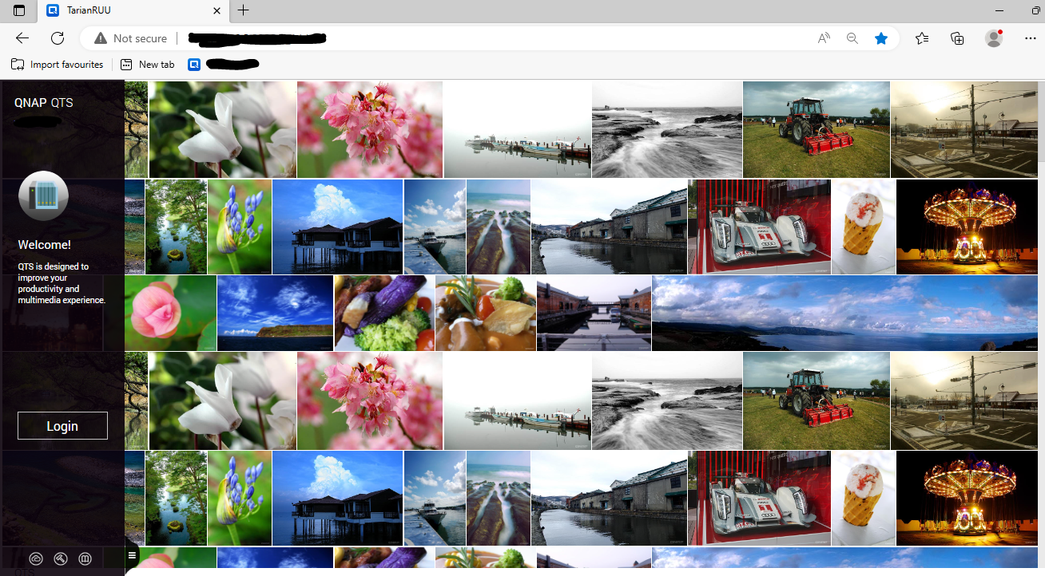

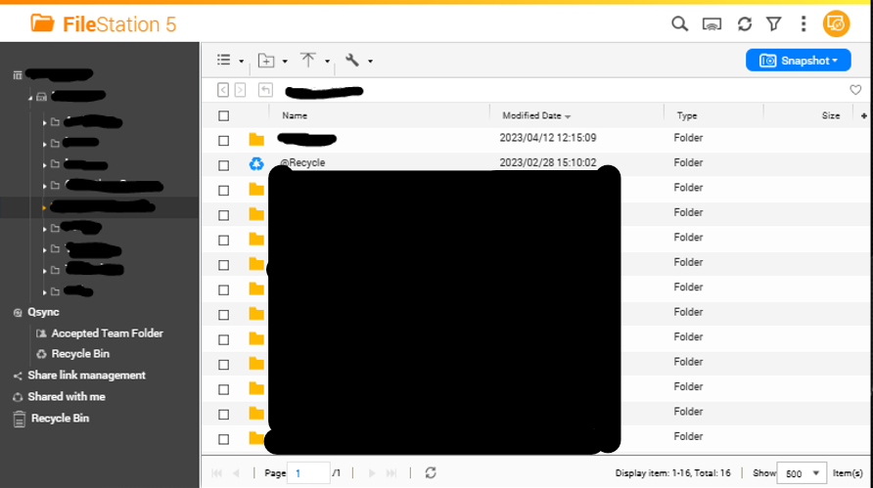

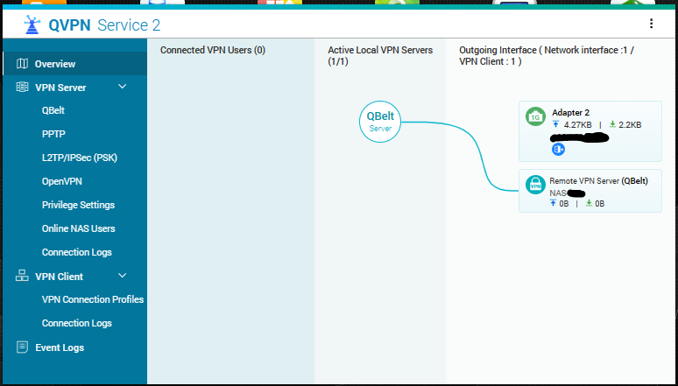

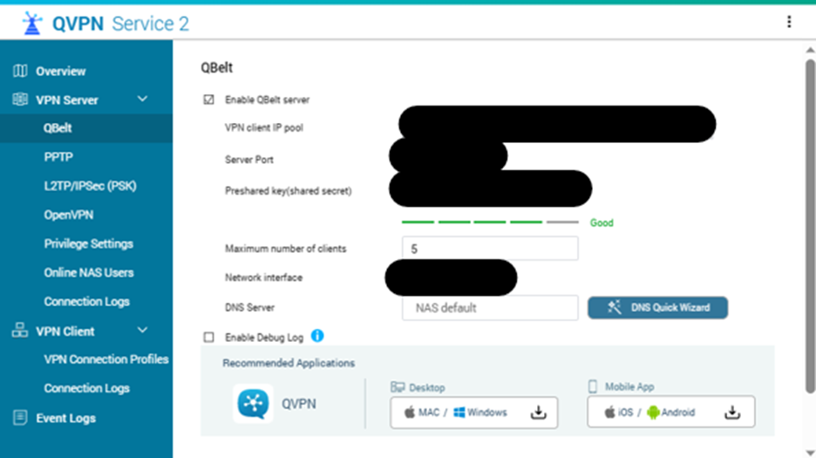

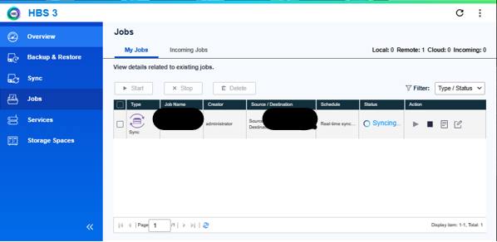

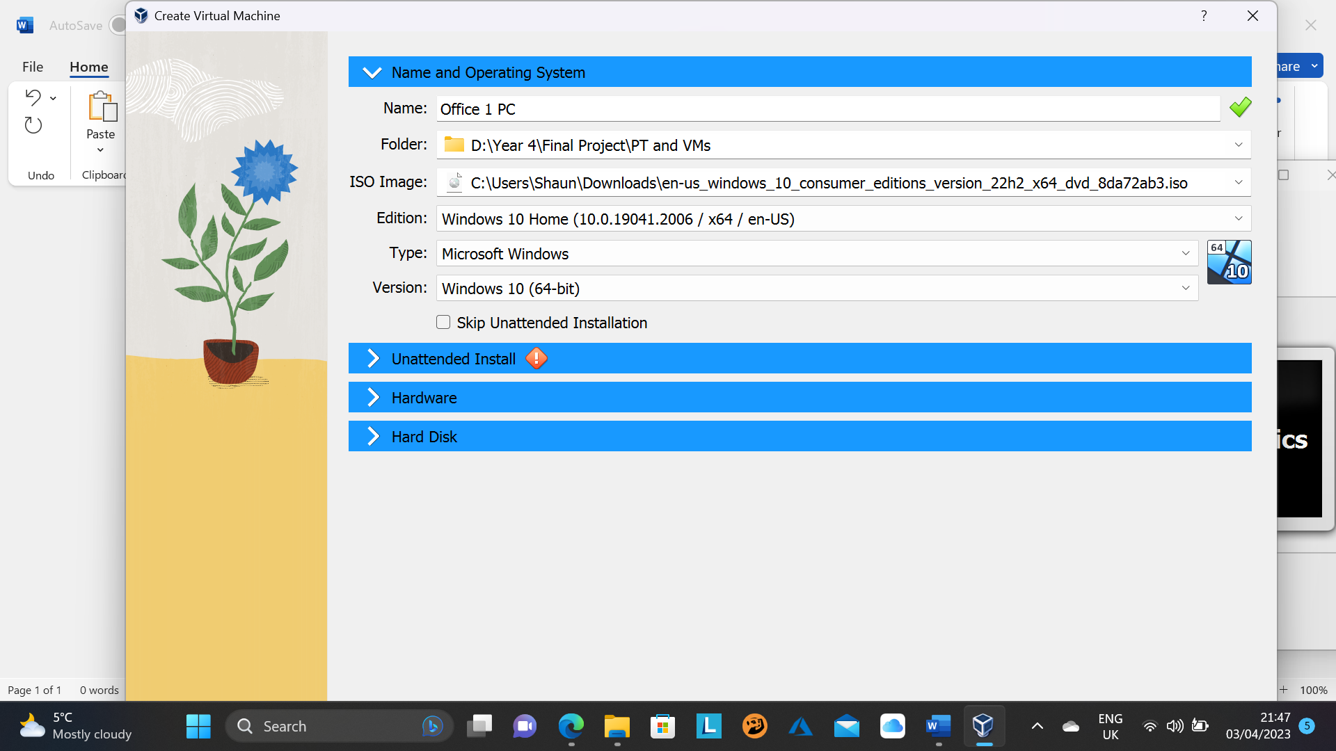

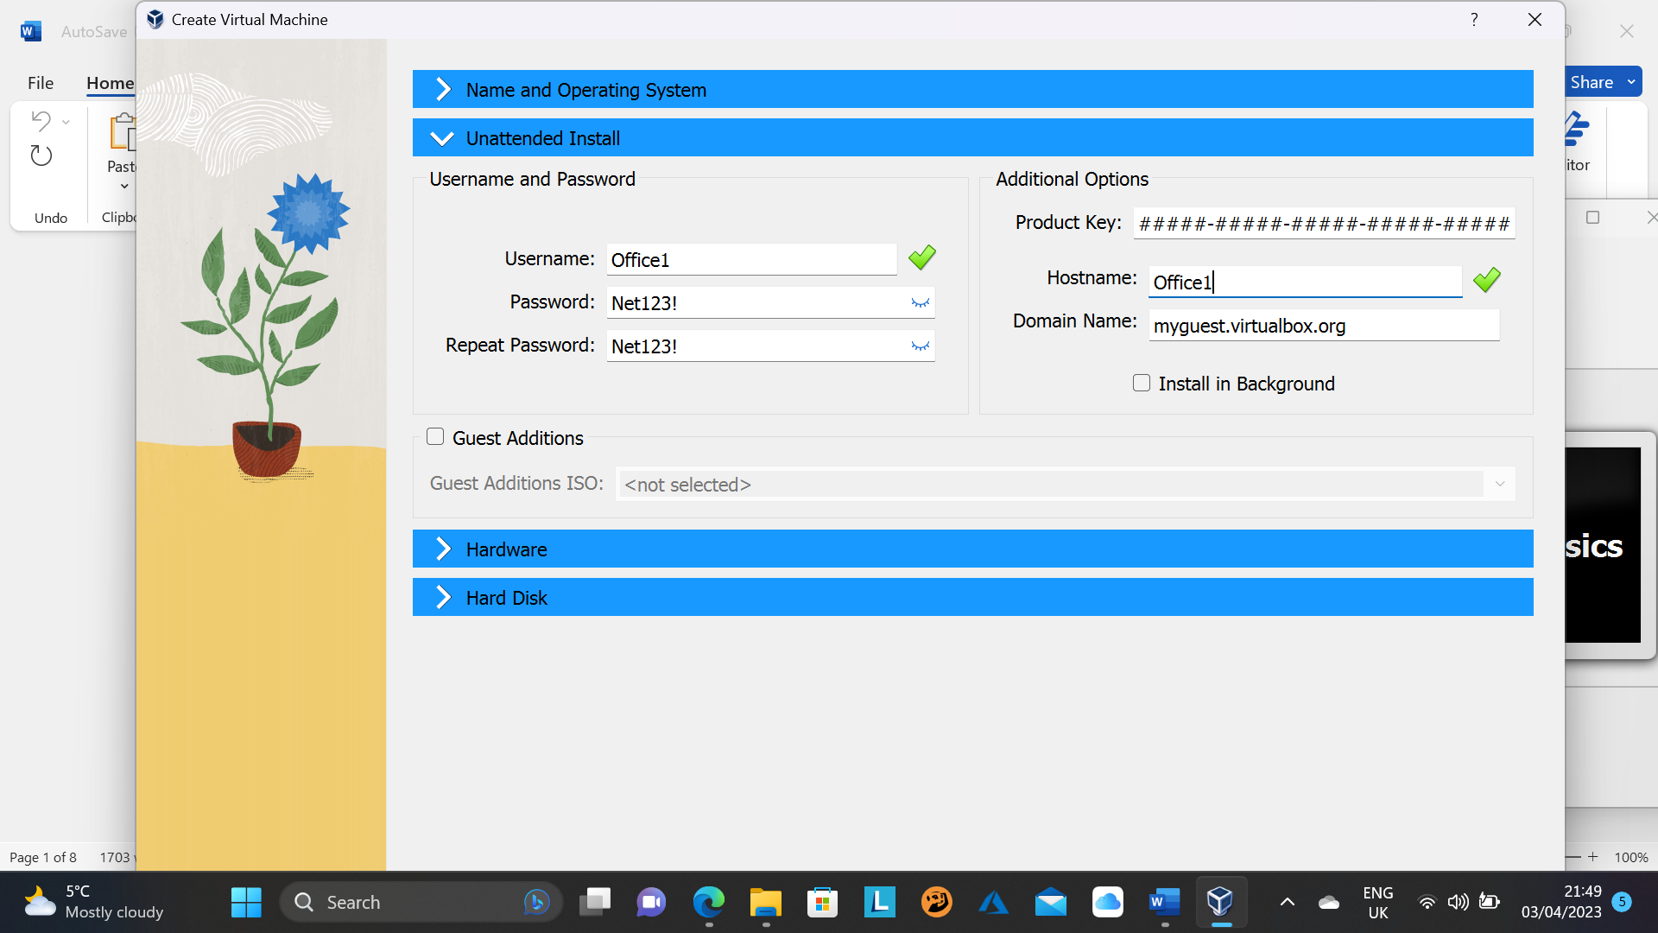

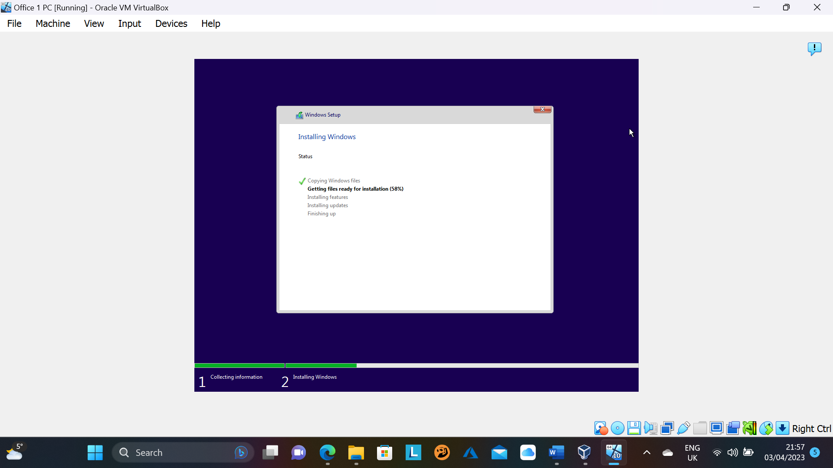

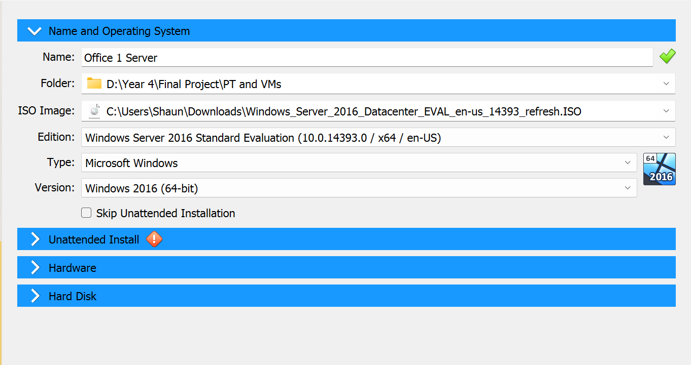

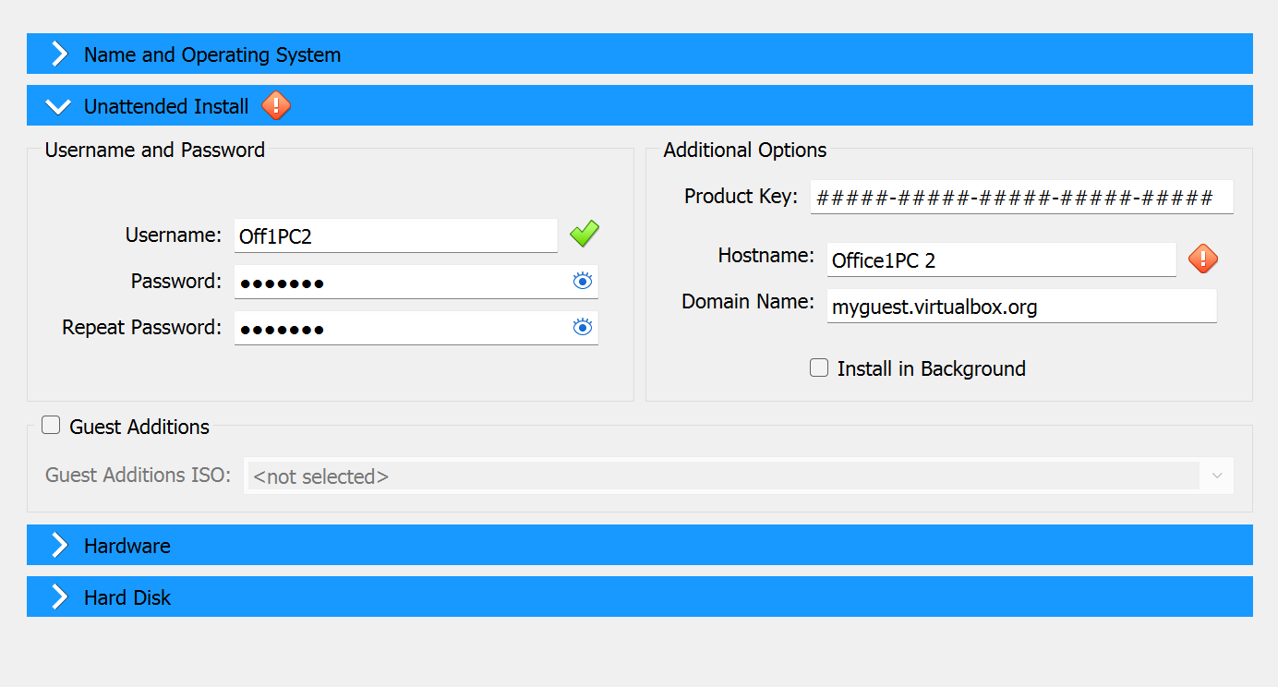

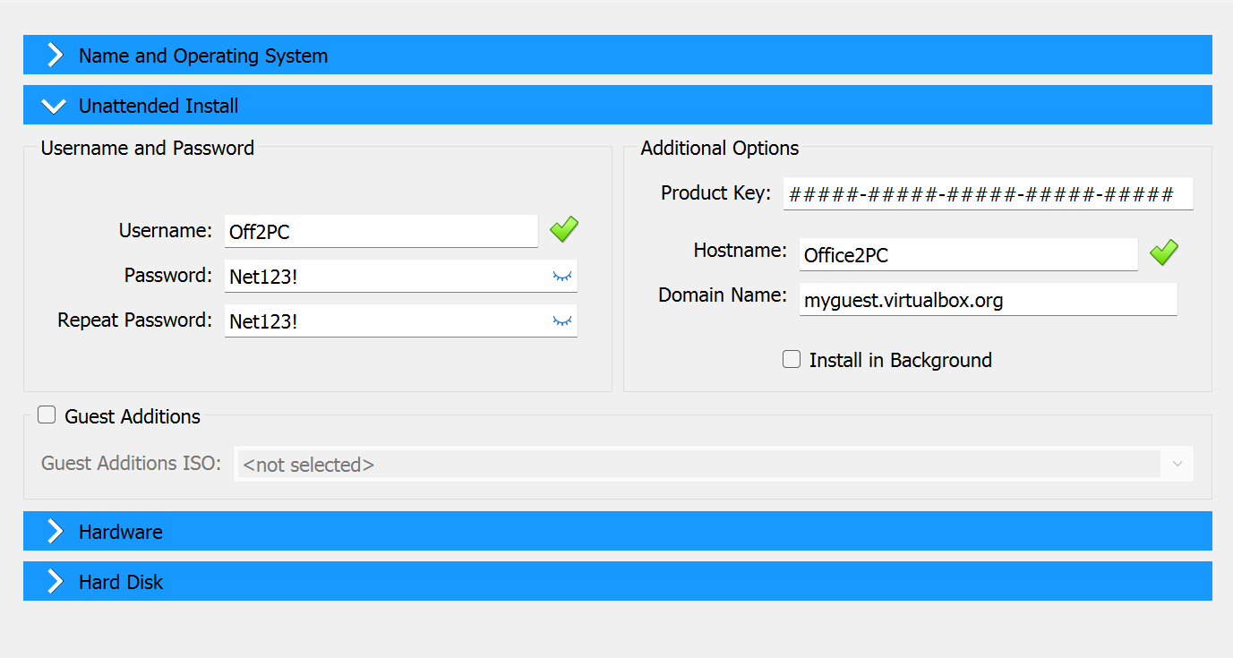

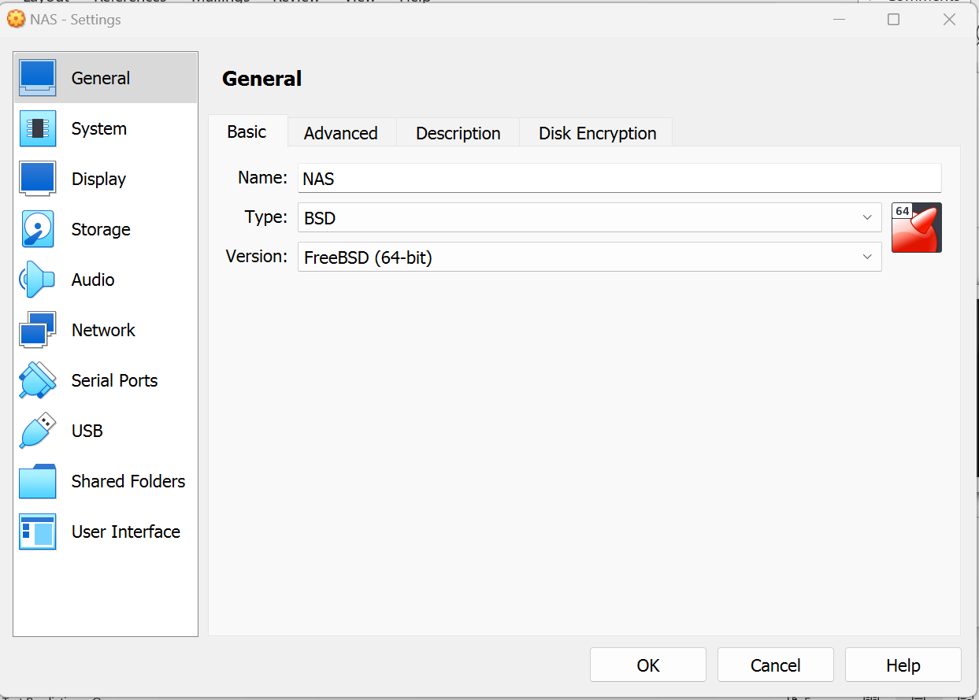

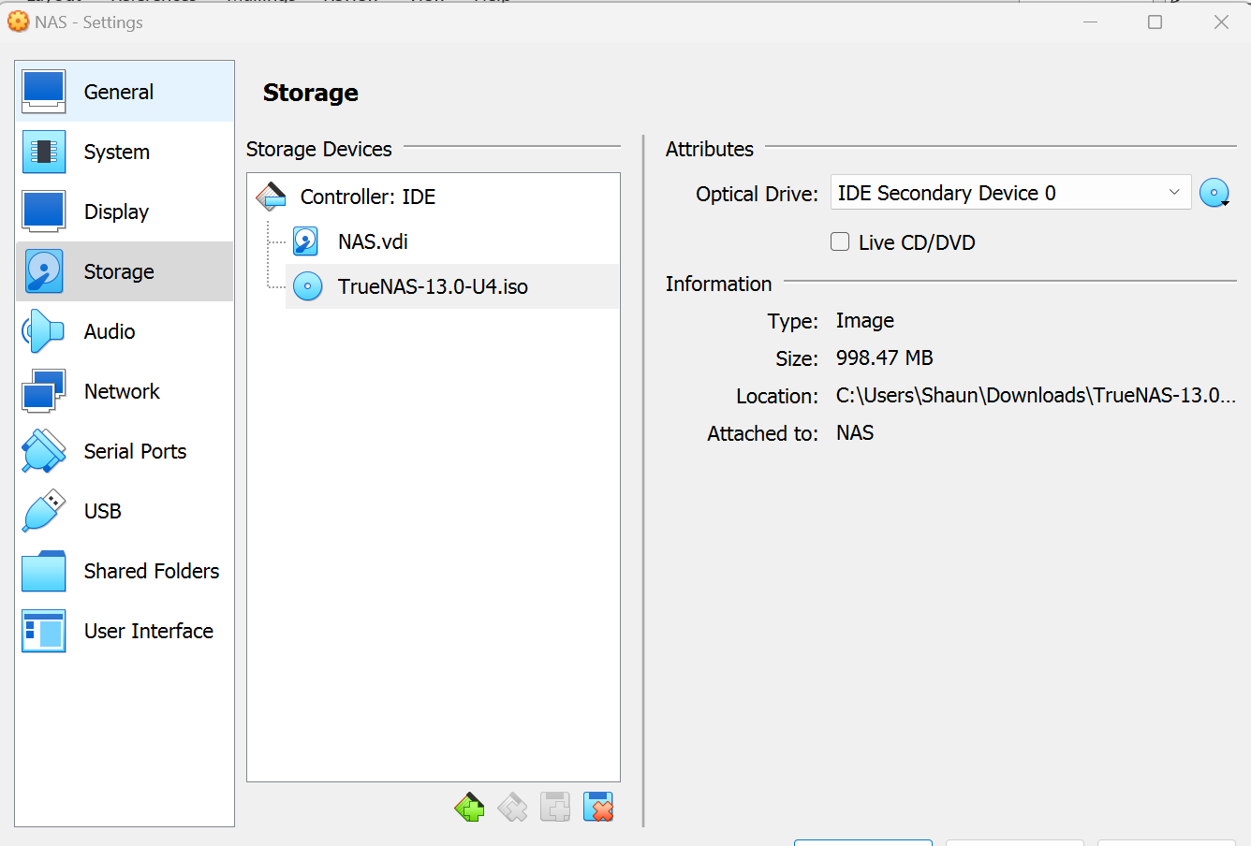

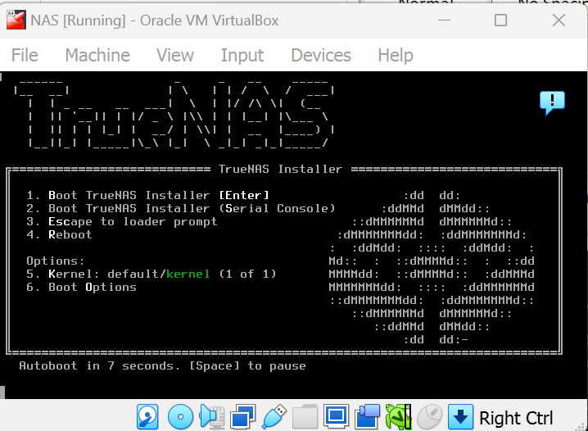

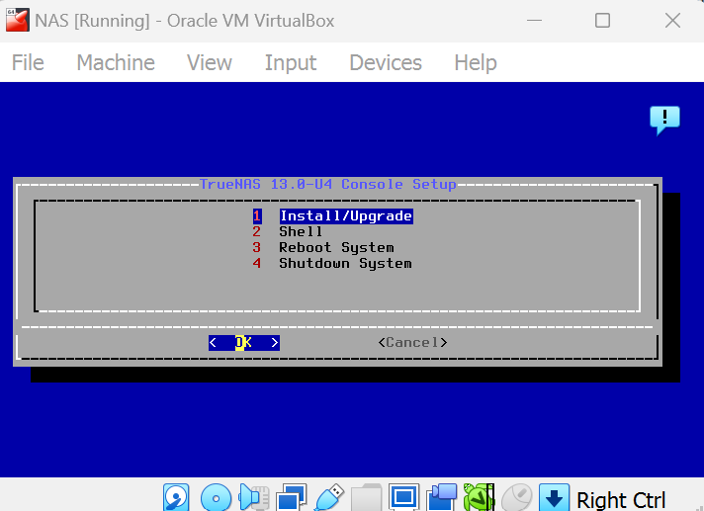

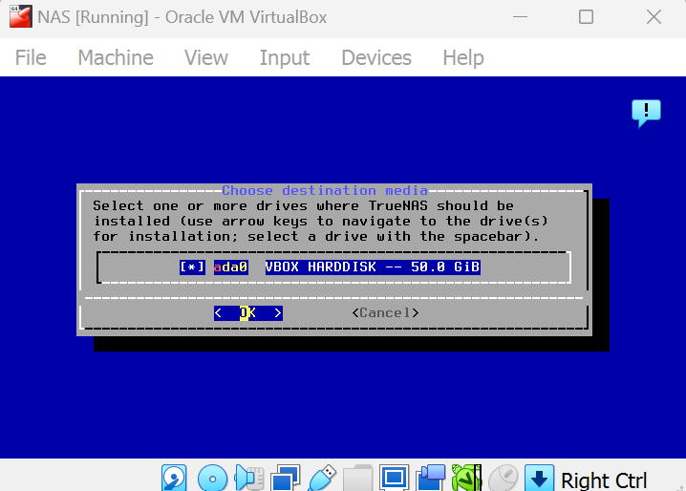

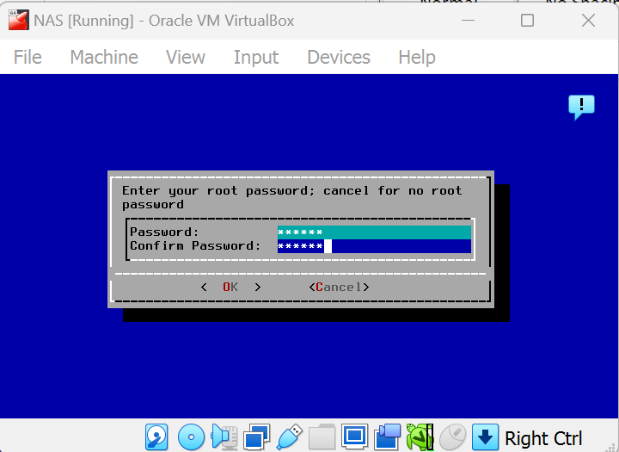

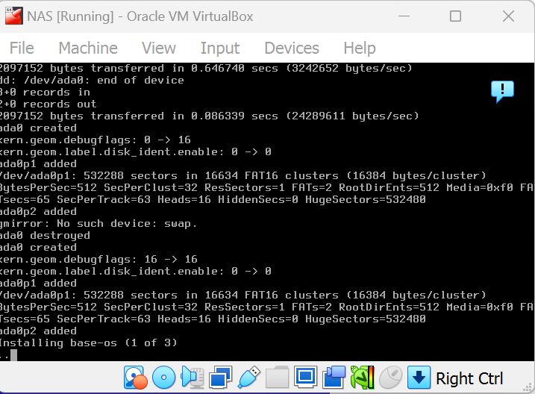

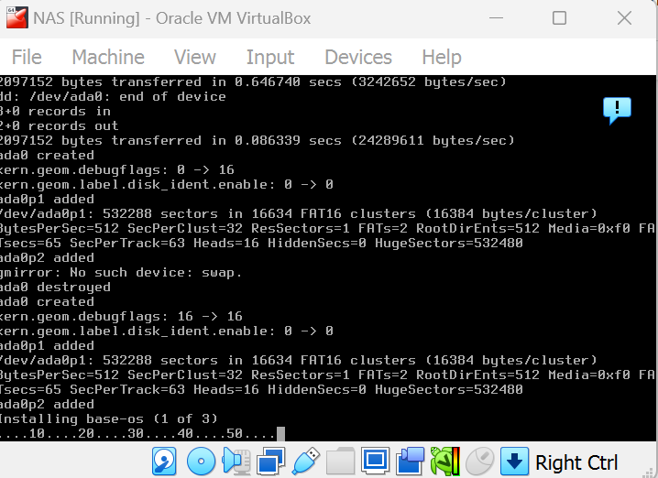

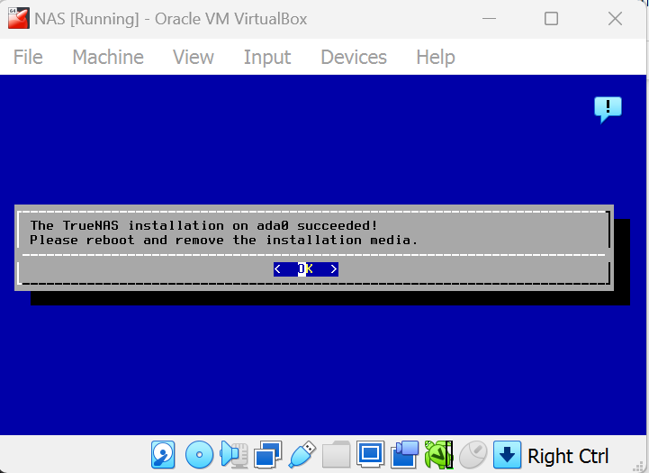

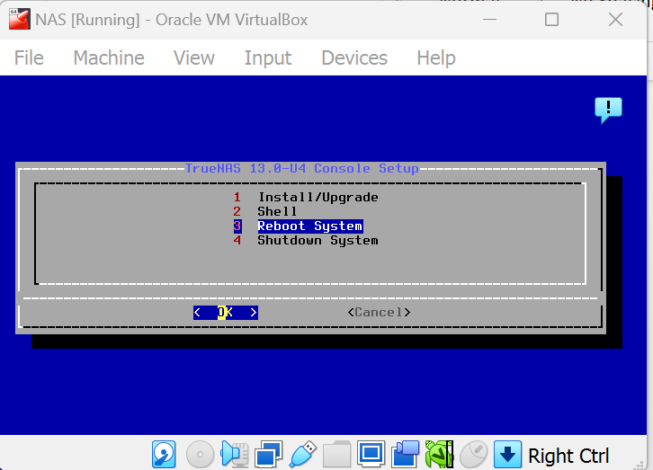

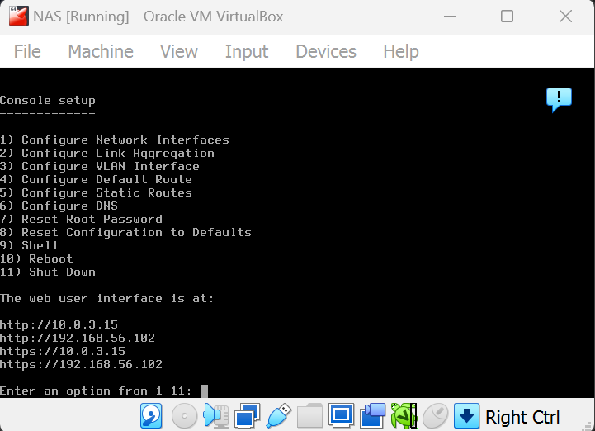

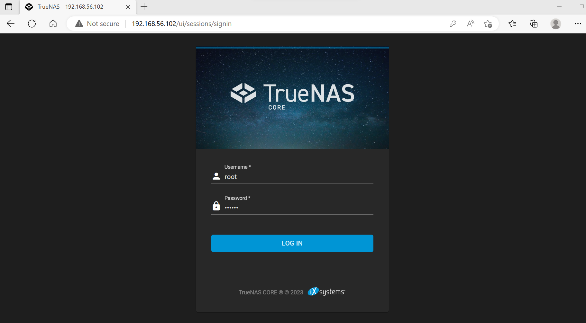

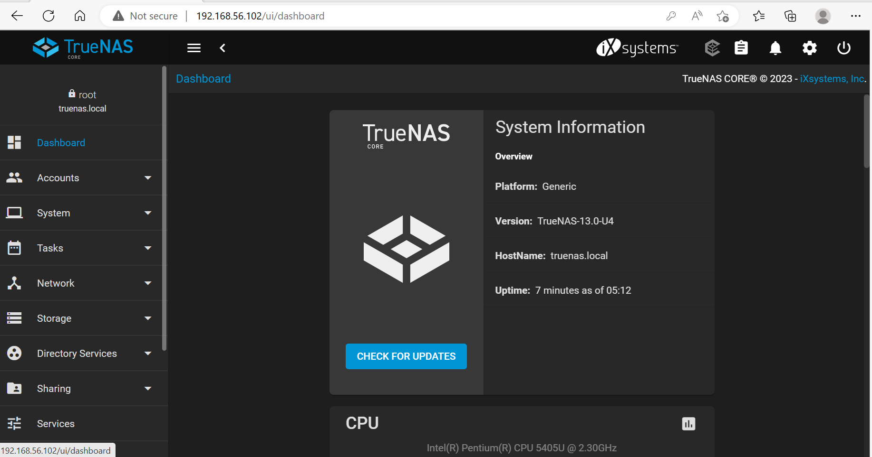

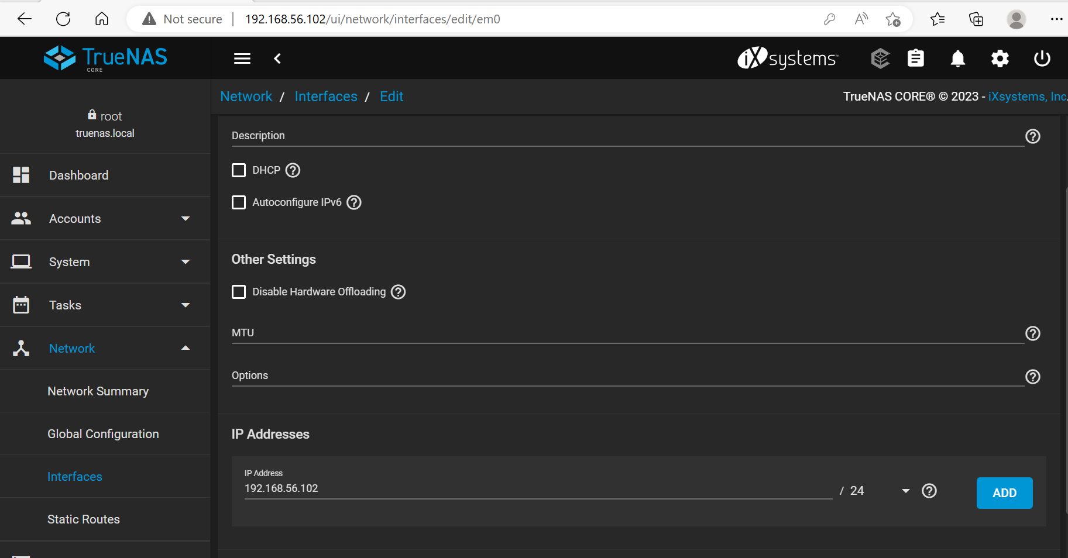

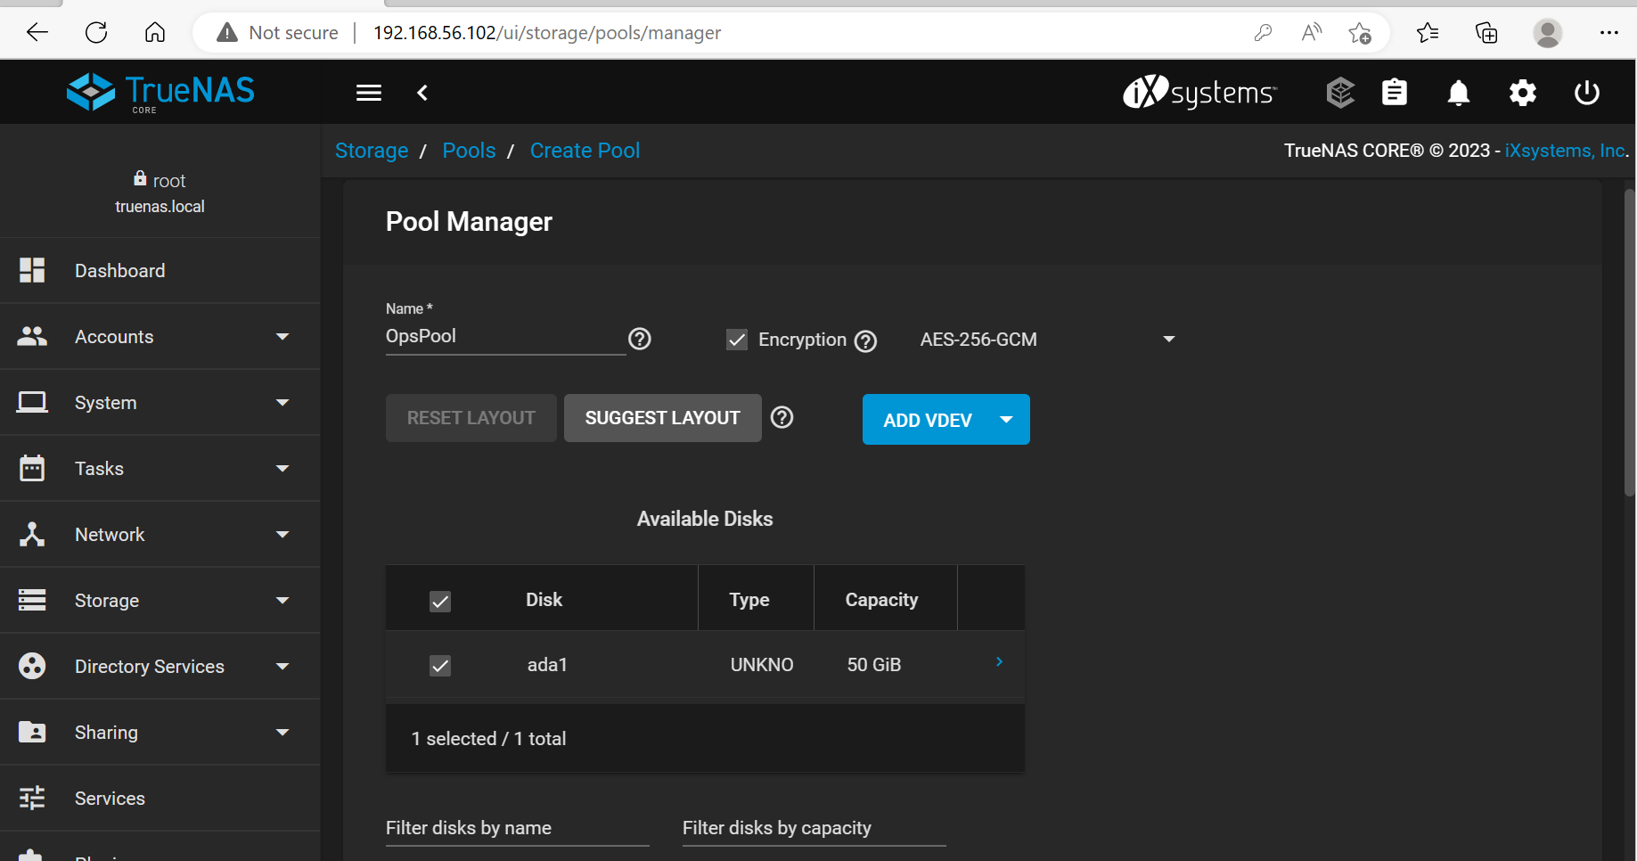

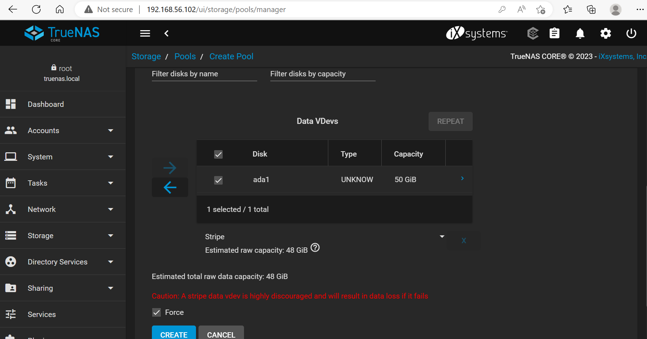

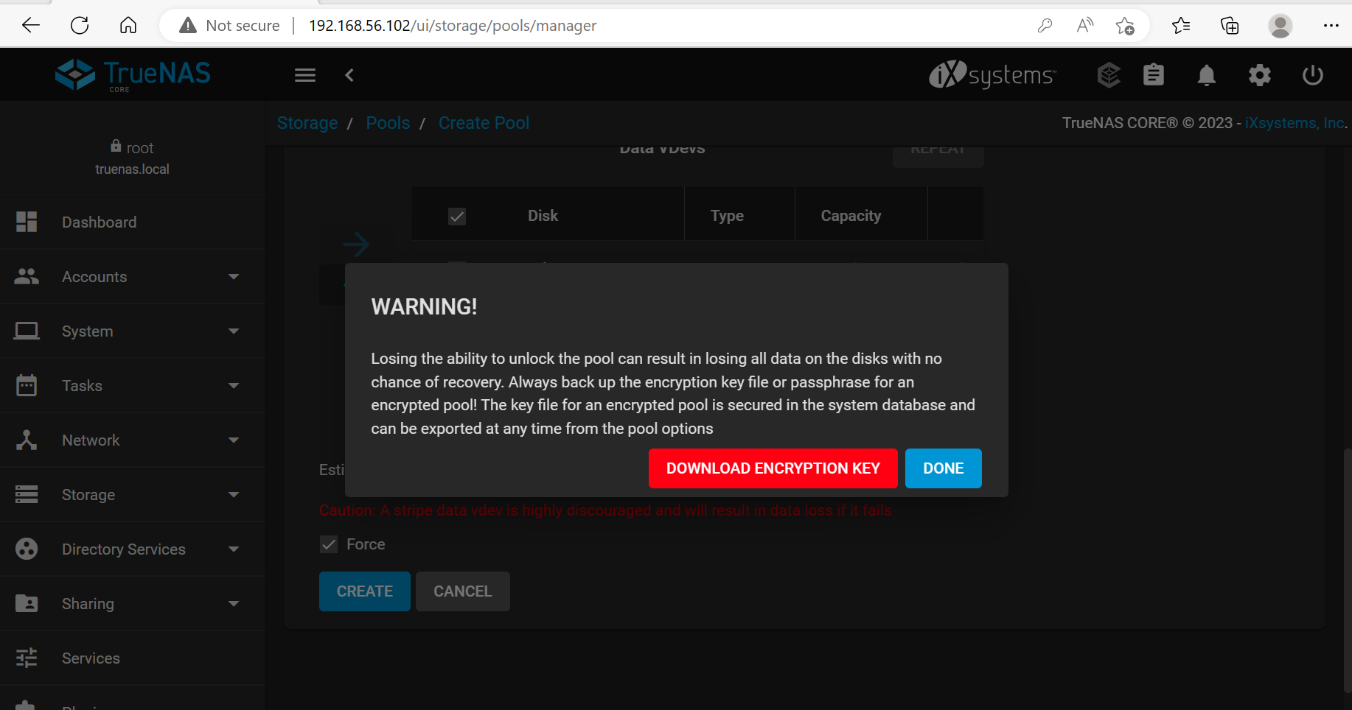

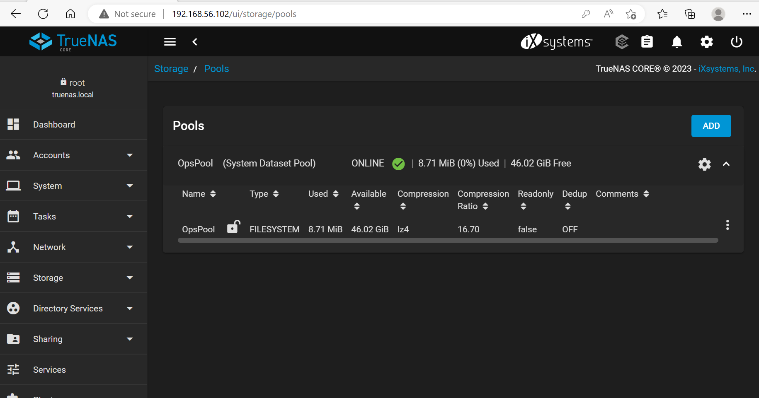

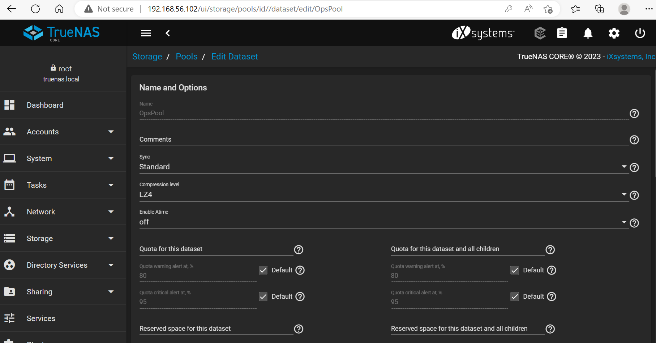

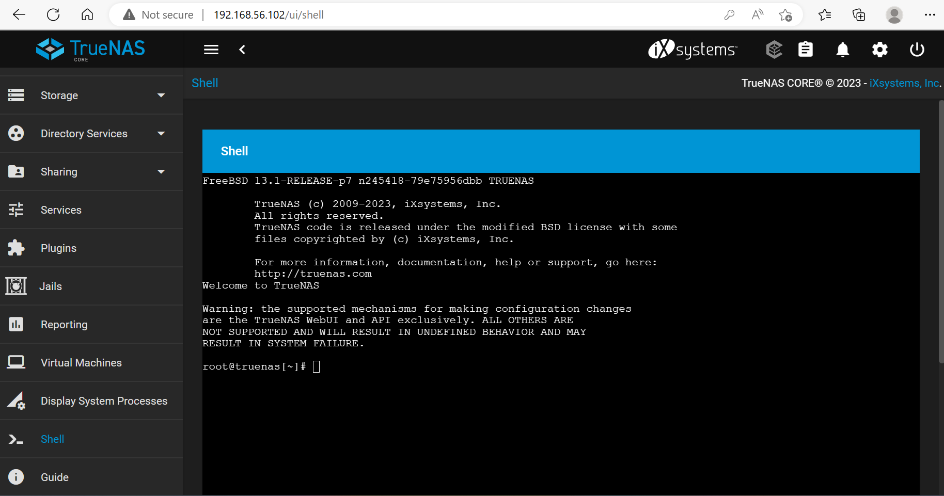

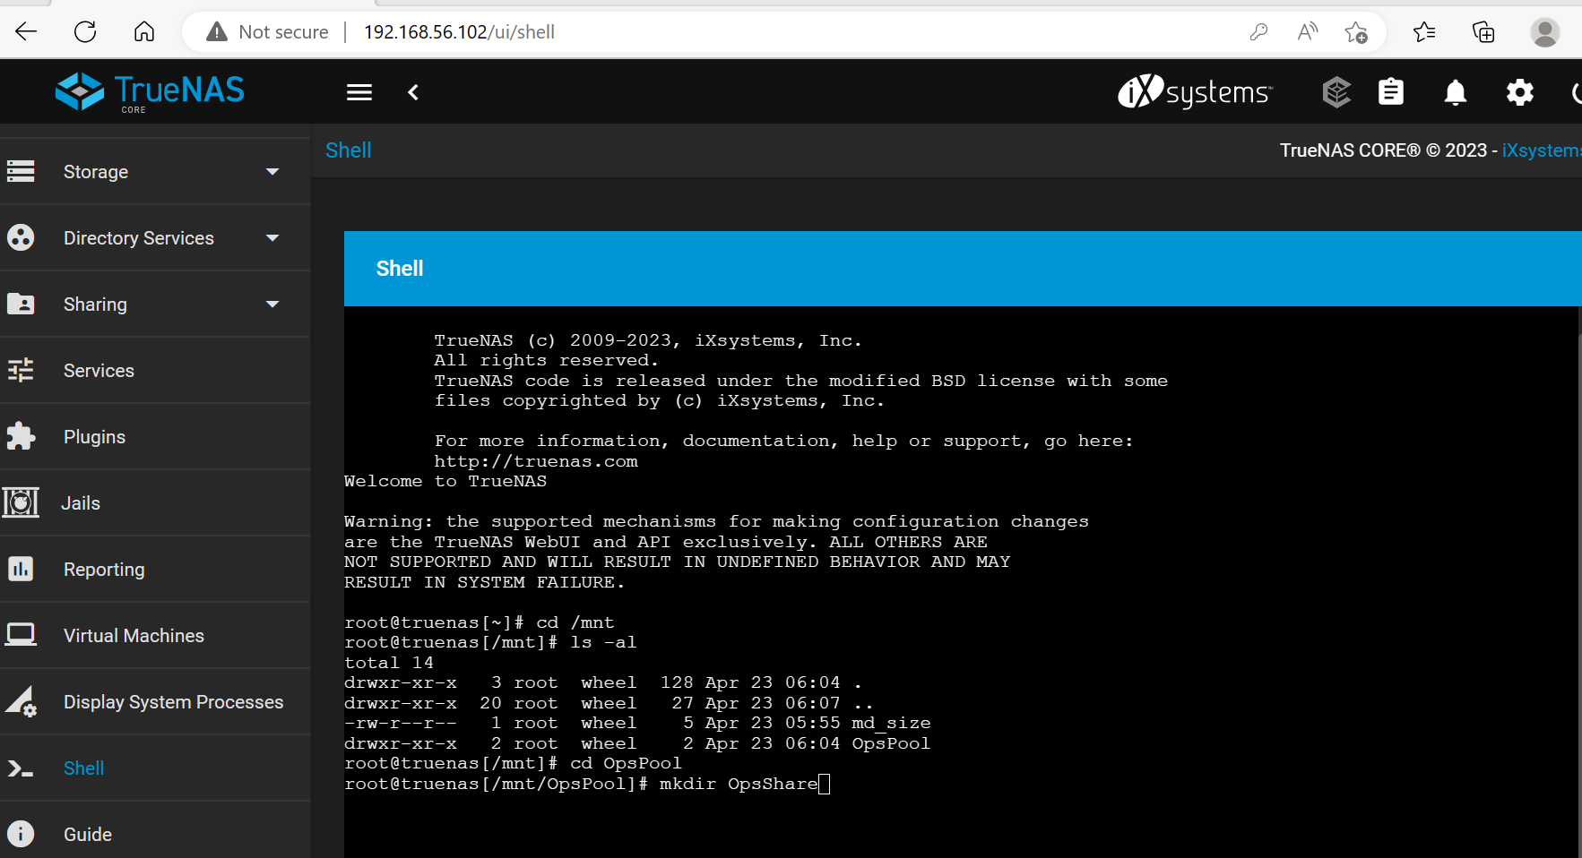

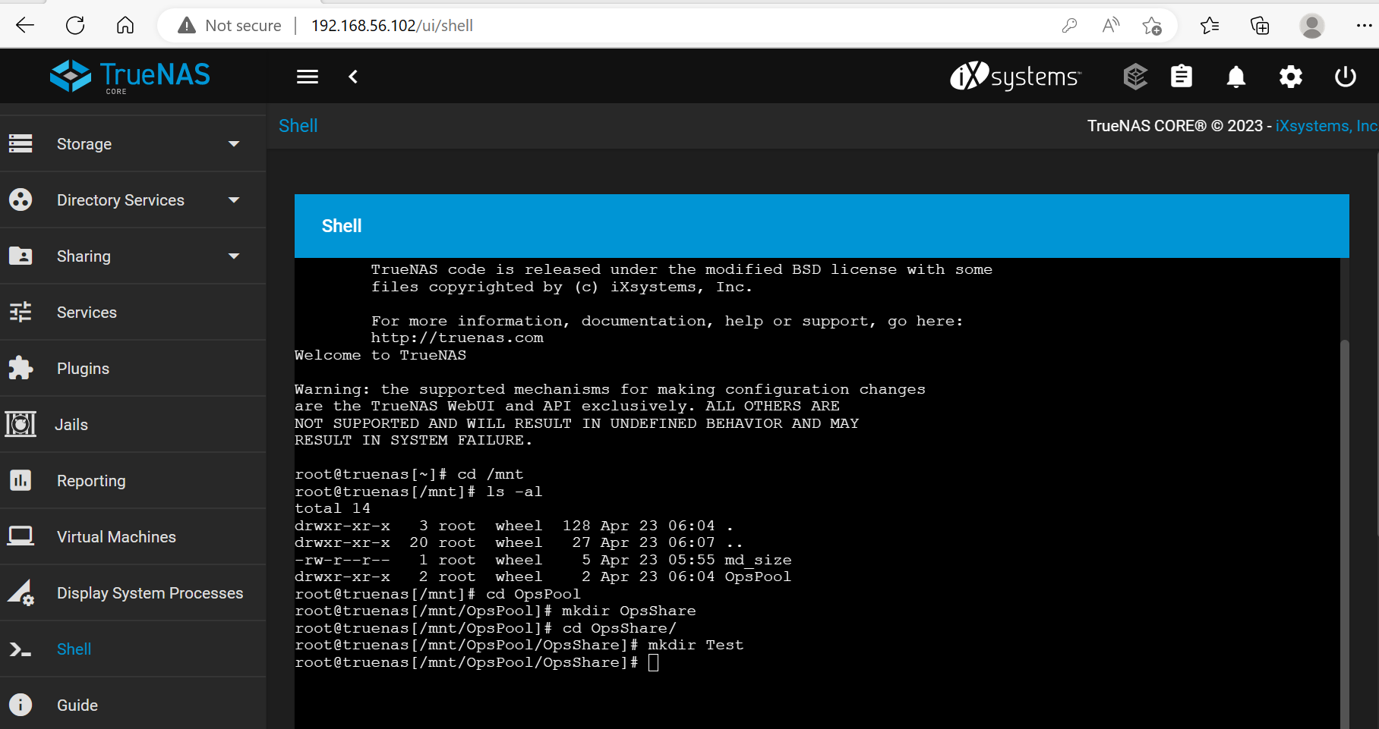

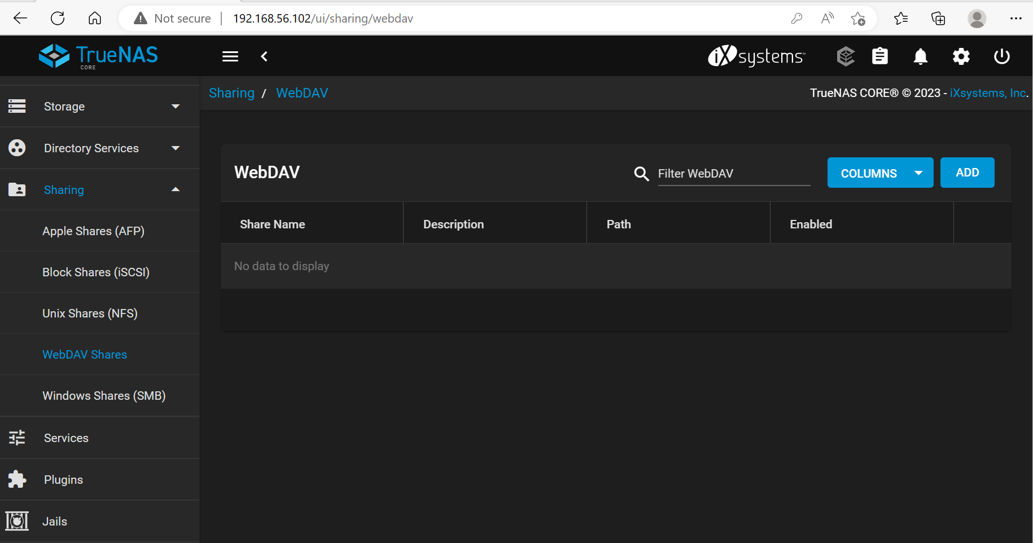

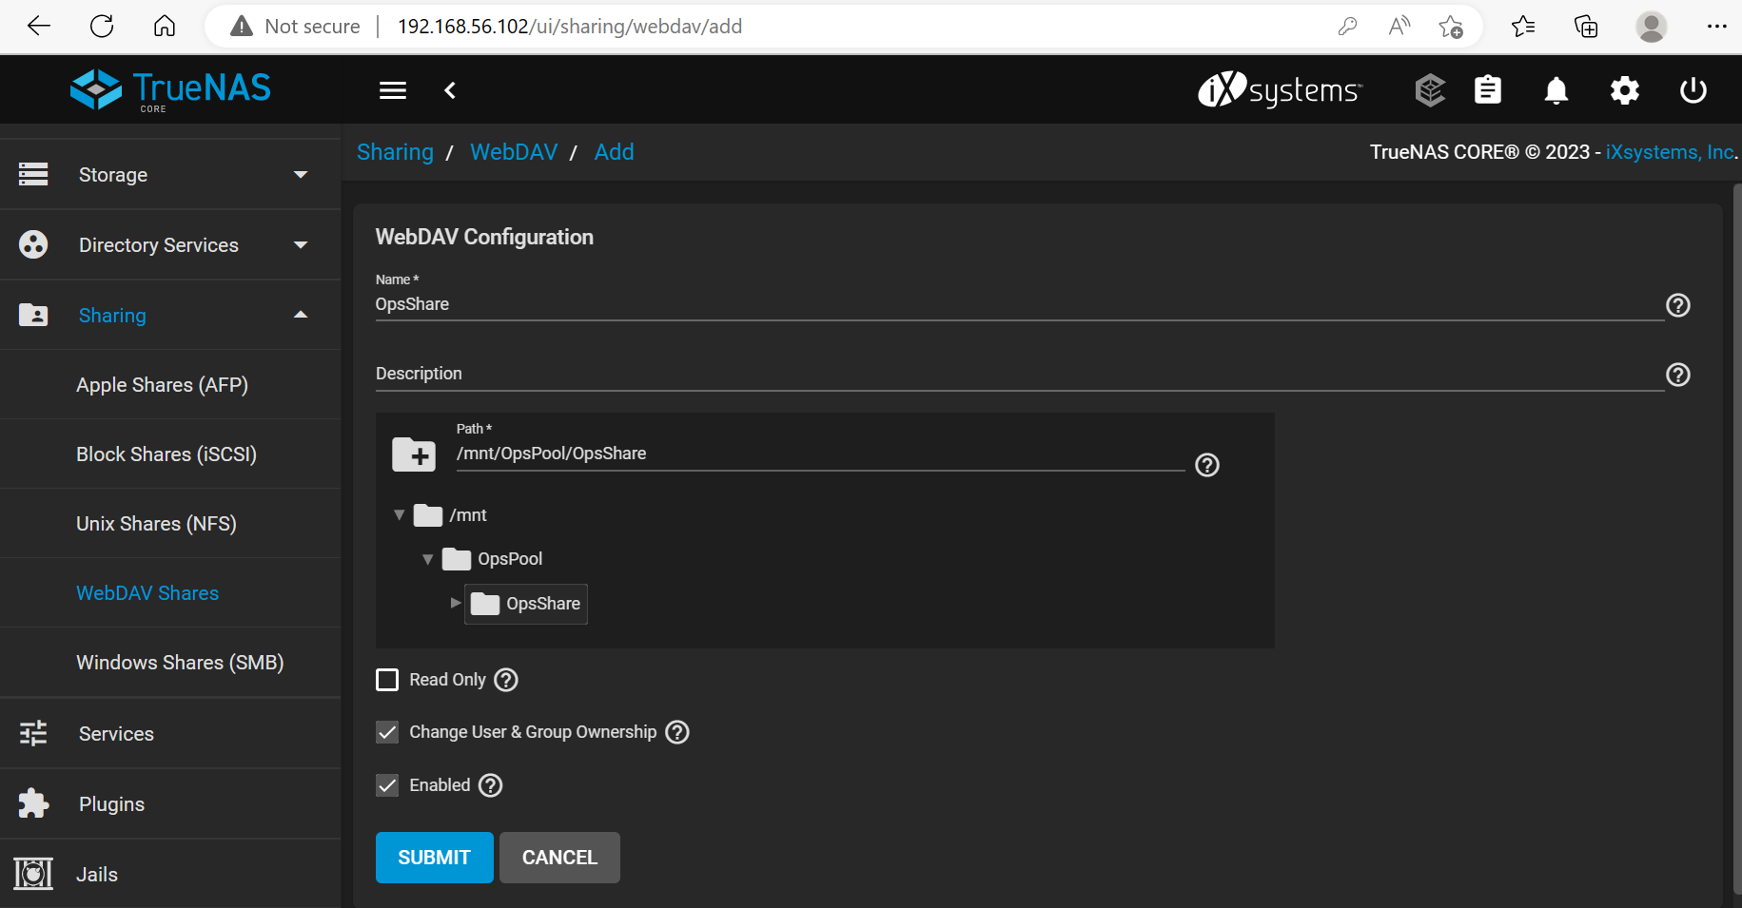

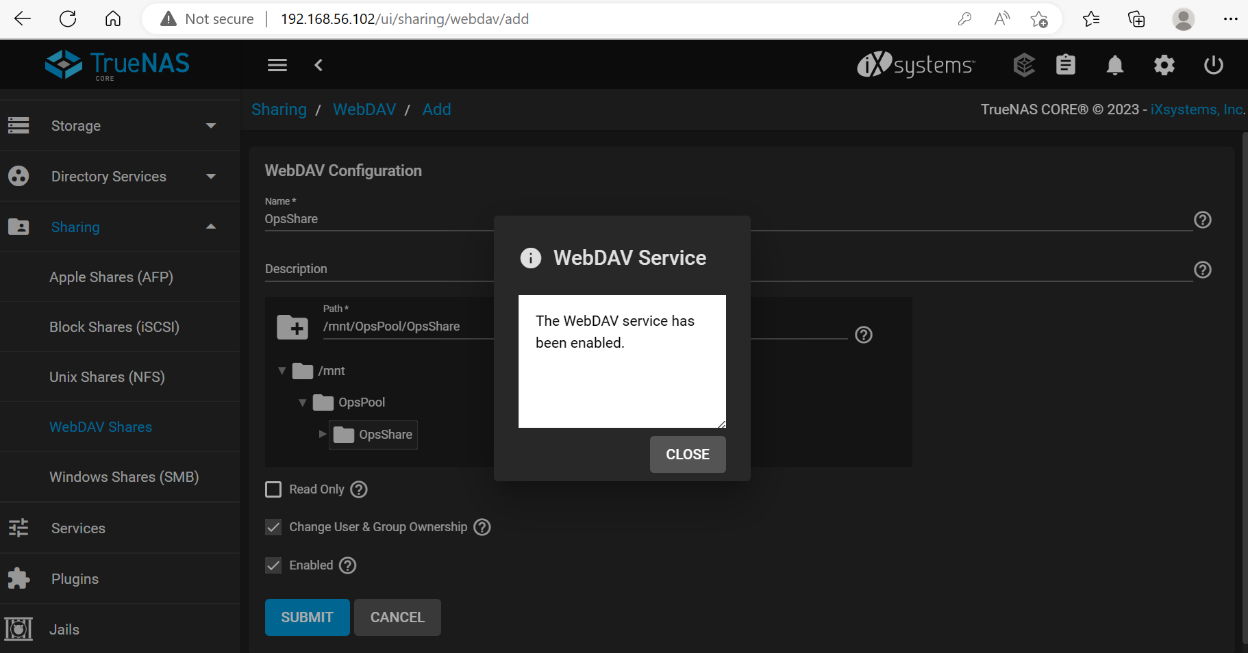

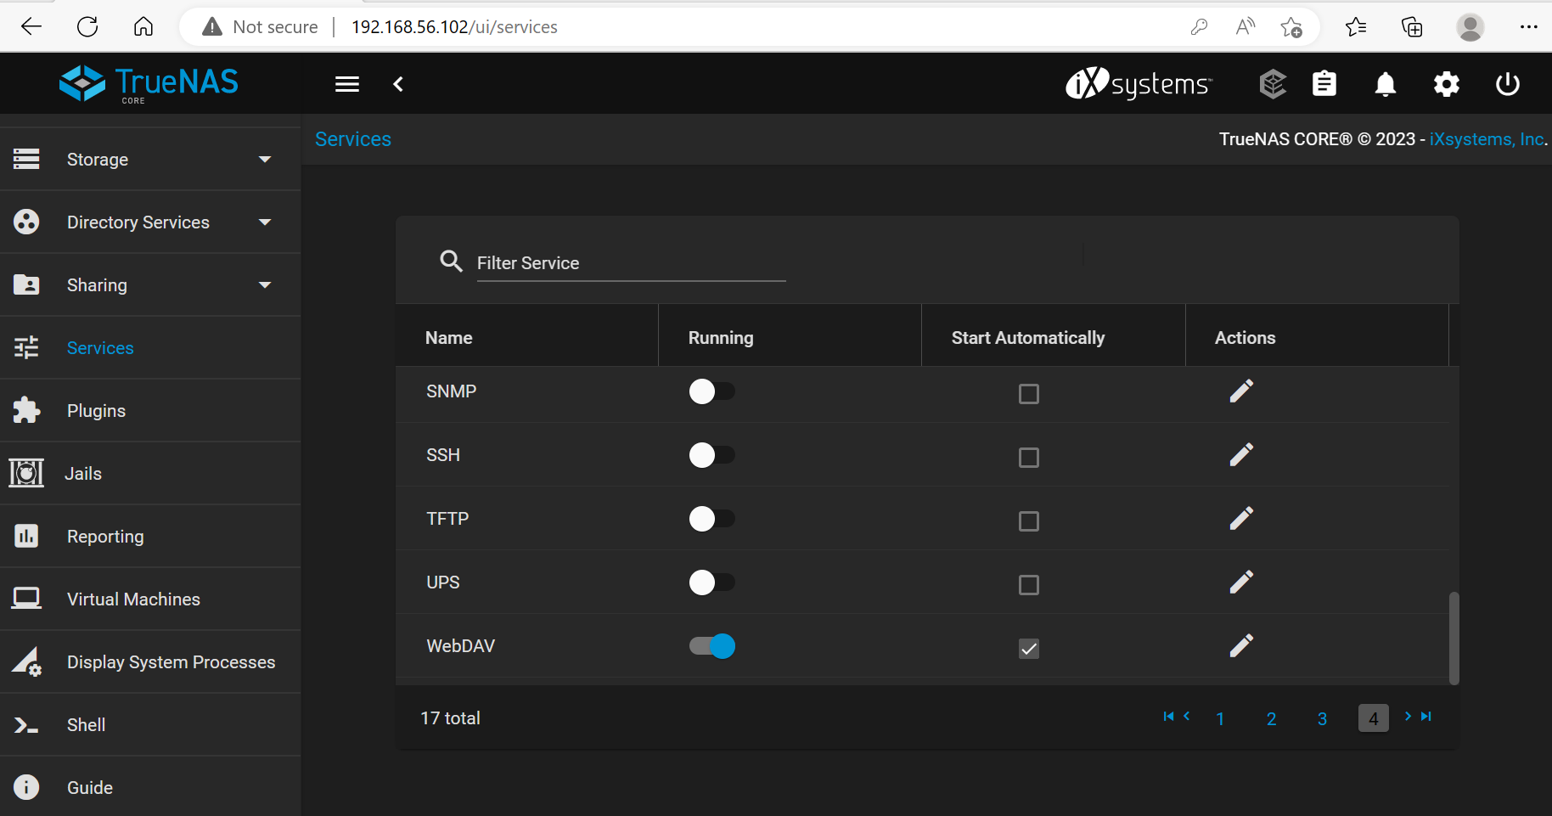

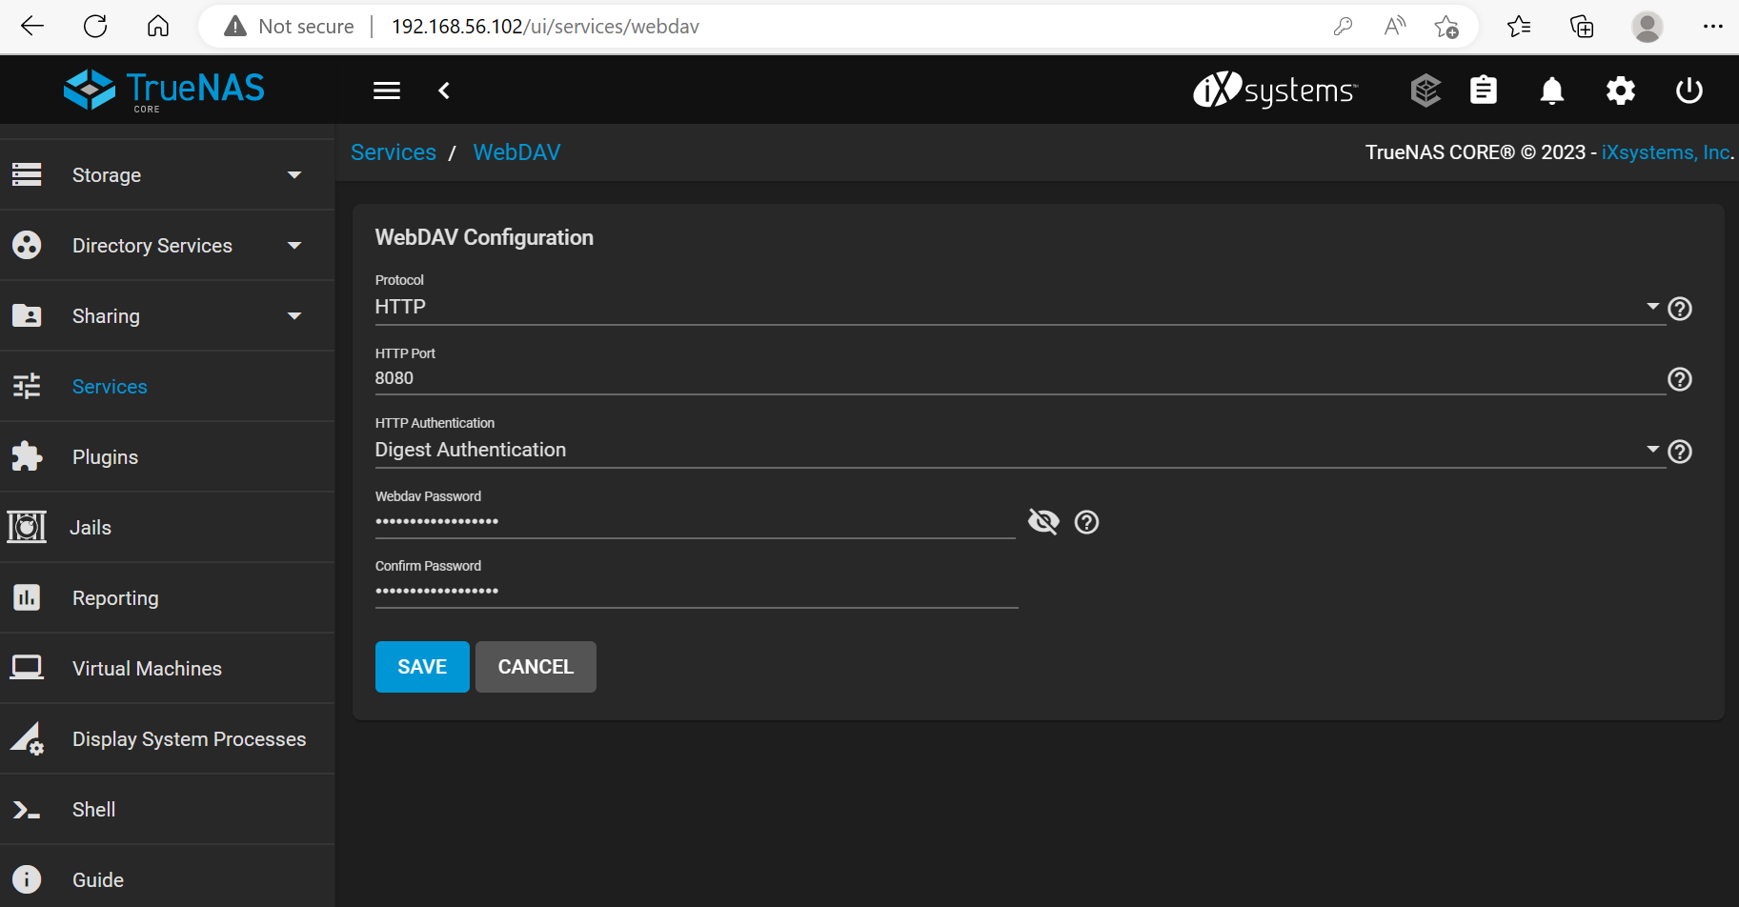

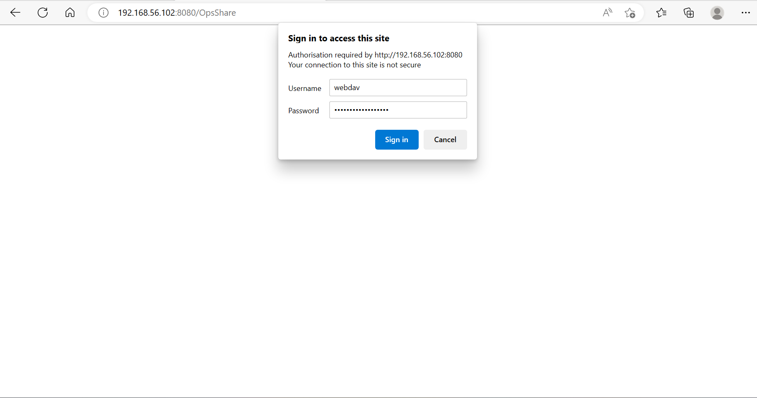
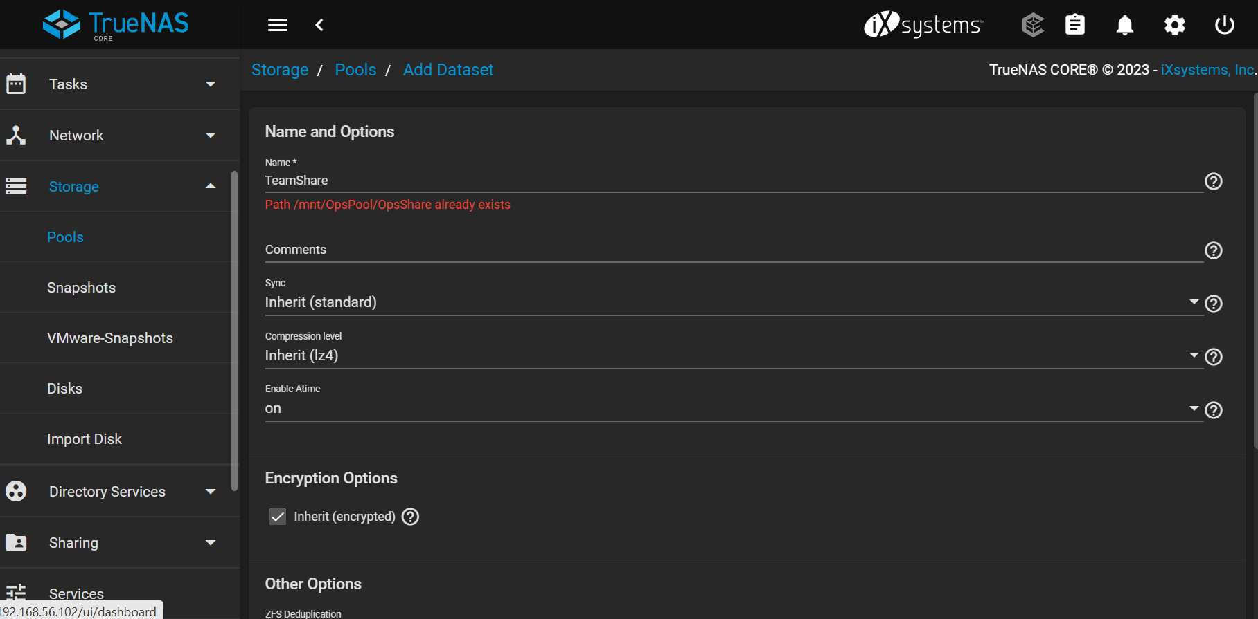

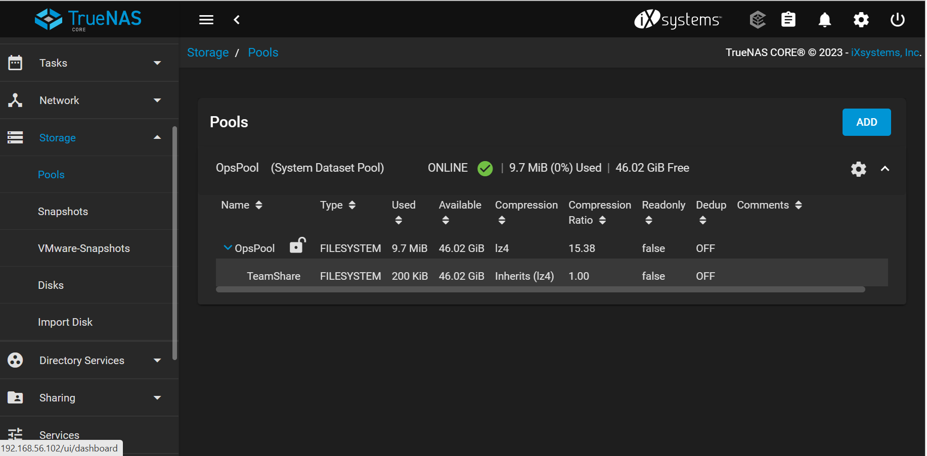

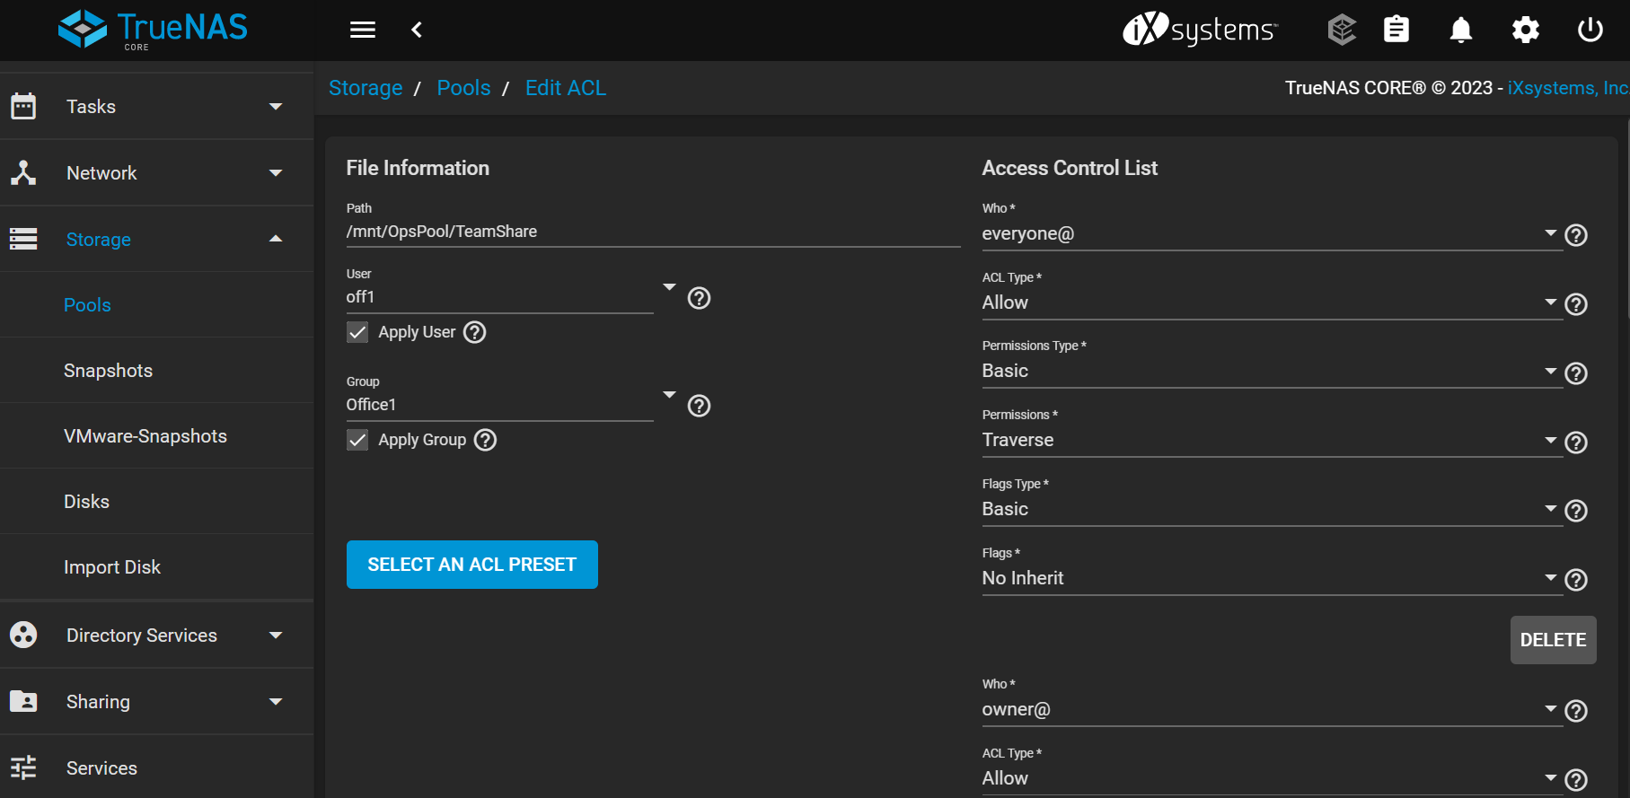

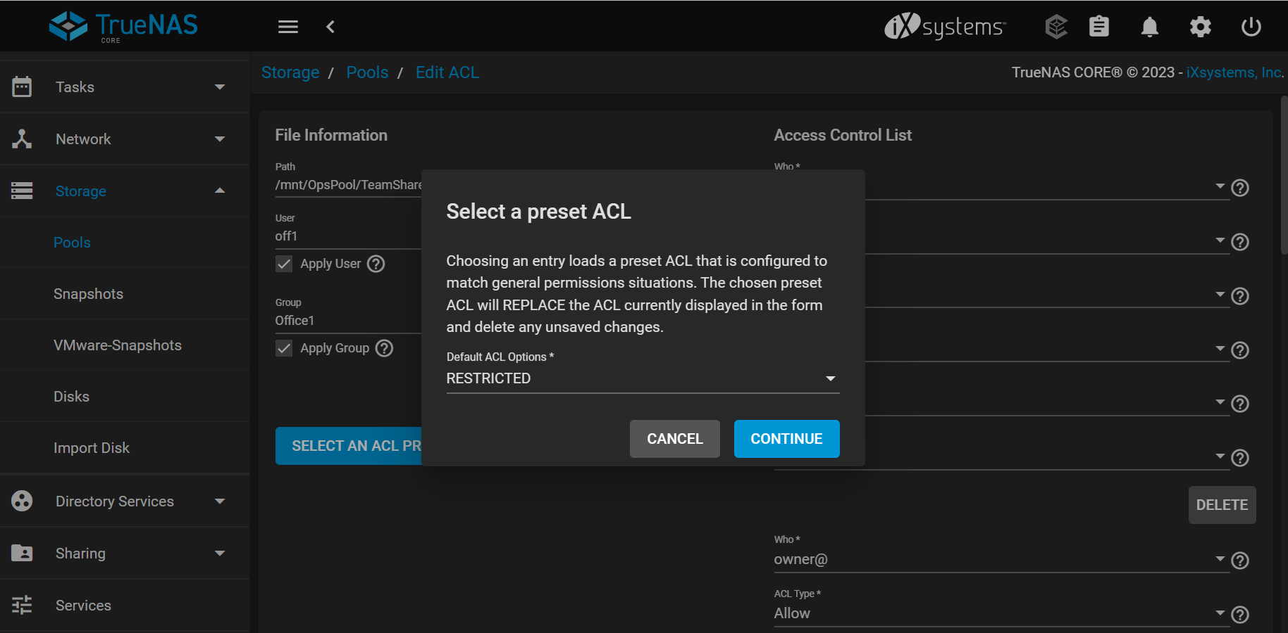

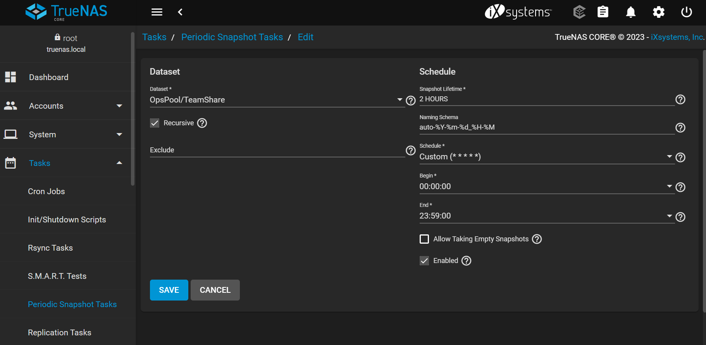

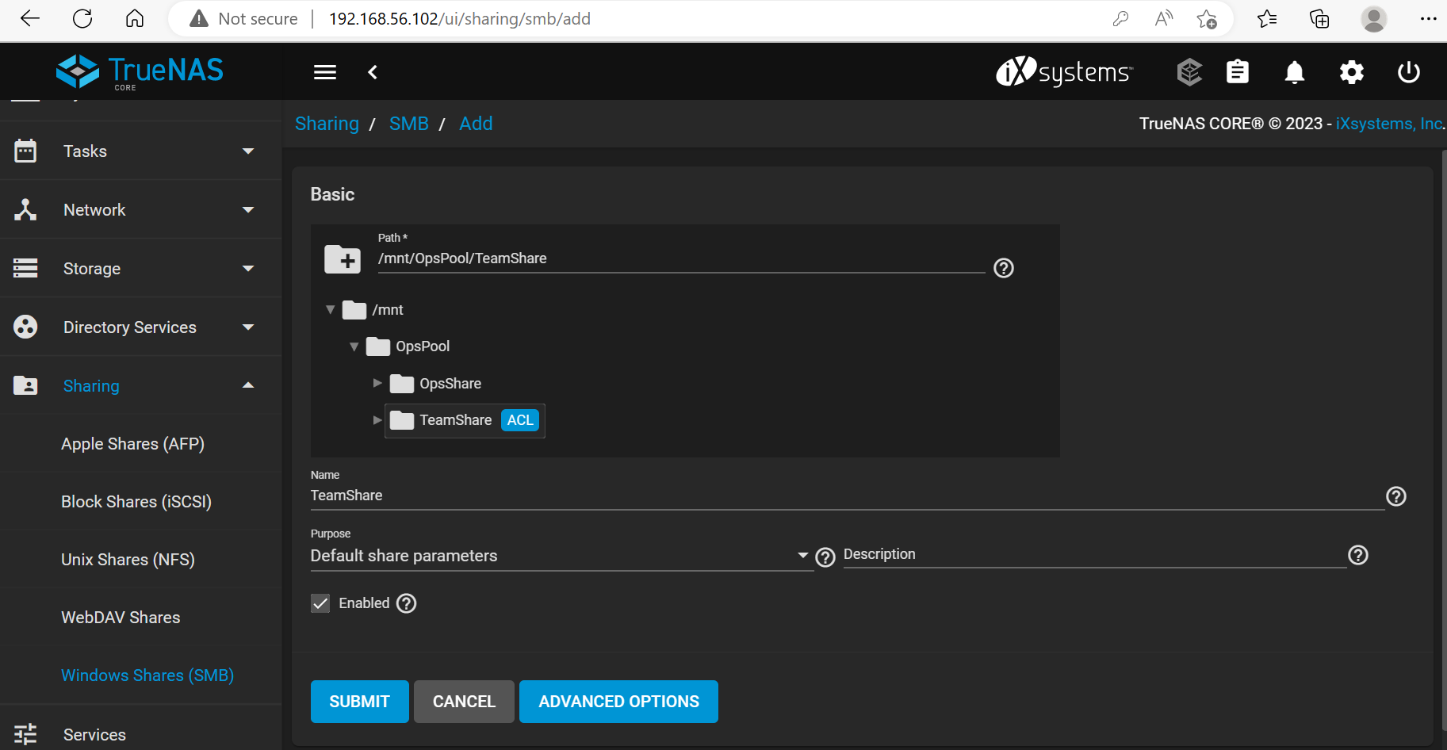

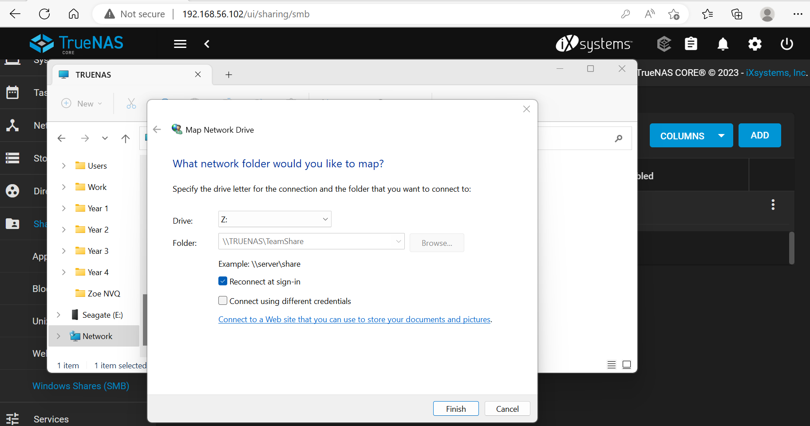

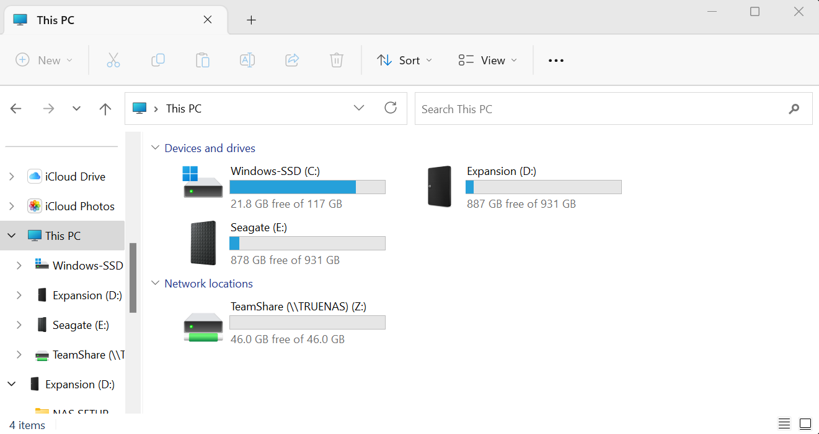

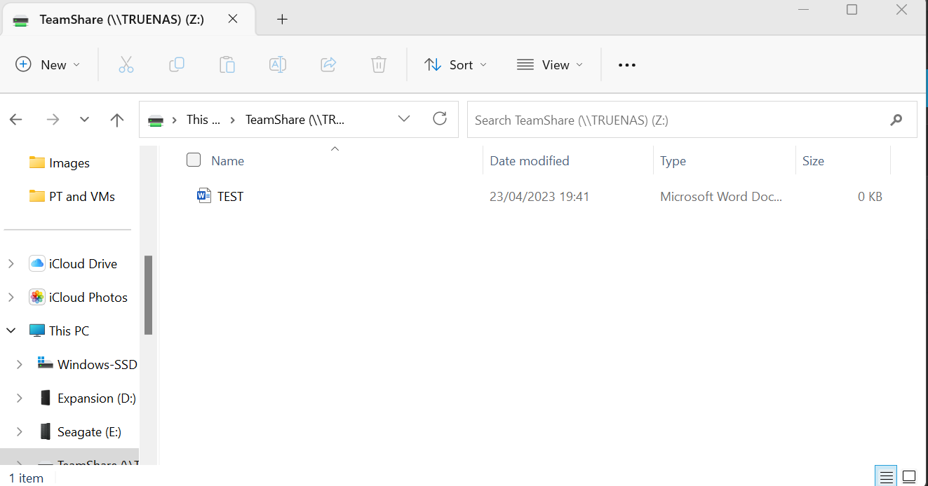

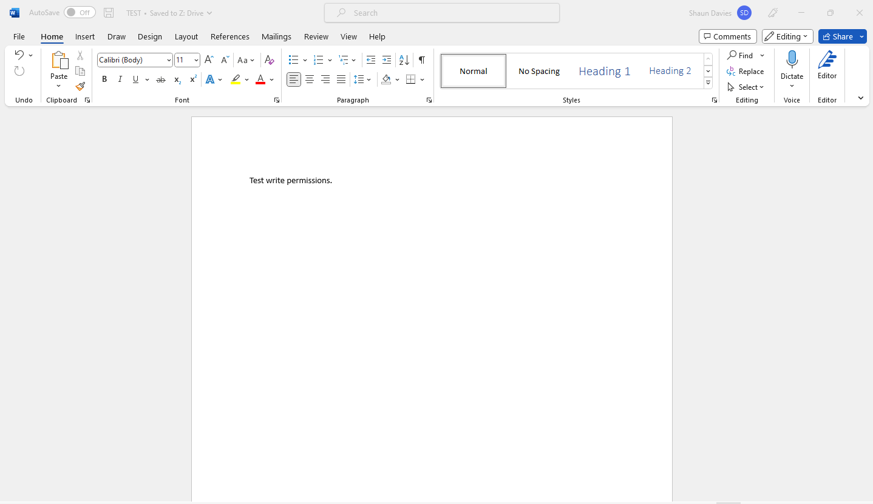

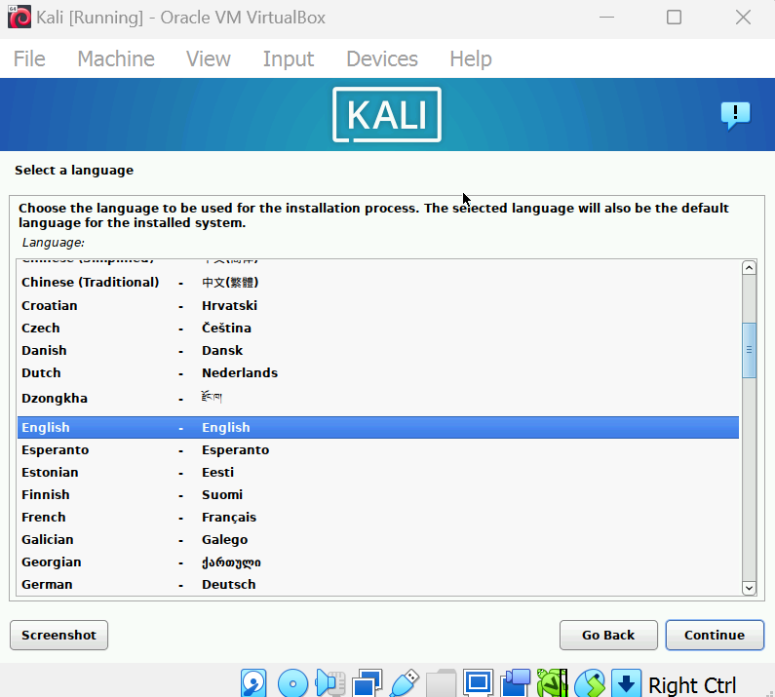

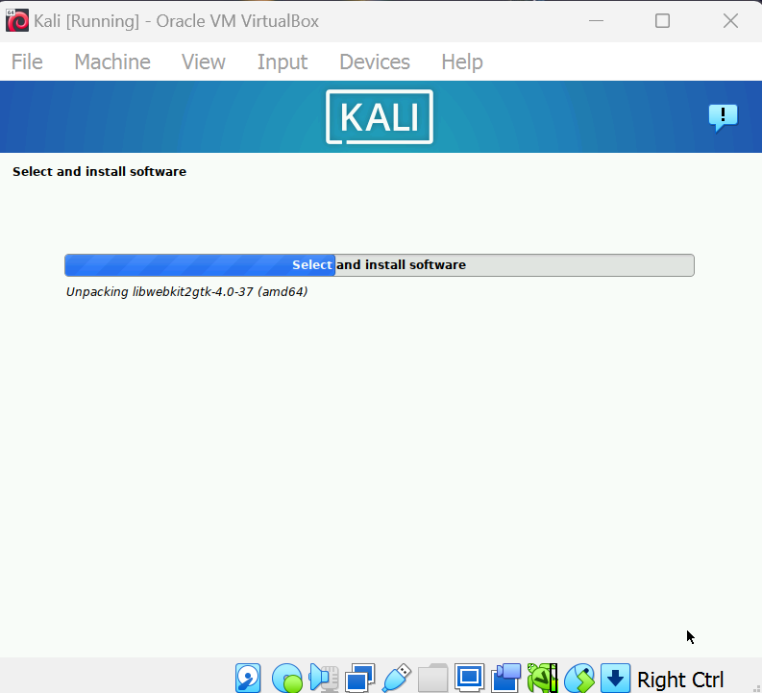
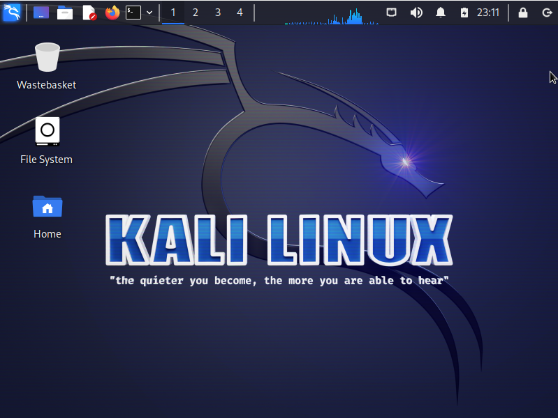

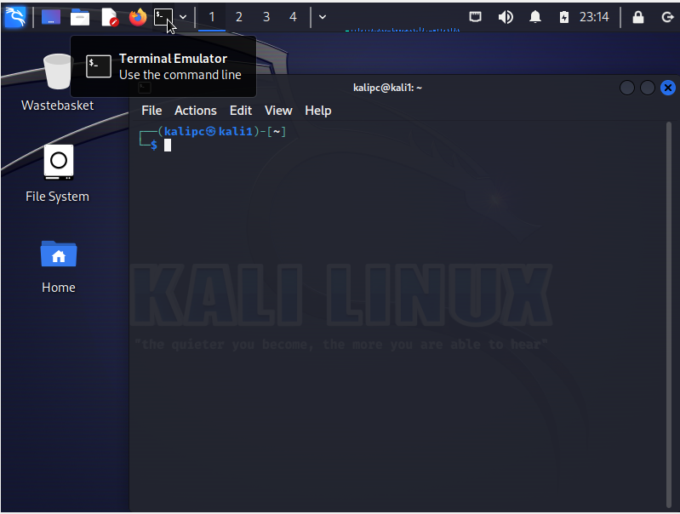
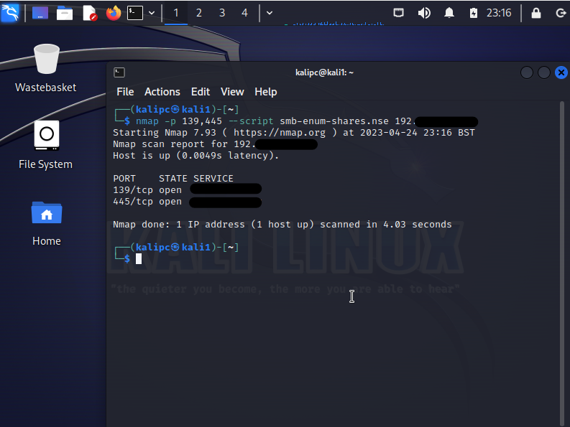
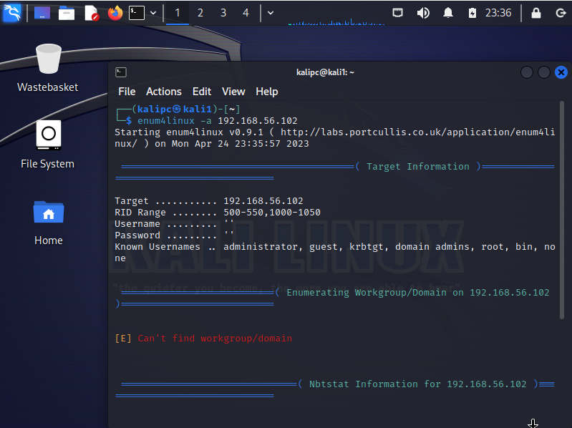
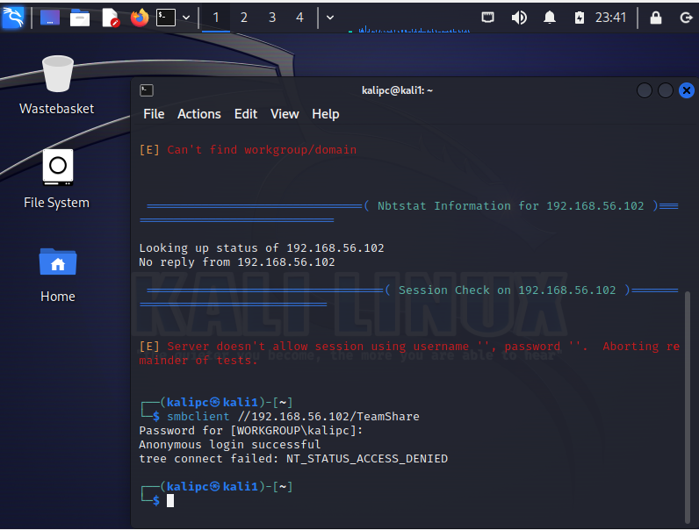

Appendix. B
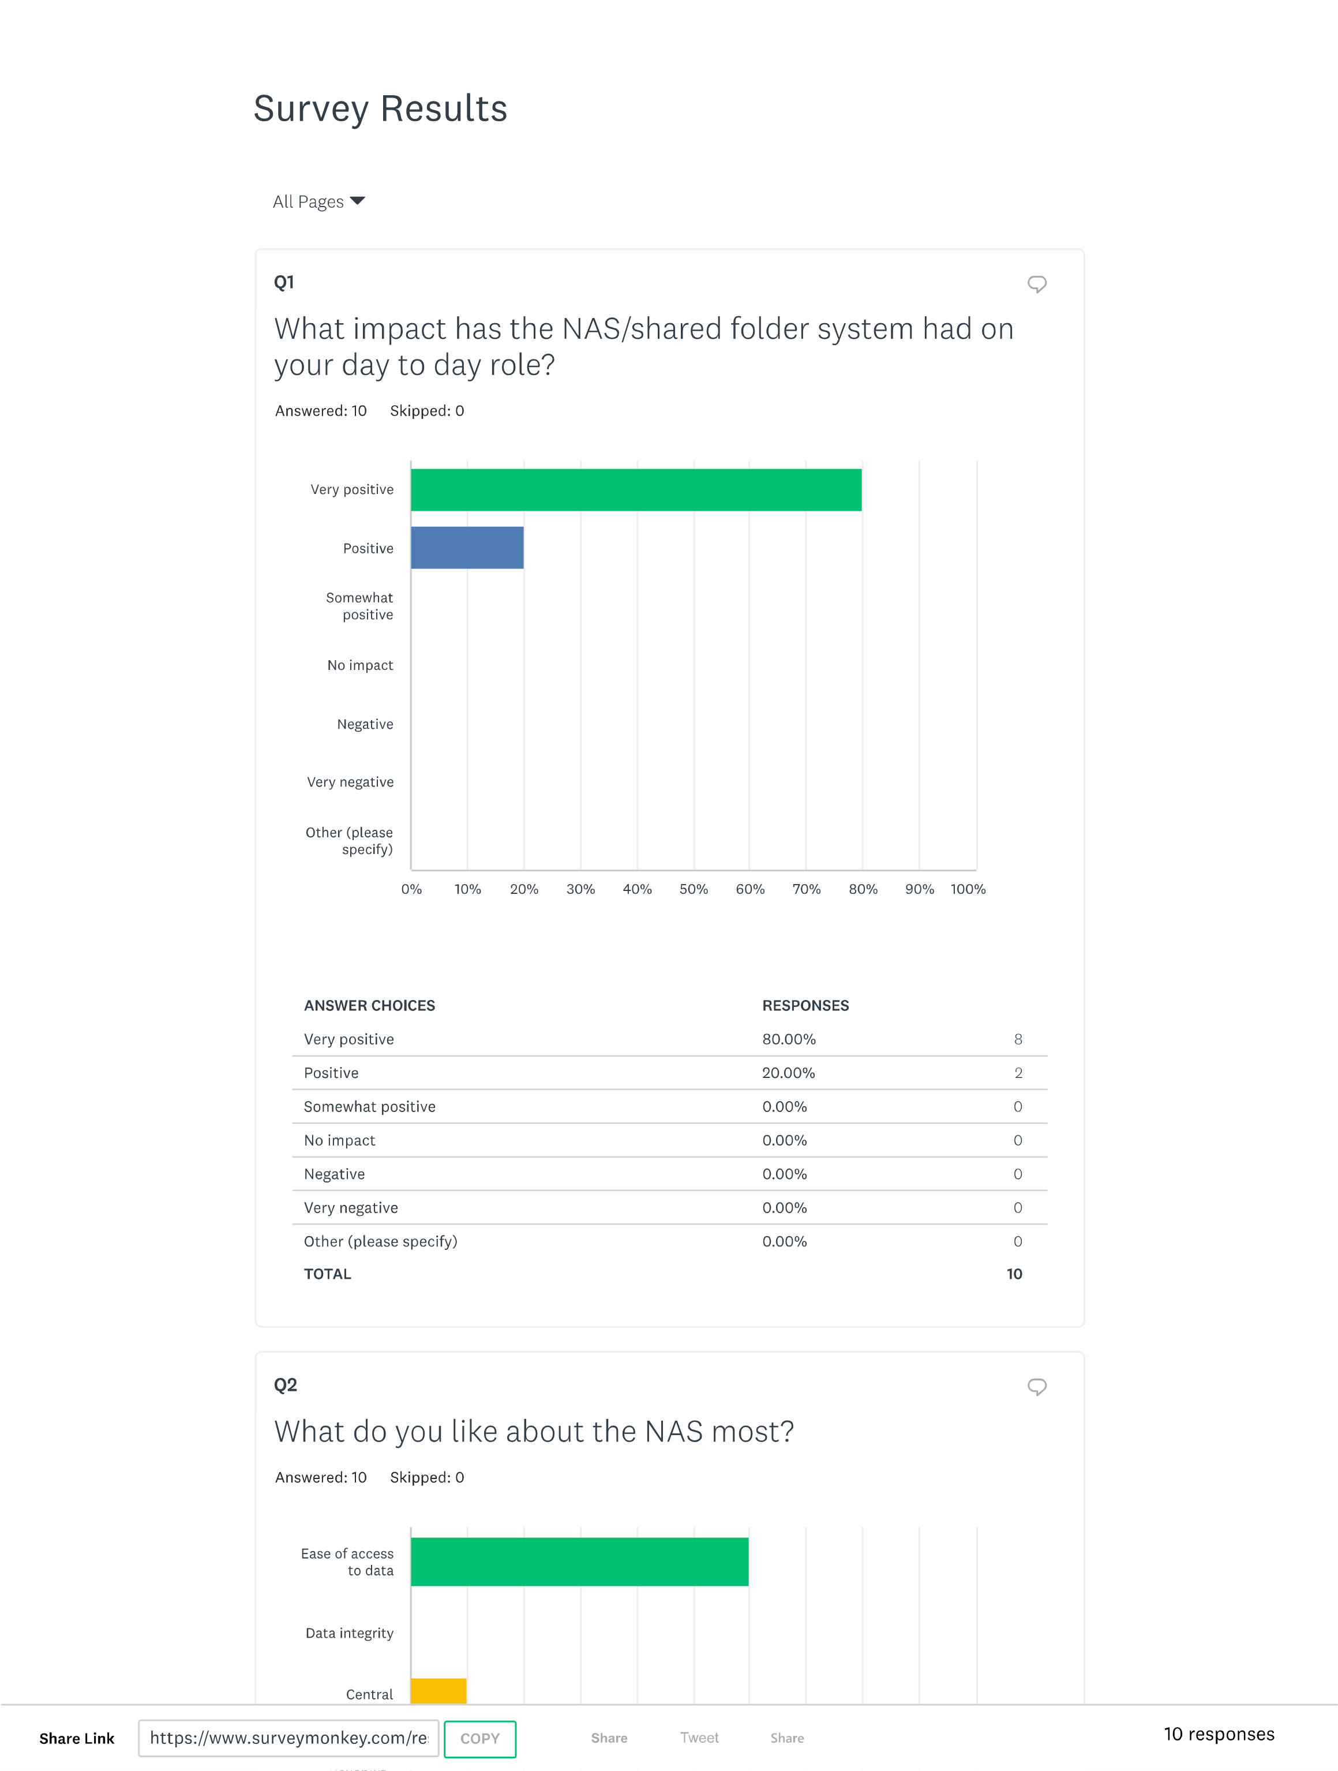
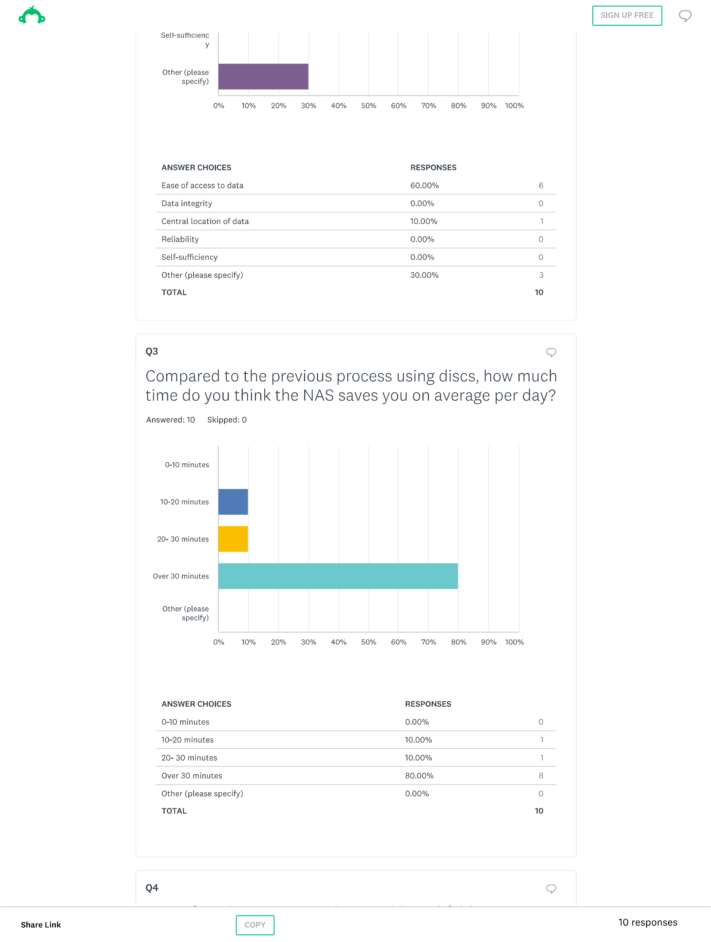
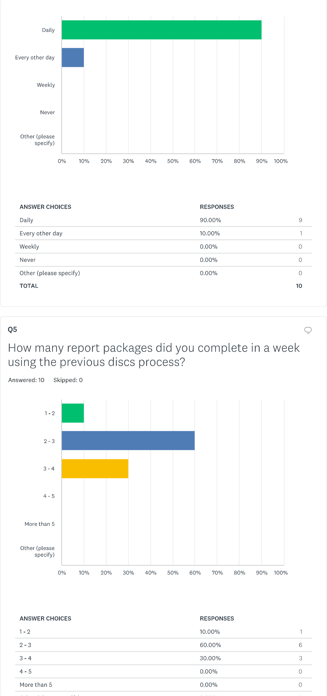
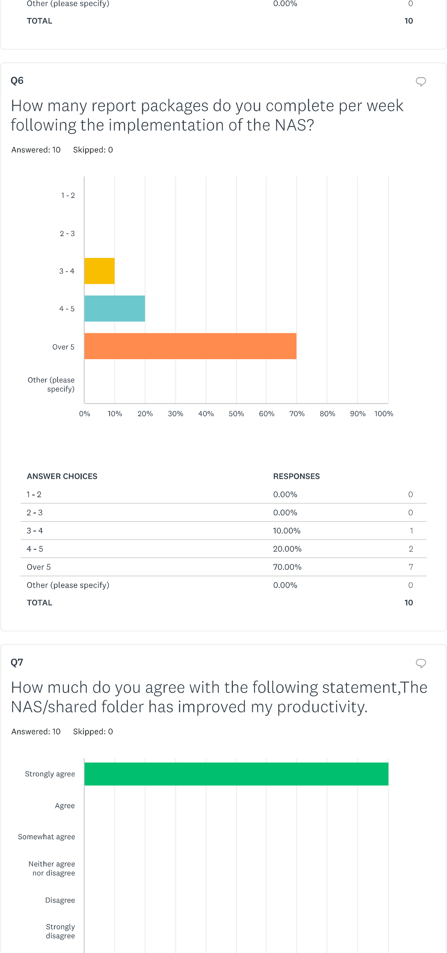
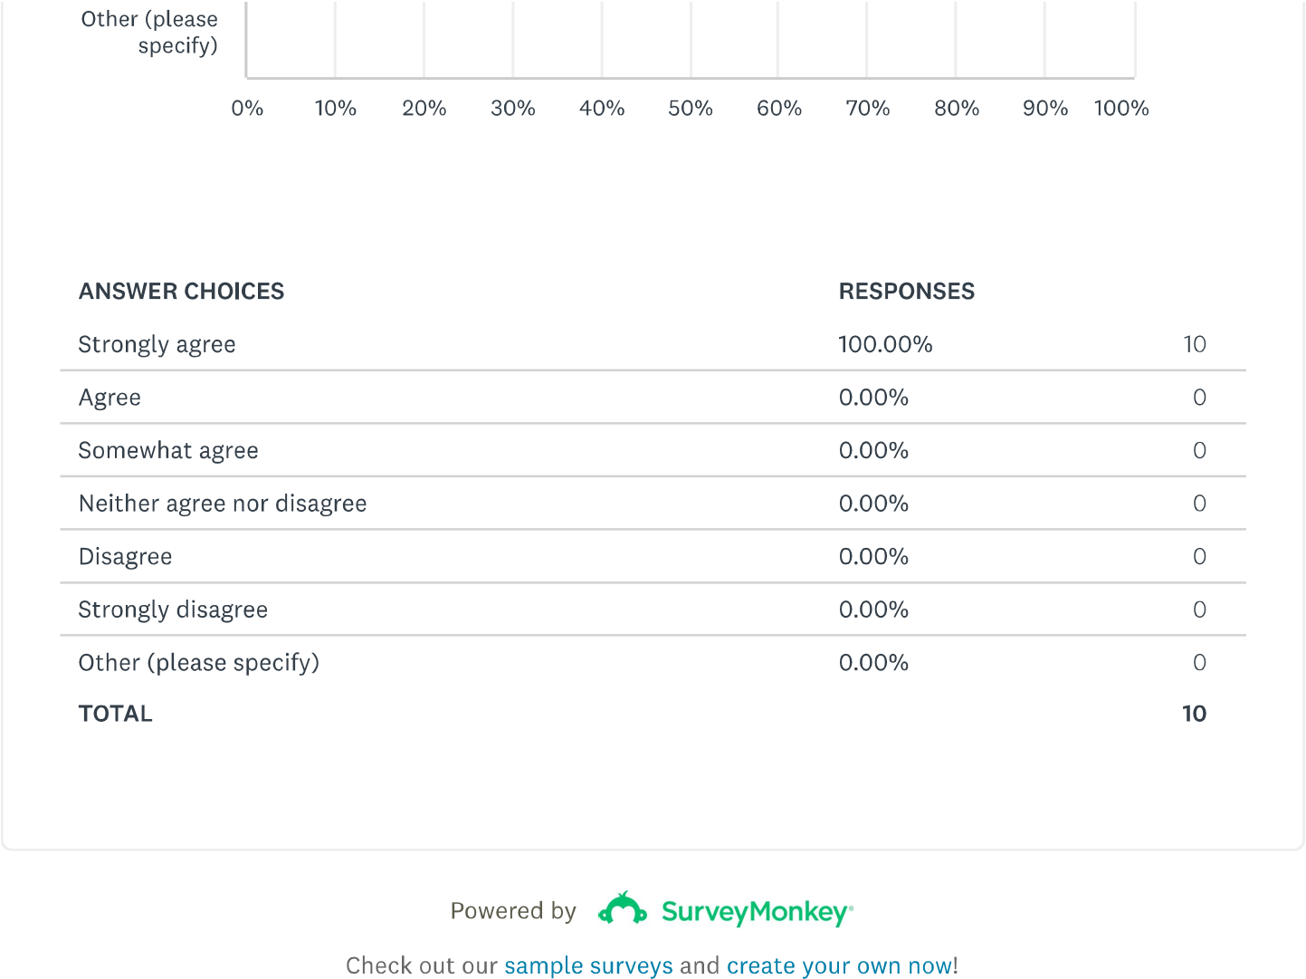 [13]

