Marketing Plan

YuhuiDong
2208741
trategic Marketing
(BMBM6016)
Deadline 22 May 2023

Summary
The purpose of this study is to analyse the marketing strategy of McDonald's Corporation in the Chinese market. For this purpose, an internal analysis was carried out using the 4P marketing theory. A SWOT analysis was also carried out to analyse and study the company's micro-environment. Through this analysis, the researcher has identified certain competitors that have won the market share that McDonald's has lost. To achieve this, these competitors are taking advantage of two main trends (which have been gaining momentum in recent years): premiumisation and toys. China's growing consumer purchasing power has fuelled demand for high-quality products in attractive packaging, which in turn has inspired some manufacturers to move away from mass-produced products. This has inspired some manufacturers to move away from mass production to high-end products. In response, this paper proposes a new marketing plan based primarily on premiumisation, which aims to The aim is to gain market share and maintain the leadership position of the brand and the company. The plan uses the SOSTAC model to provide insight into the current situation, objectives, strategies and the company's leadership position. understanding of the current situation, objectives, strategies, tactics and controls. This paper provides an implementation plan involving different departments to support the new strategy and ensure that the implementation This paper provides an implementation plan involving different departments to support the new strategy, ensure implementation and achieve desired goals.

Contents
1.0Introduction 3
2.0 Main Findings 4
2.1 McDonald's micro-environmental analysis using swot. 4
2.2 Developing a marketing plan with the sostac framework. 4
3.0Conclusion 12
4.0Reference 14

1.0Introduction
McDonald's was the first foreign company to start a fast-food chain in Shenzhen in 1990. The company embarked on an adventurous journey in an area that was unexplored at the time. Entering a new market involved both different problems and attracting a whole new type of consumer with specific characteristics. Over the years, the company has learnt how to deal with this market well and, with a market share of 35%, has become the leading company in the fast-food sector in China. However, McDonald's market share in China has declined for five consecutive years, from 40.3 per cent in 2013 to 35 per cent in 2018. Driving the downward trend is the fried chicken burger, whose value share fell from 27 per cent in 2013 to 22.6 per cent in 2018. Facing a negative trend among many competitors, this is becoming a major issue in this potentially growing segment.

2.0 Main Findings

2.1 McDonald's micro-environmental analysis using swot.
See Appendix I for details.

2.2 Developing a marketing plan with the sostac framework.
Situation
The company's participation in McDonald's has been declining since 2013, from 27% in 2013 to 22.6% of the value market share in 2018. While other players have been aggressively upgrading their product lines, and the participation of imported brands. At the same time, other players are actively upgrading their product ranges and imported brands are becoming more accessible through e-commerce. Conversely, premium burger brands, such as five guys, have seen increased participation since 2015. Participation gained since 2015. As mentioned earlier, five guys are a brand positioned as a premium product. The brand pays particular attention to the design of its packaging. It has an iconic red box, symbolising quality and quality., the red packaging symbolises quality and elegance. KFC, on the other hand, has won market share in the country and has strong growth forecasts. Both competitors are positioned as luxury brands therefore, they are both winning in the premiumisation segment. Premiumisation is currently one of the most important trends in China. Growth in Chinese consumer incomes In China, the growth in consumer incomes has stimulated demand for high quality and attractive packaging products. Stimulating demand for high quality products in attractive packaging. This situation has encouraged many manufacturers to gradually shift from mass production to high-end products. Firstly, there is the medium to high economic level of consumers who are very concerned about the importance of health. They are therefore particularly concerned about the nutritional value of the food they consume. The nutritional value of the foods they consume. A great deal of importance is given to packaging. This group of consumers also attaches great importance to foreign brands, as their consumers are less concerned with price and more concerned with the price-quality ratio. Very importantly, as their purchasing power is increasing, they want to upgrade their standard of living.

Fortunately, McDonald's has a variety of skills to handle this situation, incorporating new trends and serving the consumers they ask for. trends and serve the consumers whose demands are for something new. Based on the SWOT analysis, the main strengths of the company were identified. The company's main strengths, of which can be highlighted, are its strong understanding of the market and the way in which it does business in the country. Among these can be highlighted its strong understanding of the market and the way of doing business in China, a well-established product adapted to Chinese needs, and its factories in China. As well as its own factories in China.

Objectives
The main question to be answered in this section is, what does the company want to achieve?
The first and most important objective of this proposal is to recover market share. The objective is to restore the value market. The objective is to recover the 5% market share lost in the last five years and to secure the leading position in the category. leadership position in the category. This percentage represents a sales target of US$188 million. This percentage represents a sales target of US$188 million, taking into account a growth forecast of US$3,765 million for this market in 2023. 2023 (Statista, 2019). The goal is to achieve this in 5 years; considering that this is a slow market to conquer. Other competitors, such as five guys,kfc, have been slow to win participation, averaging only 1% per year. With this objective with this objective, it guarantees the recovery of lost value sales and prevents other competitors from gaining a leadership position in the category.
The second objective is to promote not only offline sales, but also online sales. The idea is to recover it through the appropriate channels. As the distribution analysis shows, non-store retailing is winning the space it had a few years ago, becoming the channel with the highest percentage of growth. It has become the channel with the highest percentage of growth, growing at 3% per year. We are aiming for sales of 75% and 25% offline and online respectively. Online participation should increase by 3% per year until we reach a 60% offline and 40% online mix by 2023. Store-based retailing, with the goal of focusing on convenience stores. Considering that convenience stores are the fastest growing offline shops; supermarkets are considered to be the shops with the highest concentration of sales; and finally, a new proposed Finally, a new benchmark shop will be introduced in the strategic phase.

Strategy
The main question to be answered in this section is how do we get there?
The strategy is aimed at premiumisation. Our proposal is to build on this trend in order to draw up a roadmap to guide the company towards the goals previously identified. defined objectives. This means entering a new market segment, while taking into account the important position it has already earned a few years ago. On the other hand, the rising standard of living of Chinese consumers has led them to want to try high-end products. In the following sections, we will break down the premiumisation strategy for each of the components of the marketing mix. Each component of the marketing mix: location, product, price and promotion. The proposal is to develop its own shop. Consumers will not only visit to buy products, but also to satisfy their senses. The concept of the shop is to stimulate the senses of taste and smell. Firstly, it will be set up to stimulate the "sense of smell", which includes the different elements of perceived aroma. Secondly, it will be set up to stimulate the 'sense of taste' where consumers will try different types of burger sauces. Finally, a section will be included where people can sit and share the food with their families. In addition, the shop will offer tasting burgers that can be enjoyed individually or in groups.

This premiumisation strategy will mean the development of a new range of products that represent sophistication and luxury. Our proposal is to develop a range made from quality meatloaf with exotic flavours. The boxes and bags should also reflect luxury and have a die-cut of the brand name. In the first phase, this new range will be sold only in "McDonald's shops". in order to stimulate visits to new markets. This new range will be placed in a special place in each section of the shop, with the hope that consumers will take it with them as they walk through the shop.

The shops will include a surprise factor in order to give and special value to the customer; this will be personalised. The brand will offer the following possibilities to personalise the consumer's choice of burger or any other product, by placing the name in the packaging. The campaign will be run online by the brand's website at the same time, and another activity to be included is a tour of the production plant. Even more and more Chinese consumers are interested in McDonald's, so this will be a way to show the brand's understanding and commitment to them. The idea is to offer loyal consumers an 'open day' where the winner can visit, share a special day with the brand and learn about the careful production process. This would be a way to build entertainment on site and enable more interaction with consumers.

The new collection will be approximately 20% higher than the current offer. This strategy will set a price that is a little more expensive than five guys but not too expensive. If it is a personalised burger, it will include costs associated with the process.

Tactics
The main question to be answered in this section is how exactly do we get there?
The strategy is SEO (Search Engine Optimisation). This strategy gives a brand the opportunity to compete with its competitors by improving its position in the search engines. However, the benefits of SEO go far beyond this. A good SEO positioning has a direct impact on the success of a marketing strategy, both online and offline, as a website is a digital display of a product. A good SEO can increase brand awareness by attracting more traffic, attracting more traffic to the web and increasing the chances of getting more sales or conversions. In the case, SEO will focus on providing visibility for the new 'McDonald's Store' and the new range of Shop" and visibility for the new range. On the other hand, SEO will also focus on promoting the new 'Personalisation', which will be managed both online and offline, seeking to increase sales in both channels. This strategy will be run on the Baidu search engine on which it will run.
The strategy will utilise traditional channels, namely public PR remains an important area of the brand strategy. The goal is to manage different campaigns in the new 'shop'. The goal is to manage different events in the new "store", inviting important celebrities, influencers, restaurant journalists, to attend in order to promote the new shop. to promote the new store. The channels to communicate these events will be social media platforms, as well as other media. The channels for the events will be social media platforms, but also some luxury magazines and newspapers. newspapers.
Action
Firstly, it is necessary to identify the activities related to the offline strategy, in particular those related to the construction of the new "shop" and the "Premium Collection". Firstly, it was necessary to develop a design plan for the shops. Primarily, it is necessary to develop a design for the store; to identify the materials that will be used; and to assess the purchase or rental of a site to build it. The shop must be located in a tourist destination in a first-class city in in China. Specifically, it will first be opened in Shanghai, the most important city in China. Shanghai and, based on its performance, assess the opening of other shops in first-tier cities. Opening of other shops in Tier 1 cities. Once we have identified all these areas, construction will begin. Secondly, on the development of a new high-end range. This will be necessary to start all the activities related to the development of new products, which are based on concepts that have already been established. already established concept: "premiumisation". At this point in time, it is crucial to hold a kick-off meeting with all the teams involved in the development of the new product. At the same time, it will design the packaging and labelling, which should contain the claims in the artwork. It will be necessary to include a high-quality product in the new formulation. The new formulation will contain high quality cocoa and exotic flavours. Testing The testing phase will be crucial. The marketing team, as project leader, will be responsible for overseeing and following up all the different steps to ensure that the new product is launched on time. Launch on time.

Control
The last stage in this analysis is “control”. The main question to answer here is how do we monitor performance?
This section is focused on the KPIs analysis. They are directly related to the tactics and consequently to the objectives and the strategy, and also will need to be SMARTs in order to obtain logical results. The number of metrics necessary to measure the performance of a strategy will depend on different variables, such as the channels and the objectives, but quantity does not equal quality. It is recommendable to have very clear about the figures that really interest in the projects and how they are calculated. Following there are identify the KPIs required to analyses the performance of this proposal.
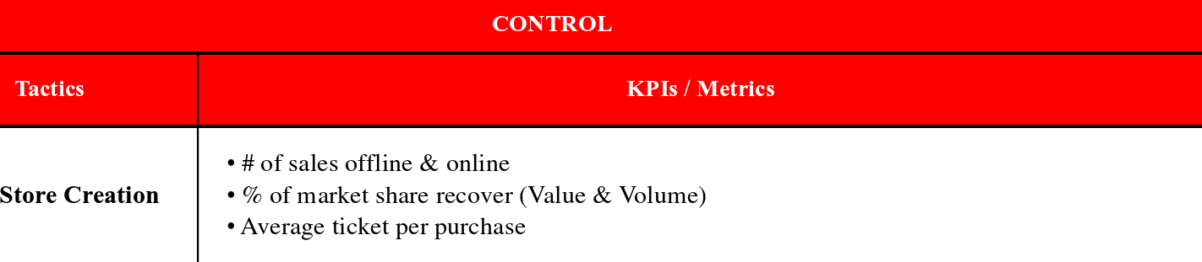
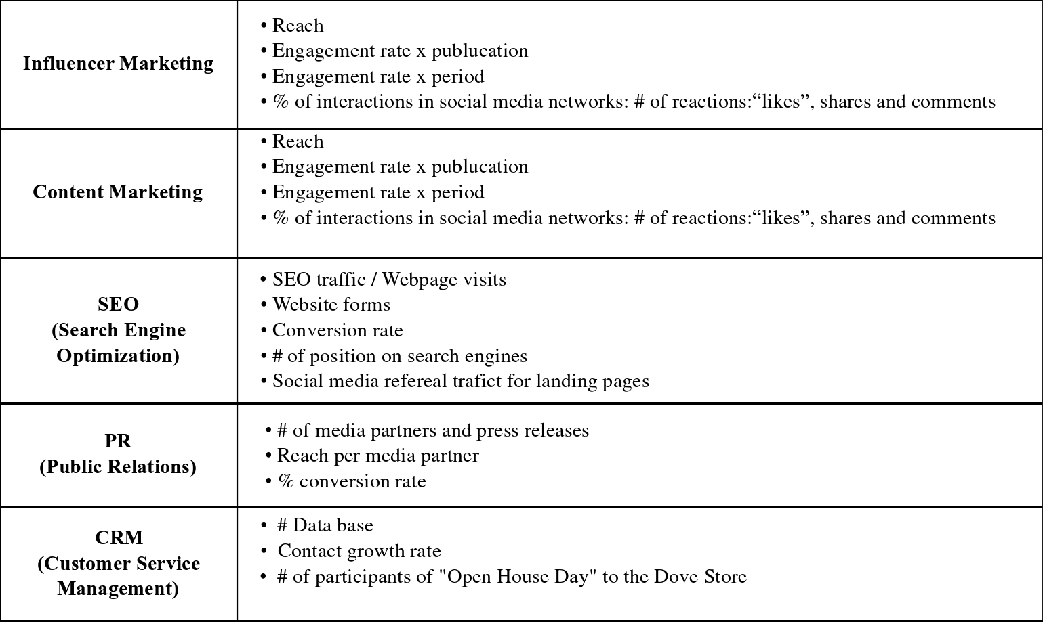

3.0Conclusion
Understanding the relevance of your market and consumers is one of the most important conclusions of this thesis. The Chinese consumer has very unique characteristics. Although the category has evolved and changed considerably, the perception of luxury is still a strong preconception they have about fast food. They have a strong preconception of what fast food should be consumed. This is a very relevant insight for companies wanting to capture this market. On the other hand, this consumer segment has undergone important changes in recent years as the country has expanded in international business. This expansion has transformed the country on all political and socio-economic levels. resulting in an improvement in the living standards of its citizens due to the increase in wages. These increases in the incomes of Chinese consumers have stimulated the demand for foreign and high-quality products. have had a positive impact on the growth of consumption. Chinese consumption is growing year on year and therefore the income generated from this market. The importance of incorporating new trends is another key conclusion. Premiumisation is one of the top trends in the world today. Even in even the most basic products, such as drinking water, some brands are trying to position themselves as Some brands are trying to position themselves as premium products in order to encourage consumers to take an interest in the brand and make them feel they are being treated differently. They feel they are being treated differently. This is one of the most important trends in China today. It is also one of the most important trends in China today and affects almost all categories. The combination of the previous three findings explains: the fact that Chinese consumers still have a strong sense of luxury; their improved standard of living; and the increasing trend towards premiumisation. The perfect combination of these factors suggests a new and rational marketing strategy. SOSTAC is a great model that allows the creation of a marketing strategy in a very structured form without getting lost in the process of trying to compile all the elements. This model allows for the creation of a cascade of logical ideas, from the most comprehensive issues to the final steps. issues, to the final steps of implementation, such as control through KPI's. Last but not least, companies that are independent of their strength and leadership in the market must remain constantly innovative in order to stay afloat in this ever-changing environment. Staying afloat in this ever-changing environment.

4.0Reference
Kotler, P. Marketing Management Millennium Edition. [M]. United States of America: Person Custom Publishing, 2000, Chapter 10, 183-198.

Lecinski, J. (2011). Winning The Zero Moment Of Truth. Unated Stated of America.
Google Books. [J].

Lee, G. A Review of Marketing Mix: 4Ps or More? International Journey of Marketing Studies. Vol 1, Nº 1, 2009. [OL]. [2019-06-13]. Available at: http://citeseerx.ist.psu.edu/viewdoc/download?doi=10.1.1.656.1894&rep=rep1&type=pdf

Mars Incorporated. (2019). “All about Mars”. [OL]. [2019-05-01].Available at: https://www.mars.com/

M&M TV Commercial, 2017, [OL]. [2019-08-01]. Available at: https://www.youtube.com/watch?v=olZmq3kdUGA

Mondelez International. (2019). Human Rights Due Diligence and Modern Slavery
Report 2018. [OL]. [2019-09-20].Available at:
https://www.mondelezinternational.com/~/media/mondelezcorporate/uploads/download
s/mdlz_human_rights_report_2018.pdf?la=en

Morris, John A. (2012). The chocolate of tomorrow: What today’s market can tell us
https://www.ub.unibas.ch/digi/a125/sachdok/2013/BAU_1_6163476.pdf

Nelson, Christina. (2011). Chocolate Fortune. China Business Review. [OL]. [2019-06-09].Available at: http://www.chinabusinessreview.com/chocolate-fortunes/

Nestle. (2019). “Key Figures” [OL]. [2019-09-20]. Available at: https://www.nestle.com/aboutus/overview/keyfigures

Nestle. (2019). Annual Report. [OL]. [2019-09-20]. Available at: https://www.nestle.com/sites/default/files/assetlibrary/documents/library/documents/ann
ual_reports/2018-annual-review-en.pdf

Platige Image. (2016). TV Commercial Dove Chocolate. [OL]. [2019-09-16].
Available at: https://www.youtube.com/watch?v=OF_jTueiHFI
’
PR Smith Market Success. (2019). SOSTAC Planning System. [OL]. [2019-06-13].
Available at: https://prsmith.org/sostac/

Reed, David. SOSTAC: The guide to the perfect digital marketing plan. Journal of
Direct, Data and Digital Marketing Practice 16, (2014), pp 146–147. Via Google Scholar.
[J]. [2019-06-13]

Ries, A and Trout, J. (1972). The Positioning Era Cometh. Advertising Age Features.
[OL]. [2019-07-11] Available:

Appendix I
Strength
One of the brand's key strengths is its in-depth knowledge of the Chinese market. The company has been working for many years to understand the characteristics of these consumers in addition to meeting their needs. The McDonald's burger is a strong product that can be perfectly adapted to the needs of China. A premium protein combination. Another key aspect is that the company has a factory in the country, the first foreign company to build a factory in Beijing in 1993, allowing more flexibility to innovate and adapt easily to changes and giving them a strong understanding of Chinese regulations and laws. Last but not least, McDonald's has been in the minds of consumers for many years.
Weaknesses
The Chinese have always been very concerned about their health and the characteristics of the food they consume. The burger has traditionally been seen as unhealthy considering the calories it contains. Therefore, they would not include it in their daily consumption and if so, they would consume it in small quantities. Burgers are an impulse product and are not included in regular or common product purchases. This impulse purchase occurs when the shopper sees the product on the shelf. Considering the increase in online shopping, if shoppers would not see the product on the shelf and therefore would not remember to buy it.

Opportunities
One of the biggest opportunities identified was Hamburg's growth forecast for the Chinese market. Since its inception, it has been growing in the 1980s and is expected to grow by 2,5% per year (CARG 2019-2023). This forecast opens a huge window of opportunity. Another major opportunity is the Chinese perception of foreigner brands. They are positioned as high-quality and sophisticated products. People therefore prefer them because they feel their money is well spent. The trend towards premiumisation of the category is another key opportunity to consider, taking into account the growing purchasing power of Chinese consumers. Demand has increased dramatically in recent years for high quality burgers in attractive packaging which is expected to continue to grow in the coming years. Finally, the burger and toy trend; this niche has become the most dynamic category in terms of value growth over the last year. Considering its mixture, it is very attractive not only to children but also to parents who are looking for products.
Threats
The most relevant threat is the fierce competition from China. This country has the most powerful fast-food chains in the world and is waging a war. Each of them is very strong in every country/region they come from in the whole world, KFC in the U.S. It is important to highlight the threat that McDonald's represents. This company has been increasing its market share little by little over the last few years. Reaching + 5% of the market share since 2013; the same amount as that lost by Mars. On the other side, there is another small competitor that has gained almost 3% of the market share. It arrived in China in 2015, five guys.

