HNC Quality and business improvement
Lean and Six Sigma methodologies
Hand out date: 21/09/2019
Submission date: 31/01/2020
Task: You are required to write a report which focusses on Lean and Six Sigma methodologies for process improvement. Your report should clearly identify and discuss the main stages or elements of Six Sigma process improvement initiatives. The report should also discuss the principles of Lean implementation with a focus on how associated principles can be utilised to optimise operational performance. Wherever possible, identify examples of where such approaches could be used in your workplace.
Lean: A lean methodology is optimizing the use of all resources in your organisation to benefit the product and company, this is done though continuous improvement and problem solving.
Six Sigma: This methodology is a discipline which is followed to decrease the amount of defects per million, this is done through continuous improvement once this is done defects in the product or service are decreased, there are many methods to aid continuous improvement which contribute to six sigma.
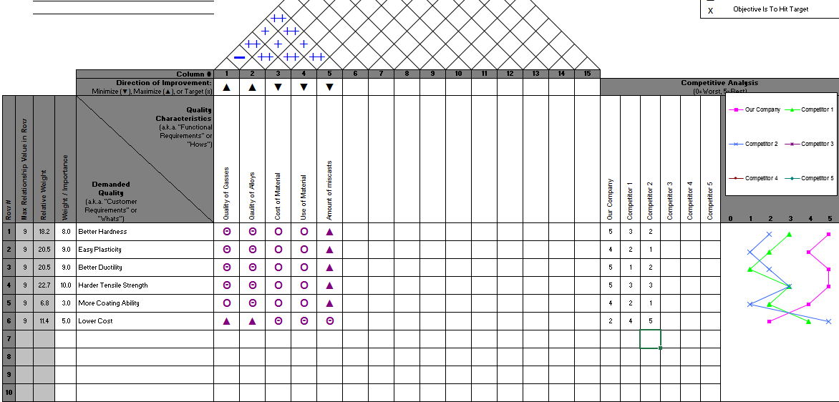
QFD: Quality Function Deployment
This is a product improvement tool, it allows the user to identify the demand from the market and the products current quality, by comparing the two it identifies what parts of the product should take priority when trying to improve the characteristics. It also maps you where there product is in the current market against competitors this is again judged ageists competitors characteristics. This shows where other products are better hence allowing you to identify where to improve to beat your competitors. The example shown is a small representation of a QFD but these can be much larger and be completed over a number of days. Though doing this method of product improvement it will decrease the number of defects in your product and allow you to identify where to improve to either beat competitors or meet the demand in the market, this will create greater sales of the product and increase revenue. The diagram is well mapped out creating charts where needed to allow easier understanding of the results. This chart will be continuously changing to the changes in market meaning they will need to be updated regularly to keep up with market change.
Bradwell, MB, Dixon, JD, Hall, MH, Williams, JW (2019) Measuring tape QFD, 1st edn., UWTSD: Jack Dixon.
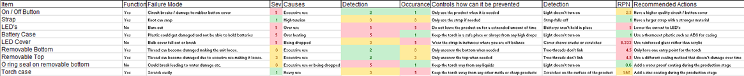
FEMA: Failure Mode Effective Analysis
This is a FMEA, this improvement method shows all aspects of the product and then focuses on the failures of that part, firstly you focus on if that part is a function that the user uses, e.g. a user what not use the LED cover as a function. You then go on to look at the failure mode, this discuss what can go wrong with that part of the product for example the Strap of a touch could fall off or untie. A severity is then made on how server the damage is if the damage stops the use of the product it will be classes as a high severity, for example on a car the window not rolling down would be low where as an engine failure would be high. Next is the causes of that problem, this section can be the longest due to multiple causes of that issue such as for a torch, over use or water could effect or damage the product. Following that the detection of the issue is evaluated, this asks how easy is that issue detected for example again is a car window is not rolling down it is an easy detection where as if an engine had failed it wouldn’t be as easy to pin point the issue. RPN is then calculated to show which issues should be tackled first, next to that are the recommended actions this is a list what should be done to correct the issue.
Bradwell, MB, Dixon, JD, Hall, MH, Williams, JW (2019) Torch FMEA, 1st edn., UWTSD: Morgan Hall
Root Cause: If an issue is found with a product or process root cause analysis will have to be taken out, this is mostly done though an investigation into the problem there are many ways to find the root cause of an issue but some are preferred to others. Some root causes are easier to find than others. https://www.taproot.com/definition-of-a-root-cause/
Pareto Analysis:
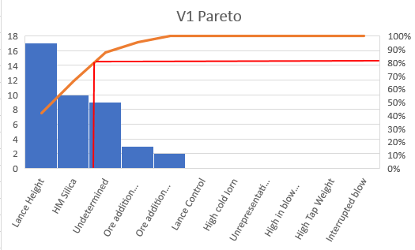

Pareto analysis is another form of business improvement, by identifying which parts make up the amount of defects you can tackle the biggest issue, this graph explains that 80% of the issues will fall in 20% of the root causes. By aiming to tackle these root causes you can drastically reduce your amount of defects. We use the method in my area of work to reduce the amount of emissions.

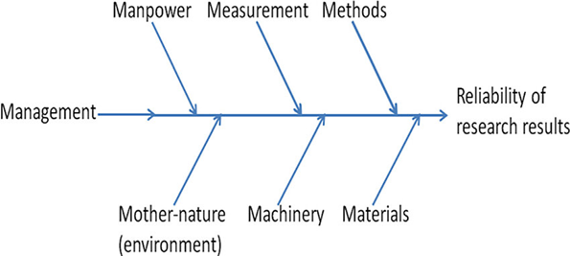
Fish Bone:
This is a fish bone analysis this splits up sections into different reasons of why something failed or needs improving.

Manpower this could be to do with the amount of staff you have. For example if a product wasn’t delivered in time it may be to do with the amount of man power you have, you may not have enough staff to deliver the product on time.
Management poor management can result in issues occurring for example you may have lots of staff off at a single time this can effect performance this would be down to poor time management of a manager.
Mother nature this is often difficult to manage because it is natural but fixes can be put into place to help prevent mother nature effecting production. For example if it was snowing and trucks could deliver the product they should be equipped with snow tires or all whether tiers to prepare for the situation.
Machinery faulty machinery can massively effect production if you spend more time fixing a machine than it being used it is wasteful and having a negative impact on costs it is better to have modern and working machinery to help the production process
Measurement these have to be extremely accurate for example if you have fill something it could cause a spillage which could cost in production time.
Materials can effect a product by making it out of cheap materials it is more prone to fail for example using a soft wood to make a product which will undergo heavy stress will be likely to fail.
Method is another fault, if you do not adapt the correct method to carry out a task it can result in a fault which can effect production time and cost by find thing the most effect method to carry out a task will make a business more successful for example car manufactures use production lines starting with the chaise to adding the interior at the end this is proven to be effective.
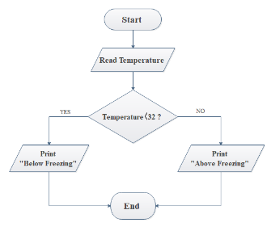
Flow Charts:
Flow Charts are another method to find an issue or improve a business, these get to the root of the issue through reading though the process, once the issue is found fixes can be explored to correct or improve the current state. You can also look back into other areas of the flow chart to see if that area needs improving this method is shown to be effective because you look at the whole system and can identify fixes for area which have not yet be exposed, this saves time and money because you will not have to revisit the issue further down the line. These are also used to find the root cause of an incident buy recording every decision that was made in one single graph you can then look back and see which decision lead to the issue occurring.
Lean: A lean methodology is optimizing the use of all resources in your organisation to benefit the product and company, it also reduces waste at every step in the process to add value to the customer.
Waste/Muda: This is any activity that consumes time, resurfaces or space but doesn’t add any value to the product or service.
History of lean: lean production first started in the 1910’s with hennery ford the founder of ford motor company. He set up a production line to create his cars it started with the ford model T by doing this it reduced wasted time making the production process more efficient. This method was soon adapted by all motor companies and is still in use today. In the 1930’s Kiichrio Toyoda the founder of Toyota reassessed there production method an revolutionised the production of motor vehicles all around the world, this was done by having machines create their cars. They put all their machines in a sequenced order of the car production sequence and created a continues flow system, this saved time and material because there machines would it the material to the correct size. This give the company massive savings and this system is used for every major car manufacture. https://sixsigmastudyguide.com/history-of-lean/
Lean Production: Many motor companies are now using lean production this mostly links to the supply of parts. Lean production is where only the required amount of parts are delivered to the production line. For example to make 100 cars only 100 car bonnets will be delivered, this minimises wasted space of storage. The space can then be utilised for more effective use. To do this the supplier and manufacture must have a strong relationship and good communication skills, this is because the smallest mistake could affect the whole production line.
Richard Morgan, RM (2019) Six sigma presentation, 1st edn., UWTSD: Richard Morgan.

Principles of Lean
- Define the value
- Map the value stream
- Make the process flow
- Pull from the customer
- Work towards perfection
Once all of these have been achieved lean production is well underway this mean the process can no longer improve for the current market and you are making substantial profits and benefits from working this way.
https://www.lean.org/whatslean/principles.cfm
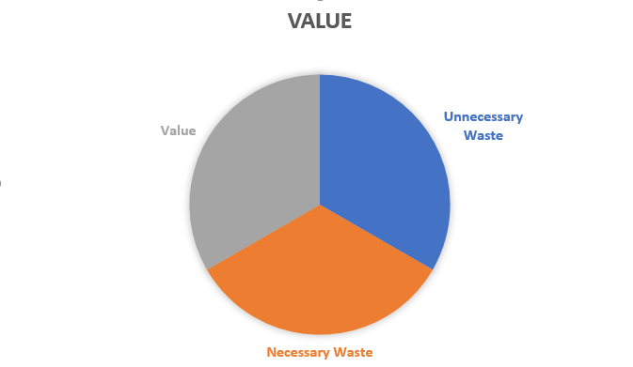
Value

Value is split into three sections dependant if the customer is willing to pay for that service. This example will be based on TATA steel
Value: New Grades, Manufacturing Process, product information, product materials. Safety equipment
Necessary Waste, Quality checks, reviewing the business, material storage, over time, shipping costs, lunch breaks
Unnecessary waste: Miscasts, poor communication, faulty equipment, incorrect information, harmful gasses.
It is import to assess are value regularly to find area where we can improve to save money or better the company or products we produce.

How can all this be used within my company
QFD – At Tata Steel we could use a QTD to compare the steel we produce to our competitors. The demands could be categorised into the properties of steel such as strength or conductivity. We could then map out where are steel needs to improve in comparison to company’s like British steel. Doing this could allow us to identify where we need to improve and allow us to better are product to beat competitors hence increasing sales and revenue.
FMEA – We could use this method of product improvement to improve the steel we produce by identifying how and why are steel fails we can investigate into methods to prevent this and better our product for example if one of a grades is not a strong as it should be a change could be made to the composition of the steel to prevent this happening in future production this would better are products and increase sales and revenue.
Fish Bone – An example of where this could be used if a ladle over poured and it took longer than expected to come back online. We could be lacking man power which caused the delay on the maintenance time, the measurement could be wrong by over filling a ladle. The machinery could be faulty which causes the torpedo to over tip. This method is used a lot when investigating into an issue. This is because this method is effective when locating the root cause.
Flow charts also used to track why an innocent occurred, it give a time line of the issue which allows use to find when and why it happened, his issue is then explored deeper to create a fix on the issue to insure this does not happen again, here is an example of a real why tree we created to find the root cause of an issue that occurred on plant. 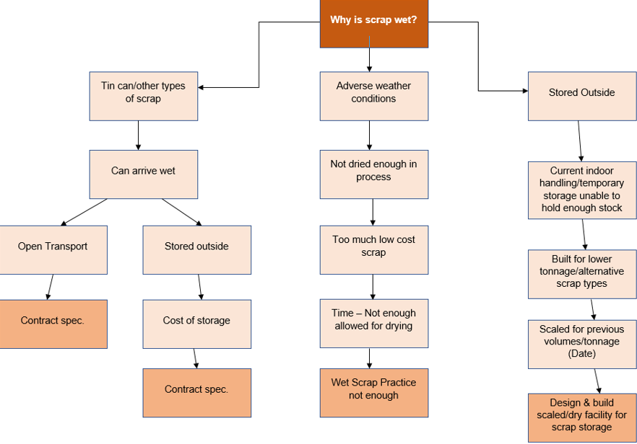
Pareto Analysis:
This is an example of a pareto analysis I created to reduce the amount of slopping emissions as you can see 80% of the issues fall in 20% of the root causes, these are the root causes we will focus on to decrease the emissions.

Conclusion
In Conclusion any form of business improvement will improve a product or business for the better, when improve a part it is important to find the root cause of why it needs to be improved, this is to insure that the issue does not arise again and a proper fix is implemented. By doing this it will improve you business or product and create a more positive profit and revenue.
Bradwell, MB (2020) Flow chat scrap ejection, 1st edn., Tata Steel: Matthew Bradwell.

Reference Number | Use of Reference | Reference type | Reference | Date of use
1 | Example | Flow Chart | Bradwell, MB (2020) Flow chat scrap ejection, 1st edn., Tata Steel: Matthew Bradwell. | 10/02/2020
2 | Obtain knowledge | Presentation | Richard Morgan, RM (2019) Six sigma presentation, 1st edn., UWTSD: Richard Morgan. | 10/02/2020
3 | Example | QFD Diagram | Bradwell, MB, Dixon, JD, Hall, MH, Williams, JW (2019) Measuring tape QFD, 1st edn., UWTSD: Jack Dixon. | 10/02/2020
4 | Example | FMEA Diagram | Bradwell, MB, Dixon, JD, Hall, MH, Williams, JW (2019) Torch FMEA, 1st edn., UWTSD: Morgan Hall | 10/02/2020
5 | Support opinion | Website | Tap Root (2019) Definition root causes, Available at: https://www.taproot.com/definition-of-a-root-cause/ (Accessed: 10/02/2020). | 10/02/2020
6 | Support opinion | Website | 60 study (2020) History of lean, Available at: https://sixsigmastudyguide.com/history-of-lean/ (Accessed: 10/02/2020). | 10/02/2020
7 | Support opinion | Website | Lean enterprise institute (2020) principles of lean, Available at: https://www.lean.org/whatslean/principles.cfm (Accessed: 10/02/2020). | 10/02/2020

