Report

Name: Abdul Kareem Al-Hagin
Student no. 1250048
Module: ECAD-7004
Assessment number: 3
Assessment Title: “Design, conduct and critically evaluate a close-to-practice research project (lesson study) focusing on the model of the transformative teacher in developing practice that has a positive impact on the learner.
Submission Date: 23rd February 2020
Word count: 4970 (without references or titles)

Declaration
“I certify this work is the result of my own investigations, except where otherwise stated. All references have been duly cited”
Signed ……………………Abdul Kareem Al-Hagin………..................……………

Appendices

Appendix 1.0 – Observer Checklist
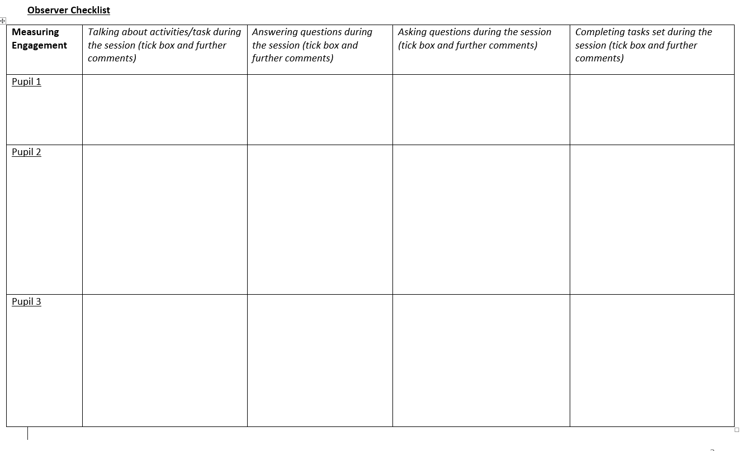
Appendix 2.0 – Arc Reflection Form

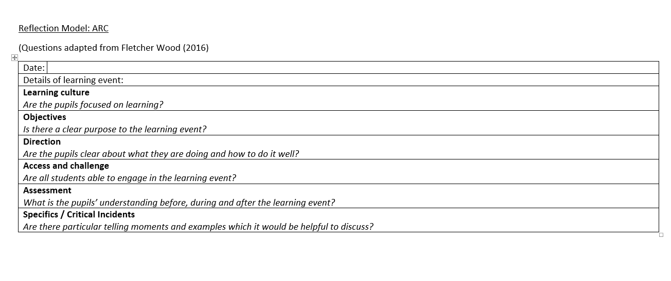

Appendix 3.0 – Focus Group Interview Question Matrix
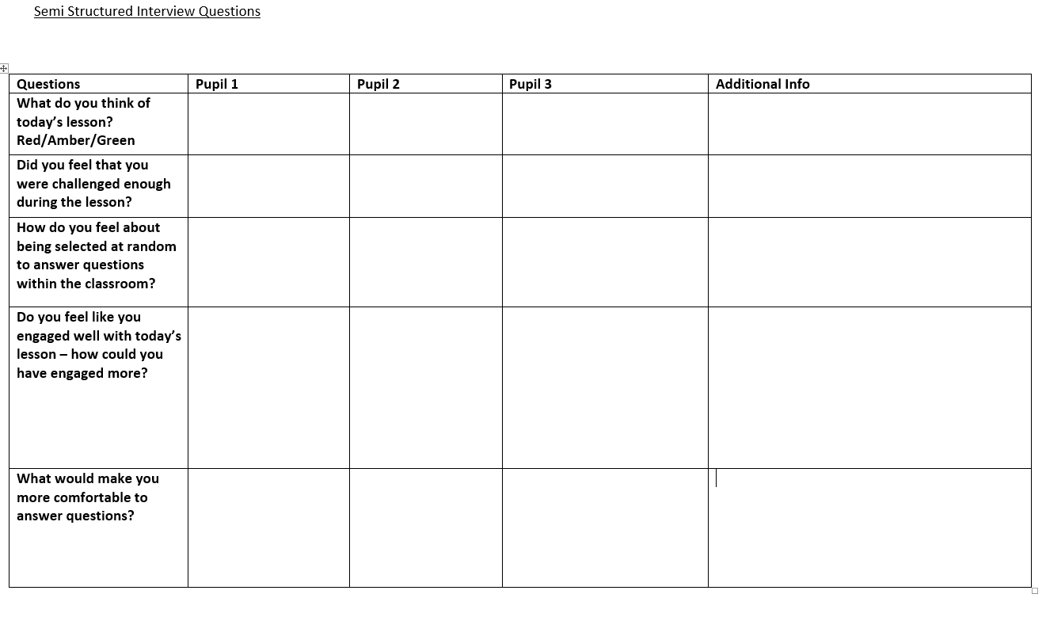
Appendix 4.0 – Lesson 1 FGIQM
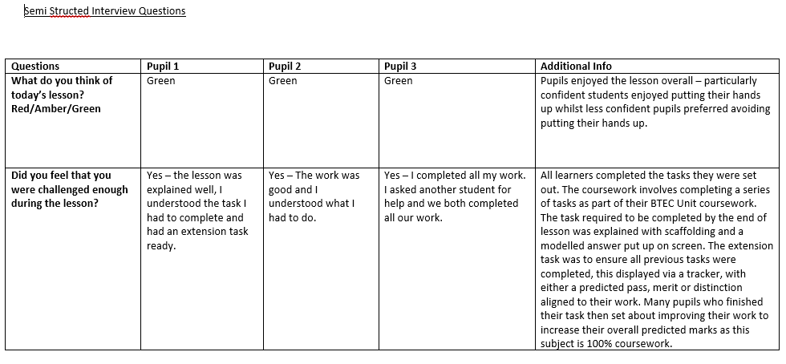
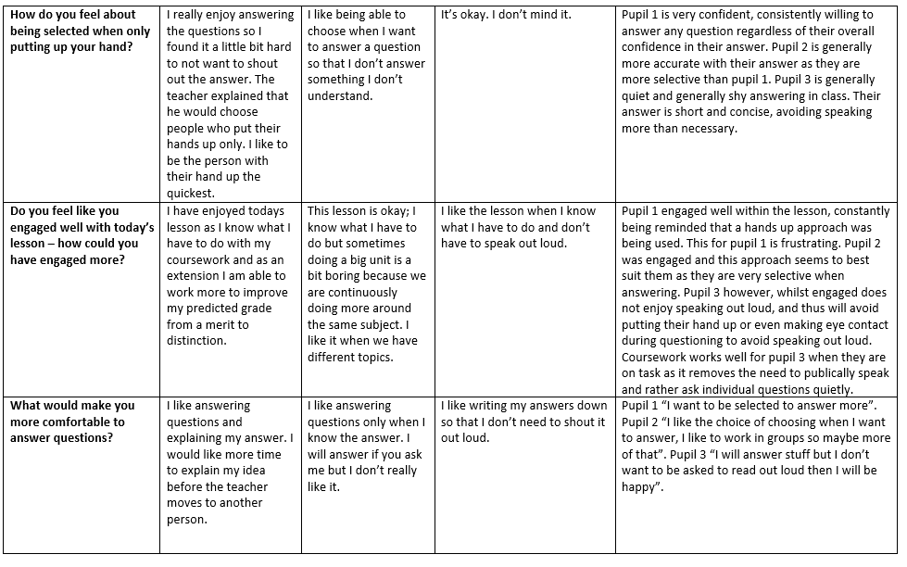
Appendix 5.0 – Lesson 1 – Observer Checklist
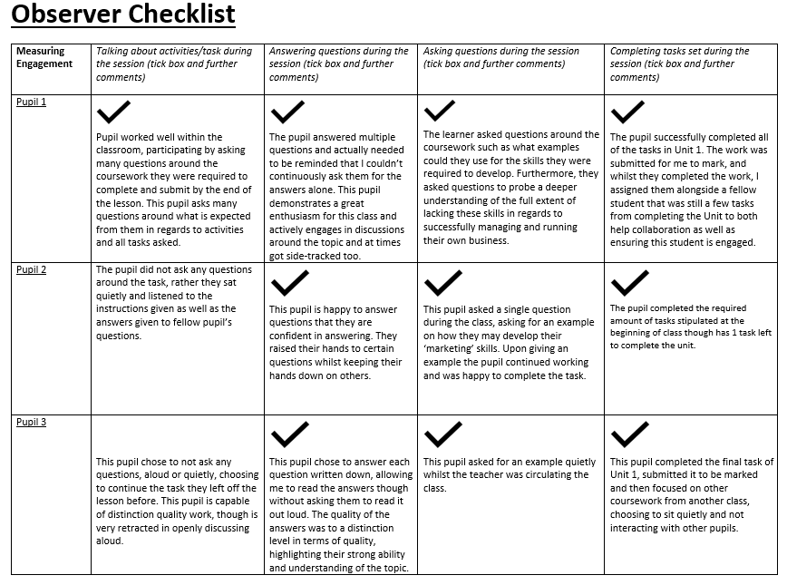

Appendix 6.0 – Lesson 1 – Arc Model
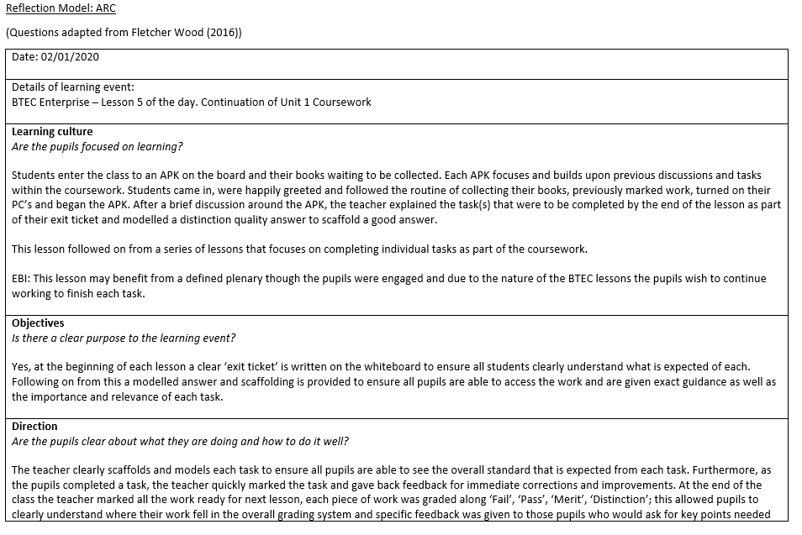
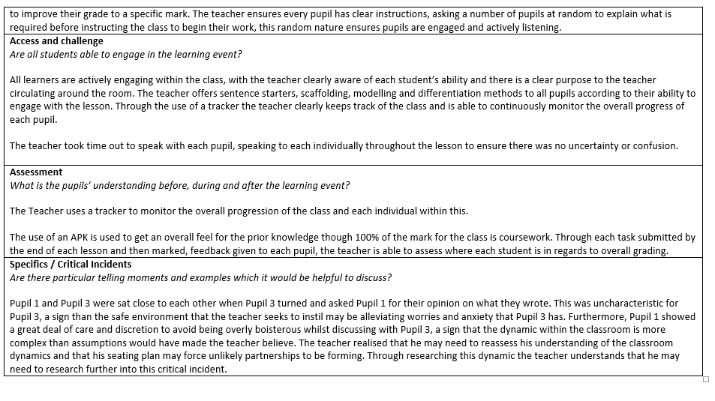

Appendix 7.0 – Lesson 2 FGIQM
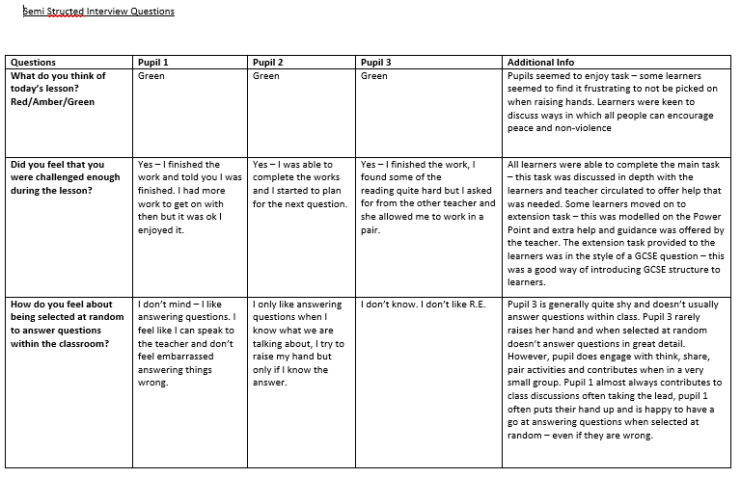
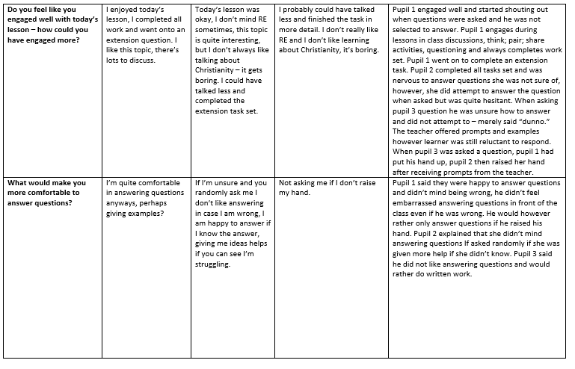

Appendix 8.0 – Lesson 2 – Observer Checklist
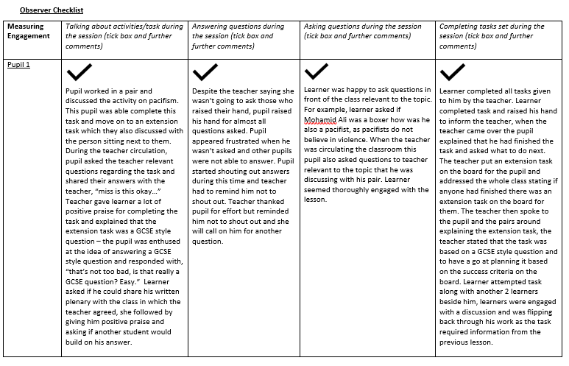
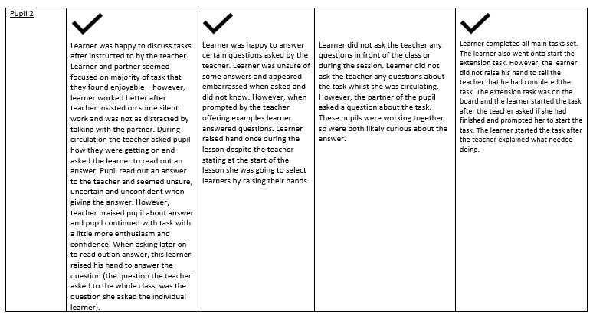
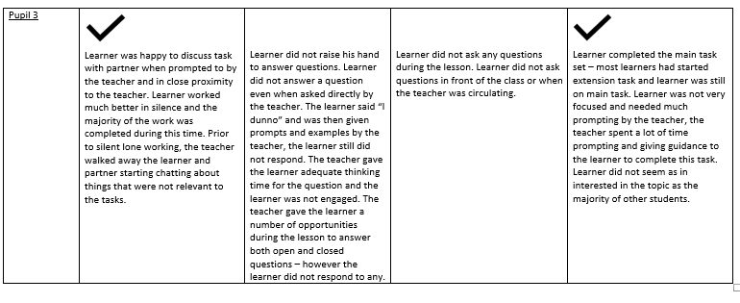

Appendix 9.0 – Lesson 2 – Arc Model


