

Applied Leadership and Management in the Workplace
Module Assignment Submission
Student Name: | Monika Wojcik
Student Number: | 2520725
Module No: | BMSK4014
Module Title: | Problem Solving and Decision Making

Statement of Confirmation of Authenticity
By the act of making this submission, the student declares that this is the work of the student named above. The work has not, in whole or in part, been knowingly presented elsewhere for assessment, or where assessment has been built on a previous assessment, this has been identified. Where materials have been used from other sources it has been properly acknowledged. If this statement is untrue, the student acknowledges that an assessment offence has been committed.
Attention is drawn to the plagiarism and unfair practice policies of both the University and of ILM.

Table of Contents

Introduction 3
1. Define the complex workplace problem 3
1.1. Evidence, actual and desired condition 3
1.2. Scope and impact 4
2. Analyse the Problem 5
2.1. Brainstorming 5
2.2. Mind mapping 6
2.3. Fishbone root-cause analysis 7
2.4. Five Whys 8
3. Propose a range of alternative solutions 8
4. Evaluate the alternative solutions 9
4.1. Weighted Grid Analysis 9
4.2. Cost-benefit analysis of the preferred option 10
CBA Calculations: 11
5. Implementation plan 12
5.1. Stakeholder analysis 14
5.2. Communication plan 15
6. Monitor and review implementation 16
6.1. Selection of Monitoring Techniques 16
6.2. Monitoring and corrective-action planning 17
Conclusion 18
References 19

Introduction
This report examines a complex operational problem within Made by Monia, a Swansea-based sole-trader business specialising in personalised handmade products for religious and family celebrations. The business has experienced increasing demand, particularly during seasonal periods, while production, customer communication, order management and fulfilment remain primarily dependent on the owner. In addition, sending products during the pre-Christmas period may be less reliable because postal workers and courier services experience increased workloads, which can increase the risk of parcels being delayed, lost or damaged in transit. This creates challenges in maintaining an efficient workflow, meeting customer expectations and completing orders within the required timescales. The problem is complex because it involves operational capacity, time management, customer service, delivery reliability, resources and business sustainability, with several stakeholders potentially affected by its consequences. Effective problem solving requires a structured approach to identifying causes, evaluating alternatives and selecting an appropriate course of action (Shannon, 2021). Therefore, this report first defines the problem, its scope and impact before analysing its underlying causes. It then evaluates alternative solutions using Grid Analysis and Cost-Benefit Analysis, followed by an implementation plan, stakeholder communication strategy, and monitoring and review procedures. The report concludes by justifying the selected solution.

Define the complex workplace problem
Made by Monia is experiencing an operational capacity problem caused by increasing and highly seasonal customer demand, while production, customer communication, order management and fulfilment remain largely dependent on one person. During peak periods, particularly before Christmas, the increased volume of personalised orders can create pressure on production time and increase the risk of delays. In addition, reliance on postal and courier services creates further uncertainty, as increased seasonal workloads may result in parcels being delayed, lost or damaged during transit. The actual condition is that orders and deliveries may not always be completed within the expected timescale, whereas the desired condition is a reliable and efficient process that consistently meets customer expectations. The problem affects the owner, customers, suppliers and delivery providers and is constrained by limited time, financial resources and production capacity. Complex workplace problems require consideration of multiple interacting factors rather than focusing only on visible symptoms (Hoerl et al., 2021).

Evidence, actual and desired condition
The table below summarises the key evidence, the current (actual) condition and the desired condition of the operational problem identified within Made by Monia. It highlights the main gaps affecting operational efficiency, customer satisfaction and delivery reliability.

Aspect | Evidence | Actual condition | Desired condition
Demand | Seasonal demand increases. | Orders may exceed capacity. | Demand is managed effectively.
Production | Production depends mainly on the owner. | Orders may be delayed. | Orders are completed on time.
Communication | The owner manages customer contact. | Responses may be delayed. | Communication is timely and consistent.
Delivery | Christmas creates higher postal workloads. | Parcels may be delayed, lost or damaged. | Delivery risks are reduced.
Resources | Human and financial resources are limited. | Workload affects efficiency. | Resources are used efficiently.
Stakeholders | Customers, suppliers and delivery providers are affected. | Delays may reduce satisfaction. | Stakeholder expectations are met.
Table 1: Summary of the key evidence

In addition, the business currently spends approximately four hours per day on administrative activities. Monthly order volume is normally around 30 orders but can increase to approximately 70 orders during the Christmas period. This increase places additional pressure on production, order management and customer communication.

Scope and impact
The scope of the problem covers production, order management, customer communication and fulfilment within Made by Monia. It is particularly significant during seasonal peaks, when increased demand places pressure on the owner’s limited time and production capacity. The problem also extends to external delivery providers, where increased Christmas workloads may affect delivery reliability. Rising demand can place businesses under increasing capacity pressure, requiring improvements in processes and operational capacity (Coad et al., 2022).
The impact includes potential delays, customer dissatisfaction, damaged or lost parcels, increased workload and financial or reputational consequences. As small businesses may have limited resources to respond to disruptions, developing operational resilience is important for maintaining effective operations (Bak et al., 2023). The owner of the problem is the business owner, who is responsible for production, order management, customer communication and fulfilment. A solution is therefore needed to reduce the reliance on one person, improve operational capacity and ensure that customer orders can be managed effectively during periods of increased demand.

Analyse the Problem
A 5 Whys analysis was used to identify the underlying causes of the operational problem. The analysis indicates that delays arise from increasing seasonal demand combined with the owner managing production, communication and fulfilment alone. Limited capacity becomes more significant as demand increases (Coad et al., 2022).
A Fishbone analysis further identifies workload, limited resources, order tracking and delivery reliability as contributing factors. These findings suggest that improving order planning and capacity management should be prioritised. A limitation is that the analysis relies mainly on internal observations rather than detailed historical performance data.

Brainstorming
Brainstorming was used to generate a range of possible causes and improvement ideas related to the operational problem at Made by Monia. The approach considers the main areas identified in the previous analysis, including seasonal demand, production capacity, order management, customer communication and delivery.

Area | Ideas identified
Production | Create a production schedule; prioritise urgent orders; prepare materials in advance.
Order management | Introduce an order-tracking system; record deadlines; organise orders by priority.
Customer communication | Use standard responses; provide clear delivery times; communicate delays promptly.
Capacity | Limit orders during peak periods; outsource selected tasks; introduce temporary support.
Delivery | Dispatch orders earlier; offer alternative delivery providers; allow additional time before Christmas.
Resources | Improve stock planning; purchase materials in advance; use low-cost digital planning tools.
Table 2: Brainstorming Analysis of the Operational Problem
The brainstorming process indicates that the problem is not caused by one factor but by the interaction of limited capacity, increasing demand and reliance on the owner. The most practical ideas focus on improving planning and order tracking, while outsourcing or additional support could provide greater capacity during seasonal peaks. This supports the need to evaluate several alternative solutions rather than addressing only one symptom.

Mind mapping
A mind map was used to visually organise the main factors contributing to the operational problem at Made by Monia. It connects the central problem with related areas, helping to identify how different factors interact and contribute to delays and reduced operational capacity.
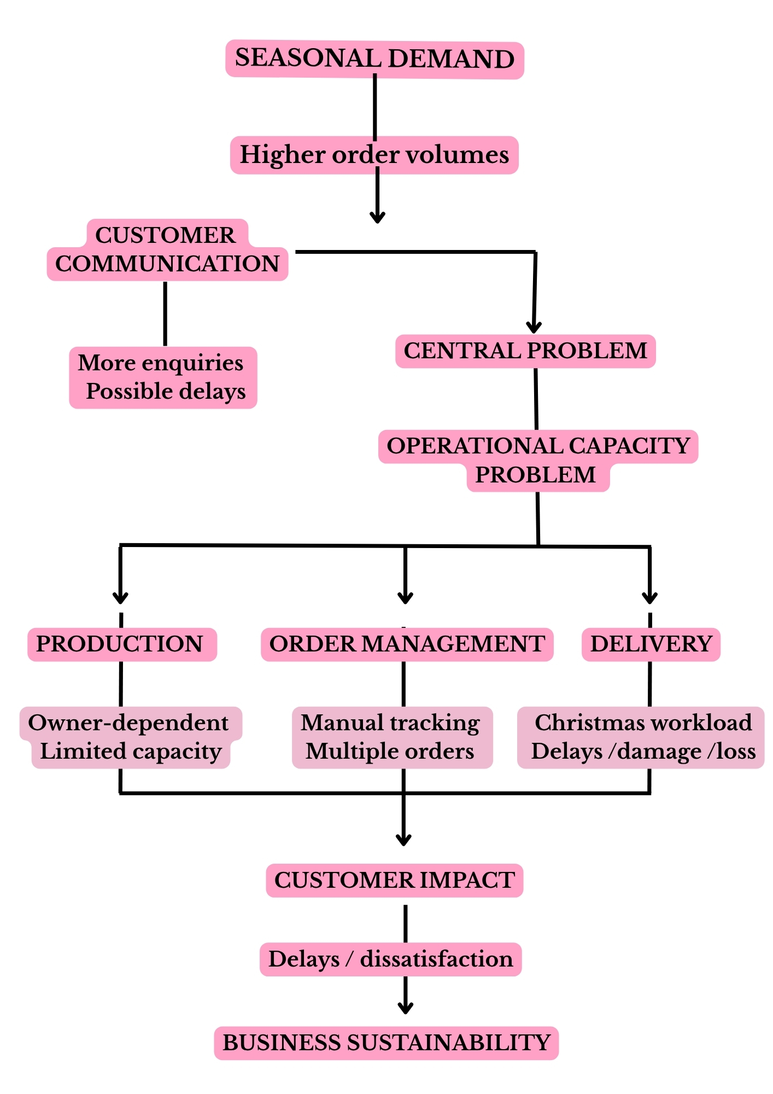
Figure 1: Mind map

The mind map shows that the operational capacity problem is influenced by several interconnected factors rather than a single cause. Seasonal demand increases order volumes, while production and order management remain largely dependent on the owner. At the same time, increased Christmas workloads may create delivery risks. These factors can lead to delays, customer dissatisfaction and pressure on business sustainability. Therefore, the analysis supports the need for an integrated solution addressing capacity, planning, order management and delivery reliability.

Fishbone root-cause analysis
A Fishbone (Ishikawa) diagram was used to identify and categorise the potential root causes of the operational capacity problem. This tool is appropriate because it helps distinguish underlying causes from symptoms and shows how different factors can interact (Carvalho et al., 2021).
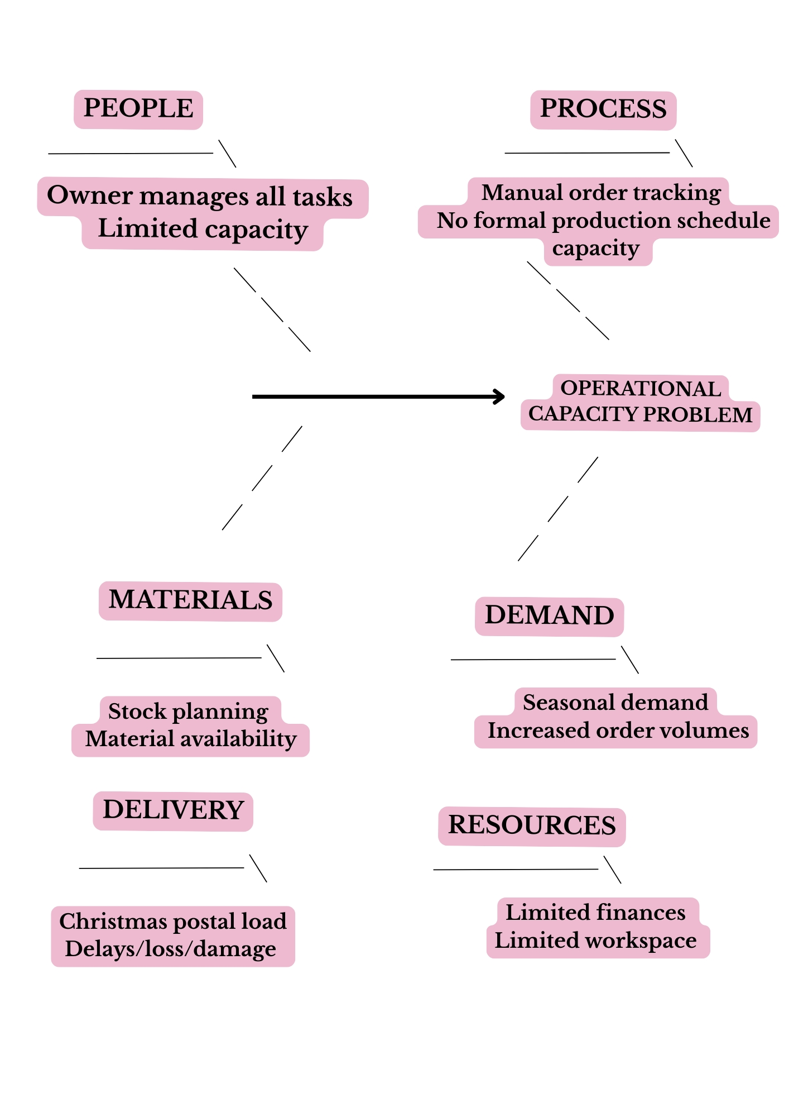
Figure 2: Fishbone root-cause analysis of Made by Monia
The analysis indicates that the main contributing causes are owner dependency, limited production capacity, seasonal demand and insufficient order planning. Delivery pressures further increase the risk of delays. Therefore, the likely root cause is the mismatch between increasing demand and the business's available operational capacity. This supports the need to improve planning, order tracking and capacity management.

Five Whys
The Five Whys technique was applied to investigate the underlying cause of delays at Made by Monia. By repeatedly asking why a problem occurs, the technique helps move beyond symptoms and identify the likely root cause (Sahoo, 2021).

Why? | Analysis
1. Why are orders sometimes delayed? | Seasonal order volumes increase.
2. Why does increased demand cause delays? | Production capacity is limited.
3. Why is capacity limited? | Production and fulfilment depend mainly on the owner.
4. Why does this create pressure? | The owner also manages customer communication, order tracking and dispatch.
5. Why are these activities difficult to manage together? | There is no sufficiently structured capacity and order-management system for peak periods.
Table 3: Five Whys

The Five Whys suggests that the main root cause is insufficient operational capacity and structured order planning during periods of increased demand, rather than delivery delays alone. This finding is consistent with the business evidence, which shows that all operational activities are managed by the owner and that order volumes increase seasonally. Therefore, solutions should focus on improving capacity planning, order tracking and workflow management, rather than addressing only delivery problems.

Propose a range of alternative solutions
Based on the root cause analysis, three alternative solutions were identified to address the operational capacity problem at Made by Monia. The options focus on improving order management, increasing production capacity and reducing delivery risks. Digital tools can support workflow organisation and operational management in small businesses (Kraft et al., 2022). In addition, resilience measures can help SMEs manage operational disruptions and protect customer relationships (Bak et al., 2023).

Solution | Description | Resources required | Barriers/Risks
1. Digital order and production system | Introduce a digital order tracker and production schedule to record deadlines, priorities and order progress. | Low-cost digital tool; owner's time for implementation. | Initial learning time and maintaining accurate records.
2. Temporary production support | Outsource selected production or packaging tasks during seasonal peaks. | Additional labour costs; training and quality control. | Higher costs and possible variation in product quality.
3. Seasonal capacity and delivery planning | Set seasonal order limits, prepare materials earlier and dispatch orders earlier before Christmas. | Advance stock purchasing and improved planning. | Requires accurate demand forecasting and may limit some sales.
Table 4: Alternative Solutions to the Operational Capacity Problem
The three options address different aspects of the identified problem. The digital order and production system directly addresses poor order tracking and workflow management, while temporary production support increases available production capacity. Seasonal planning reduces pressure during peak periods and can minimise delivery risks. The digital order and production management system is therefore the primary solution, while seasonal capacity and delivery planning can be used as a supporting measure during peak periods. This approach improves internal efficiency without creating significant additional staffing costs and is consistent with the importance of preparedness and resilience for SMEs facing operational disruption (Bak et al., 2023).

Evaluate the alternative solutions

Weighted Grid Analysis
Weighted Grid Analysis was used to compare the alternative solutions against selected criteria. This approach supports structured decision-making by evaluating alternatives against multiple criteria (Cinelli et al., 2020).
For Made by Monia, the criteria reflect the business’s operational needs, including cost, capacity, ease of implementation, reduction of delays and long-term sustainability.

Criterion | Weight | Digital order system | Temporary support | Seasonal planning
Low cost | 25% | 5 | 2 | 5
Improves capacity | 25% | 4 | 5 | 4
Ease of implementation | 15% | 5 | 3 | 4
Reduces delays | 20% | 5 | 5 | 4
Long-term sustainability | 15% | 5 | 4 | 5
Weighted score | 100% | 4.75 | 3.80 | 4.40
Ranking |  | 1st | 3rd | 2nd
Table 5: Weighted Grid Analysis of the Solutions
The digital order and production management system achieved the highest weighted score of 4.75/5 and was selected as the preferred option. It provides a relatively low-cost way to improve order tracking, production planning and communication. Seasonal capacity and delivery planning ranked second because it can reduce peak-period pressure without significant staffing costs. Temporary production support ranked third because, although it increases capacity, it involves higher costs and potential quality-control risks.
The analysis therefore supports the digital order and production management system as the primary solution, with seasonal capacity and delivery planning as a supporting measure during peak periods. This is consistent with Made by Monia’s objective of improving order tracking and production scheduling while reducing order completion time by 20%.

Cost-benefit analysis of the preferred option
The digital order and production management system was selected as the preferred option because it achieved the highest score in the Weighted Grid Analysis. A Cost-Benefit Analysis (CBA) was used to compare its expected costs and benefits (Scandizzo, 2021).
Made by Monia currently spends approximately four hours per day on administration. The business receives around 30 orders per month normally, increasing to approximately 70 during Christmas, representing a 133% increase. This creates additional pressure on the owner's time and operational capacity. A suitable laptop is required to implement the digital order and production management system. It will support order tracking, production scheduling and customer communication, reducing the time currently spent on manual administration of approximately four hours per day. The investment therefore directly supports the aim of reducing administrative workload and order completion time by 20%.

Cost | Estimated value | Explanation
Suitable laptop | £800 | Order management, design and communication
Order-management software | £120 | Digital tracking and production planning
Setup/training | £80 | System implementation
Total initial cost | £1,000 | One-off cost
Table 6: Estimated Cost of the Preferred Option
The estimated initial investment is £1,000, covering the equipment, software and resources required to introduce the digital order-management system.

Benefit | Estimated value | Explanation
Reduced administration | £600/year | Less manual order tracking
Reduced delays/errors | £500/year | Improved order control
Increased capacity | £900/year | More efficient order management
Customer satisfaction | £400/year | Better communication and fulfilment
Total annual benefit | £2,400/year
Table 7: Estimated Benefits of the Preferred Option
The estimated annual benefit is £2,400. The £600 administration saving is based on reducing administrative time by approximately 24 minutes per working day. At an estimated value of £5.77 per hour, this represents approximately £600 annually (0.4 hours×£5.77×5 days×52 weeks≈£600). The £900 increased-capacity benefit represents approximately three additional productive hours per week (3 hours×£5.77×52 weeks≈£900). The £500 saving from reduced delays and errors and the £400 customer-satisfaction benefit are estimates based on fewer order corrections, improved fulfilment and customer retention. These estimates should be reviewed after implementation.

Year | Benefits | Costs | Net benefit
Year 1 | £2,400 | £1,000 | £1,400
Year 2 | £2,400 | £0 | £2,400
Year 3 | £2,400 | £0 | £2,400
Total | £7,200 | £1,000 | £6,200
Table 8: Three-Year Cost-Benefit Analysis
Over three years, the estimated benefit is £7,200, giving a total net benefit of £6,200. This assumes that annual benefits remain consistent and the initial investment is a one-off cost.

CBA Calculations:
Benefit-to-Cost Ratio (BCR):
£2,400:£1,000=2.4:1
First-Year Net Annual Benefit:
£2,400-£1,000=£1,400
Average Annual Benefit:
£7,200:3=£2,400 per year
The BCR of 2.4:1 indicates that each £1 invested is expected to generate £2.40 in annual benefits. Overall, the CBA supports the Weighted Grid decision and the objective of introducing digital order tracking and production scheduling while reducing order completion time by 20%.

Implementation plan
The selected solution is to introduce a digital order and production management system, supported by a suitable laptop to enable efficient order tracking, production scheduling and customer communication. The implementation will be phased to minimise disruption and ensure that the system meets the operational needs of Made by Monia. A phased approach is appropriate because successful digitalisation requires SMEs to develop suitable capabilities and adapt existing processes (Chavez et al., 2020).

Phase | Activity | Responsibility | Timescale | Resources | Success indicator
1. Preparation | Confirm system requirements and purchase the suitable laptop | Owner | Week 1 | £800 budget | Equipment available
2. Software selection | Select and purchase suitable order-management software | Owner | Week 1 | £120 budget | Software selected
3. System design | Create digital order tracker, production schedule and priority categories | Owner | Week 2 | Suitable laptop, software | System ready for use
4. Data entry | Transfer current customer orders and deadlines into the system | Owner | Week 2 | Existing order information | All active orders recorded
5. Testing | Test order tracking, production scheduling and customer information | Owner | Week 3 | Digital system | Errors identified and corrected
6. Training | Develop familiarity with the new system and procedures | Owner | Week 3 | Training time | Owner can use all functions
7. Pilot implementation | Use the system for a limited number of orders | Owner | Week 4 | Digital system | Orders successfully tracked
8. Full implementation | Apply the system to all new orders | Owner | Month 2 | Suitable laptop and software | All orders digitally recorded
9. Seasonal preparation | Review stock, production capacity and delivery deadlines before peak periods | Owner | Months 2-3 | Stock and order data | Peak demand plan completed
10. Review and improvement | Measure completion times, delays and customer feedback | Owner | Monthly | Performance records | 20% reduction in completion time
Table 9: Detailed Implementation Plan

The plan provides a clear sequence from preparation and system design to testing, implementation and review. It also reflects the existing business objective of introducing an order-tracking and production schedule and reducing order completion time by 20%.
Digitalisation can support SMEs in improving business processes and productivity, but implementation may be constrained by limited resources, skills and financing. Therefore, the proposed gradual approach is appropriate for the size and resources of Made by Monia (Eller et al., 2020).

Milestone | Target | Measurement
Digital system established | End of Week 2 | Tracker and production schedule operational
Pilot completed | End of Week 4 | Pilot orders successfully managed
Full implementation | Month 2 | All new orders recorded digitally
Improved efficiency | Month 6 | Order completion time reduced by 20%
Table 10: Key Implementation Milestones

The implementation plan provides a structured and manageable approach to introducing the preferred solution. Starting with preparation and testing reduces implementation risk, while the pilot stage allows problems to be identified before full adoption. Regular measurement will determine whether the system achieves its intended objective of improving operational efficiency and increasing capacity. This approach is particularly suitable for Made by Monia because digitalisation should be matched to the firm's existing resources, processes and capabilities (Chavez et al., 2020).

Stakeholder analysis
Stakeholder analysis was used to identify the individuals and groups affected by the implementation of the digital order and production management system. This is important because stakeholders have different levels of interest, influence and expectations. Effective stakeholder communication can improve engagement and support successful implementation (Butt et al., 2016).
At Made by Monia, the main stakeholders are the owner, customers, suppliers and delivery providers. Their interests differ, therefore communication should be adapted to their level of influence and involvement.
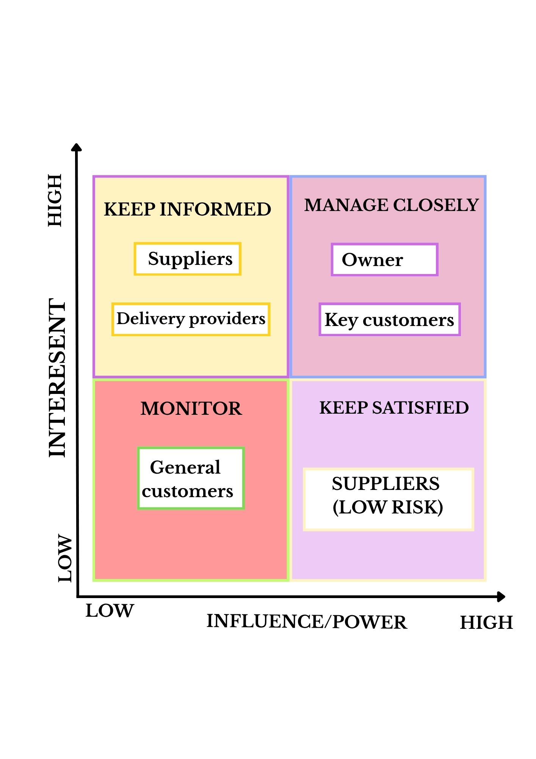
Figure 3: Stakeholder Power-Interest Matrix

Stakeholder | Interest | Influence | Main expectations | Communication approach
Owner | High | High | Efficient system, reduced workload and improved order control | Regular review meetings and progress checks
Customers | High | Medium | Accurate orders, timely communication and reliable delivery | Email, social media and order updates
Suppliers | Medium | Medium | Clear orders and timely purchasing | Email and direct communication
Delivery providers | Medium | Medium | Accurate dispatch information and appropriate collection arrangements | Email and delivery platforms
Table 11: Stakeholder Analysis

The analysis shows that the owner and customers require the greatest level of communication because they have high interest in the implementation and its outcomes. Suppliers and delivery providers should also receive clear information because their activities can influence stock availability and delivery reliability. Research indicates that effective stakeholder communication can improve participation and reduce problems during organisational change (Butt et al., 2016).
For Made by Monia, communication should therefore be clear, timely and proportionate to stakeholder needs. This approach can help manage expectations, identify concerns early and support the successful implementation of the digital system.

Communication plan
A communication plan was developed to ensure that stakeholders receive clear, timely and relevant information during implementation of the digital order and production management system. Communication will reflect each stakeholder’s level of interest and influence. Effective stakeholder communication can support participation and engagement during organisational change (Butt et al., 2016).

Stakeholder | Information | Method | Timing
Owner | Progress, costs, problems and performance | Digital records/review | Weekly, then monthly
Customers | Order and delivery updates | Email/social media | Key order stages
Suppliers | Materials, stock and demand | Email/telephone | As required
Delivery providers | Dispatch and delivery information | Email/online platform | At dispatch or when issues occur
Table 12: Communication Plan

The owner and customers require the highest level of communication because they have the greatest interest in the system and its outcomes. Suppliers and delivery providers will receive information when their activities affect production or fulfilment. Communication should be adapted to stakeholder needs and involvement (Butt et al., 2016).

Stage | Activity | Outcome
Week 1 | Introduce the new system | Stakeholder awareness
Week 4 | Share pilot progress and collect feedback | Problems identified
Month 2 | Confirm full implementation | Clear understanding
Monthly | Review feedback and performance | Continuous improvement
Table 13: Key Communication Milestones

Overall, the plan supports effective implementation, reduces misunderstandings and contributes to improved order management and fewer delays. Two-way communication also provides stakeholders with an opportunity to provide feedback and support improvements during implementation (Butt et al., 2016).

Monitor and review implementation
The implementation will be monitored to assess whether the digital order and production management system improves operational efficiency. The current average order completion time is approximately 10 days and will be used as the baseline. The main target is to reduce this to 8 days, representing a 20% reduction. Other measures will include outstanding orders, administrative workload and customer issues.

Selection of Monitoring Techniques

Measure | Baseline | Target | Frequency | Source of information
Order completion time | 10 days | 8 days | Monthly | Order tracker
Outstanding orders | Current level | Reduce | Weekly | Digital order tracker
Administrative time | 4 hours per day | Reduce by 24 minutes per day | Monthly | Time records
Customer issues/delays | Current level | Reduce | Monthly | Customer records
Orders recorded digitally | 0% | 100% | Weekly | Digital order tracker
Table 14: Monitoring and Review Techniques

The digital order tracker will provide information on outstanding orders, deadlines and production progress. Administrative time and customer issues will also be reviewed to assess whether the system is reducing workload and delays.

Monitoring and corrective-action planning
Performance will be reviewed weekly during the initial implementation period and monthly once the system is established. The current average order completion time is approximately 10 days. A 20% reduction would therefore establish a target completion time of 8 days. This provides a clear baseline against which the effectiveness of the digital order and production management system can be measured.

Area | Target | Monitoring | Corrective action
Order completion time | 8 days | Monthly | Review production schedule and priorities
Outstanding orders | Reduce | Weekly | Re-prioritise urgent orders
Administrative workload | Reduce by 24 minutes per day | Monthly | Improve digital order tracking
Customer delays/issues | Reduce | Monthly | Review communication and fulfilment
Digital order tracking | 100% of orders recorded | Weekly | Check and update missing orders
Table 15: Monitoring and Corrective-Action Planning

The owner will compare actual results with the targets and introduce corrective action where required. Overall, the process creates a continuous improvement cycle: monitor, identify problems, take corrective action and review results. This supports operational resilience in a small business with limited resources (Bak et al., 2023).

Conclusion
This report examined the complex operational capacity problem at Made by Monia, caused by increasing seasonal demand and the owner’s responsibility for production, order management, communication and fulfilment. The analysis identified insufficient operational capacity and structured order planning as the main root causes. This is supported by the increase in monthly orders from approximately 30 to 70 during the Christmas period. The Weighted Grid Analysis identified the digital order and production management system as the strongest option, scoring 4.75/5. The Cost-Benefit Analysis estimated a first-year net benefit of £1,400 and an average annual benefit of £2,400. The proposed implementation, stakeholder communication and monitoring processes provide a practical approach to managing the solution. The current average completion time of 10 days provides a baseline for the target of 8 days, representing a 20% reduction. Overall, the digital system is the most suitable solution because it addresses the main causes of the problem while remaining financially and operationally realistic for Made by Monia (Bak et al., 2023).

References
Bak, O., Shaw, S., Colicchia, C., & Kumar, V. (2023). A systematic literature review of supply chain resilience in small–medium enterprises (SMEs): A call for further research. IEEE Transactions on Engineering Management, 70(1), 328-341. https://ieeexplore.ieee.org/stamp/stamp.jsp?arnumber=9184862
Butt, A., Naaranoja, M., & Savolainen, J. (2016). Project change stakeholder communication. International Journal of Project Management, 34(8), 1579-1595. https://www.researchgate.net/profile/Aurangzeab-Butt/publication/308352652_Project_change_stakeholder_communication/links/5d47d5fea6fdcc370a7c57ce/Project-change-stakeholder-communication.pdf
Carvalho, R., Lobo, M., Oliveira, M., Oliveira, A. R., Lopes, F., Souza, J., ... & Freitas, A. (2021). Analysis of root causes of problems affecting the quality of hospital administrative data: A systematic review and Ishikawa diagram. International journal of medical informatics, 156, 104584. https://www.sciencedirect.com/science/article/abs/pii/S1386505621002100
Chavez, Z., Baalsrud Hauge, J., & Bellgran, M. (2020). A Conceptual Model for Deploying Digitalization in SMEs Through Capability Building. In IFIP International Conference on Advances in Production Management Systems (pp. 108-116). Cham: Springer International Publishing. https://inria.hal.science/hal-03635698/file/592-97.pdf
Cinelli, M., Kadziński, M., Gonzalez, M., & Słowiński, R. (2020). How to support the application of multiple criteria decision analysis? Let us start with a comprehensive taxonomy. Omega, 96, 102261. https://www.sciencedirect.com/science/article/pii/S0305048319310710
Coad, A., Domnick, C., Flachenecker, F., Harasztosi, P., Janiri, M. L., Pal, R., & Teruel, M. (2022). Capacity constraints as a trigger for high growth: Capacity constraints as a trigger for high growth. Small Business Economics, 59(3), 893-923. https://link.springer.com/content/pdf/10.1007/s11187-021-00558-6.pdf
Eller, R., Alford, P., Kallmünzer, A., & Peters, M. (2020). Antecedents, consequences, and challenges of small and medium-sized enterprise digitalization. Journal of Business Research, 112, 119-127. https://www.sciencedirect.com/science/article/abs/pii/S0148296320301600
Hoerl, R., Jensen, W., & de Mast, J. (2021). Understanding and addressing complexity in problem solving. Quality Engineering, 33(4), 612-626. https://www.researchgate.net/profile/Willis-Jensen-2/publication/354042853_Understanding_and_addressing_complexity_in_problem_solving/links/615b23654a82eb7cb5ff3bf1/Understanding-and-addressing-complexity-in-problem-solving.pdf
Kraft, C., Lindeque, J. P., & Peter, M. K. (2022). The digital transformation of Swiss small and medium-sized enterprises: insights from digital tool adoption. Journal of Strategy and Management, 15(3), 468-494. https://www.emerald.com/jsma/article-pdf/15/3/468/1654527/jsma-02-2021-0063.pdf
Sahoo, T. (2021). Root cause failure analysis: a guide to improve plant reliability. John Wiley & Sons. https://books.google.co.uk/books?hl=pl&lr=&id=KhYtEAAAQBAJ&oi=fnd&pg=PR7&dq=Sahoo,+T.+(2021).+Root+cause+analysis+process.+In+Root+Cause+Failure+Analysis.+Wiley.&ots=t45Avej0up&sig=bAD_X0o8Zq-0QzociQL9uW3twKU&redir_esc=y#v=onepage&q&f=false
Scandizzo, P. L. (2021). Impact and cost–benefit analysis: a unifying approach. Journal of Economic Structures, 10(1), 10. https://link.springer.com/content/pdf/10.1186/s40008-021-00240-w.pdf
Shannon, C. J. (2021). Collaborative problem solving: A guide to improving your workplace. Routledge. https://books.google.pl/books?hl=pl&lr=&id=_kMsEAAAQBAJ&oi=fnd&pg=PA1969&dq=Shannon,+C.+J.+(2021).+Collaborative+problem+solving:+A+guide+to+improving+your+workplace.+Routledge.&ots=FcL9ztsnB_&sig=QVWZtG7O9lZfe1aPF9WRDsxvpFA&redir_esc=y#v=onepage&q&f=false

