Application of automation in wastewater treatment

ACMA5001

Student No: 2223791
Student Name: Martin Ashe

Table of Contents
List of Figures 3
Introduction 5
Wastewater Treatment Process 6
1. Screening 6
2. Primary Treatment 6
3. Biological Treatment 6
4. Secondary Treatment 7
5. Tertiary Treatment (Conditional) 7
6. Sludge Discarding 7
Regulatory Framework and Guidelines for Wastewater Treatment 8
Evolution of ICA in WWTPs: Components & Historical Development 9
Pre-Automation 9
Introduction of ICA 9
2000 to Present Day 15
The Future of ICA in Wastewater Treatment 17
Conclusion 18
Bibliography 19

List of Figures

Figure 1: Diagram depicting wastewater treatment processes (Sharma, et al., 2024). 9
Figure 2: Main elements of DO sensors (Vela, 2023) 12
Figure 3: Key elements of the SCADA network architecture (Instrumentation Tools, n.d.) 13
Figure 4: DCS implementation example (Instrumentation Tools, n.d.) 14
Figure 5: Hydraulic wastewater sluice gate (Direct Industry, n.d.) 15
Figure 6: Block flow diagram of model predictive control (Chen, et al., 2018). 17
Figure 7: Concept of a sustainable Resource Recovery Facility (RRF) (Cairone, et al., 2024) 19

Introduction

Most people rarely consider the infrastructure that treats and cleans the wastewater produced by homes, businesses, and industrial facilities. Until the mid-19th century, wastewater management systems were virtually non-existent, with cesspools and privy vaults commonly used for waste disposal. During this period, cholera outbreaks in densely populated areas, such as London, underscored the need for a more effective solution. Initially, wastewater from waste closets was connected to storm sewers, which transferred sewage into nearby bodies of water. While this method allowed for some self-purification through dilution in flowing water, it proved inadequate for handling the large volumes of pollution from growing urban populations (Bingham, et al., 2004).
Today, wastewater is transported through an extensive network of sewage pipes to treatment facilities, where it undergoes multiple stages to remove harmful impurities, including solids and dissolved substances. With over 99.9% of sewage being liquid, the remainder consists of solids requiring treatment (Northumbrian Water Group, n.d.).
Instrumentation, Control, and Automation (ICA) refers to the use of sensors, control systems, and automation technologies to monitor and regulate processes, ensuring safety, efficiency, and reliability. ICA technology was first introduced in sewage treatment plants in the 1970s, primarily to control the activated sludge process used for removing organic matter. Today, advancements in real-time automated systems, including artificial intelligence (AI), enhance efficiency, monitoring, and decision-making. This report explores the evolution and application of ICA in wastewater treatment, from its origins to the present day (Olsson, et al., 2014).

Wastewater Treatment Process

A wastewater treatment plant (WWTP) removes organic and inorganic contaminants from sewage, such as human waste, food waste, oil, and plastics. Without treatment, sewage can cause substantial damage to ecosystems through pollution and the depletion of oxygen in rivers.
WWTPs purify water through a combination of physical, chemical, and biological processes. There are generally six steps to wastewater treatment, although these can vary depending on the region and regulations – these processes are depicted in Figure 1 (Sharma, et al., 2024).

Screening

This involves filtering the sewage through steel screens to catch and segregate large objects, such as sanitary items and plastics. Then, inorganic solids, such as sand and grit, are removed using a grit chamber. Without this stage, downstream pumps and equipment would be damaged.

Primary Treatment

The sewage is then processed through a circular settlement tank, where the water's velocity is reduced, allowing organic matter, known as sludge, to settle to the bottom of the tank. Floatable solids, such as oil and fat, rise to the surface. Rotating skimmers scrape the top layer of water and the tank's base, depositing the sludge into tanks for future processing.

Biological Treatment

After settlement, water undergoes biological treatment in a filter bed or an aeration tank, where it receives oxygen and microorganisms to break down dissolved organic matter. Filter beds use porous clinker rocks as a habitat for microbes. The aeration method mixes water with microbial-rich sludge in large tanks, where air is introduced to support decomposition and purification.

Secondary Treatment

In the secondary treatment stage, water is settled again, allowing remaining microorganisms to sink to the bottom as sludge. This sludge is either recirculated in the biological treatment process or separated for further treatment. The clarified water at the top may be clean enough for discharge into rivers or seas.

Tertiary Treatment (Conditional)

Depending on the final destination and regional regulations, the wastewater may be treated with ultraviolet (UV) light to disinfect the water by inactivating microorganisms. The water is then fed to a nearby river or sea through diffusion nozzles, which mix it evenly, thereby reducing the likelihood of environmental disruption.

Sludge Discarding

The sludge from the settlement tanks in the previous processes is dried using various techniques. It is then used by farmers as a fertiliser or heated to produce methane gas. Burning methane gas produces electricity; some treatment plants produce excess electricity, which is then sold back to the electrical grid.
(Northumbrian Water Group, n.d; Thames Water, n.d.; Welsh Water, n.d.)

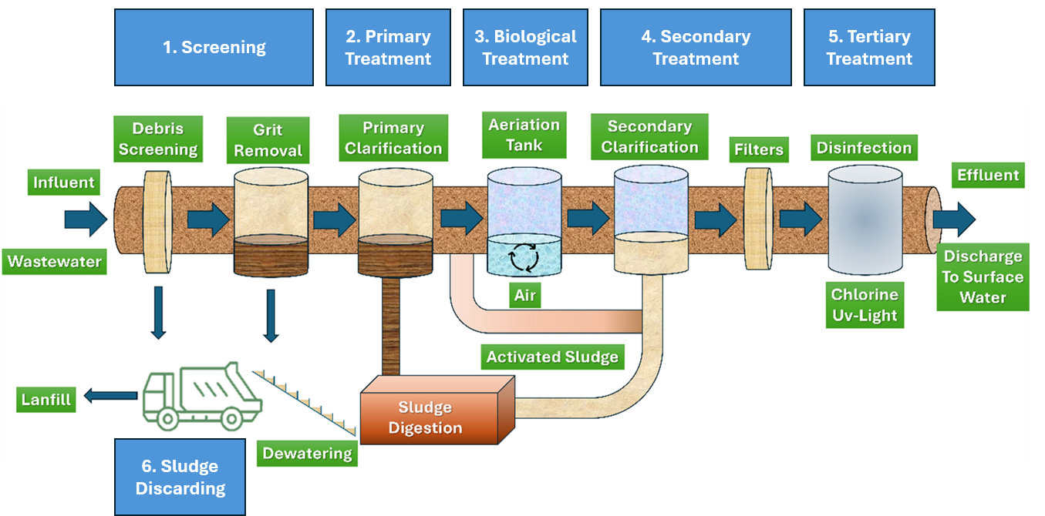

Figure 1: Diagram depicting wastewater treatment processes (Sharma, et al., 2024).

Regulatory Framework and Guidelines for Wastewater Treatment

The regulations for treating and monitoring wastewater vary depending on the local government. These strict standards and compliance limits are continually evolving and increasing to ensure treated effluent is safe for discharge into the environment. In England and Wales, these are predominantly governed by the Urban Waste Water Treatment Regulations 1994, with guidelines provided by the Environment Agency (Legislation.gov.uk, n.d.).
The Urban Waste Water Treatment Regulations 1994 establish the standards for the collection, treatment, and discharge of urban wastewater in accordance with the European Council Directive 91/271/EEC. The requirements for treatment plants are defined, including design specifications for obtaining samples and monitoring both incoming and treated wastewater. A measure of the population equivalent (PE) served by treatment plants is used to mandate the level of required treatment. For example, an agglomeration of more than 10,000 PE requires advanced tertiary treatment, such as the use of UV lights. The Environment Agency issues environmental permits to treatment plants that are deemed compliant with the regulations (Gov.uk, 2019).
Industrial wastewater contains a varied range of pollutants, such as oils, toxic chemicals, high concentrations of both organic and inorganic compounds, and heavy metals. For this reason, industrial establishments are often required to pre-treat their wastewater before discharging it into the sewer system; this may involve chemical treatment using coagulants and flocculants. Routine inspections of effluent quality are conducted by regulatory authorities to ensure compliance with the Water Industry Act 1991 and to enforce penalties for violations (Wastewater Treatment Services, n.d.).

Evolution of ICA in WWTPs: Components & Historical Development

Pre-Automation

Before the widespread adoption of ICA, wastewater treatment systems relied primarily on manual monitoring and mechanical controls. Until the 1970s, operators manually collected samples and analysed them in laboratories to assess key parameters such as dissolved oxygen (DO) levels and biochemical oxygen demand (BOD). Equipment functionality was ensured through routine visual inspections, and basic mechanical controls, such as float switches and simple relay systems, were used to regulate water levels and pump operations. While the introduction of analog instrumentation in the 1950s allowed real-time measurements of select parameters, these systems lacked automation, requiring continuous human supervision and manual adjustments to maintain process stability (Packaged Wastewater Plants, 2024).

Introduction of ICA

Due to ever-increasing regulatory requirements and improved efficiency needs, ICA was applied in wastewater treatment during the 1970s. The initial application was to remove organic matter, known as the activated sludge process. To ensure reliable operation, key variables were analysed using analog sensors, such as:
- Flow Rates - Early electromagnetic and differential pressure flow meters monitored wastewater flow through pipes, providing continuous readings. However, they required frequent manual calibration and were prone to reduced accuracy over time due to pipe fouling and sediment accumulation (Olsson, et al., 2014).
- Sludge Levels—The sludge levels in settlement tanks were measured using pressure-based and ultrasonic sludge blanket sensors. While this optimised sludge removal, debris and bubbles caused signal interference (Yuan, et al., 2019).
- Dissolved Oxygen (DO) Concentration—Oxygen levels in aeration tanks were monitored using electrochemical DO sensors, illustrated in Figure 2 (Vela, 2023). Galvanic sensors generate their current through spontaneous electron exchange, while polarographic sensors require an external power source and need a warm-up period. Both use semipermeable membranes and electrolyte solutions but require water movement to maintain accurate readings, as stagnant water depletes available oxygen. Additionally, frequent manual cleaning was required to maintain accuracy, and the sensor membranes often needed replacement (Olsson, et al., 2014).
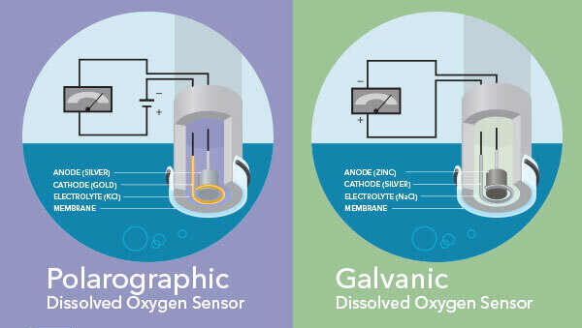
Figure 2: Main elements of DO sensors (Vela, 2023)

During the 1970s, Programmable Logic Controllers (PLC) were introduced into the wastewater treatment sector, revolutionising operational control by replacing mechanical relays, timers and loop controllers with programmable electronic control. These industrial computers automated processes by interpreting sensor inputs and executing a ladder logic program to control actuators and other equipment, ensuring precise system operation (Kendricks Jr, 1999). Benefits included:
- Dynamic control of wastewater flow, preventing overflow events.
- System-driven parameter alerts reduce operator reliance.
A prominent application of PLCs was in aeration control, enabling the automation of aeration valves and variable-speed blowers by using DO sensor readings to adjust airflow in real time. This facilitated reduced energy waste, enhanced oxygen distribution, and made aeriation more cost-effective by optimising airflow based on system demand (Olsson, 2006).
In the early 1980s, Supervisory Control and Data Acquisition (SCADA) systems were implemented, marking a transformative period in wastewater treatment. For the first time, operators could monitor effluent quality by remotely accessing real-time data from sensors and equipment, reducing manpower requirements (Zhang & B, 2014). Incorporating SCADA with existing PLC systems enabled complex processes, such as the automatic adjustments of chemical dosing, to be more precisely controlled (Akhil, et al., 2015). Key elements of the SCADA network architecture are depicted in Figure 3 (Instrumentation Tools, n.d.). This innovation significantly improved wastewater management efficiency, reliability, and safety, coinciding with a pivotal era of increasing environmental awareness.
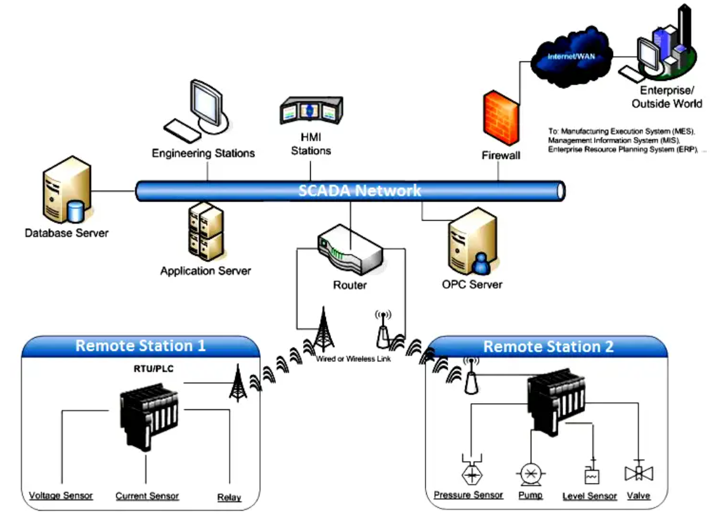

Figure 3: Key elements of the SCADA network architecture (Instrumentation Tools, n.d.)
Distributed Control Systems (DCSs) were introduced in the late 1980s. Their architecture consists of a network of distributed controllers to monitor and control plant processes across various locations, as illustrated in Figure 4 (Instrumentation Tools, n.d.). Unlike SCADA-PLC based control systems that monitor individual components or processes primarily from a centralised location, DCS facilitates a more integrated approach. It allows for real-time control, data collection, and communication across the facility, enabling operators to optimise multiple processes simultaneously. This advancement in control technology further improved efficiency, reduced response times to process disturbances, and enhanced overall system reliability, leading to better management of wastewater treatment operations.
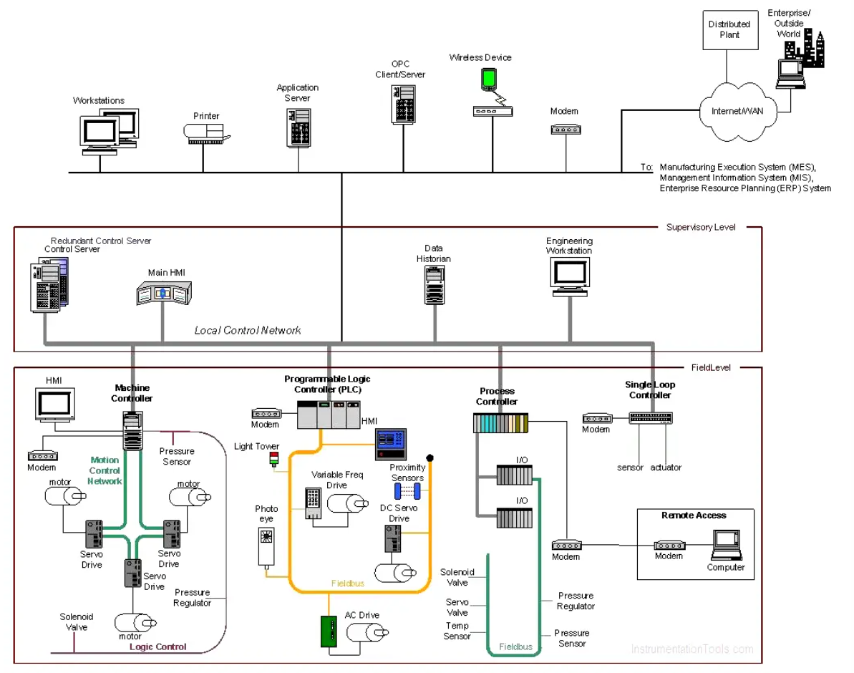

Figure 4: DCS implementation example (Instrumentation Tools, n.d.)

Actuators are fundamental for manipulating physical processes based on the output signals from DCS and PLC control systems. The main categories of actuators used in WWTPs include:
- Pneumatic: These are powered by compressed air and are valued for their speed and reliability. This makes them ideal for on-off and throttle valve control, such as the butterfly or globe valves that regulate airflow into aeration tanks. However, their reliance on a continuous air supply can limit applications.
- Electric: Electric actuators convert electrical energy into mechanical motion, enabling precise control and positioning of valves, such as those used for chemical dosing to regulate treatment reactions. They can be seamlessly integrated with DCS control systems for automated process optimisation (Jadhav, et al., 2023).
- Hydraulic: Hydraulic actuators convert fluid pressure into mechanical motion. These are employed in applications requiring significant force and precise control, such as the operation of sluice gates that regulate the water flow between treatment stages – as observed in Figure 5 (Direct Industry, n.d.). However, hydraulic fluid systems can leak, potentially contaminating treated water and the environment.
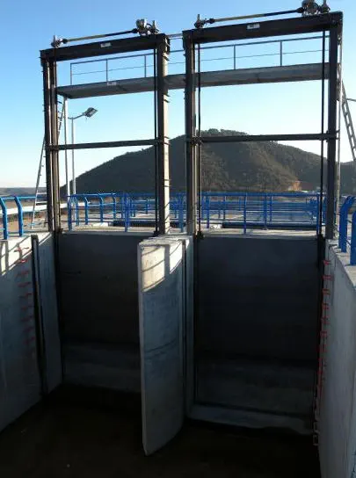

Figure 5: Hydraulic wastewater sluice gate (Direct Industry, n.d.)

All field devices—sensors, controllers, and actuators—discussed thus far are interconnected via a digital communication system known as a Fieldbus network, as illustrated in Figures 3 and 4 (Instrumentation Tools, n.d.). Unlike traditional point-to-point wiring, Fieldbus networks enable efficient, scalable, bidirectional communication using a streamlined bus-based architecture. This capability is essential for real-time process analysis and decision-making in wastewater treatment. Implementing the Profibus protocol to integrate PLC and SCADA systems at Welsh Water’s Nash Wastewater Treatment Works resulted in significant improvements in process monitoring and control (Anon., 2000).

2000 to Present Day

Since 2000, ICA has evolved from unit-process control to a more holistic, plant-wide, and even system-wide control approach, driven by the need for increased efficiency, resilience to disturbances, and capacity increases resulting from an ever-growing population. Real-time monitoring has been enhanced by smart sensor technology, providing accurate and continuous data for improved decision-making (Yuan, et al., 2019).
A fundamental development was the introduction of Model Predictive Control (MPC), an advanced control strategy that optimises wastewater treatment operations by predicting future process behaviours and adjusting control actions accordingly. The MPC cycle consists of four key steps:
- Predicting Future Behaviour: A mathematical model of the system is used to simulate the process's behaviour over a specific time horizon. In wastewater treatment, examples include the predicted changes in influent flow rates, water quality, and chemical densities based on historical and current data (Vesely & Rosinova, 2010).
- Optimising Control Actions: After predicting future behaviour, MPC determines the optimal control actions (such as modifying aeration levels or chemical dosing) to enhance performance. This involves solving an optimisation problem to minimise a specific cost function, such as lowering energy consumption or achieving effluent quality standards (Protoulis, et al., 2025).
- Implementing the Initial Control Action: MPC calculates a string of future control actions, although only the first one is applied. The system then waits for measurement feedback. This method allows the system to adapt constantly to active data and unexpected disturbances (Zhang & Liu, 2019).
- Repeating the Process: The system interprets the new measurement once again to predict, optimise, and apply the most suitable action – this process is continually repeated. This results in a highly adaptive control strategy, which is effective in dynamic wastewater treatment environments (Zhang & Liu, 2019).
An MPC block flow diagram is illustrated in Figure 6 (Chen, et al., 2018)
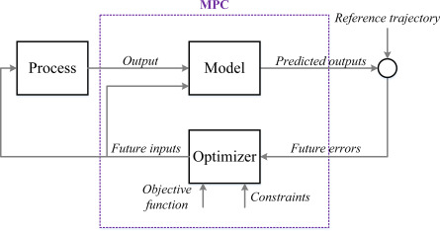

Figure 6: Block flow diagram of model predictive control (Chen, et al., 2018).

As wastewater treatment progresses through the fourth industrial revolution, ICA is evolving further through the integration of IoT-enabled sensors and AI-driven analytics, enabling real-time monitoring, predictive maintenance, and automated decision-making (Chen, et al., 2018). Furthermore, ICA has expanded from single-plant control to interconnected networks, allowing data to be shared across multiple facilities. This holistic, system-wide optimisation improves demand forecasting, leak detection, and resource allocation, further enhancing operational efficiency (Protoulis, et al., 2025).

The Future of ICA in Wastewater Treatment

In recent years, AI-based technologies have advanced exponentially, enabling a growing number of real-world applications, including the control of wastewater treatment. Coupled with IoT and digitalisation, AI and Machine Learning (ML) are poised to further enhance plant efficiency, optimise resource use, and support sustainability while ensuring compliance with increasingly stringent environmental regulations.
One of the major operational challenges in WWTPs is system failure. AI-powered predictive maintenance aims to minimise unplanned downtime and reduce operational costs by detecting early signs of system failures through advanced data analytics. ML algorithms, trained on historical and real-time sensor data, will analyse patterns in equipment behavior to predict potential faults before they accelerate. These models will continuously monitor key parameters, including pump vibration signatures, flow rate deviations, membrane permeability decline, and sensor drift. By integrating anomaly detection with automated alerts and adaptive control strategies, AI-driven systems will enable proactive maintenance scheduling, optimising asset lifespan and improving overall plant efficiency (Nagpal, et al., 2024).
The world is transitioning into the Industry 5.0 era, which emphasises human well-being and sustainability through advanced technologies and AI-powered automation (TWI, n.d.). In line with this shift, wastewater treatment is increasingly focusing on resource recovery, with AI-driven ICA systems optimising energy recovery from anaerobic digestion by dynamically adjusting key operational parameters. ICA systems will continuously monitor and regulate variables such as organic loading rate (OLR), pH, hydraulic retention time (HRT), and temperature to enhance microbial activity and maximise biogas production. These advancements will contribute to a circular economy approach, improving sustainability and resilience in wastewater treatment (Zhang, et al., 2023; Cairone, et al., 2024).

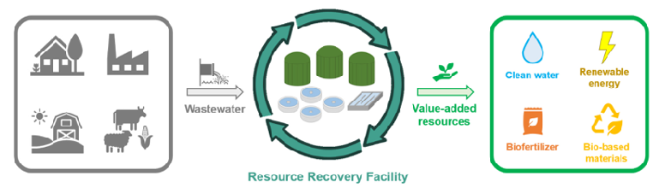

Figure 7: Resource Recovery Facility (RRF) process (Cairone, et al., 2024)

Conclusion

In summary, this report has examined the instrumental role of automation in wastewater treatment, a crucial process for maintaining public health and protecting the environment. Wastewater Treatment Plants (WWTPs) are inherently complex, with historical analogue systems relying heavily on continuous human supervision and manual intervention. The advent of ICA-based control systems and equipment, such as Programmable Logic Controllers (PLCs), Supervisory Control and Data Acquisition (SCADA) systems, and Distributed Control Systems (DCS), has incrementally improved efficiency and control. Advanced control strategies, such as Model Predictive Control (MPC), have further enhanced effluent quality and minimised energy consumption by predicting system behaviour. This evolution has been driven by the requirement of increasingly stringent environmental regulations and the growing global emphasis on sustainable practices. While the application of AI control within WWTPs remains in its early stages, it is poised to become a cornerstone of future operations, enabling predictive maintenance, resource recovery, and enhanced overall efficiency. The continued innovation in ICA technologies promises a future of more efficient, sustainable, and resilient wastewater treatment.

Bibliography

Akhil, L., Stein, J. & Montgomery, J., 2015. The role of PLCs in SCADA systems for wastewater management.. Automation in Construction, Volume 55, pp. 113-124.
Anon., 2000. Improving wastewater treatment processes in the Severn Estuary. World Pumps, 2000(407), pp. 22-24.
Bingham, P., Verlander, N. Q. & Cheal, M. J., 2004. John Snow, William Farr and the 1849 outbreak of cholera that affected London: a reworking of the data highlights the importance of the water supply.. Public Health, 118(8), pp. 520-527.
Cairone, S., Hasan, S. W. & Choo, K.-H., 2024. Revolutionizing wastewater treatment toward circular economy and carbon neutrality goals. Journal of Water Process Engineering, Volume 63, pp. 1-15.
Chen, X., Al, R., Behera, C. R. & Sin, G., 2018. Process Synthesis, Design, and Control of Wastewater Treatment Plants. Chemistry, Molecular Sciences and Chemical Engineering.
Direct Industry, n.d. Wastewater treatment sluice gate. [Online]
Available at: https://www.directindustry.com/prod/coutex/product-69476-544180.html
[Accessed 16th March 2025].
Gov.uk, 2019. Waste water treatment works: treatment monitoring and compliance limits. [Online]
Available at: https://www.gov.uk/government/publications/waste-water-treatment-works-treatment-monitoring-and-compliance-limits/waste-water-treatment-works-treatment-monitoring-and-compliance-limits
[Accessed 17th January 2025].
Instrumentation Tools, n.d. Components of SCADA. [Online]
Available at: https://instrumentationtools.com/components-of-scada/
[Accessed 16th March 2025].
Instrumentation Tools, n.d. DCS. [Online]
Available at: https://instrumentationtools.com/dcs/
[Accessed 16th March 2025].
Jadhav, I., Jagtap, S., Mahajan, P. & Aahire, N., 2023. Design of Electric Actuator. International Journal of Advanced Research in Science, Communication and Technology, 3(4), pp. 492-495.
Kendricks Jr, L. E., 1999. Reaping the Benifits of Wastewater Treatment Plant Automation. Pollution Engineering, pp. 52-53.
Legislation.gov.uk, n.d. The Urban Waste Water Treatment (England and Wales) Regulations 1994. [Online]
Available at: https://www.legislation.gov.uk/uksi/1994/2841/contents
[Accessed 31st March 2025].
Nagpal, M. et al., 2024. Optimizing wastewater treatment through artificial intelligence: recent advances and. Water Science & Technology , 90(3), pp. 731-757.
Nguyen, X. C., Nguyen, T. T. H., Ba, Q. T. & Bui, X.-T., 2022. Artificial intelligence for wastewater treatment. Current Developments in Biotechnology and Bioengineering, pp. 587-608.
Northumbrian Water Group, n.d. Sewage treatment. [Online]
Available at: https://www.nwg.co.uk/responsibility/working-with-schools/explore2/sewage-treatment/
[Accessed 7th March 2025].
Olsson, G., 2006. Intrumentation, control and automation in the water industry - state-of-the-art and new challenges. Water Science & Technology, 53(4-5), pp. 1-16.
Olsson, G., Carlsson, B. & Comas, J., 2014. Instrumentation, control and automation in wastewater. Water Science & Technology, Volume 69.7, pp. 1373-1385.
Packaged Wastewater Plants, 2024. Evolution of Wastewater Treatment Systems. [Online]
Available at: https://packagedwastewaterplants.com/home/f/evolution-of-wastewater-treatment-systems
[Accessed 1st April 2025].
Protoulis, T. et al., 2025. Control of wastewater treatment plants using economic-oriented MPC and attention-based RNN disturbance prediction models. Computers and Chemical Engineering, Volume 196, pp. 1-20.
Sharma, A., Goel, H. & Sharma, S., 2024. Cutting edge technology for wastewater treatment using smart nanomaterials: recent trends and futuristic advancements. Environmental Science and Pollution Research, Volume 31, pp. 58263-58293.
Thames Water, n.d. The Sewage Treatment Process. [Online]
Available at: https://www.thameswater.co.uk/media-library/home/about-us/responsibility/education/the-sewage-treatment-process/the-sewage-treatment-process.pdf
[Accessed 10th March 2025].
TWI, n.d. What is Industry 5.0? (Top 5 Things You Need To Know). [Online]
Available at: https://www.twi-global.com/technical-knowledge/faqs/industry-5-0
[Accessed 27th March 2025].
Vela, K., 2023. 5 Things to Consider when Selecting a Portable Dissolved Oxygen Meter. [Online]
Available at: https://www.ysi.com/ysi-blog/water-blogged-blog/2023/08/how-to-select-a-portable-dissolved-oxygen-meter-top-5-considerations
[Accessed 1st April 2025].
Vesely, V. & Rosinova, D., 2010. Robust Model Predictive Control Design. Bratislava: Sciyo.
Wastewater Treatment Services, n.d. Guide to Treating Industrial Effluent (Trade Effluent). [Online]
Available at: https://watertreatmentservices.co.uk/guide-treating-industrial-effluent/
[Accessed 31st March 2025].
Welsh Water, n.d. Waste Water Treatment. [Online]
Available at: https://corporate.dwrcymru.com/en/community/education/teaching-resources/primary-resources/waste-water
[Accessed 12th March 2025].
Yuan, Z., Olsson, G. & Cardell-Oliver, R., 2019. Sweating the assets e The role of instrumentation, control and. Water Research, Volume 155, pp. 381-402.
Zhang, A. & Liu, J., 2019. Economic MPCofWastewater Treatment Plants Based on ModelReduction. MDPI - Processes, 1st October, pp. 1-21.
Zhang, L. S. & B, L., 2014. Data management and visualization in SCADA systems for wastewater treatment plants.. Water Practice & Technology, 9(3), pp. 136-142.
Zhang, S. et al., 2023. Artificial intelligence in wastewater treatment: A data-driven analysis of. Chemosphere, Volume 336, pp. 1-8.

