

Master of Business Administration
International Business pathway

Strategic Analysis of Microsoft Corporation
The UK Cloud Infrastructure Industry: A Strategic Analysis of Microsoft’s Intelligent Cloud (Azure) Business
Assessment: Individual report. Weight: 100%

Module name: Strategic Management
Module code: LCMB7003
Lecturer name: Hoang Nguyen

Student name: HIRABEN RAMABHAI MODHAVADIYA
Student ID: 2532030

Word count: 5498
Submission date: 12th August 2026

AI Use Acknowledgement

I acknowledge the use of ChatGPT (OpenAI) (https://chatgpt.com/) during July–August 2026 to support permitted aspects of this assignment.
Research: Used to identify and compare relevant academic, industry and regulatory sources concerning Microsoft Azure and the UK cloud infrastructure market.
Example prompts: “Find recent credible sources on Microsoft Azure and UK cloud competition” and “Identify evidence relating to the CMA investigation of Microsoft.”
Proofreading: Used to check my own written work for grammar, clarity and academic expression.
Example prompt: “Proofread this paragraph for grammar and clarity without changing my meaning or argument.”
Creative Materials: Used to create figures based on my own analysis, including Balanced Scorecard, BCG Matrix and Porter’s Five Forces.
Example prompt: “Create a clear BCG Matrix and Porter’s Five forces diagram using the analysis I have provided.”
I confirm that I have not presented AI-generated text as my own work. AI was not used to determine the structure, arguments, strategic conclusions or reflective content of the assignment. I have retained my drafts, notes and supporting materials as evidence if required.

Table of Contents
Introduction 4
1. Organisational Context and Overview 4
1.1 Company Background, Mission and Business Model 4
1.2 Focus of This Report and Justification 5
1.3 Cloud Infrastructure industry and Market Position 5
2. External and Internal Analysis 5
2.1 External Analysis: PESTEL 5
2.2 Internal Analysis: VRIO 8
2.3 SWOT Analysis 10
3. Comprehensive and holistic view of the organisation 11
3.1 Critical Evaluation of Microsoft's CSR Strategy 11
3.2 Balanced Scorecard for Microsoft Intelligent Cloud (UK) 13
4. Strategic Choices and Implementation 14
4.1 Business Level Strategic Choices 14
4.2 Recommended Strategy and Validation 15
4.3 Implementation Challenges and Mitigation 17
5. Conclusion 17
Section 2: Reflective Account 19
References 22

Introduction
The cloud infrastructure industry, one of the most capital-intensive segments of the technology sector, is where this report’s analysis is centred: it is prepared as an outside consultant’s report to Microsoft’s Board, assessing the company’s strategic position and recommending stronger competitive advantage. The focus is Microsoft’s Intelligent Cloud business, in particular Azure, within the UK cloud infrastructure industry, though the company trades across three segments in 190 countries.

Section 1 applies external and internal frameworks, evaluates CSR and performance measurement, and proposes a strategy with an implementation plan; Section 2 reflects on the process using Gibbs (1988).

1. Organisational Context and Overview

1.1 Company Background, Mission and Business Model
On 4 April 1975, Bill Gates and Paul Allen established Microsoft Corporation to write software for one of the first personal computers, the Altair 8800 (Mahat et al., 2022). In February 2014, Satya Nadella was appointed to become the new chief executive of Microsoft's cloud and enterprise division, and in 2021 he was elected to become the new chairman of the company (Fortune, 2025). In place of the previous mission, Nadella introduced a new single-sentence mission statement that continues to guide the company today: “To empower every person and every organisation on the planet to achieve more,” and, a mobile first, cloud first pivot, that reallocated investments to Azure (Friedman, Nakato Hirakubo and Lewis, 2026).
Microsoft now operates under three business segments: 1. Productivity and Business Processes, which includes Microsoft 365, LinkedIn and Dynamics 365. 2. Intelligent Cloud, which includes Azure and server products and is Microsoft's segment within the cloud infrastructure industry. 3. More Personal Computing, which includes Windows, Surface, Xbox and search. Microsoft had total revenue of 281.7 billion US dollars, increasing by 15 per cent, in the fiscal year ended 30 June 2025, with revenue growth in the Intelligent Cloud segment at 106.3 billion US dollars, up 21.5 per cent, from the previous year, due to growth in Azure revenue of 34 per cent in the final quarter (Microsoft Corp, 2025a; 2025c). This expansion has coincided with the biggest job loss in over a decade, as Microsoft shifted spending towards AI infrastructure, with additional cuts announced for 2026 (Minchin, 2024). Microsoft's own trajectory mirrors the emergence of the cloud infrastructure industry itself, which did not exist as a distinct category before the mid-2000s.

1.2 Focus of This Report and Justification
The UK cloud infrastructure industry, not Microsoft as a single entity, is this report’s focus, specifically the Intelligent Cloud segment and its Azure platform. Two reasons justify this: Intelligent Cloud is Microsoft’s fastest growing segment, and the clearest example of Nadella’s cloud first strategy. Secondly, this industry in the United Kingdom is the site of the most direct regulatory challenge Microsoft’s cloud business faces anywhere, as the Competition and Markets Authority stated in 2025 that competition in the UK cloud infrastructure market is not working as it should, and subsequently launched a Strategic Market Status investigation into Microsoft’s business software ecosystem (GOV.UK, 2026a; 2026b).

1.3 Cloud Infrastructure industry and Market Position
The cloud infrastructure industry, comprising Infrastructure-as-a-Service (IaaS) and Platform-as-a-Service (PaaS) provision, is what this report concentrates on. Microsoft’s own operations spread more widely across the broader Information Technology and Software industry, but Microsoft’s role is examined here within cloud infrastructure specifically, where Azure is Microsoft’s primary product.
The cloud infrastructure industry is large and concentrated: Q1 2026 global spending totalled around 129 billion dollars, with three hyperscale providers taking the majority - Amazon Web Services (AWS) with 28 per cent share, Microsoft Azure with 21 per cent, and Google Cloud with 14 per cent (Statista, 2026). Within the UK industry specifically, Microsoft and AWS each hold around 30-40 per cent, trailed by Google Cloud at 5-10 per cent (The Register, 2025). Microsoft’s position is reinforced by integration with its Windows Server, SQL Server and Microsoft 365 installed base, though this is the practice the Competition and Markets Authority is now examining as a potential threat to customer choice (Aastha Mantri et al., 2024).

2. External and Internal Analysis

2.1 External Analysis: PESTEL
The cloud infrastructure industry is currently shaped by technological disruption and regulatory volatility, captured here using PESTEL’s six category structure, applied to the market in which Microsoft’s Intelligent Cloud business operates (Karadzhov and Patarchanova, 2025). In July 2025, the United Kingdom's Competition and Markets Authority (CMA) completed a three-year market investigation. It determined that competition in the cloud infrastructure services market is not working well, the market is highly concentrated, and barriers to entry in the form of capital requirements, economies of scale and complex licensing are excluding smaller providers (GOV.UK, 2026a; George, 2024; Data Center Dynamics, 2026). Smaller UK cloud provider Civo has publicly stated that the CMA's decision to delay a referral to Strategic Market Status until 2026 did not solve the market issues, but rather exacerbated them (Figure 1). In 2026, the CMA took its work a step further, launching a dedicated Strategic Market Status investigation into Microsoft's business software ecosystem, specifically productivity software, operating systems, database management and related security services. But not AWS because the CMA felt that the software licensing leverage was a separate and more targeted competition concern (GOV.UK, 2026b).
These pressures are not specific to Microsoft; they are structural pressures that the entire cloud infrastructure industry is facing as a whole, and are being driven by a common trend in the industry: the growth of demand for AI services.
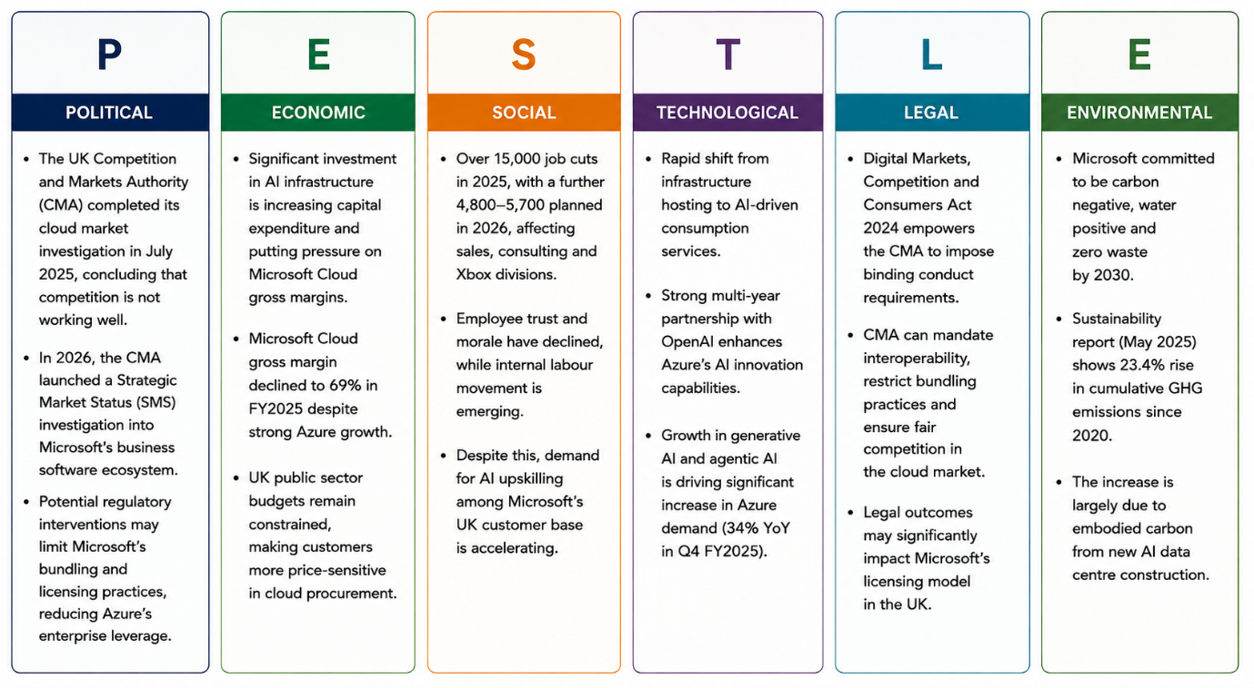
Figure 1: PESTEL Analysis of Microsoft's Intelligent Cloud Business (UK)
In terms of economics, the cost of the AI infrastructure race has also sharply raised Microsoft's own capital expenditure, squeezing Microsoft Cloud gross margin to 69 per cent despite Azure revenue growth of more than 30 per cent a year, and UK public sector customers. These are particularly leveraging Microsoft and AWS cloud contracts – are under tighter budget constraints, making their procurement decisions more price sensitive (Microsoft Corp, 2025a; George, 2024). In the social sphere, over 15,000 positions were cut across 2025, with additional cuts of around 4,800 to 5,700 jobs in 2026 focusing on sales, consulting and the Xbox division, coinciding with reports of a drop in employee trust and an emerging internal labour movement, despite a surge in demand for AI upskilling within Microsoft's own UK customer base (Elite Brains, 2026). On the technological side, customer demand is rapidly shifting from infrastructure hosting to AI consumption based services, as a result of Microsoft's multi-year partnership with OpenAI (Nazir, Vilko and Torkkeli, 2025).
Microsoft's 2020 commitment to become carbon negative, water positive and zero waste by 2030 is at odds with its own sustainability report, released in May 2025. It showed a 23.4 per cent cumulative rise in total GHGs since 2020, largely due to the embodied carbon of new data centre construction (Erb et al., 2022). The Digital Markets, Competition and Consumers Act 2024 (GOV.UK, 2026a) affords the CMA new powers to impose binding conduct requirements following the confirmation of a Strategic Market Status designation, such as making interoperability obligations for the first time and limiting bundling practices central to Microsoft's current UK enterprise strategy.
Combined, the biggest risk isn't a direct competitor, but rather a regulatory one in the traditional sense: If the Strategic Market Status designation goes bad, it could result in a change to the Windows Server and SQL Server licensing terms that are currently helping to convert Microsoft's enterprise clients into Azure customers. It would hit the mechanism behind much of Microsoft's growth in the UK cloud market, not Azure's technology. The most obvious is the AI consumption cycle, which is already the main contributor to Azure's 34 per cent quarterly growth, and is likely to continue driving UK cloud spending even if the regulatory decision is a success, as that doesn't affect the demand for AI infrastructure, just the licensing behaviour. The conflict between these two forces—one a growth engine that regulating cannot slow down very easily, and the other a licensing model that regulating can directly limit.
Microsoft has made some concession on this issue outside the formal Strategic Market Status process: it has already agreed to lower egress costs on cloud services and enhance interoperability with other clouds after direct talks with the CMA, which is due to review progress after six months (Aastha Mantri et al., 2024). Critics say the CMA's attitude is the reason the regulator has become less tough in its enforcement approach following a three-year investigation, while the regulator has maintained that relying on voluntary commitments is the quickest way to fix the most pressing harms, according to Opara et al. (2025). These voluntary commitments were apparently deemed insufficient, as the CMA has decided to carry out a full Strategic Market Status investigation into Microsoft in any case.

2.2 Internal Analysis: VRIO
The VRIO framework, which builds upon Barney's (1991) resource based view of the firm, is used here because it ties the value of the resources/capabilities within the firm directly to the durability of the advantage it can create, rather than merely cataloguing what the company owns (Mailani et al., 2024; Murcia, Ferreira and Ferreira, 2022). The resource based view on which VRIO is based can be misleading in that it treats resources merely as a checklist of resources and capabilities, rather than as a way of understanding how resources are combined into capabilities (Helfat et al., 2023), which this analysis does address by discussing, for each of the resources listed below, whether it is rare and how it has been organised by Microsoft to create an operating advantage. The framework is especially appropriate for a firm like Microsoft, in that several of its most prominent advantages, such as its licensing system, are now formally the subject of regulatory challenge, and the worth of a resource can no longer be evaluated just on a commercial basis; it now relies on a real legal and political process (El Nemar et al., 2022). Because VRIO is comparative, each resource is assessed relative to industry peers, not in the abstract.
Table 1: VRIO Analysis of Microsoft Intelligent Cloud's Key Resources (Cloud Infrastructure Industry)
Resource / Capability | Valuable | Rare | Costly to Imitate | Organised | Competitive Implication
Installed base of Windows Server, SQL Server and Microsoft 365 | Yes | Yes | Yes | Yes | Sustained competitive advantage; decades of enterprise deployment are difficult for AWS or Google to displace quickly.
OpenAI partnership and proprietary AI infrastructure | Yes | Yes | Yes | Yes | Sustained advantage while the partnership holds, though it is a contractual rather than owned asset.
Azure global data centre scale | Yes | Moderate | Yes | Yes | Temporary to sustained advantage; AWS remains larger and Google Cloud is investing heavily to close the gap. Scale is a defining battleground across the cloud infrastructure industry as a whole.
UK data residency and sovereign cloud capability | Yes | Moderate | Moderate | Yes | Temporary advantage; valuable for regulated UK public sector and financial services customers, but AWS and Google are both building comparable UK sovereign regions.
Bundled licensing practices linking on premises software to Azure | Yes | No | No | Partially | Under active regulatory challenge; the 2026 CMA Strategic Market Status investigation targets this specific practice, so its value is now legally contested rather than a clean source of advantage (GOV.UK, 2026b). This is now a live governance question for the cloud infrastructure industry as a whole.
The installed base and the OpenAI partnership are the two resources that pass all four VRIO tests without reservation, and thus are the most defendable sources of advantage found in this report. The two are expensive to copy for the reason Dierickx and Cool (1989) cite as the reason for asset stock accumulation: They are built up over years of sustained investment and are not easily bought or quickly replicated by a competitor, no matter how well funded. Azure's global data centre scale is valuable and expensive to duplicate, but not quite as rare as one might think: AWS, and Google Cloud, are investing at similar or higher absolute amounts in new capacity. And so scale alone is becoming a more level playing field than a cost advantage for Microsoft (Bari, Chimhundu and Chan, 2024). The data residency and sovereign cloud capability of the UK is also only temporary: it's certainly a benefit for regulated public sector and financial services customers who can't legally move workloads outside UK jurisdiction. But the hyperscalers are aggressively developing similar sovereign UK regions, so this advantage will only last as long as they continue to invest. By comparison, bundled licensing is the least legitimate of the resources that Microsoft's own regulators now consider to be a practice that is not legitimate. It does not meet the rarity test because other cloud providers are not subject to the same practice and do not need to be to compete on their merits, and it does not meet the organisation test because, according to the Competition and Markets Authority's findings, Microsoft has not voluntarily changed its practice the way AWS changed its egress fees and interoperability commitments during 2025. That is why they have been included in the justification for the 2026 Strategic Market Status investigation (Aastha Mantri et al., 2024).

2.3 SWOT Analysis
The findings of the PESTEL and VRIO are combined in one SWOT matrix as shown in Figure 2 to assess whether the external opportunities and threats mentioned above support or contradict the internal strengths and weaknesses identified in the VRIO analysis above.
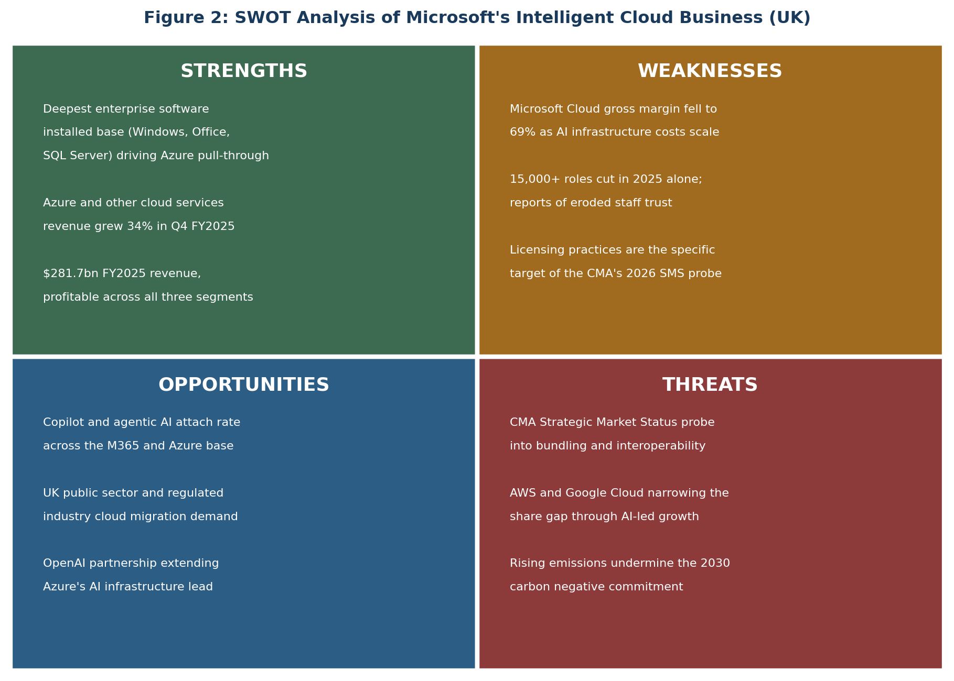
Figure 2: SWOT Analysis
The VRIO analysis highlights two resources that are still strong and become even more so with the technological transition to AI consumption: enterprise installed base and AI infrastructure position based on the OpenAI partnership. The enterprise installed base and the AI infrastructure position created through the partnership with OpenAI are two resources that are still strong and continue to become stronger with the technological transition to AI consumption, as highlighted by the VRIO analysis.
The main drawback is that it has the same licensing issue that the VRIO analysis notes is not satisfied with the rarity and organisation criteria, exacerbated by the pressure on margins from infrastructure investment in AI that the PESTEL analysis identifies as an economic risk, and the cut in workforce that the PESTEL analysis identifies as a live social risk. The best chance is the AI consumption cycle identified by the PESTEL analysis as Azure's primary growth opportunity. It is significant that this is based on two strengths identified by the VRIO analysis, not on the battleground licensing resource, indicating that Azure's growth is less driven by the practice under regulatory scrutiny than commentary on the Competition and Markets Authority investigation suggests. The largest risk is the same Strategic Market Status investigation which the PESTEL analysis outlines as the most significant political risk in the market. The four quadrants are collectively pointing towards a strategy that leverages the strengths of the VRIO further, while the licensing practice is a non-load bearing component of the company's competitive position.
There is another implication that needs to be made explicit with this reading of the SWOT matrix. If Azure's growth was indeed heavily reliant on bundled licensing, the most appropriate response to the Strategic Market Status investigation would be to defend the practice as hard as one could, as if it was removed, the core of the business would be threatened. However, the SWOT synthesis above shows the opposite – AI consumption is the fastest-growing component of Azure demand, which is a strength the VRIO analysis attributes to the OpenAI partnership, not to licensing bundling. This indicates that Microsoft's best current public and regulatory stance is not to block the CMA investigation, but to win the competition around the AI infrastructure and installed base strengths it has confirmed as enduring – and to concede that the licensing practice under scrutiny is a less robust, and more replaceable, growth strategy in the UK than it may seem. Collectively, this SWOT analysis describes Microsoft's position within the cloud infrastructure industry, not an isolated, company-specific picture.

3. Comprehensive and holistic view of the organisation

3.1 Critical Evaluation of Microsoft's CSR Strategy
In January 2020, Microsoft announced it would be carbon negative, water positive and zero waste by 2030, and that by 2050 it will remove all carbon it has emitted since its founding in 1975, either directly or through electricity usage, from the environment (Microsoft, 2020; UNFCCC, 2025). This pledge set a benchmark other cloud infrastructure industry providers have since been measured against. This commitment extends beyond the economic and legal obligations of Microsoft into the ethical and philanthropic aspects of the pyramid as described by Carroll (1991). It is not required by any UK or US law and it is a commitment to rectify emissions from past years before they were legally required to do so (Prasad Joshi, Prajapati and Adhikari, 2026). The company has supported the pledge with an internal carbon fee since 2012, which is applied to business units based on their emissions, more than $793 million invested in new climate technologies and being the world's largest single buyer of carbon removal credits (Erb et al., 2022). When considered alone, and in the context of Carroll's pyramid, this is one of the most ambitious corporate sustainability commitments by any large technology company, much more than the economic and legal floor, which the pyramid takes as the minimum baseline of responsible business conduct.
But Microsoft's own environmental sustainability report from May 2025 revealed that total GHG emissions had risen by 23.4 per cent since the 2030 commitment was made, with the vast majority of this increase due to the embodied carbon of new data centre construction to support the growth of the AI infrastructure. This is a direct, measurable difference between what Azure has committed to do and what it has actually done – and the activity is structurally important, not incidental, as the PESTEL analysis in Section 2 shows that Azure's biggest growth driver is the same. This is a real challenge to the interests of shareholders and AI customers, the former of whom are interested in rapid growth of data centres, and the latter of whom are interested in the interests of environmental stakeholders the 2030 pledge was given to reassure. Microsoft's public stance, however, is that they are "pragmatically optimistic" that they will reach their 2030 goal despite this rise, leaving stakeholders to take their word for it that they will recover (Erb et al., 2022). This tension is shared across the cloud infrastructure industry: AWS and Google Cloud face comparable emissions scrutiny.
This is reinforced by a parallel governance tension. The organisation test is not met by Microsoft's bundled licensing, in particular because Microsoft has not voluntarily adapted its licensing practices in 2025, as AWS has done, which directly led to the Strategic Market Status investigation in 2026. A consistent pattern in the emissions disclosure and in the company's voluntary sustainability commitments too emerges. 1. Microsoft's promises have been long-term, and have focused on doing very little in the short term to change the way it operates, with the result that neither the external bodies nor the environmental reporting standards in one case nor the Competition. 2. Markets Authority in the other have provided the accountability that voluntary commitment has not. Its balanced judgement is that Microsoft's CSR strategy is indeed a genuine, well-resourced commitment and not just a communication exercise, but that it must show a measurable emissions trajectory correction in the leadup to 2030, as opposed to the ambition of the original pledge, for it to be credible. Otherwise it would be a widening of the 23.4 per cent gap that is increasingly reminiscent of the same say do gap regulators have already identified in Microsoft's competition conduct.

3.2 Balanced Scorecard for Microsoft Intelligent Cloud (UK)
The limitation of not using any non-financial measures was solved by the development of the balanced scorecard by Kaplan and Norton (1992) which has been used in management research for over 30 years and has been the focus of more than 1,294 academic studies over the past 30 years (Kumar et al., 2023). This model is especially appropriate for Microsoft's situation as the CSR critique in Section 3.1 reveals that Microsoft's financial results and its environmental and governance commitments are already in conflict, which would not have been apparent in a purely financial reporting approach (Zouhair Hajji, Abderrahim Chtaoui and Abdelali Bouhmala, 2025). The tensions identified above are translated into objectives, indicators, targets and initiatives that can be monitored – not left as aspirations – in Figure 3 using the balanced scorecard approach for Microsoft's Intelligent Cloud business in the United Kingdom. Several targets are benchmarked against cloud infrastructure industry standards, such as AWS's egress fee commitments. When these four perspectives are brought together, a conflict becomes apparent that the financial perspective alone would not reveal: the financial goal of maintaining gross margin is in opposition to the internal process goal of reducing Microsoft's emissions trajectory. It in turn is in opposition to the internal process goal of spending money on lower carbon, and often higher cost, construction methods and materials.
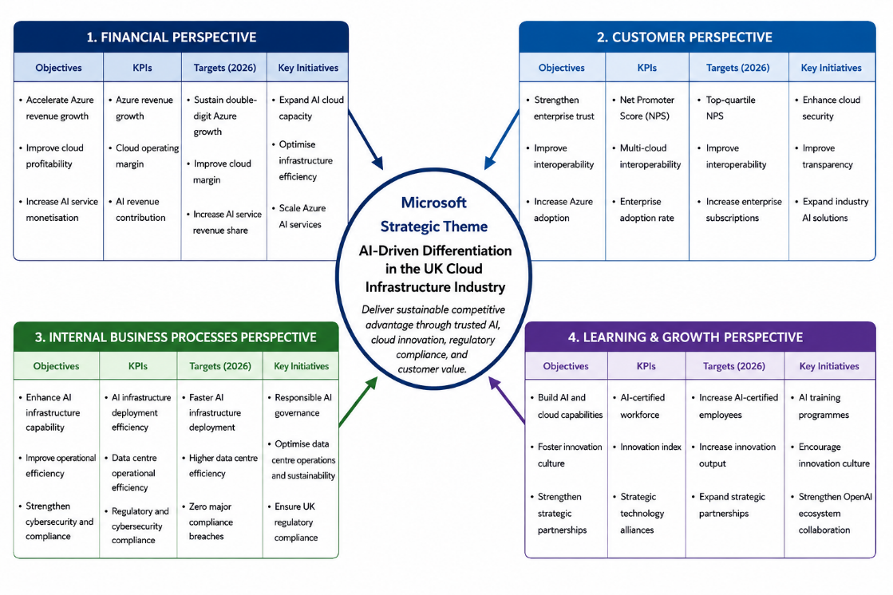
Figure 3: Balanced Scorecard for Microsoft's Intelligent Cloud Business in the United Kingdom (Cloud Infrastructure Industry)
Likewise, the interoperability goal of the customer perspective is aligned with the licensing practice that the VRIO analysis in Section 2 says is Microsoft's weakest: its licensing practices are subject to fewer regulatory risks. The learning and growth perspective is perhaps the precondition for the other three, as without a workforce that is rebuilt and has the trust it lost during restructuring in 2025 and 2026, Microsoft will have fewer engineers to support the low carbon construction, interoperability engineering, and AI infrastructure disciplines that the other three rely on.

4. Strategic Choices and Implementation

4.1 Business Level Strategic Choices
At the business level, Porter (1980) has three generic strategies that are widely available: cost leadership, differentiation, and focus, and cautions that a firm that does not clearly adopt one of these three strategies is at risk of being stuck in the middle (Armalia Reny W.A, 2023). Azure's Intelligent Cloud business differentiates more than it competes on cost: Azure is not always the lowest-cost hyperscaler on a like-for-like compute basis. But it does out-compete AWS in terms of integration with Windows Server, SQL Server and Microsoft 365, and Google Cloud in terms of AI and data analytics specialisation. This is a differentiated strategy, not a chance to be stuck in the middle, but the VRIO analysis and the SWOT analysis of Section 2 both indicate that the mechanism that's creating this differentiation (bundled licensing) is also the one that's most vulnerable to the law. So the sustainability of this generic strategy is now partly dependent on a regulatory result outside of Microsoft's influence. This differentiation strategy is defined relative to the cloud infrastructure industry's competitive structure, not Microsoft's technology alone.

4.2 Recommended Strategy and Validation
Figure 4 plots Microsoft's three reporting segments on a BCG growth share matrix based on the revenue growth for each segment in fiscal year 2025 and their competitive strength. Intelligent Cloud is a Star, having the fastest growth of the three segments at 21.5 per cent, but also has a strong competitive position as Azure is closing the gap on the global share with AWS. Productivity and Business Processes is a Cash Cow, a business that is mature and has a high share in the group, with an operating income increase of 13.1 per cent, albeit at a slower pace. More Personal Computing, which grew at a relatively low rate of 7.5 per cent and is a relatively weaker competitor in gaming against Sony and in search against Google, is more likely to be a Question Mark, generating cash but with no clear growth path like Intelligent Cloud. Only Intelligent Cloud sits within the cloud infrastructure industry; the other two segments are shown for context only.
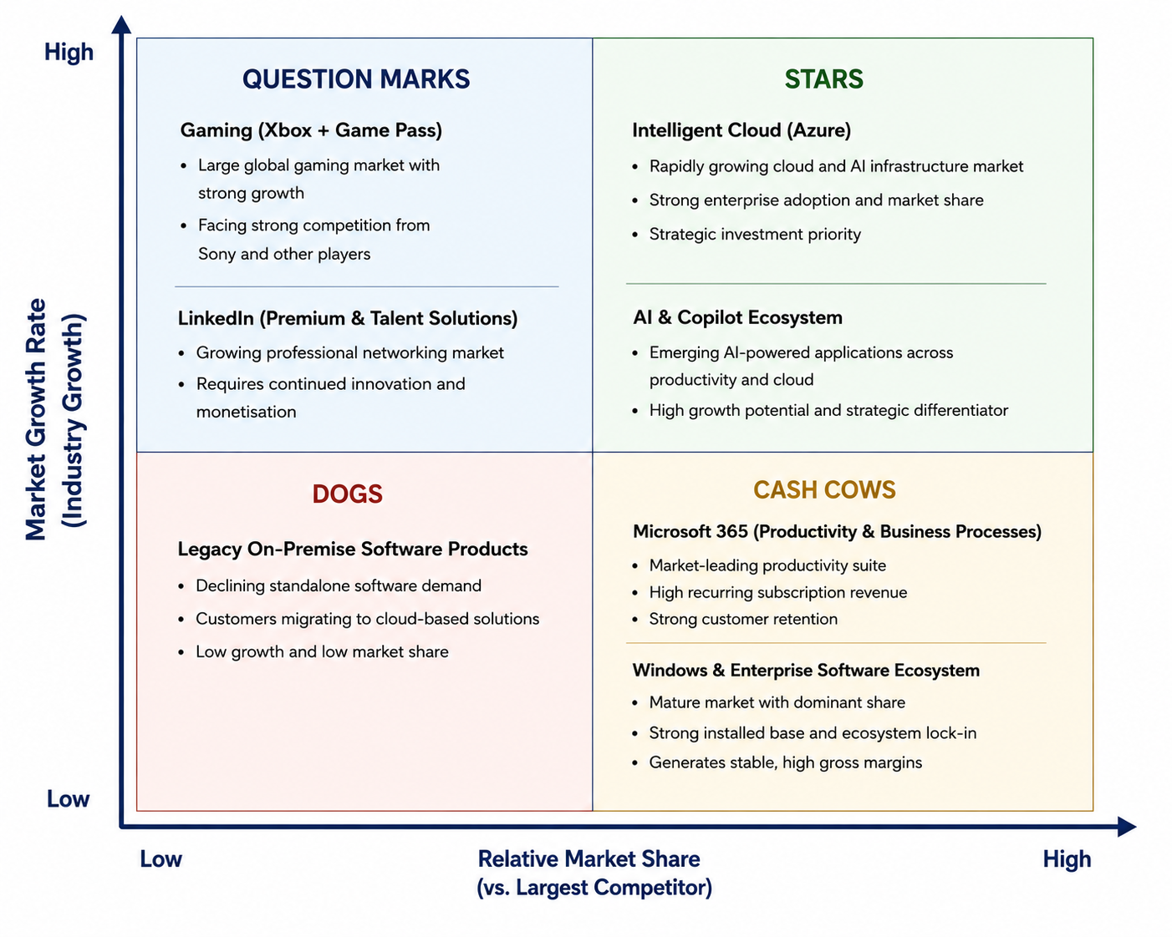
Figure 4: Illustrative BCG Matrix of Microsoft's Reporting Segments (Cloud Infrastructure Industry Context)
The cloud infrastructure industry’s structural attractiveness, not Azure’s attractiveness as a standalone business, is examined here using the five forces framework, since the profitability ceiling for any provider, including Azure, depends on this industry’s overall structure.
As per this report, Microsoft should continue to invest the Cash Cow money in the Intelligent Cloud Star, but should test this investment against Porter's (1985) five forces and not assume that Azure is growing as it is now. The power of 5 forces analysis is that it does not give a verdict of an industry being attractive or unattractive, it is about understanding which of the 5 forces is changing and why, and this approach is followed in this report by considering each force in isolation. Buyer power is growing, not declining, as the Competition and Markets Authority's Strategic Market Status investigation is specifically aimed at empowering customers to switch providers and to negotiate more equitably, and the threat of substitutes is growing thanks to open source and multi cloud tooling, which He, Li and Zheng (2023) argue is the core of platform competition more broadly. The direction of both forces is the same: they will squeeze the returns from the licensing-based differentiation identified in Section 4.1, and strengthen this report's argument that Microsoft's future investment in Azure should focus more on its strengths with OpenAI and the infrastructure for AI, as identified in the SWOT analysis, than on the licensing practice under direct attack from competition and regulation.
Rivalry among existing competitors, the fifth of Porter's forces, is intensifying rather than easing: Google Cloud has grown revenue faster than either AWS or Azure in recent quarters on the strength of AI differentiated services, and AWS retains the largest absolute share of the global market despite slower relative growth, a pattern consistent with Chand's (2023) finding that rivalry intensity, rather than any single competitor's absolute size, is often the force most likely to erode incumbent margins. Microsoft's differentiation strategy therefore cannot rely on relative market position alone; it must continue to out invest rivals in the AI infrastructure layer where the SWOT analysis identifies Microsoft's genuine, non-contested advantage.

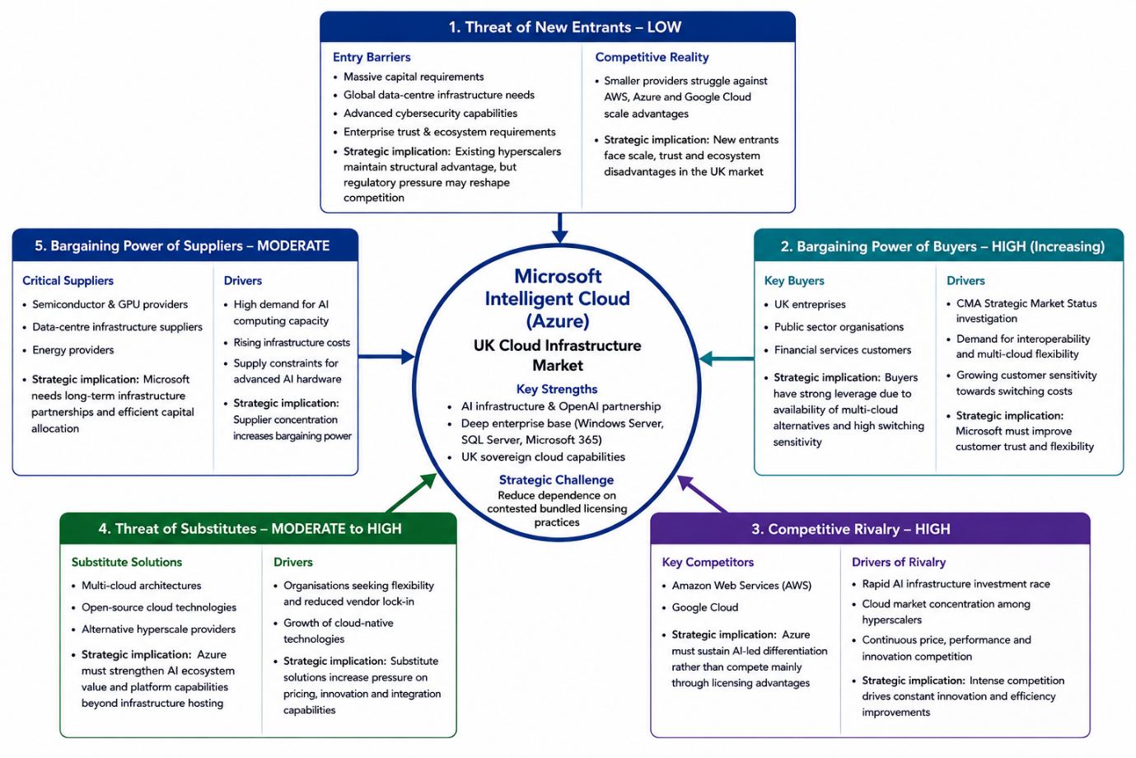
Figure 5: Porter’s Five Forces Analysis of Microsoft Intelligent Cloud (Azure) – UK Cloud Infrastructure Market

4.3 Implementation Challenges and Mitigation
There are three implementation issues to consider. First, the Strategic Market Status investigation may still lead to mandated changes to licensing practice before it is finished, and it would be prudent for Microsoft to plan a transition path for Windows Server and SQL Server pricing on Azure now rather than when it is determined to be commercial, as the balanced scorecard in Section 3.2 already suggests that proactive interoperability commitments are consistent with, not opposed to, commercial strategy. Second, workforce reductions in 2025 and 2026 will threaten to drain Azure's capacity to build its AI infrastructure when the demand is likely to be greatest, which should be addressed by reskilling programmes and voluntary transitions already called for in the balanced scorecard's learning and growth perspective, not by another round of reactive workforce reductions. Third, the margin pressure described in this report, as AI infrastructure scales, is limiting the amount of capital available to expand data centres and to achieve the lower carbon construction methods necessary to put Microsoft on course to meet its emissions trajectory. These implementation risks face every major participant in the cloud infrastructure industry, not Microsoft alone.

5. Conclusion
Microsoft's Intelligent Cloud business is in a strong but increasingly competitive position in the United Kingdom. VRIO confirmed its enterprise installed base and OpenAI partnership as sources of advantage, but its differentiation strategy is only tentatively validated when buyer power and substitution threats (Porter's five forces) are considered and its licensing practices are the subject of a Strategic Market Status investigation in 2026. This report recommends that Microsoft maintain its funding of the Intelligent Cloud Star identified in the BCG matrix from Productivity and Business Processes' Cash Cow returns, and also diversify its basis of competitive advantage in the UK from the contested licensing model it has adopted to the strengths in AI infrastructure.

Section 2: Reflective Account
This section is a reflection on the process of researching and preparing Section 1, and is organised by Gibbs (1988) reflective cycle which is divided into six stages (Hashim et al., 2023). This model was selected over Kolb's (1984) experiential learning cycle because Gibbs' explicit feelings and action plan stages were more appropriate for capturing the experience of researching a company whose regulatory position changed during the process of writing this model (Nurunnabi et al., 2022).
Description
The assignment involved identifying an organisation, justifying a particular focus on a market or product, conducting an external and internal analysis using the PESTEL framework, the VRIO framework and the SWOT framework, creating a section on corporate responsibility and performance with the Carroll's CSR pyramid, the Freeman's stakeholder theory and the balanced scorecard, and a section on strategic choices including generic strategies, Porter's five forces and the BCG matrix, and then producing Board recommendations and a reflective account (R. Edward Freeman and Lorange, 2023). I selected Microsoft, as it is a large company that has been the subject of much public reporting, and focussed on Intelligent Cloud, in this instance Azure, in the United Kingdom due to the live Competition and Markets Authority investigation into the company's cloud and licensing practices, a choice that placed the cloud infrastructure industry, not just Microsoft, at the centre of the analysis.
Feelings
When I started doing a bit of research into a company that was under an active regulatory investigation, I was unsure whether I should be more or less critical of the risk the investigation poses, or whether I should be more or less critical of an actual and well substantiated competition concern. This became a matter of confidence when I started reading the actual documents that the Competition and Markets Authority has published for the cases, and the documents from Microsoft itself, and not relying on secondary commentary, so that I could be confident in the difference between what I could see, and what people were speculating on. I also felt some satisfaction when the VRIO and SWOT analyses independently arrived at the same answer that licensing is the weakest resource for Microsoft.
Evaluation
The good thing was to carefully design the framework allocation before writing a single paragraph of analysis, to assign PESTEL and VRIO to external analysis, and Carroll and the balanced scorecard to corporate responsibility, and to assign generic strategies, five forces and BCG to strategic choices, so that no framework was analysed twice and every cross reference could point to the specific framework that created a finding, not just to a section number. This was directly in response to feedback from a previous assignment where cross references were provided for sections instead of frameworks in a few places. What didn't go so well was that some of the facts were also reported in different ways across the secondary sources, so that more time was spent checking on the most credible and well-attributed estimate, rather than the first one that came up.
Analysis
Looking back on this, the market share fluctuations are not due to any carelessness in the data sources, but are a natural outcome of the fast-growing, rapidly changing market; different data providers use different measurement windows and methodologies. This was part of a larger message: that using frameworks like PESTEL and Porter's five forces on a company that is the subject of an active regulatory investigation is not the same as using them on a stable incumbent. That the conclusions that the frameworks are supposed to draw, such as that a resource is scarce or an industry structure is unattractive, can themselves be contested findings in an active regulatory process, rather than facts. By using naming frameworks explicitly in the cross references, rather than referring to sections, I also had to check that each of the frameworks' conclusions was actually consistently used elsewhere in the report, so there was one occasion when an earlier draft would have suggested that Azure's growth was more dependent on licensing than the SWOT analysis indicated.
Conclusion
I have subsequently found this to be a useful approach to reduce rework involved in structuring an argument and to define naming conventions for cross references before drafting, rather than changing them afterwards as I did on a previous assignment, which would have added a good deal to the rework. I might have been more careful to note the exact source(s) of each market share statistic I used in the initial research, instead of piecing this information together when discrepancies arose during final review.
Action Plan
For future strategic analysis assignments, I will make the framework the first thing I think of before writing any prose, and ensure that there's no more than one heading assigned to any given figure, and that I keep a source log to record not only the figure I used, but which of the several conflicting figures was preferred and why. I also plan on continuing the cross referencing of frameworks instead of sections in the cross reference sentences.

References
Aastha Mantri, Kaltenbrunner, L., Frankel, A., Bennett, O. and Jagoe, S. (2024). Cloud services: Market reflection and a growth story. Competition Law Journal, [online] 23(1), pp.42–49. doi:10.4337/clj.2024.01.04.
Armalia Reny W.A (2023). Strategic Performance Dynamics: Elucidating the Effect of Competitive and Growth Strategies on Companies. Shirkah Journal of Economics and Business, 9(1), pp.33–48. doi:10.22515/shirkah.v9i1.664.
Baird, K., Nuhu, N. and Jiao, L. (2024). The effect of Porter's competitive forces on competitive advantage and organisational performance and the moderating role of management accounting practices. Journal of management control, 35(4), pp.303–332. doi:10.1007/s00187-024-00375-4.
Bari, N., Chimhundu, R. and Chan, K.C. (2024). Interrelation between Sustainable Dynamic Capabilities, Corporate Sustainability, and Sustained Competitive Advantage. Sustainability, [online] 16(7), p.2864. doi:10.3390/su16072864.
Chand, S.V. (2023). Relevance of Porter's five forces: a case study of RB Patel in Fiji. Open Journal of Business and Management, 11, pp.2135–2143. doi:10.4236/ojbm.2023.115117.
Civo (2026). Cloud Services Investigation: what the CMA's findings mean for the cloud industry. [online] Available at: https://www.civo.com/blog/cma-cloud-services-investigation-2025 [Accessed 9 July 2026].
Data Center Dynamics (2026). 'Competition is not working well,' says UK CMA concluding cloud market investigation. [online] Available at: https://www.datacenterdynamics.com/en/news/competition-is-not-working-well-says-uk-cma-concluding-cloud-market-investigation/ [Accessed 9 July 2026].
Elite Brains (2026). Microsoft Layoffs 2026: Full List, Statistics, and What's Really Behind the Job Cuts. [online] Available at: https://www.elitebrains.com/blog/microsoft-layoffs-2026-full-list-statistics-what-is-behind-job-cuts [Accessed 9 July 2026].
El Nemar, S., El-Chaarani, H., Dandachi, I. and Castellano, S. (2022). Resource-based View and Sustainable advantage: A Framework for SMEs. Journal of Strategic Marketing, 33(6), pp.1–24.
Erb, T., Perciasepe, B., Radulovic, V. and Niland, M. (2022). Corporate Climate Commitments: The Trend Towards Net Zero. Handbook of Climate Change Mitigation and Adaptation, 65(2), pp.2985–3018. doi:10.1007/978-3-030-72579-2_146.
Fortune (2025). Microsoft turns 50: how it's remained essential, based on my 27 years there. [online] Available at: https://fortune.com/2025/04/02/microsoft-50-years-leadership-success/ [Accessed 9 July 2026].
Friedman, H.H., Nakato Hirakubo and Lewis, B.J. (2026). Survival in the Intelligence Age: Strategic Pivoting and the New Rules of Corporate Resilience. [online] DigitalCommons@Fairfield. Available at: https://digitalcommons.fairfield.edu/nealsb/vol46/iss1/3/ [Accessed 10 July 2026].
George (2024). The Cloud Comedown: Understanding the Emerging Trend of Cloud Exit Strategies. Partners Universal International Innovation Journal, [online] 2(5), pp.1–32. doi:10.5281/zenodo.13993933.
GOV.UK (2026a). Cloud services market investigation. [online] Available at: https://www.gov.uk/cma-cases/cloud-services-market-investigation [Accessed 9 July 2026].
GOV.UK (2026b). CMA launches strategic market status investigation into Microsoft's business software ecosystem. [online] Available at: https://www.gov.uk/government/news/cma-launches-strategic-market-status-investigation-into-microsofts-business-software-ecosystem [Accessed 9 July 2026].
Hashim, S.N.A., Yaacob, A., Suryani, I., Mohd Asraf, R., Bahador, Z. and Supian, N. (2023). Exploring the Use of Gibbs' Reflective Model in Enhancing In-Service ESL Teachers' Reflective Writing. [online] Social Science Research Network. doi:10.2139/ssrn.4497558.
He, W., Li, M. and Zheng, J. (2023). Switching cost, network externality and platform competition. International Review of Economics and Finance, 84, pp.428–443. doi:10.1016/j.iref.2022.11.037.
Helfat, C.E., Kaul, A., Ketchen, D.J., Barney, J.B., Chatain, O. and Singh, H. (2023). Renewing the resource‐based view: New contexts, new concepts, and new methods. Strategic Management Journal, 44(6), pp.1357–1390. doi:10.1002/smj.3500.
Karadzhov, V. and Patarchanova, E. (2025). How to create the best PESTEL analysis. International Journal of Digital Research, [online] 1(3), pp.8–20. Available at: https://www.researchgate.net/publication/394298616_How_to_Create_the_Best_PESTEL_Analysis [Accessed 9 July 2026].
Kumar, S., Lim, W.M., Sureka, R., Jabbour, C.J.C. and Bamel, U. (2023). Balanced scorecard: trends, developments, and future directions. Review of Managerial Science, 18(8), pp.2397–2439. doi:10.1007/s11846-023-00700-6.
Mahat, N., Mohamad Najib, M.F., Sarah, R.S. and Ibrahim, I. (2022). The use of Microsoft 365 in organisation information management / Norpah Mahat ... [et al.] - UiTM Institutional Repository. [online] Uitm.edu.my. Available at: https://ir.uitm.edu.my/id/eprint/74683/ [Accessed 10 July 2026].
Mailani, D., Hulu, M.Z.T., Simamora, M.R. and Ade, S. (2024). Resource based view theory to achieve a sustainable competitive advantage of the firm: systematic literature review. International Journal of Entrepreneurship and Sustainability Studies, 4(1). doi:10.31098/ijeass.v4i1.2002.
Microsoft (2020). Microsoft will be carbon negative by 2030. [online] Available at: https://blogs.microsoft.com/blog/2020/01/16/microsoft-will-be-carbon-negative-by-2030/ [Accessed 9 July 2026].
Microsoft (2025a). Our Mission and Values. [online] Available at: https://www.microsoft.com/en-us/about [Accessed 9 July 2026].
Microsoft (2025b). Progress on the road to 2030. [online] Available at: https://blogs.microsoft.com/on-the-issues/2025/02/13/progress-on-the-road-to-2030/ [Accessed 9 July 2026].
Microsoft Corp (2025a). Form 10-K for the fiscal year ended 30 June 2025. [online] Available at: https://www.sec.gov/Archives/edgar/data/789019/000095017025100235/msft-20250630.htm [Accessed 9 July 2026].
Microsoft Corp (2025b). Form ARS: Annual Report to Shareholders, fiscal year 2025. [online] Available at: https://www.sec.gov/Archives/edgar/data/789019/000119312525245177/d61995dars.pdf [Accessed 9 July 2026].
Microsoft Corp (2025c). FY25 Q4 Performance. [online] Available at: https://www.microsoft.com/en-us/investor/earnings/fy-2025-q4/performance [Accessed 9 July 2026].
Minchin, T.J. (2024). A New Labor movement? Assessing the Worker Upsurge in the Contemporary U.S. Labor history, 65(4), pp.1–24. doi:10.1080/0023656x.2024.2327487.
Murcia, N.N.S., Ferreira, F.A.F. and Ferreira, J.J.M. (2022). Enhancing strategic management using a quantified VRIO: adding value with the MCDA approach. Technological Forecasting and Social Change, 174, 121251. doi:10.1016/j.techfore.2021.121251.
Nazir, S., Vilko, J. and Torkkeli, M. (2025). Leadership in the Age of AI. Reskilling and Upskilling in the Age of AI, 73(1), pp.181–199. doi:10.1201/9781003611677-10.
Nurunnabi, A.S.M., Rahim, R., Alo, D., Mamun, A. Al, Kaiser, A.M., Mohammad, T. and Sultana, F. (2022). Experiential learning in clinical education guided by the kolb's experiential learning theory. International Journal of Human and Health Sciences (IJHHS), [online] 6(2), p.155. doi:10.31344/ijhhs.v6i2.438.
Opara, L.C., Akatakpo, O.N., Ironuru, I.C., Kingsley Anyaene and Enobakhare, B.O. (2025). Chaos Engineering 2.0: A Review of AI-Driven, Policy-Guided Resilience for Multi-Cloud Systems. Journal of Computer, Software, and Program, [online] 2(2), pp.10–24. doi:10.69739/jcsp.v2i2.846.
Pangarkar, N. and Prabhudesai, R. (2024). Using Porter's five forces analysis to drive strategy. Global Business and Organizational Excellence, 43(3), pp.6–19. doi:10.1002/joe.22250.
Prasad Joshi, S., Prajapati, M. and Adhikari, R. (2026). Ethical, Environmental, and Sustainable Management in Corporate Responsibility: A Systematic Review. Contemporary Research: An Interdisciplinary Academic Journal, [online] 9(1), pp.437–456. doi:10.3126/craiaj.v9i1.96146.
R. Edward Freeman and Lorange, P. (2023). Theory Building in Strategic Management. Issues in business ethics, 76(8), pp.89–117. doi:10.1007/978-3-031-04564-6_4.
Statista (2026). Chart: Big Three hold dominant lead in accelerating cloud market. [online] Available at: https://www.statista.com/chart/18819/worldwide-market-share-of-leading-cloud-infrastructure-service-providers/ [Accessed 9 July 2026].
The Register (2025). UK to rein in Microsoft, AWS with 'strategic market status'. [online] Available at: https://www.theregister.com/2025/07/31/cma_aws_microsoft_sms/ [Accessed 9 July 2026].
UNFCCC (2025). Microsoft: Carbon Negative Goal. [online] Available at: https://unfccc.int/climate-action/un-global-climate-action-awards/climate-neutral-now/microsoft-carbon-negative-goal [Accessed 9 July 2026].
Zouhair Hajji, Abderrahim Chtaoui and Abdelali Bouhmala (2025). Balanced Scorecard and Performance Management: A literature Review. International Journal of Research in Economics and Finance, [online] 2(3), pp.14–25. doi:10.71420/ijref.v2i3.75

