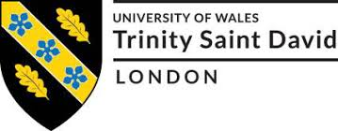

Student: | Ratchada Caliendo-Chan (1916134)
Course: | BALM Level 5
Module: | DWC BMSW5101
Title: | Developing Workplace Critical Thinking
Lecturer: | Yajesh Kumar



DEVELOPING WORKPLACE CRITICAL THINKING

Executive Summary

Tesco is a leading cosmopolitan vendor with more than 400,000 workforces worldwide with 4,316 stores. It serves millions of customers weekly in-store and online. Its total sales rose 7 per cent to more than £53 billion through the end of February this year. Trades amplified by 8.8 per cent in the UK and Ireland. Its revenues were incurred £892 million in additional costs, including hiring more workers to deliver goods online and compensating workers lost due to Covid19 of self-isolating. The biggest challenge in its one hundred- and one-year history that it has faced is the pandemic. This pandemic has caused interruption and doubt to businesses and consumers. Co-workers, contractors and all Tesco’s investors, and to react to these defies, Tesco is guided by business values ​​and is committed to providing better customer service every day. Tesco's businesses share a common goal of serving better shoppers every day. Three values ​​are backed by one: "No one is more devoted to their customers. We treat people the way they want to be treated. Every little help makes a big difference". (Tesco PLC, 2021). Tesco was at the forefront of keeping the whole of Britain fed in the pandemic. It could secure the fruit and veg in stores that come from 63 countries, all affected by the global pandemic differently at different times (Channel 5, 2021). Tesco has developed digital transformation using analytical and rational thinking to evaluate its business (Mitra, 2021). It has created resilient businesses for its organization and become pandemic proof (Imagine Digital, 2021). Also, with the distinction between beliefs, attitudes and values in the workplace, their workforces with different beliefs, attitudes, and values decipher those concepts differently by approaches to Tesco value system (Vveinhardt, 2017). Management Theories such as Taylor Scientific, Elton Mayo, Herzberg’s two-factor, and Maslow’s Hierarchy are also in practice at Tesco to motivate workforces (Business Case Studies, 2021). Ultimately, this report may benefits employees and individuals who want to develop workplace critical thinking skills and creativity training through analytical and rational thinking implement aid like Six Thinking Hats® of the De Bono method. It is for reconnoitring, evolving and executing concepts. Individuals and groups use it to isolate conflicting thought patterns. The methods encourage people to think creatively together and create transformation (Edward de Bono, 2018).
Contents
Introduction 4
Background 5
Section 1 6
1.1 The Prominence of Critical Thinking Skills and Creativity 6
1.2 The Impact of Tesco Business Service Performance 7
1.3 The Impact of Tesco Business Financial Performance 8
1.4 Tesco’s Mission Towards Workplace Critical Thinking 9
1.4.1 Step 1: Building the Right Enablers 10
1.4.2 Step 2: Building the Right Operation Hydraulics 11
1.4.4 Step 3: Having a Clear Digital Strategy 12
1.4.5 Step 4: Think Customer 13
1.4.6 Step 5: Bringing It All Together at Tesco 14
Section 2 15
2.1 Beliefs, Attitudes and Value Systems 15
2.2 Motivation and Management Theory 16
2.2.1 Taylor Scientific Model 17
2.2.2 Maslow’s Hierarchy 18
2.2.3 Herzberg’s Two-Factor Model 18
2.2.4 Elton Mayo Model 19
2.3 The Six Thinking Hats® 20
Recommendation 21
Conclusion 21
References 22

Introduction

The motive for selecting Tesco PLC came from familiarity as an ex-employee employed within its organization, including experiences from a member of the family who is currently working within the Tesco organization. Thus, the personal interest and working familiarity with Tesco PLC in the past, plus experiences from a member of the family who is currently working within the Tesco organization, helped investigate and evaluate this particular subject report of developing workplace critical thinking within the Tesco context efficiently.

Section one discusses the prominence of critical thinking skills and creativity in the workplace. Analyses the impact of Tesco business services performance during the pandemic, the impact of its business financial performance during the pandemic and its mission towards developing workplace critical thinking post-pandemic on digital and transformation using analytical and rational thinking to evaluate Tesco how it created resilient businesses.

Ultimately, section two discusses the distinction between beliefs, attitudes and values in the workplace of how someone with different beliefs, attitudes, and values decipher those concepts differently by approaches to Tesco value system. Assesses management theories Tesco uses for its organization such as Taylor Scientific theory, Elton Mayo model, Herzberg’s two-factor model, and Maslow’s Hierarchy model in practice at Tesco. Deliberates how employees and individuals who want to develop workplace critical thinking skills and creativity training through analytical and rational thinking implement aid like Six Thinking Hats® of De Bono method, showcasing De Bono’s six thinking hats method. However, this report focuses on developing workplace critical thinking.

Background

(Mitra, 2021).

In 1919 Tesco corporate found by Jack Cohen, who was running a small stall in East London and later Tesco store launched its first store in north London. Today Tesco has branches in five countries UK, Ireland, Czech Republic, Slovakia and Hungary. Tesco is a primary British cosmopolitan vendor headquartered in Welwyn Garden City, Hertfordshire, England. As a leading cosmopolitan vendor with more than 400,000 (more than 360,000 in the UK) workforces worldwide with 4,316 stores (3,629 in the UK). It serves millions of customers weekly in-store and online. Its total sales rose 7 per cent to more than £53 billion through the end of February this year. Trades amplified by 8.8 per cent in the UK and Ireland. Nevertheless, Tesco revenues were incurred £892 million in additional costs, including hiring more workers to deliver goods online and compensating workers lost due to Covid19 of self-isolating (Tesco PLC, 2021).

Tesco's businesses share a common goal of serving better shoppers every day. Three values ​​are backed by one: "No one is more devoted to their customers. We treat people the way they want to be treated. Every little help makes a big difference". “Serving customers” for Tesco means more than retailing sustenance means performing as an accountable and sustainable trade for all its stakeholders, whether the customer, co-workers, contractors, and investors, and delivering affordable, nutritious, and sustainable sustenance (Tesco PLC, 2021).

Section 1

1.1 The Prominence of Critical Thinking Skills and Creativity

The contemporary approach to defining critical thinking is recognised as a broader structure than traditional assessment. Essential elements, for example, inductive and deductive implication, are undoubtedly involved. Nevertheless, it attempts beyond these psychological manoeuvres to create second-order reflections and assess one’s own or others’ thoughts. In doing this, it is necessary to call the epistemology standard how people know. Furthermore, these have been shown to differ significantly from individuals and developments. Critical thinkers are considered constant epistemological surveillance (Byrnes and Dunbar, 2014; Kuhn, 1999; Moshman, 2015; Mercier and Sperber, 2011 quoted in Kuhn, 2018). There is significance in thinking analytically in all facets of everyone life. From constructing judgements in personal life to cross-examining the media consumption to accessing work with a critical eye, applying analytical thinking abilities is a crucial proficiency everybody should refine. Critical thinking in the workplace can discriminate a leader and a valuable mind to rebound concepts off. It can aid develop the attribute of the work and the acuity those superior up the restraint have of leaders. Critical thinking is a procedure of objective evaluation of facts and the consideration of possible solutions to problems. The concept dates back to early questioning methods to achieve knowledge practised by the Ancient Greek philosopher Socrates (The Foundation for Critical Thinking, 2019).

Many businesses are already speculating hard on their forthcoming proficiencies requirements effects of the pandemic even though there may still be a way to go before it (Prospects, 2020). The Knowledge, Evidence and Learning for Development (K4D) emerging issue reported policy and state stakeholders to focus on critical thinking as an essential feature of the definition of 21st-century skills in the age of globalisation. Critical thinking will be one of the primaries “life skills” demand for 21st Century Skills in developing countries by 2030 (K4D, 2019). PWC observed that the Local Government Association guesstimates that the 'low carbon workforce' will triple by 2030. That need for critical thinking proficiencies will also be essential because technology encroachments and simulated online work have become more regular (PWC, 2021). The World Economic Forum (WEF) also stated that, since its 2016 edition, critical thinking, analysis, and creative thinking skills have stayed at the top of the agenda with year-on-year consistency. Furthermore, these skills are increasing demand which employers see as rising in prominence in the lead up to 2025 (World Economic Forum, 2020).

Whereas creativity is concrete and profound art, it is a robust process of knowledge and cognition. Thinking, organizing, framing and forming the concepts of creative thinking is just as necessary. With consideration and understanding of the process, today’s workplace required employees to enhance their attributes to capture the flashes of creativity that limit thought processes. Excluding possibilities that are not an option instead of expanding creates the imagination and comes from the born creativity. The importance of communication in the workplace explores creativity in different work areas, thought processes in decision-making, problem-solving, creativity, and developing leadership skills. The thinking process is no different from creative thinking. The ability to think creatively is a sign of a booming business climate and an indicator of success in life. However, the creative thinking process does not stand still but continues to grow. It builds relationships and removes ambiguity in the countless steps’ employees face every day in the workplace. Special training in creativity is required in the workplace to set the scope for further research on critical thinking and communication (Tripathy, 2018). The following section, 1.2 to 1.4.6, explores how Tesco workforces performed their workplace critical thinking skills and creative thinking skills throughout the pandemic and post-pandemic at its best.

1.2 The Impact of Tesco Business Service Performance

The equilibrium of the epidemic grabbed everybody by astonishment in the year 2020. Through the end of January, Tesco had a crisis response team in place as Britain's biggest supermarket they were in the eye of the storm. It was impossible to keep up with what was happening and how quickly it was unfolding.

Customers changed their shopping habits overnight. A massive surge in demand Tesco was at the forefront of keeping Britain fed, but not everything was instantly available. Tesco could secure the fruit and veg in stores that come from 63 countries, all affected by the global pandemic differently at different times. The coronavirus was not only a significant disruption to the supply chain. There were changes on the shop floor that had happened overnight. Controlling numbers of customers inside their stove and then sourcing thousands of tons of plastic and delivering it to stores to keep a safe barrier between customers and colleagues.

Tesco critical workers in retail kept going throughout lockdown but with up to 50,000 employees ill or isolating. The business was short one-sixth of their staff they had to recruit quickly and brought on 50,000 temporary staff in a concise amount of time. Tesco was capable of getting workforces from reaching an application form to starting work in four hours. Today over 360,000 people work for Tesco, Britain's biggest supermarket retailer, in distribution transport and headquarters. Tesco has the most extensive grocery home shopping operation in the UK. It is efficient and straightforward as the dotcom teamwork can work for two hours and put around twelve thousand items in trolleys to load on the vans. During the five-week pandemic lockdown, Tesco delivered 1.5 million orders a week and picked about 10 million items a day (Channel 5, 2021).

1.3 The Impact of Tesco Business Financial Performance

Tesco Profit has fallen nearly a fifth to £825 million the last year of 2020. After adding almost £900 million in additional charges due to the coronavirus pandemic. This year of 2021, Tesco wins consumers over competitors, and overall trades increased 7 per cent to more than £53 billion through the end of February. Trades amplified by 8.8 per cent in the UK and Ireland. Nevertheless, Tesco revenues were incurred £892 million in additional costs, including hiring more workers to deliver goods online and compensating workers lost due to covid19 or self-isolating. Nearly 50,000 temporary workers join up Tesco grocery stores during the epidemic. Of these, approximately 20,000 permanently attended (Tesco PLC, 2021).

Online trades went up 77 per cent during the year to £6.3 billion as Tesco hastily doubled their online delivery capacity to £1.5 million outlets per week in the last quarter of the year-end account audit. Online grocery stores account for 18 per cent of sales as virus fears keep consumers indoors. Deprived show in Tesco group’s banking manoeuvres and lower actual sales in Tesco’s Booker grocery wholesale corporate. The closure of eateries and teashops was the issue for this.

Tesco is facing difficulty paying the money to the government after disbursing shareholders a bonus of £315 million. Because Tesco had accepted £535 million interest rate relief from the UK government and announced it would repay the total amount. All other giant grocers (except Waitrose, the Co-Op and Iceland) have returned their corporate rate aid after taking advantage of the switch to culinary and consumption at domestic as eateries, teashops and taverns closed. Mr Hindle, a forecaster at investment firm Third Bridge, said: “Tesco has lived “recast” in the community eye. However, challenges will continue after the epidemic. “While Tesco’s Aldi price matching strategy is quite successful, but the competitive threat of price cuts remains Tesco’s biggest risk. The end of the suspension project rising unemployment trend and concerns about inflation. They all send buyers back to cheaper competitors,” he said (Partridge and Butler, 2021).

Tesco predicts trades development will be sluggish as consumers return to going to pubs and eating out. However, profits will benefit as the one-time cost triggered by the epidemic are reduced. The company said it would still face additional costs related to covid19 at about a quarter in the next year. However, it vowed to uphold its dividend and to waive any existing business rate relief. Tesco says the pandemic has changed customer behaviour with fewer shoppers but purchases 50 per cent more each time (Tesco PLC, 2021).

1.4 Tesco’s Mission Towards Workplace Critical Thinking

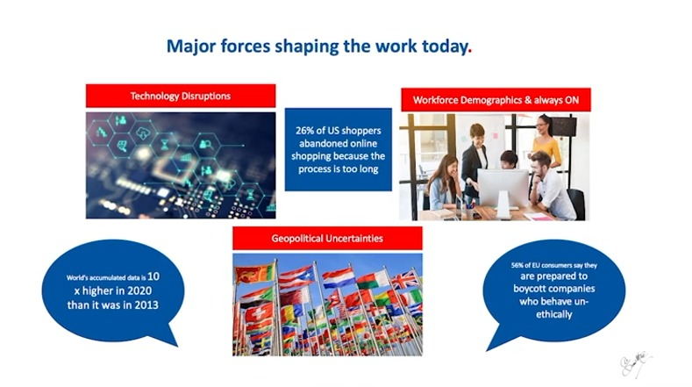
(Mitra, 2021).

Tesco's main forces to drive its transformation, such as technology disruptions, are blockchain and clouds and even cloud of the clouds. The countries are under political uncertainties and economic pressure because of the pandemic in the last 18 months and a patriotism culture moving to the far right. Brexit created and divided boundaries, which created pressure on different businesses. Through the pandemic, Tesco has almost 100 per cent of their workforces working from home. Customers' views are changing; 50 per cent of all consumers in Europe said that they are willing to boycott companies not working ethically. Its data consumption is ten times more than what it is now than in 2013. Tesco had to adopt and adapt to these changes, and that it also has different ways of engaging its workforce.

Furthermore, its customers want everything right here right now. They want it personalized and for Tesco to ensure that their data is safe and make sure they are physically healthy and safe, and the food that Tesco supports them and is available to them is healthy and very clear with instructions. Tesco is doing everything they can to reduce the kind of the impact on the environment. Its business strategies for its post-pandemic digital transformation describes in five steps.

1.4.1 Step 1: Building the Right Enablers

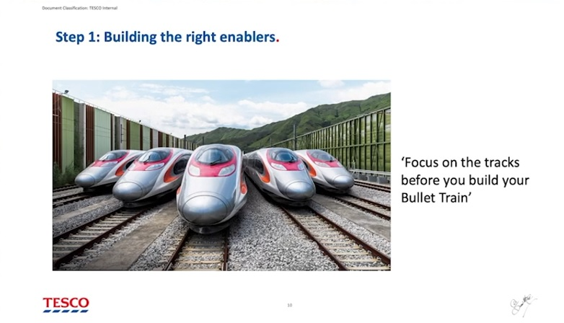
(Mitra, 2021).

Tesco has an agile culture that is ready to adopt and adapt to the changes they are driving (Hargreaves, 2021). Tesco refers to the technology as a bullet train, and hence they have to get the tracks to build before the bullet train can run in an organization. They are two tracks of the bullet train. The first track is its organisational culture which is agile, ready to adopt and adapt to the changes and that help Tesco drive the right culture. The second track is the process of the organization. Tesco created a clear blueprint of what from processors perspective, such as serving customers, building a strategy to support colleagues, dealing with the suppliers, and managing technology. They have to be apparent from the perspective of processes to which is the part is sit in Tesco business services. So, that clarity from a cultural perspective is an excellent enabler for driving.

1.4.2 Step 2: Building the Right Operation Hydraulics

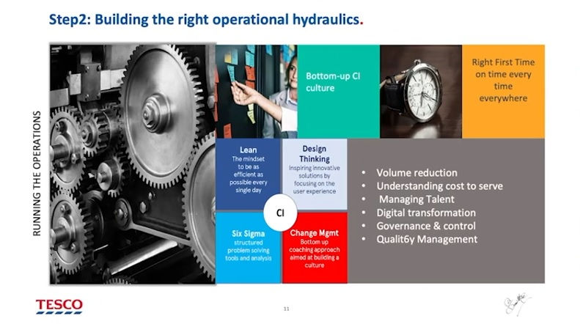
(Mitra, 2021).

Tesco motto is delivering right first time on time every time everywhere in the world. They create a culture of bottom-up continuous improvement at Tesco as their workforces have a clear and determined mind of serving their customers a diminutive healthier each day. This concept comes from the continuous improvement culture. Tesco workforces believe that continuous improvement is bottom-up, not top-down so, Tesco trains their colleagues to ensure they have the right tools and techniques. They use a Japanese methodology called kaizen, which helps them eliminate waste and ensure their colleagues have the tools to drive the continuous improvement journey through their processes. They do several interventions such as design thinking, lean six sigma, and change management within their CI framework to drive that culture. They also have its usual talent management, governance and control, quality management. The volume reduction plan has to have good volume inadequate volume to drive a world-class, efficient operation; Tesco fundamental of brilliant basics for getting it right to drive its digital transformation.

1.4.4 Step 3: Having a Clear Digital Strategy

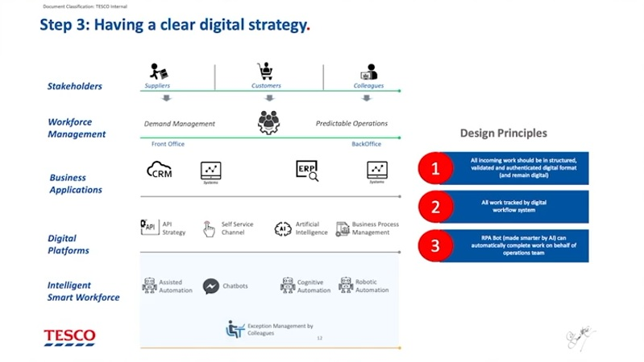
(Mitra, 2021).

Tesco has a clear strategy and design principle. The first one is that all incoming work is digitized and managed through workflow tools. It remains digital as they drive this, and all work is tracked through a digital workflow system. The work is powered by robotic capabilities such as mundane, rule bases and task-based and then made more intelligent through Tesco's AI. It has supplier interaction, colleague interaction, customer interaction, and a transparent workflow workforce management system that looks at the volume and helps them eliminate inadequate volumes. The workforce management decides how they staff up and make sure that they manage their picks and drops. It has digital platforms, API strategy, self-service channel, artificially intelligence, business process manages, assisted automation, chatbots, cognitive automation and robotic automation, which sits underneath. Anything by exception is managed by humans that requires intelligence, data interpretation, commercial skills, and emotional intelligence that a human can pick up.

1.4.5 Step 4: Think Customer

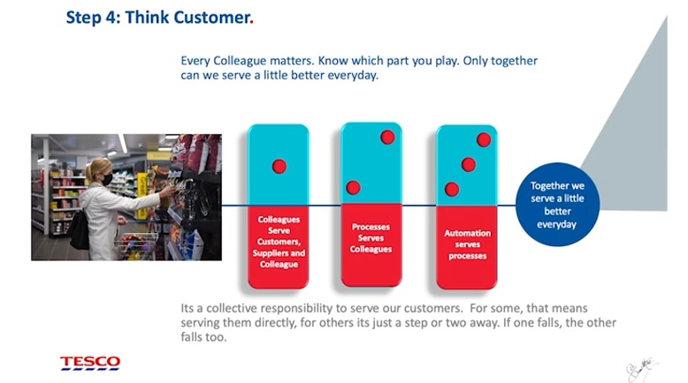
(Mitra, 2021).

Customers are right at the centre and heart of everything that Tesco do. Tesco called it the domino effect. Colleagues of their colleagues serve their customers, suppliers, and their internal colleagues. The processes serve those colleagues supporting those customers, colleagues and suppliers, and then automation serves those processes. These three are very interconnected, and if one follows the other faults and the domino effect, the interrelationship between the colleagues, the processes, and the automation must be crucial and understood end-to-end. Moreover, that has been Tesco’s philosophy regarding driving their automation and digital journey at Tesco.

1.4.6 Step 5: Bringing It All Together at Tesco

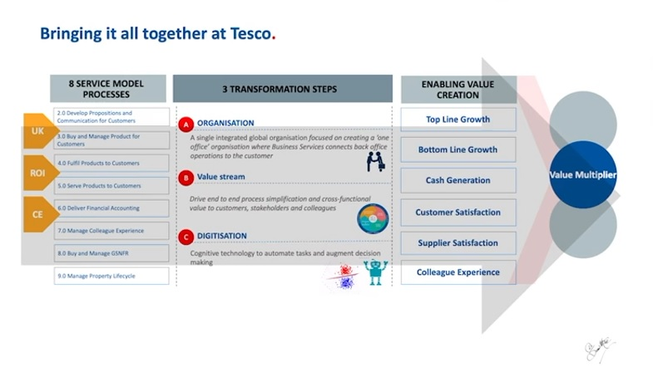
(Mitra, 2021).

Tesco business services manage the eight processes. They call it a service model such as developing proposition and communication for customers, buying and managing products for customers, serving products to customers, delivering financial accounting, managing colleague experience, and buying mange GSNFR manage property lifecycle. These processes are called the services model, and these are their guide rails. It has three transformation steps. The first one is an organization, which ensures that they scale up, bringing in everything within their organization that sits within Tesco business services and calls it one office. The second is value stream, and this is about looking through the lens horizontally across those eight processes and connecting the dots and using technology horizontally to connect the dots and create untapped value opportunities for their business. The third aspect of their transformation is digitalization, where they use such as cognitive technology and AI. Tesco uses Watson to drive commercial and contract management, which helps Tesco drive millions of pounds of savings (IBM, 2021). These three processes deliver value for Tesco, and they call it 3x value. The value Tesco create is evident as they are driving top and bottom-line growth. Tesco generating cash, customer satisfaction, supplier satisfaction, and collects experience by driving this digital transformation.

Section 2

2.1 Beliefs, Attitudes and Value Systems

Belief is the idea that a person can hold their rights. A person can express an opinion based on certainties such as mathematical principles or a matter of belief. Possible beliefs stay with the being until he/she perceives it as accurate and incorporate it into his/her belief organism. Every appraising and seeks justification or valid evidence for beliefs that may arise in their nature when a person accepts that belief as true was willing to defend that belief, and this could be the segment of their faith organism. Values are long-held viewpoints about what is vital to a being. They have befitted the standard by which individuals determine they exist and create selections. Ideas cultivate into values as a being's obligation increases, and they perceive it as necessary. It can potentially classify beliefs into distinct values, such as beliefs related to contentment, abundance, occupation achievement, or dynasty. Individuals requirement communicate their values to create precise, logical, accountable and regular conclusions. Attitude is people's approach to others and present situations beforehand, creating conclusions that outcome in comportment. Most individuals build their approaches from fundamental values and beliefs. Nevertheless, factors that may not be based on assumptions and standards still impact a decision-making attitude. Distinctive impacts comprise the wish to satisfy party-political rightness, comfort, peer pressure and mental stress (Ministry of Business Innovation and Employment, 2021).

Workplace principles are the most crucial guideline for employees on how they work. Core values are what backing the apparition, define ethnicity and reflect the corporation's values. These are the underlying of the corporation's DNA – values, dogmas or philosophy of principles. Workforces use these immutable values to decide among correct and erroneous ways of operating, and it aids workforces to construct critical conclusions. Corporate workplace values determine the direction of the culture and identify how the organisation prioritises. The reason is that employees' values must be consistent with these things, and when this happens, staff understand each other, and everybody does the right thing for valid purposes. This shared purpose and sympathy will help the workforce’s build strong operating affiliations. Consistent principles help the organisation as an entire attain its underlying task. Once values do not match, employees will work for different goals, intentions, and outcomes, destroying working relationships, job satisfaction and creative potential (Vveinhardt, 2017).

Tesco has tactics to promote its employees' growth and motivation to ensure seamlessness and corporation with everyone. Also guided by business principles ​​and is committed to providing better customer service every day. Tesco's businesses share a common goal of serving better shoppers every day. Three values ​​are backed by one: "No one is more devoted to their customers. We treat people the way they want to be treated. Every little help makes a big difference". “Serving customers” for them means more than retailing sustenance means acting as an accountable and maintainable business for all its stakeholders, whether the customer, co-workers, contractors, and investors, and delivering affordable, salubrious, and maintainable sustenance. Tesco has built a robust in-house ethnicity within its organisation, making it a trustworthy brand because it cares about its customers. It treats consumers as the very top critical fragment of their corporate. That is why its ethnicity delivers them with the most up-to-date and conducive shopping ecosystem, ensuring a smooth and seamless collaboration with all. Tesco has also shown its repute by donating to other societal and fiscal improvements of personnel served by itself, and that is because Tesco has strategies to promote employee growth and motivation (Tesco PLC, 2021).

2.2 Motivation and Management Theory

Respective welfares, such as remaining protected, or external factors, for example, commendation and rewards, can drive motivation. Workforces who are enthused work more solid and be more productive, save time and dropping workforce costs. It also necessitates less administration and shows pride in the job done and more impact on customers. Several theories, for example, Taylor scientific model, recommend motivating employees, such as “Paying” is the primary motivation. Other motivators such as Maslow’s hierarchy, Elton Mayo model and Herzberg’s two-factor model are the opportunity for advancement, responsibility, an appreciation of hard work, nous of success and delegation, a nous of dare and gratification. The reason might stem from own curiosity, such as custody harmless or external factors, commendation and recompense. Enthused employees are expected to exhibit significant devotion to the corporation and have less non-attendance. They have more excellent absorption and are fewer likely to create errors, reasons, coincidences, or divergence that existence dissatisfied with its responsibility in the employment deliberates that the corporate be contingent on customers and staff (Shield et al. 2020, pp. 42-45).

Tesco comprehends that staff members have various lifestyles outside of employment. So, it ropes its workforce with a work-life balance and propositions remunerations across pliable operational, reduction gym member participation, competitive salaries, free health welfares or abridged amount, workforce reduction and corporation portion alternatives. Tesco learned that it is essential to make faith and esteem. Tesco values its workforces and provides pragmatic ambitions and an enjoyable ecosystem for its workforces to work in, and cumulative employee enthusiasm (Tesco PLC, 2021).

An enthused workforce associate at Tesco works in partnership with others to succeed individual and team intentions. They focus on customers, treat individuals equitably, and are ultimately determined and devoted to accepting responses and advice from others via 360 feedback (ETS, 2021). Four management theories, such as Taylor Scientific, Maslow’s Hierarchy, Herzberg’s Two-Factor and Elton Mayo, were assessed to have been practised at Tesco PLC (Section 2.2.1 - 2.2.4).

2.2.1 Taylor Scientific Model

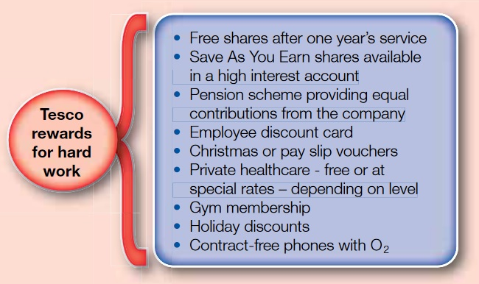
(Business Case Studies, 2021).

2.2.2 Maslow’s Hierarchy

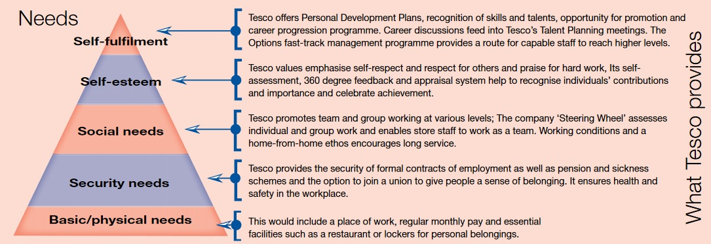
(Business Case Studies, 2021).

2.2.3 Herzberg’s Two-Factor Model

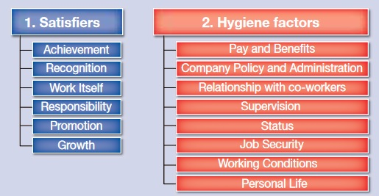
(Business Case Studies, 2021).

2.2.4 Elton Mayo Model

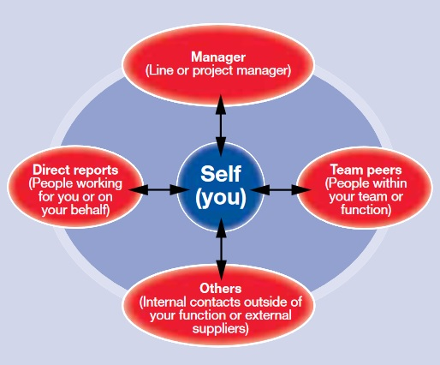
(Business Case Studies, 2021).

2.3 The Six Thinking Hats®

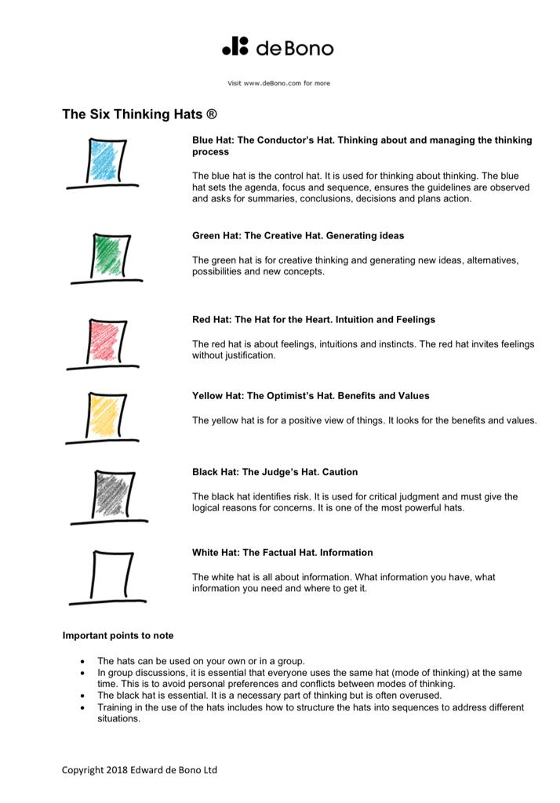
(Edward de Bono, 2018).

According to Dr Edward De Bono, having a certain level of creativity should be part of ordinary thinking skills. It must be used and apply to employees in the organization and an ideal society. The developments of the method were sympathetic in how the intellect works as a self-organized pattern perception scheme. However, this tool of the intellect aids us to cultivate habits in allocating with a multifaceted planet, its ringlets in our perspective. It creates it challenging to transform perceptions as needed. In the picture of the six thinking hats above, Edward De Bono explains how to structure thoughts so anyone can make the choices they want by wearing those six hats and act accordingly. In its place of using quarrels to round who is right and wrong, six hats are for exploring, developing and implementing ideas. Individuals and groups use it to isolate conflicting thought patterns. The methods encourage individuals to collaborate creatively and create transformation for success (Edward de Bono, 2018).

Recommendation

The core values system of the corporate must be transparent and long-lasting within the organization as they are underlying the corporation's DNA – values, dogmas or philosophy of principles. The agile working in the workplace should be continuing in business service and operation systems. Developing workplace critical thinking skills process should continue to grow also training for staff in creativity is required. To set goals that require new ideas can be processed by using the Six Thinking Hats® method. In this way, creativity becomes an organizational resource that can be used intentionally and focused.

Conclusion

To sum up, immutable corporate values are the key to deciding between right and wrong ways of operating for the workforces and can aid them in constructing critical decisions. It is also evident that critical thinking skills and creativity are signs of a booming business climate and an indicator of success in life. It helps build relationships and removes ambiguity in the countless steps’ employees face every day in the workplace environment during a pandemic and post-pandemic. Critical thinking skills and creativity are integral in quality management, continuous improvement, cost reduction, and customer service programs. There are elements of analysis and data collection programs; the principle of "common sense" is applied in the workplaces in particular areas that constantly need new ideas such as research, product development, marketing, corporate strategy, and even labour relations.

References

Business Case Studies, (2021) Motivational theory in practice at tesco. [online]. Available at: https://moodle.uwtsd.ac.uk/pluginfile.php/346272/mod_resource/content/2/HRM_CS_Tesco.pdf (Accessed: 11 July 2021).

Byrnes, J. and Dunbar, K. (2014) ‘The Nature and Development of Critical-Analytic Thinking’, Educational Psychology Review, 26(4), pp. 477-493.

Channel 5, (2021) How Tesco Fed the Country During the Pandemic | Inside Tesco: 24/7 | Channel 5: Channel 5 [video]. Available at: https://www.youtube.com/watch?v=Y2UCv4pLzLk&t=17s&ab_channel=Channel5 (Accessed: 16 July 2021).

Edward de Bono, (2018) The Six Thinking Hats® [online]. Available at: https://20dc05de-ece1-4181-bd9f-4c511a31d318.filesusr.com/ugd/acf405_4bccd1c0abd749069868fed2e223d4be.pdf (Accessed: 15 August 2021).

Edward de Bono, (2018) The Teaching of Creative Thinking [online]. Available at: https://20dc05de-ece1-4181-bd9f-4c511a31d318.filesusr.com/ugd/acf405_a286402e8ff04c8aad4b031e00ec401d.pdf (Accessed: 15 August 2021).

ETS, (2021) Case study: Tesco - Using 360 feedback to embed new leadership skills [online]. Available at: https://etsplc.com/wp-content/uploads/2020/07/ETS_Case_study_Tesco_FINAL.pdf (Accessed: 19 August 2021).

Hargreaves, D. (2021) 2021 “Agile Creative Ops” – A Case Study from Tesco: Henry Stewart Creative Ops [video]. Available at: https://www.youtube.com/watch?v=hgJ11MF0Z0I&list=PLBP83pF8kmOjXBtYd_BF7dAysVWrGrfzJ&index=3&ab_channel=HenryStewartCreativeOps (Accessed: 17 August 2021).

IBM, (2021) IBM Watson is AI for smarter business [online]. Available at: https://www.ibm.com/uk-en/watson (Accessed: 23 August 2021).
Imagine Digital, (2021) Customer Showcase [online]. Available at: https://imagine.automationanywhere.com/in/presentations/tesco-business-services-digital-transformation-journey/ (Accessed: 11 August 2021).

K4D, (2019) 21st Century Skills: evidence of issues in definition, demand and delivery for development contexts. [online]. Available at: https://assets.publishing.service.gov.uk/media/5d71187ce5274a097c07b985/21st_century.pdf#page30 (Accessed: 20 July 2021).

Kuhn, D. (1999) ‘A Developmental Model of Critical Thinking’, Educational Researcher, 28(2), pp. 16-46.

Kuhn, D. (2018) ‘A Role for Reasoning in a Dialogic’, Approach to Critical Thinking, 37(1), pp. 121-128.

Mercier, H. and Sperber, D. (2011) ‘Why do humans’ reason? Arguments for an argumentative theory’, Behavioral and Brain Sciences, 34(2), pp. 57-74.

Ministry of Business Innovation and Employment, (2021) Personal beliefs, values, attitudes and behaviour [online]. Available at: https://www.iaa.govt.nz/for-advisers/adviser-tools/ethics-toolkit/personal-beliefs-values-attitudes-and-behaviour/ (Accessed: 20 August 2021).

Mitra, S. (2021) Tesco Business Services – Digital & Transformation Journey: Dr Sumit Mitra CEO of Tesco Business Services [video]. Available at: https://imagine.automationanywhere.com/in/presentations/tesco-business-services-digital-transformation-journey/ (Accessed: 11 August 2021).

Moshman, D. (2015) Epistemic cognition and development: the psychology of justification and truth. Psychology Press: New York.

Partridge, J. and Butler, S. (2021) Tesco profits fall as Covid costs offset sales surge. [online]. Available at: https://www.theguardian.com/business/2021/apr/14/tesco-profits-fall-as-covid-costs-offset-sales-surge (Accessed: 17 July 2021).

Prospects, (2020) Skills shortages and COVID-19. [online]. Available at: https://www.prospects.ac.uk/skills-shortages-and-covid-19 (Accessed: 19 July 2021).
PWC, (2021) Upskilling the global workforce is key to stimulating the economic recovery from COVID-19, says a new report for PwC and the World Economic Forum [online]. Available at: https://www.pwc.com/gx/en/news-room/press-releases/2021/upskilling-for-shared-prosperity.html (Accessed: 19 July 2021).

Shield, J. et al. (2020) Managing Employee Performance and Reward: Systems, Practices and Prospects. 3rd edn. Australia: Cambridge University Press.

Tesco PLC, (2021) Annual Report and Financial Statements 2021. Available at: https://www.tescoplc.com/media/757589/tesco_annual_report_2021.pdf (Accessed: 15 July 2021).

The Foundation for Critical Thinking, (2019) A Brief History of the Idea of Critical Thinking. [online]. Available at: http://www.criticalthinking.org/pages/a-brief-history-of-the-idea-of-critical-thinking/408 (Accessed: 20 July 2021).

Tripathy, M. (2018) ‘Role of Creative Thinking as an Imperative Tools in Communication at Workplace’, Journal of Organizational Culture Communications and Conflict, 22(2), pp. 1-7.

Vveinhardt, J. (2017) Congruence of Personal and Organizational Values. Croatia: National and University Library in Zagreb.

World Economic Forum, (2020) The Future of Jobs Report 2020 [online]. Available at: http://www3.weforum.org/docs/WEF_Future_of_Jobs_2020.pdf (Accessed: 19 July 2021).

