

BUSINESS SKILLS FOR INTERNATIONAL HOTEL INDUSTRY

Name: Emilian Tuluca

Student reference number: 1814973

Module title:
Business Skills for International Hotel Industry

B4X 01917

Assignment Title: SWOT and PDP

Your Module Lecturer’s Name:
Dale Clarke

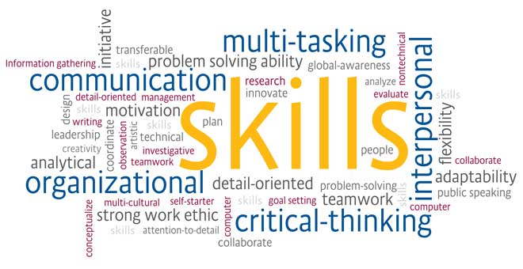

Contents

1. Introduction...............................................................Page 3
2. SWOT....................................................................Page 5-6
3. Skills to Develop.......................................................Page 7
4. My Personal Development Plan...............................Page 8
5. Conclusion..............................................................Page 10
6. References.............................................................Page 11

Introduction

Personal development plan is important for research to make your own call to future employers. Each individual has a different position to attack a top position In my desire to develop my academic and future engagement skills, I briefly analyzed the acquired acquisitions in which I would like to develop and perfect myself to enable me to advance my post as student and employee.Every budy should have a SWOT and to make a conclusion to can know his limit, minus and in wich sectors and direction to try to change in better.
Every person have gols, the important is to know wich of them to developm and wich to change in positive.
In the next pages i will talk about my:
- Strength
- Weakness
- Opportunities
- Threat

My skills are:

My Current Employability Skills:
- Team Work –working in a group
- Willingness to learn- learning new things
- Problem Solving – making decisions to help in the future and to find the right solutions and to solve the problem.
- Presentation Skills-have clear information that is presented in reports, business plan, or presentation
- Leadership Skills – Want to be able to have self-confidence.
- Enthusiasm- Want to be able to stay positive and motivated in a task or project becouse sometimes i lose the enthusiasm.

The important in the SWOT is:
SWOT analysis is tool often used in the radiography of the present situation of a person, companies, being used to understand the internal environment, but also the external environment in which they operate.
The SWOT analysis is show out in the early phase of the drafting of the project, in the stage of identification and crystallization of the project idea. It allows for a correct radiography of society.
SWOT analysis describes the scientific achievement and brings in the situation where more work is needed. A conceptualisation tool that allows you to think about critical analysis and strive to push the next steps, whether they focus a long-term goal, for example. The qualities and maladjustments are internal powers.
My own SWOT under this will to commit myself to doing on key areas for me.
My SWOT which includes the following:

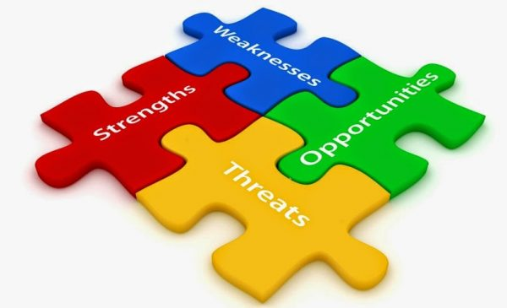

Strength  - Integrity  - Great Communication skills  - Goal orientated  - Responsible  - Problem solver  - Reliable  - Know-how-that I have | Weakness  - Very Limited experience  - Digital skills  - Writing  - Over think  - Too much attention to detail- Could affect time management, deadline
Opportunities  - Be my own bos  - New carcer direction  - More opportunities  - Grow in my own role  - Wider carcer prospects | Threat  • Ability technology change  • Hard competition  • Staying on top of assignments  • Possibility of not passing  • Staying on top of assignments

Skills to Develop
I understand that in order to acquire the qualities that recommend a very good student and a well-trained employee, you must always keep in mind the self-evaluation according to the standards regarding the competencies targeted by the company, by the current requirements.
For this, I will seek to improve my qualities, identify new opportunities for personal development, acquiring IT, specialty acquisitions that can enhance self-esteem and prestige.
Without the qualities targeted by the areas of interest, without the goals and objectives proposed, I understand that I will not have the desired success.
I will gradually take this step during the 2 years of my study, the period during which I will constantly analyze the scientific, cognitive, communication acquisitions and will continue to improve them in the medium and long term.

Personal Development plan
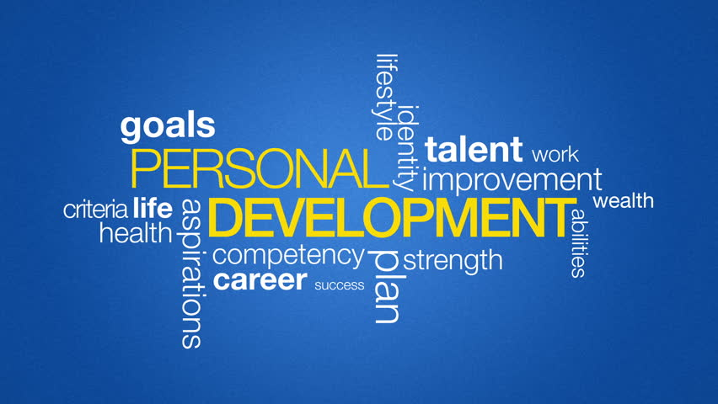

A professional development plan is widely used by both business people and students to set goals and to have a schedule of goals.
My personal development plan includes:
My IT skills-
My IT skills are to use the computer, to can write a letter, to make a plans for a team and to use the actuallity office packet, like Microsoft words, excel, power point.. I hope to improve and to learn more and to be up-to date curent with the new technoloqies
-Improving my knowledge
There are a few areas where I improve my consistency immediately, i want to learn to be more strong like person, to be more confident and to start to talk more without emotions, to be more social and not to be shame and close like person.

Being a procrastinator has caused me much anxiety as I am always on rush to get things done, as a result I found it necessary to make this an immediate goal which I will start working on. Over the next five years I hope to have a weekly diary of the upcoming events, which will be organized in terms of their priority. This will include things that happen in my school life as well as personal life, this will help me to stay on target and not procrastinate.
-Improving my presentation skills
Presentation skills are very important. I have put into place some strategies that I believe may work in order to attain this goal. Immediately practicing is highly important, I will try to practice my presentation in front of my friends and get them to give their honest feedback, when given presentations I will make use of that opportunity test my improvements as well and then ask my lecturer
-Reducing my distractions
Immediately plan to get a to do list, this will help me to have a clear view of what I need to get done and deadlines attached to this as well.

Conclusion
The values ​​set out in the hiring skills are skills and characteristics that, in principle, form a suitable person for a job. These are particularly important because they are the foundation for a job. Knowing and evaluating, acting and dynamizing can help anyone achieve their goal. Once I have identified my positive and negative aspects and set a realistic goal, I assume I am at the stage of awareness of my own values, which will allow me to find a job according to the developed skills during the years of study.

REFERENCES :

- 2011-2016, (. (2018). Personal Development & SkillsYouNeed. Skillsyouneed.com. Available at: https://www.skillsyouneed.com/ps/personal-development.html [Accessed 20 Feb. 2019].
- Bridgewater United Kingdom (2018). What is a Personal Development Plan and What Can it Meanwe develop. Available at: https://www.bridgewateruk.com/2016/09/personal-development-plan/ [Accessed 19 Nov. 2019].
- A, M., Hall, D. and Lawrence, B. (1989). Handbook of career theory. 7th ed. Cambridge, England,UK: Cambridge University Press.

