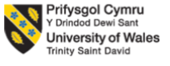

LEVEL 7 ASSESSMENT SPECIFICATION

Programme: Master of Business Administration

Module: Marketing Management
Module code: LCMB7024

Name of student: Iyappan Balakrishnan
Student ID: 2434791
Due Date: 19.11.2025
Table of Contents
Element 1 3
Community introduction and BrewDog Zero+ concept 3
Reason BrewDog Zero+ appeals to current market 3
Key market segment and selected target audiences 4
Differentiation strategy and desired positioning 5
Element 2 6
4Ps framework of BrewDog Zero+ 6
The 4Ps support and alignment with BrewDog’s brand strategy 8
Element 3 9
Element 4 10
Reflection on the brand development, marketing strategy and pitch delivery 10
References 12
Appendix: Poster 13

List of Figures
Figure 1: Logo of BrewDog Zero+ 3
Figure 2: Energy Drinks Market (2025 - 2030) 4
Figure 3: 4Ps Marketing Mix 7

Element 1

Community introduction and BrewDog Zero+ concept
BrewDog is known as the Scottish craft brewery, which has turned into the global drinks brand and famous for the bold product launches and a disruptive marketing voice. During the recent years, it has expanded into the alcohol-free lines and experience the spaces (including an alcohol-free BrewDog bar). The BrewDog Zero+ is created on the heritage, and its sugar-free, alcohol-free, energy-infused functional drink that are formulated with the natural caffeine, vitamin B12, guarana and green-tea extract for delivering craft-style flavor plus cognitive/physical lift (BrewDog, 2025). This is known as the “social energy” beverage that lets the consumers to participate in the nightlife and social occasions without having alcohol or sugar. The organisation has sold alcohol-free variants and run the alcohol-free promos while showing its capability for entering the adjacent no/low alcohol segment in the coming years (BrewDog, 2025).
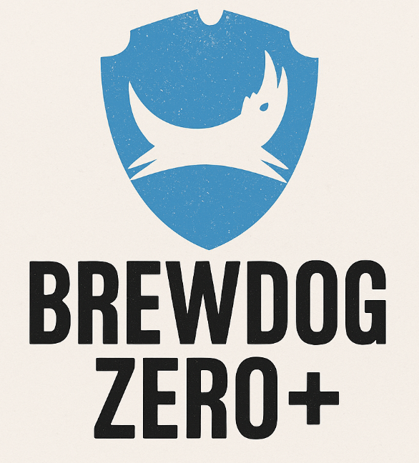
Figure 1: Logo of BrewDog Zero+
(Source: Self-made)

Reason BrewDog Zero+ appeals to current market
Mainstream growth of the no/low alcohol drinks
The No/low category is noted a rapid expansion in the UK, whereas the IWSR reports reflected a year after year increase and forecasts the continued volume growth as moderation has become a mainstream element. The UK is known as a standout market for the reformulations and launched the low-ABV beers following by the recent duty and policy shifts (The IWSR, 2024).
Rise of the functional and energy drinks
The global energy and functional beverages segment are large and rising, which address a strong demand for the products that can deliver a measurable effect (focus, alertness) along with a direct fit for the caffeinated, B12-fortified product (Grand View Research, 2025).
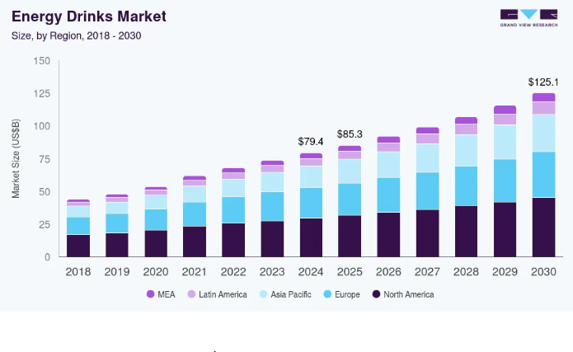
Figure 2: Energy Drinks Market (2025 - 2030)
(Source: Grand View Research, 2025)
Health and moderation behaviours among younger cohorts
The consumers, specifically, the millennials and Gen Z are practicing moderations, for example Dry January, targeted abstinence, but still want to have higher sociability and flavours. The retailers and pubs reported to have a rising off-alcohol demands across the year. Packaging and labelling of the products as sugar free and with natural ingredients will definitely drive needs of both health-conscious customers and functional performance motivations (BrewDog, 2025).

Key market segment and selected target audiences
Relevant segments
- Health-moderators: The adults, who are aged between 25-44 years, refer reducing the alcohol/sugar intake for ensuring fitness, health and family reasons.
- Fitness and performance consumers: The gym goers, and late-evening exercisers are seeking for the caffeine+ low calorie options (BrewDog, 2025).
- Social moderators / Sober curious: The younger adults (aged between 21-35) are attracted, who still attend bars and events, but prefer to have the alcohol-free options.
- Night-shift and study professionals: Students and workers are considered, who want to have alertness without alcohol’s after-effects (BrewDog, 2025).
Selected primary target audiences
The urban and young professionals aged between 25-35 years, are targeted, who lives in the cities followed by a busy schedule. They also enjoy spending time with the friends, go to the bars and stay active lifestyles, but also care about their health. They mostly want the energy without consuming alcohol and sugar as they willing to pay more Money for purchasing better and premium products. These group of people also follow fitness and lifestyle influencers via the online platforms and select the trendy and new drinks, which will be helpful for BrewDog’s new product range.

Differentiation strategy and desired positioning
Differentiation
BrewDog Zero+ focuses on the craft tastes first, and positions the energy benefits at the second spot. Unlike different energy drinks that tastes artificial and too sweet, the Zero+ is based on the BrewDog’s craft flavor style by using a real brewing knowledge and alcohol-free recipes so that the typical “chemical” tastes can be avoided. The drink also uses the clean and simple ingredients, including the natural caffeine, vitamin B12, guarana, and green tea extract (BrewDog, 2025). It includes no sugar that makes it healthier choice in comparison with the mainstream energy drinks that uses synthetic ingredients. BrewDog Zero+ is not positioned itself as the gym supplement, but also as a social drink for real-life moments. It is designed for the occasions, such as post-work meetups, concerts, late-night sessions and hanging out with the friends, where people want to stay alert without drinking the alcohol (Burke, 2025).
Positioning statement: “For the urban professionals, who want to craft the tastes and mental lift without feeling the hangover, BrewDog Zero+ offers an alcohol and sugar free energy-infused craft drink for keeping the nights social and mornings sharper” (BrewDog, 2025)
It can be found that BrewDog’s current AF range provides higher credibility and distribution of the leverages such as; on-trade and retaining options. The market data addresses both no/low and energy/functional markets are rising, where the hybrid play taps into the expansion of categories besides competing hand-on with legacy giants and AF brewers.

Element 2

4Ps framework of BrewDog Zero+
Product
The BrewDog Zero+ is noted as the alcohol free, sugar free and energy-infused craft drink. The product includes natural caffeine, Vitamin B12, guarana, and green tea extract, for delivering the energy without having any artificial stimulants. Unlike the standard energy drinks, this prioritises the flavors of the craft beers, while reducing the chemical aftertaste that commonly criticised in the category of energy drinks. This also supports the increasing demand for the clean-labelled beverage, which market report has repeatedly showcases the preferred options by the young consumers to check the ingredients transparency before making the purchase. This specifically focused on the functional drinks by pushing the brands to adopt shorter list of ingredients. The BrewDog Zero+ taps into the no/low alcohol trend, which has been seen as the fastest rising beverage sections of the UK. The industry insights have addressed that UK leads the Europe in low/no alcohol consumptions growths and driven by the millennials and Gen Zs’ who are reducing alcohol consumptions due to the health concerns.
Price
The Zero + will use the premium pricing strategy, which has estimated the price similar to the craft energy drinks and premium alcohol-free beers (for example, £2.10–£2.70 per can in retail, £5.00–£6.50 in bars). This aligns with the willingness of consumers for paying more for the functional wellness drink options. The market insights addressed that buyers pays higher prices when being perceived as the healthy and lifestyle-driven options. The energy drink market reports have estimated that global energy beverages sector has surpassed around $80+ billion while proving consumers to make regular purchase on the high-priced drinks for benefits besides mitigating thirsts. The promotions such as bundle pricing (Buy 4, Save 10%) and subscription discounts on online BrewDog store will be taken into consideration for increasing the repeat purchasing behaviors.
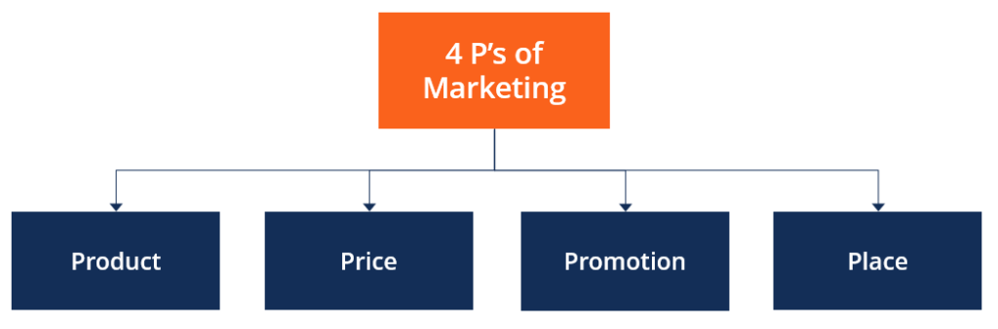
Figure 3: 4Ps Marketing Mix
(Source: CFI, 2022)
Place
The product will be distributed through the 3 main channels: such as; retail stores, on-trade locations and online channels. The retail stores will include supermarkets, like Tesco, Sainsbury’s, Morrisons and convenience chains namely; Tesco Express and Co-op, where the alcohol-free sales have already continued to rise year-around. Regarding the on-trade locations, locations like the BrewDog bars, pubs, gyms, music venues, and event spaces will be noted where the social drinking alternatives are required. Finally, for the online channel, the BrewDog website, Amazon, and subscription drink platforms will be used. The e-commerce food and beverage purchasing will continue to rise in the UK specifically among the 25-35 urban consumers.
Promotions
The promotion of the products will include mix of digital, social and experimental marketing options:
- Influencer partnerships with UK fitness, wellness and nightlife creators
- “Try Zero+ Night” events at BrewDog bars
- Limited edition seasonal flavours dropped online to create urgency
- TikTok and Instagram campaigns built around the message: “Energy without losing the night”
The user-generated content is necessary in this case as it can show the younger buyers to develop a sense of trust and real-user experiences more than the advertisements. The BrewDog will push the customer video reviews, bar-scene content and lifestyle reels over the traditional advertisement for maintaining the authenticity.

The 4Ps support and alignment with BrewDog’s brand strategy
BrewDog Zero+ is created on the similar foundation as BrewDog’s core identity, including bold, rebellious, social, and consumer-led. In this case, each of the elements of 4Ps directly reinforced these brand values, while expanding into the functional wellness.
Product alignment
BrewDog creates a global growth on the flavor innovation, community culture and doing an opposite of the traditional drink brands. The Zero+ honours the identity by rejecting typical structure of the energy drinks. Instead of competing on the extreme caffeine levels, this competes on the authenticity of tastes, cleaner ingredients, and social usability. This protects the credibility of the brand as BrewDog consumers expects to offer some bold flavours without any artificial formulations. The product is going to expand BrewDog’s opportunity into the functional wellbeing space without abandoning the social drinking culture that defines the brand value. This enables the new drinking occasions; “energy for nightlife, without alcohol,” that most of competitors fails to address. The common emery drinks dominate the convenience shelves, while some of the alcohol-free items can dominate the bars and few brands merges with both options. Zero+ fills the gap and also strengthens the relevance of the brand across more hours of the day.
Price alignment
BrewDog has never positioned itself as a low-cost brand, where the budget pricing might damage the credibility. The premium price communicates the higher quality of ingredients, including; lifestyle status, and functional benefit, while keeping it aligned with the existing products of BrewDog. The premium pricing has further justified by different category norms, where the functional drinks and craft beverages continued to become price-sensitive segments. This refers that consumers do not prioritise low price when they believe a product delivers health and social value to the higher number of audiences. The BrewDog benefits from the strong brand loyalty which might reduce the sensitivity of the price. By adding the bundle discounts and subscription offers, BrewDog has made a balance between the premiums positioning with higher affordability without diluting the perception of the value.
Promotion alignment
BrewDog has created its reputation by rejecting the traditional advertising in favour of the bold community-driven storytelling. In this case, the Zero+ promotions follow same rule, including; authentic, bold, social, digital-first, and influencer-led. Besides sponsoring the stadiums, including traditional energy brands, BrewDog will use the following options:
- Bar events
- Social challenges
- Influencer nightlife and fitness content
- Real customer stories
This keeps the marking process highly reliable, as it matches the way how 25-35 city consumers can discover the products in the current scenario. The use of the social media tools like; TikTok reels, Instagram can be used for gaining the trust of people. The slogan ideas, including event-based activation and the lifestyle social campaigns might assist in reinforcing the core message, “You don’t need alcohol to own the night”.

Element 3
Poster: Refer to the Appendix
Explanation of the poster
The BrewDog Zero+ poster is designed for capturing attention and communicating the brand’s innovation, through a new segment that offers an energized drink without alcohol. The offering holds a sleep, modern design with contrasting elements of the vibrant energy tones, such as neon blue and electric yellow, against the BrewDog’s iconic branding, which symbolises tegu fusion of both craft culture and active living. In this case, the tagline; “Stay Sharp. Stay Social. Stay BrewDog” anchors the message, while emphasising on all clarity, connection and confidence, are defining the target audience and promoting a certain lifestyle.
The poster addressed rising consumer issues, especially for the young professionals and health-conscious people, who wants to take participation in the social drinking experiences, but also prefers avoiding the alcohol negative effects. At the same time, they seek for functional beverage options, which can enhance both focus and performance (BrewDog, 2025). BrewDog Zero+ solves the issue by offering no-alcohol beer which is infused with the natural caffeine, Vitamin B₁₂, guarana, and green tea extract that provides consumers with a refreshing and revitalising experience (Dry Drinker, 2025). The poster also addressed simple product benefits, including high-impact icons, such as; “0% Alcohol,” “100% Energy,” and “All-Natural Boost.” In this case, the call-to-action, which is “The energy to enjoy. The freedom to stay in control” has reinforced the emotional appeal and positioned BrewDog Zero+ as more than just a drink option. By combining the familiar social aspect of the craft beer with the emerging trend of wellness and functionality, the business idea presents BrewDog Zero+ as a category-defining innovation.

Element 4

Reflection on the brand development, marketing strategy and pitch delivery
Development of the BrewDog Zero+ and building the full market strategy has been highly challenging and exciting for me. At the initial stage, I have realized that creation of the new brand is not only about the invention of a product but also understanding the demand of people, trends, competition and real behaviors. My first learning has been how important the research is and I need to study the trends of the market including, rise of low-alcohol drinks, growth of the energy beverages and consumer lifestyle changes. This has assisted me to make the decisions based on the data, not just making any assumptions. I have learnt that strong concepts always arrive from solving the real consumers’ issues. In my case, the issues have been young adults who expected social experiences, without consuming alcohol, but still expects the tastes, energy and connections.
While developing the brand, I have improved my creative thinking and strategic planning skills. I have learned the way to match the product idea with the personality of the brand. BrewDog has a rebellious, and bold voice so that I need to make sure that Zero+ sounded like the natural extension of the organisation. This has taught me that alignment of the brand is highly necessary as the product itself. Creating the marketing strategy has been a major learning experience, while using the 4Ps framework has assisted me to think in a structured way, and I have learnt the way each decision (product features, pricing, placement, and promotion) need to connect. For example; pricing could not be too low as it might cause damage to BrewDog’s premium image. The promotion needs to hold a bold and social, where the placement needs to match with real consumer behaviors, which refers that supermarkets, bars and online channels.
Such process has improved my ability to connect the marketing theory with the real marketing conditions. Preparing and delivering the pitch has assisted me to develop the communication and confidence, as I need to simplify the complex ideas into a clear, and persuasive points. I have learnt the fact that presenting is not just about exchanging the information, besides it is more focused on the storytelling. As I have explained Zero+ as; “energy for the night without losing your morning” I have noted the idea to become easier to connect. This has taught me that the emotional appeal matters as much as product facts.
There are certain challenges as sometime I focus too much on the data and not enough on the storytelling during early drafts. I also realised that I can improve my time management skill, as refining ideas, researching the numbers and rehearsing has taken more time than expected. These challenges have taught me with the importance of planning, revision and prioritization of the professional projects. For the future improvements, I would start customer research by gathering the real feedback through interviews and surveys. I would also practice the perching more with using mock presentations for the improvement of the fluency and reduce the hesitations.

References
BrewDog (2025). Alcohol Free. Available at: https://brewdog.com/collections/alcohol-free (Accessed on 4th Nov 2025)
Burke, P. (2025). No- and low-alcohol drinks gain popularity across 10 countries, including US: study. Nypost. Available at: https://nypost.com/2025/01/14/lifestyle/no-and-low-alcohol-drinks-gain-popularity-among-millennials-study/ (Accessed on 4th Nov 2025)
CFI (2022). 4 P’s of Marketing. [online] Corporate Finance Institute. Available at: https://corporatefinanceinstitute.com/resources/management/4-ps-of-marketing/ (Accessed 6th Nov 2025).
Dry Drinker (2025). BrewDog Alcohol Free Beers. Available at: https://drydrinker.com/collections/brewdog?srsltid=AfmBOoo_AdtDme5tRD5QTEo_41lkf7pzSr-641GT8Wu-zH6kxm3ML-4Y (Accessed on 30th Oct 2025)
Grand View Research (2025). Energy Drinks Market (2025 - 2030). Available at: https://www.grandviewresearch.com/industry-analysis/energy-drinks-market (Accessed on 4th Nov 2025)
The IWSR (2024). The UK No-Alcohol Market: Key Statistics and Trends. Available at: https://www.theiwsr.com/insight/the-uk-no-alcohol-market-key-statistics-and-trends/ (Accessed on 4th Nov 2025)

Appendix: Poster


