Narrative & World-Building
Creating storytelling elements for existing universes fallout - fictional product creation
Rebecca Jones (2305750)

Contents

Product 1
Advertising 2
CEO/Brand Backstory 5
Locations 6
Storytelling Elements 7

Product

Product description
“Mrs. Sugar-Kruhm’s Cake Mix” is a home convenience food item aimed at families and housewives who need a quick and effortless way to bake a cake.

“They just can’t get enough!”

Advertised as an emergency cake solution for children’s birthdays and other gatherings. The company encourages people to keep one just in case a cake is suddenly needed.

This product is highly popular with children, as they will ask for the cake on a regular basis. This is not seen as something unusual, merely as children wanting sweets.

In reality, the powdered cake mix is secretly laced with a highly addictive substance designed to get customers ‘hooked’ on the product. As the product is sold as a ‘housewives secret’, this means that family members will request the cake again believing it to be hers, forcing repeat purchases in order to keep the secret.

Post-war, the product’s addictive nature is a widely known fact and is traded as a chem rather than a food item, corrupted from its original purpose. The powdered version of the cake mix is a much stronger substance as there are less ingredients to dilute the effects.

The player would be able to find, buy and consume this product in the world. As the product was designed to be an addictive substance, the addiction status will occur sooner, after less repeated uses than other chems. Those who consume the product will experience visual hallucinations and due to the high sugar content, will also increase the player’s walk speed. Visual hallucinations will be represented in-game as human characters being visually replaced with enemies, as well as blurring and waving the player’s screen dramatically.

Raiders desperate for more supply eventually learn to create their own, much worse version of the powder which in addition to the above effects, will also contain more radiation and take a HP penalty.

As the ‘pure version’ of the product has been rapidly sought after and consumed over the years, it is considered a rare item. Most boxes of cake mix will be the raider imitation, but the occasional ‘pure’ box can still be found in specific locations.

Advertising

Pre-war poster
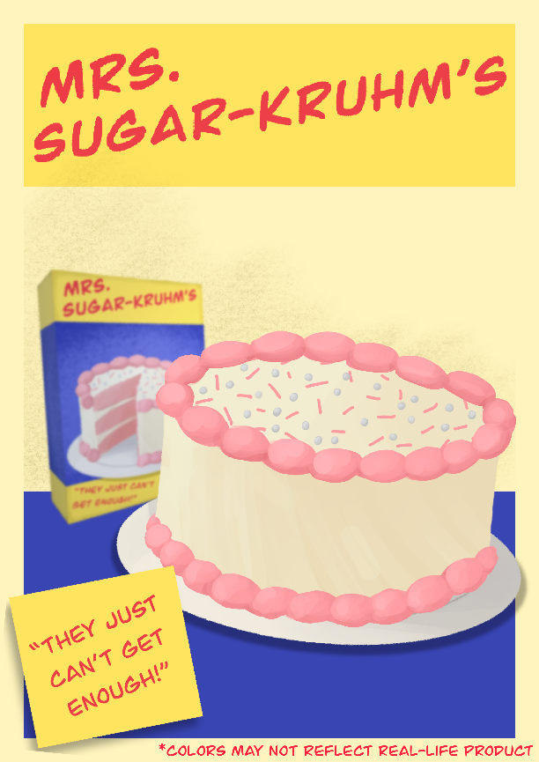

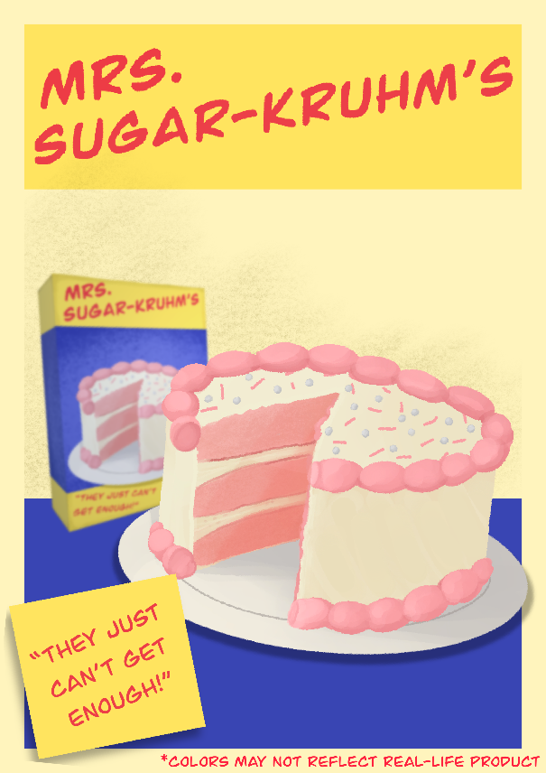

Own posters advertising the cake mix.

“They just can’t get enough” slogan, hinting at the product’s true nature as an addictive substance.

Note at the bottom right hinting to increased saturation in photography to sell more product, with American spelling used intentionally due to the story’s location.

Pre-War packaging
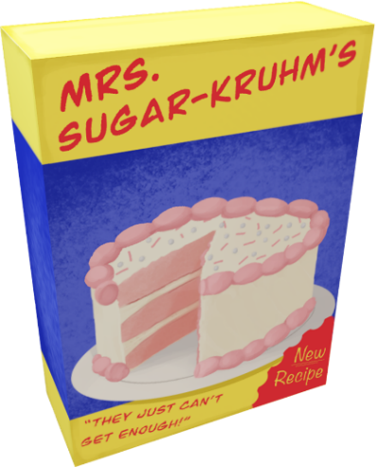

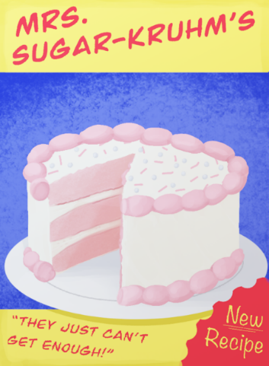

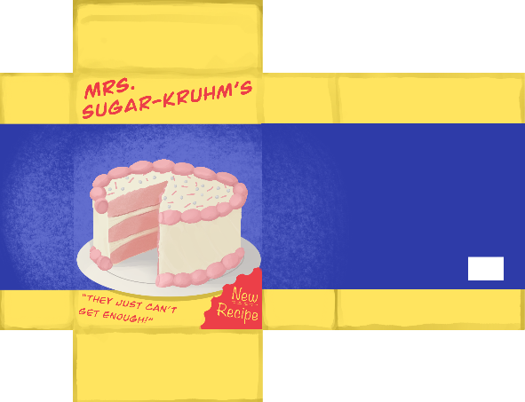

Images of a 3d model textured in procreate for “Mrs. Sugar-Kruhm’s Cake Mix”, inspired by existing 1950’s cake mix advertising and packaging.

“They just can’t get enough” slogan, hinting at the product’s true nature as an addictive substance.

“New recipe” sticker, hinting at the additional new “ingredient” and change of recipe ownership.

Cakes
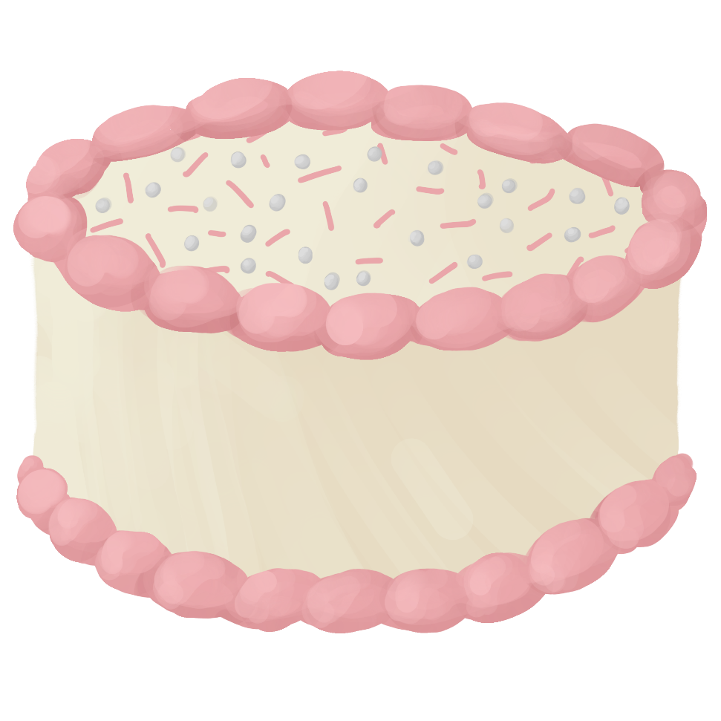
- Own drawings of the cake mix once it is made.

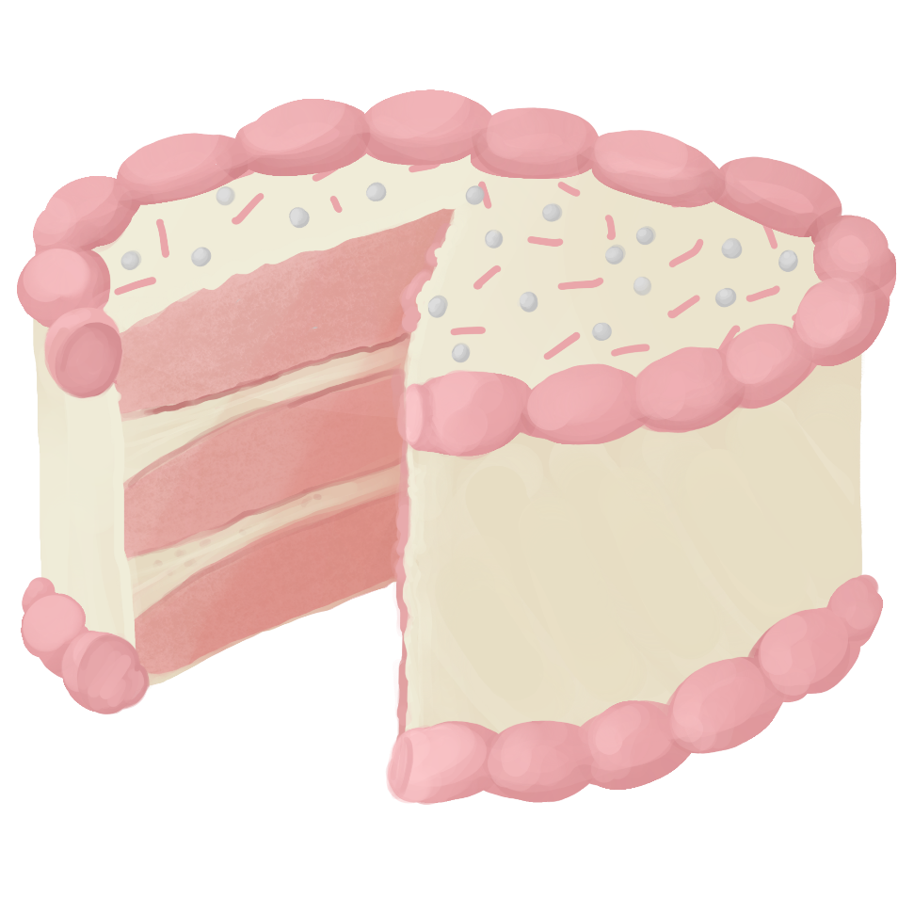

CEO/Brand Backstory
Backstory
Miss Kruhm is the last remaining family member in the Kruhm family business, a well-known company of cake makers. While Mr. Sugar is in the business of convenience food items, currently supplying the army and through his marriage to Miss Kruhm, is hoping to break into the domestic market.

After their marriage, Miss Kruhm had decided to hyphenate both surnames together in order to keep a part of her family’s legacy and thus became Mrs. Sugar-Kruhm.

Together with their combined experience in both baked goods and dried foods, as well as her family’s secret cake recipes, they released their first collaboration product between the two companies, “Mrs. Sugar-Kruhm’s Cake Mix”.

Initially, the cake mix is a tremendous commercial success, as the publicity from the famous families combining to make a product gives it momentum. Unfortunately, sales begin to decline due to the inferior quality and taste caused by the dry ingredients from the Sugar family.

Sugar begins looking into ways to improve customer reception without fixing the actual problem, first trying to increase the amount of sugar to hide the taste, with only minor results. Eventually thinks of the idea to contaminate the mixture with an addictive substance so that customers would begin to crave it, beginning test trials underneath the factory.

These tests were conducted in order to determine how much of this substance could be consumed without obvious repercussions, such as hallucinations. Or death. The product was found to have withdrawal symptoms, but this was not seen as an issue as that would require the customer to stop buying the product.

Sugar tells Kruhm his plan and she disapproves, not wishing to tarnish her family’s legacy further, she stops production entirely, taking her family recipes with her.

The next week, Mrs. Sugar-Kruhm had passed away under mysterious circumstances, though no official case was opened. All recipe ownership passes to Mr. Sugar.

Another week passes and cake mix boxes appear with altered packaging,
“New Recipe”.

A brief legal battle between “Sugar bombs” cereal and “Sugar-Kruhm’s” cake mix also occurred but was dropped due to a lack of evidence.

Locations

Map location
The “Sugar-Kruhm factory” is a pre-war landmark which can be visited by players.

Once a state-of-the-art cake making facility, now home to sprinting, hallucinating raiders high on their own supply.

In trying to obtain more of the mix, raiders broke into and now inhabit the factory in order to make more. Due to a lack of essential ingredients, the resulting imitation is far worse than the original. This version, on top of the original effects, gives a larger amount of radiation and damages HP.

Some experimental versions of the cake mix combined with other chems exist, mixing different effects together. These are only found inside the Sugar-Kruhm factory building, however.

When selling the reproduction chem on, the original packaging is repurposed with only one major difference, black marker writing on the front, “The Good Stuff”. This would be the name of the imitation product when you buy it from traders, find it around the map or when it is in the inventory.

Product locations
Pre-war, not counting the factory, this product would be found in home kitchens as a domestic product. Would also be available in supermarkets for purchase.

Post-war, this product is found very rarely in the wasteland due to over-consumption from those addicted. Could be found inside shops, sold rarely by traders, found in the Sugar-Kruhm factory or looted from the Sugar-Kruhm Raiders. The raider imitation product is much more common than its counterpart.

Advertising for this product could be found in downtown areas, as well as billboards along roadsides.

Storytelling Elements

Environmental
- Posters for the product are mostly ripped up, especially in areas where the product is actually shown. This is due to raiders suffering from the hallucinations craving more of the substance and trying to eat the poster itself. Graffiti and bullet holes also feature.

- Raiders can be seen sprinting around and fighting each other in the area around the factory building. Looting their bodies reveals that each of them hold “The Good Stuff” item.

- In the factory or a supermarket, a group of skeletons can be seen on the ground fighting for a single box of the cake mix. Implying that while the bombs were dropping, this was the last thing they did.

- Consuming the regular cake mix product gives the player additional effects and a chance of an addiction. This tells the player that this is not an ordinary food item.

- Traders will sell this item as a drug, rather than as a food item.

- Terminal entries can be found inside the factory building regarding a number of hallucinating employees after a spillage of the mixture polluted the air. Another terminal can be found further inside the building in an office with messages about how they are going to cover this up.
Quest opportunities
Players would hear about the existence of a pre-war factory becoming active again and will get a quest to investigate the area. Players could hear about this through random NPC chatter, on the radio or by encountering the factory and the raiders on their own.

- Investigate the Sugar-Kruhm factory.
- Find the origin of “The Good Stuff”.
- Defeat the Sugar-Kruhm Raiders.

Players can then use the factory as a base and would be able to use the machines to make their own “Good Stuff” mixes with other chems.

Side-quest in which someone inside a settlement wants to try the cake they have seen on posters, not realising that it is an addictive substance. Players would get this by interacting with the character.

- Find a box of cake mix for ____

Depending on whether you give this person “Mrs. Sugar-Kruhm’s Cake Mix” or “The Good Stuff”, the outcome will be different.

If you give them “The Good Stuff”, the next time you visit the settlement a different NPC will stand there and explain that the first character is in the hospital after eating the cake, asking if you know where they got it – the player can either feign innocence or own up to their mistake. The player can also visit them in the medical area of that settlement, but they will remain bedridden.

If you give them “Mrs. Sugar-Kruhm’s Cake Mix”, the next time you visit the NPC will great you again but ask if you have any more of the cake mix. Anytime the player visits this character now, they will offer a large number of caps in exchange for a box of the cake mix due to its rarity.

After every box of “Mrs. Sugar-Kruhm’s Cake Mix” has either been consumed by the player or sold, the NPC will follow “The Good Stuff” route but instead goes for treatment of the withdrawal symptoms rather than poisoning.

Giving the NPC a box of “The Good Stuff” after starting the other route will earn you caps, but you will not be able to trade real boxes with them anymore.

