Dummy Report– Individual presentation of a written business plan with individual reflection
Monday, 31 March 2025

MODULE NAME: Managing Enterprise (BMSW4011_SWAN)
Name: sALMA SHNNIB
Student Number: 2332494

EXECUTIVE SUMMARY

Roza Goldsmith Custom Jewellery is a bespoke jewellery business that specialises in an affordability, customization and ethical sourcing from midrange to high price point. As the jewellery industry has seen rising demand from personalized, high quality products at the height of purchase seasons, such as holidays and anniversaries, these empowered consumers have also equipped themselves with the information and analytics to determine when to purchase, what to buy, and how to purchase to get the most out of their budgets. To achieve this, the company’s mission is to sell premium, personalized jewellery at competitive prices while making sustainable sourcing options available. Roza Goldsmith operates from London, UK with an online first model, selling handcrafted rings, necklaces, bracelets and earrings that will allow the customer to personalize gemstones, engravings and metal choices. Price, quality and design are the key purchases for market research and ethical jewellery is a growing but niche interest. The business will position itself in order to be in line with consumer preferences such as affordability, seasonal promotions and transparency. The financial plan is to invest £50,000 from personal savings, a small business loan and crowdfunding. Projected annual expense of £76,000 and structured growth plan, this business will be profitable with the proper growth strategy. One chiefly risk mitigation strategies comprise good digital marketing, supplier relationship on cost stability and collaboration with influencers for brand awareness.

Table of Contents
EXECUTIVE SUMMARY 2
Introduction 4
Business Location and Physical Resources 4
Human Resources 4
Organizational Chart 5
Market Research 5
SWOT Analysis 6
Marketing Strategy 6
Marketing Materials 7
Financial Resources 7
Initial Setup Costs 7
Ongoing Costs 8
12-Month Cash Flow Forecast 8
Funding Sources 9
Risk Analysis 10
Implementation of the Strategy 10
Advantages and Disadvantages of the Strategy 11
Conclusion & Recommendation 11
Task Two Reflective Review 12
INDIVIDUAL REFLECTION 12
New Business Skills and Knowledge 12
My Entrepreneurial Strengths 12
Improvement Area and Plan 13
REFERENCES 14

BUSINESS PLAN- Roza Goldsmith Custom Jewellery

Introduction
Roza Goldsmith Custom Jewellery offers bespoke, customised rings, necklaces, bracelets, and earrings in gemstones, engravings, and metal options. It is a sole proprietorship but as such can be more flexible and easily in contact with its customers, and may later be transitioned to an LLC. Our goal is to deliver best quality, customized jewellery at reasonable price while still having options for sustainable sourcing. Affordable customization, premium craftsmanship and ethical sourcing are reasons that stand out making the brand distinct and appealing to diverse audience (Williams, 2022).

Business Location and Physical Resources
Based in London, UK, the business will follow an online first approach to cut costs. Production of and consultations for will be done in a small workshop. Access to supplier networks was the reason behind the selection of London as domicile, with the city having a strong custom jewellery market. Metalworking tools, engraving machines, gemstone, packaging and IT infrastructure are some of its key resources. A fully optimized e-commerce site will also enable seamless customisation of jewellery (Fioravanti, 2021).

Human Resources
Job Role | Responsibilities | Sourcing Strategy
Owner (CEO) | Management, finance, clients | Founder
Jewellery Designers (2) | Custom pieces, design | Industry experts
Marketing Specialist (1) | Social media, branding | Freelancer/in-house
Customer Support (1) | Customer service, orders | Local/remote hire
Production Assistant (1) | Jewellery making, packaging | Trained artisan

Organizational Chart
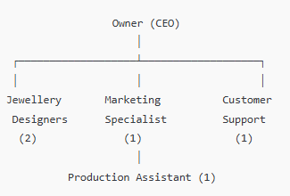

Market Research
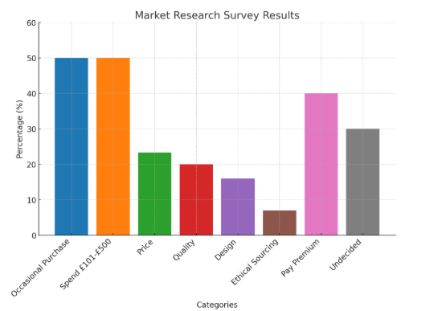
A consumer survey was conducted to find out jewellery purchasing behaviour. The findings suggested that 50 percent of people who buy jewellery do so occasionally and that of those who are willing to spend between £101 - £500. Price (23.3%), quality (20%), design (16%) and ethical sourcing (7%) are the most important purchase factors, and only 7% of consumers take into account ethical sourcing. In addition, 40% are willing to pay a premium for ethical jewellery, 30% remain undecided (Munde and Kaur, 2024). To suit consumer preference, the business strategy will concentrate on affordability, customization, and quality (Jamal, 2023). Key focus areas to improve customer engagement, and one that also drives sales will be on price transparency, seasonal promotions, and having personalization on board (Shi, Zhang and Chen, 2023; Moreno Castillo, 2023)).

SWOT Analysis
Strengths: The business is appealing to variety of customer base as they are offering customization, affordability as well as ethical options (Lejealle, Ruaud and Delecolle, 2025).
Weaknesses: A lack of brand awareness may limit the ability to acquire customers and compete in the market (Filipe, 2021).
Opportunities: Another value that the business is able to attract is a niche customer through the rise in demand for personalized jewellery.
Threats: Because of strong competition from established brands, differentiation and marketing become necessary (Keller-Aviram, 2021).

Marketing Strategy
Social media, SEO and seasonal promotions will be part of the marketing strategy to bring to the minds of people the brand and increase sales. Customization will be featured in Instagram, Facebook ads, as well as collaborations with social media influencers will widen the audience. All the keywords will be optimized for website such as “affordable custom jewellery” to get the website more visible. For events such as Valentine’s Day, Christmas and weddings, customers will be lured by seasonal promotions based on discounts and limited edition collections (KYI, 2024).

Marketing Materials
The message for Roza Goldsmith Custom Jewellery will be “affordable, elegant and personalized pieces handcrafted just for you” focusing on both customization and sustainability.

Financial Resources
It will take both an initial set up costs and on-going expenses for the business. This is the financial breakdown:

Initial Setup Costs
Expense | Cost (£)
Studio Rental | 8,000
Equipment & Materials | 15,000
Website Development & Marketing | 5,000
Total Initial Investment | 28,000
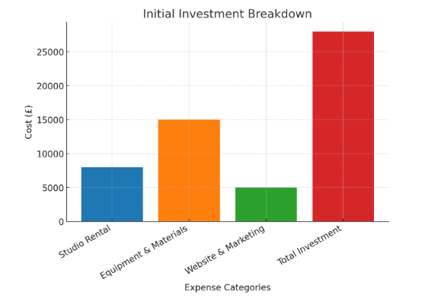

Ongoing Costs
Expense | Annual Cost (£)
Staff Salaries | 40,000
Marketing | 6,000
Material Sourcing | 30,000
Total Annual Expenses | 76,000

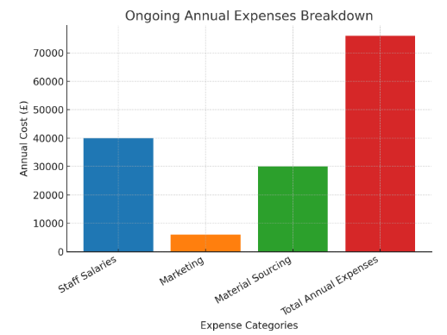

12-Month Cash Flow Forecast
Month | Income (£) | Expenses (£) | Profit (£)
Jan | 5,000 | 2,000 | 3,000
Feb | 6,000 | 2,500 | 3,500
Mar | 7,000 | 2,200 | 4,800
Apr | 5,500 | 2,800 | 2,700
May | 8,000 | 3,000 | 5,000
Jun | 7,500 | 2,700 | 4,800
Jul | 6,500 | 2,500 | 4,000
Aug | 7,200 | 2,900 | 4,300
Sep | 8,500 | 3,200 | 5,300
Oct | 9,000 | 3,500 | 5,500
Nov | 10,000 | 4,000 | 6,000
Dec | 12,000 | 4,500 | 7,500
Total | 92,200 | 35,800 | 56,400

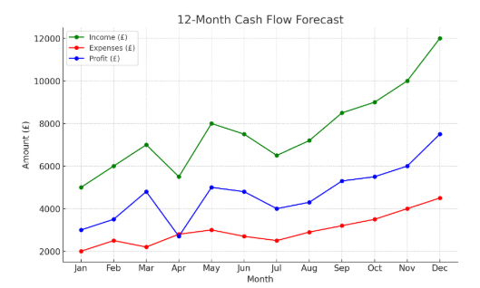

Funding Sources
There will be £50,000 investment (total) in the business (including personal savings (£10,000), small business loan (£30,000) and crowdfunding (£10,000).
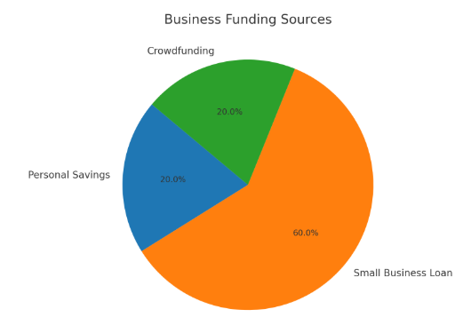

Risk Analysis
Competition from established brands presents the key risks to the business, as well as the risk of an economic downturn, fluctuation in material costs and slow brand recognition. To overcome these challenges, the business will offer personalized offerings and strong storytelling. There will be flexible pricing and financing options for a larger customer base (Ostashova, 2024). To keep price stability down, we will secure supplier contracts to decrease the effect of material cost fluctuations. Additionally, there is a great digital marketing including influencer collaborations, which will be used to increase awareness of the brand and of quick recognition in the market (Attori, 2023).

Implementation of the Strategy
The strategy is broken down into three phases for implementation. In the first three months, the focus will be on the business registration, website development and also on digital marketing (Filipe, 2021). Months four to six time will focus on customer engagement, social media growth and seasonal promotions. Consumer and social tracking will allow the company to analyse sales data for optimization (Etonde, 2024).

Advantages and Disadvantages of the Strategy
Affordability, customization and an online first model that keeps costs low and reach high are the main key advantages (Schulte and Paris, 2022). Seasonal promotions will keep the revenue steady. While the strategy has its disadvantages as well; such as being over dependent on digital marketing that needs consistent investment and engagement. Creating brand credibility amidst a competitive market will be challenging and only ethical jewellery can result in attracting a niche audience rather than the broader target group (Tenuta et al., 2024).

Conclusion & Recommendation
Roza Goldsmith Custom Jewellery takes advantage of the personalized and ethical jewellery market trends. Affordability, customization and ethical flexibility will be the company’s focus to attract a wide customer base. It remains to be seen that long term success comes with strong digital marketing, customer engagement and operational efficiency. On the other hand, it is expressly suggested that pricing strategies are reevaluated once every six months and that additional educational content related to ethical sourcing is introduced to attract undecided consumers.

Task Two Reflective Review

INDIVIDUAL REFLECTION
The experience of creating a business plan for Roza Goldsmith Custom Jewelry has been a great learning curve. It has helped me to hone and develop important business skills and understand better how one grows an enterprise. I learned to analyze market trends, plan finances as well as making a marketing strategy. I also discovered the areas where I need to develop.

New Business Skills and Knowledge
Financial planning is one of the most important skills that I learned. In line with the goal of starting a business, I made a cash flow forecast, discovered funding options and learned how to manage costs, thereby gaining knowledge of financial constraints in starting a business. I learned to balance expenses so that the business remains profitable. I was also acquainted with market research and competition. Through practicing surveying I understood what customers want that; affordable prices, customization, and sourcing ethics. It helped me to analyze competitors which is what I used to create a better business strategy. It helped me be more strategic about risks and opportunities as I did the SWOT analysis. My second skill is marketing. I did a bit of social media marketing, SEO, and I had a bit of working with influencers. This gave me to understand that such strategies will help their brands to gain awareness and attract customers. I also learned that the promotions and pricing decide how the customers make up their mind, hit or miss with different seasons.

My Entrepreneurial Strengths
Strategic thinking and adaptability are one of the best strengths I have. During the making of the business plan, I was able to anticipate challenges and work out solutions. I knew the risk of changing material cost and suggested supplier contracts such that the prices would remain stable. Another strength is creative problem-solving. For Roza Goldsmith, I built out some strong unique selling point (USP) ideas of affordability, customization, and ethical sourcing. It helped me to stand out in the market where competition is at its peak. In branding and marketing, I had also utilised the use of storytelling and personalization to get customers. I have been sure and determined, and I have demonstrated resilience. Business plan takes time, research, effort and pains. What I stayed committed to is making sure my business idea is good and very structured.

Improvement Area and Plan
My weakest area is risk management and decision making under uncertainty. After the risk analysis I found that business owners usually need to make difficult choices with incomplete information. Economic changes as well as new trend can have an impact to a business in the jewelry industry. To improve, I am going to study online courses in risk management as well as business analytics so that I can improve my ability to make better data driven decisions. I also wish to contact experienced entrepreneurs who have been in the same boat as me, who have been through similar business troubles. I can learn from them and the more confident I feel in making important key decisions even when uncertain.

REFERENCES

ATTORI, I., 2023. Jewelry design in sustainability: a co-creation approach.
Etonde, A., 2024. Setting up an online jewellery business.
Filipe, M.S., 2021. Fostering the Jewellery Sector Through the Lens of the Portuguese Assay Office with a Shared Value Approach: Exploring the Trends of the Jewellery Industry in the Portuguese Market and Analysing the Sector-s Value Chain (Master's thesis, Universidade NOVA de Lisboa (Portugal)).
Fioravanti, R., 2021. Additive Manufacturing technology in the goldsmith industry. Economic benefits, sustainability issues and diffusion in the Arezzo district (Doctoral dissertation, Politecnico di Torino).
Jamal, A.N., 2023. Business plan for a clothing and artificial jewellery business in Central Ostrobothnia, Finland.
Keller-Aviram, D., 2021. Traceability, sustainability, and circularity as mechanism in the luxury jewelry industry creating emotional added value. Sustainable Luxury and Jewelry, pp.87-115.
Keller-Aviram, D., 2021. Traceability, sustainability, and circularity as mechanism in the luxury jewelry industry creating emotional added value. Sustainable Luxury and Jewelry, pp.87-115.
KYI, H.H.M., 2024. THE LUCRATIVE BUSINESS OF JEWELRY INVESTMENT IN SOUTHEAST ASIA (Doctoral dissertation, SIAM UNIVERSITY).
Lejealle, C., Ruaud, S. and Delecolle, T., 2025. Eco-sustainable luxury jewellery firms: The case of Courbet's social entrepreneurship model Theme of the case: sustainable business models (SBMs) and social entrepreneurship. The International Journal of Entrepreneurship and Innovation, p.14657503241307137.
Moreno Castillo, E., 2023. The sustainable modular jewellery box: for Pablo Joyería Relojería and Olby Design.
Munde, A. and Kaur, J., 2024. Predictive modelling of customer sustainable jewelry purchases using machine learning algorithms. Procedia Computer Science, 235, pp.683-700.
Ostashova, M., 2024. Digital marketing plan for Natalina Jewellery.
Schulte, M. and Paris, C.M., 2022. Supply chain transparency, ethical sourcing, and synthetic diamond alternatives: exploring the perspectives of diamond retailers. International Journal of Intelligent Enterprise, 9(4), pp.438-457.
Shi, M., Zhang, C. and Chen, C.L., 2023. The Evolution of Corporate Innovation in the O2O Model—Case Studies in the Chinese Jewelry Retail Sector. Sustainability, 15(17), p.13017.
Tenuta, L., Testa, S., Antinarelli Freitas, F. and Cappellieri, A., 2024. Sustainable Materials for Jewelry: Scenarios from a Design Perspective. Sustainability, 16(3), p.1309.
Williams, S. (2022) The Financial Times guide to business start-up 2021/2023: The most comprehensive guide for entrepreneurs. 32nd edn. Harlow: Pearson. Available at: https://www.pearson.com/en-gb/subject-catalog/p/financial-times-guide-to-business-start-up-2021-2023-the/P200000008921/9781292408392 (Accessed: 13 March 2025).

