ASSIGNMENT 1: FEASIBILITY PLAN FOR AN INTERNATIONAL MEETING
Name of the student: Ionut Kostyal
Name of the university: UWTSD
Student’s ID: 2125398
Lecturer : Jemma Smith
Module code: BMIH6007
Module: International Meetings Management for the Hotel Industry
Contents
Introduction 3
Market factors 4
Target market and demand 4
Supply 5
Competition 6
Operational factors 7
Venue availability 7
Skills required 8
Resources 9
Financial factors 10
Cost and predicted revenues 10
Funding resources 11
Conclusion 12
References 14

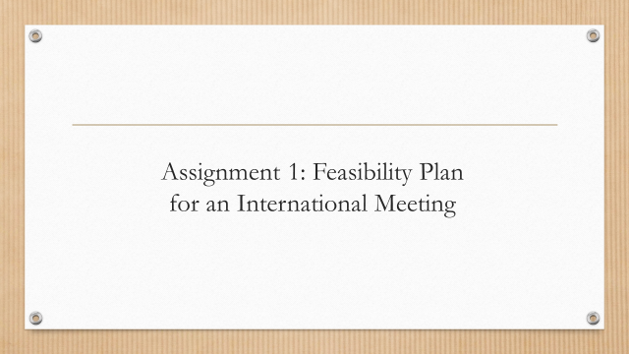Introduction
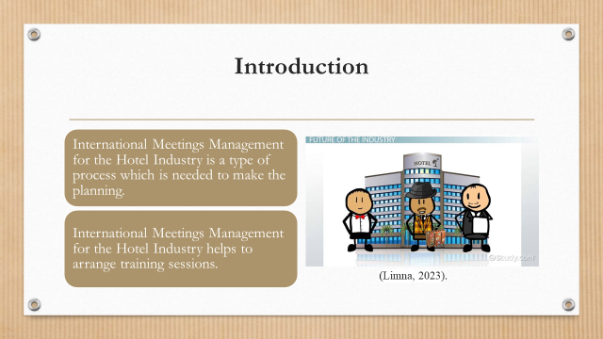
- International Meetings Management for the Hotel Industry is a type of planning process which is needed to create meetings,incentives,conferences,exhibitions,training sessions and leisure events.
International Meetings Management for the Hotel Industry is a kind of process that is used for making various types of planning that will help in hosting public and private events for social purposes. International Meetings Management for the Hotel Industry is also used for arranging proper training sessions for employees to upgrade their skills and knowledge so that they can perform well in their future career paths. In the report, an event is selected on which the topic is going to be described. The name of the event is “Seminar on AI Technology” which will be used in the hospitality industry to make the industry faster and more advanced.

Market factors

Target market and demand
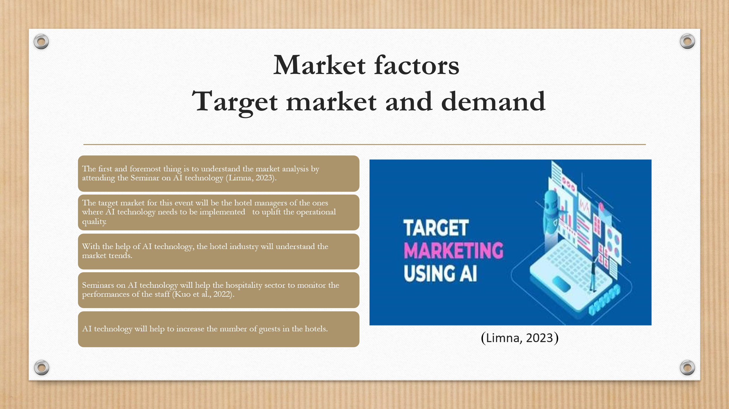
- The first and foremost thing is to understand the market analysis by attending the “Seminar on AI technology” (Limna, 2023).
- The target market for this event will be the hotel managers of the ones where AI technology needs to be implemented to uplift the operational quality.
- With the help of AI technology, the hotel industry will understand the market trends.
- Seminars on AI technology will help the hospitality sector to monitor the performances of the staff (Kuo et al., 2022).
- AI technology will help to increase the number of guests in the hotels.
In the target market, the first and foremost thing is to identify and make proper segmentation of customers based on their demographic behavior needs and preferences. This will help the hospital sector to understand the needs and demands of customers. A seminar on AI technology is a type of event that will help the hospitality sector to understand the market trends and hire staff for the hotel who can use the AI Technology efficiently. The AI Technology will be used by the managers of the hospitality industry to monitor the performance of the staff as this will enhance the growth of the hotel.

Supply
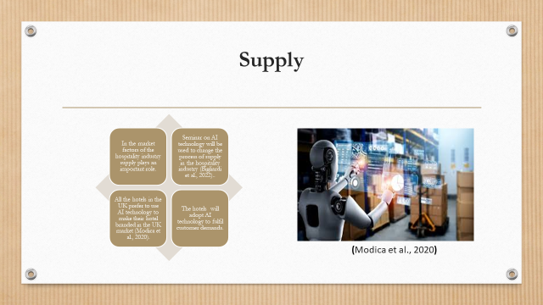
- In the market factors of the hospitality industry supply plays an important role.
- Seminars on AI technology will be used to change the process of supply in the hospitality industry (Bigliardi et al., 2022).
- All the hotels in the UK prefer to use AI technology to make their hotel branded in the UK market (Modica et al., 2020).
- The hotels will adopt AI technology to fulfill customer demands.
Seminar on AI Technology has the potential power to focus on the supply chain management system in the hotel territory industry. All the hotels in the UK prefer to use AI Technology because AI Technology has the power to handle all types of customers by communicating with them in their native language. This will change the supply chain management system of the hotel industry, increasing its brand value throughout the industry.

Competition
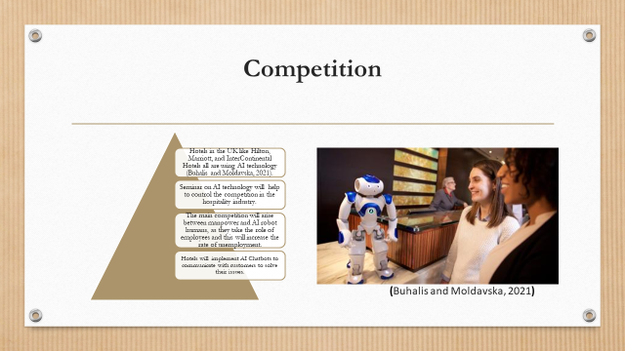
- Hotels in the UK like Hilton, Marriott, and InterContinental Hotels all are using AI technology (Buhalis and Moldavska, 2021).
- Seminars on AI technology offers an advantage over the competition in the hospitality industry.
- The main competition will arise between manpower and AI robot humans, as they take the role of employees and this will increase the rate of unemployment.
- Hotels will implement AI Chatbots to communicate with customers to solve their issues.
All the international hotels in the UK like Hilton Marriott Intercontinental hotels prefer to use AI Technology to increase customer value and customer feedback rates. Hence, to focus on these parts the Seminar on AI Technology helps the hospitality industry to control the competition that arose in the hotel industry as all the hotels of the UK are using AI Technology. The main competitor of AI technology is human employment because the AI robot humans are taking their position and becoming unemployed. Hotels are using the AI chatbot process to communicate with customers regarding their booking issues or payment issues.

Operational factors

Venue availability
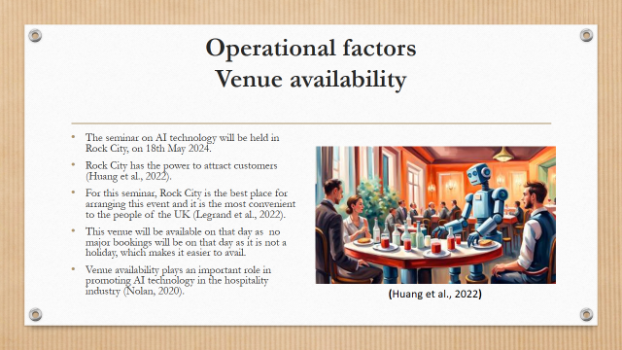
- The seminar on AI technology will be held in Rock City, on 18th May 2024.
- Rock City has the power to attract customers (Huang et al., 2022).
- For this seminar, Rock City is the best place for arranging this event and it is the most convenient to the people of the UK (Legrand et al., 2022).
- This venue will be available on that day as no major bookings will be on that day as it is not a holiday, which makes it easier to avail.
- Venue availability plays an important role in promoting AI technology in the hospitality industry (Nolan, 2020).
Venue availability is an important part that is focused by the hospitality industry. Venue means a place where an occasion or an event is going to be held. AI Technology can be used for searching the best venue for the event seminar on AI technology that helps the hospitality industry to know about the customer's needs and demands and that should be in a convenient place so that it becomes easy for customers to find the venue of the event. AI technology is the advanced technology that makes the hospitality industry faster and smarter.

Skills required
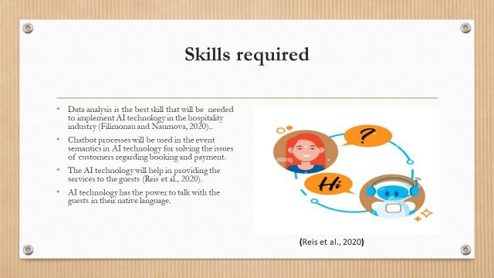
- Data analysis is the best skill that will be needed to implement AI technology in the hospitality industry (Filimonau and Naumova, 2020).
- Chatbot processes will be used in the event Seminars in AI technology for solving the issues of customers regarding booking and payment.
- The AI technology will help in providing the services to the guests (Reis et al., 2020).
- AI technology has the power to talk with the guests in their native language.
Data analysis is the best skill that is required for making AI technology. Data analysis is used for inspecting, cleaning and transforming the data so that the company or the hospitality can reach their goals by gathering various types of information from the market for making the decision That will benefit the hotel and the customers. The hospitality industry implements the chatbot process for communicating with customers regarding their booking issues or payment issues that they want to do online. AI Technology has the authority to provide the best services to the guest by communicating with them in their native language. These are the skills that the staff of the event needs to make the event successful.

Resources
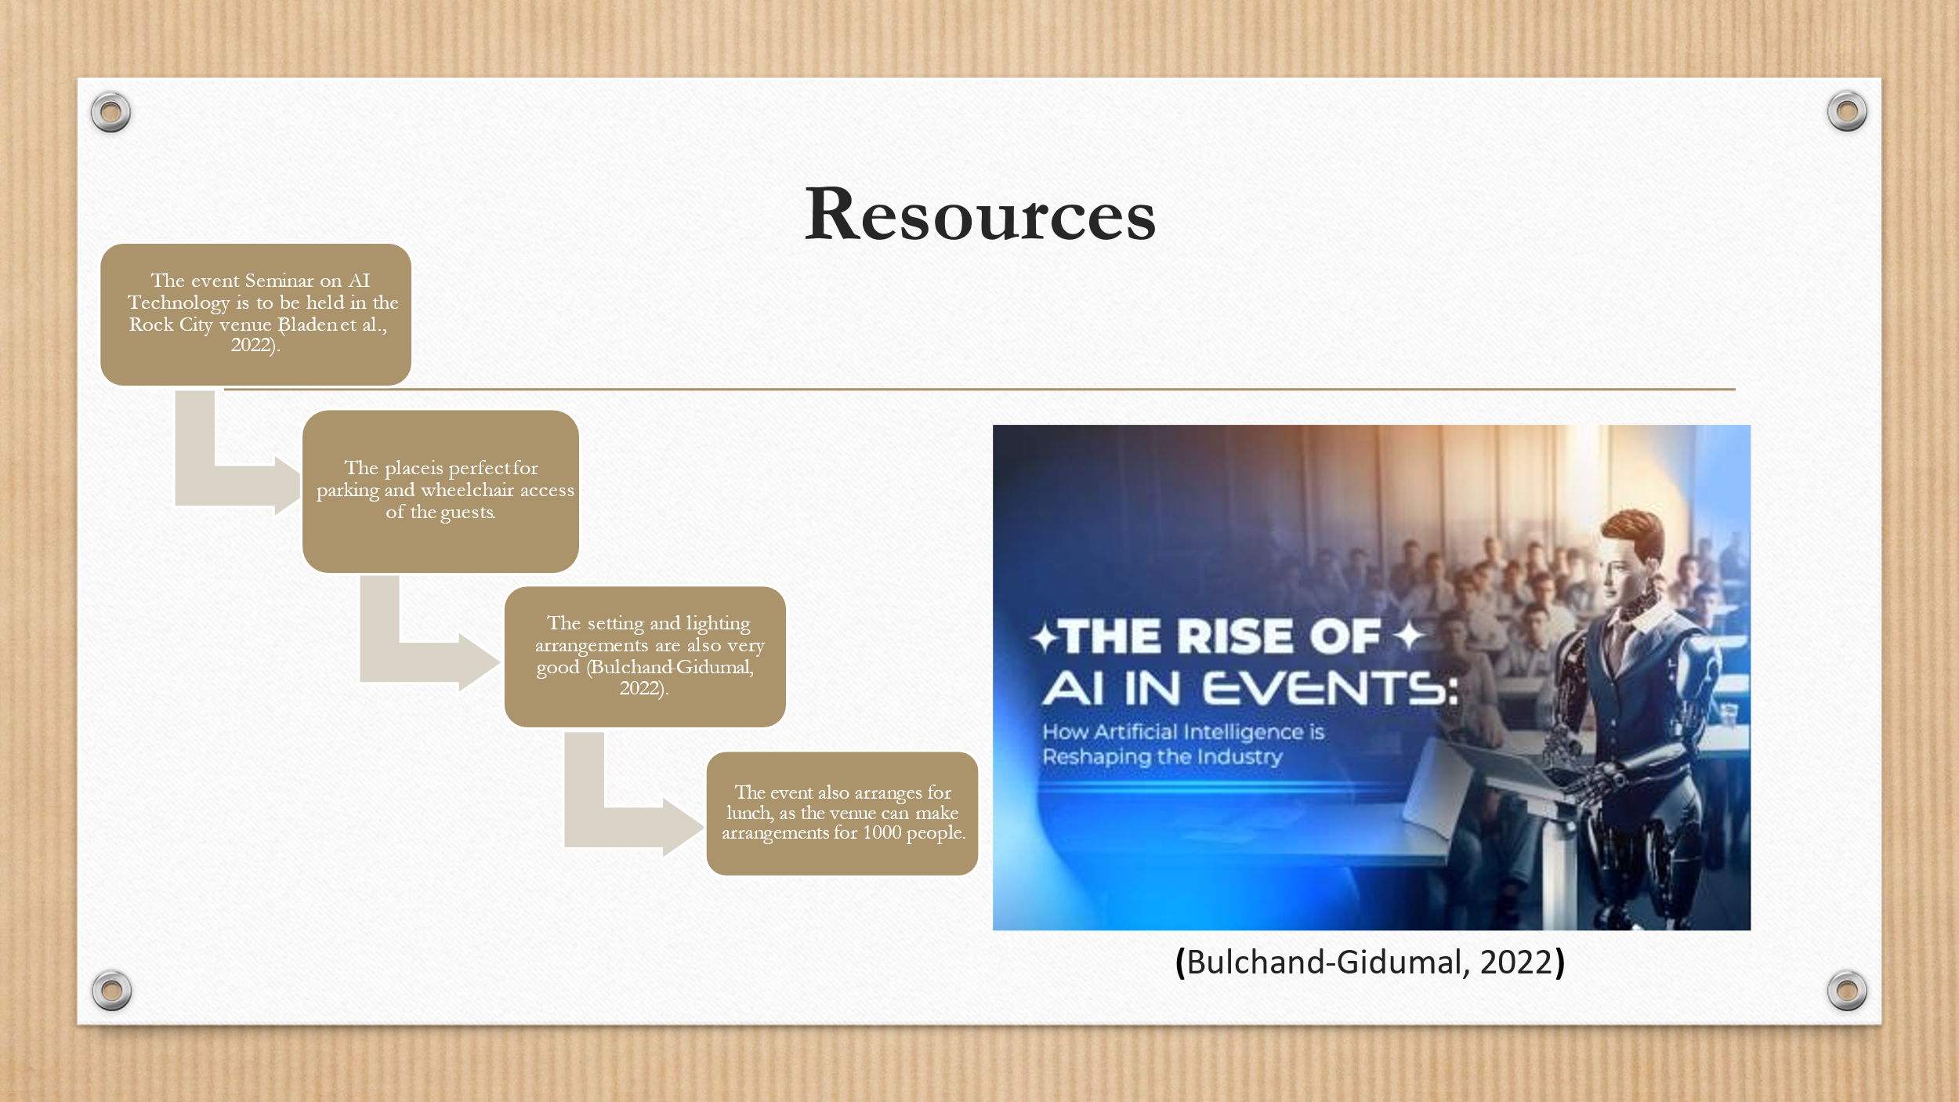
- The event Seminar on AI Technology is to be held in the Rock City venue (Bladen et al., 2022).
- The place is very perfect for parking the vehicles of the ateendees.
- Venue is wheelchair and mobile scooter accessible.
- The setting and lighting arrangements are also very good (Bulchand-Gidumal, 2022).
- The event also arranges for lunch, as the venue can make arrangements for 1000 people.
The event seminar on AI technology is very important in the hospital sector and for that, all the hotel owners and managers would prefer to join this seminar. Hence, to make the seminar successful the event organiser chose the Rock City venue where the attendees can park their vehicles properly and sit in their allocated seat. The lighting of the venue is very appropriate and the event organiser also arranges lunch for those who attend the seminar. Rock City is a big place, and it is very easy for the event organiser to make arrangements for a thousand people easily.

Financial factors

Cost and predicted revenues
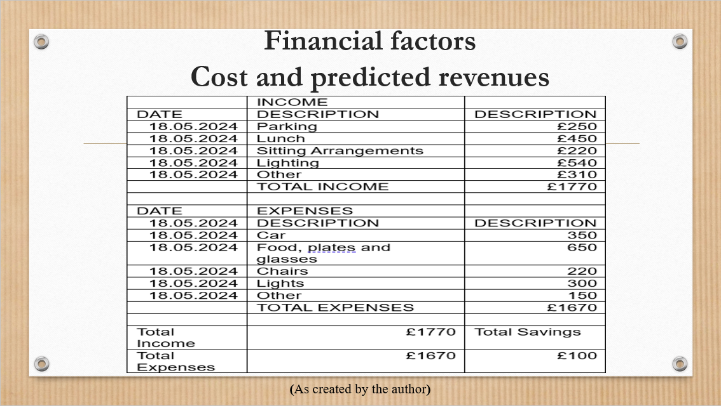

 | INCOME
DATE | DESCRIPTION | DESCRIPTION
18.05.2024 | Parking | £250
18.05.2024 | Lunch | £450
18.05.2024 | Sitting Arrangements | £220
18.05.2024 | Lighting | £540
18.05.2024 | Other | £310
 | TOTAL INCOME | £1770
DATE | EXPENSES
18.05.2024 | DESCRIPTION | DESCRIPTION
18.05.2024 | Car | 350
18.05.2024 | Food, plates, and glasses | 650
18.05.2024 | Chairs | 220
18.05.2024 | Lights | 300
18.05.2024 | Other | 150
 | TOTAL EXPENSES | £1670
Total Income | £1770 | Total Savings
Total Expenses | £1670 | £100

Figure 1: Cost structure
(As created by the author)

The event “Seminar on AI Technology” is a successful event because most of the hotel managers come to this event to know about the usage of AI in the hospitality industry. In the above picture, a total income and expense cost has been described and that amount is gathered by the event organiser. The event was so successful that the organiser gathered 100 pounds from the event and they became very excited to make another type of event based on the technology that can be used by hotels to make the industry or sector more advanced and comfortable for the customers to make their booking and payment through online basis. For every event this income and expenditure have to be maintained because this will motivate them to create more events like this.

Funding resources
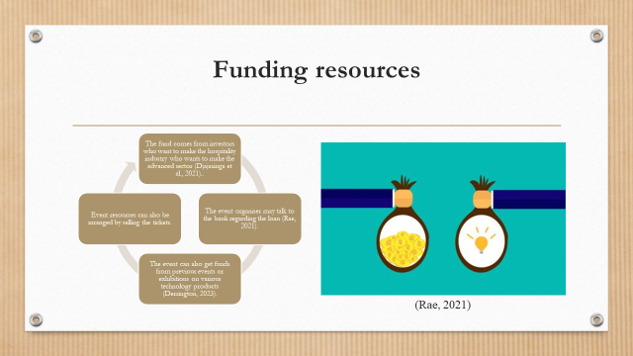
- The fund comes from investors who want to make the hospitality industry an advanced sector (Djajasinga et al., 2021).
- The event organiser will talk with the bank regarding the loan.
- The event will get funds from previous events or exhibitions on various technology products (Rae, 2021).
- Event resources will be arranged by selling the tickets (Derrington, 2023).
The funds for the event come from various ways if the motive of the event is useful and practical for the hospitality sector. Many hotels in modern times want to make their hotels more advanced and technology-oriented and they will be eager to invest their money in this type of event. The event organiser of the “Seminar on AI Technology” funded this seminar from previous events that were done on Technology and from selling tickets for the event.

Conclusion
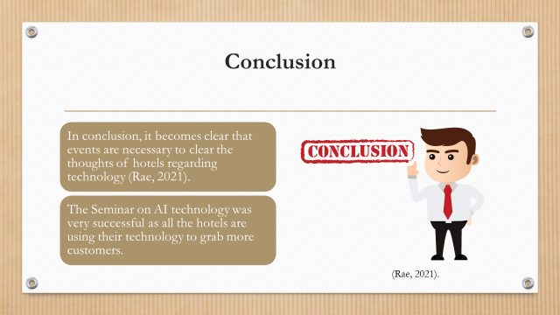
- In conclusion, it becomes clear that events are necessary to clear the thoughts of hotels regarding technology (Rae, 2021).
- The Seminar on AI technology was very successful as all the hotels are using their technology to grab more customers.
From the above discussion, it becomes clear that International meeting management for the hotel industry is very important and this will help in making this event the seminar on AI Technology. This event helps the hotel industry to become faster and smarter.

References
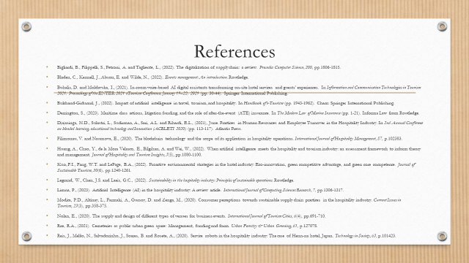
Bigliardi, B., Filippelli, S., Petroni, A. and Tagliente, L., (2022). The digitalization of supply chain: a review. Procedia Computer Science, 200, pp.1806-1815.
Bladen, C., Kennell, J., Abson, E. and Wilde, N., (2022). Events management: An introduction. Routledge.
Buhalis, D. and Moldavska, I., (2021). In-room voice-based AI digital assistants transforming on-site hotel services and guests’ experiences. In Information and Communication Technologies in Tourism 2021: Proceedings of the ENTER 2021 eTourism Conference, January 19–22, 2021 (pp. 30-44). Springer International Publishing.
Bulchand-Gidumal, J., (2022). Impact of artificial intelligence in travel, tourism, and hospitality. In Handbook of e-Tourism (pp. 1943-1962). Cham: Springer International Publishing.
Derrington, S., (2023). Maritime class actions, litigation funding, and the role of after-the-event (ATE) insurance. In The Modern Law of Marine Insurance (pp. 1-21). Informa Law from Routledge.
Djajasinga, N.D., Sulastri, L., Sudirman, A., Sari, A.L. and Rihardi, E.L., (2021, June). Practices in Human Resources and Employee Turnover in the Hospitality Industry. In 2nd Annual Conference on blended learning, educational technology and Innovation (ACBLETI 2020) (pp. 113-117). Atlantis Press.
Filimonau, V. and Naumova, E., (2020). The blockchain technology and the scope of its application in hospitality operations. International Journal of Hospitality Management, 87, p.102383.
Huang, A., Chao, Y., de la Mora Velasco, E., Bilgihan, A. and Wei, W., (2022). When artificial intelligence meets the hospitality and tourism industry: an assessment framework to inform theory and management. Journal of Hospitality and Tourism Insights, 5(5), pp.1080-1100.
Kuo, F.I., Fang, W.T. and LePage, B.A., (2022). Proactive environmental strategies in the hotel industry: Eco-innovation, green competitive advantage, and green core competence. Journal of Sustainable Tourism, 30(6), pp.1240-1261.
Legrand, W., Chen, J.S. and Laeis, G.C., (2022). Sustainability in the hospitality industry: Principles of sustainable operations. Routledge.
Limna, P., (2023). Artificial Intelligence (AI) in the hospitality industry: A review article. International Journal of Computing Sciences Research, 7, pp.1306-1317.
Modica, P.D., Altinay, L., Farmaki, A., Gursoy, D. and Zenga, M., (2020). Consumer perceptions towards sustainable supply chain practices in the hospitality industry. Current Issues in Tourism, 23(3), pp.358-375.
Nolan, E., (2020). The supply and design of different types of venues for business events. International Journal of Tourism Cities, 6(4), pp.691-710.
Rae, R.A., (2021). Cemeteries as public urban green space: Management, funding and form. Urban Forestry & Urban Greening, 61, p.127078.
Reis, J., Melão, N., Salvadorinho, J., Soares, B. and Rosete, A., (2020). Service robots in the hospitality industry: The case of Henn-na hotel, Japan. Technology in Society, 63, p.101423.


