University of Wales Trinity Saint David
School of engineering

Materials in Service – ACMA5004
Joseph Tobin
2317637

Word count – 1,997

Abstract

This investigation aims to identify the material of a failed component and analyse its mechanical properties. Tensile testing was conducted to determine the yield strength, ultimate tensile strength, modulus of elasticity, and elongation at fracture. By comparing the results with the properties of common engineering materials, the material was identified as polypropylene (PP). The low modulus, yield strength, and ultimate tensile strength, along with moderate elongation, are characteristic of PP. Potential failure mechanisms for PP, including creep, environmental stress cracking, and brittle fracture, were discussed. Recommendations were made to mitigate these issues, such as material substitution, design modifications, and process improvements. Future research should focus on expanding the investigation to include additional mechanical tests and explore alternative materials for specific applications.

Contents
1 Abstract 2
3 Table of figures 3
4 Introduction 4
5 Materials testing method 4
6 Literature review 4
6.1 Tensile Properties of Metals 4
6.2 Tensile properties of Plastics 5
6.3 Tensile Properties of Ceramics 5
6.4 Tensile Properties of Composites 5
7 Results and Discussion 6
7.1 Failure modes 10
7.2 Further Characterisation 10
8 Conclusions and Recommendations 11
9 References 12

Table of figures

Figure 1 - Stress strain graph of data provided (Tobin, 2024) 7
Figure 2 - Stress vs strain Youngs modulas (Tobin, 2024) 8
Figure 3 - Stress vs Strain data with 0.2% offset line (Tobin, 2024) 9

Introduction
The investigation aims to identify the material, analyse its mechanical properties, and determine the root cause of failure. By conducting tensile tests, examining fracture surfaces, and reviewing literature, the study will propose solutions to prevent future failures.

Materials testing method
Tensile testing is a widely used technique in material science for evaluating a material’s mechanical properties, which are critical for identifying the material type and understanding its performance under stress (Davis, 2004). Studies highlight that properties such as yield strength, ultimate tensile strength (UTS), modulus of elasticity, and elongation at fracture are key indicators for classifying materials into categories like metals, polymers, ceramics, or composites (William D. Callister, 2014).
The UTS represents the maximum stress a material can withstand before fracturing. It is determined by identifying the peak point on the stress-strain curve (Hosford, 2005). Young's modulus, a measure of a material's stiffness, is calculated from the slope of the linear elastic region of the stress-strain curve. A steeper slope indicates a stiffer material. The percentage elongation quantifies a material's ductility, or its ability to undergo plastic deformation before failure (Hosford, 2005).
Standard procedure followed would be a ASTM standard (ASTM, 2024), ASTM standards outlines the method for determining the tensile properties of materials. Depending on the material it could either be ASTM E8-04 (ASTM, 2024) which is used for metallic testing or ASTM D638-14 (ASTM, 2024) which is used for plastic testing. The test involved applying a uniaxial load to the test coupon until it fractured, while measuring the force and elongation. The resulting force-deformation data, provided in an Excel file, will be used to construct the stress-strain curve. Key properties will be derived from the stress strain curve.

Literature review

Tensile Properties of Metals
Metals generally exhibit high ductility, tensile strength, and stiffness, making them well-suited for applications requiring significant load-bearing capacity and resilience to deformation (Meyers, 2008). Metals have distinct yield points and a well-defined elastic-to-plastic transition, reflecting high Young’s modulus values, such as around 200 GPa for steel (Web, 2024) and 70 GPa for aluminium (The engineering toolbox, 2024), which indicate substantial stiffness. Yield strengths vary widely by alloy and treatment: low-carbon steels typically range from 200-250 MPa (Web, 2024), while aluminium alloys can reach 100-400 MPa (The engineering toolbox, 2024), depending on the alloy series. Ultimate tensile strength for steels spans broadly from 400 MPa to over 1000 MPa for high-strength steels (Web, 2024). Metals also demonstrate considerable elongation at fracture, showing their capacity for plastic deformation before failure; aluminium alloys, for example, often exhibit elongation around 10-25% (The engineering toolbox, 2024), while steels range from 15-40% (Web, 2024). Additionally, metals typically fail through ductile mechanisms, displaying necking in stress-strain curves, which is a critical indicator in failure analysis.

Tensile properties of Plastics
Plastics exhibit significantly lower tensile properties compared to metals and ceramics, with characteristics that vary widely due to their polymer structure (Ross, 1999). Common plastics like polyethylene (Web, 2024), PVC (Web, 2024) and polypropylene (Web, 2024) have yield strengths between 10-40 MPa, while engineering plastics such as polycarbonate (Web, 2024) can reach up to 80 MPa. Young’s modulus for plastics is generally low, between 0.5 to 3 GPa, indicating flexibility, and ultimate tensile strength varies, with lower-strength plastics around 20 MPa (Web, 2024) and high-performance types reaching over 100 MPa (Web, 2024). Plastics also display a range of ductility, with thermoplastics showing high elongation at fracture 50-500% (Plastics, 2024) , while thermosets, such as polystyrene, exhibit brittle behaviour with elongations under 5% (data, 2024). The stress-strain curve for plastics is often nonlinear, lacking a distinct yield point, with a gradual yielding phase or plateau (Crawford, 2020) particularly in thermoplastics making plastics easily distinguishable from metals and ceramics.

Tensile Properties of Ceramics
Ceramics offer high stiffness 200-400 GPa but are brittle with low tensile strength 50-500 MPa common engineering ceramics like alumina or silicon carbide (materials, 2024) . Due to their rigid, crystalline structure, ceramics have minimal elongation at fracture usually <1% and lack plastic deformation, resulting in abrupt failure without a distinct yield point. Ceramics show a linear stress-strain relationship up to their UTS, failing catastrophically with little to no necking, which makes them easily distinguishable from metals and plastics (Wachtman, 2009).

Tensile Properties of Composites
Composites, formed by combining two or more materials, offer a wide range of customisable mechanical properties. Fiber-reinforced composites, such as carbon fibre-reinforced polymers , are particularly notable for their exceptional strength up to 1500 MPa and stiffness up to 200 GPa (Compospites, 2024). Unlike traditional materials like metals, plastics, and ceramics, composites exhibit anisotropic behaviour, demonstrating significantly higher strength and stiffness along the fibre direction, a unique feature not seen in metals, plastics, or ceramics (Krishan, 2012).

Results and Discussion
The raw data provided was plotted onto a stress-strain scatter graph as seen in fig 1. to visualize the material’s mechanical behaviour under tension.
To determine the stress-strain data, I began by using the raw force and elongation measurements provided. Stress was calculated by dividing the applied force by the original cross-sectional area of the sample, using the formula
Stress = Force / Area
Strain was determined by dividing the elongation (change in length) by the original gauge length, using
Strain = Δ𝐿 / 𝐿0​
These calculations allowed me to convert the raw data into stress and strain values, which were then plotted on a scatter graph to visualize the material's mechanical behaviour (toolbox, 2024).
From this plot, the curve displayed characteristics typically associated with plastics: an initial nonlinear elastic region with a gradual transition into plastic deformation and a lack of a distinct yield point. Unlike metals, which usually exhibit a sharper yield point and necking, this material's curve suggested the gradual yielding behaviour often seen in plastic materials.
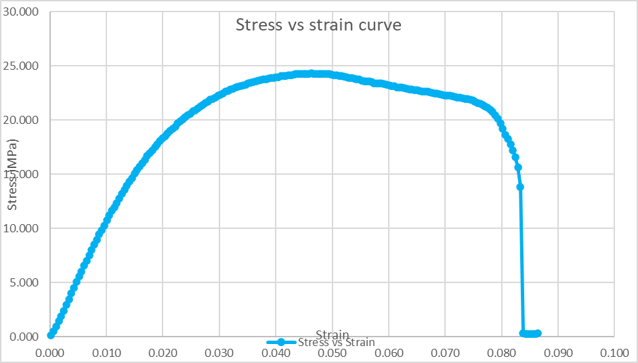
Figure 1 - Stress strain graph of data provided (Tobin, 2024)

To determine the Young's modulus for the plastic material, I followed the method outlined in ASTM D638 (ASTM, 2024), which is the standard for tensile testing of plastics. Unlike metals, plastics often lack a well-defined linear elastic region, resulting in a gradual initial response on the stress-strain curve. To address this, ASTM D638 suggests calculating Young’s modulus by focusing on a specific strain range, typically between 0.05% and 0.25%. This range provides a reliable estimation of the modulus by capturing the most linear part of the curve, allowing for a consistent measure of stiffness across different plastic materials without including significant plastic deformation (Crawford, 2020).
Using this approach, I plotted a stress-strain graph for the data within this strain interval. I applied a linear fit to the selected data points, which provided a slope representing Young's modulus for the material. This approach allowed me to approximate the modulus accurately, reflecting the material’s elastic behaviour within the selected strain range.
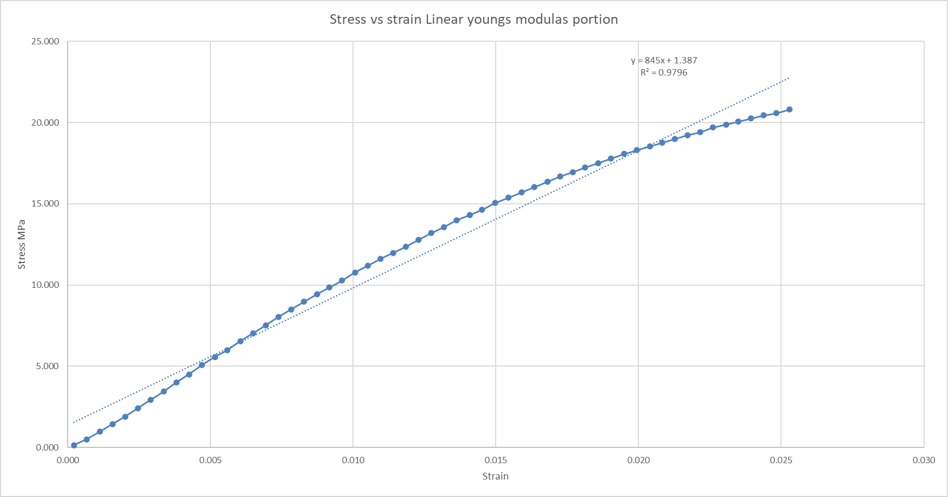
Figure 2 - Stress vs strain Youngs modulas (Tobin, 2024)
Using the linear fit, or trendline, on the selected stress-strain data within the 0.05% to 0.25% strain range, I calculated the Young's modulus. The trendline equation for this section was determined to be y=845x+1.387. From this, the Young’s modulus is 845 MPa, which equates to approximately 0.845 GPa. This value represents the material’s stiffness and aligns with the characteristics expected of plastics, as they typically have lower Young’s modulus values compared to metals and ceramics (Forums, 2024).
To determine the yield strength, the 0.2% offset method was used. A strain offset of 0.002 was added to each strain value, and the equation 845 × strain + 1.387 was applied to plot the offset line on the stress-strain graph (Lync, 2024). The intersection of this offset line with the stress-strain curve indicated the yield strength of the material, which was calculated to be 20.585 MPa as seen in fig 3.
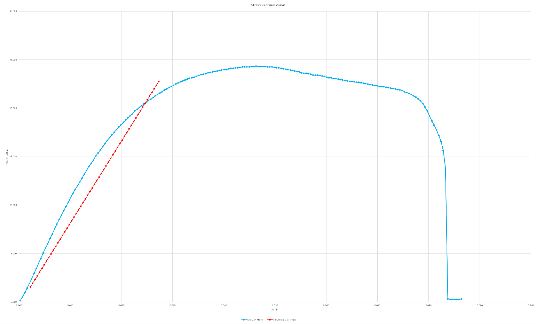
Figure 3 - Stress vs Strain data with 0.2% offset line (Tobin, 2024)
The ultimate tensile strength (UTS), or the maximum stress the material withstood before fracturing, was found to be 24.349 MPa. This value represents the peak stress on the stress-strain curve, beyond which the material began to fail (TWI, 2024)
Finally, the elongation at fracture was calculated to be 8.64%. This was determined by calculating the percentage increase in the gauge length from its initial measurement to the point of fracture, using the formula: Elongation =(Δ𝐿 / 𝐿0) ×100% (TWI, 2024).
These results align with typical plastic material behaviour, characterised by relatively low yield and tensile strengths, and moderate elongation, confirming the material's plastic nature based off my previous literature review.
UTS = 24.349 MPa
Young's Modulus = 845 MPa (0.845 GPa)
Yield Strength = 20.585 MPa
% Elongation = 8.64%

Based on the results, Polypropylene (PP) is the most likely material, as its properties align with the observed data. The measured Young's modulus of 845 MPa, yield strength of 20.585 MPa, and UTS of 24.349 MPa fall within the typical ranges for PP, which generally has moduli from 0.008 to 8.25 GPa and yield strengths and UTS between 9-80 MPa. Additionally, the elongation at fracture of 8.64% matches the moderate ductility of polypropylene, which can range from 2.4-900% depending on the grade (Web, 2024). In contrast, materials like polyethylene (PE), polystyrene (PS), and polycarbonate (PC) exhibit much higher Young's modulus and tensile strength, particularly PS and PC, making them less suitable matches (INC, 2024).

Failure modes
Polypropylene (PP) is widely used in applications ranging from packaging materials to automotive parts, textiles, and consumer goods due to its excellent chemical resistance, low cost, and ease of processing. The material’s ductility and moderate elongation at fracture make it ideal for applications requiring flexibility, such as plastic containers, ropes, and automotive bumpers. However, the susceptibility to failure modes like creep deformation and fatigue failure can limit its use in certain environments. For instance, in applications where PP is subjected to continuous stress or elevated temperatures, such as in automotive components or piping, creep could lead to long-term dimensional changes or failure under normal loads (omnexus, 2024).
Additionally, the potential for environmental stress cracking could be a concern in applications exposed to harsh chemicals or extreme environmental conditions. This could impact its reliability in industries such as chemical processing or outdoor storage. The tendency of PP to undergo brittle fracture at low temperatures or high strain rates also restricts its use in environments where rapid or extreme loading could occur. These failure modes, if not accounted for, could shorten the material’s lifespan in critical applications. Thus, while polypropylene remains versatile, its suitability for specific applications must consider the potential failure mechanisms to ensure long-term performance and reliability (omnexus, 2024).

Further Characterisation
To further characterise polypropylene (PP) and confirm its properties, several complementary techniques can be used alongside tensile testing. Differential Scanning Calorimetry (Berlin, 2009) is particularly useful for determining the thermal transitions of PP, such as its melting point and glass transition temperature, which are key to understanding its behaviour in different temperature ranges. Fourier Transform Infrared Spectroscopy (Intertek, 2024) can identify the chemical bonds in PP, distinguishing it from other polymers by analysing its characteristic functional groups. Scanning Electron Microscopy (SEM) provides high-resolution imaging of the surface and fracture morphology, helping to reveal microstructural features and failure modes, such as necking, which are common in PP (solutions, 2024). X-ray Diffraction (XRD) can assess the crystallinity and crystalline orientation of PP, offering insight into its degree of crystallinity, which affects its mechanical properties (intertek, 2024).

Conclusions and Recommendations
The material is most likely Polypropylene (PP), as its mechanical properties—Young's modulus of 845 MPa, yield strength of 20.585 MPa, and ultimate tensile strength (UTS) of 24.349 MPa—align with typical values for PP. The material also exhibited a moderate elongation at fracture of 8.64%. Common failure mechanisms include creep deformation, environmental stress cracking, and brittle fracture at low temperatures or high strain rates, which are characteristic of PP, particularly in automotive and industrial applications.
To address these failure mechanisms, several engineering recommendations can be made. First, for applications requiring long-term performance under continuous stress or high temperatures, it may be beneficial to consider a material with improved creep resistance, such as high-density polyethylene (HDPE) or an engineering plastic like polycarbonate (PC). In terms of design modifications, reducing sharp corners or incorporating reinforcements could help minimise stress concentration points, reducing the risk of brittle fracture.
Process improvements, such as optimising manufacturing conditions to reduce residual stresses, could also improve material performance. The economic and environmental impacts of these recommendations must be considered; while substituting PP with a more robust material might increase costs, it could enhance the longevity and reliability of the product, ultimately providing long-term cost savings and reducing waste.
While tensile testing provided valuable data, other mechanical tests such as impact testing or fatigue testing could offer a more comprehensive understanding of the material's performance under varying conditions. Future research should focus on expanding the sample size, utilising additional testing techniques, and exploring alternative materials with enhanced properties for specific applications. This will help ensure that the recommendations are applicable to a broader range of real-world scenarios, improving the material selection process and overall product reliability.

References
ASTM, 2024. ASTM D638-14 Standard Test Method for Tensile Properties of Plastics. [Online]
Available at: https://www.astm.org/d0638-14.html
[Accessed 08 11 2024].
ASTM, 2024. ASTM E8-04 Standard Test Methods for Tension Testing of Metallic Materials. [Online]
Available at: https://www.astm.org/standards/e8
[Accessed 08 11 2024].
ASTM, 2024. What Is ASTM?. [Online]
Available at: https://www.astm.org/about/overview/fact-sheet.html
[Accessed 08 11 2024].
Berlin, H., 2009. Investigation of polymers with differential scanning calorimetry. Adv. Lab DSC Investig. Polym, pp. 1--17.
Compospites, P., 2024. Mechanical Properties of Carbon Fibre Composite Materials, Fibre. [Online]
Available at: https://www.performance-composites.com/carbonfibre/mechanicalproperties_2.asp
[Accessed 09 11 2024].
Crawford, R. J. a. M. P. J., 2020. Plastics engineering. s.l.:Butterworth-Heinemann.
data, d., 2024. Thermo plastics. [Online]
Available at: https://designerdata.nl/materials/plastics/thermo-plastics/polystyrene?cookie=YES
[Accessed 09 11 2024].
Davis, J. R., 2004. Tensile testing. s.l.:ASM international.
Forums, P., 2024. Graphing stress-strain plots on excel. [Online]
Available at: https://www.physicsforums.com/threads/graphing-stress-strain-plots-on-excel.840580/
[Accessed 10 11 2024].
Hosford, W. F., 2005. Mechanical Behavior of Materials. Cambridge: Cambridge University Press.
INC, T. P., 2024. Properties of Plastics. [Online]
Available at: https://www.tedpella.com/company_html/plastics-properties.aspx
[Accessed 09 11 2024].
Intertek, 2024. Fourier Transform Infrared Spectroscopy Analysis of Polymers and Plastics. [Online]
Available at: https://www.intertek.com/polymers-plastics/analysis-ftir/#:~:text=FTIR%20combined%20with%20these%20techniques,unknown%20plastics%20and%20polymeric%20materials.
[Accessed 10 11 2024].
intertek, 2024. X-Ray Diffraction for Polymers and Composites. [Online]
Available at: https://www.intertek.com/polymers-plastics/x-ray-diffraction-composites/
[Accessed 10 11 2024].
Krishan, K. C., 2012. Composite materials: science and engineering. s.l.:Spinger.
Lync, S., 2024. The 0.2% Offset Method for Yield Stress. [Online]
Available at: https://skill-lync.com/blogs/the-02-percent-offset-method-for-yield-stress
[Accessed 10 11 2024].
materials, A., 2024. Alumina - Aluminium Oxide - Al2O3 - A Refractory Ceramic Oxide. [Online]
Available at: https://www.azom.com/properties.aspx?ArticleID=52
[Accessed 09 11 2024].
Meyers, M. A. a. C. K. K., 2008. Mechanical behavior of materials. s.l.:Cambridge university press.
omnexus, 2024. Polypropylene: How to Select the Right Grade?. [Online]
Available at: https://omnexus.specialchem.com/selection-guide/polypropylene-pp-plastic
[Accessed 10 11 2024].
Plastics, C., 2024. Plastic Properties Table. [Online]
Available at: https://www.curbellplastics.com/resource-library/material-selection-tools/plastic-properties-table/?srsltid=AfmBOorswc3XGh8BXVZf-2Q9rkH8JL5MX4nhPbKegeYZf2JzUZbu0RBK
[Accessed 09 11 2024].
Ross, C. T. a. C. A., 1999. Strength of materials and structures. s.l.:Elsevier.
solutions, I., 2024. Scanning Electron Microscopy. [Online]
Available at: https://www.impact-solutions.co.uk/plastic-testing/testing-capabilities-list/various-material-analysis-2/scanning-electron-microscopy/#:~:text=SEM%20technique%20is%20a%20key,for%20particle%20and%20dust%20contamination.
[Accessed 10 11 2024].
The engineering toolbox, 2024. Aluminum Alloys - Mechanical Properties. [Online]
Available at: https://www.engineeringtoolbox.com/properties-aluminum-pipe-d_1340.html
[Accessed 09 11 2024].
Tobin, J., 2024. Stress strain graph of data provided. s.l.:s.n.
Tobin, J., 2024. Stress vs Strain data with 0.2% offset line. s.l.:s.n.
Tobin, J., 2024. Stress vs Strain youngs modulas. s.l.:s.n.
toolbox, t. e., 2024. Stress, Strain and Young's Modulus. [Online]
Available at: https://www.engineeringtoolbox.com/stress-strain-d_950.html
[Accessed 10 11 2024].
TWI, 2024. Mechanical testing - Tensile testing, Part 1. [Online]
Available at: https://www.twi-global.com/technical-knowledge/job-knowledge/mechanical-testing-tensile-testing-part-1-069#:~:text=From%20this%20curve%20we%20can,0%20%3D%20original%20cross%20sectional%20area.
[Accessed 10 11 2024].
Wachtman, J., 2009. Mechanical properties of ceramics. s.l.:John Wiley \& Sons.
Web, M., 2024. Overview of materials for High Density Polyethylene (HDPE), Injection Molded. [Online]
Available at: https://www.matweb.com/search/datasheet.aspx?MatGUID=fce23f90005d4fbe8e12a1bce53ebdc8
[Accessed 09 11 2024].
Web, M., 2024. Overview of materials for Polycarbonate, Extruded. [Online]
Available at: https://www.matweb.com/search/DataSheet.aspx?MatGUID=501acbb63cbc4f748faa7490884cdbca
[Accessed 09 11 2024].
Web, M., 2024. Overview of materials for Polypropylene, Molded. [Online]
Available at: https://www.matweb.com/search/datasheet.aspx?MatGUID=08fb0f47ef7e454fbf7092517b2264b2&ckck=1
[Accessed 09 11 2024].
Web, M., 2024. Overview of materials for PVC extruded. [Online]
Available at: https://www.matweb.com/search/datasheet_print.aspx?matguid=bb6e739c553d4a34b199f0185e92f6f7
[Accessed 09 11 2024].
Web, M., 2024. Steels, General Properties. [Online]
Available at: https://www.matweb.com/search/datasheet.aspx?bassnum=MS0001&ckck=1
[Accessed 09 11 2024].
William D. Callister, J., 2014. Materials science and engineering - 9th edition. In: s.l.:s.n., pp. 586-587.

