Alex Thomas 1352162
1352162@student.uwtsd.ac.uk

Governance, Legislation and Ethics Work-Based Project
ACCA5016

Contents
Abstract 2
Introduction 2
1. Head of Governance Report 2
1.1 Data Breach 2
1.2 Data Type and Principles 2
1.3 Swansea Council Data Breach Policy 3
1.4 Risk Exposure 6
1.5 Prevention of Future Data Breach 6
1.5.1 Process 6
1.5.2 Data 7
1.6 Recommendations for Breach Panel 7
1.7 Actions for Affected Staff 7
2. Executive Board Report 8
2.1 Initial Incident 8
2.1 Data Breach 8
2.2 Data Principles and Breaches 8
2.3 Risk to the Council 11
2.4 Mitigating Risk 11
2.5 ICO (Information Commissioners Office) 12
3. IG (Information Governance) Committee Report 12
3.1 Data Breach 12
3.2 Risk Exposure 12
3.3 Data Principles 12
3.4 Actions to Mitigate Risk 13
3.5 Further Actions 13

Abstract
The purpose of this report is to perform an investigation as a manager responsible for IG (Information Governance) into the accidental breach of data by a manager in an operational department. This paper will contain three reports generated in compliance with Swansea Councils GDPR (General Data Protection Regulation) policy all centred around this data breach. The Head of Governance, the Executive Board and the IG Committee will each receive a report on the breach, there will also be a poster design, to be displayed in staff areas providing a visual reminder to all staff of their responsibilities regarding GDPR.

Introduction
The growth of digital communications contributes to the expansion of data held by companies. This raises many questions into not only how this data is held but why is it held and how long for. The introduction of GDPR was put into effect on May 25th 2018 [1]. This regulation ensures companies are accountable in terms how users referred to as data subjects rights and freedoms are respected. One of the first requirements to be established by this report is to look at the question what is personal data? Providing this answer will determine if GDPR is applied and activated. Defined by GDPR, a brief not exhaustive summary of personal data constitutes information relating to natural persons who can be directly or indirectly identified by the information in question [2], persons who can be identified indirectly from said information combined with other information [2]. Personal data can also be explored further into special categories or criminal convictions and offences data.

Head of Governance Report

Data Breach
A data breach has occurred accidentally in an operational department, a manager emailed the names and addresses of their staff members to a member of the public. The incident occurred when the manager downloaded the list off an operational system to try and make a task more efficient, in doing so the manager attached the wrong document to an email, instead of sending the intended leaflet to the member of the public, the list of staff names and addresses was sent. This contravenes the Council Data Breach Policy 3.2 “Disclosing personal information to someone not authorised to have it; verbally, in writing or electronically” [5].

Data Type and Principles
For the purpose of this report initially the data type must be identified to assess whether GDPR is engaged. The data breach contained the names and addresses of staff which were stored on an internal filing system, therefore is classed as personal data this engages GDPR [2]. Article 6 under GDPR requires the council to practice lawful processing when handling data setting six lawful bases, consent, contract, legal obligation, vital interest, public task and legitimate interest [3]. Special category data would require an additional condition for processing under Article 9 of GDPR, the most common conditions being, explicit consent, not for profit bodies and substantial public interest [3]. My role as a manager of IG dictates my standing as a controller under GDPR [3], this involves full compliance with the GDPR data protection principles regarding personal data, as noted in GDPR article 5:
Article 5(1) requires that personal data shall be:
“(a) processed lawfully, fairly and in a transparent manner in relation to individuals (‘lawfulness, fairness and transparency’);
(b) collected for specified, explicit and legitimate purposes and not further processed in a manner that is incompatible with those purposes; further processing for archiving purposes in the public interest, scientific or historical research purposes or statistical purposes shall not be considered to be incompatible with the initial purposes (‘purpose limitation’);
(c) adequate, relevant and limited to what is necessary in relation to the purposes for which they are processed (‘data minimisation’);
(d) accurate and, where necessary, kept up to date; every reasonable step must be taken to ensure that personal data that are inaccurate, having regard to the purposes for which they are processed, are erased or rectified without delay (‘accuracy’);
(e) kept in a form which permits identification of data subjects for no longer than is necessary for the purposes for which the personal data are processed; personal data may be stored for longer periods insofar as the personal data will be processed solely for archiving purposes in the public interest, scientific or historical research purposes or statistical purposes subject to implementation of the appropriate technical and organisational measures required by the GDPR in order to safeguard the rights and freedoms of individuals (‘storage limitation’);
(f) processed in a manner that ensures appropriate security of the personal data, including protection against unauthorised or unlawful processing and against accidental loss, destruction or damage, using appropriate technical or organisational measures (‘integrity and confidentiality’).”
Article 5(2) adds that:
“The controller shall be responsible for, and be able to demonstrate compliance with, paragraph 1 (‘accountability’).” [4].
Firstly, the author considers which of the above data protection principles have been breached. Section (a) of Article 5 has been breached this principle calls for personal data to be processed lawfully, fairly and transparently, process was not conducted lawfully, was not carried out in the vital interest of the data subject or the public, the data subject had not given consent, no contract was involved, process was not a legal obligation, process was not of vital interest to the data subject and did not have a legitimate interest for processing [3]. This process can be neither fair or transparent because the staff would have needed to be informed beforehand by the manager that their personal data was being accessed and processed to make a task more efficient. Section (b) of Article 5 has been breached due to the further processing of this data, purpose limitation should have been considered in this instance, the manager in this case should have specified the exact process being carried out before the action and not created a process. Further breaches to the staff’s personal data include section (c) of Article 5 the question of what is relevant and necessary must be raised, the manger was acting independently of protocol to potentially carry out a task more efficiently, this is a potential breach requiring investigation to clarify if the data needed to be stored at this location. Section (d) will need investigation from IT staff to confirm if this principle has been breached the data will need to be compared to a verified data base to ensure accuracy. Section (e) will also need to be investigated a possible breach of this principle may have occurred, Council will need to involve IT staff to assess how long the names and addresses of staff have been kept on this system and whether it is justified, a possible breach of storage limitation will need clarification. Ensuring appropriate security of the personal data section (f) of Article 5 has been breached by the manager by not using the appropriate technical or organisational measures this resulted in unauthorised access being gained by the member of the public.

Swansea Council Data Breach Policy
The Councils data breach policy states that every manager must follow three basic steps, where the manager of the staff member reporting the breach takes on the role of IO (Investigating officer) –
Step 1.
The IO without any delay must assess the risk level, if the risk is high to the data subject involving a risk of discrimination, identity theft, fraud, financial loss or damage to reputation, the data subject(s) must be informed straight away to protect themselves. In the case of the risk being low the issue will then go to the data breach panel to decide if the IO needs to inform the data subject(s) whose data has been breached [5].
Step 2.
Every effort should be made to contain the breach if possible, by retrieving the information. If personal data has been sent to the wrong individual (‘recipient’) and the authority is informed about it, the member of staff responding must apologise for the mistake and collect the information if possible. The following points need to be confirmed [5].
- The information has been recalled
- The recipient has not made copies of the information
- The information has not been shared
- Has the information been read
- Whether the recipient knows the individual(s) concerned
Step 3.
The data breach must be reported at corporate level, the IO must complete the first section of the breach form and send it to the Information Security Officer, the breach must also be confirmed via telephone. In compliance with GDPR the Council has 72 hours if the data subject(s) and the ICO (Information Commissioners Office) need to be informed. The ISO(Information Security Officer) will then summon a data breach panel, with the IO required to attend [5]. The steps are highlighted in figure 1.
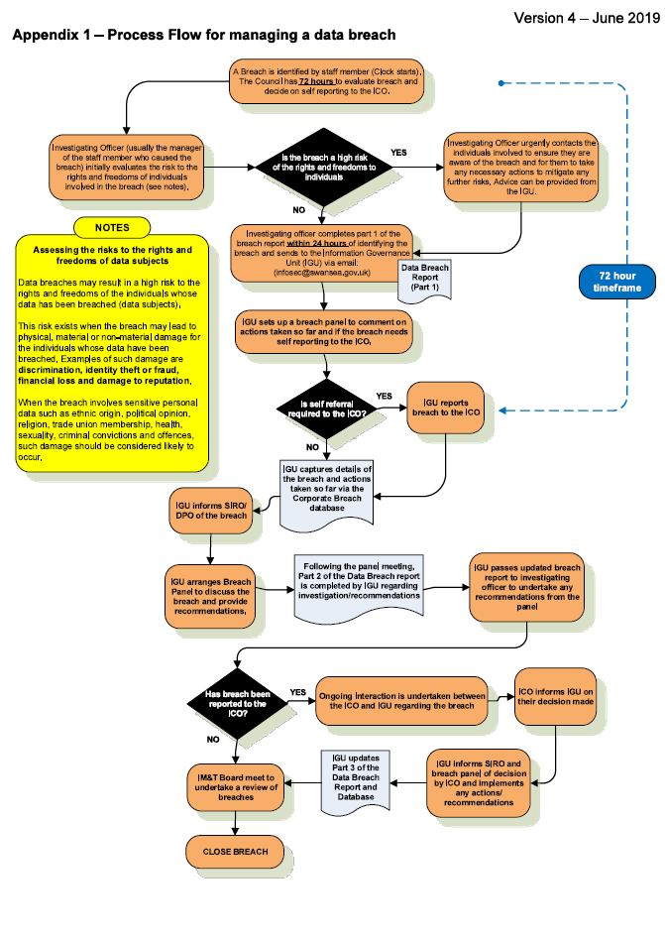
Figure 1: Process flow for data breach [5]

Risk Exposure
The authority must gauge the level of risk attributed to the breach of the data. According to GDPR and the Data Protection Act 2018 there are three classes of data, personal, special category and criminal data [6]. Firstly, to consider which has been breached in this case there are the names and addresses of staff, as mentioned previously this under GDPR is classed as personal data. The fact that the data does not reveal political, ethnic, racial beliefs, trade union membership, genetic, biometric data or anything concerning the staffs health, sexual orientation, sex life or criminal offences means under GDPR this is not classified as special data or criminal offence data [6] . The image in figure two provides a scale factor for assessing risk on a scale of one to five.
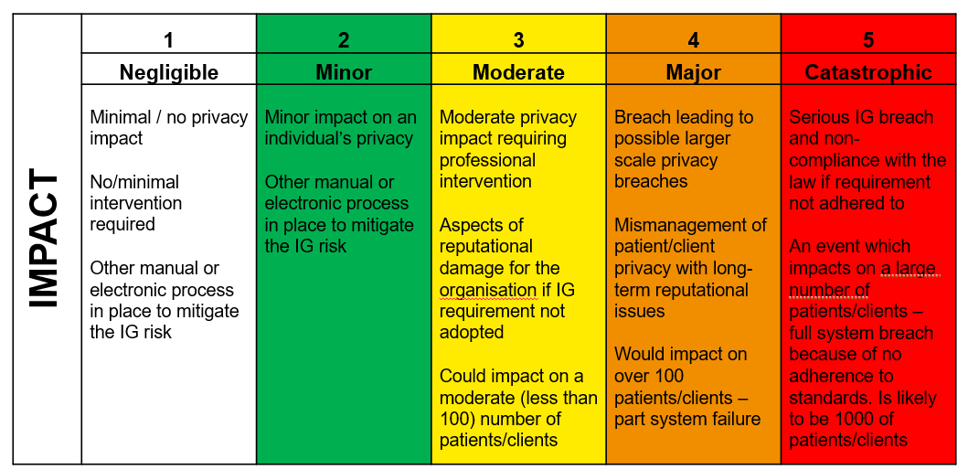
Figure 2: Impact matrix [6]
The author considers the risk to be scored at two or minor in this case, the argument being only name and addresses have been breached which could easily be obtained publicly via the internet, no special category or criminal offence data was breached. In accordance with the Councils Data Breach Policy Step 1, the Data Breach Panel will decide if the IO needs to notify the individual(s) whose data has been breached [5]. Stated in the authority’s data breach policy the IO in this case will be expected to attend the breach panel.

Prevention of Future Data Breach
Prevention of future breaches of this nature is essential to ensure the authority does not repeat mistakes leading to further breaches. In this instance an assessment will need to be made as to why the breach happened. The manager decided to undertake a task whilst trying to save time that inadvertently led to the emailing of the addresses to the member of the public. This raises several questions regarding process and data, that need to be taken to the Councils Data Breach Panel for discussion.

Process
- Has the manger received training regarding the protection of data?
- Is the manager involved aware of the Councils data breach policy?
- Does the manger understand GDPR law?
- Should the data be accessible by the manager?
- Who else can access the data?
- Can this data be managed by another department?

Data
- Why is the data held on this system?
- Does this data need to be held on this system?
- Can the storage be moved centrally?
- What is the content of the data, are all fields within the data relevant for storage purpose?
- Is the data secure?

Recommendations for Breach Panel
The author recommends firstly that the staff information sent by the manager has been deleted securely from the mangers computer system and the email recalled in compliance with council policy, this will also apply to all scanned copies of staff sick notes and occupational health reports found on the mangers desktop. A full internal audit is recommended for the mangers departmental filing system considering the knowledge that sick notes and occupational health reports have accumulated on the mangers desktop this is to determine if the issue is local or global. To review the managers current level of training regarding data protection and awareness of GDPR. As a matter of course the manager should undertake training to enhance the current level of understanding. The councils policies for data protection, GDPR, records management and data breach will also be raised, not only in the sense of the mangers awareness of the policies but also the ease of access all staff have in respect of these policies, this can be highlighted via the councils internal staffnet website, emails sent to all staff reminding them of responsibilities when handling data, links to all relevant council GDPR policies to be included in the emails this will be in addition to the new poster design part of this brief, this in line with Councils current Data Breach Policy, Risks section 4.2 states “To help identify areas for improvement to decrease the risk and impact of future incidents” [5]. The reasons why this breach occurred need to be addressed in this case access to data is a critical point, is the manger concerned the correct member of staff to handle the information. The author proposes an in-depth review using Council IT staff alongside operations to evaluate the storage and access to the data. The review should include an analysis of how the data is currently stored, is it stored securely is the metadata relevant. The manager potentially should not have access to this data and the management of the data could be moved centrally to be managed via HR(Human Resources) or Finance, this would strengthen security by having less staff handling data and the staff that are responsible following a strict and clear process which would include a strong password and two step authentication process for data access improving security. Moving the data centrally would reduce the margin of error by removing multiple managers handling data with varying knowledge levels of GDPR an increase would be gained in efficiency by streamlining the process. This movement and restriction of the data adheres to the Councils current Data Breach Policy, Purpose section 1.3 states “To ensure appropriate measures and recommendations are put in place to ensure the likelihood of any recurrence is reduced” [5].

Actions for Affected Staff
ICO advise controllers to consult the WP29 (Article 29 Working Party) which has now been replaced by EDPB (European Data Protection Board) who endorse the guidelines [9], for advice on personal data breach communication. The controller is required to inform affected individuals before contacting the supervisory body if there is a high risk breach, Article 34(1) states “When the personal data breach is likely to result in a high risk to the rights and freedoms of natural persons, the controller shall communicate the personal data breach to the data subject without undue delay”[10]. The author scored the risk as low, therefore the proposal to the data breach panel is to action communication to staff after contacting the supervisory body ICO. It can be argued that the breach is not reportable to ICO due to the minimal information breached and the information being available publicly, Article 33(1) of WP29 states “In the case of a personal data breach, the controller shall without undue delay and, where feasible, not later than 72 hours after having become aware of it, notify the personal data breach to the supervisory authority competent in accordance with Article 55, unless the personal data breach is unlikely to result in a risk to the rights and freedoms of natural persons. Where the notification to the supervisory authority is not made within 72 hours, it shall be accompanied by reasons for the delay” [10], however the author advises the panel to report the breach to the ICO for transparency, this will help placate the data subjects when they are informed that the authority is following the correct channels and being proactive in its approach to minimise risk. The authors opinion is to inform the individual(s) of the breach again as a matter of transparency even though the Article 29 Working Party states “This risk exists when the breach may lead to physical, material or non-material damage for the individuals whose data have been breached” [8]. Arguably due to this information being available publicly it can be said the data subjects risk is not high and that informing the data subjects isn’t necessary however transparency must be the main factor for the authority when dealing with data processing, any form of camouflage bureaucratic or otherwise could lead to unwanted political pressure and staff feeling they are not being dealt with in a fair and transparent manner. Actioning the method of communication to affected staff is the next logical step for the panel, WP29 advises dedicated messages to be used and not to combine the information with other notices to staff [10]. Data security is essential given the nature of the communication, several forms of relaying the information to staff would follow the guidance of WP29 [10]. The authors proposition to the panel for method of communication is to action an initial meeting with the staff member as good practice followed by a dedicated email. The meeting and email will need to follow GDPR practice which requires a certain amount of information to be provided to staff as a minimum. Article 34 (2) of WP29 [10] states when notifying individuals, the minimum a controller should provide is
- Describe the breach to staff
- Provide contact details for the Councils Data Protection Officer
- The likely consequence of the breach
- Describe the measures proposed by the controller to mitigate the effects of the breach

Executive Board Report

Initial Incident
Staff names and addresses have been sent to a member of the public unintentionally by a manager. The manager downloaded the staff names and addresses and was not following a set procedure or department action. The names and addresses were sent via email instead of an intended leaflet. The manager also had scanned copies of staff sick notes and occupational health reports stored on the desktop of the computer.

Data Breach
The action performed by the manger whilst unintentional has resulted in a data breach, this contravenes the Council Data Breach Policy [3]. It is considered a breach because a member of the public has gained unauthorised access to personal data [11]. GDPR (General Data Protection Regulation) has three categories for data, personal, special and criminal offence data. In this case the data is classed as personal data as it only contained the names and addresses of the staff not further detailed information regarding political, religious beliefs or criminal offence data [2].

Data Principles and Breaches
GDPR lists seven principles to adhere to whilst processing data, a brief summary of the principles and potential breaches [12] –
- Lawfulness, fairness and transparency – Can only be undertaken where the Council has a lawful basis for processing for example a legal obligation or it’s in the public interest
A breach occurred for point one there was not a lawful basis, the process was not carried out in the best interest of the staff, consent was not given, it was not in the public interest, there was no legal obligation involved.
- Purpose limitation – Staff need to ensure when gathering personal data that a privacy notice is issued to ensure data subjects are informed how data will be used
A breach on point two the manger created his own process and was not following protocol.
- Data minimisation – Staff to ensure data processed is adequate and relevant for the purpose it was obtained. Data obtained for one purpose should not be used for another
Point three a potential breach investigation required to clarify if the data should have been stored on this system.
- Accuracy – Data must be accurate and where possible kept up to date, individuals may ask the Council to correct data stored about them to be corrected if they consider it inaccurate
Possible breach on point four IT staff to verify database for accuracy.
- Storage limitation – Personal data should not be kept longer than necessary circumstances may vary depending upon circumstance
Investigation required to confirm length of time data has been stored on this system potential breach on point five.
- Integrity and confidentiality – Staff to keep data secure against loss or misuse, guidance is provided by the corporate records retention schedule
Point six a breach has occurred data has been sent without authorisation breaching confidentiality.
- Accountability – Ensuring the Council is compliant with GDPR data principles
Point seven Council staff to document and record investigation for compliance.
The graphic in figure 1 provides an illustration to summarise GDPR data principles
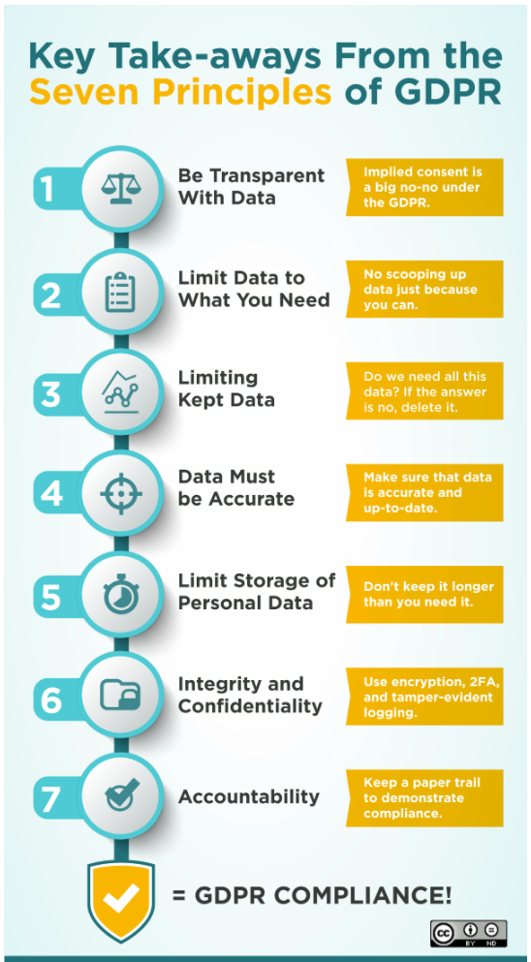
Figure 1: GDPR Data principles [13]

Risk to the Council
The risk exposure in this case is considered minor by the author, due to the fact the data sent by the manager only contains names and addresses and is classed as personal data under GDPR [2]. The author has used a risk matrix for scoring the risk level in this case, highlighted below in figure 2.
Figure 2: Risk matrix [6]
The breach in this case has been scored a two on the above risk matrix, the reason for this score is only names and addresses have been sent to a member of the public, it can be argued this information could have been gained publicly via the internet or electoral roll. No information regarding the staffs genetic or biometric data, criminal offence data, health, sex life, sexual orientation, ethnicity, political, religious beliefs was breached emphasizing the minor score [6].

Mitigating Risk
Data protection staff are now involved to help mitigate risk. In line with the Council Data Breach Policy officers have implemented the three-step policy in place, first step is for the IO (Investigating Officer) to assess the level of risk, step two is containment of the breach where officers try to retrieve the information and ensure the data has not been shared or copied, step three is reporting the incident at corporate level which gives the council 72 hours in which the Data Breach Panel conduct a meeting for further investigation and clarification of the incident and decide whether to inform the ICO (Information Commissioners Office) and data subjects. The author has recommended the following operational measures are considered to the breach panel meeting to reduce further risk to the council. The initial email message is recalled, a full internal audit carried out on the department to determine if the issue is more extensive, a review of training requirements for the manger and staff to ensure adequate training has been provided and awareness of responsibilities raised. The availability of council policies to be checked, staff should be aware of their location and they should be easy to access via the internal website. Emails will be sent to staff to highlight the policies with links placed in the emails for direct access accompanied with a short message as a reminder to staff of responsibility whilst handling data. The storage and access to the data will also be considered with the possibility of moving the data to a central location to be managed by another department this will streamline the process and improve security of the data by restricting access.

ICO (Information Commissioners Office)
The Councils Data Breach Panel will make the final decision as to whether the staff and ICO who are the independent authority for data privacy will be informed of the data breach. The author recommends that both parties are informed of the breach. Legislation in this case provides an argument for the case not to be reported due to the fact its personal data only containing names and addresses and does not pose a high risk to the rights and freedoms of the staff involved [10]. The authors justification in informing both parties is based on the need for the council to show transparency when processing data. When the data breached is scored high risk then the data subjects (staff) would need to be informed before the ICO, the risk being low in this case the author proposes the panel inform the ICO then the data subjects. This pro-active stance will help placate staff once they are informed of the breach that the council is doing everything in its power to mitigate risk and follow the correct protocol in a transparent manner. A further consideration regarding the scanned copies of sick notes and occupational health reports stored on the manger’s computer, if the manager had accidentally sent staff sick notes and occupational health reports this would have amplified the risk factor. The fact medical records would have been breached would have meant under GDPR the data would have been classified as special data [2]. The authors recommendation would have still been to inform the ICO and the data subjects, but the order of contact could be changed due to the nature of the data being sensitive. In this scenario the data subject would have a case of being informed before the ICO. The manger in question could have also face disciplinary action for serious misconduct and possible personal prosecution as specified in the councils Data Protection Policy [12], a demand for a Data Protection Impact Assessment would be made immediately due to corporate risk [12].

IG (Information Governance) Committee Report

3.1 Data Breach
Staff names and addresses have been sent by a manager accidentally to a member of the public. The manger had also stored scanned copies of sick notes and occupational health reports on the desktop of the computer system. This is classed as a data breach by GDPR (General Data Protection Regulation) because unauthorised access to the data has been given to a member of the public. The council must be compliant with GDPR.

3.2 Risk Exposure
Risk exposure has been assessed by the IO (Investigating Officer), in this case the risk has been deemed minor. A risk matrix is utilised using a scoring system one to five, one being negligible and five catastrophic. This case was scored at two, because the data only contained names and addresses and did not contain any further information of the staffs medical records, political, religious beliefs or any criminal offence data [2]. This data is classed by GDPR as personal data.

3.3 Data Principles
Data processing conducted by the council must adhere to GDPR legislation which contains seven principles. The principles and potential breaches are listed below –
- Lawfulness, fairness and transparency – Breach not lawful
- Purpose limitation – Breach manager not following process
- Data minimisation – Potential breach investigation required
- Accuracy - Potential breach investigation required
- Storage limitation - Potential breach investigation required
- Integrity and confidentiality – Breach data sent without authorisation
- Accountability – Council staff to document and record investigation for compliance

Actions to Mitigate Risk
Council data protection officers are working in line with policy to ensure risk is minimised. The Councils Data Breach Policy is being followed, implementing a three-step process. Step one the IO (Investigating Officer) assesses the risk, step two the breach is contained, the retrieval of the data sent being paramount, step three the incident is moved to corporate level. The council under GDPR law has 72 hours to report the breach where feasible [12], the following actions are to be taken as a matter of urgency to minimise the risk to the council. The sick notes and occupational health reports stored on the managers desktop are to be deleted securely. The email sent by the manger is recalled, an internal audit will be carried out on the entire department to ensure the issue is not ubiquitous. Training for the manager and staff will be reviewed and assessed to gauge knowledge levels, further training will be provided to staff where required.

3.5 Further Actions
The following approaches are to be taken to prevent the recurrence of data breaches. Email sent to all staff with a message as a way of reminding those who process data of their responsibilities, links will be placed in the messages to all council policy documents regarding processing data securely and GDPR legislation. The data will be evaluated by IT staff to ensure accuracy and relevance, further investigation to be carried out regarding security of the data with the potential of management being carried out at a central location by HR (Human Resources) or Finance, this will restrict access and improve security. A new poster designed and displayed in communal areas to help raise staff awareness.

References
[1] | B. Wolford, “What is GDPR, the EU’s new data protection law?,” Proton Technologies AG, 2020. [Online]. Available: https://gdpr.eu/what-is-gdpr/#:~:text=Though%20it%20was%20drafted%20and,effect%20on%20May%2025%2C%202018.. [Accessed 01 August 2020].
[2] | ICO, “What is personal data?,” Information Commisoners Office, [Online]. Available: https://ico.org.uk/for-organisations/guide-to-data-protection/guide-to-the-general-data-protection-regulation-gdpr/key-definitions/what-is-personal-data/. [Accessed 01 August 2020].
[3] | ICO, “Annex C: Lawful basis for processing,” Information Comissioners Office, [Online]. Available: https://ico.org.uk/for-organisations/guide-to-data-protection/key-data-protection-themes/age-appropriate-design-a-code-of-practice-for-online-services/annex-c-lawful-basis-for-processing/. [Accessed 2 September 2020].
[4] | ICO, “Controllers and processors,” Information Commisioners Office, [Online]. Available: https://ico.org.uk/for-organisations/guide-to-data-protection/guide-to-the-general-data-protection-regulation-gdpr/key-definitions/controllers-and-processors/. [Accessed 03 August 2020].
[5] | ICO, “The principles,” Information Commisoners Organisation, [Online]. Available: https://ico.org.uk/for-organisations/guide-to-data-protection/guide-to-the-general-data-protection-regulation-gdpr/principles/. [Accessed 03 August 2020].
[6] | K. Collis, “Data Breach Policy,” Swansea Council, Swansea, 2019.
[7] | A. Fletcher, “The Data Protection Framework,” University of Wales, Swansea, 2020.
[8] | ICO, “Special category data,” Information Commsioners Office, [Online]. Available: https://ico.org.uk/for-organisations/guide-to-data-protection/guide-to-the-general-data-protection-regulation-gdpr/lawful-basis-for-processing/special-category-data/. [Accessed 26 August 2020].
[9] | ICO, “Self-assessment for data breaches,” ICO, 2020. [Online]. Available: https://ico.org.uk/for-organisations/report-a-breach/personal-data-breach-assessment/y/q1y/1y. [Accessed 26 August 2020].
[10] | ICO, “Personal data breaches,” ICO, 2020. [Online]. Available: https://ico.org.uk/for-organisations/guide-to-data-protection/guide-to-the-general-data-protection-regulation-gdpr/personal-data-breaches/. [Accessed 30 August 2020].
[11] | D. P. W. PARTY, “Guidelines on Personal data breach notification under Regulation 2016/679 (wp250rev.01),” 20 August 2018. [Online]. Available: https://ec.europa.eu/newsroom/article29/item-detail.cfm?item_id=612052. [Accessed 30 August 2020].
[12] | ICO, “Security breaches,” ICO, 2020. [Online]. Available: https://ico.org.uk/for-organisations/guide-to-pecr/communications-networks-and-services/security-breaches/#:~:text=A%20personal%20data%20breach%20is,a%20public%20electronic%20communications%20service%E2%80%9D.. [Accessed 31 August 2020].
[13] | K. Collis, “Data Protection Policy,” Swansea Council, Swansea, 2019.
[14] | J. EDWARDS, “GDPR Overview: Complying With EU Laws For Personal Data,” Progress, 01 April 2019. [Online]. Available: https://blog.ipswitch.com/gdpr-eu-personal-data. [Accessed 31 August 2020].
[15] | ICO, “How do we do a DPIA?,” Information Commisioners Office, 2020. [Online]. Available: https://ico.org.uk/for-organisations/guide-to-data-protection/guide-to-the-general-data-protection-regulation-gdpr/data-protection-impact-assessments-dpias/how-do-we-do-a-dpia/. [Accessed 13 August 2020].

