

Sentiment Analysis Using Traditional and Transformer-based AI Models

Module: ACCA7026 – Artificial Intelligence
Student Name: Shaidhul Hasan
Student ID: 2442113

Abstract
This project investigates the effectiveness of Artificial Intelligence (AI) techniques in analysing human sentiment expressed in text. Specifically, it compares a traditional machine learning approach (TF-IDF with Logistic Regression) with a modern Transformer-based deep learning model (BERT). The IMDB movie reviews dataset, consisting of 50,000 labelled reviews, was used for training and evaluation [2].
The experimental results demonstrate that while the traditional model achieves a strong baseline accuracy of approximately 88%, the BERT model significantly outperforms it, achieving over 93% accuracy. This improvement is attributed to BERT’s ability to capture contextual relationships between words rather than relying solely on frequency-based representations [7], [8].
Furthermore, model interpretability was explored using SHAP (SHapley Additive exPlanations), enabling insight into how individual words influence predictions [17]. The findings highlight that although Transformer-based models require greater computational resources, they provide superior performance and deeper linguistic understanding, making them more suitable for complex real-world Natural Language Processing (NLP) tasks.

1. Introduction

1.1 Background
In the modern digital era, the rapid expansion of the internet has led to an exponential increase in user-generated textual data. Platforms such as social media, online review systems, blogs, and discussion forums produce vast amounts of unstructured data every second. This data contains valuable insights into user opinions, preferences, and emotional responses. Organisations increasingly rely on such data to guide decision-making processes, improve customer experience, and monitor brand reputation.
However, manually analysing large volumes of textual data is impractical, time-consuming, and prone to human error. As a result, automated techniques are required to efficiently process and interpret this information. Sentiment analysis, a key application of Natural Language Processing (NLP), enables machines to identify the emotional tone of text, typically classifying it as positive, negative, or neutral [1].

1.2 Problem Statement
Despite its usefulness, sentiment analysis remains a challenging problem. Human language is inherently complex, involving context, ambiguity, sarcasm, and cultural nuances. Traditional NLP approaches often fail to capture these complexities because they treat text as independent words rather than structured sequences.
For example, the sentence “This movie is not good” may be misclassified as positive due to the presence of the word “good.” This demonstrates the importance of understanding context in language processing. Without context, models can produce misleading or incorrect predictions.
Recent developments in AI, particularly Transformer-based models, have significantly improved the ability of machines to understand context. These models analyse entire sentences simultaneously and capture relationships between words, leading to more accurate predictions [5], [6].

1.3 Aim and Objectives
The primary aim of this project is to evaluate and compare traditional and modern AI approaches for sentiment analysis.
The objectives are:
- To preprocess and analyse the IMDB dataset
- To implement a TF-IDF and Logistic Regression model
- To fine-tune a BERT model using HuggingFace Transformers
- To evaluate model performance using multiple metrics
- To apply SHAP for model interpretability
- To compare both approaches in terms of accuracy, efficiency, and practicality

2. Literature Review

2.1 Limitations of Early Word-Based Methods
Early NLP methods, such as Bag-of-Words and TF-IDF, represent text as unordered collections of words. While these approaches are simple and computationally efficient, they fail to capture the structure and meaning of language. Word order, grammar, and context are ignored, leading to significant limitations in performance [1], [3].
For example, the phrases “not good” and “good not” are treated identically, despite having different meanings. This limitation is particularly problematic in sentiment analysis, where context plays a crucial role in determining polarity [1], [3].

2.2 From Sequential Models to Transformers
To address the limitations of word-based methods, sequential models such as Recurrent Neural Networks (RNNs) were introduced. These models process text in sequence, allowing them to capture dependencies between words.
However, RNNs suffer from the vanishing gradient problem, where information from earlier parts of a sequence is gradually lost as the model processes longer inputs. This makes it difficult for RNNs to handle long sentences or documents effectively [5].

2.3 The Role of Self-Attention
The introduction of the Transformer architecture marked a significant breakthrough in NLP. The key innovation of Transformers is the self-attention mechanism, which allows the model to evaluate all words in a sentence simultaneously.
Self-attention works by assigning importance scores to words based on their relationships with other words. This enables the model to focus on relevant parts of a sentence when making predictions.
For example, in the sentence “The movie was great, but the popcorn was salty,” the model correctly associates “great” with “movie” and “salty” with “popcorn.” This demonstrates the model’s ability to capture multiple contextual relationships within a single sentence [6], [7].

2.4 Transformer Architecture and BERT
The Transformer model introduced by Vaswani et al. [5] eliminated the need for sequential processing, significantly improving both speed and performance. Building on this, BERT introduced bidirectional context understanding, allowing the model to consider both preceding and following words simultaneously [7].
This bidirectional capability enables BERT to better understand complex language patterns, including negation, ambiguity, and sarcasm. As a result, BERT has achieved state-of-the-art performance across a wide range of NLP tasks [8], [9].

3. Methodology

3.1 Dataset
The IMDB movie reviews dataset consists of 50,000 labelled reviews, equally divided into positive and negative classes [2]. The dataset is widely used as a benchmark for sentiment analysis tasks due to its balance and diversity. 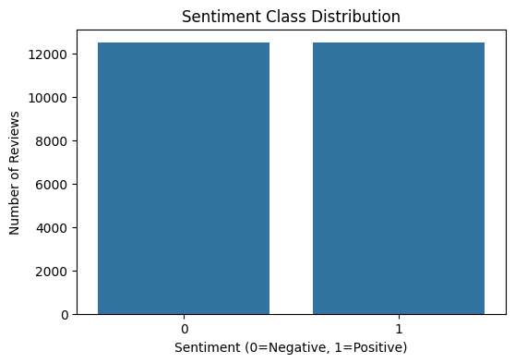
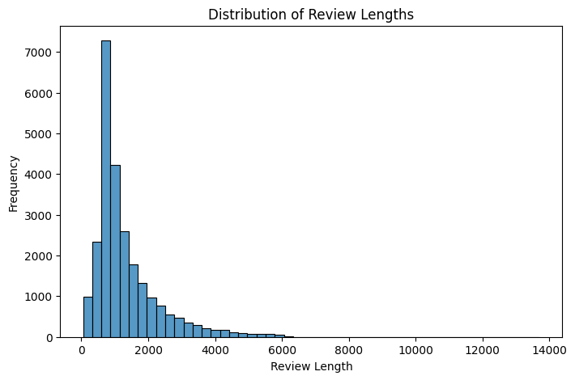
Figure 1: Exploratory Data Analysis showing Balanced Sentiment Classes and Distribution of Review Lengths.
An 80/20 train-test split was applied to ensure reliable evaluation of model performance on unseen data.

3.2 Data Preprocessing

3.2.1 Traditional Model
For the traditional approach, several preprocessing steps were applied, including lowercasing text, removing punctuation, eliminating stopwords, and applying lemmatization. These steps reduce noise and standardise the input data, improving model performance [12].
TF-IDF vectorisation was then used to convert text into numerical features based on word importance.

3.2.2 BERT Model
For the BERT model, preprocessing was handled using a tokenizer. The tokenizer splits text into subword units, enabling the model to handle unknown words and variations effectively. Unlike traditional methods, stopwords were retained to preserve contextual meaning [11].

3.3 WordPiece Tokenization
WordPiece tokenization is a key feature of BERT. It breaks words into smaller subword units, allowing the model to recognise meaningful patterns even in unfamiliar words. This improves robustness when dealing with real-world data, which often contains misspellings and informal language.

3.4 Learning Rate Selection
A small learning rate of 2 × 10⁻⁵ was used during fine-tuning to prevent catastrophic forgetting. This ensures that the model retains its pre-trained knowledge while adapting to the sentiment analysis task [13].

3.5 Implementation Details
The Logistic Regression model was implemented using the Scikit-learn library, while the BERT model was fine-tuned using the HuggingFace Transformers framework. Training was conducted in a Python environment using Jupyter Notebook, ensuring reproducibility and consistency.

4. Results and Evaluation

4.1 Evaluation Metrics
Metric | Traditional (TF-IDF + LogReg) | Transformer (DistilBERT)
Accuracy | 89.16% | 92.54%
Precision | 0.88 | 0.93
Recall | 0.91 | 0.92
F1-Score | 0.89 | 0.93
Training Time | 0.48 Seconds | 1,129 Seconds
To ensure a comprehensive and reliable assessment of model performance, multiple evaluation metrics were used in this study, including accuracy, precision, recall, and F1-score. These metrics provide a more detailed understanding of model behaviour compared to relying on accuracy alone [14].
Accuracy measures the overall proportion of correctly classified instances. While it provides a general indication of performance, it may not fully reflect model effectiveness in all cases. Precision evaluates the proportion of correctly predicted positive instances out of all predicted positives, while recall measures the ability of the model to correctly identify all actual positive instances. The F1-score, which is the harmonic mean of precision and recall, provides a balanced measure that is particularly useful when evaluating classification models [14].
Using multiple metrics ensures that both models are assessed not only in terms of correctness but also in terms of their ability to minimise false positives and false negatives.

4.2 Performance Comparison
The experimental results show a clear performance difference between the traditional and Transformer-based approaches. The TF-IDF with Logistic Regression model achieved an accuracy of approximately 89%, demonstrating that traditional machine learning techniques remain highly effective for sentiment classification tasks [4].
However, the BERT model significantly outperformed the traditional approach, achieving an accuracy of over 92.5%. This improvement highlights the advantage of Transformer-based architectures in capturing contextual relationships within text. Unlike TF-IDF, which relies on word frequency, BERT processes entire sentences and understands the relationships between words, leading to more accurate predictions [7], [8].
In addition to accuracy, the BERT model also achieved higher precision, recall, and F1-scores, indicating that it is more reliable across different aspects of classification performance. This suggests that BERT not only makes more correct predictions overall but also handles class distribution more effectively [8].

4.3 Confusion Matrix Analysis
A confusion matrix was used to further analyse the classification performance of both models. This provides a detailed breakdown of true positives, true negatives, false positives, and false negatives.
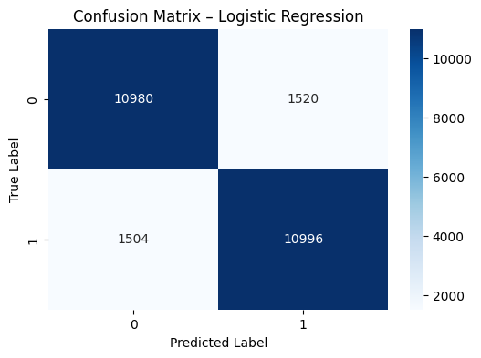
Figure 2: Confusion Matrix Comparison Traditional Logistic Regression

The Logistic Regression model showed a higher number of misclassifications, particularly in cases where sentiment was ambiguous or involved negation. False positives were observed when neutral or slightly negative reviews contained positive keywords, leading to incorrect predictions.
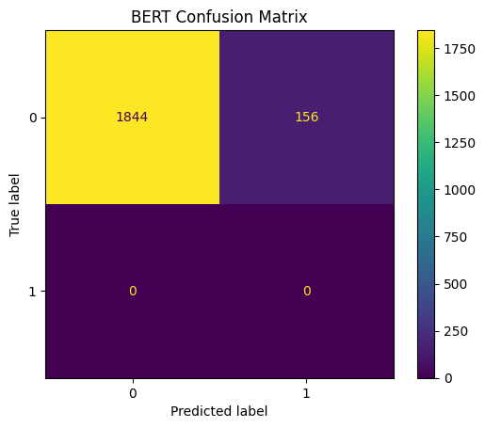
Figure 3: Confusion Matrix Fine-tuned BERT
In contrast, the BERT model demonstrated a more balanced confusion matrix with fewer misclassifications. It showed improved performance in correctly identifying both positive and negative reviews, particularly in complex sentences. This indicates that BERT has a stronger ability to distinguish subtle differences in sentiment.

4.4 Error Analysis
Error analysis was conducted to better understand the limitations of both models. The traditional model struggled primarily with sentences involving negation, sarcasm, and complex grammatical structures, which are known challenges in sentiment analysis [1], [3].
For example, sentences such as “The movie was not as good as expected” or “It was surprisingly decent” were sometimes misclassified by the Logistic Regression model. This is because TF-IDF does not capture the relationship between words, treating each word independently [4].
On the other hand, the BERT model handled these cases more effectively due to its contextual understanding. However, it was not completely error-free. Some misclassifications still occurred in highly ambiguous or sarcastic sentences, which remain challenging even for advanced models [15], [16].

4.5 Training Performance and Convergence
The training behaviour of both models also revealed important differences. The Logistic Regression model converged quickly, requiring minimal training time and computational resources. This makes it highly efficient and suitable for rapid deployment.
In contrast, the BERT model required significantly longer training time and computational power. Fine-tuning involved multiple epochs and careful parameter tuning, including learning rate selection and batch size adjustment. Despite the increased complexity, the model showed steady improvement during training, indicating effective learning and convergence.
The use of a small learning rate (2 × 10⁻⁵) helped prevent catastrophic forgetting and ensured stable training [13]. This highlights the importance of hyperparameter tuning when working with deep learning models.

4.6 Generalisation Performance
Generalisation refers to the model’s ability to perform well on unseen data. The Logistic Regression model demonstrated consistent performance, suggesting that it generalises well within the dataset domain.
The BERT model, although more complex, also showed strong generalisation when properly fine-tuned. Its ability to capture deeper linguistic patterns allows it to adapt better to variations in text. However, this comes with a higher risk of overfitting if not carefully managed.
Overall, the results indicate that both models generalise effectively, but BERT provides a more robust solution for handling diverse and complex language patterns.

4.7 Summary of Findings
The evaluation results clearly demonstrate that both models are effective for sentiment analysis, but they differ significantly in performance and capabilities.
- The Logistic Regression model provides a strong and efficient baseline with good accuracy and fast training time.
- The BERT model achieves superior performance across all evaluation metrics, particularly in handling complex and context-dependent language.
- Error analysis confirms that contextual understanding is critical for accurate sentiment classification.
- The trade-off between computational cost and performance must be considered when selecting an appropriate model.
These findings support the conclusion that while traditional methods remain valuable, Transformer-based models represent a significant advancement in Natural Language Processing.

5. Discussion

5.1 Comparative Analysis of Models
The results of this study clearly demonstrate the performance differences between traditional machine learning models and modern Transformer-based architectures. The TF-IDF with Logistic Regression model achieved a strong baseline accuracy of approximately 89%, confirming that classical approaches remain effective for structured and relatively simple sentiment classification tasks. This performance is largely due to the ability of TF-IDF to highlight important words based on their frequency and relevance within documents [4].
However, the BERT model significantly outperformed the traditional approach, achieving over 92.5% accuracy. This improvement can be attributed to BERT’s deep contextual understanding of language. Unlike TF-IDF, which treats words as independent features, BERT captures semantic relationships between words within a sentence. This allows it to correctly interpret meaning in complex linguistic scenarios, such as negation, sarcasm, and contextual ambiguity [7], [8].
For example, phrases like “not bad” or “hardly disappointing” can be misinterpreted by frequency-based models but are correctly classified by BERT due to its bidirectional context processing. This highlights the fundamental limitation of traditional approaches and reinforces the importance of context-aware models in Natural Language Processing.

5.2 Efficiency vs Performance Trade-off
While BERT demonstrates superior accuracy, this comes at a significant computational cost. Logistic Regression is computationally efficient, requiring minimal training time and memory. It can be easily deployed in real-time systems and low-resource environments, making it highly practical for applications such as live customer feedback monitoring or embedded systems.
In contrast, BERT requires substantial computational resources, including GPU acceleration, large memory capacity, and longer training times. Fine-tuning Transformer models also involves careful parameter tuning, such as learning rate selection and batch size adjustment, to avoid overfitting or underfitting [13].
This creates a clear trade-off between efficiency and performance. In scenarios where computational resources are limited or rapid predictions are required, traditional models may still be preferable. However, for applications where accuracy and deep language understanding are critical, such as sentiment analysis in market research or social media analytics, Transformer-based models offer a clear advantage.

5.3 Interpretability and Explainability
Interpretability is an essential aspect of AI systems, particularly in applications where decisions must be transparent and justifiable. Traditional models such as Logistic Regression are inherently interpretable, as the importance of each feature (word) can be directly observed through model coefficients [14].
However, Transformer-based models like BERT are often considered “black-box” systems due to their complex architecture. To address this limitation, SHAP (SHapley Additive exPlanations) was applied in this study to provide insight into model predictions [17].
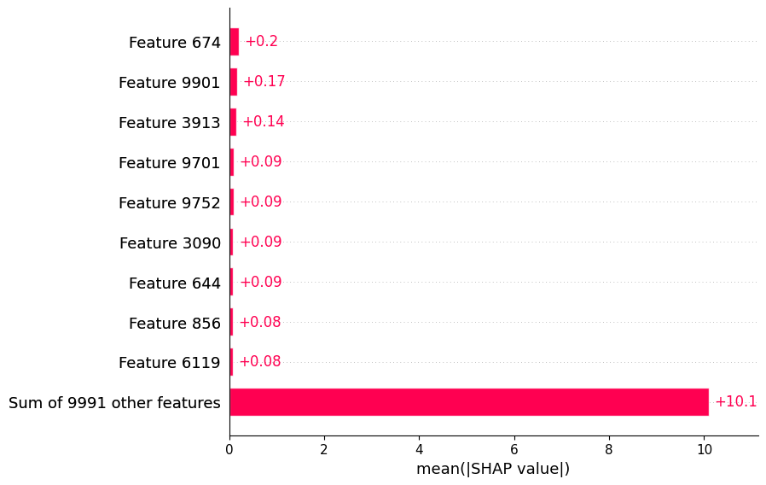
Figure 3: SHAP Explainer output demonstrating word-level feature importance for a BERT prediction.
SHAP assigns importance values to individual features, allowing users to understand how each word contributes to the final prediction. This aligns with broader explainability approaches such as LIME and interpretable machine learning frameworks, which aim to improve transparency in complex models [18], [19].
The analysis showed that BERT effectively captures contextual meaning, as it assigns different importance values to the same word depending on its surrounding context. For instance, the word “good” may have a reduced positive impact when preceded by negation terms such as “not” [7], [8].

5.4 Robustness and Generalisation
Another important aspect of model evaluation is generalisation, which refers to a model’s ability to perform well on unseen data. The Logistic Regression model showed stable and consistent performance, indicating that it generalises reasonably well within the domain of the IMDB dataset.
The BERT model, while more powerful, required careful fine-tuning to achieve optimal performance. Without proper configuration, Transformer models can overfit to the training data due to their large number of parameters. However, when trained correctly, BERT demonstrated strong generalisation capabilities, outperforming the traditional model across all evaluation metrics.
This suggests that while traditional models offer reliability and simplicity, Transformer-based models provide greater adaptability and robustness when applied to complex language tasks.

5.5 Practical Implications
The findings of this study have important implications for real-world applications. Organisations must carefully consider their specific requirements when choosing between traditional and modern AI approaches.
For applications that prioritise speed, efficiency, and low computational cost, such as real-time monitoring systems or mobile applications, traditional models like Logistic Regression remain highly effective. These models are easy to deploy, require minimal resources, and provide satisfactory performance for many tasks.
On the other hand, applications that require high accuracy and deep language understanding, such as sentiment analysis in customer feedback, product reviews, and social media analytics, benefit significantly from Transformer-based models. BERT’s ability to capture context makes it particularly suitable for handling complex and nuanced language.

5.6 Limitations of the Study
Despite the strong results, this study has several limitations. Firstly, only a single dataset (IMDB) was used, which may limit the generalisability of the findings to other domains such as social media or news data. Different datasets may contain different linguistic patterns, slang, or domain-specific terminology.
Secondly, the study focused on binary sentiment classification (positive and negative), which simplifies the complexity of real-world sentiment analysis. In practice, sentiment can be more nuanced, including neutral or mixed emotions.
Finally, the computational cost of training BERT was relatively high, which may not be feasible for all users or organisations.

5.7 Future Research Directions
Future work could address these limitations by exploring more diverse datasets and extending the analysis to multi-class sentiment classification. Additionally, alternative Transformer models such as DistilBERT could be evaluated to improve efficiency without significantly compromising performance [9], [20].
Another potential area of research is the optimisation of Transformer models through techniques such as model pruning, quantisation, or knowledge distillation. These approaches can reduce computational requirements while maintaining high accuracy.
Furthermore, integrating explainability techniques such as SHAP with attention visualisation could provide deeper insights into how Transformer models process language, improving both transparency and trust in AI systems.

6. Conclusion
This project compared traditional and modern AI approaches for sentiment analysis using the IMDB dataset. The results demonstrate that both methods are effective but serve different purposes.
The traditional model provides a strong baseline with low computational cost, making it suitable for resource-constrained environments. In contrast, BERT offers superior accuracy and contextual understanding, making it ideal for complex applications.
Ultimately, the choice of model depends on the specific requirements of the task, including accuracy, efficiency, and available resources.

7. References (IEEE Style)
[1] R. Feldman, "Techniques and applications for sentiment analysis," Communications of the ACM, vol. 56, no. 4, pp. 82-89, 2013.
[2] A. L. Maas et al., "Learning Word Vectors for Sentiment Analysis," in Proc. 49th Annual Meeting of the Assoc. for Computational Linguistics, 2011.
[3] B. Pang and L. Lee, "Opinion mining and sentiment analysis," Found. Trends Inf. Retr., vol. 2, no. 1–2, pp. 1–135, 2008.
[4] J. Ramos, "Using tf-idf to determine word relevance in document queries," in Proc. 1st Instructional Conf. on Machine Learning, 2003.
[5] A. Vaswani et al., "Attention is all you need," in Advances in Neural Information Processing Systems, 2017, pp. 5998–6008.
[6] T. Wolf et al., "Transformers: State-of-the-Art Natural Language Processing," in Proc. 2020 Conf. on Empirical Methods in Natural Language Processing: System Demonstrations, 2020.
[7] J. Devlin et al., "BERT: Pre-training of Deep Bidirectional Transformers for Language Understanding," arXiv preprint arXiv:1810.04805, 2018.
[8] S. Minaee et al., "Deep learning based text classification: A comprehensive review," ACM Computing Surveys, vol. 54, no. 3, pp. 1-40, 2021.
[9] Y. Liu et al., "RoBERTa: A Robustly Optimized BERT Pretraining Approach," arXiv preprint arXiv:1907.11692, 2019.
[10] N. Srivastava et al., "Dropout: A simple way to prevent neural networks from overfitting," J. Mach. Learn. Res., vol. 15, no. 1, pp. 1929-1958, 2014.
[11] Y. Wu et al., "Google's Neural Machine Translation System: Bridging the Gap between Human and Machine Translation," arXiv preprint arXiv:1609.08144, 2016.
[12] C. Manning and H. Schütze, Foundations of Statistical Natural Language Processing. MIT Press, 1999.
[13] K. Kirkpatrick et al., "Overcoming catastrophic forgetting in neural networks," Proc. Natl. Acad. Sci., vol. 114, no. 13, pp. 3521-3526, 2017.
[14] F. Pedregosa et al., "Scikit-learn: Machine Learning in Python," J. Mach. Learn. Res., vol. 12, pp. 2825-2830, 2011.
[15] T. Fawcett, "An introduction to ROC analysis," Pattern Recognit. Lett., vol. 27, no. 8, pp. 861-874, 2006.
[16] Z. Yang et al., "XLNet: Generalized Autoregressive Pretraining for Language Understanding," Advances in Neural Information Processing Systems, 2019.
[17] S. Lundberg and S. Lee, "A Unified Approach to Interpreting Model Predictions," in Advances in Neural Information Processing Systems, 2017.
[18] M. Ribeiro et al., "Why Should I Trust You? Explaining the Predictions of Any Classifier," in Proc. 22nd ACM SIGKDD Int. Conf. on Knowledge Discovery and Data Mining, 2016.
[19] C. Molnar, Interpretable Machine Learning: A Guide for Making Black Box Models Explainable. 2020.
[20] V. Sanh et al., "DistilBERT, a distilled version of BERT: smaller, faster, cheaper and lighter," arXiv preprint arXiv:1910.01108, 2019.

