University of Wales Trinity Saint David
School of Engineering

2D Transient Heat Equation Solved with the Explicit Finite Difference Method
Computational Methods
ACMA6012

Heather Came
2208198
02/02/2026

Abstract

This report models two-dimensional transient heat diffusion in an aluminium plate using an Explicit Finite Difference Method (EFDM) implemented in MATLAB. The system is defined by the two-dimensional heat equation with constant material properties and no internal heat generation. The plate is discretised using a uniform Cartesian grid, and temperatures are advanced in time using a five-point explicit finite difference stencil. A prescribed-temperature boundary condition is applied along the top edge at $T_{top}$, while the remaining boundaries are held at 0°C, and the initial temperature is 0°C throughout the domain. Numerical stability is maintained by enforcing the explicit 2D diffusion constraint $Fo=αΔt/h^{2}≤1/4$. Thermal equilibrium is identified using a convergence criterion based on the maximum absolute change between successive temperature fields falling below a specified tolerance.
Model validation is performed at steady state by comparing the converged numerical temperature field with an analytical benchmark available for the chosen boundary conditions, evaluated using a truncated Fourier series. Agreement is assessed visually using contour plots and an absolute difference map, and quantitatively using the maximum absolute error and root mean square error (RMSE). The numerical and analytical fields show close agreement in overall temperature distribution and symmetry, with the most notable differences occurring near the heated edge where gradients are steepest.
A sensitivity study investigates how grid spacing, time step and equilibrium tolerance influence computational cost, reported equilibrium time and agreement with the analytical solution. The results show that parameter choice affects both runtime and error metrics, and that tightening the equilibrium tolerance substantially increases the number of iterations required to converge. These findings highlight that equilibrium time and final error measures are conditional on discretisation settings and the stopping criterion, rather than being purely physical outputs. Potential improvements are discussed, including adopting unconditionally stable implicit schemes and using more robust equilibrium detection criteria for steady-state detection.

Contents

1 Introduction 1
2 The governing equation 2
3 Explicit finite difference form of the governing equation 3
3.1 Taylor series basis and finite difference approximations 3
3.2 Spatial and temporal discretisation 3
3.3 EFDM formulation for the 2D heat equation 4
3.4 Stability analysis and Fourier number limit 5
4 The initial and boundary conditions implemented 6
5 Code’s details and explanations 8
6 Validation of the model 13
7 Sensitivity analysis of the model 16
7.1 Sensitivity to grid spacing 16
7.2 Sensitivity to time step, Δt 18
7.3 Sensitivity to convergence tolerance 19
7.4 Recommended settings 21
Considering all three sweeps, recommended settings for this model are h ≈ 0.75–1.2 m and ε ≈ 0.0001°C, while Δt should satisfy stability and avoid tolerance-driven premature termination (≈ 400–1000 s for the tested configuration). These recommendations depend on the tolerance-based equilibrium definition used here and therefore motivate the Chapter 8 discussion of improved stopping criteria (Crank, 1975). 21
8 Limitations of the Numerical Model. 22
8.1 Numerical method limitations 22
8.2 Implementation limitations 23
9 Suggested improvements and future developments 24
10 Conclusion 25
11 References 26
12 Appendix 28
12.1 Matlab Script 28

Figure 1 - Stencil used for the EFDM Laplacian (reproduced from University of Wales Trinity Saint David, 2026, p.2) 4
Figure 2 - Computational domain and boundary/initial conditions (reproduced from University of Wales Trinity Saint David, 2026, p.3) 6
Figure 3 - Environment setup and property definition (α) 8
Figure 4 - User inputs and validation (X, Y, h) 9
Figure 5 - Grid construction, initial condition, and boundary application 9
Figure 6 - Time-step acceptance and Fo reporting 10
Figure 7 - Explicit update loop and stopping criterion 10
Figure 8 - Numerical field output and contour plot 11
Figure 9 - Analytical benchmark evaluation and contour plot 11
Figure 10 - Error map, validation metrics and equilibrium time 12
Figure 11 - EFDM steady-state temperature field map 13
Figure 12 - Analytical steady-state temperature field map 14
Figure 13 - Absolute difference map |$Tnum - Tana$| 15
Figure 14 -Thermal equilibrium time vs grid spacing $h$ 17
Figure 15 – RMSE vs grid spacing plot 17
Figure 16 - Thermal equilibrium time vs time step Δt graph 18
Figure 17 – RMSE vs time step plot 19
Figure 18 - Thermal equilibrium time vs tolerance graph 20

Table 1 - Thermal equilibrium time vs grid spacing 16
Table 2 - Thermal equilibrium time vs time step Δt table 18
Table 3 - Thermal equilibrium time vs tolerance ε 20

Introduction

Transient heat conduction describes the time-dependent redistribution of temperature within a solid. For many practical boundary conditions and geometries, numerical methods are used to approximate temperature fields while controlling stability and approximation error (Bergman et al., 2017). This report models two-dimensional heat conduction in an aluminium plate and evaluates the accuracy of an Explicit Finite Difference Method (EFDM) implementation. Performance is judged by agreement with the analytical steady-state temperature field, and by the sensitivity of equilibrium time, RMSE and maximum absolute error to numerical settings.
The objectives are to: state the governing equation, assumptions, initial condition and boundary conditions; derive the EFDM discretisation and stability requirement using the Fourier number; implement a forward-in-time, central-in-space five-point stencil and define an equilibrium criterion; validate the numerical steady-state field against an analytical benchmark using maximum absolute error and RMSE; and assess sensitivity to grid spacing, time step and convergence tolerance before proposing improvements. The report progresses from model formulation and discretisation, through implementation and results, to validation, sensitivity analysis, limitations and recommendations.

The governing equation

Transient heat diffusion in solids is governed by the heat equation derived from conservation of energy and Fourier’s law of conduction (Bergman et al., 2017). For a homogeneous, isotropic plate with no internal heat generation, the two-dimensional transient heat equation is:
$$\frac{dT}{dt} = α (\frac{d^{2}T}{dx^{2}} +\frac{d^{2}T}{dy^{2}})$$
An equivalent rearranged form is:
$$\frac{d^{2}T}{dx^{2}} +\frac{d^{2}T}{dy^{2}} = \left(\frac{1}{α}\right)\frac{dT}{dt}$$

where T is temperature (°C), t is time (s), x and y are spatial coordinates (m), and α is thermal diffusivity ($\frac{m^{2}}{s}$). Thermal diffusivity is defined as:
$$α =\frac{k}{ρ cp}$$

where k is thermal conductivity ($\frac{W}{m°C }$), ρ is density ($\frac{kg}{m^{3}}$), and cp is specific heat capacity ($\frac{J}{kg°C }$). A larger α implies faster diffusion of thermal disturbances through the material (Çengel and Ghajar, 2020).
The model assumes constant material properties, no volumetric heat generation (q̇ = 0), and negligible through-thickness gradients so the problem is treated as two-dimensional. Prescribed-temperature (Dirichlet) boundary conditions are applied on the relevant plate edges, enabling validation of the numerical method against an analytical steady-state benchmark (Bergman et al., 2017).

Explicit finite difference form of the governing equation

This chapter outlines how the Explicit Finite Difference Method (EFDM) is obtained from Taylor-series-based approximations, leading to a forward-in-time, central-in-space (FTCS) scheme for the 2D heat equation and its associated stability limit (Strikwerda, 2004).

Taylor series basis and finite difference approximations

Finite difference approximations are obtained by expanding the temperature field about a grid point and retaining leading-order terms. A Taylor expansion in time about $t^{n}$gives:
$$T^{n+1} = T^{n} + {\left(\frac{∂T}{∂t}\right)}^{n} Δt + O\left(Δt^{2}\right)$$
Rearranging produces the forward (explicit) approximation:
$${\left(\frac{∂T}{∂t}\right)}^{n} ≈\frac{T^{n+1} - T^{n}}{Δt}$$
with truncation error O (Δt) (LeVeque, 2007).
For the second spatial derivative in $x$, expansions about $x_{i}$ give the standard central difference form:
$${\left(\frac{∂^{2T}}{∂x^{2}}\right)}_{i} ≈\frac{T_{i+1}- 2T_{i}+ T_{i-1}}{h^{2}}$$
with truncation error $O\left(h^{2}\right)$ (Strikwerda, 2004).
The same approximation applies in the $y$-direction (Strikwerda, 2004). Therefore, the FTCS diffusion scheme is first-order accurate in time and second-order accurate in space, meaning temporal error scales with $Δt$while spatial truncation error scales with $h^{2}$until other effects dominate (Smith, 1985).

Spatial and temporal discretisation

The plate is discretised using a uniform Cartesian grid with $Δx=Δy=h$. Grid nodes are located at $x_{i}=ih$, $y_{j}=jh$, and the solution is evaluated at discrete times $t^{n}=nΔt$. The nodal temperature is denoted $T_{i,j}^{n}$. Using a uniform grid produces the standard five-point stencil for the Laplacian, where each interior node couples to its north, south, east, and west neighbours.

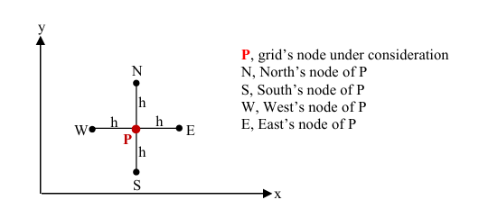
Figure 1 - Stencil used for the EFDM Laplacian (reproduced from University of Wales Trinity Saint David, 2026, p.2)

EFDM formulation for the 2D heat equation

Starting from the governing equation:
$$\frac{∂T}{∂t} = α\left(\frac{∂^{2T}}{∂x^{2}}+\frac{∂^{2T}}{∂y^{2}}\right)$$
and applying a forward difference in time with central differences in space gives:
$$\frac{T_{\left\{i,j\right\}}^{\left\{n+1\right\}}- T_{\left\{i,j\right\}}^{n}}{Δt} = α\left[\frac{T_{\left\{i+1,j\right\}}^{n}- 2T_{\left\{i,j\right\}}^{n}+ T_{\left\{i-1,j\right\}}^{n}}{h^{2}}+\frac{T_{\left\{i,j+1\right\}}^{n}- 2T_{\left\{i,j\right\}}^{n}+ T_{\left\{i,j-1\right\}}^{n}}{h^{2}}\right]$$
Rearranging produces the explicit update equation:
$$T_{\left\{i,j\right\}}^{\left\{n+1\right\}} = T_{\left\{i,j\right\}}^{n} + Fo\left[\left(T_{\left\{i+1,j\right\}}^{n}+ T_{\left\{i-1,j\right\}}^{n}+ T_{\left\{i,j+1\right\}}^{n}+ T_{\left\{i,j-1\right\}}^{n}\right)- 4T_{\left\{i,j\right\} }^{n}\right]$$
where the Fourier number Fo is:
$$Fo =\frac{αΔt}{h^{2}}$$
The Fourier number is a non-dimensional diffusion parameter that links spatial and temporal discretisation and directly governs the behaviour of explicit diffusion time-marching (Crank, 1975).

Stability analysis and Fourier number limit

The conditional stability of explicit diffusion schemes can be shown using von Neumann analysis, by assuming Fourier-mode errors and requiring that the amplification factor magnitude does not exceed unity for all wave numbers (LeVeque, 2007). For the 2D FTCS five-point stencil with equal spacing in $x$and $y$, this gives the standard stability condition:
$$Fo ≤\frac{1}{4}$$
(Crank, 1975).
Using $Fo=\frac{αΔt}{h^{2}}$, the limit enforced in the implementation is:
$$Δt ≤\frac{h^{2}}{4α}$$
This links the stability theory directly to the code’s time-step check and explains the main computational trade-off used later in the sensitivity analysis: reducing $h$improves spatial resolution but forces $Δt$to reduce with $h^{2}$, increasing the number of time steps required (Strikwerda, 2004).

The initial and boundary conditions implemented

The initial condition (IC) applied throughout the plate is a uniform temperature of 0°C, such that T(x,y,0) = 0 for all interior nodes. This represents a plate initially at a reference temperature before a thermal boundary is imposed and provides a clear baseline from which transient diffusion can be observed (Bergman et al., 2017).

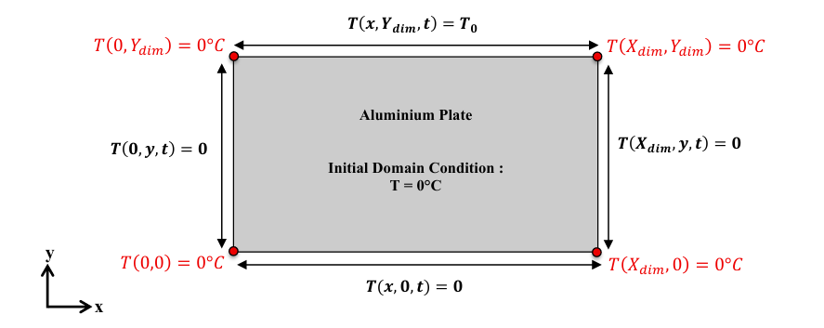
Figure 2 - Computational domain and boundary/initial conditions (reproduced from University of Wales Trinity Saint David, 2026, p.3)

Figure 2 summarises the initial and boundary conditions used for the two-dimensional plate model. The initial condition is a uniform temperature field, $T(x,y,0)=0$for $0<x<X_{dim}$and $0<y<Y_{dim}$, representing a plate initially at the reference temperature prior to heating. Dirichlet boundary conditions are imposed: the north boundary is prescribed as $T(x,Y_{dim},t)=T_{0}$for $0<x<X_{dim}$, while the west, east and south boundaries are maintained at T = 0 °C. In the numerical implementation, the corner nodes are set consistently with the adjacent 0 °C boundaries, so the top-left and top-right corners remain at 0 °C while the interior of the top edge is fixed at $T_{0}$. These time-invariant prescribed-temperature boundaries represent ideal contact with thermal reservoirs and provide an unambiguous validation case (Çengel and Ghajar, 2020).
At thermal equilibrium, $\frac{∂T}{∂t} = 0$ and the governing equation reduces to Laplace’s equation,
$$\frac{∂^{2}T}{∂x^{2}} +\frac{∂^{2}T}{∂y^{2}} = 0$$
For this rectangular Dirichlet problem, an analytical steady-state series solution exists and is used as the benchmark for validating the EFDM results. The solution is written as a sine-series in x to satisfy the zero-temperature side boundaries, which yields odd harmonic indices k = 2n + 1 (Carslaw and Jaeger, 1959).

Code’s details and explanations

The following commentary summarises each code section shown in Figures 3–10 and explains its role in producing the model outputs. The MATLAB script proceeds through property definition, user input validation, stability checking, explicit time marching, convergence testing, and post-processing outputs. Code–report mapping: gridSpacing = h, timeStep = Δt, alpha = α, FourierNumber = Fo, tolerance = ε. Equilibrium is declared when $max⁡∣T^{n+1}-T^{n}∣<ε$.
Figure 3 clears the command window, workspace and figures (clc, clear, close all) to ensure a clean, repeatable run. Aluminium properties are defined and the thermal diffusivity alpha is calculated and printed.

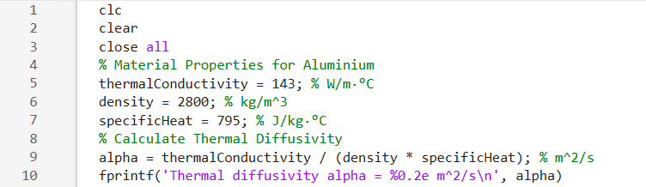
Figure 3 - Environment setup and property definition (α)

Figure 4 prompts for plateWidth, plateHeight, and gridSpacing, rejecting empty/non-positive values and enforcing that h divides both dimensions (and is not equal to a dimension) to ensure a valid grid and indexing.

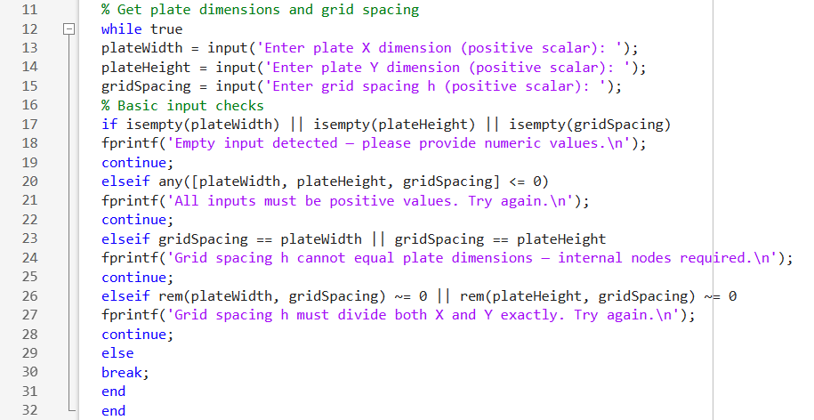
Figure 4 - User inputs and validation (X, Y, h)

Figure 5 computes node counts, initialises T_current to enforce $T(x,y,0)=0$, and applies the top boundary T_top on the north edge excluding corners (2:numCols-1), leaving the other edges at 0 °C.

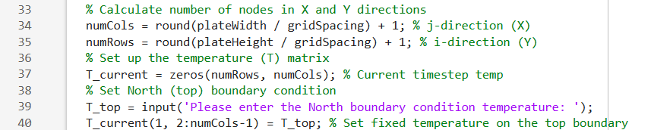
Figure 5 - Grid construction, initial condition, and boundary application

Figure 6 computes maxTimeStep = h^2/(4*alpha), re-prompts until timeStep is valid, then prints FourierNumber so the run settings are explicit and repeatable.

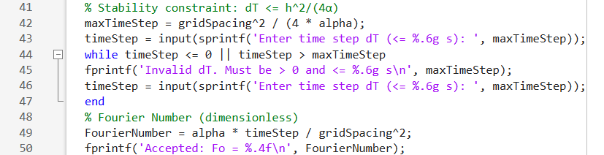
Figure 6 - Time-step acceptance and Fo reporting

Figure 7 advances only interior nodes using a five-point stencil with T_next to avoid overwrite within an iteration, and applies the stopping criterion via maxDiff = max(abs(T_next(:) - T_current(:))).

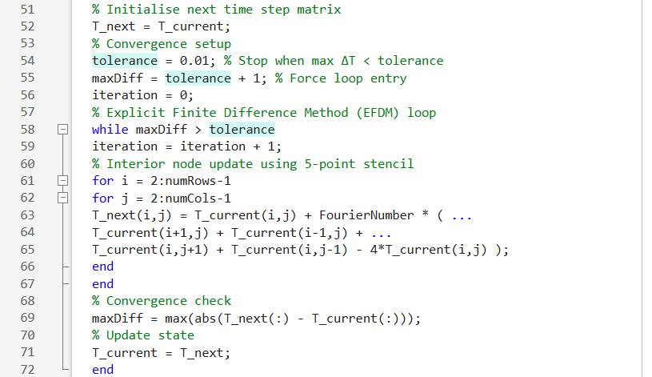
Figure 7 - Explicit update loop and stopping criterion

Figure 8 displays the converged numerical field, prints the step count, and plots the numerical contour (T_current) with labelled axes and reversed y-direction.
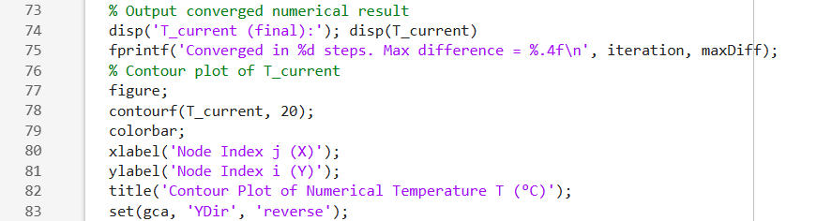
Figure 8 - Numerical field output and contour plot

Figure 9 evaluates the analytical steady-state field on the same grid (meshgrid) using a truncated odd-term series (numTerms, k = 2*n + 1) and plots the analytical contour (T_analytical) for direct comparison.

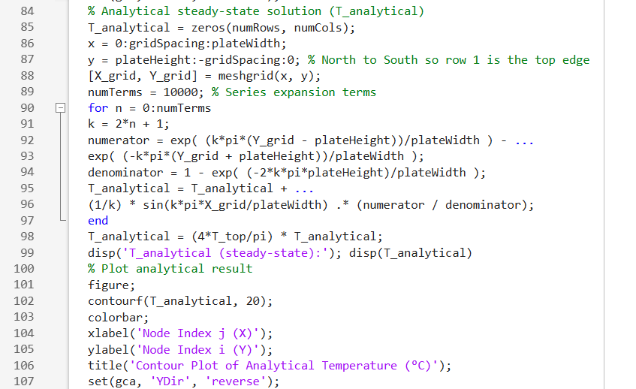
Figure 9 - Analytical benchmark evaluation and contour plot

Figure 10 computes the absolute error field (absError), plots it, prints maximum absolute error and RMSE, and reports equilibrium time as iteration * timeStep with automatic unit formatting.
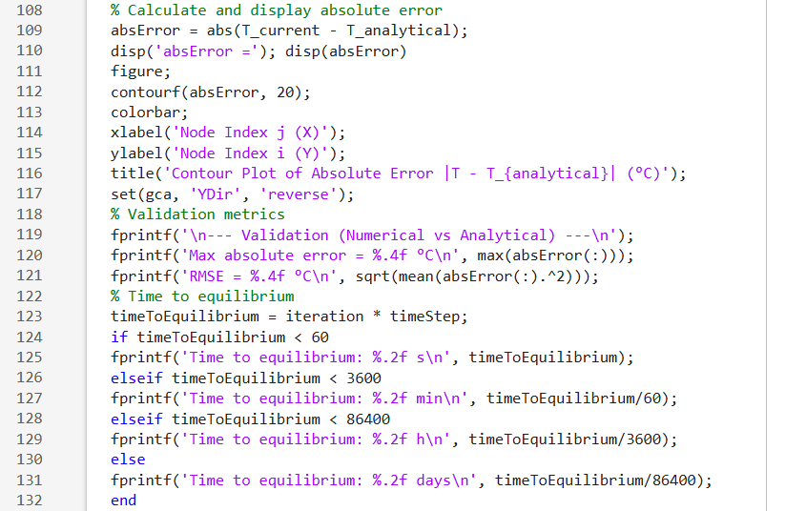
Figure 10 - Error map, validation metrics and equilibrium time

Because equilibrium is tolerance-based, the reported equilibrium time and final error metrics depend on ε, Δt, and h (discussed later).

Validation of the model

Model validation compared the EFDM steady-state temperature field, $T_{num}$ (x,y), with the analytical steady-state solution, $T_{ana}$(x,y), for identical boundary conditions (Oberkampf and Trucano, 2002). Numerical equilibrium was defined when the maximum absolute change between successive fields satisfied $max|T^{n+1} - T^{n}| < ε$ (AIAA, 1998). Validation used a 12m×12m plate with T_top = 50°C, h = 1m and Δt = 1500s and tolerance ε = 0.0010 °C, converging in 423 steps (7.34 days). The remaining discrepancy is expected to be localised near the heated edge where gradients are steep, with residual error dominated by analytical series truncation.

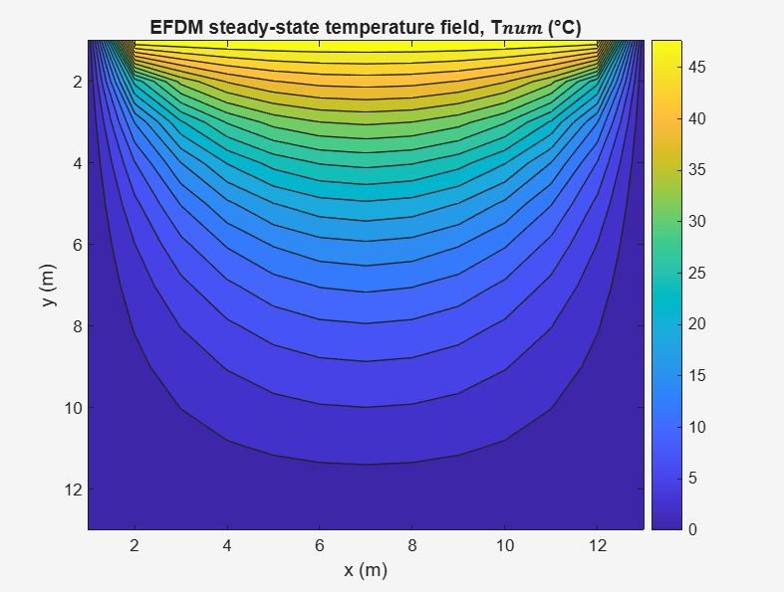
Figure 11 - EFDM steady-state temperature field map

Visual validation is provided by Figure 11 (EFDM steady-state field) and Figure 12 (analytical steady-state field), which show closely matched isotherm structure and symmetric gradients (Croft and Lilley, 1977).

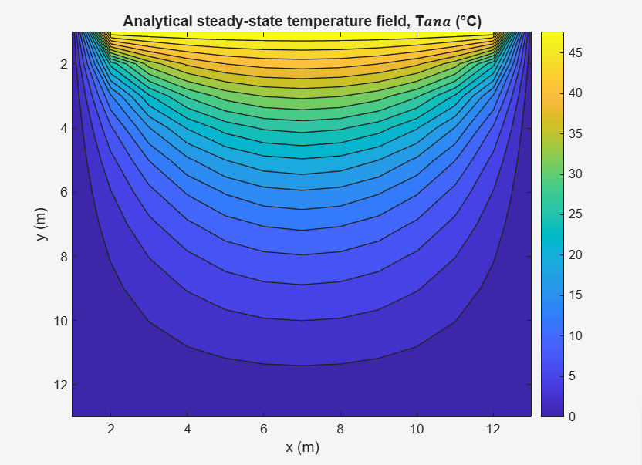
Figure 12 - Analytical steady-state temperature field map

Figure 13 presents the absolute difference |$T_{num} - T_{ana}$|, with the largest differences near the heated top edge and top corners where gradients are steepest, consistent with greater local truncation error in high-gradient regions (Croft and Lilley, 1977). Quantitative validation used maximum absolute error of 0.3756°C and RMSE of 0.0884°C.
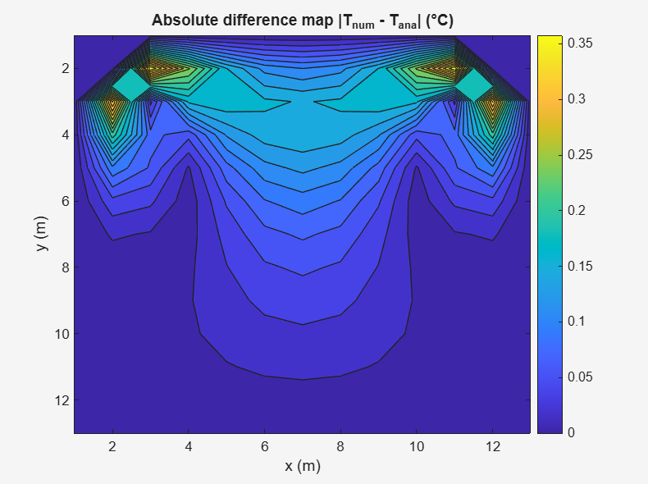
Figure 13 - Absolute difference map |$T_{num} - T_{ana}$|

Truncation of the analytical series introduces a smaller residual contribution to the benchmark field (Ozisik, 2013). Overall, the EFDM steady-state result shows strong agreement with the analytical solution for the selected h and Δt, supported by sub-0.4°C peak error and low RMSE.

Sensitivity analysis of the model

This chapter evaluates sensitivity of the EFDM outputs to grid spacing h, time step Δt and equilibrium tolerance ε. Sensitivity is quantified using convergence behaviour (steps and the reported equilibrium time $t_{eq}=N_{steps}Δt$, where $N_{steps}$ is the iterations to satisfy ε) and accuracy against the analytical steady-state benchmark (RMSE and maximum absolute error) (Crank, 1975).

Sensitivity to grid spacing

The reported equilibrium time is effectively constant across most meshes (≈ 373,350–374,100 s for 0.2 m ≤ h ≤ 3 m), while the coarsest mesh converges earlier (345,150 s), as summarised in Table 1 and shown in Figure 14. RMSE improves from 0.4196°C at h = 4 m to a minimum of 0.3596°C at h = 1.2m, then changes only marginally with further refinement, as shown in Figure 15. This diminishing-return behaviour under refinement is characteristic of grid convergence studies (Roache, 1994)

Table 1 - Thermal equilibrium time vs grid spacing

Near-constant $t_{eq}$ across many h values indicates that the reported equilibrium time is dominated by the tolerance-based termination criterion rather than the physical diffusion time scale for these settings (Crank, 1975). The divergence between RMSE and peak error, e.g., the h = 3 m case where maximum error is elevated despite improved RMSE in Table 1, is consistent with localised discretisation error; typically near steep boundary gradients influencing the maximum metric more than the global RMSE (Smith, 1985).
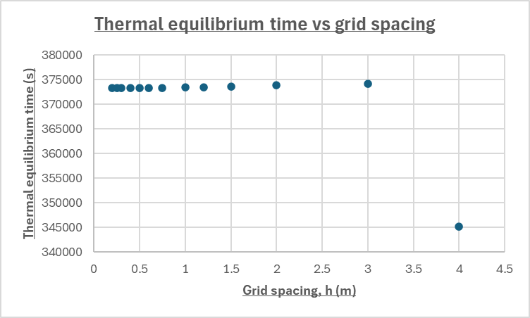
Figure 14 -Thermal equilibrium time vs grid spacing $h$

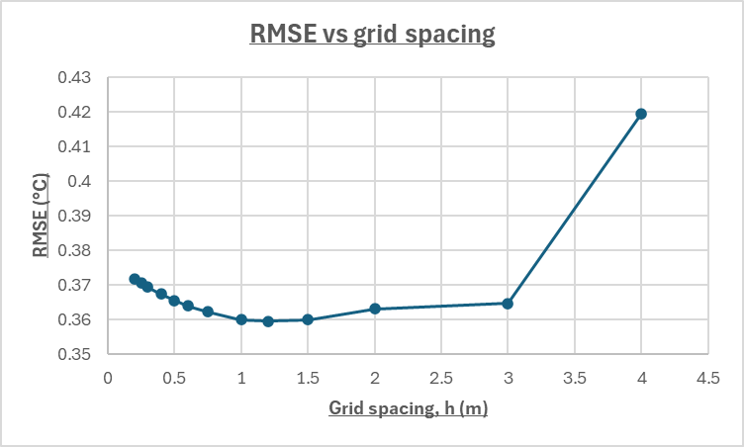
Figure 15 – RMSE vs grid spacing plot

A defensible compromise is h ≈ 0.75–1.2 m: RMSE is near-minimum while avoiding unnecessary computational cost for negligible accuracy gain (Roache, 1994).

Sensitivity to time step, Δt

As Δt is reduced, the step count increases substantially, but the reported equilibrium time decreases (from 926,000s to 431,575s), as reported in Table 2 and shown in Figure 16. Accuracy does not improve monotonically: RMSE is lowest and stable for larger time steps (≈ 0.0624–0.0637°C for 400–2000s) but increases sharply at small Δt (0.2233°C at 25s), with maximum absolute error also increasing, as shown in Figure 17 and reported in Table 2.

Table 2 - Thermal equilibrium time vs time step Δt table

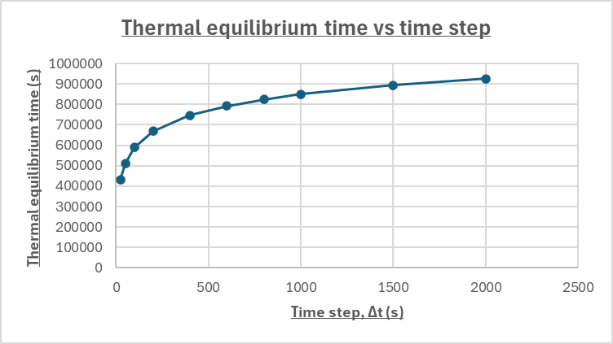
Figure 16 - Thermal equilibrium time vs time step Δt graph

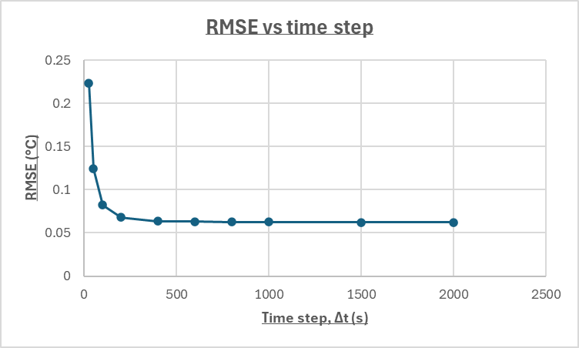
Figure 17 – RMSE vs time step plot

This behaviour indicates that the stopping rule can cause premature termination at small Δt (Roy, 2005). The per-step temperature change scales with Δt, so reducing Δt reduces $∣T^{n+1}-T^{n}∣$ and can satisfy the tolerance at a smaller physical time t_eq = N_steps Δt, even when the temperature field remains measurably different from the analytical steady state (Press et al., 2007).
This reflects a limitation of the equilibrium definition rather than a physical acceleration of diffusion and is discussed further in Chapter 8 (Morton and Mayers, 2005). For the tested configuration, Δt ≈ 400–1000 s provides low RMSE while avoiding tolerance-driven early stopping at very small Δt (Crank, 1975).

Sensitivity to convergence tolerance

Tightening ε increases the reported equilibrium time strongly (55,500s at 0.1°C to 1,298,000s at 0.000001°C), as reported in Table 3 and shown in Figure 18. Accuracy improves rapidly at first (RMSE reduces from 6.1147°C to 0.1327°C by ε = 0.001°C), but improvements plateau beyond ε = 0.0001°C (RMSE changes only from 0.0821°C to 0.0814°C while runtime increases substantially), as reported in Table 3.

Table 3 - Thermal equilibrium time vs tolerance ε

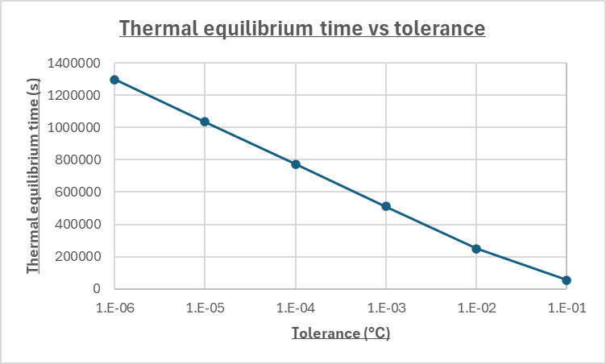
Figure 18 - Thermal equilibrium time vs tolerance graph

The plateau indicates diminishing returns where additional runtime is dominated by enforcing a tighter numerical threshold rather than materially improving the final steady-state temperature field (Press et al., 2007).
A practical tolerance is ε ≈ 0.0001°C, which lies on the accuracy plateau without the disproportionate runtime penalty of tighter criteria (Morton and Mayers, 2005).

Recommended settings

Considering all three sweeps, recommended settings for this model are h ≈ 0.75–1.2 m and ε ≈ 0.0001°C, while Δt should satisfy stability and avoid tolerance-driven premature termination (≈ 400–1000 s for the tested configuration). These recommendations depend on the tolerance-based equilibrium definition used here and therefore motivate the Chapter 8 discussion of improved stopping criteria (Crank, 1975).

Limitations of the Numerical Model.

Numerical method limitations

- Truncation error
Discretisation introduces truncation error that decreases as h and Δt are refined (Morton and Mayers, 2005).
Evidence: reducing h from 4m to 1.2m reduced RMSE from 0.4196°C to 0.3596°C but increased equilibrium time from 345150s to 373500s (Table 1; Figure 15).
Impact: accuracy gains require increased runtime and show diminishing returns (Roache, 1998).
- Round-off accumulation
Long explicit runs can accumulate floating-point rounding effects (Higham, 2002).
Evidence: tightening ε from 0.1°C to 0.000001°C increased steps from 111 to 2596 and equilibrium time from 55500s to 1298000s (Table 3; Figure 18).
Impact: results from very tight tolerances may be influenced by accumulated numerical noise (Higham, 2002).
- Conditional stability and Δt–ε interaction
Explicit diffusion requires $Fo ≤ ¼$ , constraining Δt as h is refined (Crank, 1975).
Evidence: reducing Δt from 2000s to 25s increased steps from 463 to 17263, while RMSE increased from 0.0624°C to 0.2233°C (Table 2; Figures 16–17).
Impact: smaller Δt increases cost and, with a per-step tolerance criterion, can terminate earlier in physical time without improving agreement (Morton and Mayers, 2005).
- Geometry restriction
A structured Cartesian EFDM generalises poorly to complex boundaries (Ferziger and Perić, 2002).
Evidence: the sensitivity study varies only numerical parameters for a fixed rectangular plate (Tables 1–3; Figures 14–18).
Impact: extension to curved/irregular domains would require boundary treatment that increases discretisation error and implementation complexity (Ferziger and Perić, 2002).

Implementation limitations

- Tolerance-based equilibrium
The stopping rule $max|T^{n+1} - T^{n}| < ε$ is numerical rather than physics-based (Roache, 1998).
Evidence: tightening ε from 0.01°C to 0.0001°C increased equilibrium time from 248500s to 773000s and reduced RMSE from 1.0490°C to 0.0821°C (Table 3; Figure 18).
Impact: reported equilibrium time and final errors depend strongly on ε and are not unique physical quantities (Roache, 1998).
- Benchmark and sampling limits
The analytical field uses a truncated series, and comparison is node-based (Ozisik, 2013).
Evidence: the largest discrepancies occur near the heated edge/corners (Figure 13).
Impact: max error and RMSE include benchmark truncation and under-resolution effects, especially where gradients are steep (Morton and Mayers, 2005).

Suggested improvements and future developments

The present forward-time, central-space EFDM is constrained by the explicit stability requirement for the 2D FTCS scheme ($Fo ≤\frac{1}{4}$ for a uniform grid) (LeVeque, 2007). Since $Fo =\frac{αΔt}{h^{2}}$, the stability limit implies $Δt ∝ h^{2}$, so mesh refinement rapidly increases runtime due to both a higher node count and a smaller allowable time step, consistent with the Chapter 7 sensitivity trends (LeVeque, 2007).
An improvement is to use an implicit time-stepping method such as Backward Euler or Crank–Nicolson. These methods largely remove the strict explicit stability limit, so a larger time step can be used for a chosen grid spacing. The trade-off is that each time step no longer updates temperatures using only known values; instead, the temperatures at the new time level must be found by solving a set of simultaneous algebraic equations (Smith, 1985; Strikwerda, 2004). For structured 2D grids, Alternating Direction Implicit (ADI) methods reduce this cost by solving the 2D implicit problem as two cheaper 1D solves per time step, which is computationally efficient because each 1D solve has a simple matrix structure that can be solved efficiently (Peaceman and Rachford, 1955).
If the geometry or boundary conditions are extended beyond a simple rectangle, finite element methods support unstructured meshing and local refinement, while finite volume methods preserve strong local conservation and extend naturally to flux-based formulations (Zienkiewicz and Taylor, 2005; Patankar, 1980).
Finally, the equilibrium definition can be strengthened. Chapters 7–8 show that termination based on $max|T^{n+1} - T^{n}| < ε$ is sensitive to both Δt and ε, so a residual-based stopping rule is recommended (for example, requiring the discrete Laplacian residual norm to fall below a threshold), optionally combined with monitoring the change in total thermal energy to reduce premature termination in slowly evolving regions and improve robustness to Δt and ε (Morton and Mayers, 2005).

Conclusion

The aim of this work was to implement and evaluate a two-dimensional transient heat diffusion model for an aluminium plate using an Explicit Finite Difference Method with Dirichlet boundary conditions. Stability was enforced using the explicit Fourier number constraint when selecting the time step.
Validation against an analytical steady-state benchmark demonstrated close agreement between the converged EFDM field and the analytical temperature distribution, with a maximum absolute error of 0.3756 °C and an RMSE of 0.0884°C. Residual differences were concentrated near the heated boundary, where gradients are steepest.
Sensitivity analysis indicated that grid spacing, time step and equilibrium tolerance strongly affect both computational cost and the reported equilibrium time. Mesh refinement reduced spatial error initially but showed diminishing returns beyond a practical resolution. Reducing the time step increased iteration count and, under a fixed per-step tolerance, can lead to apparent convergence at an earlier simulated time, reducing agreement with the analytical benchmark (Morton and Mayers, 2005). Tightening the tolerance reduced error rapidly at first, then plateaued, while equilibrium time continued to increase.
The main limitations are the conditional stability of the explicit scheme and the tolerance-based equilibrium criterion; the most effective improvement would be an unconditionally stable implicit approach (for example Crank–Nicolson or ADI) combined with a residual-based stopping condition to reduce sensitivity of equilibrium time to numerical settings (Crank, 1975).

References

American Institute of Aeronautics and Astronautics (AIAA) (1998) Guide for the Verification and Validation of Computational Fluid Dynamics Simulations (AIAA G-077-1998). Reston, VA: American Institute of Aeronautics and Astronautics.
Bergman, T.L., Lavine, A.S., Incropera, F.P. and DeWitt, D.P. (2017) Fundamentals of Heat and Mass Transfer. 8th ed. Hoboken, NJ: Wiley.
Carslaw, H.S. and Jaeger, J.C. (1959) Conduction of Heat in Solids. 2nd ed. Oxford: Oxford University Press.
Çengel, Y.A. and Ghajar, A.J. (2020) Heat and Mass Transfer: Fundamentals and Applications. 6th ed. New York, NY: McGraw-Hill Education.
Crank, J. (1975) The Mathematics of Diffusion. 2nd ed. Oxford: Clarendon Press.
Croft, D.R. and Lilley, D.G. (1977) Heat Transfer Calculations Using Finite Difference Equations. London: Applied Science Publishers.
Ferziger, J.H. and Perić, M. (2002) Computational Methods for Fluid Dynamics. 3rd rev. and extended ed. Berlin: Springer.
Higham, N.J. (2002) Accuracy and Stability of Numerical Algorithms. 2nd ed. Philadelphia, PA: Society for Industrial and Applied Mathematics.
LeVeque, R.J. (2007) Finite Difference Methods for Ordinary and Partial Differential Equations: Steady-State and Time-Dependent Problems. Philadelphia, PA: Society for Industrial and Applied Mathematics.
Morton, K.W. and Mayers, D.F. (2005) Numerical Solution of Partial Differential Equations: An Introduction. 2nd ed. Cambridge: Cambridge University Press.
Oberkampf, W.L. and Trucano, T.G. (2002) ‘Verification and validation in computational fluid dynamics’, Progress in Aerospace Sciences, 38(3), pp. 209–272.
Ozisik, M.N. (2013) Boundary Value Problems of Heat Conduction. Mineola, NY: Dover Publications.
Patankar, S.V. (1980) Numerical Heat Transfer and Fluid Flow. Washington, DC: Hemisphere Publishing Corporation.
Peaceman, D.W. and Rachford, H.H. (1955) ‘The numerical solution of parabolic and elliptic differential equations’, Journal of the Society for Industrial and Applied Mathematics, 3(1), pp. 28–41.
Press, W.H., Teukolsky, S.A., Vetterling, W.T. and Flannery, B.P. (2007) Numerical Recipes: The Art of Scientific Computing. 3rd ed. Cambridge: Cambridge University Press.
Roache, P.J. (1994) ‘Perspective: A method for uniform reporting of grid refinement studies’, Journal of Fluids Engineering, 116(3), pp. 405–413.
Roache, P.J. (1998) Verification and Validation in Computational Science and Engineering. Albuquerque, NM: Hermosa Publishers.
Roy, C.J. (2005) ‘Review of code and solution verification procedures for computational simulation’, Journal of Computational Physics, 205(1), pp. 131–156.
Smith, G.D. (1985) Numerical Solution of Partial Differential Equations: Finite Difference Methods. 3rd ed. Oxford: Oxford University Press.
Strikwerda, J.C. (2004) Finite Difference Schemes and Partial Differential Equations. 2nd ed. Philadelphia, PA: Society for Industrial and Applied Mathematics.
University of Wales Trinity Saint David (2026) Level 6 Assessment Specification for Computational Methods (ACMA6012): used for Figure 1 and Figure 2 (five-point stencil; computational domain and boundary conditions). Swansea: University of Wales Trinity Saint David.
Zienkiewicz, O.C., Taylor, R.L. and Nithiarasu, P. (2005) The Finite Element Method for Fluid Dynamics. 6th ed. Oxford: Butterworth-Heinemann.

Appendix

Matlab Script

Please see below the script written in Matlab for the purposes of this report..

clc
clear
close all
% Material Properties for Aluminium
thermalConductivity = 143; % W/m·°C
density = 2800; % kg/m^3
specificHeat = 795; % J/kg·°C
% Calculate Thermal Diffusivity
alpha = thermalConductivity / (density * specificHeat); % m^2/s
fprintf('Thermal diffusivity alpha = %0.2e m^2/s\n', alpha)
% Get plate dimensions and grid spacing
while true
plateWidth = input('Enter plate X dimension (positive scalar): ');
plateHeight = input('Enter plate Y dimension (positive scalar): ');
gridSpacing = input('Enter grid spacing h (positive scalar): ');
% Basic input validation
if isempty(plateWidth) || isempty(plateHeight) || isempty(gridSpacing)
fprintf('Empty input detected — please provide numeric values.\n');
continue;
elseif any([plateWidth, plateHeight, gridSpacing] <= 0)
fprintf('All inputs must be positive values. Try again.\n');
continue;
elseif gridSpacing == plateWidth || gridSpacing == plateHeight
fprintf('Grid spacing h cannot equal plate dimensions — internal nodes required.\n');
continue;
elseif rem(plateWidth, gridSpacing) ~= 0 || rem(plateHeight, gridSpacing) ~= 0
fprintf('Grid spacing h must divide both X and Y exactly. Try again.\n');
continue;
else
break;
end
end
% Calculate number of nodes in X and Y directions
numCols = round(plateWidth / gridSpacing) + 1; % j-direction (X)
numRows = round(plateHeight / gridSpacing) + 1; % i-direction (Y)
% Initialise temperature matrix
T_current = zeros(numRows, numCols); % Current timestep temp
% Set North (top) boundary condition
T_top = input('Please enter the North boundary condition temperature: ');
T_current(1, 2:numCols-1) = T_top; % Dirichlet BC on top edge
% Stability constraint: dT <= h^2/(4α)
maxTimeStep = gridSpacing^2 / (4 * alpha);
timeStep = input(sprintf('Enter time step dT (<= %.6g s): ', maxTimeStep));
while timeStep <= 0 || timeStep > maxTimeStep
fprintf('Invalid dT. Must be > 0 and <= %.6g s\n', maxTimeStep);
timeStep = input(sprintf('Enter time step dT (<= %.6g s): ', maxTimeStep));
end
% Fourier Number (dimensionless)
FourierNumber = alpha * timeStep / gridSpacing^2;
fprintf('Accepted: Fo = %.4f\n', FourierNumber);
% Initialise next time step matrix
T_next = T_current;
% Convergence setup
tolerance = 0.01; % Stop when max ΔT < tolerance
maxDiff = tolerance + 1; % Force loop entry
iteration = 0;
% Explicit Finite Difference Method (EFDM) loop
while maxDiff > tolerance
iteration = iteration + 1;
% Interior node update using 5-point stencil
for i = 2:numRows-1
for j = 2:numCols-1
T_next(i,j) = T_current(i,j) + FourierNumber * ( ...
T_current(i+1,j) + T_current(i-1,j) + ...
T_current(i,j+1) + T_current(i,j-1) - 4*T_current(i,j) );
end
end
% Convergence check
maxDiff = max(abs(T_next(:) - T_current(:)));
% Update state
T_current = T_next;
end
% Output converged numerical result
disp('T_current (final):'); disp(T_current)
fprintf('Converged in %d steps. Max difference = %.4f\n', iteration, maxDiff);
% Contour plot of T_current
figure;
contourf(T_current, 20);
colorbar;
xlabel('Node Index j (X)');
ylabel('Node Index i (Y)');
title('Contour Plot of Numerical Temperature T (°C)');
set(gca, 'YDir', 'reverse');
% Analytical steady-state solution (T_analytical)
T_analytical = zeros(numRows, numCols);
x = 0:gridSpacing:plateWidth;
y = plateHeight:-gridSpacing:0; % North to South so row 1 is the top edge
[X_grid, Y_grid] = meshgrid(x, y);
numTerms = 10000; % Series expansion terms
for n = 0:numTerms
k = 2*n + 1;
numerator = exp( (k*pi*(Y_grid - plateHeight))/plateWidth ) - ...
exp( (-k*pi*(Y_grid + plateHeight))/plateWidth );
denominator = 1 - exp( (-2*k*pi*plateHeight)/plateWidth );
T_analytical = T_analytical + ...
(1/k) * sin(k*pi*X_grid/plateWidth) .* (numerator / denominator);
end
T_analytical = (4*T_top/pi) * T_analytical;
disp('T_analytical (steady-state):'); disp(T_analytical)
% Plot analytical result
figure;
contourf(T_analytical, 20);
colorbar;
xlabel('Node Index j (X)');
ylabel('Node Index i (Y)');
title('Contour Plot of Analytical Temperature (°C)');
set(gca, 'YDir', 'reverse');
% Calculate and display absolute error
absError = abs(T_current - T_analytical);
disp('absError ='); disp(absError)
figure;
contourf(absError, 20);
colorbar;
xlabel('Node Index j (X)');
ylabel('Node Index i (Y)');
title('Contour Plot of Absolute Error |T - T_{analytical}| (°C)');
set(gca, 'YDir', 'reverse');
% Validation metrics
fprintf('\n--- Validation (Numerical vs Analytical) ---\n');
fprintf('Max absolute error = %.4f °C\n', max(absError(:)));
fprintf('RMSE = %.4f °C\n', sqrt(mean(absError(:).^2)));
% Time to equilibrium
timeToEquilibrium = iteration * timeStep;
if timeToEquilibrium < 60
fprintf('Time to equilibrium: %.2f s\n', timeToEquilibrium);
elseif timeToEquilibrium < 3600
fprintf('Time to equilibrium: %.2f min\n', timeToEquilibrium/60);
elseif timeToEquilibrium < 86400
fprintf('Time to equilibrium: %.2f h\n', timeToEquilibrium/3600);
else
fprintf('Time to equilibrium: %.2f days\n', timeToEquilibrium/86400);
end

