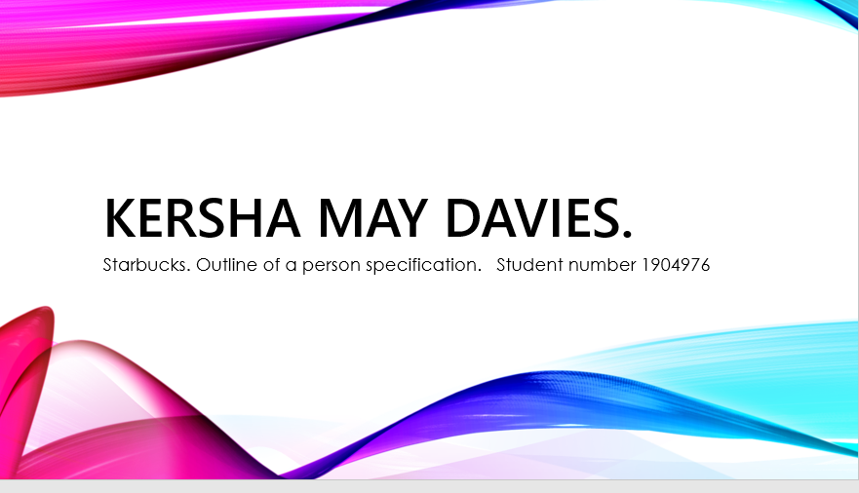

Introduction.
This is an outline of personal specification (CV). I will be showing what person specification we use for our company Starbucks and why.

Outline of a person specification.
Starbucks
An outline of a person specification means a person must have these skills to complete tasks of a position offered by the company. A personal specification shows a person’s education requirements their training experiences. And all other qualifications a person has. We are asking for applicants to apply thorough our online application process. We ask for candidates to attach a CV with your Application this is stated in the application process. (BusinessDictionary.com, 2019).

Qualifications.
There are no essential qualifications for our company Starbucks, only food safety or a food hygiene certificate would be preferred. This is more of a desirable qualification for our company.

Skills & Competencies.

We are looking for employees who can work under high pressure environments. This is one of the skills required for our company, they should be customer centric and have attention to detail. These skills are essential for an employee to have to work for our company.

Knowledge:

Employees must have retail Knowlagent E.G experiences in coffee shops and cafes. They should have some experience in various coffees this isn’t essential but is preferred. Employees should have good memory skills to learn company polices and keep up with any new procedures within our company.

Personal Attributes.

Employees should be friendly happy candidates and are keen to provide an exceptional customer experience and service. This is an essential skill to have for our company (UKEssays.com, 2019).
Supervisor
Job Summary and Mission
This job role includes assisting the store manager. They are asked to deploy partners and delegate tasks, so that partners can create a good experience at star bucks and follow the Starbucks guiding principles.

Summary of Key Responsibilities
We ask you to maintain a calm dementor during busy times. Evaluate the environment managing customer cues and communicate to the manager, so that the team can respond as necessary to create the third-place environment. Executes store operations and follow Starbucks cash handling and safety and security. We ask you to provide quality beverages. Help the manager with training other employees and gives a positive atmosphere in the workplace. And to develop good relationships with employees in the workplace.

Experience & Qualifications:
Candidates are asked to Maintain regular and consistent attendance and punctuality good attendance and punctuality. Flexible with hours and meets Starbucks policy (Starbucks.taleo.net, 2019).

Customer satisfaction.
We strive and take pride to make customers feel a comfortable and uplifting experience. To achieve this ambiance employees, need to follow the customers unique experience customers can customize their beverage to their required taste. Employees are required to make the customer feel as positive and welcomed as possible. Using an emotional connection and try and get to know the customers on a personal level so that they can know their required beverage. This is essential in our company as we aim to make the customers feel they have the best positive experience.
Our company executives and managers understand the importance of this personal connection. Therefore, it is so important for employees to understand the skills. And meet Starbucks criteria and policies (Michelli, 2019).

Reference list.
BusinessDictionary.com. (2019). What is person specification? definition and meaning. [online] Available at: http://www.businessdictionary.com/definition/person-specification.html [Accessed 26 Nov. 2019].

Michelli, J. (2019). McGraw Hill.

Starbucks.taleo.net. (2019). Starbucks Careers. [online] Available at: https://starbucks.taleo.net/careersection/1000222EuroRetail/jobdetail.ftl?job=180002328&lang=en-GB [Accessed 28 Nov. 2019].

UKEssays.com. (2019). Starbucks Recruitment and Selection Process. [online] Available at: https://www.ukessays.com/services/example-essays/business/recruitment-starbucks.php [Accessed 26 Nov. 2019].

