REVIEWING THE CURRENT CHALLENGES FACED BY HILTON LONDON HOTELS IN MANAGING THEIR EMPLOYEE ENGAGEMENT IN THE UK

- Mohammed Majid
- Personnel Resourcing and Development
- BMIH5005
- Kathryn Roberts

Table of Contents
Task 1 3
Introduction and Background 3
Task 2 5
Task 3 6
Task 4 11
Evaluation and conclusion 11
References 13

Task 1

Introduction to the hotel and issue faced by the hotel
Hilton hotels in UK are a global brand of hospitality with 34 resorts and hotels in at least 15 countries worldwide. The concerning hotel chains are rebound in the hospitality sector for providing the customers most luxurious experience to the tourists’ worldwide (hilton.com, 2022). Recent outbreak of covid-19 pandemic had impacted adversely in almost every industry worldwide. As a result, the hospital industry had gone through serious economical declination in UK (Parliament.UK, 2022). Additionally, the ever-changing needs of customers lead the hospitality industry to be conscious to provide effective service for retaining customer satisfaction.
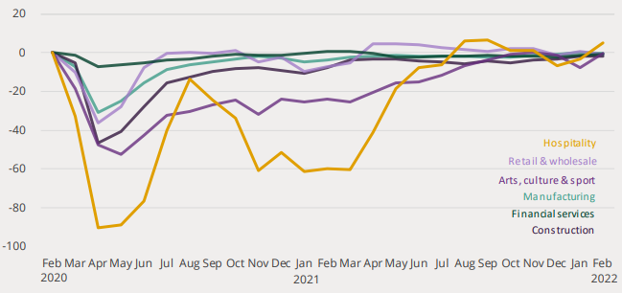
Figure 1: Significant economic decline of hospital industry during pandemic
(Source: Parliament.UK, 2022)
The above figure highlights the havoc declination of the economic performance of the hospitality sector of UK at the time of the ongoing pandemic (Parliament.UK, 2022).
Aim and objective
The study aims to evaluate the current challenges faced by Hilton London hotels in managing their employee engagement in the UK
Objectives
RO1: To evaluate the current challenges in the hospital industry in managing the employees
RO2: To examine the importance of employee retention and development of team for enhancing business performance in Hilton London hotels
Research question
RQ1: What are the current challenges in the hospital industry in managing the employees?
RQ2: Why employee retention and the development of teams for enhancing business performance in Hilton London hotels are important?

Task 2
The present study will be conducted based on the primary data, which will be collected by conducting survey. The study will try to collect quantitative data from the Hilton hotel chains in UK. Therefore, this primary and quantitative research will follow a positivism philosophy as its research framework. According to Alharahsheh and Pius (2020), positivism philosophy helps to analyze the quantitative data with the understanding of the values and trends of the phenomena. Moreover, this research will follow a deductive approach which will help the study to gain a scientific approach (Cramer-Petersen et al. 2019). Deductive approach helps to analyze the quantitative data and provide real-time results on the research phenomena, which will be effective for the present study. The research will follow an exploratory design that would scientifically investigate and define the research phenomena. Exploratory design helps the quantitative study with the ability of understanding the remaining issues and generates ideas from the analysis of quantitative data (Hochbein and Smeaton, 2018).

Task 3
The study will follow a primary and quantitative method that would provide reliability and validity at the end of the study. However, several sources of secondary data will enrich the study by providing an understanding of current challenges in the management in retaining and engaging employees. There remain several challenges in the hospitality industry that the hotels are facing, which will be highlighted in the present task.
Discussion
Current challenges faced by the hotels in managing the employees
The hospitality industry went through severe challenges for the recent outbreak of the covid-19 virus. In the past few years, the hospitality industry has already gone through several challenges in managing employees due to the heavy amount of employee turnover (Bufquin et al. 2021). The hospitality industry faces several challenges regarding global competition. The hotel industry faced serious struggle due to the shutdown of the hotel business worldwide, and as a result, the hotel faced issues regarding paying the employees (Gursoy and Chi, 2020). Therefore, it impacted the lifecycle of the employees, and a massive amount of employee turnover happened.
A significant challenge faced by the hotel managers is due to the inability to recruit workforce in the hospitality sector (Ons.gov.uk, 2022). The challenges regarding managing employees include several external and global factors. The ever-changing market trends and evolving customer needs demand effective and productive service from the hospitality sector (Njoroge et al. 2019). Therefore, the hotels’ demands for experienced staff and other criteria make several interested candidates unable for joining the job role. Additionally, the negative work environment of the hospitality sector, as well as high competition and lack of supervision and human resource-related policies, creates a vast amount of employee turnover.
The research will further proceed with the collection of data following a quantitative strategy. The study will be based on collecting numerical data from developing questionnaires. Questionnaire development is essential for obtaining numerical data for conducting primary quantitative analysis (Sürücü and MASLAKÇI, 2020). The study will be conducted on the basis of conducting surveys by collecting data from managers and employees. The study will be validated by the analysis of statistical data to conclude the study with the evaluation of management strategies of Hilton Hospitals of UK in engaging and managing staff. Hence, this research will evaluate current challenges of hotel businesses for managing and retaining employees and help to understand the benefits of employee retention in business development. Therefore, the present study will shed light on the challenges faced by Hilton London hotels while engaging and managing their employees in UK to evaluate the impotence of managing and retaining the employees.

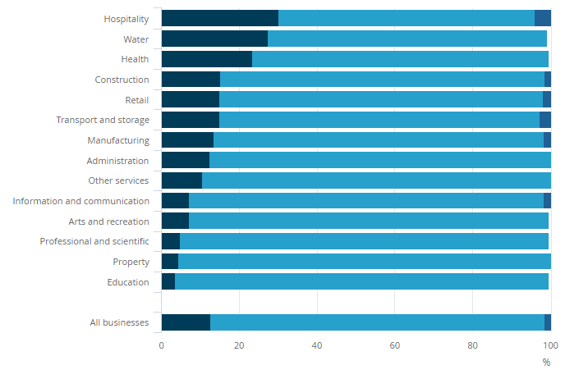
Figure 2: Hospitality sector faced recruitment issues the most in UK
(Source: Ons.gov.uk, 2022)
The above-mentioned factors adversely impact the hospitality industry, which leads to employee turnover at a high rate. Moreover, there are some lacks from the management that leads to the dissatisfaction of the employees. According to Font and Lynes, (2018) Lack of communication with the employees makes the working culture challenging for them. Furthermore, Operations need to work properly in managing reservations, handling guest requests, housekeeping and front desk duties, there’s a lot to juggle on a daily basis. The managers' decision regarding providing training to make employees efficient is absent whereas their demand for maintaining efficiency is rising (Waqanimaravu and Arasanmi, 2020). Hence, the study will try to find the current challenges in the Hilton Hotel group as well as evaluate their managerial performance in engaging the employees.
Importance of engaging and retaining employees in hospitality industry to enhance business performance
The hospitality industry is mostly dependent on its workforce, whose constant efforts to provide adequate service to the customer bring success to the industry. The management of the hospital industry, therefore, plays a significant role in engaging the employees and making efforts in retaining employees. According to Book et al. (2019), the role of leaders and managers is essential in retaining the workforce in the hospitality sector by maintaining effective relationships with them. Similarly, as commented by Bhardwaj and Kalia (2021), hospitality is a major service all over the world which seeks a large workforce and the ability to serve the customers that maintain the performance of the hotels as well. However, the hospital industry faces several challenges in retaining and engaging employees, which should be improved.
The hotel industry faces major challenges in managing and retaining employees. The other reasons faced by the hotels in hospitality management include the major changes in market dynamics and trends that make the customers’ needs ever-changing. Moreover, the hospital industry faces operational issues, housekeeping-related issues, and high pricing of daily essentials, which leads to face major difficulties for the hotels. According to Ertuna et al. (2019), Hilton hotel chain believes that the engagement of employees and employee retention can enhance the internal operational activities of the hotels. However, several factors are creating issues in the hotel chain regarding the employee engagement and retention. The present study shows several challenges and issues the hospitality industry goes through in managing employees.
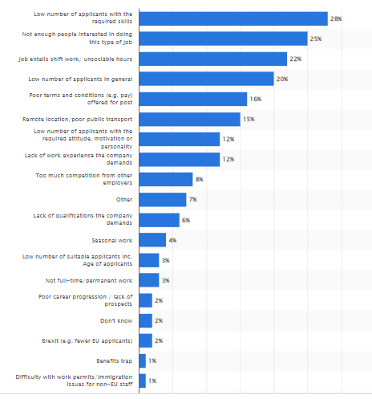
Figure 3: Challenges faced by the management in recruiting in hospitality industry in UK, 2019
(Source: statista.com, 2022)
The above figure shows that the hotel industry faced several issues in retaining employees and recruiting. In the year 2019, the UK travel management companies failed to fill up the positions for the employees related to hospitality industry mostly because of the low number of applicants (statista.com, 2022). Therefore, the hotels face several challenges to meet the customer demands by providing effective service. As a result, the brand reputation of the hotels becomes on the verge of decreasing. Hospitality industry had also been severely affected by the sudden spread of covid-19 virus that brought several issues among the employees and the hospitality industry.
The less opportunity of developing a career, poor retention strategies, poor work environment and the inability of providing the employees job satisfaction are the other reasons. According to Baharin and Hanafi (2018), employee retention should be a significant major concern for organizations to maintain their performance. The management of the hotels should adopt several strategies that lead to promoting the culture for retention in the organization (Ali and Anwar, 2021). Therefore, the management should adopt several effective strategies in creating interest among the eligible candidates for attracting the talented workforce in the hospitality sector.
Hence, the business organizations including hospital industries should focus on the implementation of several strategies in their policy and recruitment which would be beneficial for the organizations in a long run. Therefore, Hilton London hotel’s managers can adopt the same strategies and focus on employee retention as well as engaging employees for maintaining the hotel's performance and providing customer effective satisfaction.
Theoretical underpinning
In the context of conducting research on the current challenges faced by the Hilton London hotels in engaging and managing the employees, the hotel can grasp effective theories regarding employee engagement. The hospital can adopt Herzberg's two-factor theory in order to engage the employees and maintain their efficiency in providing effective service. The concerning theory has two factors such as motivation and hygiene which are the dual-factor that maintains the workplace culture of the employees (Yousaf, 2020). The concerning theory explains that the first-factor motivation includes several psychological and emotional factors taken care of by the management to enhance employee satisfaction and motivate them. The second-factor hygiene explains the physical factors and workplace conditions that also motivated the employee are working in such environments. The hotels face several challenges to meet the customer demands by providing effective service.
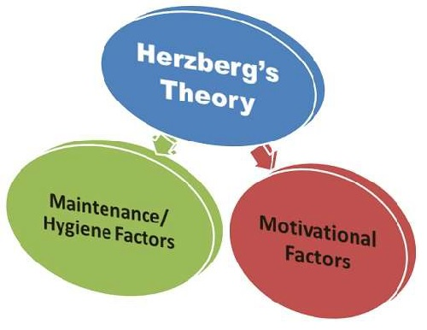
Figure 4: Herzberg's two-factor theory
(Source: Yousaf, 2020)

Task 4

Evaluation and conclusion
The study will try to highlight the current challenges the employees of hospitality industry goes through. The hospitality industry went through the outbreak of the pandemic, which had a significant setback on the economy of the industry. Over the past few years, the hospitality industry has gone through several issues and challenges, which include the severe effect on the employee's lifecycle within the industry. Therefore, both the management and the workforce of the hospitality industry had faced several issues with the sudden arrival of covid-19.
Globalization and the competition among the hotels in the hospitality industry in providing effective service to the customers for having a broad customer base have also been a challenge for the hospitality industry. Therefore, the management should focus on mitigating the issues to reduce the high rate of employee turnover and enhancing recruitment. More reasons include less interest in providing the hospitality sector, poor terms and conditions of the job role, and lack of work experience compared to the company’s demand.
Globalization has been creating a great competitive environment for the business industries, which is another issue for the hospitality industry. Therefore, the concerning study will shed light on the impact of the issues highlighted on the lifestyle of the employees. Additionally, the study will show the importance and significance of understanding the ever-changing customer demands for providing proper service for their satisfaction. Furthermore, the present research will highlight and discuss several challenges faced by Hilton London hotels in managing and engaging the employees in the UK.
The satisfied employees in an organization serve as a competitive advantage. Due to lack of enough time and resources, the paper is written on the basis of one case study, this might decrease the generalizability of research findings. Moreover, future studies can be conducted for examining the importance of organizational culture for other important factors of the firm. The study would help to understand the current challenges of the Hilton London hotels in managing and retaining the employees. The significance of the research lies within its discussion regarding the importance of the management’s strategy in employee retention and employee engagement in the hospitality industry. Organizational commitment and culture, as well as human resource-related policies create issues that enhance the turnover of employees at a high rate. Thereby managing the employees in the hotel industry are required to be managed in a proper way so that Hilton London hotels are trying to manage the employee so that employee management can be managed.

References
Alharahsheh, H.H. and Pius, A., 2020. A review of key paradigms: Positivism VS interpretivism. Global Academic Journal of Humanities and Social Sciences, 2(3), pp.39-43.
Ali, B.J. and Anwar, G., 2021. An empirical study of employees’ motivation and its influence job satisfaction. Ali, BJ, & Anwar, G.(2021). An Empirical Study of Employees’ Motivation and its Influence Job Satisfaction. International Journal of Engineering, Business and Management, 5(2), pp.21-30.
Baharin, N.L. and Hanafi, W.N.W., 2018. Effects of talent management on employee retention: A case study of hospitality industry. Global Business and Management Research, 10(3), p.697.
Bhardwaj, B. and Kalia, N., 2021. Contextual and task performance: role of employee engagement and organizational culture in hospitality industry. Vilakshan-XIMB Journal of Management.
Book, L., Gatling, A. and Kim, J., 2019. The effects of leadership satisfaction on employee engagement, loyalty, and retention in the hospitality industry. Journal of Human Resources in Hospitality & Tourism, 18(3), pp.368-393.
Bufquin, D., Park, J.Y., Back, R.M., de Souza Meira, J.V. and Hight, S.K., 2021. Employee work status, mental health, substance use, and career turnover intentions: an examination of restaurant employees during COVID-19. International Journal of Hospitality Management, 93, p.102764.
Cramer-Petersen, C.L., Christensen, B.T. and Ahmed-Kristensen, S., 2019. Empirically analysing design reasoning patterns: Abductive-deductive reasoning patterns dominate design idea generation. Design Studies, 60, pp.39-70.
Dwesini, N.F., 2019. Causes and prevention of high employee turnover within the hospitality industry: A literature review. African Journal of Hospitality, Tourism and Leisure, 8(3), pp.1-15.
Ertuna, B., Karatas-Ozkan, M. and Yamak, S., 2019. Diffusion of sustainability and CSR discourse in hospitality industry: Dynamics of local context. International Journal of Contemporary Hospitality Management.
Font, X. and Lynes, J., 2018. Corporate social responsibility in tourism and hospitality. Journal of Sustainable Tourism, 26(7), pp.1027-1042.
Gursoy, D. and Chi, C.G., 2020. Effects of COVID-19 pandemic on hospitality industry: review of the current situations and a research agenda. Journal of Hospitality Marketing & Management, 29(5), pp.527-529.
hilton.com, 2022. Hilton hotels in United Kingdom [Online] Available at: https://www.hilton.com/en/locations/united-kingdom/ Accesses on 23rd June, 2022
Hochbein, C. and Smeaton, K.S., 2018. An Exploratory Analysis of the Prevalence of Quantitative Research Methodologies in Journal Articles. International Journal of Education Policy and Leadership, 13(11), p.n11.
Njoroge, M., Anderson, W. and Mbura, O., 2019. Innovation strategy and economic sustainability in the hospitality industry. The Bottom Line.
Ons.gov.uk,2022. hospitality businesses are most likely to be struggling to fill vacancies https://www.ons.gov.uk/employmentandlabourmarket/peopleinwork/employmentandemployeetypes/articles/hospitalitybusinessesaremostlikelytobestrugglingtofillvacancies/2021-09-16 Accesses on 23rd June, 2022
parliament.uk, 2022. Hospitality industry and covid 19. [Online] Available at: https://researchbriefings.files.parliament.uk/documents/CBP-9111/CBP-9111.pdf Accesses on 23rd June, 2022
statista.com, 2022. Main causes given by of hard-to-fill vacancies in the hotel and restaurant sector in the United Kingdom (UK) as of 2019 [Online] Available at: https://www.statista.com/statistics/506893/reasons-difficult-recruitment-hospitality-sector-united-kingdom-uk/ Accesses on 23rd June, 2022
Sürücü, L. and MASLAKÇI, A., 2020. Validity and reliability in quantitative research. Business & Management Studies: An International Journal, 8(3), pp.2694-2726.
Waqanimaravu, M. and Arasanmi, C.N., 2020. Employee training and service quality in the hospitality industry. Journal of Foodservice Business Research, 23(3), pp.216-227.
Yousaf, S., 2020. Dissection of Herzberg’s two-factor theory to predict job satisfaction: empirical evidence from the telecommunication industry of Pakistan. The Lahore Journal of Business, 8(2), pp.85-128.

