

Investigation into the Effects of Mental Health in Police Officers during their Probationary Period.

Marc Antony Fitchett
1920581

BSc (Hons) Professional Police Practice

Due Date: 9th January 2023
Word Count: 7849

Acknowledgements:
I would like to begin my thanking my family for the support they have provided me to complete this course. The guidance and support I received over the 3 years I will be forever grateful as I would not have been able to complete this without them, My children Dylan and Rhys have been patient and understanding why I have been unable to commit to family events or engagements as I have had to study.
My wife Samantha has been my rock when times have been difficult between studying full time and working full time as a police officer. Sacrificing family time to ensure my studies are completed and submitted in a timely manner and throughout pushed me and provided me positive feedback to help me by. Thank you Samantha.
Further acknowledgements have to be passed to Deepak Patel. I cannot express my gratitude enough to him being my dissertation supervisor from University Wales Trinity Saint David (UWTSD). His Patience and simple guidance in providing me feedback with my dissertation has been invaluable to hopefully help me achieve my goals of completing this dissertation and concluding my academic journey with UWTSD.
Finally, I would like to express my gratitude to my policing team with South Wales Police. Team 4 Response based in Penarth have been there to support me when I have had a rollercoaster of emotions, trying to juggle personal matters, workloads, and academic studies. Different members of the team have passed on recommendations or helped me brainstorm ideas around the questions I would go on to ask as part of my surveys, or just be supportive and giving me the opportunities to move my protected learning time to give me the best chance of completing my work. To each one of you, thank you.
Declaration

This work has not previously been accepted in substance for any degree and is not being concurrently submitted in candidature for any degree.

Signed: M.Fitchett
Date: Sunday 01st January 2023

Statement 1

This dissertation is being submitted in partial fulfilment of the requirements for the degree of BA.

Signed: M.Fitchett
Date: Sunday 01st January 2023

Statement 2

This dissertation is the result of my own independent work/investigation, except where otherwise stated.
Other sources are acknowledged by footnotes giving explicit references. A bibliography is appended.

Signed: M.Fitchett
Date: Sunday 01st January 2023

Statement 3

I hereby give consent for my dissertation, if accepted, to be available for photocopying and for interlibrary loan, and for the title and summary to be made available to outside organisations.

Signed: M.Fitchett
Date: Sunday 01st January 2023

Statement 4

I hereby give consent for my dissertation, if accepted, to be available on the university’s IT system to those who have consent to use the system.

Signed: M.Fitchett
Date: Sunday 01st January 2023

Abstract

This investigation into the effects of mental health in police officers during their probationary period, has reviewed the impact of the role on a person entering police work in the United Kingdom. Throughout this review there has been consideration for the welfare of police officers and research into what can the police service do better to improve wellbeing and support their officers to reduce stress in the workplace.
Noticeably, there has been a decline in job satisfaction and increased stress levels due to the demands of the modern police training and the ever-changing role and demands of dealing with complex crime. There has been an apparent greater strain on student police officers to study academically as an apprentice whilst working full time as a police officer. There is a requirement for people wishing to join the police to have a degree or be willing to work towards obtaining one whilst being employed as a full-time police officer. With minimal protected time off to help support the student which are often moved or cancelled at short notice.
Additionally, officers have highlighted that the constant demands in areas of policing that cause greater strain on the service. Police officers have taken part in this investigation have expressed personal views how stress has increased from increasing workloads and multiple academic studies reducing the amount of downtime they have to rest and decompress from the stressful role of being a police officer. Research supports that emergency workers are more likely to develop a mental health related illness and this study will reflect on this too.
Modern day police training may not be best suited to graduate level, but more job focussed on dealing with varying functions such as dealing with distressing incidents or that of a mental health nature of which officers have not the skills but can be very demanding, volatile, and upsetting.

Table of Contents

Chapter One – Introduction
1.0 Introduction – Page 7
1.1 Background – Page 7
1.2 Research Rationale – Page 8
1.3 Aims & Objectives – Page 8
1.4 Structure – Page 9
1.5 Conclusion – Page 9

Chapter Two – Literature Review
2.0 Introduction – Page 10
2.1 Sickness Absence – Page 10
2.2 Exposure – Page 13
2.3 Seeking Support – Page 15
2.4 Three-Year Degree – Page 18
2.5 Conclusion – Page 19

Chapter Three – Methodology
3.0 Introduction – Page 21
3.1 Research Design – Page 21
3.2 Research Settings – Page 23
3.3 Ethical Considerations – Page 23
3.4 Pilot Study – Page 25
3.5 Conclusion – Page 25

Chapter Four – Data Analysis and Findings
4.0 Introduction – Page 27
4.1 Data Analysis – Page 27
4.2 Method of Analysis – Page 27
4.3 Analysis of qualitive data gathered from interviews – Page 28
4.4 Theme one – Poor Mental Health – Page 28
4.5 Theme two – Exposure to incidents – Page 29
4.6 Theme Three – Support for Policer Officers – Page 30
4.7 Theme Four – Qualitative data from Interviews – Page 32

Chapter Five – Conclusion
5.0 Introduction – Page 34
5.1 Completion and Achievement of objective – Page 34
5.2 Findings – Page 34
5.3 Recommendation – Page 35
5.4 Conclusion – Page 36

Bibliography – Page 37

Appendices
Appendix A – Copy of Survey Questions sent out to candidates. – Page 52

Chapter 1 Introduction

1:0 Introduction
The aim of this dissertation is to investigate the effects of mental health in police officers during their probationary period. This section of the dissertation will provide background and depth to explain what the importance of the research in this area is.
  - Background

Police officers in the UK now have to complete a three-year degree alongside working full time. It is emphasized that police officer’s do not need a degree to join a force, but a degree must be completed during the probationary period (UCAS, 2022). This programme has been running for a few years, and it has been recognised as a struggle for most police officers who have started (Edwards, 2021). The struggle’s highlighted are having to work full time whilst finding the time to write assignments for the degree. Alongside this, trying to adjust to working as a police officer and learning the role itself (UCAS, 2022).
It is essential that police officers have access and support for their mental health, a shortage of staff and an increase in workload will with no doubt increase poor mental health (Bell & Eski, 2018). Hale & Hunt (2020) states that short staffing is a key factor of poor mental health and states that an increase in workload impacts the stress levels of police officers.
Mental health focuses on psychological, emotional, and social wellbeing and it affects the way people think and feel (World Health Organisation) (WHO) (2022).

  - Research Rationale

The rationale for conducting this research is because it is seen that mental health issues have increased in police officers joining the force. It has been evidenced that there is an increase in staff sickness levels within policing in the UK, due to psychological ill health, trauma and stress (Cartwright & Roach, 2020). Additionally, having less team members per shift has an impact on police officer’s mental health due to receiving a higher workload and not enough hours to complete the tasks, due to a shortage in staff, again impacting on staff morale (Demou, 2020).
Furthermore, due to the last few years police officers now must undertake a degree to become a police officer, whilst working full time and juggling staff shortages can contribute to mental health issues (Bell & Eski, 2018).

1.3 Aims & Objectives
The aims of this research project are to research, analyse and evaluate the effects of the probationary period on a student police officer’s mental health. It will also provide recommendations to further manage and assist police officers who may be suffering with poor mental health, and support police officers in their probationary period.
These aims will be achieved by completing the following objectives:
1. Conduct a survey for police officers to identify how many may be suffering with mental health, during their probationary period. This consists of both working full time and undertaking a degree.
2. Explore and investigate key detriments such as staff shortages, high workloads, and academic studies and how the role of the police officer impacts mental health.
3. Seek whether there are common themes that could be explored to promote coping strategies or reduce exposure to unnecessary stressors.

1.4 Structure
To successfully complete the stated objectives, the chapters will be elaborated to ensure each objective is completed.
The literature review of this dissertation will analyse the impact of completing a degree alongside working full time, on a police officer’s mental health.
Chapter three will identify a research technique best suited to primary data collection.
Chapter four will then focus on data that has been collected from chapter three, to identify any common themes within the research conducted.
Lastly, chapter five will provide a conclusion from the research and provide recommendations to be put in place to further better police officer's mental health in the future.

1.5 Conclusion
This first chapter has provided the background surrounding the research topic, of poor mental health on police officers during their probationary period.
It has outlined the aims and objectives of the dissertation, and why further research is needed to further reduce student police officer’s mental health.
The following chapter will now critically analyse academic literature, to identify issues surrounding police officer’s mental health and look at ways to reduce this and provide support.
Chapter 2: Literature Review
2.0 Introduction
This chapter of the dissertation aims to provide an analysis of academic and relevant sources of literature relating to the effects of the job role within the probationary period, on a police officer’s mental health.
The aim of this chapter is to achieve objective two of the dissertations, for reference is to; Explore and investigate key detriments of how the role of the police officer impacts mental health, during the probationary period.
The objective will be obtained by examining literature from Google Scholar and the UWTSD database online library to further search for journals, books and articles to best support the dissertation. In order to make a search within the databases the key terms that will be used are ‘Police Officers’, ‘Mental Health’ and ‘Probationary Period’.
2.1 Sickness Absence
Mental illness or disorder can be defined as affecting mood, behaviour and thought processes (National Institute of Mental Health) (NIH) (2022).
In the UK in 2021 there were over 135,000 employed police officers, with nearly 5000 of these on long term sickness leave (Home Office, 2022). The statistics for January 2022 show a national 9.4% of police officers are on sickness absence (Police Federation, 2022). The Police Federation (2022) states that the pressure on police officers nationally is increasing as the staffing levels are diminishing frequently.
A study conducted by Cartwright & Roach (2020) found that 39% of police officers who took their first sickness absence due to poor mental health, would continue to take further sickness absences in the future.
During the Covid-19 pandemic at least one in four of sickness absences was due to covid, due to the severity of cases across the UK this could have impacted the mental health of police officers who had to continue to work, alongside short staffing levels (Wilmot & Leaker, 2022).
Edwards & Kotera (2020) conducted a qualitative investigation into the stigma of mental illness in the UK police force. The study found that with 130,000 employed police officers, half of these officers are taking sickness leave due to mental health illness (Edwards & Kotera, 2020). Mind (2019) states there is a high prevalence of mental illness within the police and emergency services than any other profession. This could be due to being a fast-paced environment (Police Care UK, 2021).
Police Federation (2016) highlighted that police officers sickness absences are due to depression, stress, and anxiety which all cover mental health illness.
Edwards & Kotera (2020) found that the reasoning for high levels of mental health illness is due to the types of incidents, the police officers are witnessing on a daily basis. It is recognised that repetitive sensitive cases, such as sudden deaths, abused children, stabbings can impact a person physically and emotionally. In turn, effecting their poor mental health (Mind, 2019).
Hale & Hunt (2020) conducted a study to assess mental health issues for student police officers working within Scotland in their probationary period, the aim was to conduct interviews face to face to assess what causes, triggered mental health illness. The study concluded the main stressors were long working hours and the types of workloads that cannot be completed at the time of the incident, such as file building. All whilst completing the three-year degree in parallel. Linked with the three-year degree, police officers are entitled to protected learning time (PLT) days which are given to allow police officers to complete their academic studies alongside their work life. However, these PLT days are often cancelled due to staff shortages which has an impact on their safety as well as being able to best support the general public (CoP, 2020). Furthermore, this may be a reason as to why stress and sickness absence increases (Hale & Hunt, 2020).
The study conducted by Hale & Hunt (2020) also noted that more support for mental health needs to be addressed. The Blue Light Programme was implemented for emergency services, to help with people’s mental health (Mind, 2022). In 2021, evidence shows that 69% of emergency workers feel their mental health has deteriorated since the covid pandemic (Mind, 2022). It is fair to note that having to cope with the pandemic whilst completing a three-year degree can be challenging at times (Police Federation, 2016).
A review known as ‘Thriving at Work’ by Stevenson and Farmer (2017) found that 300,000 people every year lose their job due to their mental health. Most stress for police officers’ manifests physically and psychologically, which impacts their home life, job performance and general wellbeing (Anshel, 2000). Therefore, ensuring police officers have access to support services can help reduce mental health in the workplace (Police Federation, 2016).
National Policing Wellbeing Service (NPWS) is an establishment set up to guide and support all police officers to improve health and wellbeing (Police Now, 2020). This has been supported by the National Policing Vision 2025.
All the studies mentioned above in this review have demonstrated similar reasons for poor mental health, all in agreement that increasing workload, academic studies and the types of incidents being attended, impact their mental health. It is recognised that support in the workplace for poor mental health needs to be improved, to better improve the work force (Newell, 2022).
2.2 Exposure
Marchand, et al (2015) states that having frequent exposure to operational stressors has the potential to cause a psychological impact on the police officer. It is paramount to understand that due to the critical role police officers undertake, it is bound to provide a psychological strain (Wood, et al 2017). Velazquez & Hernandez (2019) conducted a study that found many police officers suffer in silence with their mental health due to the stigma this holds and environmental factors. Environmental factors such as adhering to the force’s culture ideologies (Velazquez & Hernandez, 2019). It is portrayed that the force’s promote stigmas unknowingly, by police officer’s trying to act strong so they do not display signs of weakness (Wood, et al 2017). This could encourage police officers to suffer with mental illness in silence (Police Federation, 2016).
Cummings & Jones (2010) recognises that there is a lack of mental health training within the police force. Therefore, accessing support and ways of inhibiting this will allow short term sickness not to extend to long term (Summerfield, 2011). University of Cambridge (2022) conducted a survey which had over 16,000 responses that found that 1 in 5 police officers suffer with Post Traumatic Stress Disorder (PTSD) due to their job. It is noted that these police officers suffering with PTSD struggle with their emotions and often feel hopeless (University of Cambridge, 2022). The National Alliance on Mental Illness (NAMI) (2022) reports that police officers hold a high rate of depression, anxiety and burn out due to their job, in comparison to the general population (Walden University, 2022). Walden University (2022) also noted that police officers have to protect the public, with an increase in emergency calls and situations and suffering with poor mental health has a clear impact on keeping up with the workload. It is evidenced that America displays high levels of mental illness, however the UK also display high levels of mental illness. This highlights that the role of the police officer plays a significant element in the causation of mental illness in all countries (Jetelina, 2020).
Stevelink, et al (2020) found that police officers who have been exposed to traumatic events, in comparison to police officers who had not have a 2.5 higher chance of having depression. In agreement, Javanbakht (2020) states that humans are not programmed to explore these traumatic scenes on a regular basis. Therefore, over time mental health problems arise as people no longer know how to cope (Stevelink, et al (2020).
University of Cambridge (2022) highlighted that in 2018 12% of police officers in England suffered with complex - post traumatic stress disorder (C-PTSD) which is a chronic condition where continuous exposure to traumatic events causes feelings of low self-esteem and worthlessness, unable to socially interact and unable to regulate emotions. Having regular staffing levels could limit the number of traumatic events, student police officers need to attend (CoP, 2022).
Response police officers are usually the first officers to attend an incident, this could be complex or confrontational (Leicestershire Police, 2022). Not only do response officers protect the community, but they also need to protect each other (College of Policing) (CoP) (2022). Response officers are susceptible to attending an ongoing incident which leads them to potential traumatic incidents, due to the urgency of calls being made to the police force (Police Care UK, 2019). The Centre for Addiction and Mental Health (CAMH) (2022) defines trauma as a lasting emotional response to witnessing a distressing event. It is also important to recognise that people deal with trauma in different ways, what might affect one person might not another (CAMH, 2022). Additionally, trauma can cause reactions such as shock and denial (Mind, 2023).
Many police officers face traumatic incidents nearly all the time in their job role, this could be a traumatic death, severe injuries or hazardous events (CoP, 2018). Having exposure to these types of incidents can cause harm and mental health problems (Violanti, 2018). Being able to reduce this or be able to access support services could reduce mental illness (Mind, 2023).
2.3 Seeking Support
Most police officers do not seek care for their mental health issues due to worrying what people may think of them, may feel it shows a weakness (Walden University, 2022). However, Police Care UK (2019) have informed police forces across the UK and the health authorities that a national strategy needs to be put in place to help tackle the impact the role has on a police officer’s mental health. According to CoP (2022), all police forces have a psychological risk management guidance to risk assess and manage high risk roles in policing. Each force has a duty of care to risk assess psychological hazards and look at ways of mitigating these, to manage psychological risk to employees (CoP, 2022).
Over 20% of police officers are suffering with their mental health due to traumatic experiences in their job role, which has a detrimental effect on their health (Police Care UK, 2019). In agreement, Edwards (2020) conducted a study with 17,000 police officers and found that mental health is extremely high in comparison to the general population of the UK. Edwards (2020) states that police forces need to have training and education in this field which needs to be put into practice.
However, Hailstone (2018) highlights different support programmes available to emergency workers such as ‘The Blue Light programme’. This programme aims to tackle stigma and discrimination, focuses on wellbeing in the workplace and looks at improving support pathways. Closely linked with the Blue Light programme is ‘The Trauma Risk assessment’ (TRIM), this is a peer led risk assessment that aims to identify and support colleagues in the workplace (March on Stress, 2012).
South Wales Police provides different types of support services to help police officers with their health and wellbeing such as, access to gyms, wellbeing champions, occupational health and TRiM (South Wales Police, 2022). An initiative implemented by National Police Chief’s Council (NPCC) (2022) in March 2022, known as ‘The Celebration of Response Police Officers’ in collaboration with South Wales Police to celebrate the work of response officers and focus on wellbeing and resilience, and signpost resources available to them (South Wales Police, 2021).
Senior officers are being supported with how to recognise the signs of poor mental health in their colleagues how to deal with this. Focusing on ways to signpost their employees to support services and how best to help them (CoP, 2022). CoP (2022) states that supporting employees and colleagues can help boost self-esteem and reduce workplace stress.
However, Newell et al. (2021) states that 36% of police officers would not disclose information about their mental health due to barriers they feel would impact this; stigma, confidentiality and occupation experiences. In agreement, Edwards & Kotera (2020) also state that there are limitations to disclosing poor mental health such as affecting career prospects, the police officer may feel weak and discriminated against.
Research conducted by Velazquez & Hernandez (2019) into the effects of exposure to traumatic events for police officers and why they do not access support. The research found that police officers developed PTSD, depression and high suicidal thoughts and would not access support due to workplace culture (Velazquez & Hernandez, 2019). Furthermore, Russell (2022) states that poor mental health is exacerbated by lack of time and support.
TRiM is a tool used to build resilience by helping people to function after a traumatic event by providing education and support (The March on Stress, 2022). TRiM focuses on enabling organisations with the ability to recognise the need for support and to provide reassurance (The March on Stress, 2022). It Is highlighted that TRiM allows the individual to talk through what happened and allow them to state what impact this had on them. Often people need support, kindness and reassurance in these situations, and TRiM can provide that given the opportunity to talk (Hampshire Fire and Rescue Service, 2016). However, a limitation of TRiM is that it is not always confidential and personal information may be shared with other agencies if deemed necessary. This could reduce the amount of police officers wanting to seek support (Kent Police, 2021). In turn, this could increase the amount of police officers on sickness absence and having long term stress due to not seeking support (CoP, 2022).

2.4 Three-Year Degree
As part of the role of becoming a police officer within the UK, it is a requirement to complete a three-year degree in policing whilst working full time (CoP, 2022).
Many police officers find this challenging whilst learning a new role of becoming a police officer, learning the law and legislation, learning how and when people can be arrested, all whilst bonding with a new team and their colleagues (CoP, 2021). The degree focuses mainly on reflection and how best to improve on incidents in the future (CoP, 2020).
The degree impacts on police officers stress levels as there seems to be a lot to adjust to and learn, all at the same time (CoP, 2020). However, many universities such as University of Bristol (2023) offer support for health and wellbeing.
Although policing is deemed a stressful job it does have good prospects, such as becoming a sergeant, inspector, superintendent or chief constable (University of London, 2023). Therefore, completing the degree opens many opportunities (CoP, 2022). It has been evidenced that completing the degree alongside working full time has impacted on a police officer’s mental health, police officer’s find it difficult to adhere to deadlines of assignments due to working 6 days on, as well as cancelled PLT days (Police Care UK, 2019). It has been highlighted that since 2019 police officer’s sickness leave for mental health for West Midlands Police force was 632 people, however this steadily increased to 985 in 2020, and 1212 people in 2021, this could indicate that introducing a degree has impacted upon this (West Midlands Police, 2022).
Cox & Kirby (2017) state that police officers have the added pressure to ensure the degree is completed to be confirmed in rank. Furthermore, CoP (2023) state that emergency workers are more likely to suffer with mental illness yet are unlikely to access help, due to the worry of what will help to their probation.
2.5 Conclusion
To conclude the literature review suggests that there are many underlying factors as to why police officers suffer with their mental health. The literature review identifies that police officers continue trying to adjust to staff shortages and an increase in workload. As well as long working hours whilst completing a three-year degree. It is important to recognise that many police officers are exposed to a variety of different incidents every day that they are on shift, which can impact their physical and mental wellbeing. In collaboration of all these factors it is evidenced in this literature review, that it plays a significant role in the increase of poor mental illness.
The literature review recognises that South Wales Police are supportive of their employee’s mental wellbeing. South Wales Police focuses on building resilience for their employees and helping them to function after attending traumatic events. TRiM has been noted as a suitable tool to provide support and reassurance in the workplace and focus on ways to put things in place to help employees deal with their mental health.
The evidence suggests that not all police officers would want to disclose their concerns as they feel embarrassed or judged. Additionally, as noted above a limitation of TRiM is police officers having their information shared with other agencies if the organisation feels necessary. Furthermore, it has been noted that for police officers during their probationary period would not want to disclose their mental illness as this could impact their probation (CoP, 2023).
In order for this to be improved, research needs to be conducted at ways to further better the opportunity for police officers, to talk or seek other forms of support in order for them to open up.

Chapter Three - Methodology
3.0 Introduction
The aim of this section is to provide a summary of how the study will be conducted and the types of methods used. To conduct this study, interviews and surveys will be undertaken by police officers of the South Wales Police force.
The data will then be collected and may highlight a trend and create a consensus.
3.1 Research Design
To conduct this study there will be both quantitative and qualitative data research obtained, by completing a survey and interviewing police officers who have given their consent. Verhoef & Casebeer (1997) states that combining both quantitative and qualitative data research increases the validity of the results as this shows more accuracy of results. Additionally, this will also enhance the research quality by answering the research question more fully (Osbladeston, 2021). This allows the research to have more depth in the answers given (Qualtrics, 2022).
A survey analyses data that has been collected from asking a sample of participants a series of questions and processes (Qualtrics, 2022). A survey was completed for the quantitative research which consisted of 10 questions relating to mental health for police officers in their probationary period. Please see Appendix 1. It also focused on how South Wales police manage mental health in the workplace and if people felt supported.
This was an anonymous survey allowing participants information to be kept private, the same survey was given to all participants ensuring the data to be standardised. The survey was open for a month in total, with 40 responses. According to Boynton (2004) a standardised survey is a survey that is written and administered to all participants, in an identical format. An advantage of a standardised survey is the increase it has on the reliability of the results (Boyton, 2004). However, a limitation of a standardised survey is that the questions need to be suitable for all participants (Sincero, 2022).
Furthermore, an interview method was conducted for the qualitative research which consisted of asking a series of questions surrounding mental health in the workplace and how people coped or accessed support.
George (2022) defines an interview as a conversation between two or more people to acquire data. Clements (2022) highlights that there are many advantages to conducting an interview for research, such as they can be easy to undertake, and results are obtained quickly. Additionally, the answers collated can be direct and in depth and the questions can be modified to obtain the required information (Clements, 2022). However, interviews also hold limitations such as they may be deemed unreliable as each interview is unique, questions may be worded slightly differently for each participant (Thompson, 2016). To reduce this, the questions were written on a piece of paper to be used for each participant. Furthermore, the interviewer may have bias as they may react differently to each answer provided. In turn, this can encourage or discourage the participant in their answers (Thompson, 2016).
Shorten (2017) states that by using a mixed method approach for collating my research, it allows the data to be broad, expanding the research. Although, this can be deemed timely (Almeida, 2022).
To comply with the Code of Ethics for obtaining the data, I ensured to maintain professionalism and adhere to the standards of behaviour (College of Policing) (CoP) (2014). Due to talking about people’s mental health can be deemed sensitive, I ensured to maintain confidentiality and people’s dignity. Maintaining confidentiality when conducting research is paramount in order to comply with ethical standards (National Research Ethics Committee, 2015). A study that lacks trust and confidentiality will question the credibility of the research (Coffelt, 2022).
3.2 Research Settings
The study consisted of participants of mixed gender and different age ranges, but all police officers from South Wales police.
The survey was open to all employees of South Wales police, and the interview was conducted with a sample size of participants who were willing to expand their answers after completing the survey. To assist me in ensuring my questions were suitable, I tested a number of different questions on an informal and unrecorded process with different colleagues I worked with. The purpose was to explore which answers best focussed on my research without misleading or diverting away from my lines of investigation.
3.3 Ethical Considerations
Ethical considerations focus on ensuring participants give informed consent, they do not come to any harm, being anonymous and having the right to confidentiality (Bhandari, 2022). The Research Ethics Committee (2015) states that all research must comply with ethics to protect the participants. It is important to focus on the benefits vs harms to explore whether the process will have a negative impact on participants or whether this is beneficial to provide a positive outcome (Welcome Trust, 2014).
During the planning stage of this dissertation many ethical considerations came to light.
The first ethical decision was not allowing the participant to feel exposed to hurt and memories of why they may have experienced poor mental health. To minimise this reoccurring, participants were given the option as to whether they would like to participate. However, having the option to select participants for this by choosing people who had not been exposed to traumatic events could be an ethical consideration, although this could form a bias.
The survey also displayed the option to access support from different programmes such as TRIM and Blue Light.
Before completing the interview process, a consent form was provided for the participants to complete, then a debrief session at the end.
Another ethical consideration was how this might affect the researcher. The questions being asked might affect the way they feel due to the answers being provided by others.
To comply with ethical standards, I ensured all participants were kept anonymous and confidentiality was maintained. The Research Ethics Committee (2015) stipulates that confidentiality and anonymity are a requirement, to protect the participants right to privacy.
The interview information was stored safely on a work computer which is password protected that can only be accessed by the researcher, to maintain high security.

3.4 Pilot Study
Simkus (2022) defines a pilot study as a small-scale study that is conducted to assess whether a large-scale quantitative study is justified. A pilot study is fundamental to the research process and identifies practicality, feasibility and cost (Simkus, 2022). A pilot study allows the researcher to develop a research question and plan (Teijlingen & Hundley, 2001). In contrast, a pilot study is initially used to hypothesise the results, this can be timely (Nakazawa, 2012).
A pilot study was conducted which then allowed for it to be distributed to all employees of South Wales police.
The pilot study that was conducted allowed the researcher to gain a sense of direction of the outcome and show the length of time it would be to conduct this.
3.5 Conclusion
To conclude, the research methods used for the dissertation were both quantitative and qualitative research. It is evidenced from the literature review that using a mixed method approach has allowed the data to be expanded. The evidence also suggests that there are many advantages and limitations to using both research types, however overall combining the two allows for deeper results.
Following the Ethics Committee, it is important to remember that the participants need to remain confidential and anonymous and to ensure the benefits outweigh the harm when conducting research.
An ethical consideration arose during this process. The researcher did not want bad memories to be brought to the participants. However, this was rectified by putting measures in place to allow participants to be given all the information before participating.
The research had been completed and the data had been collected to help answer the research question.

Chapter 4 – Data Analysis and Findings

4.0 Introduction
The aim of this chapter is to analyse the results which have been collated from the quantitative and qualitative research.
This chapter will display the data collated from the research and be displayed in a pie chart. This will then be analysed and answer the research objectives.
1. Conduct a survey of police officers to identify how many admit to suffering with mental health, during the probationary period.
2. Explore and investigate key detriments of how the role of the police officer impacts mental health, such as staff shortages and a high workload.
3. Seek whether there are common themes that could be explored to promote coping strategies or reduce exposure to unnecessary stressors.
All the information collated are from student police officers who are in their probationary period.
4.1 Data Analysis
Data analysis is basically the method of filtering through large amounts of information and finding patterns or trends that become clear through all the different research and analysing any differences or common themes directing towards my research question.
4.2 Method for analysis
This was achieved by distributing a survey and conducting an interview on the effects of mental health on police officers working within their probationary period. To aid the analysis of the data each participant who conducted a survey were given the same web link to complete the survey. To differentiate and make each survey unique each participant was only identifiable by a unique number code. To help ensure the data I collected was sufficient and relevant I produced draft surveys and asked colleagues I worked with of different service lengths to answer them. Additionally, this was to ascertain if the questions were suitable for student officers.
4.3 Analysis of Qualitive data gathered from interviews:
Four themes were chosen from the survey and interview which have been displayed below. They have been chosen as they display the main reasons for mental illness in police officers during their probationary period and how they have received support, if any. The themes were highlighted in the survey as being the biggest causes.
4.4 Theme One – Poor Mental Health
This theme highlights an indicator for poor mental health in the probationary period. The pie chart identifies that academic studies, traumatic incidents and high workloads all play a significant role in causing stress in students. However, the pie chart shows that completing a degree alongside working full time has highly contributed to added stress levels in students. The pie chart also displays a high prevalence of stress for police officers, due to a high workload.
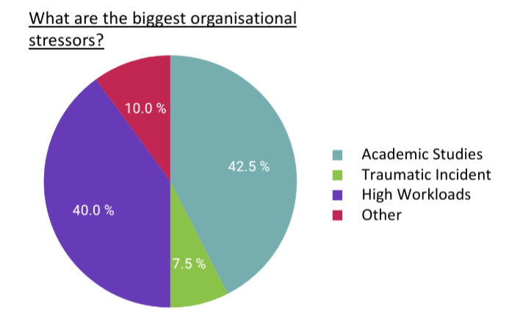
Figure 1:

Combining both academic work and a high work shows a high level of poor mental health in the workplace, in this insistence high stress levels.
4.5 Theme Two – Exposure to incidents
Theme two demonstrates the ‘exposure’ section of the literature review. The pie chart illustrated in figure 2 below, highlights how police officers having exposure to traumatic events can impact on a student’s mental health.
Figure 2:
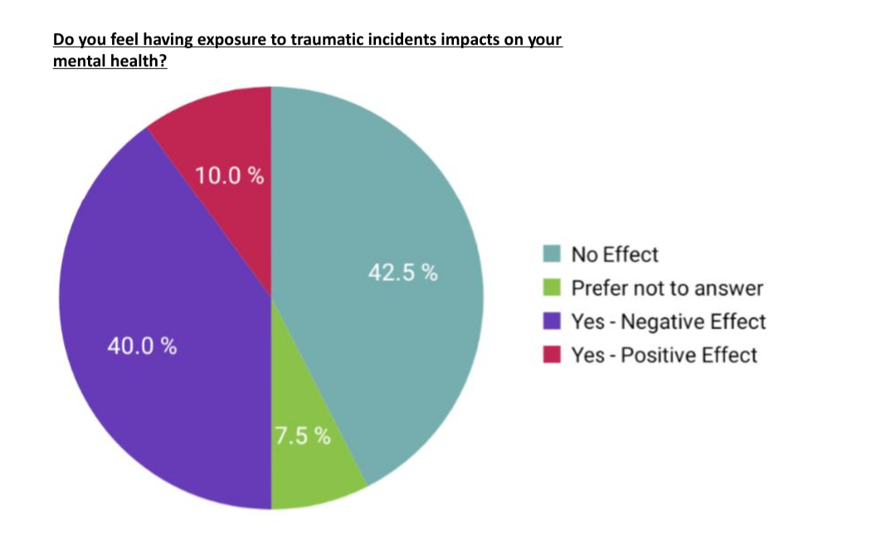

It is fair to state that figure 2 suggests that 40% of police officers are affected by traumatic incidents in the workplace, this identifies that police officers may need support. However, 42.5% of police officers state traumatic incidents have no impact on their mental health. Therefore, it is fair to suggest that maybe this percentage of people know how to deal with their concerns. 10% of police officers state that traumatic incidents have a positive impact on their mental health. This could be due to people feeling they work better under pressure. A small percentage of people at 7.5% prefer not to comment.

4.6 Theme Three – Support for Police Officers
This theme displays how police officers of South Wales Police have been offered support, when displaying signs of poor mental health. The pie chart in figure 3 below displays that 55% of police officers of South Wales Police had been offered support and had used this.
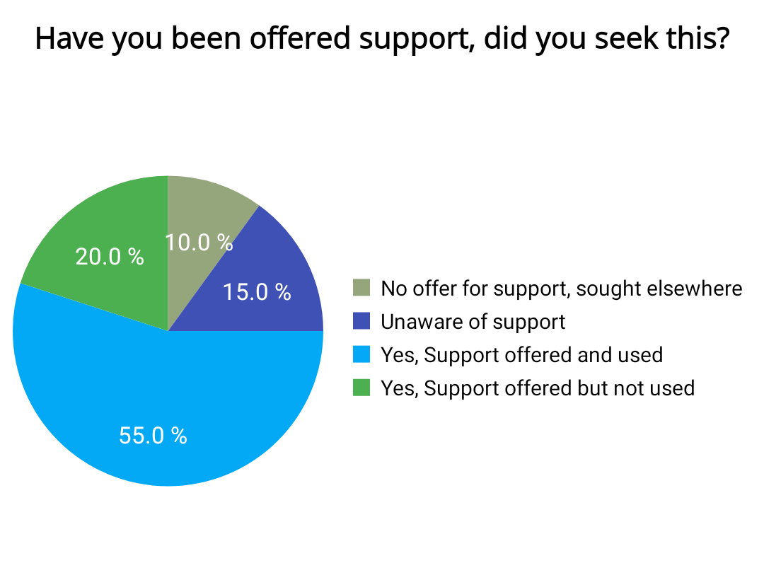
Figure 3:

Figure 3 highlights that 55% of police officers had been offered support for their poor mental health and used this. On the other hand, 20% of police officers had been offered support but did not use this. Therefore, it is important to understand that South Wales Police does offer support for their employees. However, if the police officers decide not to use this, it is important to understand why and explore ways of promoting this in a positive way.
The pie chart in figure 4 below shows the type of support given and used by police officers of South Wales Police who had been suffering with poor mental health.

Figure 4:
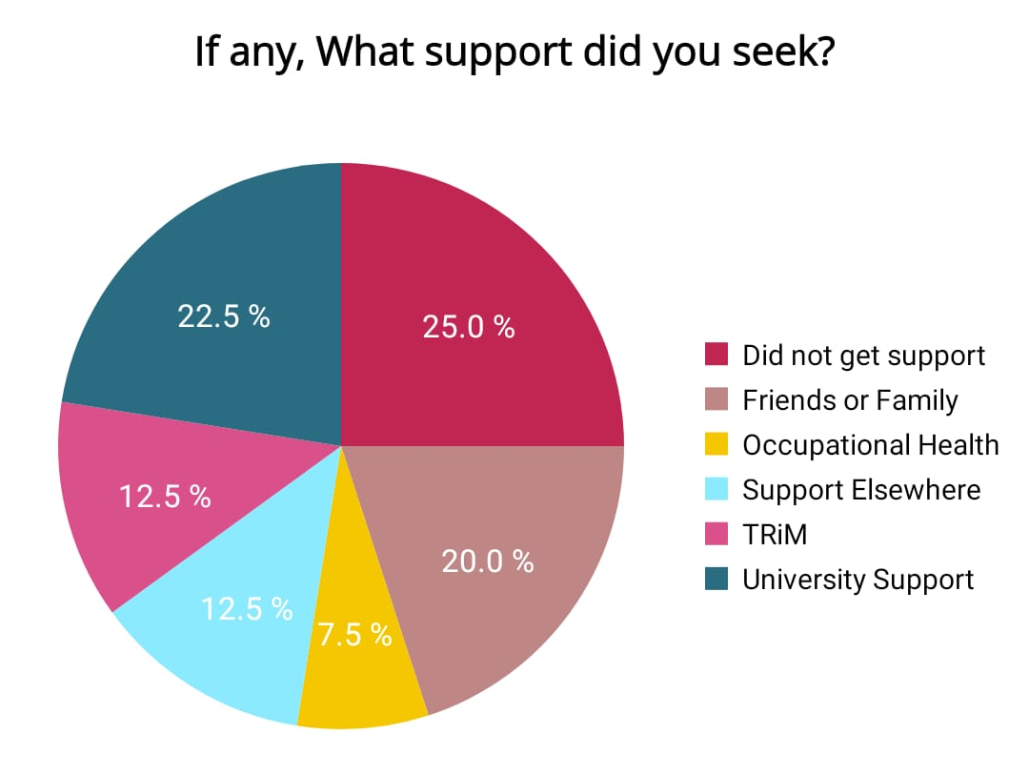

The pie chart highlights that 75% of police officers sought support due to poor mental health. It shows that 12.5% of police officers accessed support from TRiM. TRiM is a protocol that focuses on people in the workplace who have suffered a traumatic event. TRiM effectively manages and supports people and are trained in being able to support people who have had a cumulative of events, in a short space of time (Kent Police, 2021). The pie chart also shows that 25% of police officers did not get any support, this could be due to police officers not wanting to have that stigma of feeling weak or undervalued. The 25% of people could be worried about being discriminated against, if they wanted to apply for a different role in the police force.
It is also important to note that the pie chart in figure 4 also shows support as an option from the University, there is support for academic studies as well as in the workplace.
Linking all the pie charts together it is fair to note that operational stressors such as being exposed to traumatic events, and having to complete academic studies alongside working full-time, influences police officers’ mental health.
Figure 3 shows that South Wales Police are very supportive of their employees which has a positive outlook for police officers looking to join the force.
4.7 Theme Four – Qualitative Interviews
For the qualitative research, an interview was conducted for police officers who had completed the survey. The interview was completed for people who wanted to further expand on their answers after completing the survey.
The table below displays 6 participants answers relating to open ended questions asked by the researcher.
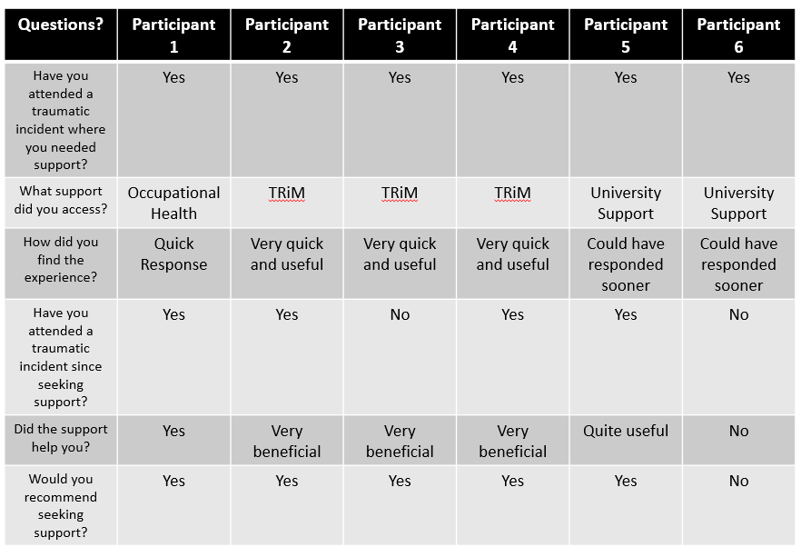
Figure 5:

The table in figure 5 above overall suggests that seeking support from services, is beneficial after being exposed to a traumatic incident. The table shows that 2 of the participants sought support from their University Support services. These police officers found that seeking advice from the university allowed them to liaise with an outside source to explain their concerns. It is important to recognise that the university is there to support their students, how best they can.
Out of the 6 participants, half of them sought support from TRiM with all 3 participants stating they received a quick response after getting in contact. The 3 participants also state that they found the education and support from TRiM was very beneficial, in helping them to cope with their poor mental health and would recommend them to other colleagues.
Participant 1 received support from the Occupational Health service, who highlighted the support to be beneficial and would recommend to other colleagues.
Whereas participants 5 and 6 both received support from their university, who both agreed that the university could have been in contact sooner. Although, participant 5 would recommend to other colleagues, participant 6 would not.

Chapter Five - Conclusion
5.0 Introduction
To conclude, four themes have been correlated from the quantitative and qualitative research. The results from the surveys and interviews conducted, have shown a clear indication for poor mental health in police officers of South Wales Police. Thus providing information about the “Investigation into the mental health of police officers in their probationary period”
5.1 Completion and Achievement of objective
The aims of this investigation I feel have been achieved by completing the research utilising anonymous surveys to provide a more honest picture of the problem relating to mental illness in student police officers. The research has explored key detriments that effect newly appointed police officers and found a number of factors which are having a negative effect on these officers.
5.2 Findings
The evidence indicates that police officers having regular exposure to traumatic incidents in their workplace, has impacted on their mental health. Additionally, it has been identified that police officers completing the degree alongside working full-time has also impacted on their mental health. Increasing workloads as well as having PLT days cancelled to cover staff shortages, has also impacted on the academic studies, increasing stress and poor mental health.
The pie charts have highlighted that support services such as TRiM and access to University Support, has provided a beneficial outcome for police officers seeking support who have poor mental health. The table in figure 5 above recognises that the police officers who accessed support from TRiM would recommend this to other colleagues. This suggests that TRiM is an effective protocol that can be accessed and used by the organisation.
5.3 Recommendations
Only 2 of the participants have accessed support from their university, but it is important to recognise that support for their students is also accessible. Some people may find it easier to talk to university support as this is outside of their workplace.
The research conducted has highlighted a need to improve support services, and how police officers need to be signposted to access these.
The evidence has shown that many student police officers were happy to a complete a survey. However, only a handful of participants wanted to continue and expand on their answers, during an interview.
It is important to encourage police officers to talk and liaise with support services, not to feel embarrassed or worried about seeking support. It is normal for people to have these feelings after being exposed to such a traumatic incident. Furthermore, people completing the degree should have regular contact with their university and to access their support services where needed. Maybe every few weeks once a new assignment had been launched, a contact from the university should be in contact with the student to touch base and see if they need any support. This could encourage the student to open up and ask for help if needed.
This dissertation has highlighted why students are experiencing poor mental illness in their probationary period. Furthermore, the dissertation highlights the importance and benefit of using the protocol TRiM. A recommendation that has been illuminated in this dissertation, is the regular cancelling of PLT days for police officers completing the three-year degree. Staff shortages should not be a reason for police officers to be cancelled off these days. If there seems to be a consistency in staff absence then South Wales Police, need to initiate more over time to other police officers and allow student officers the ability to complete their academic studies. If this becomes continuous then they could see a further increase in staff absences, due to the police officers not having enough time to complete their academic studies.
Another recommendation is exploring ways of encouraging police officers to talk about their feelings, to encourage more use of debriefing after incidents, and focus on ways of supporting each other.
5.4 Conclusion
Overall, this dissertation has been informative, and highlighted there is a high level of poor mental illness for student officers during their probationary period and a vital need for engagement to reduce the biggest stressors to avoid burnout and cause mental health spiralling out of control. There is little research conducted in relation to the new PEQF programme and the effects this programme has on police officers working full time. Police forces already stretched are not necessarily getting the most out of their officers due to the academic burden. This then detracts from problem solving and crime detection. The main conclusion of my research is there is poor mental health, and the problem appears to be getting worse each year. Police forces and universities need to engage with students and seek what they can do to support people.

Bibliography
Almeida, F. (2022). “Research Gate” [Online] Available at: https://www.researchgate.net/figure/Analysis-of-the-advantages-and-limitations-of-mixed-methods-approaches_tbl2_329402482 Accessed 28th December 2022.

Anshel, M. (2000) “A Conceptual Model and Implications for Coping with Stressful Events in Police Work” [Online] Available at: https://journals.sagepub.com/doi/10.1177/0093854800027003006 Accessed 30th August 2022.

Bell, S., & Eski, Y. (2016). ‘Break a leg—it’s all in the mind’: police officers’ attitudes towards colleagues with mental health issues. Policing, 10(2), 95–101.

Bhandari, P. (2022). “Ethical Considerations in Research | Types & Examples” [Online] Available at: https://www.scribbr.co.uk/research-methods/ethical-considerations/ Accessed 30th November 2022.

Boynton, P. (2004). “Selecting, designing, and developing your questionnaire” [Online] Available at: https://www.ncbi.nlm.nih.gov/pmc/articles/PMC420179/#:~:text=A%20standardised%20questionnaire%20is%20one,a%20measure%20increases%20its%20reliability. Accessed 28th December 2022.
Cartwright, A., Roach, J. (2020). “The wellbeing of UK Police: A study of recorded absences from work of UK police employees due to psychological illness and stress using Freedom of Information Act data.: Policing: A Journal of Policy and Practice.” [Online] Available at: https://www.researchgate.net/publication/342344191_The_wellbeing_of_UK_Police_A_study_of_recorded_absences_from_work_of_UK_police_employees_due_to_psychological_illness_and_stress_using_Freedom_of_Information_Act_data_Policing_A_Journal_of_Policy_and_ Accessed 28th December 2022.

Clements, J. (2022). “What Are The Benefits Of Using Interviews In Research?” [Online] Available at: https://www.legaltranscriptionservice.com/blog/what-the-benefits-of-using-interviews-in-research/ Accessed 28th December 2022.

Coffelt, T. (2022). “Confidentiality and Anonymity of Participants” [Online] Available at: https://methods.sagepub.com/reference/the-sage-encyclopedia-of-communication-research-methods/i3126.xml Accessed 28th December 2022.

College of Policing. (2014). “Code of Ethics” [Online] Available at: https://www.college.police.uk/ethics/code-of-ethics Accessed 30th November 2022.

College of Policing. (2018). “Responding to trauma in policing” [Online] Available at: https://assets.college.police.uk/s3fs-public/2021-02/responding-to-trauma-in-policing.pdf Accessed 20th December 2022.
College of Policing. (2022). “Response Policing Career Pathway” [Online] Available at: https://www.college.police.uk/career-learning/career-development/career-pathways/response-policing#:~:text=Response%20officers%20are%20at%20the,proactively%20patrol%20their%20communities Accessed 20th December 2022.

College of Policing. (2022). “Supporting wellbeing” [Online] Available at: https://www.college.police.uk/guidance/effective-supervision/supporting-wellbeing Accessed 20th December 2022.

College of Policing. (2023). “Saving life and limb: An investigation into the mental health of student police officers in the UK” [Online] Available at: https://www.college.police.uk/research/projects/saving-life-and-limb-investigation-mental-health-student-police-officers-uk Accessed 3rd February 2023.

Cox, C., Kirby, S. (2017). “Can higher education reduce the negative consequences of police occupational culture amongst new recruits?” [Online] Available at: https://www.researchgate.net/publication/320799598_Can_higher_education_reduce_the_negative_consequences_of_police_occupational_culture_amongst_new_recruits Accessed 3rd February 2023.
Cummings, I., & Jones, S. (2010). Blue remembered skills: mental health awareness training for police officers. Journal of Adult Protection, 12(3), 14–19.

Demou, E. (2020). “Understanding the mental health and wellbeing needs of police officers and staff in Scotland” [Online] Available at: https://www.ncbi.nlm.nih.gov/pmc/articles/PMC7116541/ Accessed 3rd February 2023.

Edwards, A. (2020). “Mental Health in the UK Police Force: a Qualitative Investigation into the Stigma with Mental Illness” [Online] Available at: https://link.springer.com/article/10.1007/s11469-019-00214-x#Sec29 Accessed 29th November 2022.

Edwards, A. (2021). “Mental Health in the UK Police Force: a Qualitative Investigation into the Stigma with Mental Illness” [Online] Available at: https://link.springer.com/article/10.1007/s11469-019-00214-x Accessed 15th October 2022.

Edwards, A., Kotera, Y. (2020). Mental Health in the UK Police Force: a Qualitative Investigation into the Stigma with Mental Illness. 19 (1) 1116-1134.

George, T. (2022). “Types of Interviews in Research | Guide & Examples” [Online] Available at: https://www.scribbr.co.uk/research-methods/types-of-interviews/ Accessed 30th November 2022.

Hailstone, J. (2018). “The Thin Blue Line – mental health in the police force” [Online] Available at: https://www.shponline.co.uk/culture-and-behaviours/thin-blue-line-mental-health-police-force/ Accessed 29th November 2022.

Hale, H., Hunt, K. (2020) “Understanding the mental health and wellbeing needs of police officers and staff in Scotland” [Online] Available at: https://www.tandfonline.com/doi/full/10.1080/15614263.2020.1772782 Accessed 30th August 2022.

Hampshire Fire and Rescue Service. (2016). “The Trauma Risk Management Handbook” [Online] Available at: https://documents.hants.gov.uk/corprhantsweb/Traumahandbook.pdf Accessed 20th December 2022.

Have you ever wondered what it's like to be a response officer?” [Online] Available at: https://www.leics.police.uk/news/leicestershire/news/2022/june/have-you-ever-wondered-what-its-like-to-be-a-response-officer/ Accessed 20th December 2022.

Home Office. (2022) “Police workforce, England and Wales: 31 March 2022” [Online] Available at: https://www.gov.uk/government/statistics/police-workforce-england-and-wales-31-march-2022/police-workforce-england-and-wales-31-march-2022 Accessed 27th August 2022.

Javanbakht, A. (2020). “The Aching Blue: Trauma, Stress and Invisible Wounds of Those in Law Enforcement” [Online] Available at: https://adaa.org/learn-from-us/from-the-experts/blog-posts/consumer/aching-blue-trauma-stress-and-invisible-wounds Accessed 15th October 2022.

Jetelina, K. (2020). “Prevalence of Mental Illness and Mental Health Care Use Among Police Officers” [Online] Available at: https://jamanetwork.com/journals/jamanetworkopen/fullarticle/2771400 Accessed 3rd February 2023.

Kent Police. (2021). “Human Resources - Trauma Risk Incident Management (TRIM) protocol (L11260)” [Online] Available at: https://www.kent.police.uk/foi-ai/kent-police/Policy/human-resources/trauma-risk-incident-management-trim-protocol-l11260/ Accessed 20th December 2022.

Leicestershire Police. (2022). “Breadcrumb News
March on Stress. (2012). “Trauma Risk Management (TRiM)” [Online] Available at: https://www.marchonstress.com/page/p/trim Accessed 29th November 2022.

Marchand, A., Nadeau, C., Beaulieu-Prévost, D., Boyer, R., & Martin, M. (2015). Predictors of posttraumatic stress disorder among police officers: a prospective study. Psychological Trauma: Theory, Research, Practice, and Policy, 7(3), 212–221.
Mind. (2019) “Mental Health in the emergency services” [Online] Available at: https://www.mind.org.uk/media-a/4847/2019-survey-ambulance-service-summary.pdf Accessed 27th August 2022.

Mind. (2022) “Blue Light Programme” [Online] Available at: https://www.mind.org.uk/news-campaigns/campaigns/blue-light-programme/ Accessed 30th August 2022.

Mind. (2023). “Trauma” [Online] Available at: https://www.mind.org.uk/information-support/types-of-mental-health-problems/trauma/about-trauma/ Accessed 3rd February 2023.

Nakazawa, M. (2012). “Examining the advantages and disadvantages of pilot studies: Monte-Carlo simulations” [Online] Available at: https://digitalrepository.unm.edu/cgi/viewcontent.cgi?referer=&httpsredir=1&article=1103&context=psy_etds Accessed 28th December 2022.

National Institute of Mental Health. (2022). “Mental Illness” [Online] Available at: https://www.nimh.nih.gov/health/statistics/mental-illness Accessed 3rd February 2023.

National Research Ethics Committee. (2015). “Confidentiality” [Online] Available at: https://www.forskningsetikk.no/en/resources/the-research-ethics-library/data-protection-and-responsibility-concerning-the-individual/confidentiality/ Accessed 28th December 2022.

Newell, C.J., et al (2022). “Police staff and mental health: barriers and recommendations for improving help-seeking” [Online] Available at: https://www.tandfonline.com/doi/pdf/10.1080/15614263.2021.1979398 Accessed 28th December 2022.

Osbaldeston, A. (2021). “5 Reasons To Combine Qualitative And Quantitative Research” [Online] Available at: https://www.questback.com/blog/5-reasons-to-combine-qualitative-and-quantitative-research/ Accessed 28th December 2022.

Police Care UK. (2019). “Police Care UK calls for a dedicated mental health strategy tackling trauma-related stress in UK policing.” [Online] Available at: https://www.policecare.org.uk/mental-health-strategy-for-policing-urgently-required/ Accessed 29th November 2022.

Police Care UK. (2019). “Police Traumatic Events Checklist” [Online] Available at: https://www.policecare.org.uk/get-informed/traumatic-events-checklist/ Accessed 20th December 2022.

Police Federation. (2016) “Mental Health” [Online] Available at: https://www.polfed.org/our-work/wellbeing/mental-health/ Accessed 30th August 2022.

Police Federation. (2022). “NPCC data shows a national absence rate for police officers and staff of 9.4 per cent” [Online] Available at: https://www.polfed.org/news/latest-news/2022/npcc-data-shows-a-national-absence-rate-for-police-officers-and-staff-of-94-per-cent/#:~:text=NPCC%20data%20shows%20a%20national,staff%20of%209.4%20per%20cent Accessed 28th December 2022.

Qualtrics. (2022). “What is a survey?” [Online] Available at: https://www.qualtrics.com/uk/experience-management/research/surveys/ Accessed 30th November 2022.

Russell, S. (2022). “Poor working conditions exacerbate PTSD issues for police – study” [Online] Available at: https://www.independent.co.uk/news/uk/ptsd-trauma-police-officers-cambridge-university-b2205863.html Accessed 28th December 2022.

Shorten, A. (2017). “Mixed methods research: expanding the evidence base” [Online] Available at: https://ebn.bmj.com/content/20/3/74 Accessed 30th November 2022.

Simkus, J. (2022). “What is a Pilot Study?” [Online] Available at: https://www.simplypsychology.org/pilot-studies.html Accessed 30th November 2022.
Sincero, S. (2022). “Advantages and Disadvantages of Surveys” [Online] Available at: https://explorable.com/advantages-and-disadvantages-of-surveys Accessed 28th December 2022.

South Wales Police. (2021). “Inaugural response policing wellbeing and recognition ‘Week of Action’” [Online] Available at: https://www.south-wales.police.uk/news/south-wales/news/2021/march/inaugural-response-policing-wellbeing-and-recognition-week-of-action/ Accessed 20th December 2022.

South Wales Police. (2022). “Health Safety & Wellbeing” [Online] Available at: https://www.swpf.org/localcontent.php?ContentID=9 Accessed 20th December 2022.

Stevelink, S., Greenberg, N., Fear, N. (2020). “Depression is 2.5 times more common than Post-Traumatic Stress Disorder in UK police officers” [Online] Available at: https://kcmhr.org/depression-is-2-5-times-more-common-than-post-traumatic-stress-disorder-in-uk-police-officers/ Accessed 15th October 2022.

Stevenson, S., Farmer, R. (2017) “Thriving at work” [Online] Available at: https://assets.publishing.service.gov.uk/government/uploads/system/uploads/attachment_data/file/658145/thriving-at-work-stevenson-farmer-review.pdf Accessed 30th August 2022.
Summerfield, D. (2011). First person: Metropolitan police blues: protracted sickness absence, ill health retirement, and the occupational psychiatrist. BMJ, 342. https://doi.org/10.1136/bmj.d2127.

Teijlingen, E., Hundley, V. (2001). “The importance of pilot studies” [Online] Available at: https://sru.soc.surrey.ac.uk/SRU35.html Accessed 28th December 2022.

The Centre for Addiction and Mental Health. (2022). “Trauma” [Online] Available at: https://www.camh.ca/en/health-info/mental-illness-and-addiction-index/trauma#:~:text=Trauma%20is%20the%20lasting%20emotional,regulate%20emotions%20and%20navigate%20relationships. Accessed 20th December 2022.

The March on Stress. (2022). “What is TRiM?” [Online] Available at: https://www.marchonstress.com/page/p/what_is_trim Accessed 20th December 2022.

Thompson, K. (2016). “Interviews in Social Research: Advantages and Disadvantages” [Online] Available at: https://revisesociology.com/2016/01/23/interviews-in-social-research-advantages-and-disadvantages/#:~:text=The%20main%20theoretical%20disadvantage%20is,different%20ways%20to%20different%20respondents. Accessed 28th December 2022.

UCAS. (2022). “How to become a police officer” [Online] Available at: https://www.ucas.com/careers-advice/employment/how-to-become-a/police-officer#:~:text=The%20College%20of%20Policing%20really,the%20new%20Degree%20Apprenticeship%20Programme. Accessed 15th October 2022.

University of Bristol. (2023). “Health and wellbeing” [Online] Available at: https://www.uwe.ac.uk/life/health-and-wellbeing Accessed 3rd February 2023.

University of Cambridge. (2022). “POLICE WORKFORCE: ALMOST ONE IN FIVE SUFFER WITH A FORM OF PTSD” [Online] Available at: https://www.cam.ac.uk/policeptsd Accessed 15th October 2022.

University of Cambridge. (2022). “UK policing: psychological damage among officers heightened by bad working conditions” [Online] Available at: https://www.cam.ac.uk/research/news/uk-policing-psychological-damage-among-officers-heightened-by-bad-working-conditions#:~:text=Sociologists%20surveyed%20thousands%20of%20police,and%20an%20inability%20to%20regulate Accessed 28th December 2022.

University of London. (2023). “How to become a police officer” [Online] Available at: https://www.city.ac.uk/prospective-students/career-development/pathways/how-to-become-a-police-officer Accessed 3rd February 2023.

Velazquez, E., Hernandez, M. (2019) “Effects of police officer exposure to traumatic experiences and recognising the stigma associated with police officer mental health” https://doi.org/10.1108/PIJPSM-09-2018-0147 Accessed 28th December 2022.

Verhoef, M., Casebeer, A. (2019). “Broadening horizons: Integrating quantitative and qualitative research” [Online] Available at: https://www.ncbi.nlm.nih.gov/pmc/articles/PMC3327344/#:~:text=Third%2C%20qualitative%20and%20quantitative%20research,the%20result%20of%20the%20other. Accessed 28th December 2022.

Violanti, J. (2018). “PTSD among Police Officers: Impact on Critical Decision Making” [Online] Available at: https://cops.usdoj.gov/html/dispatch/05-2018/PTSD.html Accessed 20th December 2022.

Walden University. (2022). “5 Reasons the Mental Health of Police Officers Needs to Be a Priority” [Online] Available at: https://www.waldenu.edu/programs/criminal-justice/resource/five-reasons-the-mental-health-of-police-officers-needs-to-be-a-priority Accessed 15th October 2022.

Walden University. (2022). “5 Reasons the Mental Health of Police Officers Needs to Be a Priority” [Online] Available at: https://www.waldenu.edu/programs/criminal-justice/resource/five-reasons-the-mental-health-of-police-officers-needs-to-be-a-priority#:~:text=4.%20Most%20law%20enforcement%20officers%20do%20not%20seek,factor%20that%20prevents%20police%20officers%20from%20getting%20help. Accessed 29th November 2022.

Welcome Trust. (2014). “Ensuring your research is ethical: A guide for Extended Project Qualification students” [Online] Available at https://wellcome.org/sites/default/files/wtp057673_0.pdf Accessed 28th December 2022.

West Midlands Police. (2022). “Police officer sickness” [Online] Available at: https://foi.west-midlands.police.uk/police-officer-sickness-614a-22/ Accessed 3rd February 2023.

Wilmot, A., Leaker, D. (2022). “Sickness absence in the UK labour market: 2021” [Online] Available at: https://www.ons.gov.uk/employmentandlabourmarket/peopleinwork/labourproductivity/articles/sicknessabsenceinthelabourmarket/2021 Accessed 28th December 2022.

Wood, J. D., Watson, A. C., & Fulambarker, A. J. (2017). The “gray zone” of police work during mental health encounters: findings from an observational study in Chicago. Police Quarterly, 20(1), 81–105.

World Health Organization. (2022). “Doing what matters in times of stress” [Online] Available at: https://www.who.int/publications/i/item/9789240003927?gclid=CjwKCAjwtKmaBhBMEiwAyINuwBzmyt1qNCtEkOapqBMJ5M9EOz9bzwJSm87aZQh4SFEVsfE6ZuabXhoCq4AQAvD_BwE Accessed 15th October 2022.

Appendix 1 – Survey
Investigation into the Effect of Mental Health in Police Officers during their Probationary Period Survey.
Question 1
What year did you join the police?
A – 2019
B – 2020
C – 2021
D – 2022
Question 2
What was the length of your probationary period?
A - 2 years
B - 3 Years
Question 3
During your probationary period, did the role of a police officer have a significant effect on your mental health?
A – Yes – Positive
B – Yes - Negative
C – No
D – Prefer not to answer
Question 4
What programme under PEQF did you join?
A – PCDA
B – DHEP
C – Direct Entry
D – Pre PEQF (SOLAP)
E – Police Now
Question 5
What workplace stressors would you consider the biggest cause that increases stress and caused poor mental health?
A – Traumatic Injury
B – Serious Domestic Violence
C – Child Abuse
D – Mental Health
E- Workloads
F – Staffing Levels
G – University Studies. (PCDA / DHEP Assignments)
H – Management decisions
I – Cancelled PLT days / Cancelled Rest Days
J – Kept on Duty
K – Restriction on personal life
Question 6
What actions could help minimise the stress and improve your mental health?
*Open Question / Free type*
Question 7
Have you been absent from work, with a mental health related illness? If so how long?
A – Not been off work with ill mental health.
B – 1-2 weeks
C – 3-4 weeks
D – 1-2 months
E – 3+ months
Question 8
Have you engaged with any support services for your mental health?
A – South Wales Police Occupation Health
B – TriM
C – GP24 Telephone service (Police Federation)
D – UWTSD
E – Friends or Family
F – Other (Free text comment below)
Question 9
Has the PCDA / DHEP aided you in your development as a student constable?
A – Yes
B - No
C - Too early to say
D – Prefer not to answer
Question 10
Has the demanding and stressful role of a police officer impacted on your personal life, and how?
*Open Question – Free type*
----------------------------------------------------------------------------------------------------------------
Interview Request
Would you be willing to answer further questions by the researcher in more depth regarding your mental health and the role of being a police officer?
If so, please provide your e-mail address for further contact.
*Open Question – Free type*

Thank you for your time and assistance completing this survey.
Marc Fitchett, Student Police Constable

