

Independent Project

Independent Project

Analysis of the Interventions that are in place by the police to protect women suffering from domestic Violence in England and Wales and reasoning behind why some women don’t use the support available.

Lily Turner
1900649
University of Wales Trinity St David
Professional Policing BSc
BMPL6008
Lecturer: Rhiannon Lloyd
Word count: 5324

Acknowledgements

Firstly, I would like to thank Rhiannon for her endless help and support throughout the process of completing this research project. Without the constant assistance, I would have not been able to complete this project to the best of my abilities. I am very thankful to have had a supervisor with such great knowledge and understanding around the degree and that was always happy to help and support in the best way possible. Also the constant reassurance and guidance whenever needed is greatly appreciated.
I also would like to show my appreciation to both my mother and father for always believing in me and pushing me to achieve the best in everything I do. I could not have completed this without their continuous support from the very beginning of my journey through education. Being the first person in my family to complete a degree has been both a challenge and reward to have been able to graduate from a professional policing degree.

Declarations

This work has not previously been accepted in substance for any degree and is not being concurrently submitted in candidature for any degree.

STATEMENT 1

This dissertation is being submitted in partial fulfilment of the requirements for the degree of BA/BSc.

STATEMENT 2

This dissertation is the result of my own independent work/investigation, except where otherwise stated.

STATEMENT 3

I hereby give consent for my dissertation, if accepted, to be available for photocopying and for interlibrary loan, and for the title and summary to be made available for outside organisations.

STATEMENT 4

I hereby give consent for my dissertation, if accepted, to be available on the university system to those who have consent to use the system.

Student Name: Lily Turner

Signed:
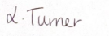

Date: 27th April 2022

Abstract
This study is an in-depth review of the interventions that are put in place by the police to protect women suffering from domestic violence in England and Wales and the reasoning behind why some women don’t use the support available. This project will include statistics around domestic violence, the support and guidance available for women, the charities and organisations that are available for women and to understand why some women choose not to use the support that is available to them. Also a mini research project will be undertaken to analyse the opinions of members of the public within the South Wales Police area. As a special constable I will be evaluating the interventions that are in place for women and researching why some women don’t utilise the help that is available for them. I have a passion for domestic violence as currently I am a special constable where I attend domestic violence related incidents towards women frequently, by doing this research project it will allow me to develop my effective communication skills, using empathy to help support these victims in the best way possible.

Table of Contents

Acknowledgements …………………………………………………… 1

Declaration ………………………………………………………………2

Abstract ………………………………………………………………….3

Introduction …………………………………………………………….5-6

Placement ………………………………………………………………7-8

Literature Review ………………………………………………………9-12

Methodology …………………………………………………………….13-14

Mini Research Project Findings ……………………………………….15-18

Reflection ……………………………………………………………….19-23

Conclusion ………………………………………………………………24-25

Appendix ………………………………………………………………….26-31

References …………………………………………………………………32-37

Introduction

The aim of this individual project is to conduct, through my professional experiences as a Special Police Constable, the analysis of the interventions that are in place by the police to protect women suffering from domestic violence in England and Wales and the reasoning behind why some women don’t use the support available, specially concentrating on South Wales Police being the force in which I work. I have decided to focus my project on domestic violence due to the severity of domestic violence cases I attend daily as a special constable. Domestic violence is a topic of interest to me due to the cases I have worked closely in to allow myself to gain a better understanding and knowledge of the subject and to help the victims in need in the best way possible.
I have completed over 80 hours outlined on the police force system - duty sheet. Please see appendix 1.
Here in the 21st century, whoever you are, wherever you live and whatever lifestyle you lead, you have the right to live in a safe and secure environment. Unfortunately, for many women this right has been taken away and has had a detrimental effect on their lives. Alarmingly, in 2021 almost 850,000 victims in England and Wales reported a domestic abuse related crime to the police which has increased by 6% from the previous year (Office of National Statistics, 2021). Domestic abuse is often seen by many as the form of being physically abused by a spouse or intimate partner however, there are several different forms of domestic abuse which some victims are unaware of (South Wales Police, 2021). The different forms of domestic abuse include, Physical abuse, coercive control, financial abuse, sexual abuse, emotional abuse, psychological and digital abuse (Stop Domestic Abuse, 2021). The high number of domestic abuse cases in England and Wales are echoed across the world as statistics state that internationally around 1 in 3 women have been a victim of some form of domestic abuse (World Health Organization, 2021). Regrettably, domestic violence in England and Wales can result in innocent women being killed. Staggering, statistics suggest that two women a week lose their lives through the suffering of domestic violence (Refuge, 2022).

Placement

I am currently a Special Constable (SC) for South Wales Police, based in the Maesteg area near Bridgend. The majority of my time as a SC I have been assigned to team 4 response in Maesteg station under the collar number of 77021. During studying for my professional policing degree, I decided to apply for the role as a SC to gain extra experience and knowledge of the role of a Police Officer. A SC is a person who receives full professional police training which then enables them to become a volunteer Police Officer who will have equal authority to a serving Police Constable (West Midlands Police, 2022). Specific requirements need to be followed to fulfil the role as a SC, these include working a minimum of 200 hours a year on a volunteer basis, attending all training courses and ensuring fitness levels are maintained throughout (South Wales Police, 2022). As a SC I have the responsibility to respond to emergency calls (999 calls), protect and prevent individuals becoming victims of crime, offer support and guidance to victims of crimes and build relationships with the public to provide a safe and secure community. All my duties carried out as a SC comply with the official roles and responsibilities of a SC outlined by College of Policing (College of Policing, 2021).
Since becoming a SC it’s made me more aware of the high volume of domestic violence cases the police respond to. Due to the high percentage of domestic violence calls I have been attached to as a SC, I decided to dedicate this research project on domestic violence against women to better my knowledge and understanding of why women suffering don’t utilise the resources available to help and support them. Alongside this, I wanted to research the current support available and analyse the statistics to get a better perception of victim’s experiences suffering the abuse.
The majority of daily calls received by the police for domestic violence cases are high priority calls, known as G1s. These types of calls are first and number one priority for myself and other police officers in my team as ensuring public safety is of utmost importance for South Wales Police. Whilst initially responding to domestic violence calls it is vital that all police officers attached to the case familiarises themselves with full details regarding the situation, what has occurred, and background information of the parties involved. This is the starting process where I would consider the National Decision Model (NDM), Code of Ethics. The NDM is the decision-making model that is protocol for all Police Officers (Sullivan, 2017). When receiving the initial call this is where I would be considering the first stage where I am gathering the information and intelligence of the case I am about to attend. Once this has been established, I would then proceed with assessing the threat and risk and lead onto considering the powers and policies that would be most effective to the individual case. In the final steps, I would consider productive options and contingencies for a positive outcome, implement the action I have taken and review the outcomes and assess the effectiveness of decision making and recommendations to improve outcomes if necessary (College of Policing, 2014).

Literature Review

According to South Wales police (2021) Domestic abuse is recognised throughout England and Wales where there are many organisations who offer interventions and support for all victims. One of the most effective organisations available to any victim of domestic abuse is the police service who are available 24 hours a day, 365 days a year as victims can ring 999 or 101 to report the abuse they are suffering (South Wales Police, 2021). Within the police force, expert training has been provided by Women’s Aid to ensure that police officers have the correct knowledge and understanding of how domestic abuse can affect victims so that they are able to fully support victims who have reported a crime. Women’s Aid, alongside the College of Policing, have introduced “The Domestic Abuse Matters Programme” to develop police officer’s roles when dealing with victims of domestic violence. This initiative has been welcomed by members of the police force who believe that this specific training has had a positive impact when dealing with victims (Women’s Aid, 2021).
As correspondent to Women Aid (2022) Once a victim has reported a crime to the police, the police will ensure that they stay in contact with the victim, keep the victim informed throughout their investigation and to offer specific interventions if needed. One intervention that is available to victims is the Independent Domestic Violence Advocate (IDVA) which offers a person who can advocate on the victim’s behalf and supports the victim with advice regarding the criminal justice system, keeping the victim and their family safe, provide support with emotional needs and help rebuild their future (EVA Women’s Aid, 2019). A number of victims of domestic abuse often report the crime to the police when the abuse becomes too unbearable to live with and help is needed immediately. This is where Refuge (2017) comes into place and plays a vital role in supporting the victims' needs instantly. Organisations such as Refuge helps provide a safe and secure place for victims and their children to live whilst the crime is being investigated. Fully skilled trained and professional staff are available to support victims with their individual specific needs to guarantee that their welfare and wellbeing is protected and ensure confidentiality when needed (Refuge, 2017). For victims who have insufficient evidence to prove domestic violence but have been brave enough to come forward to the police, the police provide the Domestic Violence Protection Order (DVPO). The DVPO provides the victim with protection from the abuser as the abuser is not allowed no contact with the victim for a period of 28 days to allow the victim to access relevant support (South Wales Victim Focus, 2022). The above interventions help and assist victims who are currently being abused, however for some people concerns they may become a victim of domestic abuse can also be an issue. Clare’s Law has been founded to allow the public to enquire information regarding a member of the public, who is a current partner or close contact to a family member who they believe may have been a domestic abuser in the past (Metropolitan Police, 2021).
Safe Lives (2021) suggests that there have been hundreds of women who have had positive experiences and outcomes using the interventions that have been provided for them during their suffering as a domestic violence victim. An example of this was a victim who had struggled in a relationship which involved alcohol and drugs, where the victim held back from getting support at the beginning due to feelings of self-blame and embarrassment. However, she finally found the courage to report the abuse to police and was overwhelmed by the police officer who dealt with her case in regard to how professional and understanding he was towards her. Alongside this, the professionalism of this particle police officer enabled the victim to turn her life around and felt confident and safe enough to leave the abusive relationship (Safe Lives, 2021). It is also encouraging for victims to know that the police do their utmost to convict abusers and in March 2021, 1 in 3 people were arrested in relation to domestic violence crimes which clearly shows that the police are protecting the victims (Office of National Statistics, 2021).
According to Women’s Aid (2021) although there are a wide range of interventions and organisations available for victims of domestic abuse to access, unfortunately, there are many victims, for their own personal reasons who chose not to utilise these services. One of the major factors that contribute to victims of domestic abuse not coming forward is the fear and danger they may be putting themselves in by naming the perpetrator. Evidence suggests that violence still occurs after many victims have found the courage to leave the abusive relationship, as over 40% of women are killed by their partner after separation. As stated on the National Coalition Against Domestic violence website (2022) another reason why women stay in abusive relationships is fear of being judged as many perpetrators are able to manipulate the victim in convincing them that they are the reason why they receive the abuse. A victim is often too ashamed to share their experiences as they believe they are fully to blame for the situation they are in (Whiting, 2016). In addition to this, what often hinders the progress of tackling domestic violence is the opinion of the public where many people believe that if women were that scared then they simply would leave the relationship (LaViolette, Barnett, 2000). For many women it is not as simple as just leaving the relationship as they are financially dependent on their partner and fear of the inability to look after and care for herself and her children stops them from leaving (Edwards, 1989).
The Government takes an active role in evaluating the interventions and organisations relating to domestic violence which are always assessed to review the effectiveness they have on the women suffering. The continuing high number of domestic abuse cases has had an influential effect on the Home Office to contribute £11.3 million to continue to develop domestic abuse interventions programmes within the Police and Crime Commissioners. This money will ensure that domestic abuse crimes will continue to be a priority and victims will continue to receive the best professional standard of care (Home Office, 2021). The important part about tackling domestic abuse is ensuring that the police work collaboratively with other specialised professionals to encourage victims to come forward and report domestic crimes being committed. Working with outside agencies who will educate people in the community to get a better understanding of the scope of domestic violence will hopefully give women the encouragement they need to contact the police (Hester, Westmarland, 2005).

Methodology

In order to develop professionally within my career as a SC, I have taken this opportunity to conduct mini research for the force to get a better understanding as to what the general public's opinions and feelings on the topic of domestic violence.
The literature review above portrays the secondary research that has been used to gain an understanding of the research that is available on online sources. The primary research that has been decided to be used in this project is a questionnaire which will be delivered to a variety of different people, male and female of ages ranging between 18-70 in order to get a broad perspective. According to Mcleod (2018) A questionnaire is a variety of questions that have been arranged together to retrieve information on a specific subject from people responding to the questions. Alongside this a questionnaire is going to be used as it is a cost effective and efficient way of collecting responses from a large quantity of people, however questionnaires can be difficult to know if the responders are being truthful with their responses and not just ticking any box (Mcleod, 2018). Both qualitative and quantitative data will be collected from the questionnaire allowing a full analysis of the topic in question. As stated by Streefkerk (2019) quantitative data is the gathering of numbers and statistics allowing data to be reviewed in relation to the topic in question which can be used through close-ended questions. Qualitative data is illustrated through words to understand the view, feelings and opinions of the topic that is being discussed and can be demonstrated with open-ended questions (Streefkerk, 2019). This questionnaire will include a mixture of both open-ended and closed-ended questions allowing to get the respondents full opinions and feelings on the topic. Open-ended questions allow the responder to express their beliefs and views on the matter, allowing them to write as much or as little about the topic as they know, or feel is necessary to mention (Farrell, 2016). Furthermore, Farrell stated that where close-ended questions usually entail the responder replying yes or no or not sure to the question they have been asked. Close-ended questions are used to allow the researcher to get the exact answer they are looking for and to easily analyse the results. The questionnaire will have different sections in a chronological order allowing the responder to be able to easily follow the questions. These will include an introduction which will allow the responder to fully understand what the questionnaire will entail, followed by questions ensuring the participant is happy to answer the following questions and gives full consent in completing the questionnaire. This will then lead into the main section of the questionnaire involving a variation of questions, quantitative and qualitative, open and closed questions (Gorard, 2007).

Mini Research Project Findings

Following the distribution of the questionnaire, (please see appendix 2) it is clear from the analysis that most people who responded to the questionnaire have an awareness of what domestic violence is, although many people's responses included the term physical violence. This suggests that to many, domestic violence is linked to physical violence however, there are numerous areas of domestic violence types which can include emotional, verbal, and financial as stated by Women’s Aid (2021). These types of domestic violence issues are being portrayed on different forms of media which is building awareness of all areas of domestic violence and allowing the public to have a better understanding of domestic abuse as a whole. A small number of responses highlighted that they have a greater knowledge around the different types of domestic violence due to television programmes such as Coronation Street where coercive control was a major storyline.
One significant question included in the questionnaire asked respondents “who could be involved in domestic violence”. It was recognised by a high number of individuals that a wide range of people are involved in domestic abuse, not just women and their partners. Many identified that children and other relatives or household members can often be involved in domestic violence cases.
Although a high number of respondents are aware of domestic violence, less than 50% of these respondents were aware of the actual number of women who suffer from domestic violence. A staggering 1 in 3 women experience domestic violence at least once in their lifetime which was recognised by only 47%, where the remaining 53% believed that the statistics for domestic violence were a lot lower. These statistics show that members of the public are unaware of the high volumes of domestic violence crimes committed against women in the UK. Alarmingly, almost 75% of respondents have themselves been victims of domestic violence or know someone that has been a victim of domestic violence which suggests that many people's lives are affected in some way by crimes of domestic violence.
The police deal with domestic violence calls on a day-to-day basis which suggests that police are often the first protocol for help for a lot of women who are victims seeking support. One of the questions included in the questionnaire was used to establish the knowledge the participant holds regarding the role of the police when dealing with domestic violence. Just over half (60%) have some knowledge of how the police respond to domestic violence and 40% were unsure of police procedures carried out when dealing with domestic violence. Of the 60% who have an understanding of the role of the police, many people gave examples of their awareness within the role of the police. These included safeguarding and protecting the victim, arresting necessary perpetrators, carrying out welfare checks on the victims and providing appropriate victim support and using Clare’s Law. Clare's Law proves to be a successful strategy in helping protect vulnerable women as also highlighted in the secondary research above. These responses indicate that the police strategies and procedures are recognised by the 60%, however, in order to educate the remaining 40% more information needs to be published by the police to raise awareness on the vital help and support they provide for victims.
Due to the ever-rising number of domestic violence victims, one of the most important questions to analyse is “Do you believe enough is being done to help protect women suffering from domestic violence?”. Unfortunately, only 6% of respondents believed that enough was being done to help protect these vulnerable women suffering. From previous secondary research, which states that there is a yearly increase of domestic violence victims, this primary research statistic validates that not enough is being done to help protect victims and to decrease the actual number of women who are suffering. Many of the respondents were able in the following question to identify what support and help is available for women where many domestic violence charities where listed and recognised, these include Women’s Aid, Refuge and Calan DVs. Although these charities and organisations names are recognised, unfortunately feedback from this question suggests that several people are unsure of the specific support and advice that are offered from these individual charities. Therefore, charities and organisations need to communicate the support they offer to instil confidence and courage in women coming forward and getting the help and support they desire. Participants of the questionnaire were requested to share all the known establishments where they could get domestic violence help if they were to become a victim. Many identified Social Services, the Doctors, Police, Refuge and Healthcare professionals as reliable and professional points of contact. Although many support organisations were named, some participants could only name the police as a source of help which may indicate as to why many cases of domestic abuse go unreported as many victims do not want the police involved and are unaware of other services that are available that have no police involvement.
Regardless of the high number of organisations available to help and support victims of domestic violence, unless a victim comes forward and seeks support and advice, domestic violence will continue to torture and destroy their lives. The question was asked as to why victims of domestic violence fail to utilise the help that can be provided to them. A variety of responses were recorded to this question which shows empathy and compassion to reasons why victims continue to stay victims even when support is accessible. Duplicate responses suggest that victims often feel ashamed, scared, and worthless as often the perpetrator has manipulated the victim into feeling this way. A popular response to this question was the victim would be in fear of the repercussions they would receive from the perpetrator which in severe cases has resulted in serious injury and death. Alongside this, many victims are in love with their abuser and strive to keep their family together at all costs. Without having actual proof many victims feel that they will be deemed untruthful and will not be believed and therefore decide to remain silent. As addressed on Women’s Aid (2021) it illustrates the reasoning behind why women refrain from coming forward and speaking about the domestic violence they are experiencing.
It is apparent from this questionnaire that support for domestic violence victims is recognised and acknowledged, however, it is an area that needs to be developed and expanded to ensure that victims feel comfortable and confident in taking the courageous step to report their abuser and receive the help and support they deserve. Only then will the number of victims of domestic violence decrease.

Reflection

Having done the above research this has enabled me to deal with domestic violence incidents with a wider knowledge and understanding around how to respond to incidents using best practice and how to provide appropriate support. During the research project and my experiences as a SC I have allowed myself to build on my effective communication skills towards domestic violence victims, this has been shown through conversation engagement, statement taking of victims and undertaking key research surrounding the topic. For an effective response to domestic violence incidents every individual case needs to be dealt with showing empathy towards the victim and to ensure a positive outcome, presenting assertive skills are essential.
As part of being a Special Constable (SC) attending domestic violence calls is a frequent part of my daily duty. Although I have attended many domestic violence incidents, each individual case is unique, and you never know what you are going to be faced with until you arrive at the scene. I have decided to reflect using Gibbs Reflective Cycle (2020) on a serious domestic violence case to fully analyse the events that occurred. Gibbs Reflective Cycle is a structured learning tool which provides six stages to allow you to learn from the experiences you have gained from a particular scenario (University of Edinburgh, 2020). The six stages outlined by Gibbs include description, feeling, evaluation, analysis, conclusion and action plan which I will use to reflect on the case I will be discussing (Gibbs, 1988).
I was responding to a 999 call from a neighbour of a previous individual we have visited recently who has been involved in domestic violence against his partner which was a top priority call for the police to attend and was listed as a Grade 1. A Grade 1 call is an incident that must be attended to within 15 minutes as it is deemed a dangerous and life-threatening situation (Greater Manchester Police, 2022). Usually in domestic violence calls two officers attend the scene, however due to the preparator on previous occasions showing aggression and violence towards the police, on this occasion the decision was made for myself and three other officers to attend the incident. In the early afternoon, we arrived at the scene within 10 minutes of receiving the call which was an incident in a third-floor flat building. The neighbour had reported hearing screams and shouts from a woman in the flat above which is occupied by the reoffending perpetrator. On arrival, we immediately knocked on the door of the address that we had been given but there was no response, however, we could hear the distressed woman inside the property. Concerned for the victim's safety, the decision was made to gain access and entry into the property by using a battering ram by a fully trained police officer. Once entry was gained, the distressed woman was curled up in a ball crying rocking back and forth, however at this immediate time there was no sighting of the perpetrator. Immediately following this, we heard screams of pain coming from outside the window which was a result of the suspect jumping out of the third-floor window and landing on the ground below. A colleague and I remained with the distressed woman to comfort and support her injuries whilst the other two officers attended to the suspect outside.
When attending any domestic violence case, you can never anticipate what lies ahead and during the journey to the scene I was optimistic that we would face a verbal complication between a couple that could be resolved at the scene as most domestic violence calls that I have attended have ended in this situation. As I arrived on the scene, my concerns began to grow as the distress screams from the woman inside alarmed me that this was a very serious and dangerous situation. The decision taken by my colleagues to ram down the door was a welcome relief to myself as my feelings of serious concern at the time for the woman's safety were growing rapidly. Whilst entering the flat I was relieved to see that the woman was fully conscious and had no major signs of serious injury, however, her distress state was a cause of concern for me as I tried to comfort and assess her minor injuries. Although the perpetrator had scared and injured the victim, I was shocked and very concerned about his welfare and injuries due to the horrific fall he had been involved in. Following the incident, I was relieved that both parties survived the incident and remained a little distressed at the events that had occurred, and the images witnessed after the fall.
The sole purpose of attending the scene was to ensure that the victim of domestic violence was removed from the situation as quickly as possible with as little injuries as possible and for the perpetrator to be dealt with in the correct procedure. Police pride themselves on attending serious incidents in a timely manner and on this occasion, we arrived within 15 minutes which had a beneficial impact on the woman’s safety. The positive outcome from the call out was that the victim did not sustain serious injury and was removed safely from the scene and offered necessary support. Unfortunately, there was a negative outcome to the situation where the perpetrator received serious life changing injuries which were self-inflicted and not expected by the officers who made the decision to gain forced access to the property.
As with any 999 call it is of utmost importance that myself and the officers attending the scene are fully informed of as much detail as possible regarding any history involving the perpetrator, victim and address being reported. This was the case in this situation as I was able to familiarise myself with previous dealings with the individuals involved in this incident and made myself aware of the current DVPO in place regarding this couple. As stated previously in this report, if a DVPO has been put in place then there must be no contact between the two individuals involved to ensure safety and wellbeing of the victim (South Wales Victim Focus, 2022). However, in this circumstance it was the victim who initiated the meeting by attending the perpetrators home which she was not permitted to do to protect her own safety. As I was fully informed of the situation it made decision making at the scene straightforward as the victim's life was at risk being left inside with a known violent offender. Making the decision to force entry did result in a serious life-threatening injury situation which gave us a negative outcome and unfortunately the decisions were being investigated. I was asked to provide a statement and present the body worn footage that had been obtained at the time of the incident which has resulted in no further action required. On previous occasions this particular victim of domestic violence has often held back information regarding the abuse she has suffered which has often resulted in the perpetrator not being held accountable for his actions. However, on this occasion myself and my colleague were able to comfort and reassure the victim using techniques and strategies which encouraged the victim to give a formal statement of the abuse she had suffered.
From this incident I have learnt the importance of being fully informed of all relevant details from the current case to ensure that I am aware of the situation that will be presented in front of me, and the correct decisions are made. There will be occasions where this is not possible, and I need to prepare myself to the realisation that anything can happen at any scene. One of the most influential things I have learnt on this occasion was the importance of dealing with victims in a compassionate and sensitive nature to gain trust from the victim which leads to a victim statement. One of the first steps of supporting a victim is to help them recognise they are a victim and then to inform them of interventions provided by the police to ensure a safer and better life for them in the future.
Hopefully in future cases I will have more confidence in supporting a victim at the scene to ensure they have trust and faith in me to make certain they will be fully supported in the prosecution of the perpetrator and the care and support they receive when rebuilding their lives. To progress in this area, I would look to access further training regarding domestic abuse using programmes such as domestic abuse matters training and vulnerability awareness training. The vulnerability awareness training will hopefully build on my knowledge and understanding of domestic violence and how to successfully identify victims and perpetrators to ensure a safer environment for victims (Police Crime and Commissioner, 2022).

Conclusion

Following both the primary and secondary research that has been carried out for this research project it is clear to see that domestic violence is an ongoing issue that affects innocent lives day in and day out that is continuing to destroy innocent lives. There are high quality organisations and professional experts who provide vital and experienced support to ensure victims have the confidence and strength to rebuild their fragile and often shattered lives. The police work tremendously hard to collaborate with healthcare professionals and charities once victims have found the courage to report the abuse they have been receiving. A recent survey carried out by HMICFRS to assess the police response to domestic abuse revealed that almost 70% of practitioners (not police officers) working with domestic violence victims believe that the strategies and interventions used by the police have significantly developed over time and are continuing to improve (Billingham, 2019). Although there are successful and positive interventions available for domestic violence victims, unfortunately, victims are often reluctant to disclose their abuse which often means they are unable to access the support that is available to them. Statistics suggest that it can take up to 3 years for women to speak out about the abuse they are experiencing ( Safe Lives, 2015). This suggests that encouraging innocent victims to come forward at the beginning of their abusive relationship is an area that the police need to focus on to increase the high number of domestic victims receiving the life changing interventions and support they need.

Appendix -
1 -
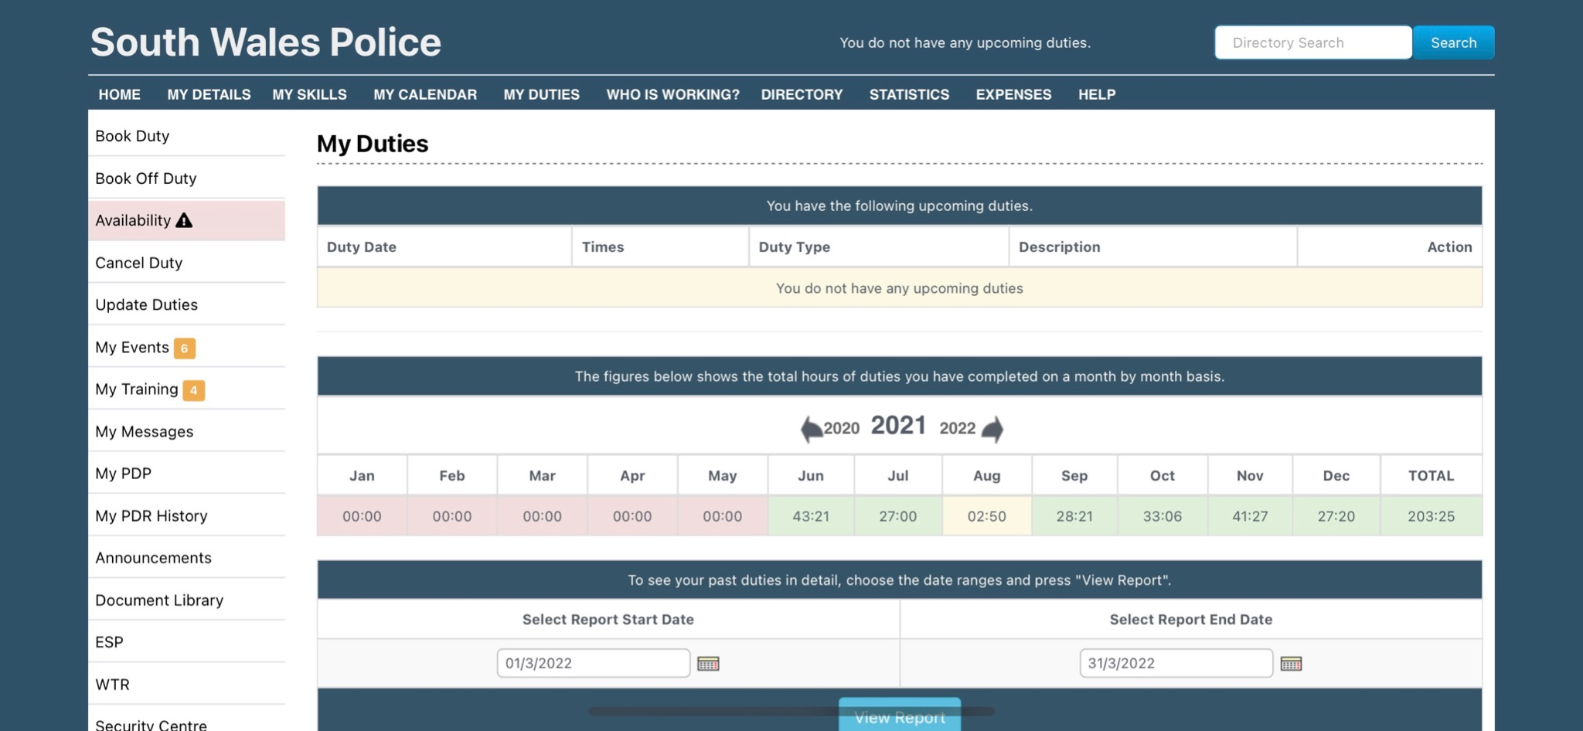

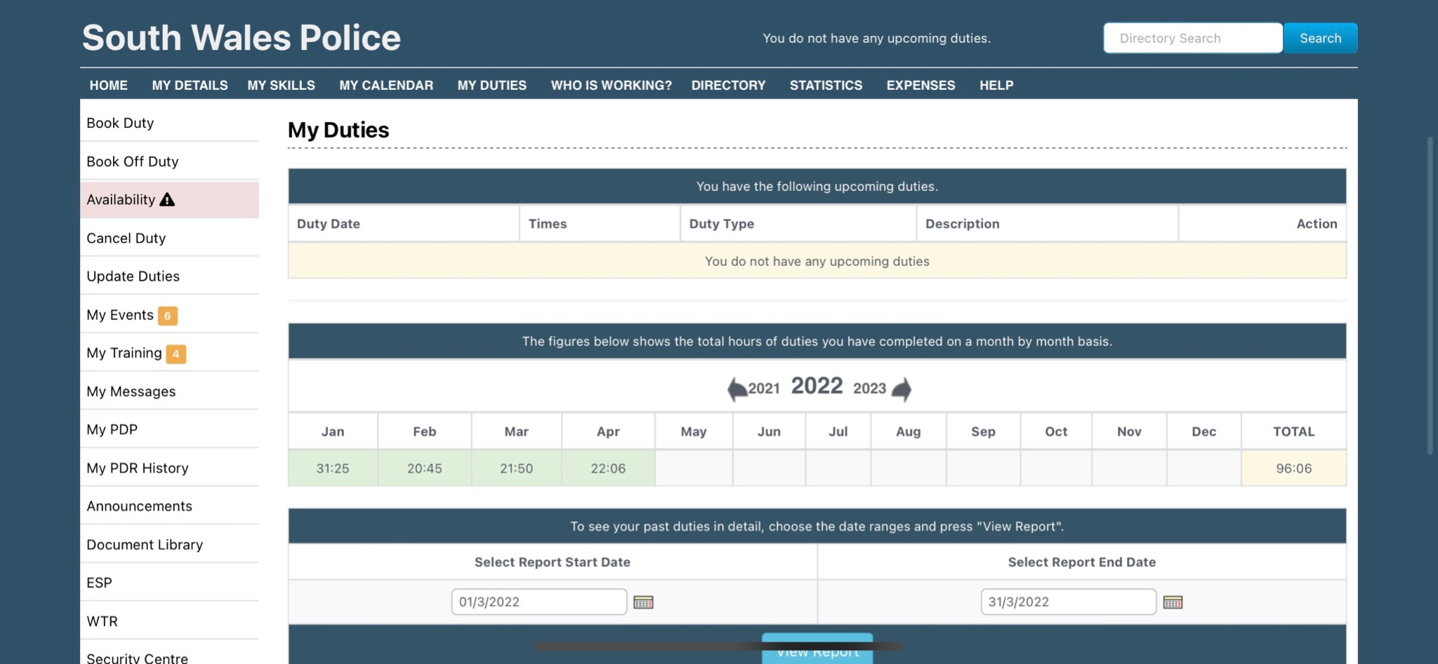

2)
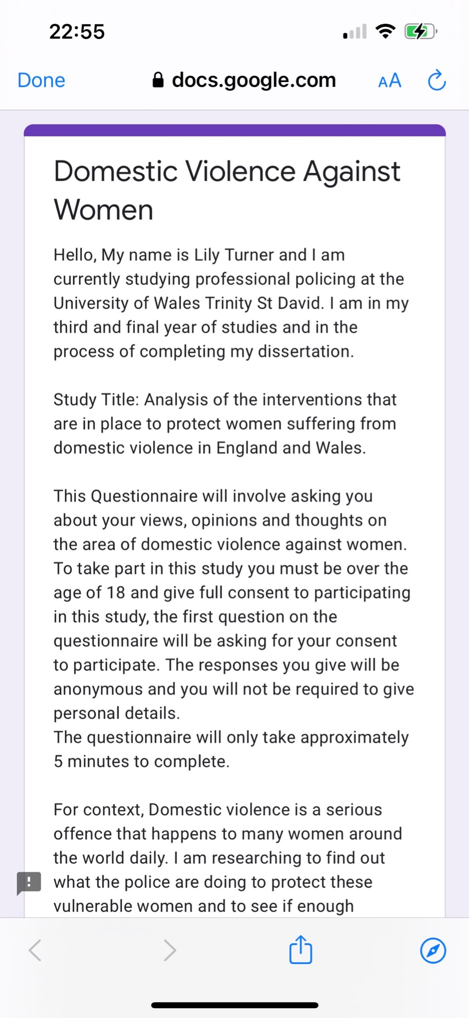
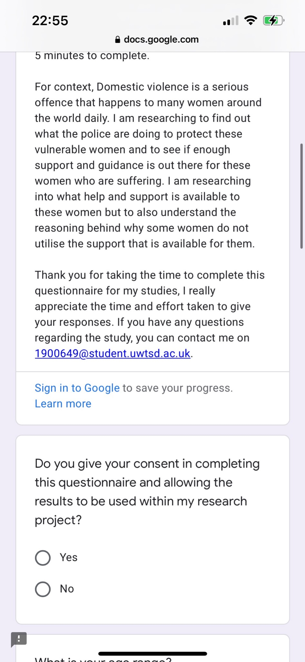
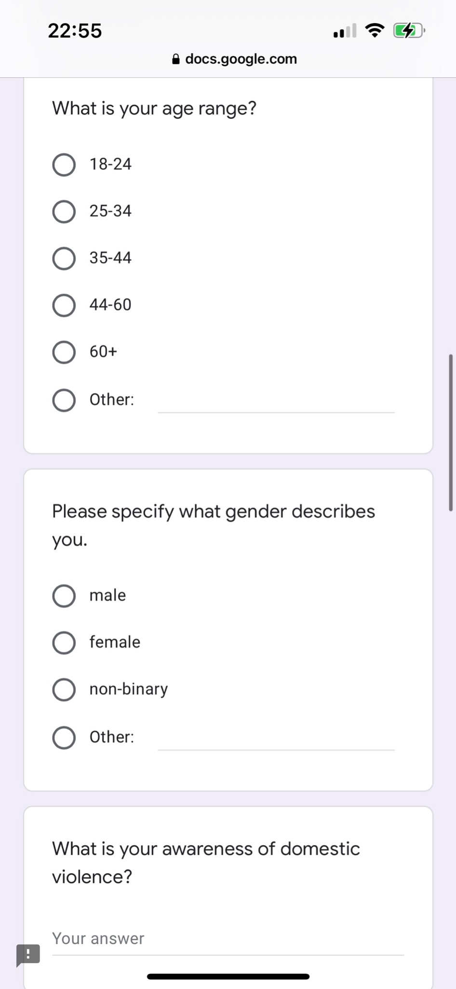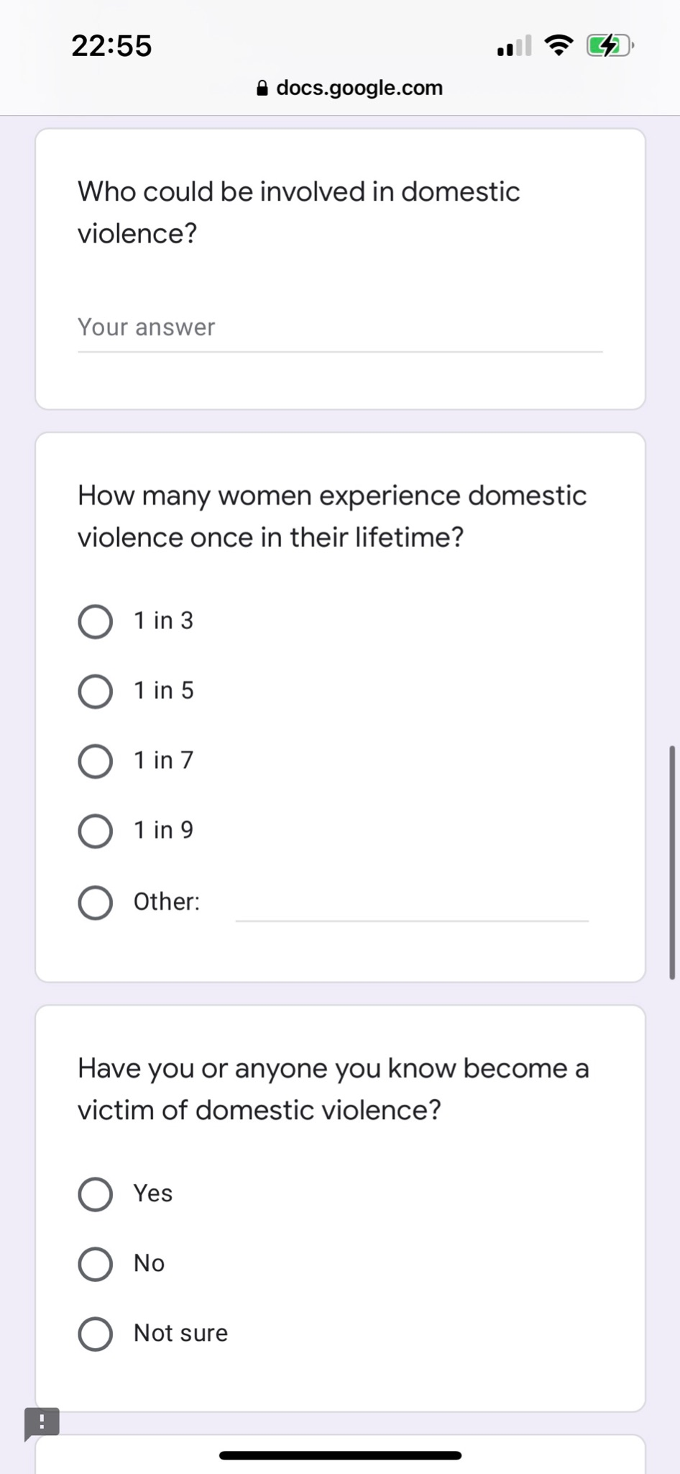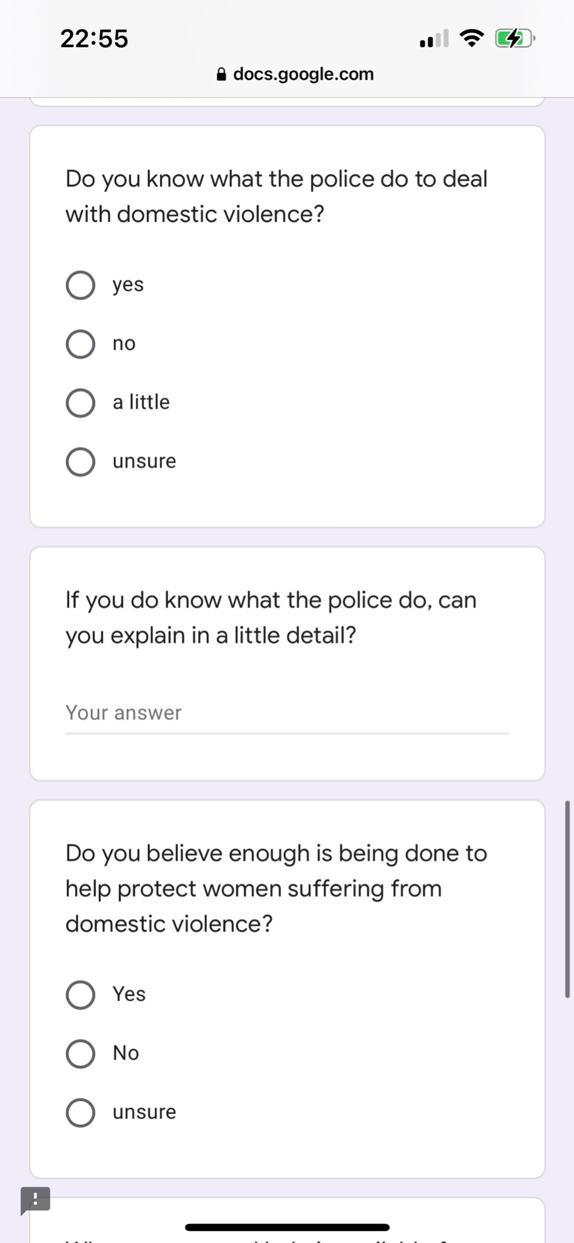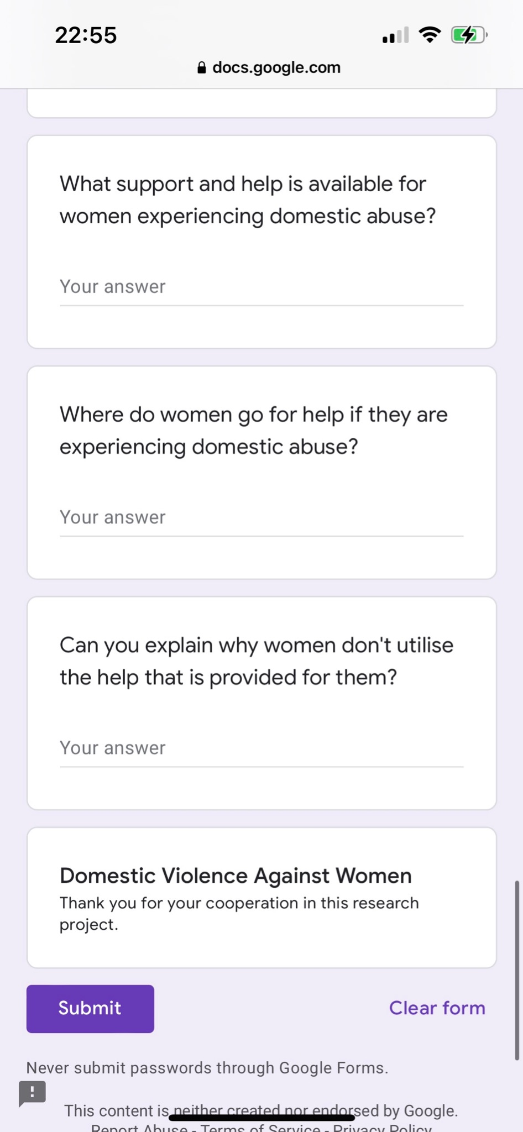
References

Billingham. Z, (2019) The police response to domestic abuse. Available at: https://www.justiceinspectorates.gov.uk/hmicfrs/wp-content/uploads/the-police-response-to-domestic-abuse-an-update-report.pdf

College of Policing, (2014) National Decision Model. Available at: https://www.app.college.police.uk/app-content/national-decision-model/the-national-decision-model/

College of Policing, (2021) Special Constable. Available at: https://www.college.police.uk/career-learning/career-development/role-types/special-constable

Edwards. S, (1989) Policing ‘Domestic’ Violence. Women the Law and the State. Sage Publications - London. Pages 153-154.

EVA Women’s Aid, (2019) Independent Domestic Violence Advocate (IDVA). Available at: https://evawomensaid.org.uk/services/independent-domestic-violence-advocate-idva/

Farrell. S, (2016) Open-ended vs Close-ended questions in user research. Available at: https://www.nngroup.com/articles/open-ended-questions/

Gibbs G (1988). Learning by Doing: A guide to teaching and learning methods. Further Education Unit. Oxford Polytechnic: Oxford.

Gorard. S, (2007) Quantitative Methods in Educational Research; The Role of Numbers made easy. Continuum.

Greater Manchester Police, (2022) Incident Responses Policy. Available at: https://www.gmp.police.uk/SysSiteAssets/foi-media/greater-manchester/policies/incident-response-policy-v1.3-july-2017-redacted.pdf

Hester. M, Westland. N, (2005) Tackling Domestic Violence effective interventions and approaches. Available at: https://dro.dur.ac.uk/2556/1/2556.pdf

Home Office, (2021) Police awarded £11.3m for programmes to prevent domestic abuse crimes. Available at: https://www.gov.uk/government/news/police-awarded-113m-for-programmes-to-prevent-domestic-abuse-crimes

LaViolette. A, Barnett. O, (2000) It Could Happen To Anyone: Why Battered Women Stay. Edition 2. Sage Publications.

Mcleod. S, (2018) Questionnaire: Definition, Examples, Design and Types. Available at: https://www.simplypsychology.org/questionnaires.html

Metropolitan Police, (2021) Request information under Clare’s Law: Make a Domestic Violence Disclosure Scheme (DVDS) application. Available at: https://www.met.police.uk/advice/advice-and-information/daa/domestic-abuse/alpha2/request-information-under-clares-law/

National Coalition Against Domestic Violence, (2022) Why do Victims stay? Available at: https://ncadv.org/why-do-victims-stay

Office of National Statistics, (2021). Domestic abuse in England and Wales Overview: November 2021. Available at:
https://www.ons.gov.uk/peoplepopulationandcommunity/crimeandjustice/bulletins/domesticabuseinenglandandwalesoverview/november2021

Police and Crime Commissioner, (2022) Vulnerability awareness training. Available at: https://www.southwalescommissioner.org.uk/en/our-work/tackling-violent-crime/vulnerability-awareness-training/

Refuge, (2017) Get Help. Available at: https://www.refuge.org.uk/get-help-now/

Refuge, (2022) The Extent of Domestic Violence. Available at: https://www.refuge.org.uk/our-work/forms-of-violence-and-abuse/domestic-violence/domestic-violence-the-facts/

Safe Lives, (2015) Insight IDVA National Dataset 2013-2014. Available at: https://safelives.org.uk/sites/default/files/resources/Insights%20Idva%20national%20dataset%202013-2014.pdf

Safe Lives, (2021) End Domestic Abuse - Amy. available at: https://safelives.org.uk/news-views/real-life-stories/amy

South Wales Police, (2021) What is Domestic Abuse? Available at: https://www.south-wales.police.uk/advice/advice-and-information/daa/domestic-abuse/what-is-domestic-abuse/

South Wales Police, (2022) The special constable role. Available at: https://www.south-wales.police.uk/police-forces/south-wales-police/areas/careers/careers/volunteers-and-special-constables/special-constable/

South Wales Victim Focus, (2022) Things to help someone as a result of domestic abuse. Available at: https://www.southwalesvictimfocus.org.uk/specialist-services/domestic-abuse/

Stop Domestic Abuse, (2021) Forms of Domestic Abuse. Available at: https://stopdomesticabuse.uk/domestic-abuse-types

Streefkerk. R, (2019) Qualitative and Quantitative research. Differences. Examples and methods. Available at: https://www.scribbr.com/methodology/qualitative-quantitative-research/

Sullivan. C, (2017) Interoperability of the National Decision Making Model. Available at: https://www.empac.org.uk/interoperability-national-decision-making-model/

West Midlands Police, (2022) What is a special constable? Available at: https://jobs.west-midlands.police.uk/what-is-a-special-constable/

Whiting. J, (2016) Eight Reasons why women stay in abusive relationships. Brigham Young University - BYU Scholars Archive.

Women’s Aid, (2021) Police training: Domestic Abuse Matters. Available at: https://www.womensaid.org.uk/what-we-do/training/police-training/

Women’s Aid, (2021) Why women don’t leave abusive relationships. Available at: https://www.womensaid.org.uk/information-support/what-is-domestic-abuse/women-leave/

Women’s Aid, (2022) Police and the Criminal Prosecution process. Available at: https://www.womensaid.org.uk/the-survivors-handbook/police-and-the-cps/

World Health Organization, (2021) Violence against women. Available at: https://www.who.int/news-room/fact-sheets/detail/violence-against-women

University of Edinburgh, (2020) Gibbs Reflective Cycle. Available at: https://www.ed.ac.uk/reflection/reflectors-toolkit/reflecting-on-experience/gibbs-reflective-cycle

