BMSW4005_BIRM – Professional Career Development
Lecturer – Olubukola Adegbite
Student – Ishrat Rehman 2118374

Contents Page

Title Page…………………………………………………………………………………1
Contents Page……………………………………………………………………………2
Introduction……………………………………………………………………………….3
Evaluation…………………………………………………………………………………4
SWOT……………………………………………………………………………………..5
PDP..……………………………………………………………………………………...6
Reflective Account Open Book Assessment.…………………………………………7
Reflective Account Interview……………………………………………………………7
Reflective Account Employment Law………………………………………………….9
Conclusion……………………………………………………………………………….10
References……………………………………………………………………………….11
Appendix………………………………………………………………………………….13

Introduction
The following report will consist of an audit of my competencies while using analytical tools such as the professional development plan. I will be identifying the skills required for a prospective career choice and then I will be evaluating the skills I currently have against the skills that are required.
The report will also contain an assessment and a reflection on the tasks that were undertaken for the completion of the module, the method I will be using is the Gibbs Reflective cycle (1988). According to the HCPC (2021) reflective practise enables you to recognise and appreciate experiences while also identifying opportunities to enhance your profession and service delivery. It may also be beneficial after more difficult situations, assisting you in processing and learning from them. Employers can also benefit when their employees engage in reflective practise. Reflection, according to Atkins and Schutz (1993), is also a key learning method in professional development.

Career Choice
Before joining UWTSD, I had come to the conclusion that education was the path for me. I knew that if I wanted to make a difference then I needed a degree to proceed with my career choice. My chosen career choice is that of a post 16 teacher. I have often wondered how best to use my skills, which are modest but not yet of the level required in order to achieve a position as a post 16 teacher.
My chosen career path has taken me on a journey which started prior to my enrolment at UWTSD, in 2014 I gained a Level 3 diploma in Children and Young People in the Workforce. This allowed me to work with children from 0-19 years in the educational sector. Instead of looking for paid work, I proceeded with 3 years of volunteer work, learning new skills and enhancing my knowledge and awareness which would enable me to proceed. I also completed Level 2 British Sign Language in the same year. This advanced my language skills even further.

Evaluation
According to GOV.UK (2022) the qualifications and skills required to become a post 16 teacher are a teaching degree, a masters in a specialised subject, a degree apprenticeship in teaching from a relevant body, these are something I don’t currently possess,
The skills I possess and use regularly can assist me whilst I am on the pathway to my chosen career. Good communication is a vital part of day-to-day life. It is essential that I can convey messages – whether orally or written - clearly and concisely. Having the ability to speak 4 languages and being able to communicate in level 2 BSL enables to me to use my communications skills even further. According to Khan et al (2017) effective communication skills are critical for teachers in the transmission of education, classroom management, and contact with students in the classroom. The educator must both instruct and think differently from the students. A teacher must also adopt communication techniques that drive pupils to study in order to provide education in line with their ability and potential.
I also have very good interpersonal skills, having taken the skillsyouneed (2021) interpersonal skills questionnaire it confirmed my own assessment, and I scored an above average rate. This enables me to effectively actively listen, have the ability to be emotionally intelligent, have an awareness of other people feelings and communicate confidently while speaking to a group. According to Hays (2022) interpersonal skills are required in order to have a positive working relationship.
Having taken the Dr Tasha Eurich Insight Quiz, it has given me an indication on my level of self-awareness. At the end of the quiz, I was sent an email with my level of self-awareness. This was rated high and gave me some insight on my evaluation. The report stated that I was internally and externally aware. Internally, I have strong clear opinions on myself and what’s important. Externally, I am very likely to have strong relationships both personally and professionally.
Comparing my skills to that of what are required I feel I lack a few, checking my skills against the GOV.UK (2022) website I have found that I lack skills in public speaking and subject knowledge. When it comes to public speaking my nerves kick in and I feel under pressure to perform. Subject knowledge is something that I will be furthering myself in whilst doing my degree. After researching qualifications there are still some that are required before I can take up any position in post 16 teaching.
For post 16 I will need:
- A further education teaching qualification
- A degree in the subject I would like to teach
- Minimum grade 4 or equivalent in maths and English
I am working towards my degree in Health and Social Care. This is the subject area I would like to teach, and once successfully completing the degree I will move on to a PGCE or a master’s qualification.
I have completed a SWOT analysis on my education and career path. This shows that my strengths can be built on. According to CIPD (2021) using SWOT can help me identify areas that are positive and negative. I need to be able to best manage my weaknesses, I am planning to start a self-help course which will aid me to overcome the issues which can cause me problems. My opportunities and threats equally outweigh themselves. Both opportunities and threats can be easily managed.
I have also completed a 3 – 5 year personal development plan on how I can best achieve my intended career goal.

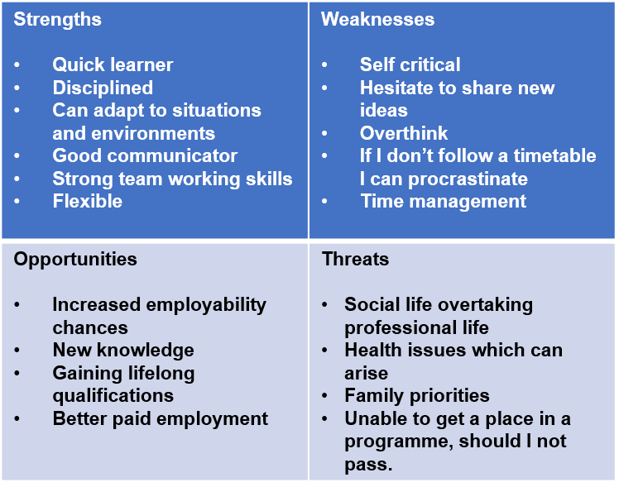

Personal Development Plan

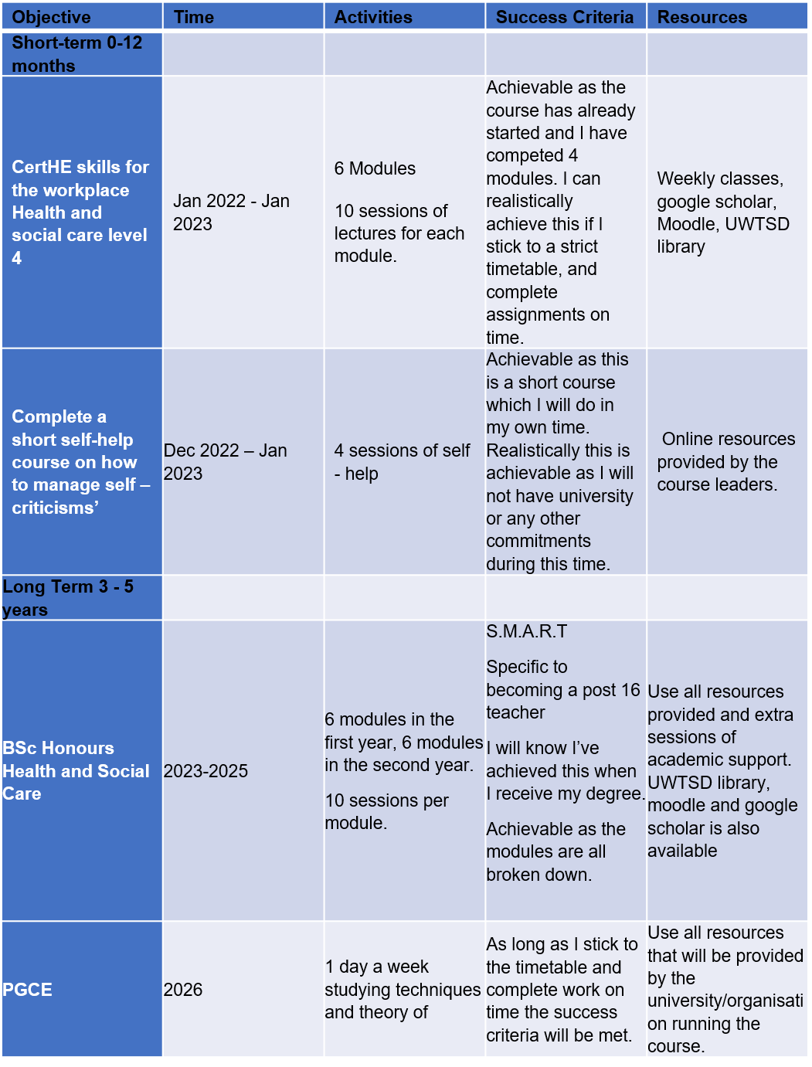

Gibbs Reflective Cycle – Open Book Assessment 5th October 2022

Description
During the first week our lecturer informed the class of impending assessments that we would need to complete in order to pass the module. The open book assessment was introduced to us. The lecturer went through what would be the conditions and the topic of the assessment. We were informed of what an open book assessment would entail, we were to write 500 words on a case study that was provided to us and a question that would be given to us on the day.
The question I chose on the day was : Does having mental health problems affect the way one functions in their job?
Feelings
When the assessment was revealed, I panicked, having 2 hours to write 500 words sounds achievable but I wanted to do the question I chose justice. I am overly critical of my work and deleted several versions of my short report. As the clock ticked my nerves were at breaking point, I felt I would not be able to complete in time. I feel that my nerves held me back on the day. I produced a report of 500 words and uploaded it within the time limit imposed.
Evaluation
The assessment taught me that I can work well under pressure and that sometimes I over complicate what doesn’t need to be complicated. It has also taught me that time management is essential, especially when researching, I felt I spent too much time looking for the right resources, when I could use my own experiences and understanding.
Analysis
I have analysed my experiences on the open book assessment, it has led me to realising that I struggle with time-imposed tasks, and that I overly criticise my work when it meets the standard expected of a student.
Conclusion
In conclusion I found that I did not effectively do my research which led me to wasting time. I also feel that I did not need to delete and start over, as the work was up to standard.

Action Plan
Going forward I will be hoping to learn techniques on how to best research and exclude nonsensical information. This will enable me to manage my time on short term and long-term tasks. I will also try to be less critical of myself. According to Ali (2022) time is an asset, and effective use of it can have a positive effect on future investments, whether personal or professional.

Gibbs Reflective Cycle – Mock Interview – 26/10/2022
Description
As part of the module, we were expected to have created a CV and prepare for a mock interview. Our lecturer informed us of what was required alongside the CV there was to be a cover letter and job advertisement. The mock interview was to be held in the university but in the conditions of an actual job interview. As part of the interview, we were to look at the S.T.A.R model, this was to enable us to be able to answers questions relating to our chosen career coherently and concisely. During the two sessions where this was discussed I had come down with covid and was very unwell. This meant that I had missed the session on campus and would have to research the method prior to my interview. The day of the interview arrived, and I had only just recovered.
Feelings
When the lecturer discussed that we would be doing an interview, I relished at the opportunity. I struggle with speaking about myself, and this would give me some time to learn techniques that I could use in the future. The interview itself was around 10 minutes. My lecturer asked me questions relating to the organisation, which I completely froze and forgot. Once I came into the rhythm of speaking everything else came naturally. I felt I portrayed myself quite well.
Evaluation
The interview taught me to always be aware of the whole situation. I gave me a small insight on how I can best manage myself and prepare for future interviews. I was able to see what would let me down.

Analysis
I feel I could’ve improved my interaction, learn more ‘buzz’ words about the organisation to improve my prospects further.
Conclusion
I felt overall the interview went well. I believe I gave a good impression and having received the feedback in which my lecturer stated I was confident and asked relevant questions. My lack of knowledge of the organisation let me down. I scored 75% which I was really pleased with but feel I could’ve done better. See Appendix 1.
Action Plan
Going forward I will be researching any organisations background extensively in order to be a candidate that is deserving of an employment position.

Gibbs Reflective Cycle – Employment Legislation 09/11/2022
Description
In this session we learnt about employment legislation. Our lecturer informed us of the many different laws and legislation relation to the workplace. A PowerPoint presentation was prepared, and each slide was explained thoroughly. Some of the legislation was relatively new to me and I gained plenty of new knowledge. Whilst in the session we had a small quiz on the different topics we had covered.
Feelings
I thoroughly enjoy reading and learning about new legislation and regulations and found this to be one of my favourite sessions to date. I found the information to be clear without any jargon. It was easy to understand the rights and responsibilities of individuals. I would really enjoy a full module relating to the legislation and regulations of the health and social care industry.
Evaluation
The session taught me that there are many pieces of legislation relating to the workplace. It also allowed me to have previous unanswered questions get solved.

Analysis
Having analysed my experience, I feel I could’ve asked more questions relating to employment legislation.
Conclusion
The session was thoroughly enjoyable however, I feel I missed an opportunity to ask more questions with regards to employment legislation.
Action Plan
Going forward I will be doing some research in my own time with regards to employment legislation. I believe it’s a very important subject and individuals such as myself need to be aware of anything that can affect us. Knowing about the legislations and regulations surrounding employment leaves no room for misunderstandings.

Conclusion
Overall, the module professional career development has been enabled me to gain a lot of knowledge. It has helped me to identify areas of improvement relating to my future career prospects. I have gained insight into what I need to achieve to progress through and achieve my ultimate goal of becoming a post 16 teacher. I have built on small amount of knowledge I previously had acquired. It has shown me how to evaluate my skills against the skills and qualifications required. This can only benefit me greatly in the future.

References
Ali, H., (2022). ‘Why time management is so important The Way Ahead’, IEEE Potentials, vol. 41, (2), pp. 3-C3.
Atkins, S. and Schutz, S., (2013). ‘Developing skills for reflective practice’. Reflective practice in nursing, pp.23-52
Eurich, T,. (N.D) The insight quiz: Dr. Tasha Eurich, How self-aware are you? Take the Insight Quiz to find out. Available at: http://www.insight-quiz.com/ThankYouSelf.aspx?z=Re47K5vV7PwCRfdw5Ijr1F6UnXdIOA9c2IHG2NWtMlPOCEV5JEzyKQ%3D%3D (Accessed: September 21, 2022).
Gibbs G., (1988). ‘Learning by Doing: A guide to teaching and learning methods. Further Education Unit’. Oxford Polytechnic: Oxford.
GOV.UK., (2022). Further education lecturer Explore careers National Careers Service. Available at: https://nationalcareers.service.gov.uk/job-profiles/further-education-lecturer (Accessed: November 20, 2022).
Hays.nz., (2022). Interpersonal skills in the workplace: Career Advice: Hays, Go to Hays NewZealand. Available at: https://www.hays.net.nz/career-advice/upskilling/interpersonal-skills (Accessed: November 18, 2022).
HCPC., (2021). What is reflection?, Health & Care Professions Council. Available at: https://www.hcpc-uk.org/standards/meeting-our-standards/reflective-practice/what-is-reflection/#:~:text=Reflection%20allows%20you%20to%20identify,process%20and%20learn%20from%20them. (Accessed: November 15, 2022).
Khan, A. et al., (2017). ‘Communication skills of a teacher and its role in the development of ..., Communication Skills of a Teacher and Its Role in the Development of the Students' Academic Success’. Available at: https://www.researchgate.net/publication/315836040_Communication_Skills_of_a_Teacher_and_Its_Role_in_the_Development_of_the_Students'_Academic_Success (Accessed: November 16, 2022).
Skillsyouneed., (2022). Interpersonal skills self-assessment, Interpersonal Skills Self-Assessment . Available at: https://www.skillsyouneed.com/quiz/343479 (Accessed: November 18, 2022).
The University of Edinburgh., (1970). Gibbs' reflective cycle, The University of Edinburgh. Available at: https://www.ed.ac.uk/reflection/reflectors-toolkit/reflecting-on-experience/gibbs-reflective-cycle (Accessed: November 21, 2022).

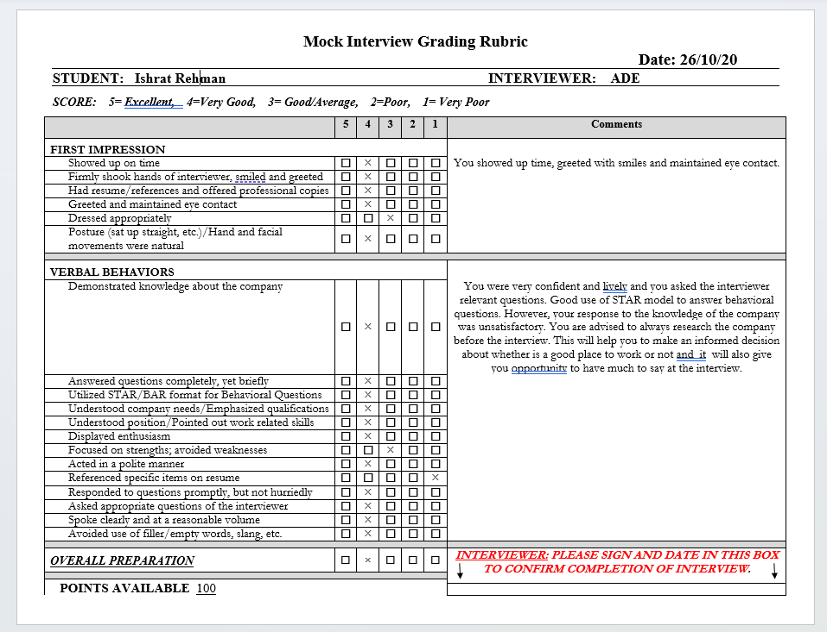
Appendix 1



