Tom Braddock
Task 1 Word Count = 2,306
Task 2 Word Count = 1,067

- Define the term professional and explain what it means to be a ‘people professional’. (AC 1.1)

According to the Cambridge dictionary (2023), a professional is someone with a particular set of skills, training and/or education. For example, healthcare professionals require medical training, qualifications and memberships in order to work within the NHS. Armstrong (2014) suggests that a people professional is someone who provides advice and services to others to ensure people meet accepted standards of behaviour. Whilst I agree, I would add that being a people professional is a privilege that we get to attract, recruit, develop, support, retain and offboard individuals that plays an essential role in their careers. We have a unique opportunity to change the world of work for the better and create a way of working that suits individuals from a variety of different backgrounds (Seychell, 2022).

CIPD (2023) state that people practices are the processes and tools that we use throughout the employee lifecycle. For example, analysing people data, developing talent pools and managing grievances. Some people professionals may specialise in one specific area, for example resourcing or talent, whilst others may take a more generalist approach and choose to dip in and out of various parts of the lifecycle. Relating back to professionalism, CIPD (2023) have created a profession map for all people practitioners to benchmark the whole profession. This map gives practitioners a foundation for decision making, it includes eight core behaviours that create value for people, organisations, society and the profession as a whole, these behaviours are; ethical practice, professional courage and influence, valuing people, inclusivity, commercial drive, passion for learning, insight focused, and situational decision making. If people practitioners adopt this profession map and behaviours, they will have professional integrity and be part of a wider group of HR professionals that are members of the CIPD.

- Explore how the role of a people professional (either a generalist or a particular specialist) is evolving and the priorities this raises for continuing professional development (CPD) (AC 3.1)

The role of Talent Acquisition within the people profession is one that has changed over time, and probably will always be changing. Previously, talent acquisition roles were seen more as recruitment roles, however, whilst the two are very similar, recruitment is seen as filling roles, whereas talent acquisition refers to the wider candidate lifecycle.
The People Profession 2030 report shows that old processes are no longer relevant, instead, digitalisation is speeding up processes and giving professionals shortcuts, but more importantly, time to rethink how we work CIPD (2020). The report also highlights that technology allows practitioners to collect and analyse data in a way like never before. As a result of this, there are two key priorities that stand out for talent acquisition specialists looking to the future of the role, data and technology.
New systems and artificial intelligence allow talent acquisition specialists to automate many parts of their recruitment processes, for example, Pinpointhq (2023) show how AI can automatically read CV’s and applications to qualify or disqualify candidates before any hiring manager can see them. It also sends out various emails to applicants throughout the process automatically, creating a better candidate experience.
Data is another key priority as this can link into other aspects of the business and HR, especially when it comes to EDI. Sloyan (2022) supports this and states 95% of CEO’s see this as a key priority for the future. As new systems automate the process, talent specialists are now able to track where applications are coming from and who they are coming from. As a result, this gives organisations a much better picture about the groups of people they are attracting, or more importantly, not attracting. For example, if data suggests that an organisation is not receiving any applicants who identify as black, it can suggest that the organisation needs to do more to attract and retain candidates from that background. This data can also be compared with current employee data to create a better picture of how diverse the workforce and organisation is.
If talent specialists spend some of their professional development on being technology savvy and understanding how to use data meaningfully, they can evolve with their role to be future-fit, as outlined within the people profession 2030 report (CIPD, 2020).

- Discuss the concept of ‘ethical values’, and how at least three ethical values that you hold personally, impact (or could impact) on your work as a people professional. (AC 1.2)

Ethical values play an important role within people practice, this is supported by CIPD (2022) who suggest that many workplace scandals are a direct result of poor ethics. However, this doesn’t only mean individually, it means from an organisational perspective too. CIPD (2022) continue on to suggest that organisational values should align with leaders’ ethical values, for example, if a senior leader within an organisation says one thing, but does another, it can cause serious harm to credibility and can leave employees disengaged.

CIPD (2022) suggest all decision making should be based on good principles and values to ensure that our workforce become happier, more engaged and gain positive experiences at work. However, this also applies when decisions may not have a positive outcome. Ethical values ensure that decision makers manage the process in the best way and ensure that people are treated correctly throughout. There are three ethical values that I personally hold, these are fairness, honesty, and inclusivity.

CIPD (2022) state that often people professionals are blamed for decisions that come from organisations, for example, redundancies. This isn’t a positive experience for many, and so the majority of workers may see this as unethical, or not fair. However, if people professionals work within their ethical values and the CIPD code of conduct, they can carry out difficult tasks such as redundancies in the correct way. For example, linking back to my personal values, I will ensure that fairness and honesty have been considered throughout, whilst conducting an inclusive process throughout. If I was to ignore my personal values, leaders may decide to conduct an unfair process that is not inclusive and ultimately damaging for the organisation. Furthermore, as a people professional and as stated by CIPD (2022), I can be blamed an ultimately my reputation will be damaged. This will lead to a lack of trust, respect and integrity for my future within the organisation.

- Explain why it is essential for people professionals to contribute confidently to discussions, and ways of doing this that are (AC 1.3):
- informed
- clear
- engaging.

People professionals provide an essential insight into any organisation and should always be considered during decision making processes. CIPD (2022) say that people professionals value people and we bring those people perspectives to decision making. Whilst others may place business at the heart of their decisions, practitioners bring people in and ensure a balanced and fair approach that gives employees a voice throughout.

One way in which people professional contribute confidently is by having an evidence-based approach, this is a professional value within the CIPD profession map. CIPD (2022) state that people professionals are essential to discussions because having an evidence-based approach allows better and more informed decision making. This is because critical thinking is used on the best available evidence, not individuals’ personal opinions or beliefs. As a result, this can remove unconscious bias and unethical decision making. Briner (2015) adds support to this by saying that evidence-based approaches give a more informed and clear decision. Furthermore, he says that the approach also forces people practices in being more engaging because it includes collaborating with as many stakeholders and individuals as possible.

Engagement is another key skill for people practitioners, and as stated by CIPD (2022), effective communication develops a trust across organisations which in turn can positively impact engagement, culture and productivity. Therefore, people practitioners play be a valuable part in organisation decisions to ensure messaging is clear, fair and engaging. As a result, if an organisation wanted to make a change that impacts the workers, people professionals will ensure through consultations with staff and leaders that everyone is aware of the proposed changes.

- Discuss when and how to raise concerns when issues such as organisational policies or leadership approaches conflict with ethical values or legislation. (AC 1.4)

Taylor and Woodhams (2016) argue that people practitioners have a tough role in ensuring that leaders within organisations operate in a way that complies with employment law. This is supported by CIPD (2022) who state that people professionals have a code of conduct and responsibility to ensure all practice is carried out in an ethical way.

In a previous role, I had a line manager who was displaying unethical behaviour and values that risked bringing the organisations reputation into question. Furthermore, the behaviour and values were not aligned with my own personal values, or the organisational values and risked breaking employment law. As a result of this, I felt that if I sat back and did nothing, my integrity and honesty would be damaged and so I decided, along with my wider HR team, to raise a concern through the whistleblowing policy.

A whistleblowing policy allows employees to raise concerns that has an impact on others. Under the whistleblowing policy, employees are able to make a disclosure that protects them, so if they are treated badly or dismissed after whistleblowing, they are able to make a claim to an employment tribunal (CIPD, 2023). Given that my line manager was part of the executive leadership team, we felt that the whistleblowing policy was the best route because it offered protection to us as a team. However, Bothwell (2017) argues that whilst whistleblowing can provide protection from retaliation, it can lead to career and relationship implications. Bothwell states that often organisations may indirectly punish employees further on in their career because they will always be remembered for being a whistle-blower. On the other hand, whilst Patton (2019) agrees that whistle-blowers can be subject to career implications, organisations should value their whistleblowing procedures because it highlights negative cultures and allows leaders to take actions before things get out of control.

In my example, if I didn’t report through the whistleblowing policy, I was going against the CIPD code of conduct and I would no longer have my professional integrity. Lewis (2021) says that toxic and unethical leaders create toxic work environments that give workers the feeling of suffocation at work and looking for a way out. This shows the negative impact that could have happened if we had done nothing, and so to ensure ethical practices were carried out, the whistleblowing policy was an essential process.

- Provide a robust argument for ethical people practice that is supported by academic theory and details both the business and human benefits of people at work feeling included, valued and fairly treated. (AC 2.1)

Ethical people practice can have various benefits for both employees and employers. CIPD (2022) explain that good ethical practice develops an organisations reputation and success through staff, customers and products. This is because the success of many businesses relies on the relationships between employees, customers and the communities. However, in the current climate where employee retention is important, ensuring current staff are valued, included, and fairly treated is essential to avoiding resignations (Hill, 2019).

One way that can help organisations with employee engagement and motivation is by working inclusively. CIPD (2023) explain that listening to diverse voices in planning and implementation of work is essential to creating high-trusted working relationships. However, further research by CIPD (2021) suggests that whilst employee motivation leads to high performance, it can often also be high performance that leads to better motivation. Eng-Sing (2020) supports this to say that whilst diverse groups are often difficult to construct in key decisions at senior level, focus groups and sub groups can be used prior to ensure all views are considered throughout. He believes this will allow for deeper thinking and new insights. This can be a stand out trait for a high performing organisation in a challenging market.

Diversity in the workplace is a key ethical focus that can positively impact workers motivation, increase retention, and employer branding. Smyth (2021) states that this is no longer a nice to have, but an essential part of any people strategy. To link in with Maslows Heirarchy of Needs, this focus would fulfil the safety and social stages of the pyramid. By promoting and actively supporting diversity in the workplace, employees will feel heard, valued and able to participate which increases motivation. Furthermore, Hill (2019) argues that organisations that make the effort to do the right thing and treat everyone how they would like to be treated inclusively will not only increase staff performance levels, but also the customer retention and overall business performance.

- Drawing on your own or a hypothetical example of providing a people practice solution to meet a particular need or introducing a new policy or initiative, describe:
- strategies for designing the solution/initiative so that it will be inclusive
- strategies for checking that, when in practice, the solution/initiative engages and meets the needs of all those it is aimed at. (AC 2.2)

Within talent acquisition, the candidate market is extremely competitive and reward packages are becoming essential to ensure competitiveness in attraction and retention of key talent (Makoff-Clark, 2019). During the current cost of living crisis, Leech (2022) suggests that organisations have the ability to help with mobility and financial wellbeing of employees through a salary sacrifice scheme. Therefore, as a result, I am looking to implement a salary sacrifice reward initiative that allows employees to have a brand new fully maintained car at a fraction of the normal private cost.

Before rolling out a programme, I created a survey for all staff to ask their opinions of the scheme, and how likely they were to use it. I kept the survey anonymous which removed the potential for any unconscious bias and allowed me to focus on results only. After receiving results, I found that whilst many were in support of the scheme, there were some that felt it was not inclusive because not everyone is able to drive and there was no clarity on Motability cars. This supports Pritchard (2022) who states that whilst reward packages are important, organisations must be careful not to unintentionally negatively impact their EDI values. As a result of this, we were able to find a provider that was able to provide a car to any employee, not just the high earners. We were also able to ensure staff that family members and carers were able to be insured on the policy, so those without cars or the ability to drive were still able to benefit.

After rolling out the scheme, another survey was sent out to measure the impact. The results showed that many had felt the reward had positively impacted on their financial wellbeing, whilst others said their mental wellbeing had got better because they were no longer worrying about car repairs. Even though there are lots of positive signs, there are continuous reviews going on to ensure that the initiative is fit for purpose and encompasses all staff to be inclusive throughout.

Activity 2
Task 1
I’ve chosen to use various sources of information to inform my self-assessment, these include 360-degree feedback forms, verbal conversations with colleagues and reflections. I feel that these methods gather a range of opinions and gives me the best chance of gaining a true picture, whilst also removing any potential conscious, or unconscious bias in decision making. My 360-degree feedback form and conversations were obtained from my line manager, a member of the senior leadership team, and two members of my HR team. I did this to ensure there were a range of opinions and that I had the best evidence possible to inform my decisions. As a result, my scores show (see appendix 1) that when considering valuing people, I scored higher than others. However, when you consider professional courage and influence, this is an area that I was weaker on and needed improvement.

Task 2
Based on my self-assessment, I’ve chosen four actions that I feel relate to my role as a talent acquisition manager. I’ve chosen those actions that I feel compliment my areas of weakness, the weaknesses highlight coaching, mentoring and contributions to discussions. The first two actions that I have chosen are, “Act as a mentor to a new or less experienced colleague” and “Research the 70:20:10 model”. I feel these relate to me as they will develop my own leadership and coaching skills, whilst also having an impact on members of my team and wider people mangers across the organisation. I’ve also chosen “Reflect on a time when you contributed to a discussion successfully”, this is because I am regularly involved in management and senior management meetings and confidence in this area will benefit me and the decision making within these meetings. Finally, I have chosen to “research difference coaching models” because as my role develops, I will start to coach various managers on people issues to ensure the talent within their teams are happy and developing. Overall, If I am to complete these actions and use the development within my role, I think the impact will be positive for myself and the organisation around me.

Task 3
Over the last twelve months, I welcomed a new hire to the team and so I took the opportunity to act as a mentor to share my knowledge and expertise, as outlined within my self-assessment plan. Instead giving them an induction and explaining how to do their own role, I also decided to embed time into their week to learn more about my role. I felt that this would give them more experience and knowledge about HR and Talent Acquisition, it also provides a better understanding of how my role impact theirs as a line manager. Thirdly, it provides them with a good foundation to progress in their career, if a position ever became available. Whilst I don’t have a result for this reflection because it is always ongoing, I have noticed that my team members enjoy their roles more and when conducting 1 to 1 meetings, they explain how they want to progress within the organisation. I feel this is a direct impact of sharing my knowledge and expertise that is creating a passion for learning.
My second reflection was to complete a professional courage and influence course from the CIPD. By doing this course, it has allowed me to understand better ways of communicating and challenging in work situations. One key takeaway from the course was about tailoring my style to influence various stakeholders, for example, I think this would be a key skill when I am looking at bringing in a new reward initiative to my organisation and I need senior leadership and board sign off. Whilst many of the takeaways were around communication, another key learn for me was about taking responsibility for mistakes within my remit. I will now consider various learning and development opportunities to correct any wrongdoing and ensure better outcomes in the future. Since completing this course, I was successful in influencing a senior leader within my organisation to buy in to a salary sacrifice reward scheme. I tailored my approach to each senior leader so that my presentation met the needs of those that were in front of me, this also allowed me to become more confident in the delivery. As a result, the initiative was approved by the board and I am currently in the process of rolling this out to all staff across the organisation.
My final reflection was to research various coaching models, for this I have used ‘Grow’ and ‘Clear’. The ‘grow’ model is an acronym that stands for goals, reality, options, and will. According to Duncan (2022), it is the one of the simplest methods to use and excellent for new coaches, therefore, I feel this fits my purpose well. Grow allows individuals to think about where they are at the moment and where they want to be, the rest then thinks about building blocks between the two about how to get to the final destination. Within my Talent Acquisition role, this will be key when advising various people managers about creating development plans and succession plans across the organisation. I feel this method allows the individuals to set their own goals, my role is to ensure those targets are realistic and to support in anyway that I can, without taking away ownership. Duncan (2022) suggests that the most important part of the method is to review progress and adjust where required. The ‘clear’ method differs to ‘grow’, one way is that it can be more structured as the first stage sets out expectations that include the logistics of the process. However, this method allows the coach to find out issues from the individual and explore ways together of solving problems and overcoming steps.
To summarise, I feel that my reflections will give me a good platform and confidence to be a better people professional. By keeping myself refreshed and up to date with the latest updates and developments within HR will not only benefit me, but also the people and organisations around me. Through the three reflections detailed above, I am very pleased to see that the reflections that I have chosen to do have had a positive impact on the behaviours of people around me, the performance of the organisation, and key metrics such as staff retention. I look forward to completing more reflections and seeing positive impacts in the near future.

Reference List
- Armstrong, M. (2014) A Handbook of Human Resource Management Practice. 11th edn. London: Kogan Page.
- Bothwell, M. (2017) Pros and cons of whistleblowing in the workplace. Bothwell Law Group. Available at: https://whistleblowerlaw.com/whistleblowing-in-the-workplace/ (Accessed: March 9, 2023).
- Briner, R. (2015) What's the evidence for... Evidence-based HR? HR Magazine. Available at: https://www.hrmagazine.co.uk/content/features/whats-the-evidence-for-evidence-based-hr (Accessed: March 9, 2023).
- Cambridge Dictionary (2023) Professionalism. Cambridge Dictionary. Available at: https://dictionary.cambridge.org/dictionary/english/professionalism (Accessed: March 8, 2023).
- CIPD (2021) Employee engagement & motivation: Factsheets. CIPD. Available at: https://www.cipd.co.uk/knowledge/fundamentals/relations/engagement/factsheet (Accessed: March 9, 2023).
- CIPD (2022) Ethical practice and the role of people professionals. CIPD. Available at: https://www.cipd.co.uk/knowledge/culture/ethics/role-hr-factsheet#23818 (Accessed: March 8, 2023).
- CIPD (2022) Evidence-based practice for effective decision-making. CIPD. Available at: https://www.cipd.co.uk/knowledge/strategy/analytics/evidence-based-practice-factsheet#gref (Accessed: March 8, 2023).
- CIPD (2023) Information on whistleblowing. CIPD. Available at: https://www.cipd.co.uk/knowledge/fundamentals/emp-law/whistleblowing#gref (Accessed: March 9, 2023).
- Duncan, S. (2022) Choosing a business coaching model to achieve the best results. Real Business. Available at: https://realbusiness.co.uk/coaching-models (Accessed: March 10, 2023).
- Eng-Sing, S. (2020) Unlock the Value of Diversity and Inclusion in Decision-Making. Linkedin. Available at: https://www.linkedin.com/pulse/unlock-value-diversity-inclusion-decision-making-eng-sing-soon/ (Accessed: March 10, 2023).
- Hill, B. (2019) The advantages of ethical behavior in business. Small Business. Available at: https://smallbusiness.chron.com/advantages-ethical-behavior-business-21067.html (Accessed: March 9, 2023).
- Leech, A. (2022) How salary sacrifice electric cars can help staff lower costs. Personnel Today. Available at: https://www.personneltoday.com/hr/how-salary-sacrifice-electric-cars-can-help-staff-lower-costs/ (Accessed: March 11, 2023).
- Lewis, C. (2021) Toxic: A guide to rebuilding respect and tolerance in a hostile workplace. London: Bloomsbury Business.
- Makoff-Clark, A. (2019) Firms prioritising employee experience and total reward packages to attract talent. PeopleManagement. Available at: https://www.peoplemanagement.co.uk/article/1742590/firms-prioritising-employee-experience-and-reward-package-attract-talent (Accessed: March 11, 2023).
- Patton, C. (2019) Are whistleblowers good for your company? HR Executive. Available at: https://hrexecutive.com/are-whistleblowers-good-for-your-company/ (Accessed: March 10, 2023).
- Pritchard, N. (2022) Why you should factor inclusion into your benefits package. People Management. Available at: https://www.peoplemanagement.co.uk/article/1789237/why-factor-inclusion-benefits-package (Accessed: March 10, 2023).
- Seychell, R. (2022) What's in store for the People Profession in 2022? People Management. Available at: https://www.peoplemanagement.co.uk/article/1751752/whats-store-for-people-profession-2022 (Accessed: March 10, 2023).
- Sloyan, T. (2022) Talent acquisition leaders say these 3 areas deserve your attention in 2023. Forbes Magazine. Available at: https://www.forbes.com/sites/forbestechcouncil/2022/11/11/talent-acquisition-leaders-say-these-3-areas-deserve-your-attention-in-2023/?sh=3912d3664ff6 (Accessed: March 9, 2023).
- Smyth, Y. (2021) Recruitment's role in supporting edi. HR Magazine. Available at: https://www.hrmagazine.co.uk/content/comment/recruitment-s-role-in-supporting-edi/ (Accessed: March 12, 2023).
- Taylor, S. and Woodhams, C. (2016) Studying Human Resource Management. London: Chartered Institute of Personnel and Development.

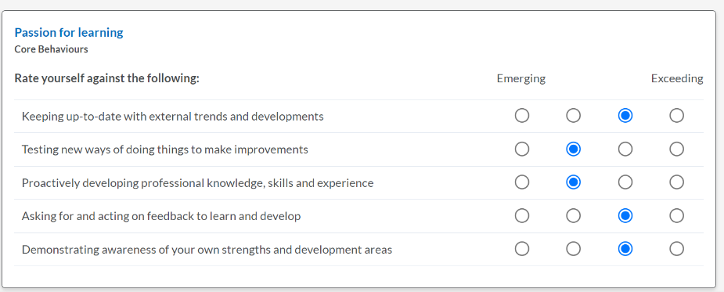
Appendix 1

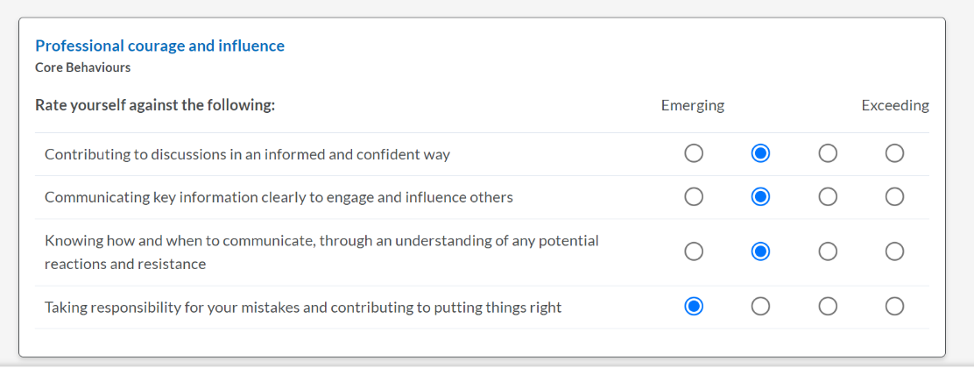

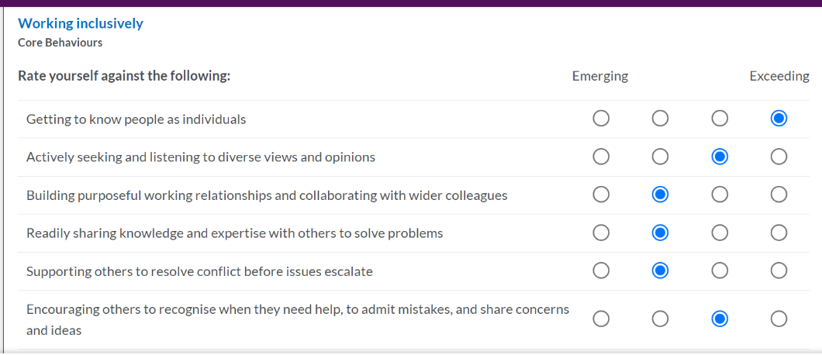

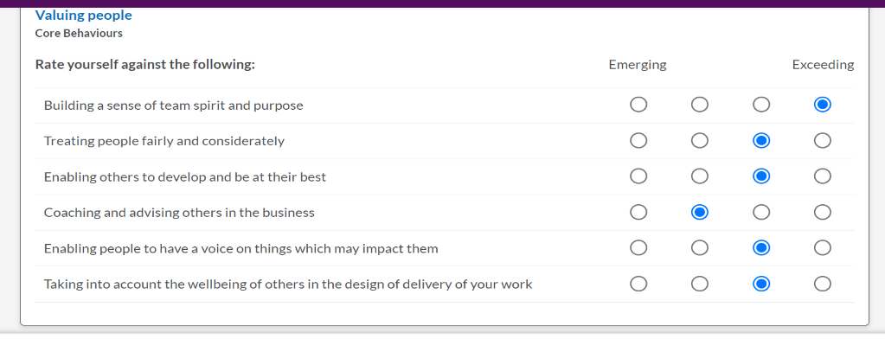

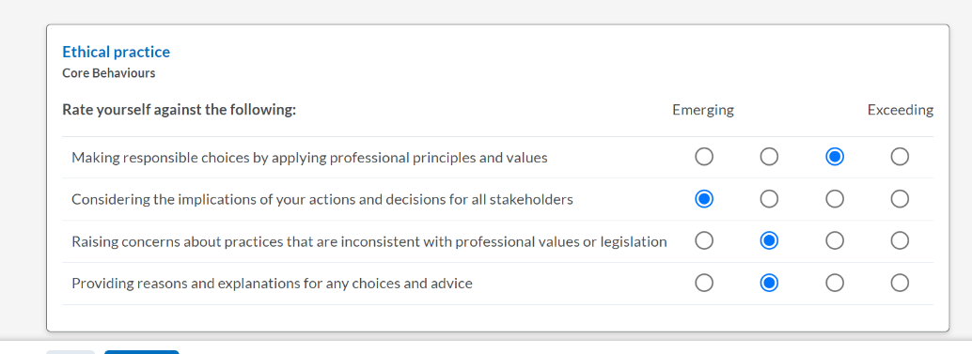

Appendix 2


