
Module Assignment Submission
Student Name: | Jemma Rees
Student Number: | 2008032
Module Code: | BMSK 6001
Module Title: | Emergent Leadership Skills for the Workplace

Statement of Confirmation of Authenticity
By the act of making this submission, the student declares that this is the work of the student named above. The work has not, in whole or in part, been knowingly presented elsewhere for assessment, or where assessment has been built on a previous assessment, this has been identified. Where materials have been used from other sources it has been properly acknowledged. If this statement is untrue, the student acknowledges that an assessment offence has been committed.
Attention is drawn to the plagiarism and unfair practice policies of the University.

Table of Contents
1.0 Introduction 3
2.0 Evaluate own ability to use a range of leadership styles, in different situations and with different types of people, to fulfil the leadership role 3
2.1 Leadership Defined 3
2.2 Emergent Leadership 4
2.3 Leadership Styles Defined 4
2.3.1 Authoritarian 4
2.3.2 Democratic 5
2.3.3 Laissez-Faire 5
2.3.4 Leadership As A Continuum 5
2.4 Leadership Evaluation 5
2.4.1 Conceptualising Leadership 6
2.4.2 Leadership Traits 6
2.4.3 Leadership Strengths 6
2.4.4 Leadership Styles 6
2.4.5 Situational Leadership Style 7
2.6 Summary 7
3.0 Critically assess a recognised leadership model or theory in relation to its ability to impact on individual workplace performance 8
3.1 Great Man Theory And Its Impact On Individual Workplace Performance 8
3.2 Impact On Individual Workplace Performance 8
3.3 Disruption In The Workplace 8
3.4 Is There Another Way 9
3.5 Summary 10
4.0 Situational Leadership And Its Impact On Individual Workplace Performance 10
4.1 Situational Leadership Approach 10
4.1.1 Telling (S1) 11
4.1.2 Selling (S2) 11
4.1.3 Participating (S3) 11
4.1.4 Delegating (S4) 11
4.2 Impact On Individual Workplace Performance 11
4.3 Neurodiversity In The Workplace 12
4.4 Summary 13
5.0 Assess your own ability to set direction, motivate, delegate and empower others to bring about a workplace change 13
5.1 Introduction 13
5.2 Direction 13
5.3 Motivation 14
5.4 Delegation 15
5.6 Empowerment 15
5.7 Summary 16
6.0 Conclusion 16
7.0 References 18
8.0 Bibliography 22
9.0 Appendices 24
Appendix 1 – Leadership As A Continuum 24
Appendix 2 – 2.4.1 Conceptualising Leadership 25
Appendix 3 - 2.4.2 Leadership Traits 28
Appendix 4 – 2.4.3 Leadership Strengths 35
Appendix 5 – 2.4.4 Leadership Styles 37
Appendix 6 – 2.4.5 Situational Leadership 38
Appendix 7 – A Conceptual Model Of Servant Leadership 40
Appendix 8 – Situational Leadership Model 41
Appendix 9 – (S3) Situational Leadership Theory, Aligns With Theory Y 42
Appendix 10 – Maslow's Hierarchy Of Needs 43

Introduction
Effective leadership enhances employee satisfaction and performance in today's rapidly evolving workplace. This assignment will evaluate our leadership abilities by applying various leadership styles in diverse situations and with different individuals. Furthermore, we will critically analyse various recognised leadership models and theories and their impact on individual workplace performance.
One of the earliest leadership theories is the Great Man Theory, which suggests that leaders are born with innate traits that distinguish them from others. However, this theory has been criticised for its lack of empirical evidence and gender bias.
In this assignment, we will delve into the impact of this theory on individual workplace performance, the challenges posed by high levels of neuroticism, and the traits necessary for effective leadership. We will also explore servant leadership and its potential as a management strategy.
We will then examine the importance of situational leadership in enhancing job satisfaction and employee performance while creating an inclusive work environment that enables everyone to realise their full potential. Finally, we will assess our ability to set direction, motivate, delegate, and empower others to bring about workplace change.

2.0 Evaluate own ability to use a range of leadership styles, in different situations and with different types of people, to fulfil the leadership role

2.1 Leadership Defined
Scholars (Ciulla, 2002; Caroll, 2005; Washbush, 2005; as cited in Kort, 2008) argue that leadership is the same as management and that it is superfluous to define leadership.
Despite this assertion, Kort (2008) attempts to define leadership using a philosophical procedure to deconstruct the language used in defining leadership. Kort's (2008) analysis reports that leadership is not definable in a series of characteristics; but a series of intentionally beneficial and ethical actions; which inspire others to follow them, thus creating the leader-follower relationship. Kort (2008) proposes that the action is joint, intentional, and cooperative.
However, Kort's (2008) analysis falls short in its attempt to define leadership as solely a series of ethical actions. While ethical behaviour is undoubtedly essential, leadership involves a complex set of characteristics that we cannot reduce to a simple formula. Additionally, the idea that ethical leaders inspire others to follow them is not always accurate, as some individuals may choose to follow a leader for reasons other than their ethical behaviour. Ultimately, defining leadership requires a more nuanced approach considering individual characteristics and ethical actions.
Smircich and Morgan (1982) describe emergent leadership as a social process involving defining reality for followers through a dependency relationship, whereas formal roles institutionalise this process.
According to Peters (1978) and Pondy (1976, as cited in Smircich and Morgan, 1982), leaders are created; they argue that some people naturally assume leadership positions, while others do so due to external factors; effective leaders naturally create focus and challenge preconceived notions.
Berger and Luckmann (1966, as cited in Smircich and Morgan, 1982) argue that leadership is a socially constructed process. A leader only takes on official status when granted an acknowledged duty, expectation, or right to influence others' experiences.

2.2 Emergent Leadership
The concept of emergent leadership, as defined by Smircich and Morgan (1982), raises concerns about creating dependent relationships between leaders and followers. This process can lead to a shared sense of reality that may not accurately reflect all individuals' diverse perspectives.
Additionally, the idea that leaders are both born and made, as suggested by Peters (1978) and Pondy (1976, as cited in Smircich and Morgan, 1982), may perpetuate the belief that specific individuals are inherently more capable of assuming leadership positions than others, this can result in a lack of opportunities for individuals who may possess the necessary skills and qualities to be influential leaders but not recognised due to external factors.
Moreover, the socially constructed nature of leadership, as proposed by Berger and Luckmann (1966, cited in Smircich and Morgan, 1982), raises questions about the legitimacy of official leadership status and the potential for power imbalances within organisations. It is essential to critically examine the processes and assumptions underlying leadership to ensure that they promote inclusivity, fairness, and accountability.

2.3 Leadership Styles Defined
Lewin et al. (1939) first characterised leadership styles into three categories, authoritarian, democratic, and laissez-faire.

2.3.1 Authoritarian
Leaders who practice authoritarianism tend to be strict with their expectations and prioritise their authority and control over their followers.
One notable example of this leadership style is Elon Musk, whose leadership approach has been described as inspiring and motivating by the George Business Review (2022). Musk is known for making decisions independently, in line with the classic authoritarian style.
However, his leadership is controversial, with reports of unethical behaviour from his employees (Bhuiyan, 2022). While some may not agree with his methods (Sander, 2022; Wells, 2023), it cannot be denied that Musk has achieved significant success.

2.3.2 Democratic
Lewin et al.'s. (1939) research suggests that democratic leadership is the most effective style. It encourages group members to participate in decision-making while allowing the leader to have the final say. This approach fosters engagement, motivation, and creativity among the group members.
According to Carlin (2022), Nelson Mandela demonstrated democratic leadership through his inclusive approach, valuing contributions from individuals of all races and political affiliations. Despite being imprisoned, he became South Africa's first democratically elected president and forgave those who oppressed him.

2.3.3 Laissez-Faire
According to Lindberg (2022), Laissez-faire leadership is characterised by a hands-off approach that can be effective for skilled teams. Steve Jobs is a prime example of this, as he often provided vague instructions to his team, allowing them to discover their own ways of moving forward. This approach unleashed creativity and innovation within the organisation.
However, Leadership and Performance Partners' (2022) research suggests that leaders who adopt a laissez-faire style can negatively impact group productivity. A lack of guidance and decision-making can result in undefined roles and reduced motivation.

2.3.4 Leadership As A Continuum
Tannenbaum and Schmidt's influential work (1958; as cited in The Institute of Leadership, 2023) posits that leadership can be conceptualised along a continuum (Appendix 1). Therefore, a leader must adopt a flexible approach that can adapt to diverse situations. This approach, popularly known as 'Situational Leadership', is widely regarded as more effective than relying on personal preferences alone.
Since Lewin et al. (1939) initial categorisation of leadership styles, scholars have expanded on these theories (Bass & Bass, 2009); (Hersey et al., 2001), creating a plethora of leadership theories and models.

2.4 Leadership Evaluation
To evaluate one's leadership abilities, we have completed several questionnaires using descriptive analytics (Roy et al., 2022); these can be viewed in Appendix 2-6.
The results below provide insight into our leadership styles and our ability to fulfil leadership responsibilities within the workplace.

2.4.1 Conceptualising Leadership
According to Northouse (2016), the conceptualising leadership questionnaire provides insight into one's perception, attitudes and beliefs of leadership and which aspects are more or less essential to the individual.
Our results indicate that a higher emphasis is given to a leader's traits, relationships, and process, whereas less emphasis is given to ability and skill, although there is very little difference between the calculated scores for each category.
A possible explanation for this could be that we believe leaders should exhibit a wide variety of skills at a competent level. Consideration is given to traits, relationships, and processes in the workplace above technical ability and skills, providing a flexible approach to leadership to enable others to reach their potential.

2.4.2 Leadership Traits
This questionnaire aims to provide an awareness of oneself whilst highlighting any disparities between this and others' perceptions. It also indicates strengths and weaknesses whilst identifying assets and areas requiring improvement.
Although we scored reasonably low in confidence and self-assurance, it was interesting that our colleagues scored us lower again. Although surprising, it identifies that significant improvement is required in our confidence and self-assurance. We scored high persistence, dependability, trustworthiness and diligence; this is not unexpected and highlights these areas as leadership strengths.
As previously mentioned, we consider these outcomes to align with our attitudes, values and beliefs, such as endeavouring to lead ethically and authentically. By doing so, we hope to establish trust with our followers and inspire them to follow our lead.

2.4.3 Leadership Strengths
The results are assessed against the following leadership traits; implementation, innovation, encouragement, analysis and mediation. Designed to develop ones understanding of their leadership strengths and weaknesses and the specific areas to which these apply.
Analysis from the questionnaire shows that one's leadership strengths are categorised as 'very high' within the range of 26-30 for all categories except one mediator. Mediator falls into the 'high range' 21-25; this is interesting because we did not expect our strengths to be as high in the other areas as we perceive difficulties in our capability to implement and innovate; additionally, the lower range of mediator was surprising as this area is where we feel most comfortable.

2.4.4 Leadership Styles
Leadership styles in comparison with other leadership styles, the findings indicate that democratic leadership scores 24 out of 30 and is our most dominant style and autocratic and laissez-faire as our least dominant, scoring 14 and 16, respectively; this is not surprising as we would have expected to see these result, this is possibly due to negative past experiences in the workplace where authoritarian leadership was incorrectly applied resulting in micromanagement.
Our leadership approach deliberately avoids the typical characteristics and behaviours of autocratic leadership. However, we understand that leadership must adapt and change according to the situation. This flexibility proves advantageous in dealing with diverse personalities and various scenarios.
Every employee has different requirements for productivity. While some may thrive with direct instruction and supervision, others may not benefit from it and could be hindered.

2.4.5 Situational Leadership Style
The final questionnaire has been adapted from the Situational Leadership Model developed by Hersey, Blanchard and Natemeyer (1979) and uses forced choice questions which compare answers but do not provide perspective. Hersey, Blanchard (1977; as cited in Hersey, Blanchard and Natemeyer (1979) propose that situational leadership enables the understanding of which leadership style is likely to succeed in relation to an individual's maturity.
An analysis of our result concludes that our leadership styles are 'selling' and 'participating', which are most suitably employed with individuals of medium to high maturity. However, it is crucial to note that Hersey, Blanchard and Natemeyer (1979) suggest that an individual's perception of a leader's power can affect the application of leadership styles.
'Selling' and 'participating' align with previous questionnaires suggesting a democratic leadership where we are comfortable and confident in providing supportive direction and motivation. These styles are most successful with the use of reward, legitimate and referent power, meaning employees with an adequate level of maturity are influenced by a leader with strong interpersonal skills; they may perceive the leader to be of good hierarchical standing within the organisation and see themselves reflected in their leader.
Moreover, followers can be influenced when they perceive that the leader can enable peer recognition or offer incentives.

2.6 Summary
After careful consideration, we believe these questionnaires' results accurately reflect our leadership style, ability, and skills. The analysis confirms our strengths and weaknesses and highlights improvement areas.
Our leadership styles correlate with our values, attitudes, and beliefs. At work, we prioritise empathy, compassion, understanding, and patience as we interact with others. Acknowledging that each person learns differently and that various work environments can affect trust and security, we strive to tailor our leadership approach accordingly while staying true to our core values.

3.0 Critically assess a recognised leadership model or theory in relation to its ability to impact on individual workplace performance

3.1 Great Man Theory And Its Impact On Individual Workplace Performance
The Great Man Theory of Leadership, as theorised by Thomas Carlyle (as cited in Villanova University, 2015), states that great leaders are born with innate traits that set them apart from others. These abilities enable them to lead and shape history and emerge when they are needed. Essentially, the theory implies that those in power deserve to lead because of their inherent traits and talents.
Similarly, Bass and Bass (2009) argued that great leaders possess inherent qualities, not acquired through learning. They suggested that aristocrats intentionally seek out these qualities in their partners to ensure the emergence of the next generation of leaders.
Despite its continued popularity, the "Great Man Theory" of leadership is the subject of significant criticism for its lack of supporting empirical evidence. This unreliability was noted by House & Aditya (1997; as cited in Colbert et al. (2012).
Furthermore, Spector's (2016) study of Carlyle et al.'s (1968/2013) work suggests a noticeable gender bias and religious influence underlying the theory.

3.2 Impact On Individual Workplace Performance
Research using meta-analysis conducted by Judge, Bono, Ilies, & Gerhardt (2002; as cited in Colbert et al. (2012) has suggested that personality traits, such as extraversion, conscientiousness, emotional stability, and openness, may predict emergent leadership and its effectiveness.
The study utilises the 'Five-Factor Model' (Digman, 1990); as cited in Colbert et al. (2012), where 'extraversion, conscientiousness, emotional stability, and openness' are considered the five traits of a leader; however, when critiquing the results, it is found that the correlation between personality and leadership is at best moderate.
Moreover, the validity of the data collected through self-reporting is questionable as it is the perception of oneself. Additionally, it is unclear why these personality traits are linked to emergent leadership; therefore, further research in this area is highly recommended to develop a more comprehensive understanding of leadership.

3.3 Disruption In The Workplace
When considering effective leadership, high levels of neuroticism can pose challenges and prevent one from emerging as a leader. Individuals with this trait tend to display inconsistent behaviours, emotional reactions, and difficulty forming relationships, leading to a lack of trust within the team and poor workplace performance. Additionally, should this individual achieve leadership, their tendency towards overthinking and introspection can negatively impact effective leadership (Weisband & Atwater,1999), as cited in Colbert et al. (2012)
An example of the impact created by the application of The Great Man Theory by Carlyle et al. (1968/2013) can be seen in the recent appointment of a new director, which has caused concern among employees due to a perceived shift in leadership style.
Many feel that the director's approach is more authoritarian than that of a servant or transformational leader, which has resulted in mistrust and fear among staff; this has led to a decrease in employee motivation and job satisfaction, as well as an increase in staff turnover. These negative impacts highlight the importance of ensuring leadership styles align with an organisation's culture and values to maintain a positive and productive work environment.

3.4 Is There Another Way
Barrick & Mount (1991; as cited in Colbert et al., 2012) argue that effective leaders possess various qualities, with openness to new ideas, conscientiousness, and agreeableness being key factors.
Openness to experience is linked to creativity, divergent thinking, and the ability to guide followers towards achieving goals. Conscientiousness is characterised by responsibility, hard work, and perseverance, strongly relates to job performance, and while not always associated with leadership, agreeableness can be beneficial in certain situations.
However, according to Colbert et al. (2012), these might not necessarily determine one's true potential for leadership. These traits can sometimes be misleading and distract from the issues that must be addressed. Evaluating a person's leadership capabilities is crucial by looking beyond superficial qualities and considering their actual skills and achievements.
An example of effective leadership can be seen in the civil service, which is primarily aligned with servant leadership, demonstrated in their values and organisational culture, where leaders empower employees to develop personally and professionally.
For context, the concept of servant leadership, initially proposed by Greenleaf in the 1970s, is considered by some researchers, such as Parris and Peachey in 2012, to be more of a lifestyle than a mere management strategy.
However, Greenleaf's lack of a precise definition of servant leadership has led some scholars (Spears, 1995); (Laub, 1999); as cited in Van Dierendonck, (2011) to question its scientific validity as a philosophy. Although Van Dierendonck noted in 2011 that servant leadership shares similarities with transformational leadership, as both emphasise ethics, virtues, and values, a conceptual model is provided in Appendix 7 for better understanding.

3.5 Summary
Our analysis indicates that the particular theory in question appears to be excessively rigid and could potentially result in harm due to its inherent gender bias, lack of adaptability, and apparent favouritism towards individuals who are already in positions of power.
Furthermore, such an approach may be detrimental to people from lower socioeconomic backgrounds who aspire to become societal leaders. There is a real danger of perpetuating the status quo by keeping individuals out of touch with modern values and the complexities of contemporary society in power; this may result in decisions based on outdated notions and failure to consider the challenges all members of society face.
Instead of relying on the great man theory of leadership, adopting a different approach, such as servant leadership, could be more beneficial, which focuses on empowering employees and assisting them to reach their full potential.

4.0 Situational Leadership And Its Impact On Individual Workplace Performance
The situational leadership model, Hersey et al. (2001), is a effective tool that equips individuals to make effective decisions and influence others. This practical framework can help individuals navigate complex situations and achieve success in their personal and professional lives.
Thompson and Vecchio (2009) acknowledge that the situational leadership model is widely utilised but caution that it lacks empirical evidence. According to Thompson and Vecchio's (2009) research, behaviour is often influenced by how one perceives and interprets reality rather than what is true.
Understanding how others perceive a leader's power is vital, as this can heavily impact their compliance and behaviour. To increase a leader's ability to influence others, one must be aware of the sources of power that people perceive. It is also essential for a leader to communicate their power to others.
However, a leader's style alone cannot determine their maximum effectiveness. It is equally important to consider if the available power bases align with the maturity level of the followers.

4.1 Situational Leadership Approach
The Situational Leadership approach assesses the readiness and suitability of the follower using four different approaches (Schermerhorn, 1997). The diagram in Appendix 8 shows a bell curve which represents this overlaid on the four leadership quadrants.

Briefly, these are:

4.1.1 Telling (S1)
The leadership style "telling" relates to high-task/low-relationship behaviour; this approach uses one-way communication, in which the leader dictates the roles of their followers and provides specific instructions on what, how, when, and where to complete various tasks.

4.1.2 Selling (S2)
The leadership style of "selling" involves high-task and high-relationship behaviour. The leader still provides most of the direction. However, they also use two-way communication and socio-emotional support to persuade followers to support decisions.

4.1.3 Participating (S3)
The leadership style "participating" involves a high emphasis on building relationships and a low emphasis on task completion. This approach involves leaders and followers collaborating through open communication and facilitation, as followers possess the necessary skills and knowledge to complete the task.

4.1.4 Delegating (S4)
The leadership style "delegating" relates to low relationship/task. This style involves giving followers the freedom to manage their tasks. The leader delegates because the followers are ready, capable, and willing to take charge of their actions.

4.2 Impact On Individual Workplace Performance
According to research conducted by Pasaribu et al. in 2022, data analysis reveals that adopting a situational leadership style can significantly enhance job satisfaction, directly impacting and improving employee performance. The study also suggests that employees who are involved in decisions and encouraged to share ideas make them feel valued and that they have a stake in company activities, ultimately affecting their satisfaction. However, this approach alone may not be enough to improve employee performance.
Furthermore, research conducted by Rahadiyan et al. (2019) highlights the significance of job satisfaction in enhancing employee performance. The study suggests that situational leadership is a crucial factor influencing job satisfaction and performance outcomes. It can be inferred that employees who are content with their job, receive appropriate motivation, and are led effectively in varying circumstances are likely to exhibit optimal performance.
For instance, leaders must adapt their leadership style to match their employees. If there is a mismatch, such as using a "telling" style with a mature employee, it can harm the relationship, decrease motivation, and negatively affect performance. However, it is necessary to acknowledge that further investigation is required to understand the complex interplay between these variables.
In the workplace, we recognise that leadership is a dynamic role subject to change over time, acknowledging that individuals with leadership potential may not always exhibit the expected leadership traits and behaviours. Therefore, we promote and aid all employees in developing leadership skills, regardless of their role or position, without imposing a strict set of criteria for evaluation.
Applying situational leadership to the workplace enables an adaptable leadership style to suit the employee and situation. It has proven impactful to motivation and performance, whereas more rigid outdated leadership styles, such as 'The Great Man Theory' (Carlyle et al., 1968/2013), encourage damaging stereotypes, gender bias and exclusion.

4.3 Neurodiversity In The Workplace
Situational leadership could be especially beneficial for neurodiverse employees, an effective leader requires taking the broader context into account and cannot be achieved in isolation, as proven by existing leadership literature. Theories like situational leadership stress the importance of leaders considering the broader organisation, industry, or societal context beyond just their followers. This is especially critical for neurodivergent employees, where organisational culture and climate are crucial factors, as research indicates (Erickson et al., 2014).
According to Boldt (2023), neurodivergent individuals face bias that prevents them from being represented in leadership positions due to harmful stereotypes and societal norms. It is essential to challenge these biases to foster a more inclusive work environment that enables everyone to achieve their full potential.
Furthermore, Seitz's (2022, pp. 149–167) research shows that employees with learning differences may have difficulty documenting and describing their accomplishments and work experiences, regardless of actual achievement, and would thus be at a disadvantage compared to their neurotypical counterparts.
For example, the civil service acknowledges that neurodivergent employees may encounter obstacles in advancing to leadership positions. Neurodivergent individuals may struggle in traditional job interviews due to differences in social interaction, but research shows they can still excel at work (Sarrett, 2017; as cited in Seitz, 2022, pp. 149–167). To overcome these challenges, they offer learning opportunities, resources and a supported pathway into leadership.

4.4 Summary
Our analysis of the available research has shown that situational leadership can improve job satisfaction and employee performance and highlights the importance of leaders adjusting their style to meet the unique needs of their team. Job satisfaction is crucial in enhancing employee performance, and situational leadership plays a significant role.
Furthermore, it can prove especially beneficial for neurodiverse employees who face bias and need an inclusive work environment to achieve their full potential. While we acknowledge that this field of study is still emerging, we recommend further research to comprehend the intricate relationship between these factors fully.

5.0 Assess your own ability to set direction, motivate, delegate and empower others to bring about a workplace change

5.1 Introduction
In order to assess our ability to implement a workplace change, we will refer to a recent challenge in the workplace, which required an improved process for identifying critical pieces of work across the directorate and important details such as the respective team and ongoing work phase. However, the challenge lies in ensuring that this new process is implemented effectively across the organisation and that all areas affected are on board with it.
The following will explain our ability and approach to set direction, motivate others, delegate and empower our colleagues to implement a workplace change. In order to increase the likelihood of success, we will be utilising The Situational Leadership Theory (Hersey et al., 1979) as a guide to identify distinct audiences and determine the most appropriate leadership style.

5.2 Direction
According to the definition provided by Maxson in 2021, direction refers to setting a vision for the future of one's team.
Before implementing any changes, we consulted with our immediate team; we aimed to discuss the current situation, identify necessary improvements, and evaluate their effects on each affected area, whether positive or negative. We acknowledged the importance of considering the organisation, its culture, and its impact on employees.
According to Carter et al. (2012), people often feel a sense of mistrust which can hinder their willingness to accept change. Past unsuccessful attempts at change can also have a negative impact on their attitude towards it. We aim to explain the identified problem clearly, along with our proposed solution and implementation plan. We welcome feedback and seek agreement on our approach.
Assuming that our colleagues are mature and self-motivated to improve the situation, we should apply McGregor's (1960) Y Theory. This approach is encouraging and enabling, unlike McGregor's X Theory, which assumes that people are distrustful and unmotivated.
By applying McGregor's (1960) Y Theory to Hersey et al.'s (1979) Situational Leadership Theory, we can observe that Theory Y (Appendix 9) is aligned with S3 or "participating".
Both theories place a significant emphasis on building relationships and a lower emphasis on task completion, as mentioned earlier in 4.1.3, which are crucial in setting direction.

5.3 Motivation
Woodbridge (2020) defines motivation as the degree of passion, drive, dedication, and innovation an employee brings to the company daily.

In order to motivate people, it is important to have a firm grasp of Maslow's (1943) hierarchy of needs (Appendix 10). By ensuring that individuals' needs are met, we can establish a strong base on which to build.
Furthermore, Vroom's expectancy theory (1960/2019, p. 15) suggests that involving employees in decision-making can positively affect their attitude and motivation. However, Vroom also notes that this may not be the case for individuals who prefer to be in charge and do not benefit from participating.
When we compare Maslow's hierarchy of needs (1943) to Vroom's expectancy theory (1960/2019, p. 15), we can observe that they both emphasise the concept of 'self-actualisation'; this is where individuals work towards achieving their full potential and become the best version of themselves.
As previously stated, if faced with an employee who enjoys being in charge, they are unlikely to become motivated through involvement in decision-making alone. According to Tannenbaum and Schmidt (1957), as cited by Hersey et al. (1979), a leader can give more autonomy to experienced, self-motivated individuals who value independence; this is in line with the Situational Leadership Theory (Hersey et al., 1979), and the principles of S4 'delegating', where individuals capable and willing to manage their own tasks are given the freedom to do so.
We find that once the vision has been clearly defined and we have identified personalities and behaviours, we can work to inspire our colleagues, individually or in groups, adjusting our leadership style accordingly.
According to Hersey et al. (1979), a goal can be seen as an "incentive" or a desirable outcome that we hope to achieve. To ensure that our colleagues are motivated and committed, we must provide a substantial incentive or reward that justifies their efforts. Once we have established a clear direction, the motivation to achieve our goal will become a shared vision, and our colleagues will feel a sense of ownership that will help us achieve our vision.

5.4 Delegation
According to Connolly and James (2018), delegation involves assigning responsibility to another. Aryee et al. (2012; as cited in Choi et al. 2017) propose that leaders must lead by example and share their knowledge and ideas with their team members to ensure a productive and innovative team.
Additionally, studies have shown that employees are more likely to contribute their ideas when they see their leader as a role model, leading to increased team effectiveness (Pearce & Sims, 2002; as cited in Choi et al., 2017).
Furthermore, a shared leadership approach can encourage employee participation in developing and implementing plans, leading to increased motivation and better team collaboration and productivity (Erkutlu, 2012; Hoch, 2013; as cited in Choi et al., 2017).
By adopting these practices, leaders can inspire their team members and create a successful and effective team.
Similarly to shared leadership, when determining roles and responsibilities, we found that utilising a democratic leadership style, which aligns with Theory Y (McGregor, 1960), is the most effective approach. By fostering open group discussions and decision-making processes, we can delegate tasks to competent employees genuinely interested in the work at hand. This delegation method promotes a sense of ownership and value among our team members while ensuring everyone has an opportunity to contribute.
While our approach may not produce immediate results like an authoritarian leadership style (Northouse, P.G, 2017; as cited in Maund, 2018. p. 10), we prioritise establishing a safe and respectful work environment.

5.6 Empowerment
According to Newsome (2022), workplace empowerment enables employees to take charge of their work and actively participate in important decision-making processes.
Research by Lee et al. (2018) shows that empowering leaders effectively influence employee creativity and fosters greater trust and respect from their team members; this leadership style encourages employees to generate new ideas, assist others in the workplace, and support their organisation beyond their job requirements. Employees who view their leaders as more empowering feel a greater sense of autonomy, competence, and meaning in their job, which explains the positive impact on creativity.
Furthermore, Regan et al. (2016) highlight the importance of authentic leadership in creating an empowering work environment. However, it is disappointing that traits like trust, mutual respect, and ethical decision-making are still considered exceptional rather than standard leadership qualities. It is time that organisations prioritise cultivating collaborative behaviours and hold their leaders responsible for setting an example.
Providing we have coherently set direction (as per 5.2), have suitably motivated others (as per 5.3), and correctly delegated (as per 5.4), our colleagues should be sufficiently empowered to undertake the work needed to implement change. Of course, our leadership and support remain visible should anyone require it, but recognising that our team consists of motivated, empowered and mature individuals, we are comfortable taking a step back; micromanagement is not required and can prove a hindrance when applied unnecessarily (Franken and Plimmer, 2019).

5.7 Summary
Our analysis of our ability to set direction, motivate, delegate and empower others to bring about a workplace change reveals that we are competent in initiating workplace change, motivating and empowering others, and adapting our style to ensure their success. We understand that change requires careful consideration of various factors to ensure everyone's compliance.

6.0 Conclusion
As discussed, the 'Great Man Theory' of leadership is outdated and perpetuates harmful stereotypes related to gender and class. Relying on this theory in the workplace can create distrust and low employee morale as it portrays leadership as unattainable. Ultimately, this can lead to poor performance among employees. Focusing on more inclusive and diverse leadership models that recognise the importance of different perspectives and experiences of effective leadership is vital.
Moreover, there is a concerning trend in society to favour and promote individuals with extroverted, overconfident personalities as leaders while undervaluing the strengths and abilities of introverts. This bias towards extroversion perpetuates a narrow definition of what it means to be an effective leader and ignores the valuable contributions that introverts can bring to the workplace. It is essential to recognise and value the unique qualities of all individuals, regardless of their personality type, to adopt a more diverse and inclusive leadership culture.
In conclusion, effective leadership is essential in today's evolving workplace, and it requires a nuanced approach that considers individual characteristics and ethical actions. The concept of emergent leadership highlights the importance of examining the processes and assumptions underlying leadership to ensure inclusivity, fairness, and accountability.
Moreover, understanding different leadership styles, such as authoritarian, democratic, and laissez-faire, can help leaders choose the most appropriate approach for different situations and individuals.
Situational leadership is a contemporary style of leadership that can adjust according to the circumstances. This style acknowledges that people in the workplace are unique individuals. Consequently, our leadership approach should be flexible to accommodate to the diverse needs of employees, enabling optimal and effective leadership.
To improve our leadership skills and boost employee satisfaction and performance, we must consistently assess our leadership style and examine established leadership models and theories.

7.0 References
Bass, B. M., & Bass, R. (2009). The Bass Handbook of Leadership: Theory, Research, and Managerial Applications (4th ed.). Simon & Schuster.
Bhuiyan, J. (2022, November 19). How Elon Musk's Twitter reign magnified his brutal management style. The Guardian; The Guardian. https://www.theguardian.com/technology/2022/nov/19/elon-musk-management-style-twitter-tesla-spacex
Boldt, B. (2023, April 20). Embracing Neurodivergent Leadership: Challenging Stereotypes and Empowering Innovation. Medium; Medium. https://medium.com/@dogood.silence/embracing-neurodivergent-leadership-challenging-stereotypes-and-empowering-innovation-4c92852ffc25
Carlin, D. (2022, October 12). Democratic, Authoritarian, Laissez-Faire: What Type Of Leader Are You? Forbes. https://www.forbes.com/sites/davidcarlin/2019/10/18/democratic-authoritarian-laissez-faire-what-type-of-leader-are-you/?sh=6423ed492a6b
Carlyle, T., Atwood, S., Edwards, O. D., Harvie, C., Reed, T. J., Taylor, B., Sorensen, D. R., & Kinser, B. E. (2013). On Heroes, Hero Worship, and the Heroic in History. In JSTOR. Yale University Press. http://www.jstor.org/stable/j.ctt5vm0w4 (Original work published 1968)
Carter, L., Ulrich, D., & Goldsmith, M. (2012). Best Practices in Leadership Development and Organization Change: How the Best Companies Ensure Meaningful Change and Sustainable Leadership. Wiley.
Choi, S. B., Kim, K., & Kang, S.-W. (2017). Effects of transformational and shared leadership styles on employees' perception of team effectiveness. Social Behavior and Personality: An International Journal, 45(3), 377–386. https://doi.org/10.2224/sbp.5805
Colbert, A. E., Judge, T. A., Choi, D., & Wang, G. (2012). Assessing the trait theory of leadership using self and observer ratings of personality: The mediating role of contributions to group success. The Leadership Quarterly, 23(4), 670–685. sciencedirect. https://doi.org/10.1016/j.leaqua.2012.03.004
Connolly, M., & James, C. (2018). Completing the affective turn in educational organisational theory: educational organising as an emotion. University of South Wales, UK. Research Gate. https://www.researchgate.net/publication/324755176_Title_Completing_the_affective_turn_in_educational_organisational_theory_educational_organising_as_an_emotion?enrichId=rgreq-50464d7f6078b7596f036c917da358d5-XXX&enrichSource=Y292ZXJQYWdlOzMyNDc1NTE3NjtBUzo2MTkyODUzNzQzMTY1NTNAMTUyNDY2MDU0NzcwNw%3D%3D&el=1_x_2&_esc=publicationCoverPdf
Franken, E., & Plimmer, G. (2019). Mediocre and harmful public sector leadership. International Journal of Public Leadership, 15(4), 274–286. Emerald Insight. https://doi.org/10.1108/ijpl-09-2019-0058
George Business Review. (2022, December). Leadership style of Elon Musk. George Business Review. https://www.george-business-review.com/the-leadership-style-of-elon-musk/#:~:text=Enhance%20workplace%20communication%3A%20As%20Elon,between%20himself%20and%20his%20team.
Hersey, P., Blanchard, K. H., & Johnson, D. E. (2001). Management of Organizational Behavior : Leading Human Resources (8th ed.). Prentice Hall.
Hersey, P., Blanchard, K. H., & Natemeyer, W. E. (1979). Situational Leadership, Perception, and the Impact of Power. Group & Organization Studies, 4(4), 418–428. https://doi.org/10.1177/105960117900400404
House, R. J. (1996). Path-goal theory of leadership: Lessons, legacy, and a reformulated theory. The Leadership Quarterly, 7(3), 323–352. https://doi.org/10.1016/s1048-9843(96)90024-7
Institute Of Leadership And Management (London. (2007). Introduction to leadership (5th ed.). Amsterdam [U.A.] Elsevier [U.A.
Kort, E. D. (2008). What, after all, is leadership? "Leadership" and plural action. The Leadership Quarterly, 19(4), 409–425. Science Direct. https://doi.org/10.1016/j.leaqua.2008.05.003
Lee, A., Willis, S., & Tian, A. W. (2018, March 2). When Empowering Employees Works, and When It Doesn't. Harvard Business Review. https://hbr.org/2018/03/when-empowering-employees-works-and-when-it-doesnt
Lewin, K., Lippitt, R., & White, R. K. (1939). Patterns of Aggressive Behavior in Experimentally Created "Social Climates." The Journal of Social Psychology, 10(2), 269–299. Academia. https://www.academia.edu/41251936/Lewin_1939_original
Lindberg, C. (2022, December 28). Famous Laissez-Faire Leaders - Leadership Ahoy! Leadership Ahoy! https://www.leadershipahoy.com/famous-laissez-faire-leaders/
Maslow, A. H. (1943). Theory of Human Motivation. In Psychological Review (Vol. 50). Wilder Publications.
Maund, A. (2018). BA in leadership and management : skills for the workplace. Student yearbook, 1st year (p. 10). Sage.
Maxson, J. (2021, May 13). Roadblocks to Setting Direction | Executive Leadership Tools. Jennifer Maxson & Associates. https://jennifermaxsonassociates.com/roadblocks-setting-direction/#:~:text=Setting%20direction%20for%20your%20team%20is%20all%20about%20creating%20the,Direction%20is%20long%2Dterm.
McGregor, D. M. (1960). The Human Side of Enterprise. Mcgraw-Hill.
Mcleod, S. (2022, November 3). Maslow's Hierarchy of Needs Theory. Simply Psychology. https://www.simplypsychology.org/maslow.html
Newsome, P. (2022, June 6). Empowerment In The Workplace: What It Is And Why It Matters. 4 Corner Resources. https://www.4cornerresources.com/blog/empowerment-in-the-workplace-what-it-is-and-why-it-matters/#:~:text=Empowerment%20in%20the%20workplace%20means,from%20members%20of%20their%20team.
Northouse, P. G. (2016). Leadership + interactive ebook + introduction to leadership, 4th ed. + interactive ebook. (4th ed.). Sage Pub.
Parris, D. L., & Peachey, J. W. (2012). A Systematic Literature Review of Servant Leadership Theory in Organizational Contexts. Journal of Business Ethics, 113(3), 377–393. https://doi.org/10.1007/s10551-012-1322-6
Pasaribu, S. B., Goestjahjanti, F. S., Srinita, S., Novitasari, D., & Haryanto, B. (2022). The Role of Situational Leadership on Job Satisfaction, Organizational Citizenship Behavior (OCB), and Employee Performance. Frontiers in Psychology, 13. https://doi.org/10.3389/fpsyg.2022.896539
Rahadiyan, A., Triatmanto, B., & Respati, H. (2019). The Effect of Motivation and Situational Leadership Style Towards Employee Performance Through Work Satisfaction at Developer Company. International Journal of Advances in Scientific Research and Engineering, 5(4), 249–256. https://doi.org/10.31695/ijasre.2019.33162
Regan, S., Laschinger, H. K. S., & Wong, C. A. (2016). The influence of empowerment, authentic leadership, and professional practice environments on nurses' perceived interprofessional collaboration. Journal of Nursing Management, 24(1), E54–E61. Wiley. https://doi.org/10.1111/jonm.12288
Roy, D., Srivastava, R., Mansi Jat, & Mustafa Said Karaca. (2022). A Complete Overview of Analytics Techniques: Descriptive, Predictive, and Prescriptive. Springer, 15–30. https://doi.org/10.1007/978-3-030-82763-2_2
Sander, E. (2022, November 22). Elon Musk's "hardcore" management style: a case study in what not to do. The Conversation. https://theconversation.com/elon-musks-hardcore-management-style-a-case-study-in-what-not-to-do-194999
Schermerhorn, J. R. (1997). Situational Leadership: Conversations with Paul Hersey. Mid American Journal of Business, 12(2), 5–11. https://scholar.google.co.uk/scholar_url?url=https://citeseerx.ist.psu.edu/document%3Frepid%3Drep1%26type%3Dpdf%26doi%3D1dcfb286c8ffa0b36e9a51ba8d1bf44316b45a65%23page%3D4&hl=en&sa=X&ei=OBCTZIv0H56Sy9YPj5q4kAw&scisig=AGlGAw8sUiVYe_lnhHHxaHMN2WzP&oi=scholarr
Seitz, S. R. (2022). Do Traditional Leadership Theories Work in a Neurodiverse Context? In S. M. Bruyère & A. Colella (Eds.), Neurodiversity in the Workplace (pp. 149–167). Routledge. https://doi.org/10.4324/9781003023616-6
Smircich, L., & Morgan, G. (1982). Leadership: The Management of Meaning. The Journal of Applied Behavioral Science, 18(3), 257–273. https://doi.org/10.1177/002188638201800303
Spector, B. A. (2016). Carlyle, Freud, and the Great Man Theory More Fully Considered. Leadership, 12(2), 250–260. Sagepub. https://doi.org/10.1177/1742715015571392
The Institute of Leadership. (2023). Spotlight on Leadership Styles. Institutelm.com. https://www.institutelm.com/learning/leadership-framework/authenticity/self-awareness/spotlight-on-leadership-styles.html
Thompson, G., & Vecchio, R. P. (2009). Situational leadership theory: A test of three versions. The Leadership Quarterly, 20(5), 837–848. https://doi.org/10.1016/j.leaqua.2009.06.014
Van Dierendonck, D. (2011). Servant Leadership: A Review and Synthesis. Journal of Management, 37(4), 1228–1261. https://doi.org/10.1177/0149206310380462
Villanova University. (2015, January 8). Great Man Theory of Leadership Explained | What is the Great Man Theory? Villanova University. https://www.villanovau.com/resources/leadership/great-man-theory/#:~:text=The%20Great%20Man%20Theory%20was,biographies%20belonging%20to%20great%20men.
Vroom, V. H. (2019). Some Personality Determinants of the Effects of Participation (1st ed., p. 15). Routledge. (Original work published 1960)
Wells, P. (2023, January 10). Tesla: what 2023 holds for the electric vehicle company and why it might be time for Musk to go. The Conversation. https://theconversation.com/tesla-what-2023-holds-for-the-electric-vehicle-company-and-why-it-might-be-time-for-musk-to-go-197317
Woodbridge, C. (2020). The importance of motivation in the workplace. Penguins.co.uk. https://www.penguins.co.uk/incentive-travel-blog/the-importance-of-motivation-in-the-workplace#:~:text=Employee%20motivation%20is%20defined%20as,in%20your%20organisation%20is%20invaluable.

8.0 Bibliography
Bass, B. M., & Riggio, R. E. (2005). Transformational Leadership. Routledge.
Birt, J. (2022). Guide To 6 Top Leadership Theories and How To Apply Them. Indeed Career Guide. https://www.indeed.com/career-advice/career-development/leadership-styles-and-theories
Blanchard, K., & Muchnick, M. (2012). The Leadership Pill. Simon and Schuster. (Original work published 2003)
Carroll, B., Ford, J., & Taylor, S. (Eds.). (2019). LEADERSHIP : contemporary critical perspectives. (2nd ed.). Sage. (Original work published 2015)
Chatfield, T. (2018). Critical thinking : your guide to effective argument, successful analysis & independent study. Sage.
Clayton, M. (2017, May 2). Robert Tannenbaum & Warren Schmidt: Leadership Continuum - Management Pocketbooks. Management Pocketbooks. https://www.pocketbook.co.uk/blog/2017/05/02/robert-tannenbaum-warren-schmidt-leadership-continuum/
Graeff, C. L. (1997). Evolution of Situational Leadership theory: a Critical Review. The Leadership Quarterly, 8(2), 153–170. https://doi.org/10.1016/s1048-9843(97)90014-x
Herrity, J. (2022). What Is Transformational Leadership? (And How To Lead With Motivation). Indeed Career Guide. https://www.indeed.com/career-advice/career-development/transformational-leadership?from=careeradvice-US
Hoffman, B. J., Woehr, D. J., Maldagen-Youngjohn, R., & Lyons, B. D. (2011). Great man or great myth? A quantitative review of the relationship between individual differences and leader effectiveness. Journal of Occupational and Organizational Psychology, 84(2), 347–381. https://doi.org/10.1348/096317909x485207
Hopper, E. (2020, February 24). Maslow's hierarchy of needs explained. Thought Co. https://www.thoughtco.com/maslows-hierarchy-of-needs-4582571
Lawler, E. E., & Suttle, J. Lloyd. (1973). Expectancy theory and job behavior. Organizational Behavior and Human Performance, 9(3), 482–503. https://doi.org/10.1016/0030-5073(73)90066-4
Leadership & Performance Partners. (2022, June). Lewin's Leadership Theory Explained | Leadership and Performance Partners. Leadership & Performance Partners. https://leadershipandperformance.com.au/leadership-development/lewins-leadership-theory-explained/
Miles Anthony Smith. (2019). Why Leadership SucksTM Volume 2. Kompelling Publishing.
Razak, A., Sarpan, S., & Ramlan, R. (2018). Effect of Leadership Style, Motivation and Work Discipline on Employee Performance in PT. ABC Makassar. ProQuest, 8(6), 67–71. https://www.proquest.com/scholarly-journals/effect-leadership-style-motivation-work/docview/2129405772/se-2
Tannenbaum and Schmidt's Leadership Behaviour Continuum – BusinessBalls.com. (2023). Businessballs.com. https://www.businessballs.com/leadership-styles/leadership-behaviour-continuum-tannenbaum-schmidt/
Tavanti, M. (2011). MANAGING TOXIC LEADERS: DYSFUNCTIONAL PATTERNS IN ORGANIZATIONAL LEADERSHIP AND HOW TO DEAL WITH THEM. Human Resource Management, 2011 6(83) Dark Side of the Leadership, 127–136. https://www.infona.pl/resource/bwmeta1.element.desklight-ef315caf-6826-42af-9ee9-886149cb10a2
Uslu, O. (2019). General Overview to Leadership Theories from a Critical Perspective. Marketing and Management of Innovations, 1(1), 161–172. Research Gate. https://doi.org/10.21272/mmi.2019.1-13

9.0 Appendices

Appendix 1 – Leadership As A Continuum
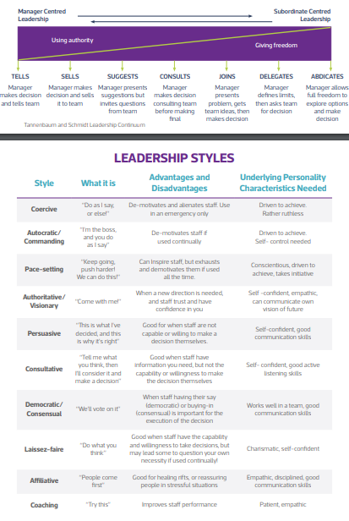
(Tannenbaum and Schmidt,1958; as cited in The Institute of Leadership, 2023)

Appendix 2 – 2.4.1 Conceptualising Leadership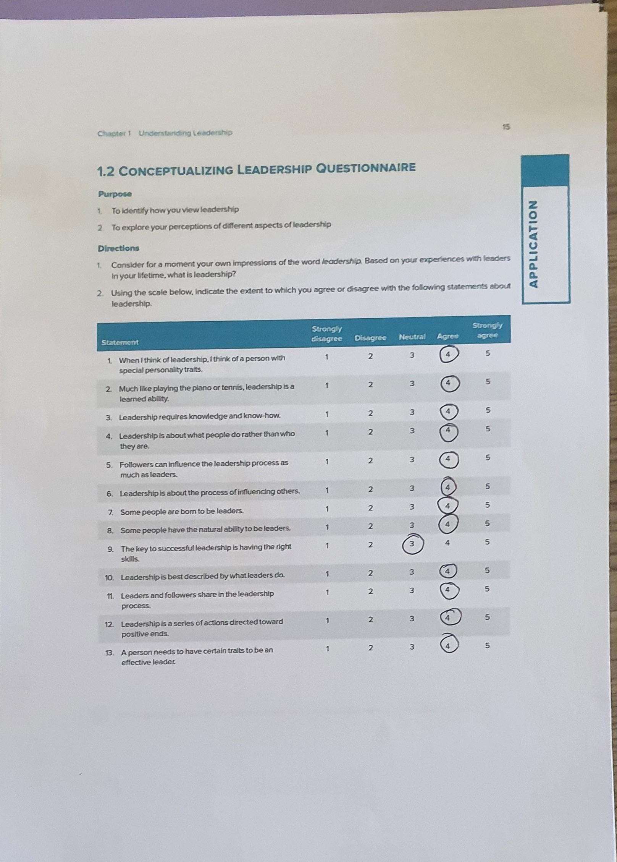
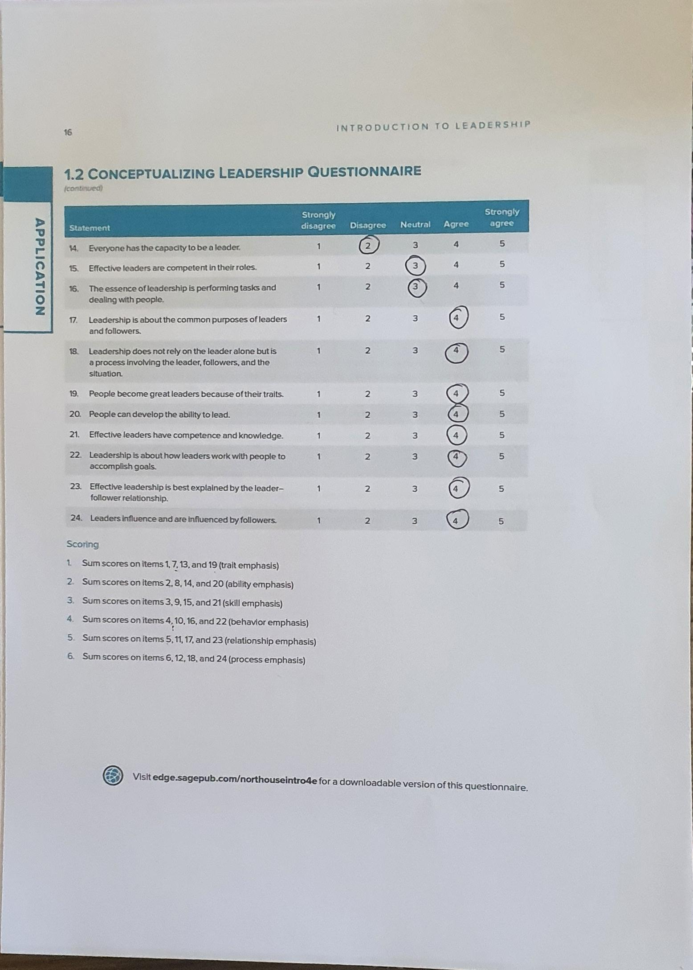
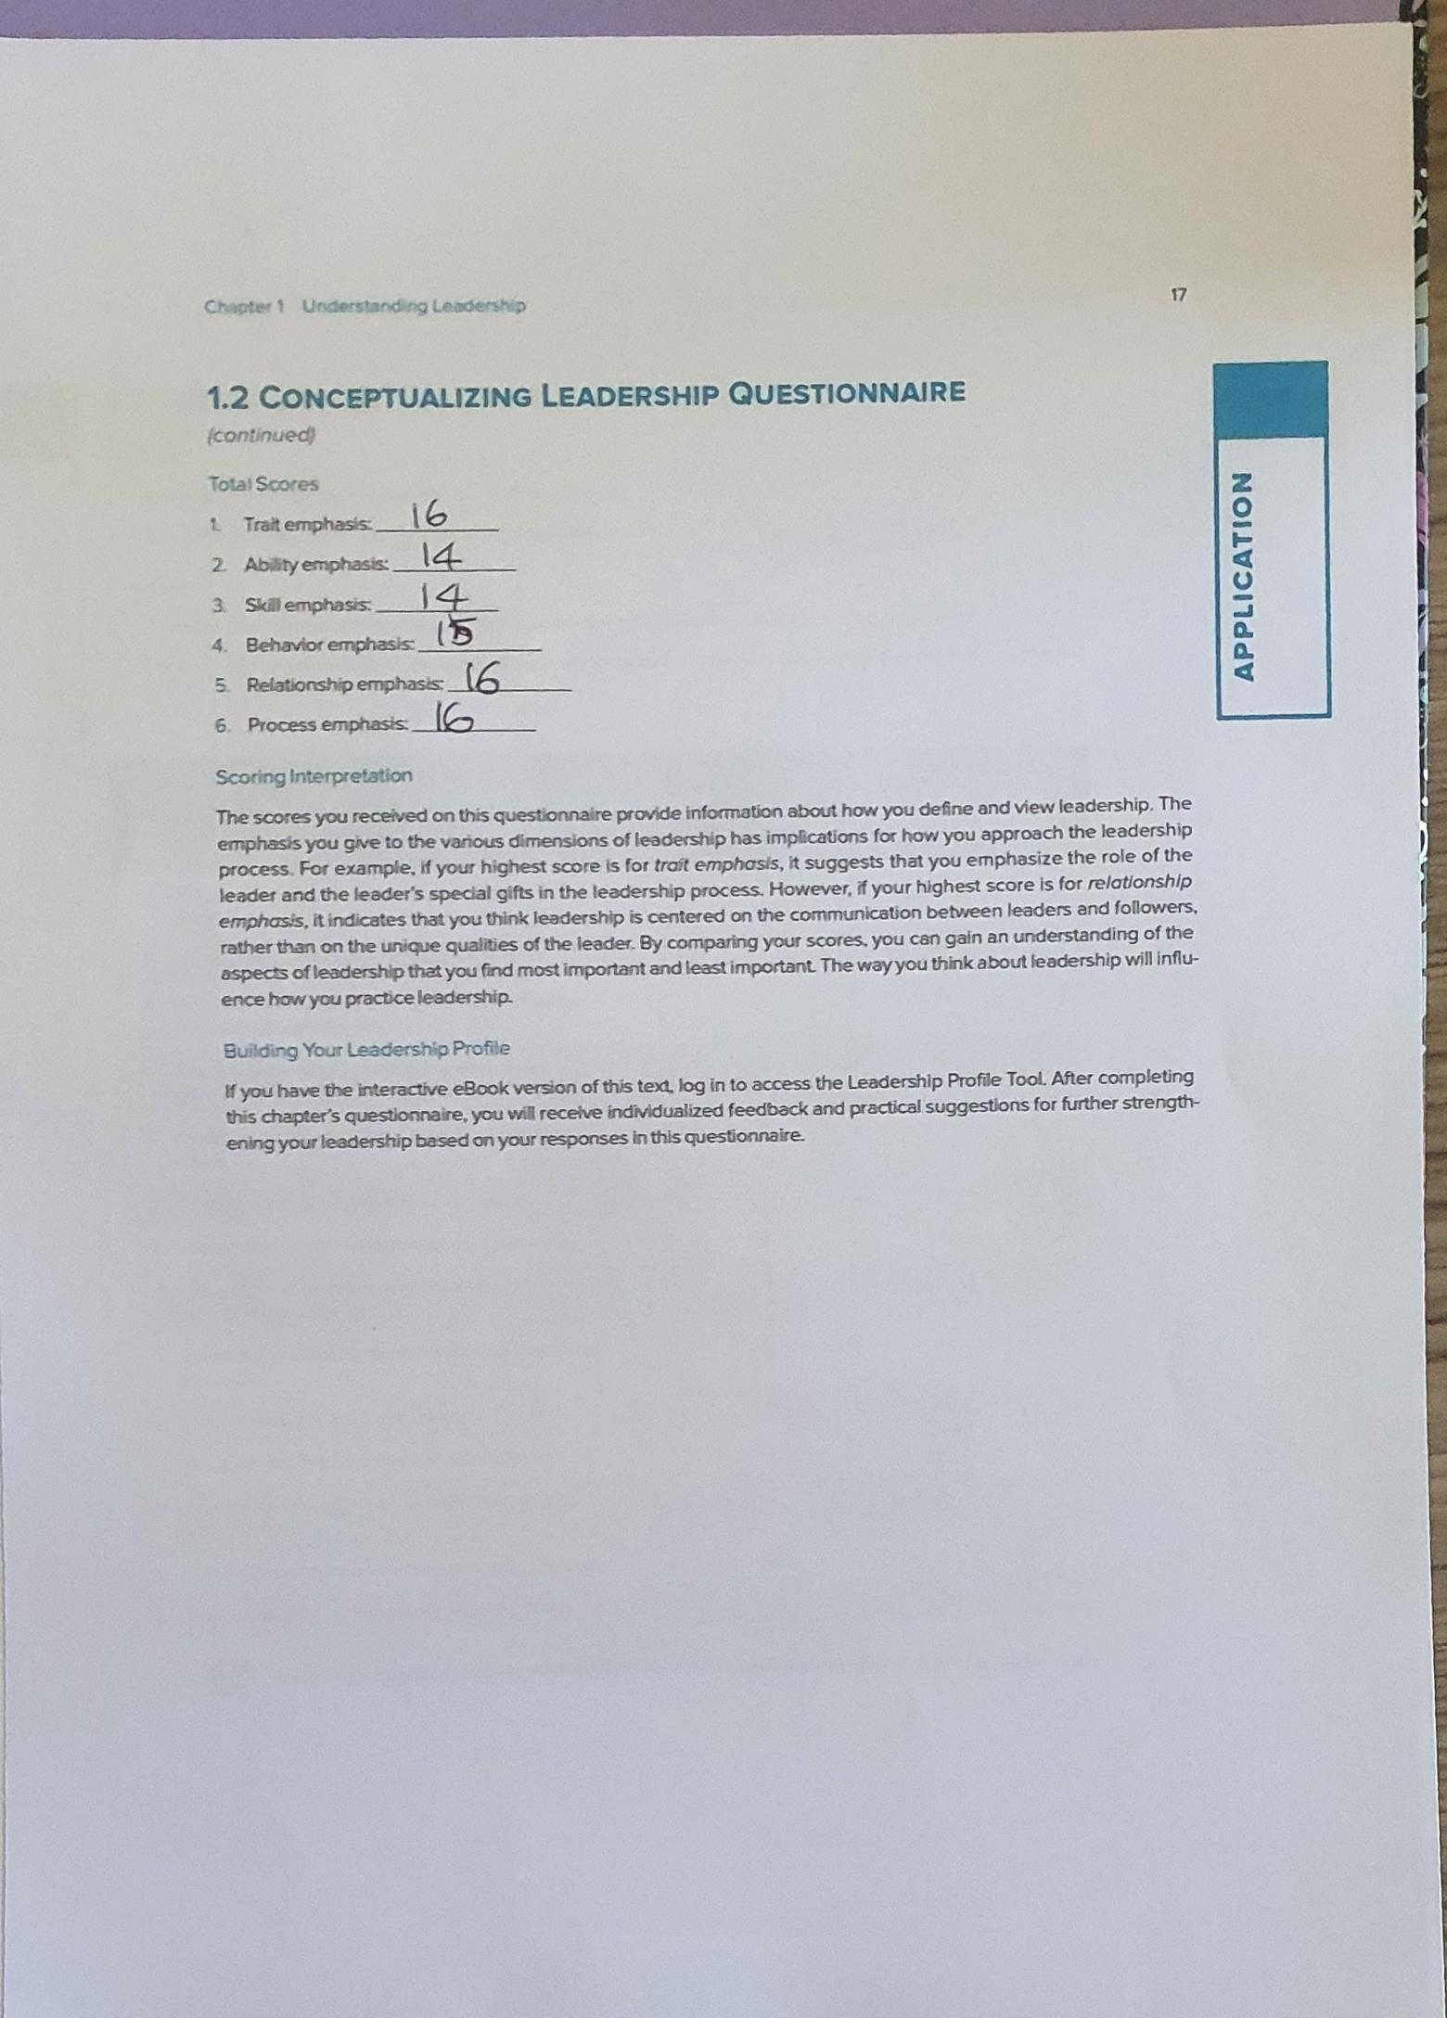

Appendix 3 - 2.4.2 Leadership Traits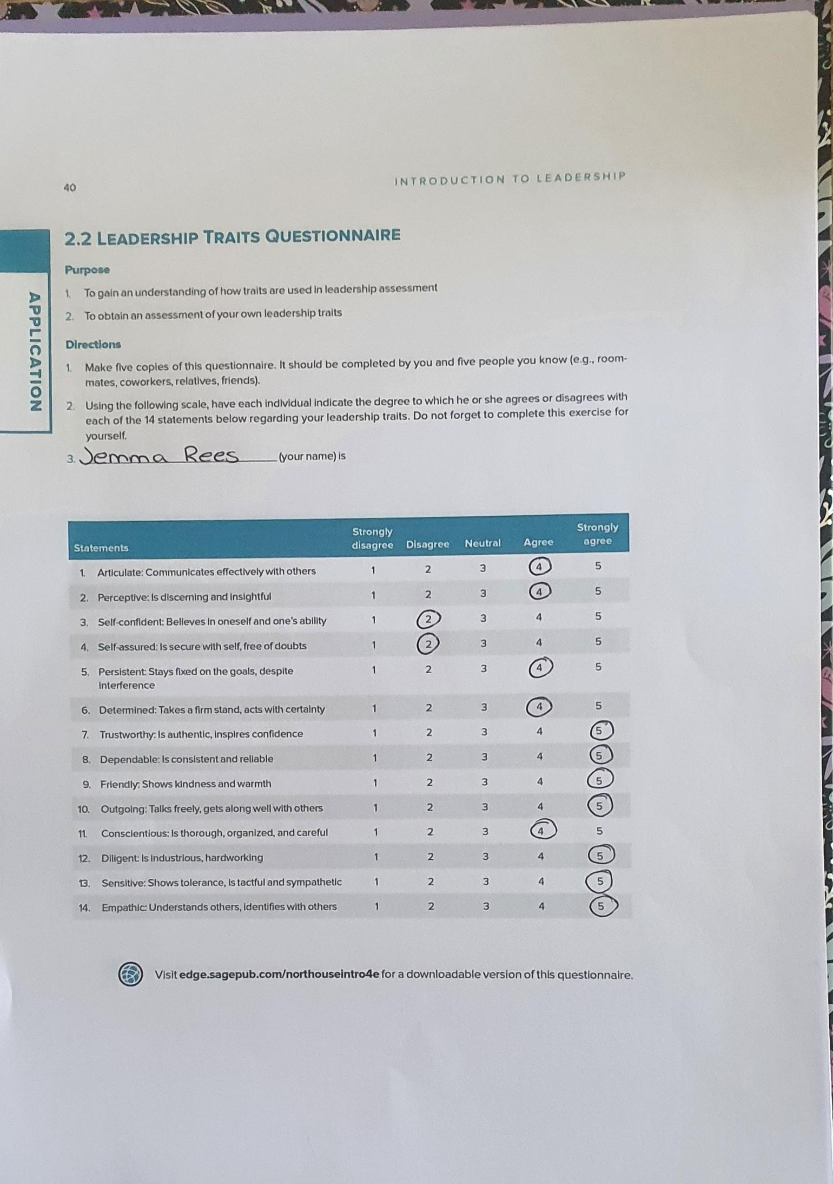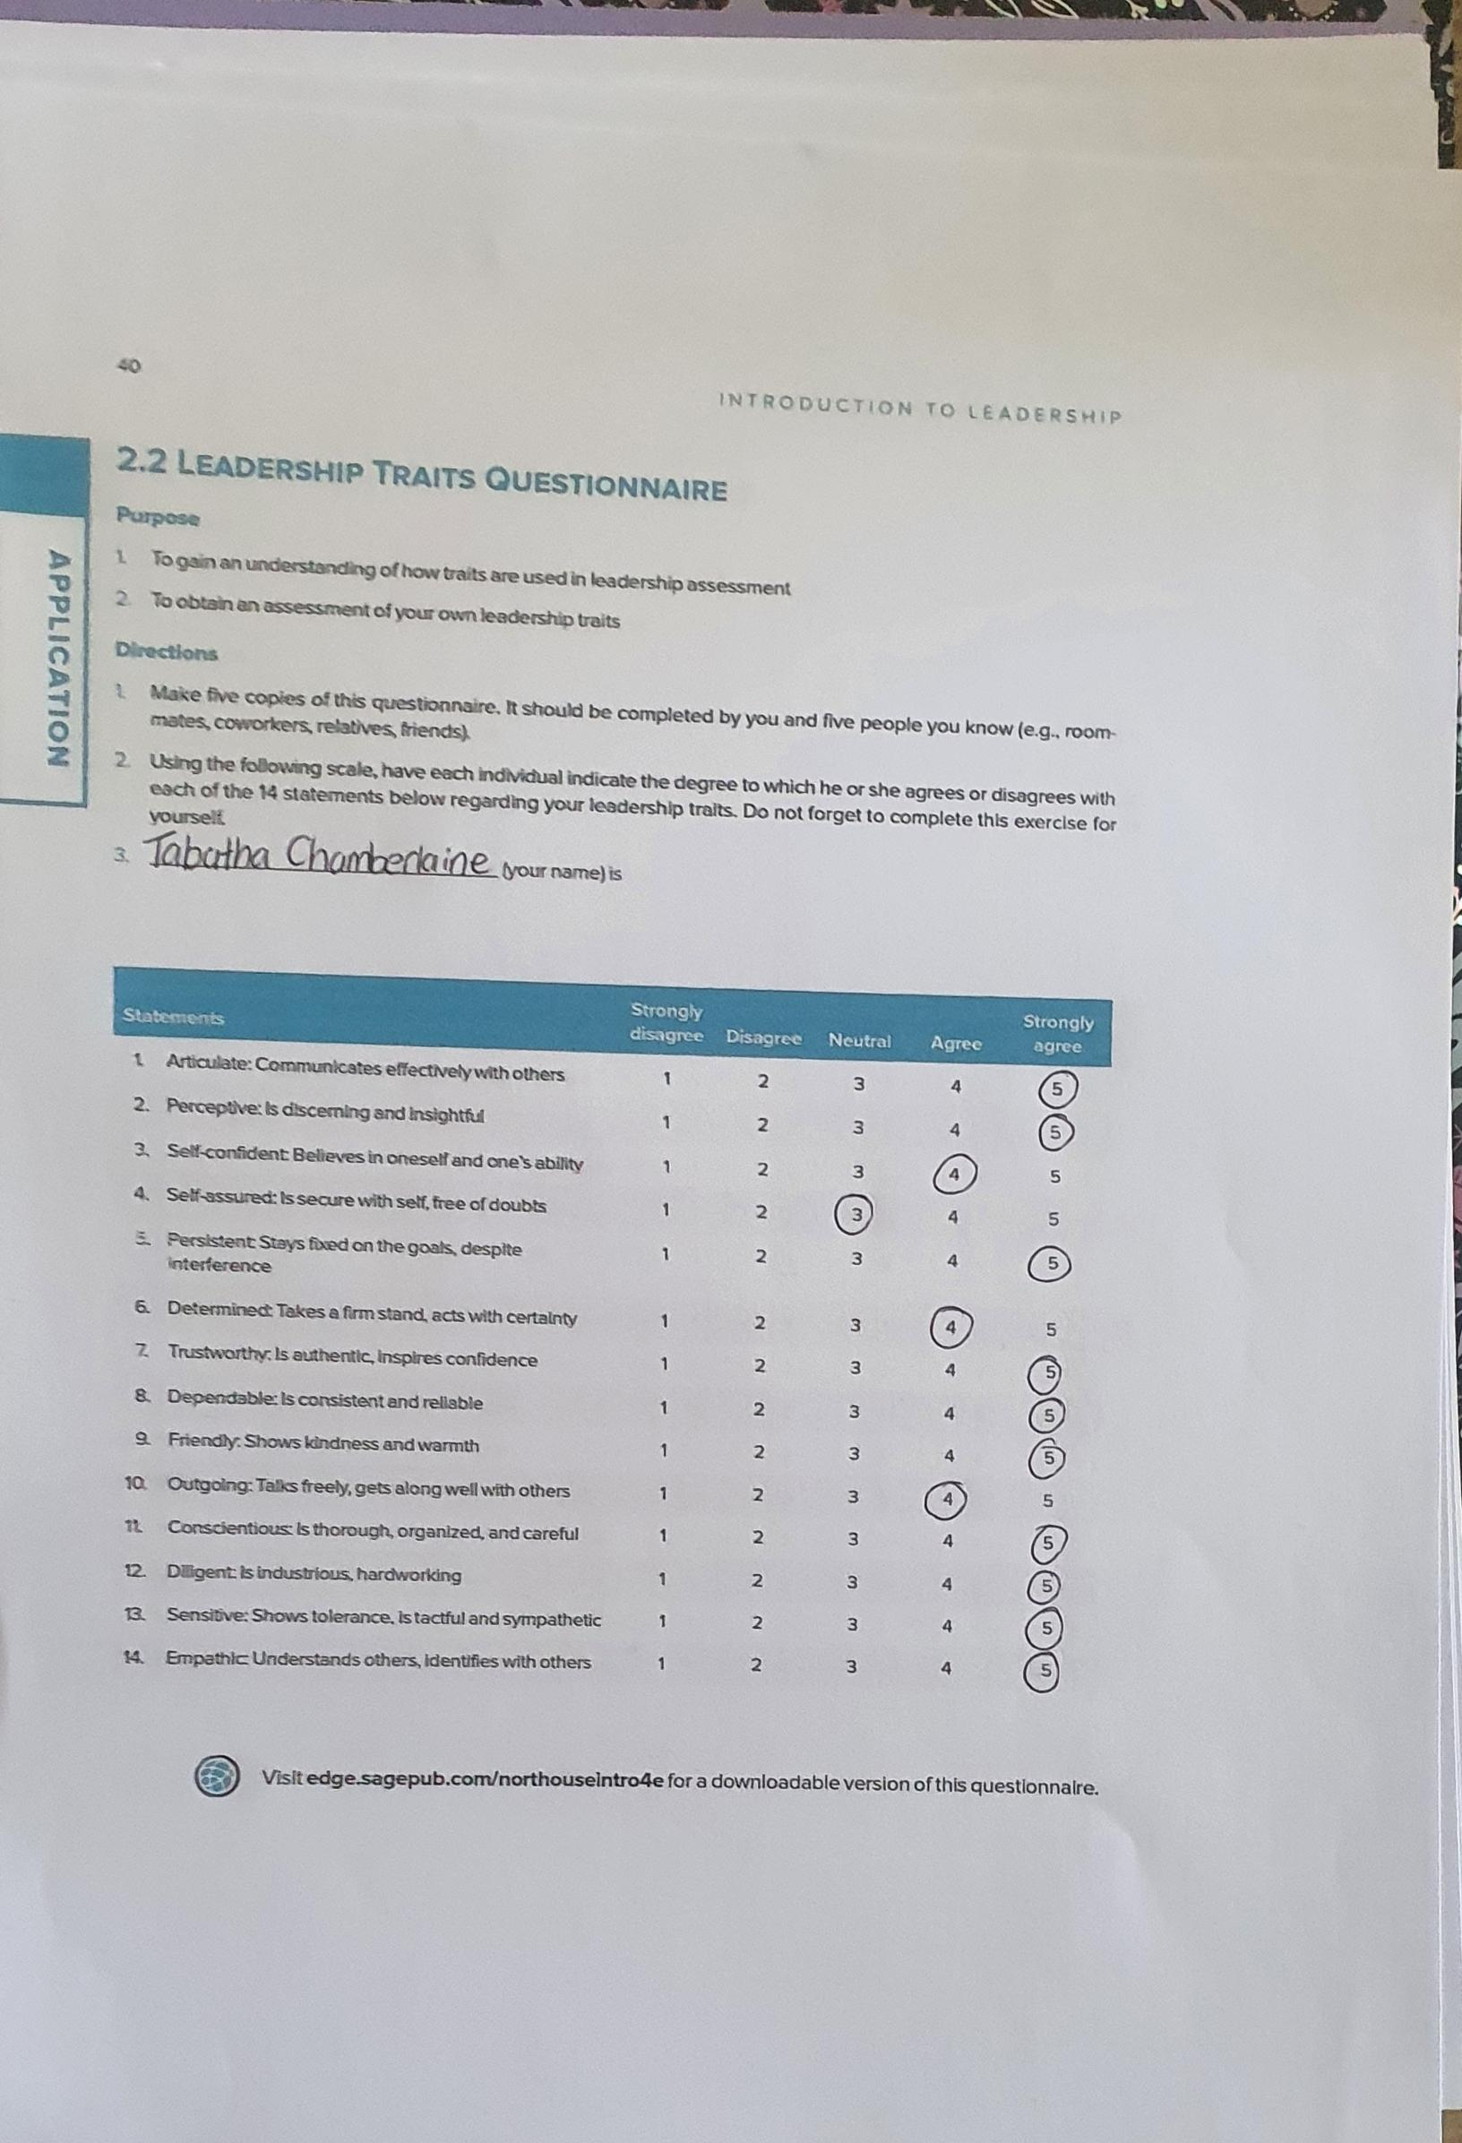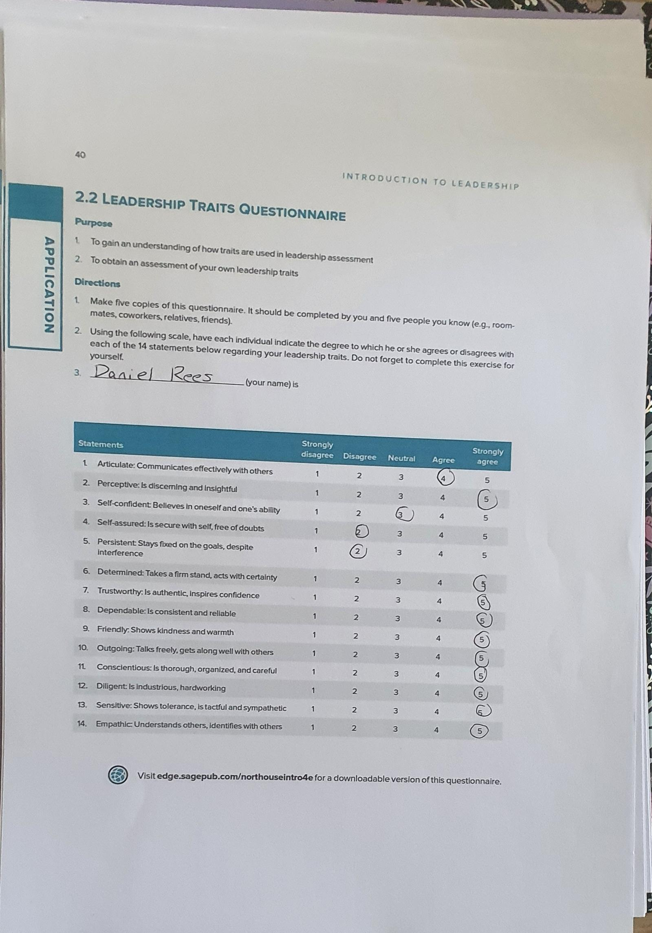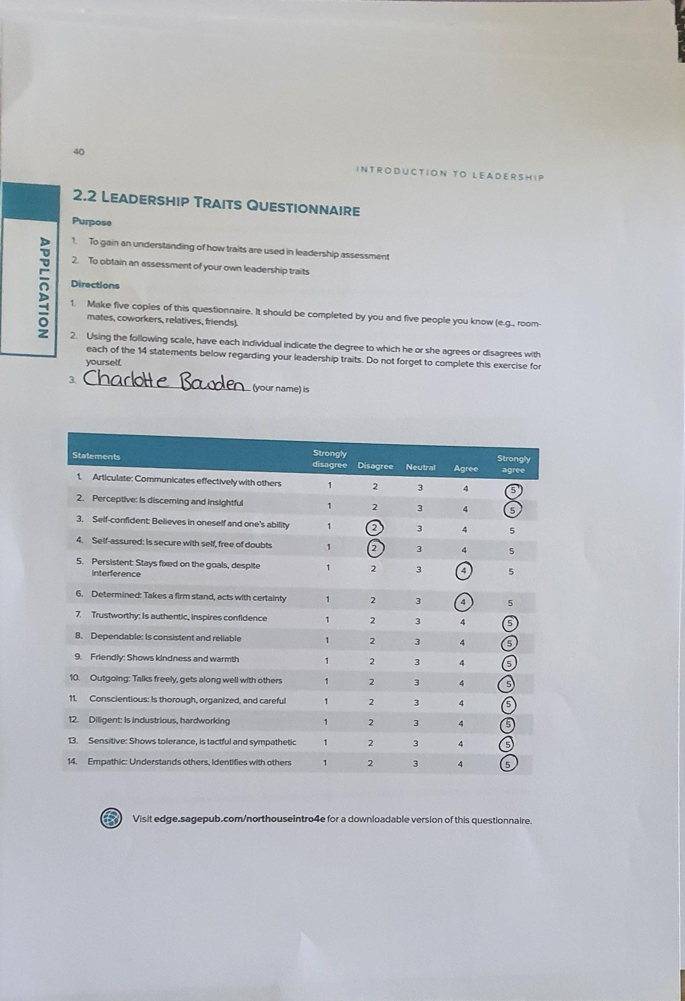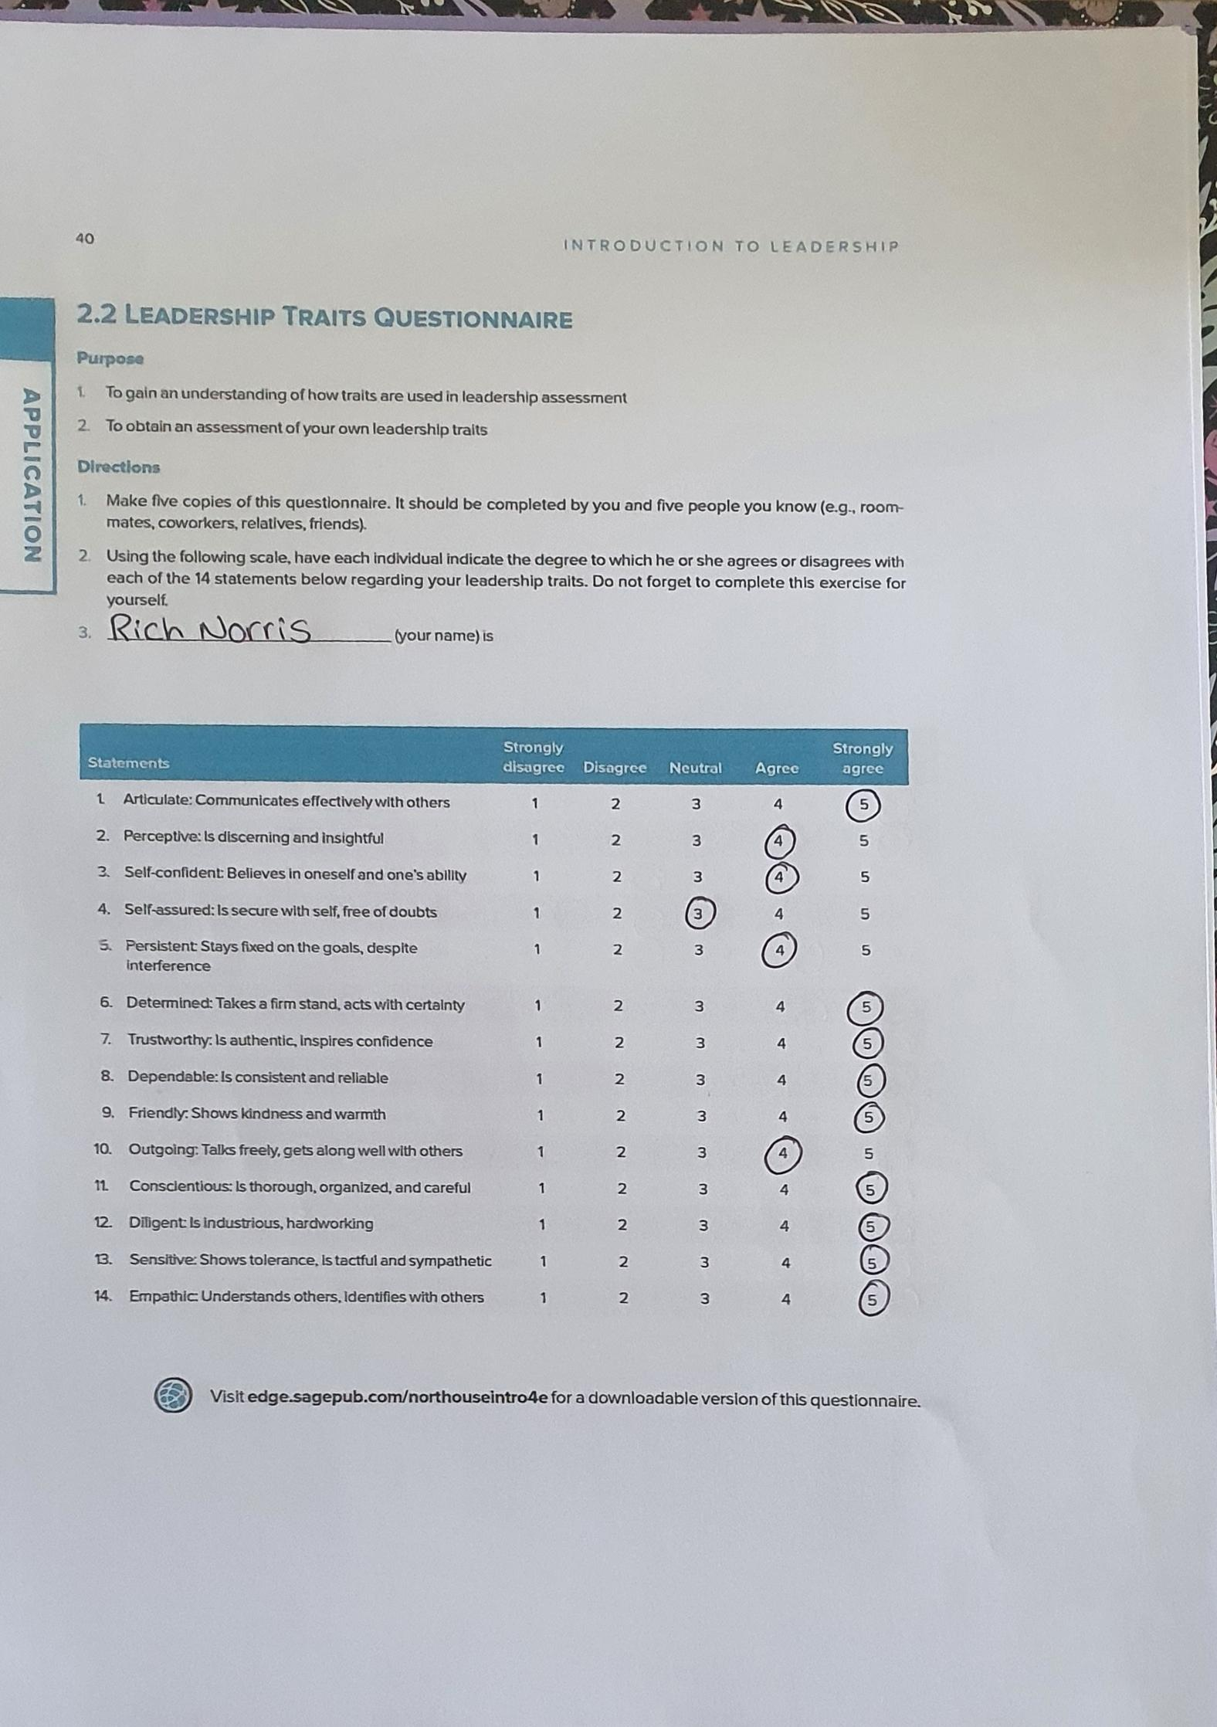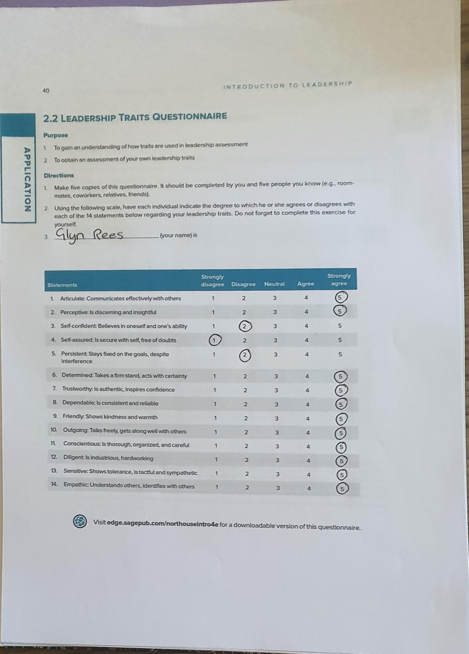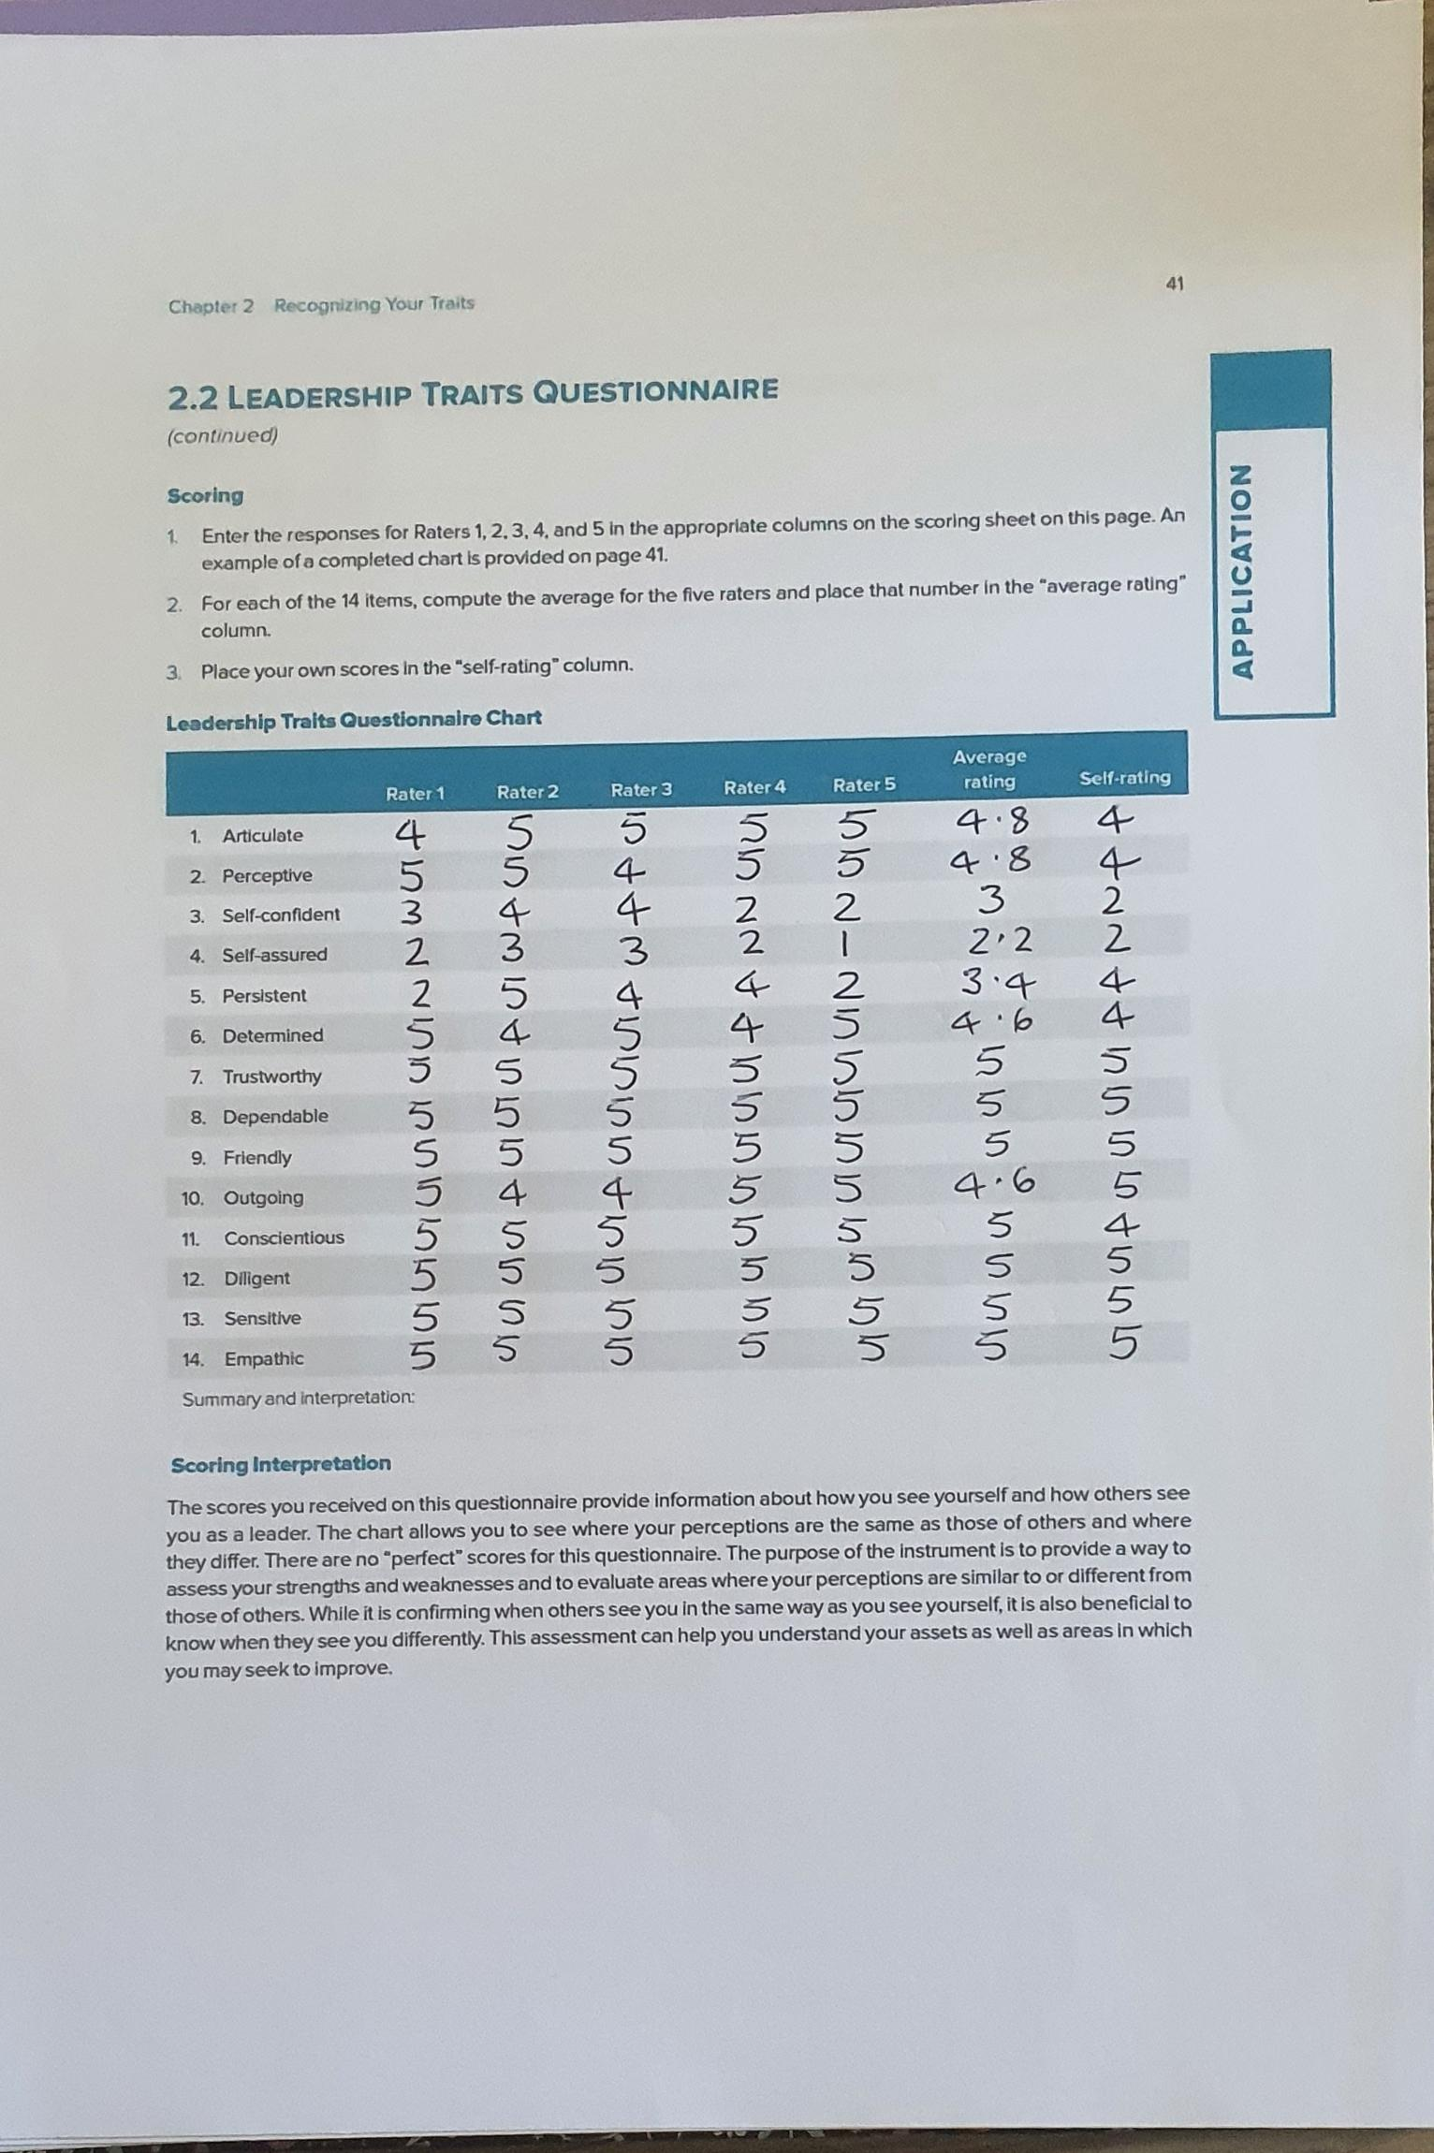

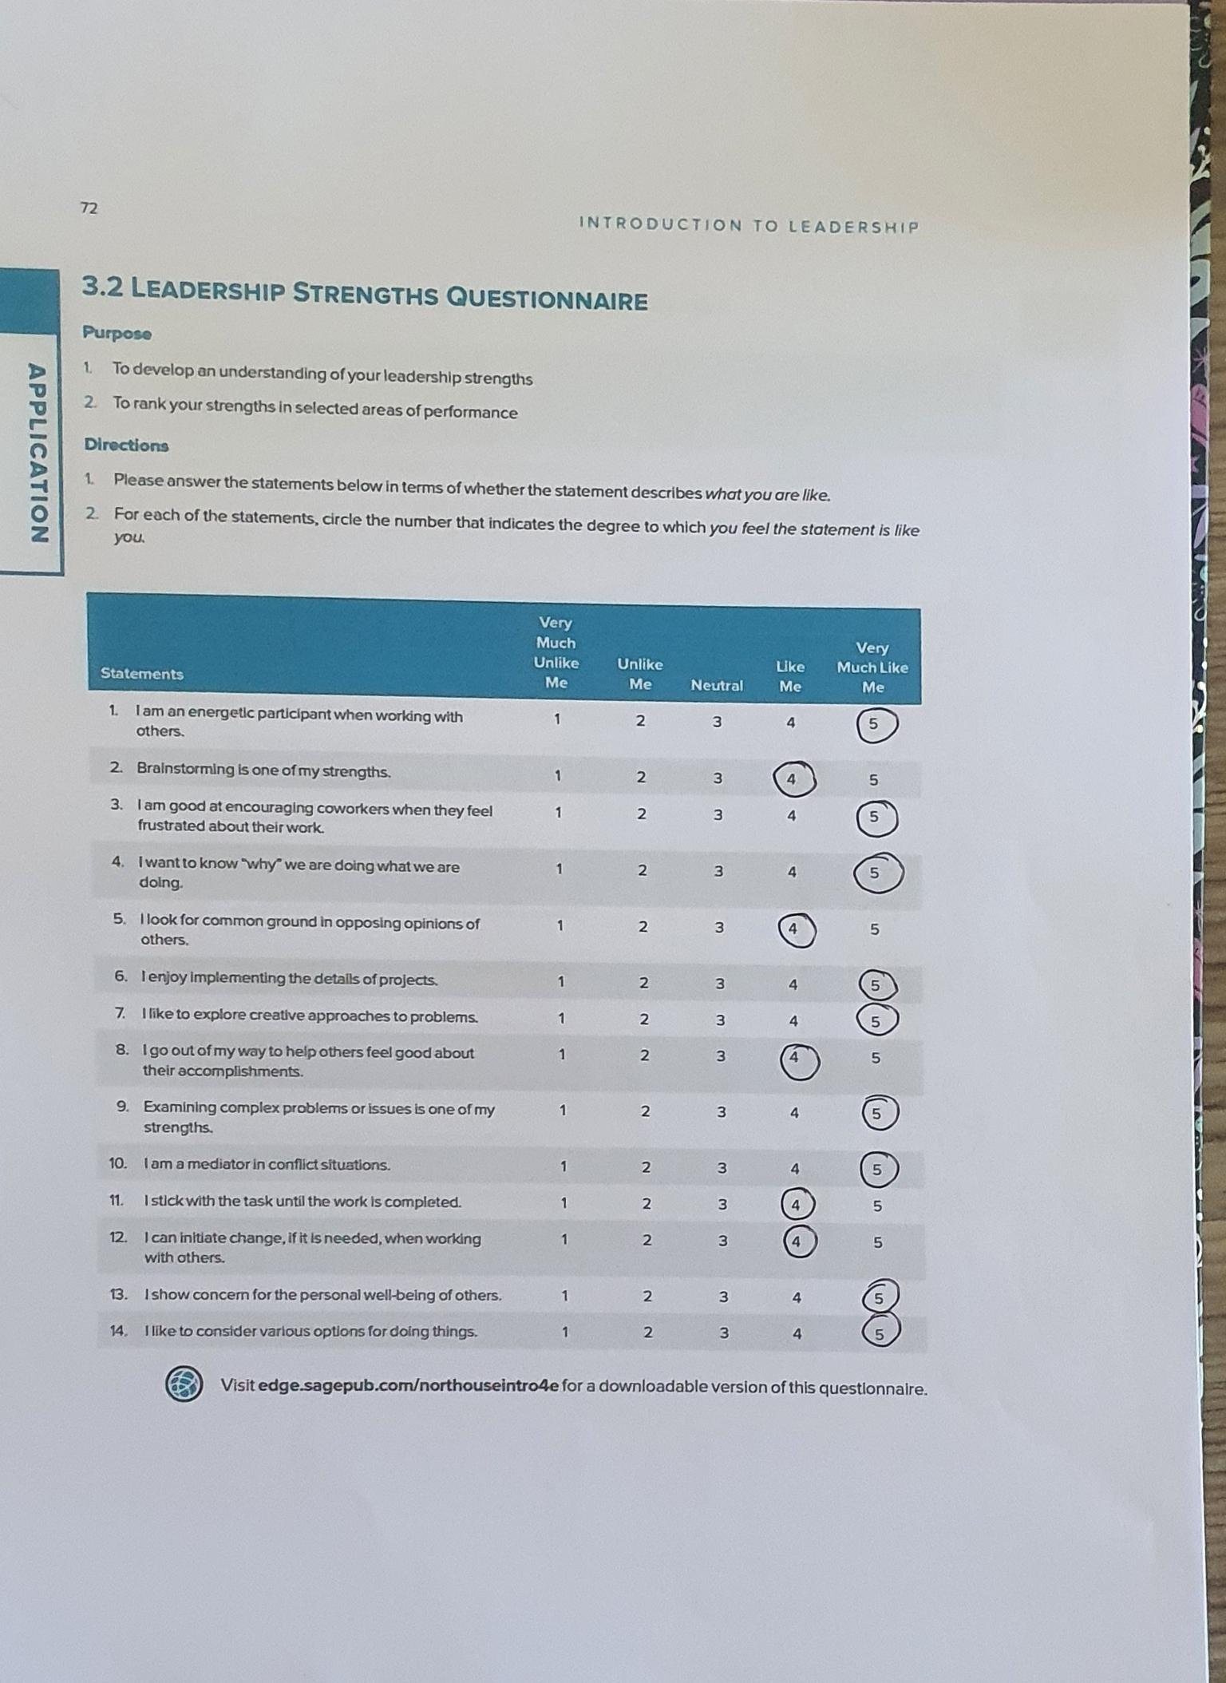
Appendix 4 – 2.4.3 Leadership Strengths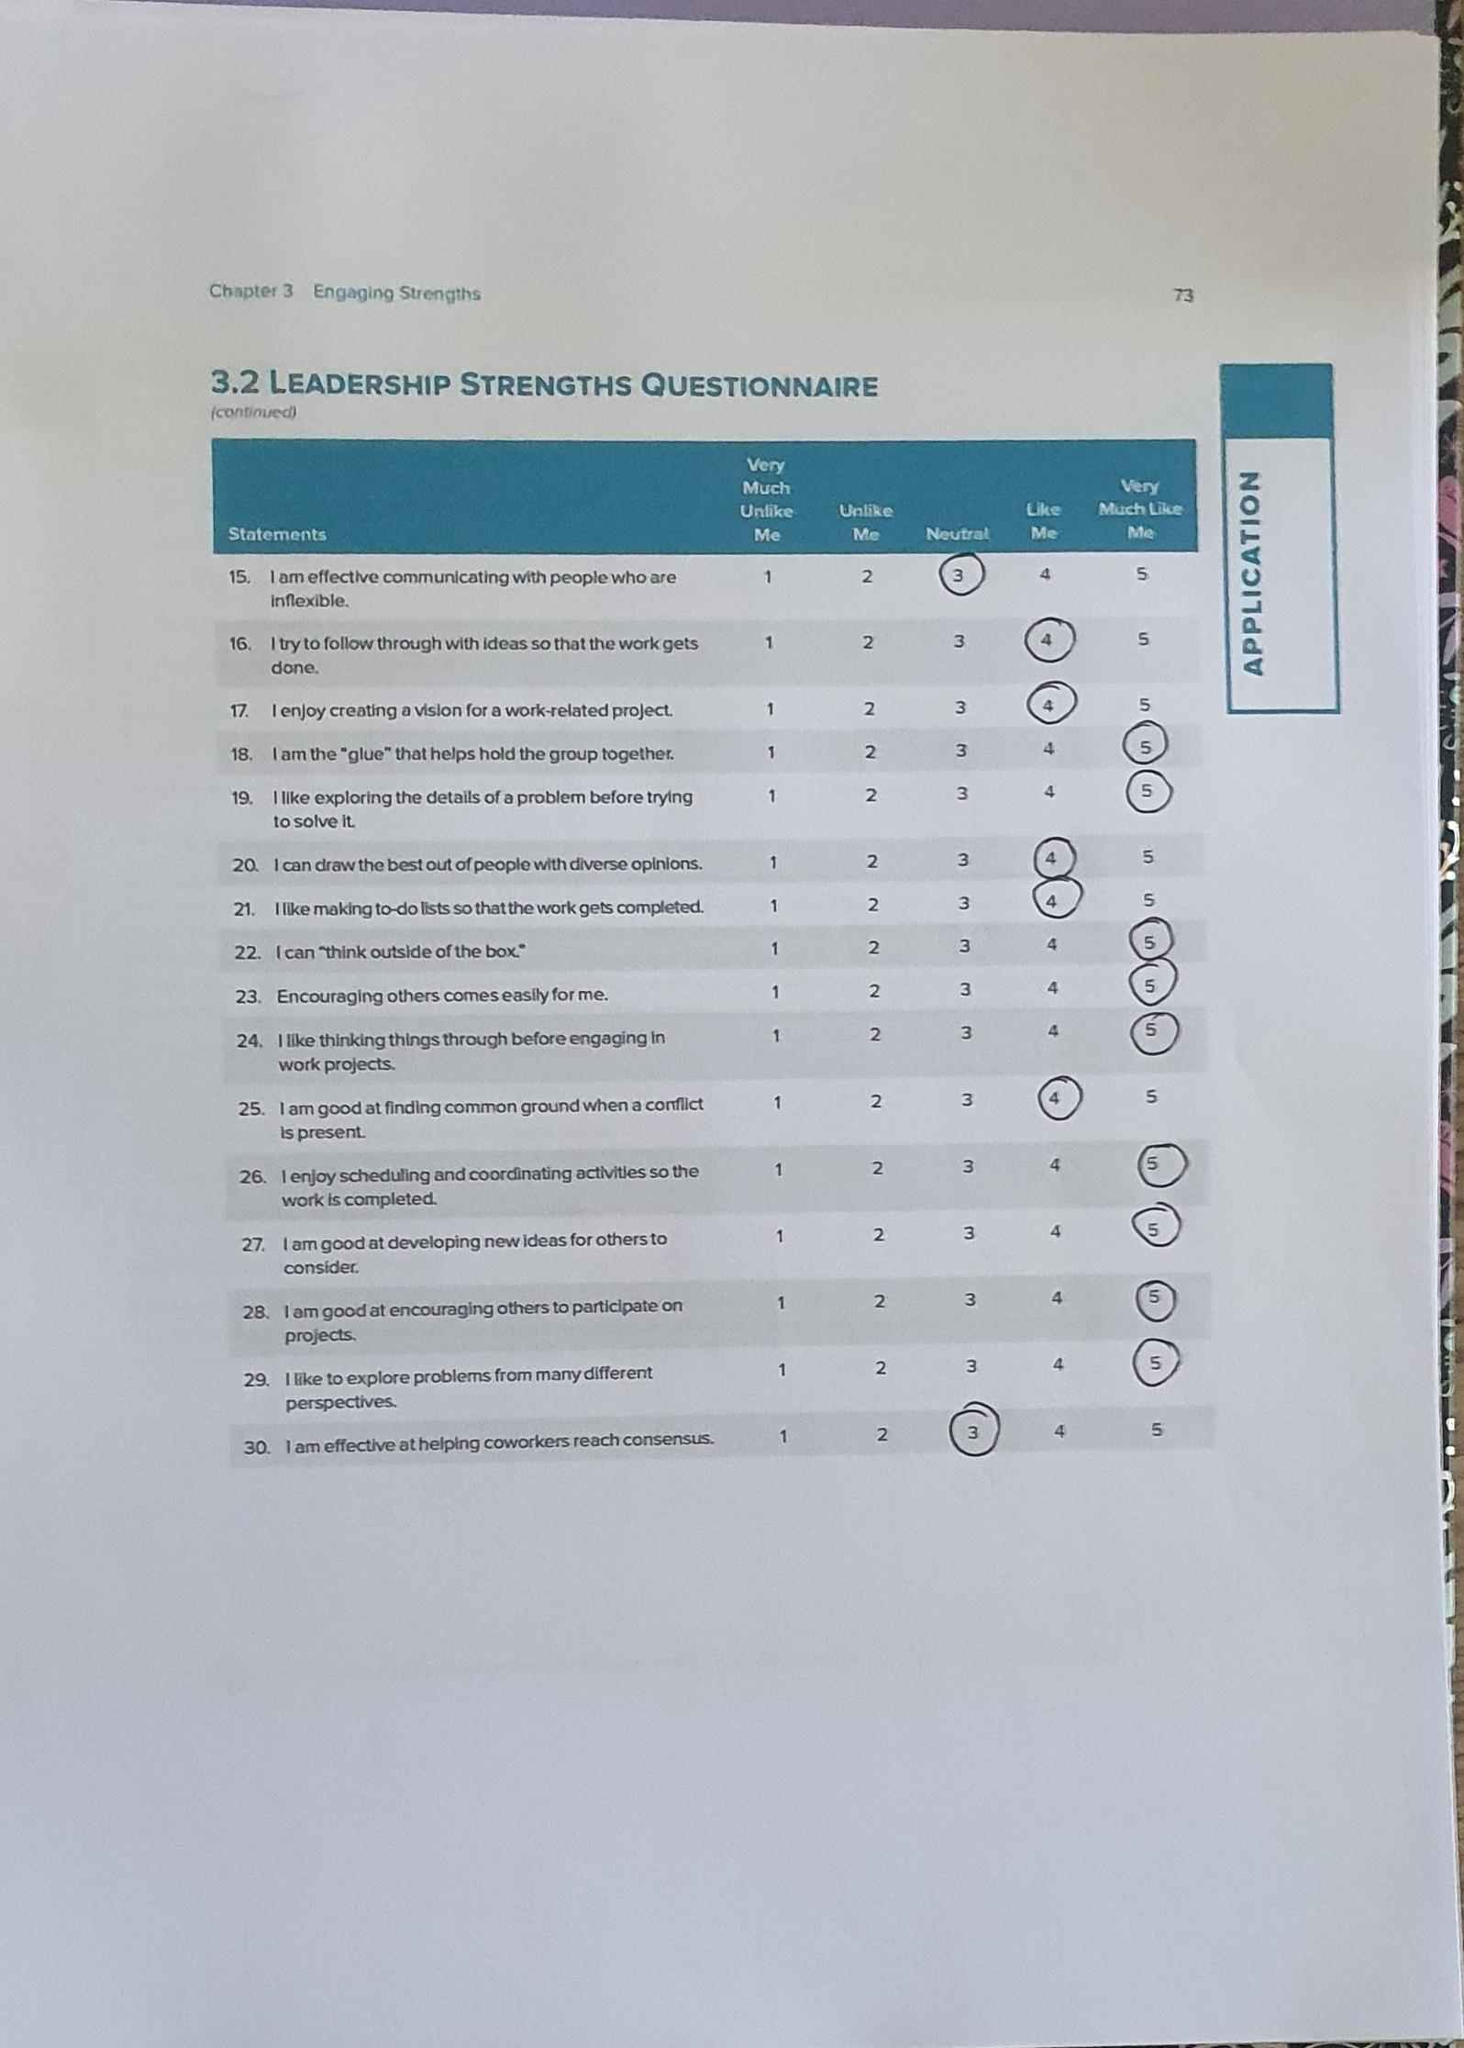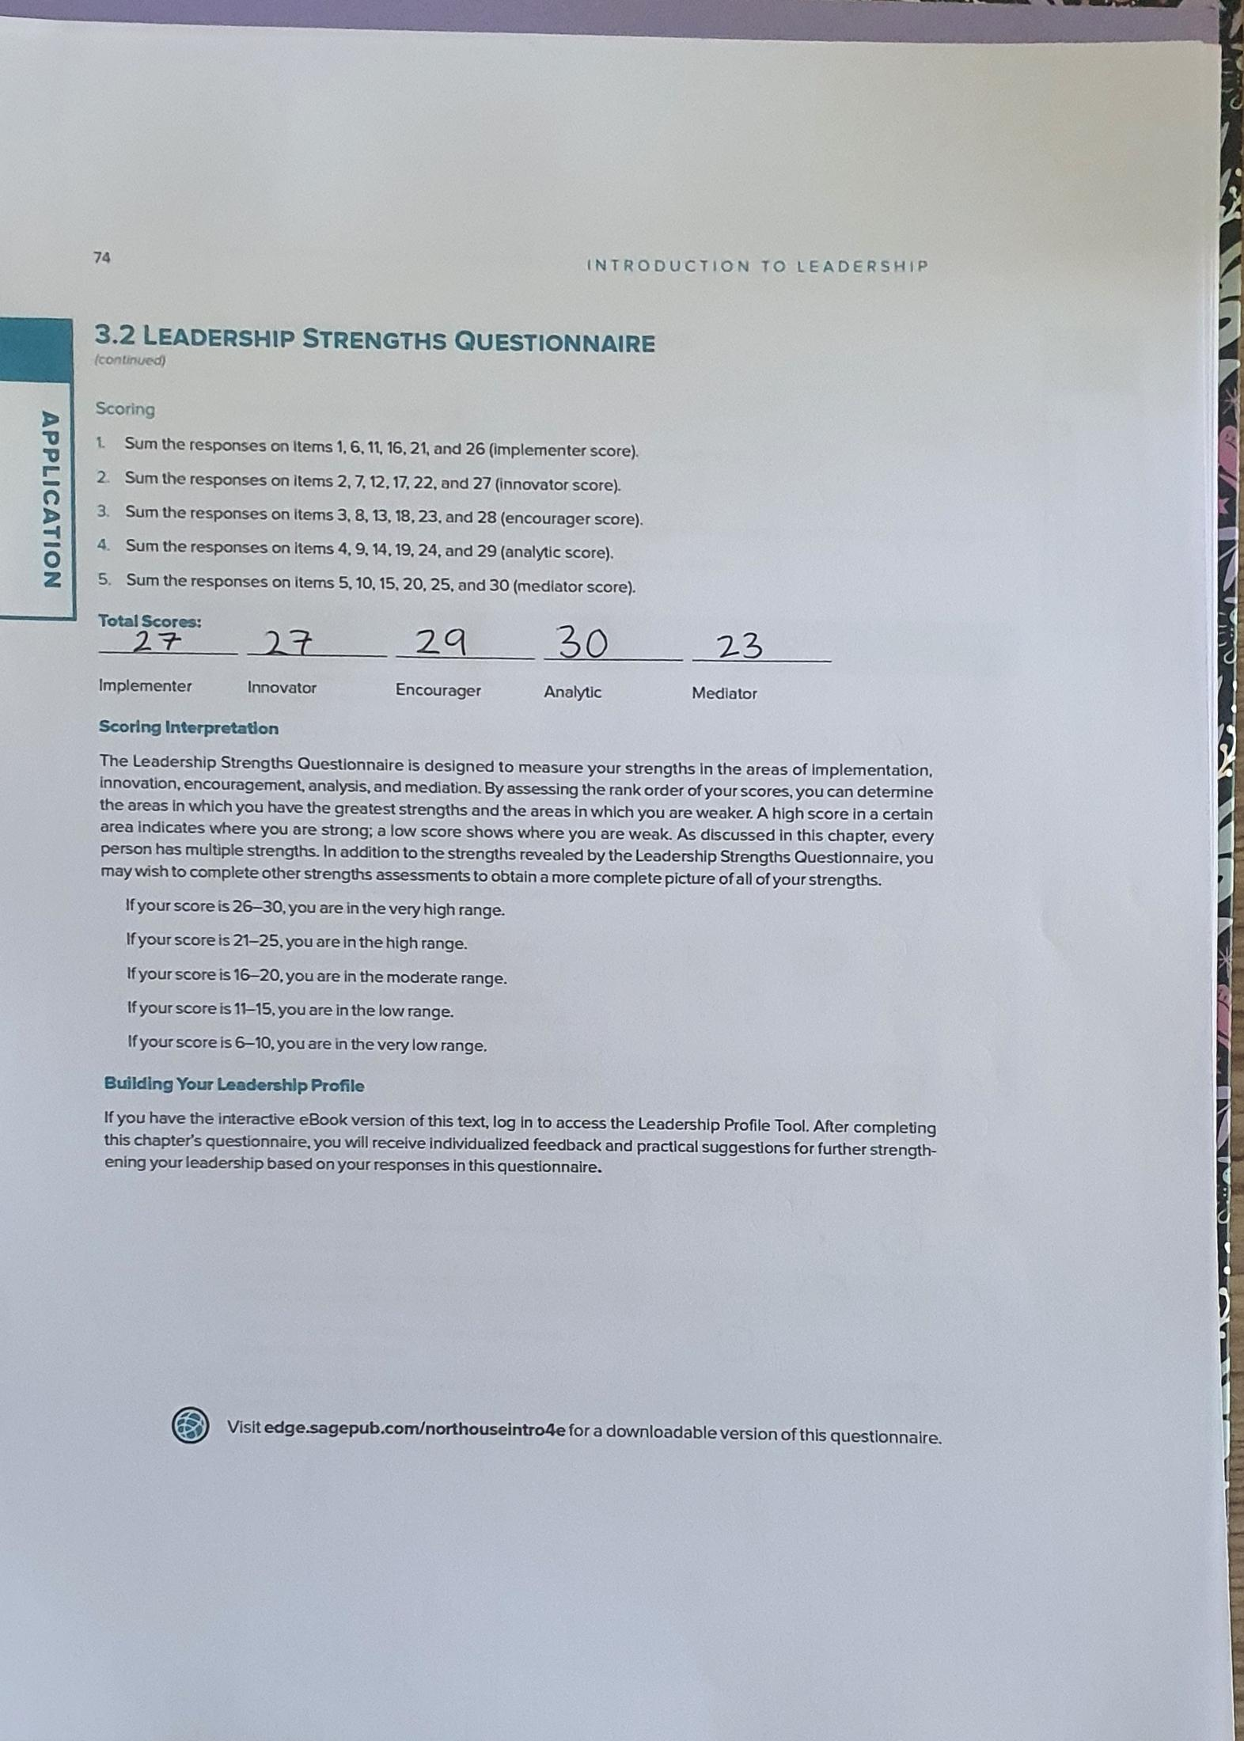

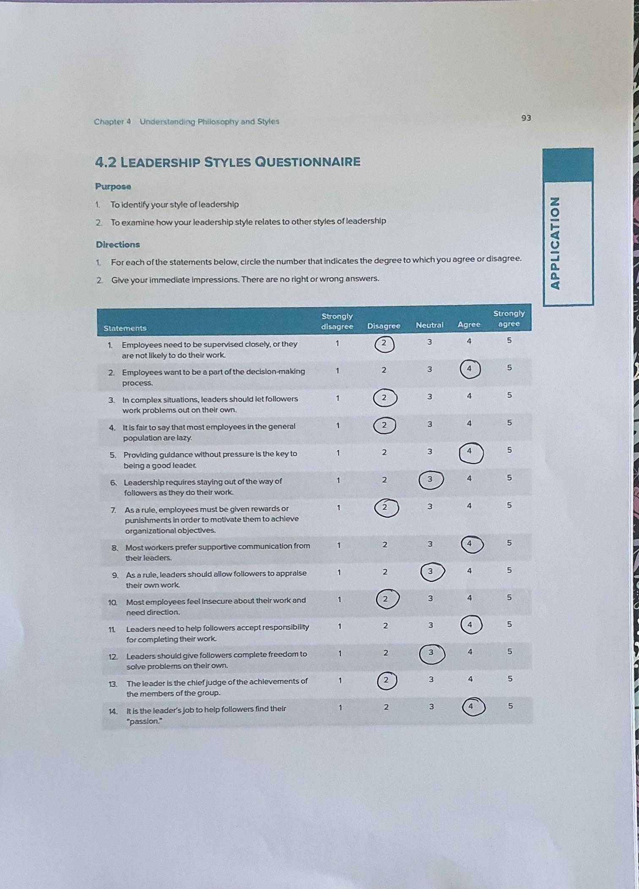
Appendix 5 – 2.4.4 Leadership Styles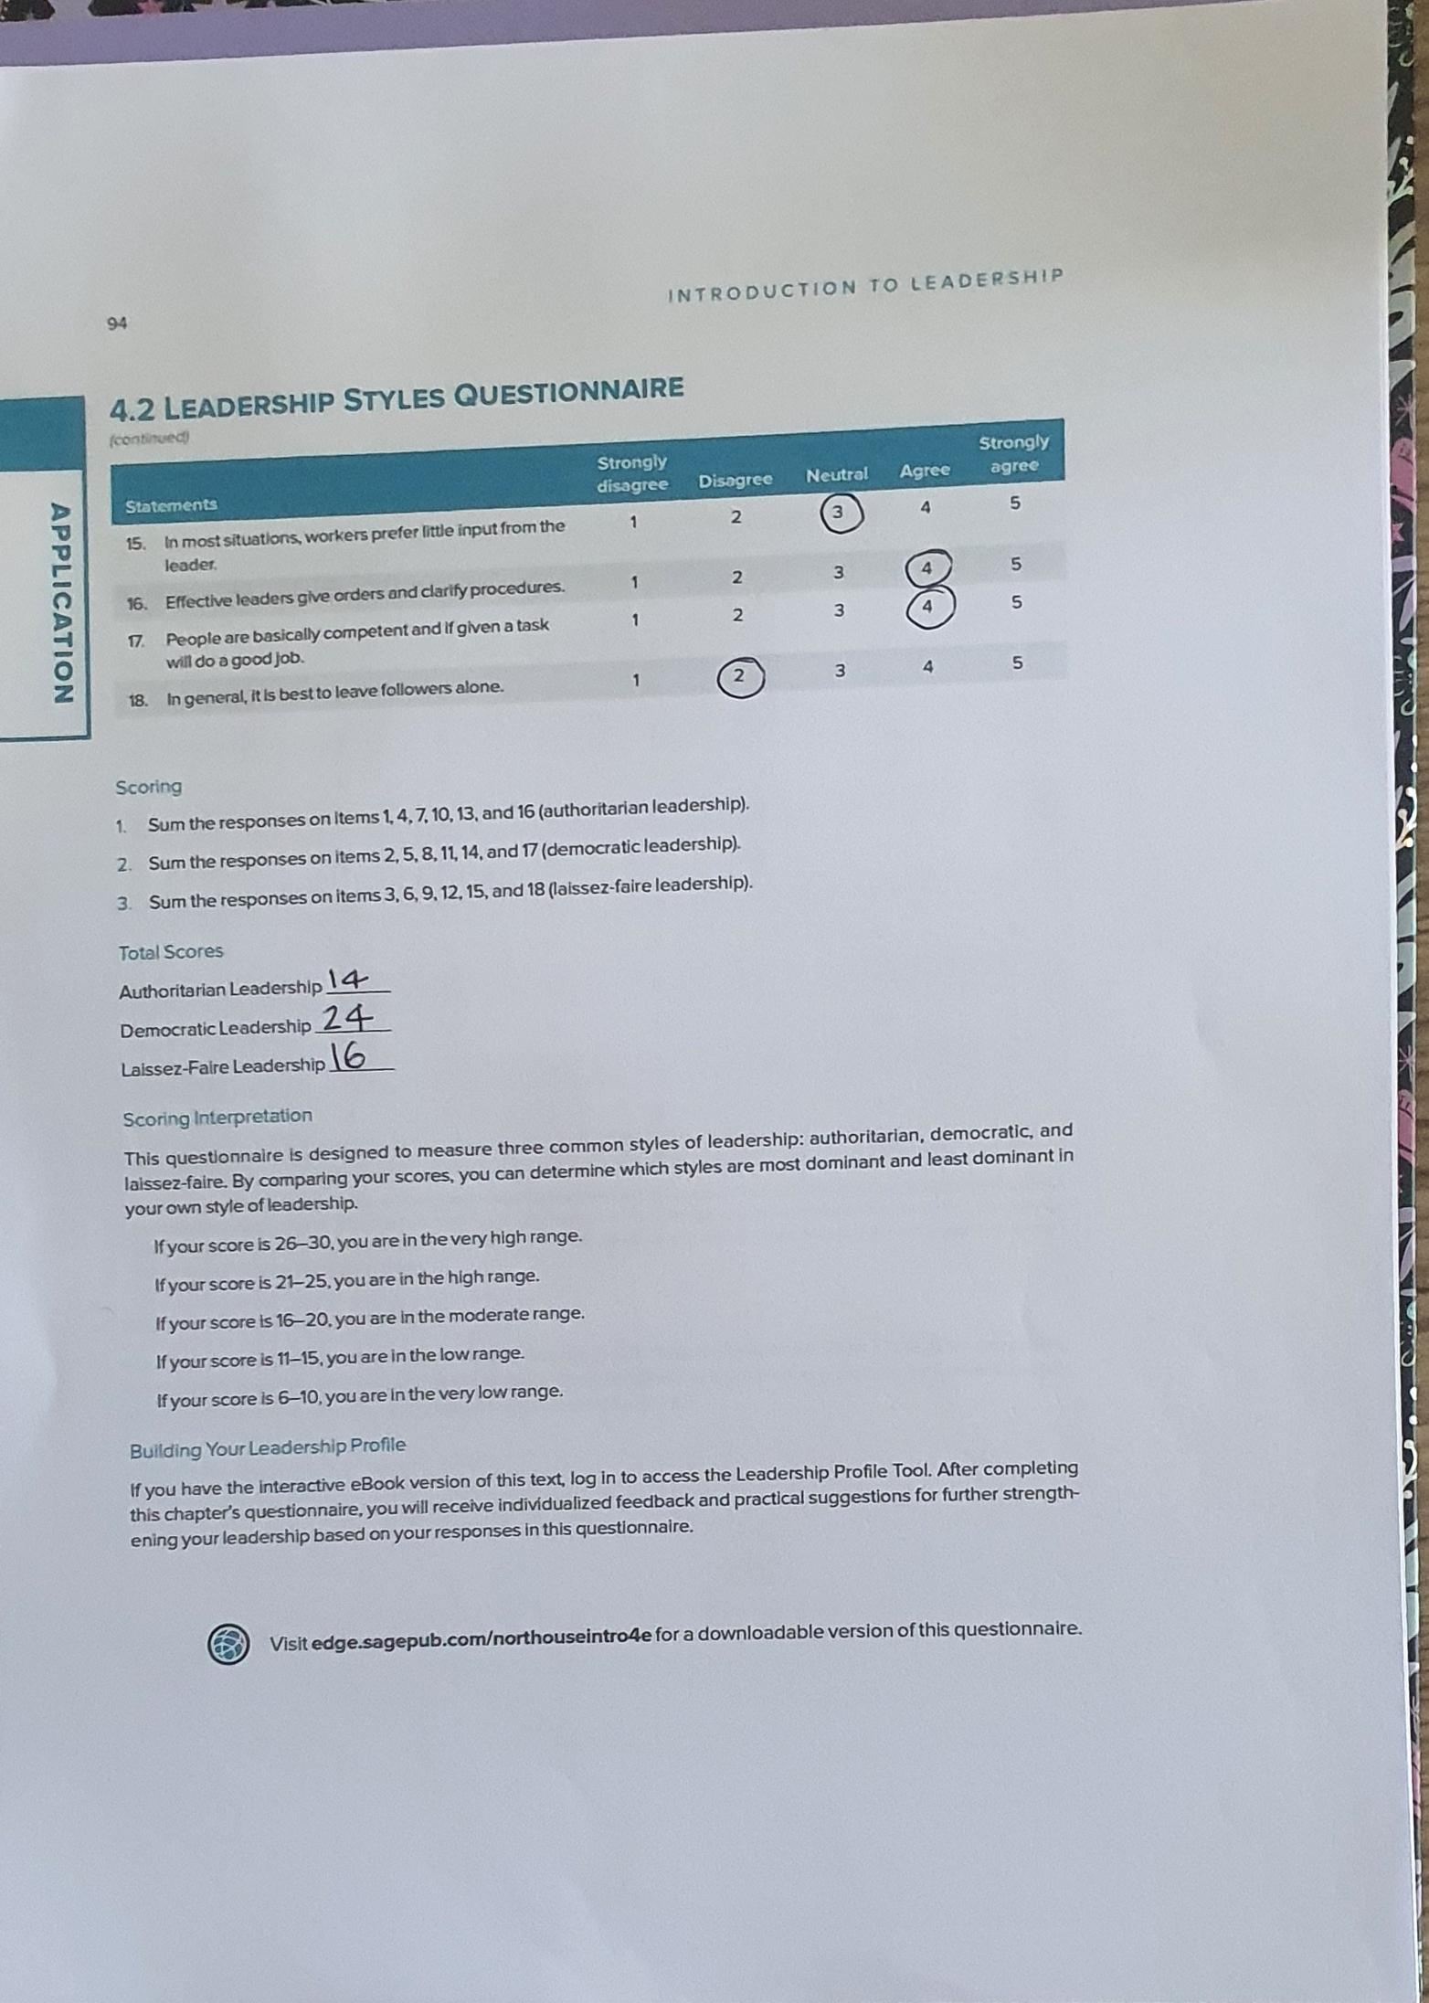

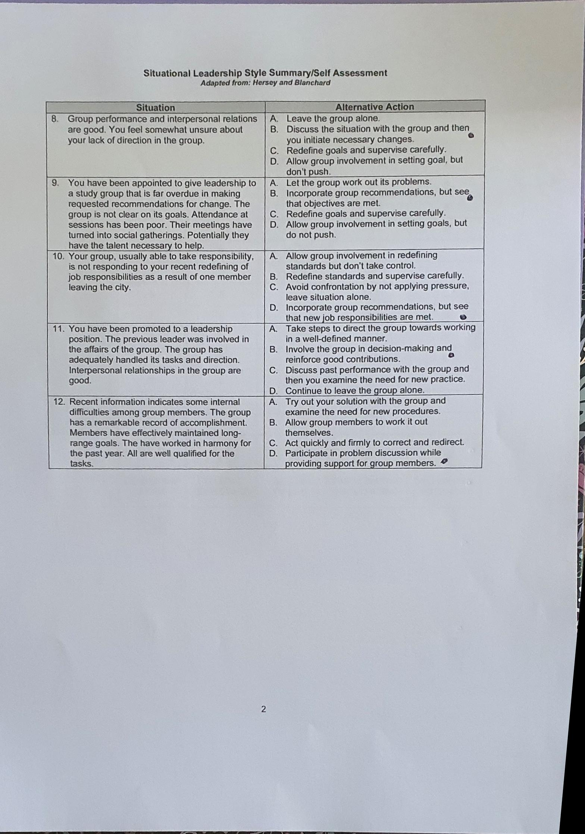
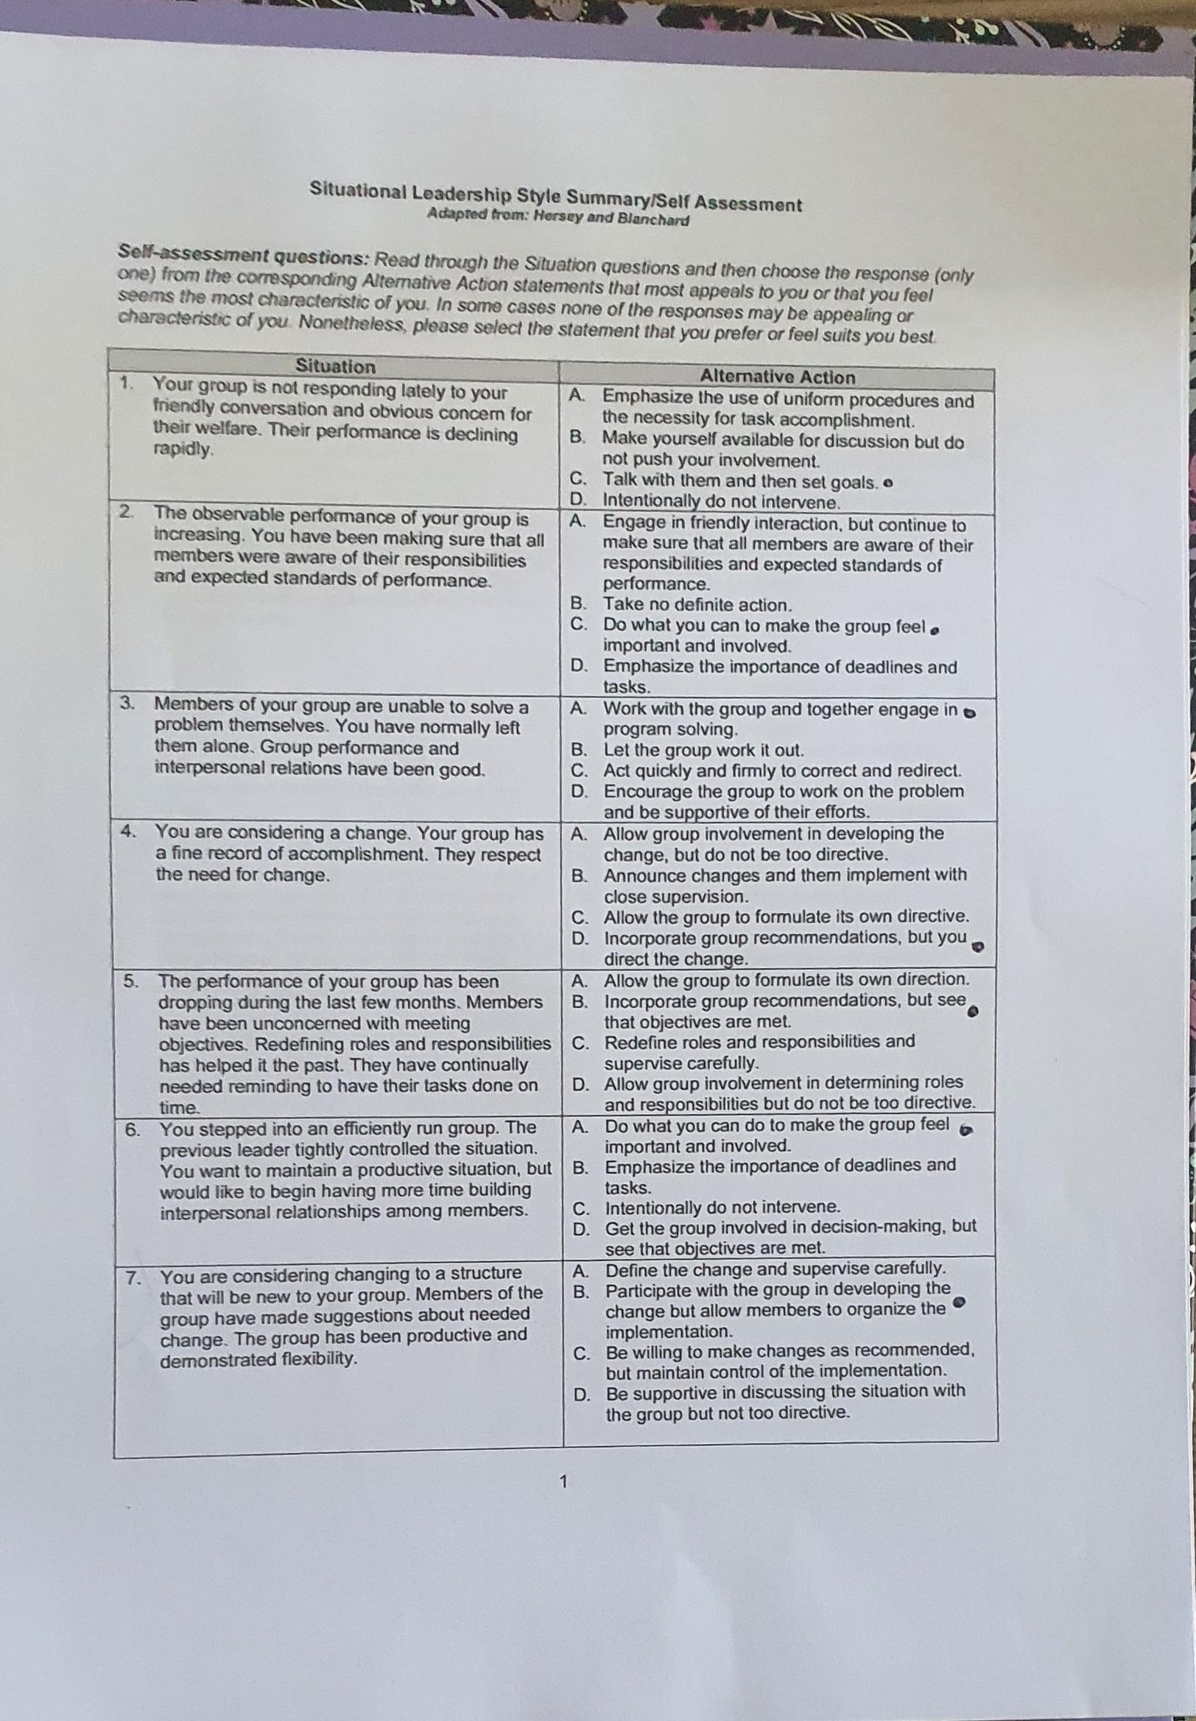
Appendix 6 – 2.4.5 Situational Leadership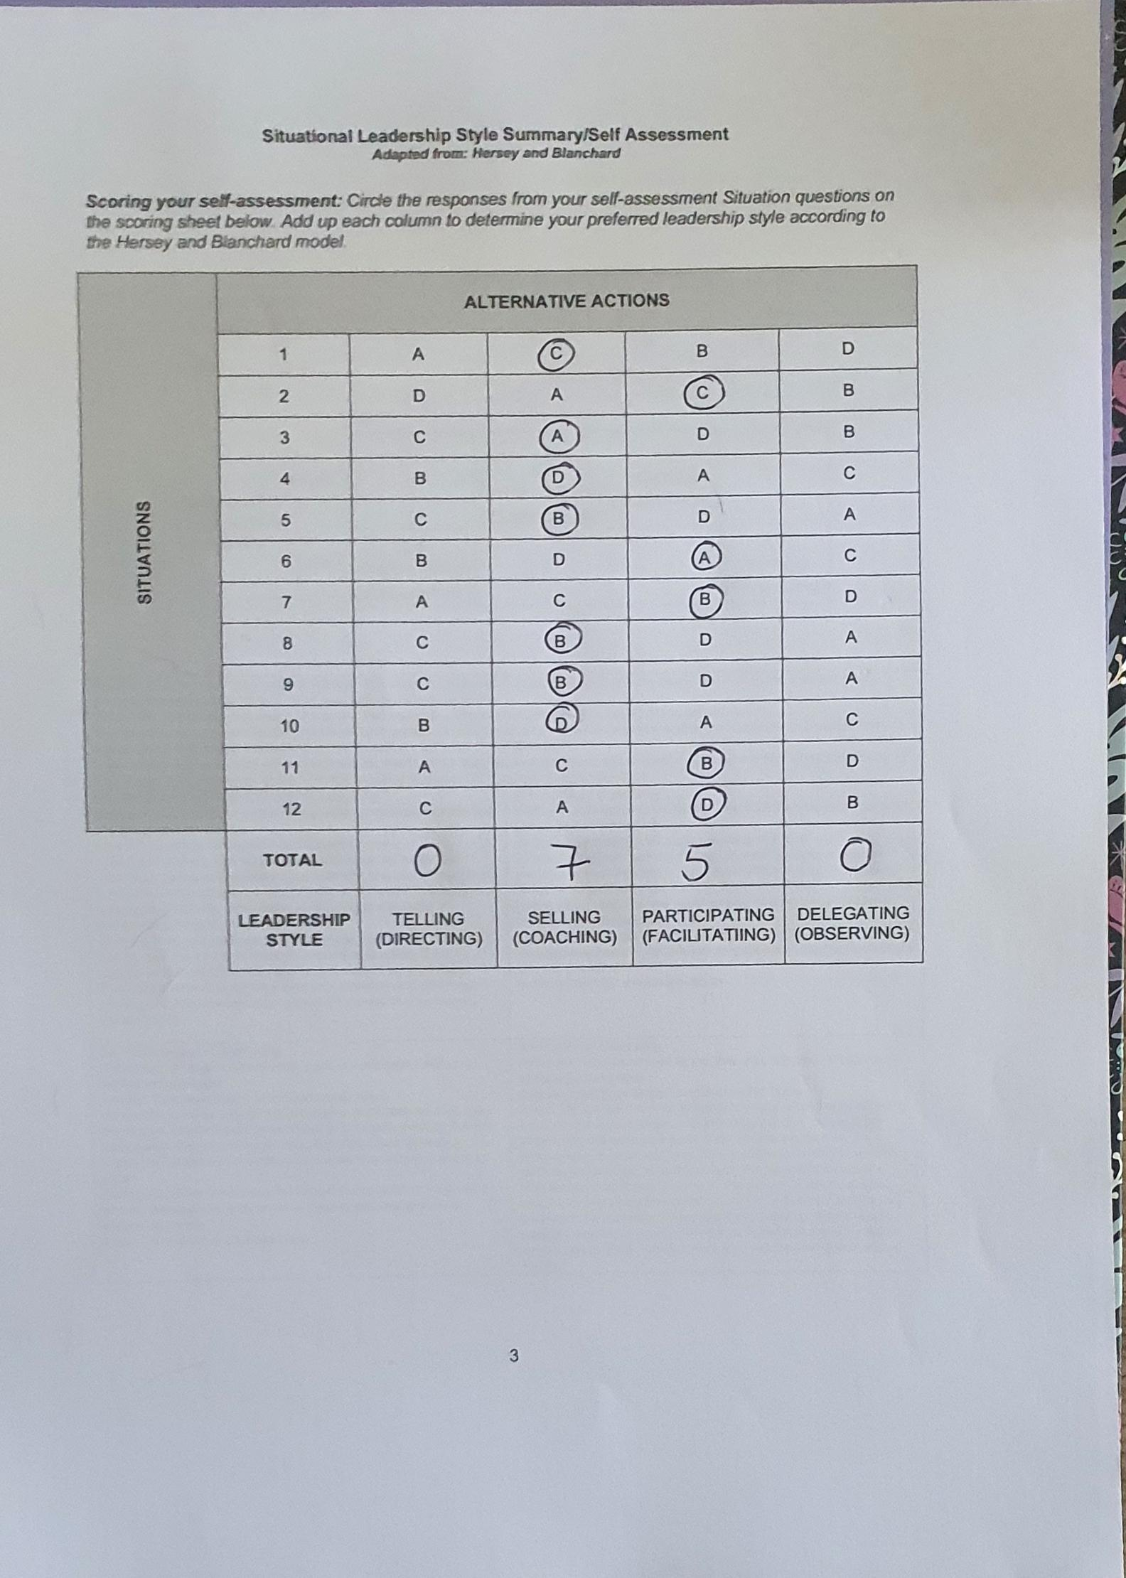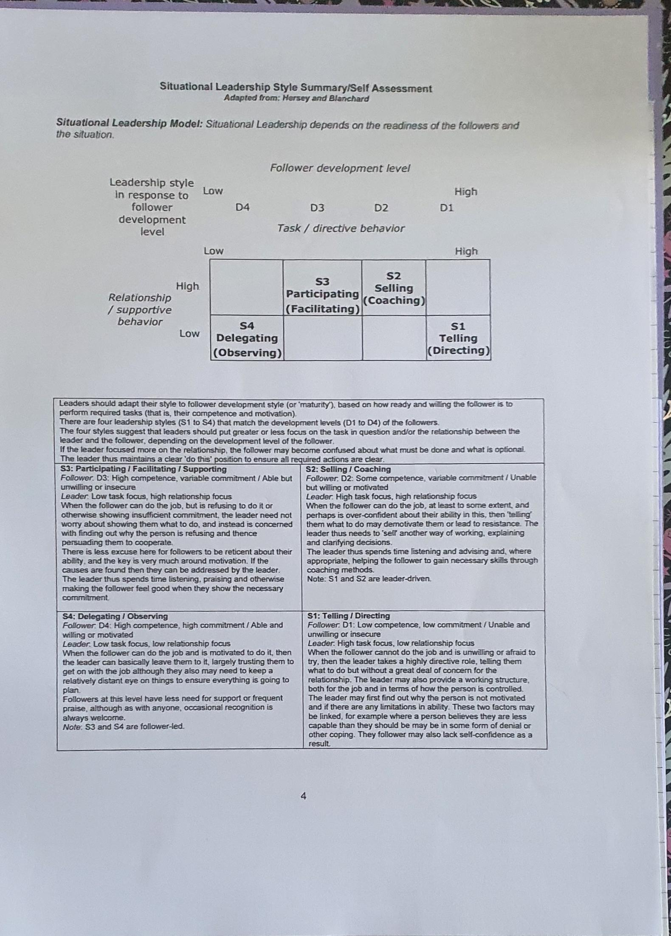

Appendix 7 – A Conceptual Model Of Servant Leadership
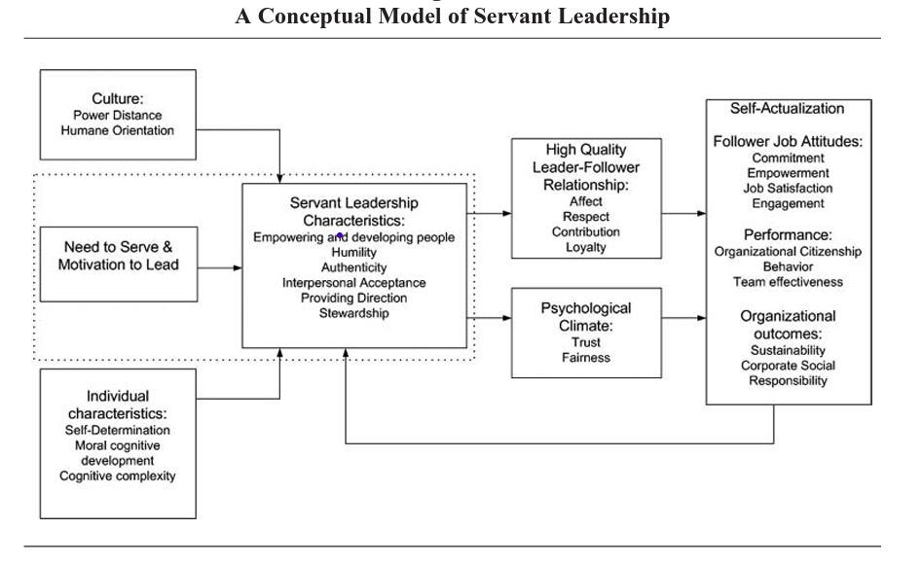
Van Dierendonck (2011)

Appendix 8 – Situational Leadership Model
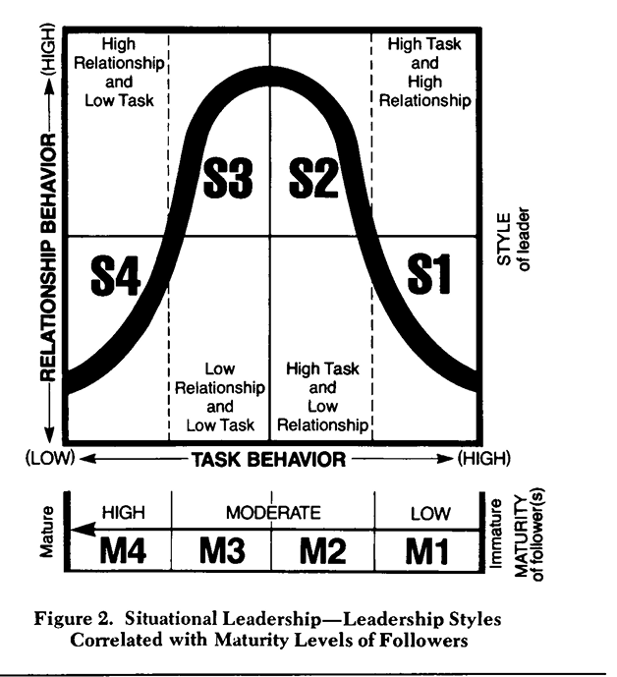
Hersey, Blanchard and Natemeyer (1979)

Appendix 9 – (S3) Situational Leadership Theory, Aligns With Theory Y

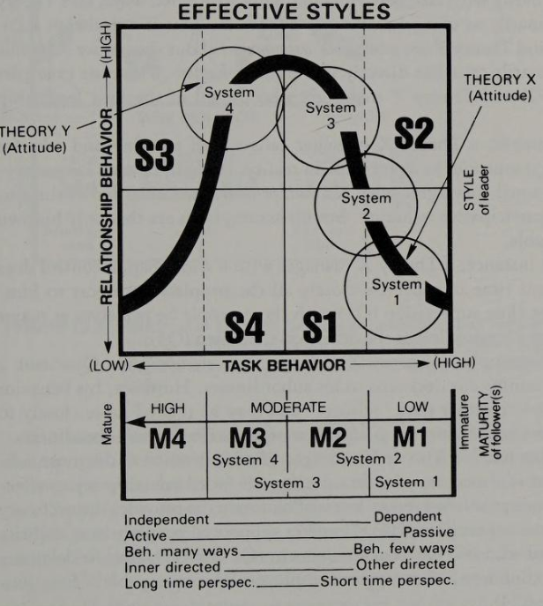
Hersey et al. (1979)

Appendix 10 – Maslow's Hierarchy Of Needs
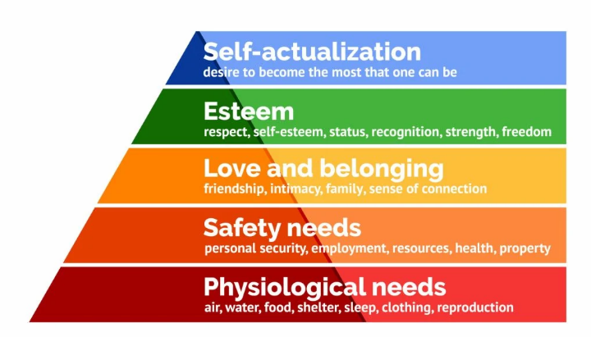
(Mcleod, 2022)

