Strategic HR Management in the Public Sector: Case Study of ECC
Module: Human Resource Management

Student Id:

Contents
1. Introduction 2
2. HR in Private and Public Sector 3
2.1. HRM in the Private Sector 3
2.2. HRM in the Public Sector 4
2.3. Critical Differences and Their Implications 4
3. Sector based Implications on HR Strategy 5
3.1. Influence of Organizational Goals and Regulations 5
3.2. Business Environment and Market Conditions 5
3.3. SWOT Analysis 6
4. Strategy Goals and Employee Development 7
4.1. Resource-Based View (RBV) Theory 7
4.2. 70-20-10 Learning Model 7
5. HR Strategy and Organisational Climate: A Critical Analysis 9
5.1. Organizational Climate Measure (OCM) Framework 9
5.2. Transformational Leadership Theory 10
5.3. Social Exchange Theory (SET) 10
6. Recommendations 11
7. Conclusion 12
References 13

Introduction
Human Resources (HR) is crucial to an organization's success in today's complicated and uncertain business climate. Its traditional role as an administrative backbone has given way to one of a more strategic kind, one that contributes significantly to the overall goals and strategies of businesses. However, the HR policies and practices of the public and private sectors can differ substantially. The purpose of this work is to look into these distinctions, analyze the effects of various industries on HR performance, investigate various approaches to employee growth, and evaluate the impact of company culture on HR tactics.(Bernardin and Russell, 2006, Wood, 1999). The situation in East Coast County (ECC) offers a great chance to investigate these ideas in depth. The HR and OD consulting firm ECC found a serious deficiency in the public sector when it came to the capacity for strategic HR partnering. Because of the difficulty in finding people with business partnering abilities, ECC has created a talent pipeline to fill senior HR positions. The Ulrich HR model, which is useful for examining HR in both the private and governmental sectors, will serve as our analytical framework. Human resources (HR) play four main functions, according to the Ulrich Model: strategic partnership, change facilitator, administration professional, and employee champion. This paradigm is particularly applicable to ECC's current situation because it stresses the need of HR's alignment with business objectives (Brockbank and Ulrich, 2009).
It is important to critically evaluate the Ulrich model's relevance across diverse industries, despite the fact that it presents a generic view of HR functions. various regulatory environments and organisational structures may impart various meanings to the term "administrative expert" in the public and private sectors. We shall examine how an organization's HR approach is affected by the industry in which it works in the following sections. The role of HR in fostering employee growth in service of organisational objectives will be dissected, and the variables of the organisational climate that can make or break HR initiatives will be identified. These findings will be essential in helping ECC and other organisations like it develop suggestions to enhance their strategic HR partnering capacity.
.

HR in Private and Public Sector
Human Resources (HR) is critical to every company's success, as it affects every aspect of operations. Human resource management (HRM) is an integral part of any organization, whether public or commercial. Using academic theories and models, this section provides a deeper, critical investigation of HRM dynamics in the commercial and public sectors (Knies et al., 2017).
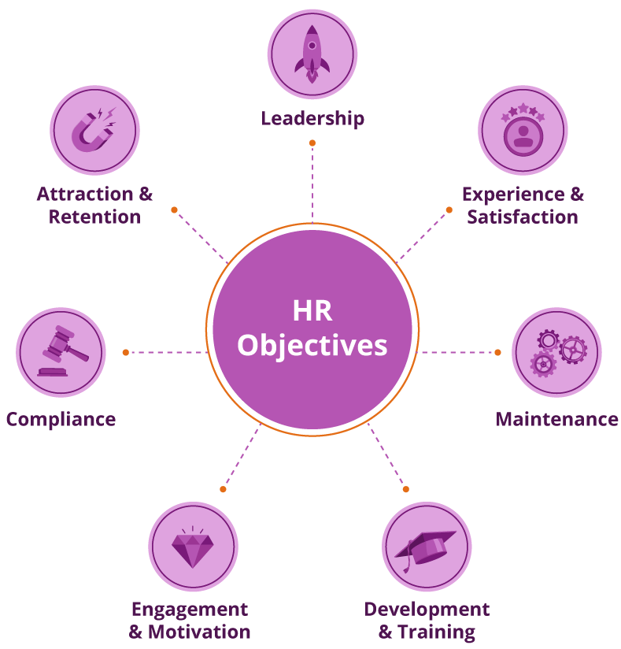
Figure 1 Objectives of HR Management Source: (Resources, 2022)

HRM in the Private Sector
In private business, the primary motivation for most businesses is profit. Human resource management is to help businesses achieve their overall mission by improving efficiency, encouraging creativity, and developing in-house experts who may boost their competitive edge. Human resource policies and procedures in the private sector tend to be nimbler and more sensitive to market shifts and the evolving requirements of workers. This quickness to adapt could be seen as a positive quality by some. However, the strategic focus on profitability and competitiveness may occasionally sacrifice staff wellness, balance between work and personal life, and sustainable practices, which could be problematic in the long run (Harel and Tzafrir, 2001). The provision of competitive remuneration, which frequently includes a basic salary, performance-driven bonuses, and stock options, is an essential component of human resource management in the private sector. A compensation plan like that has the ability to inspire top-notch work, but it also has the risk of fostering unhealthy competition and widening wage gaps inside the company (Vanhala and Stavrou, 2013). Market participants From the perspective of Ulrich's HR Model, HRM takes on the roles of strategic partner and change agent, contributing to the development of organisational strategy and leading change efforts. However, the 'employee champion' function may be overlooked as HR becomes more strategically involved, which can cause a rift between HR standards and employee expectation.

HRM in the Public Sector
Public sector HRM prioritizes regulatory compliance, openness, and community service, unlike the private sector. Public sector bureaucracy slows decision-making, delaying HR innovations. Although criticized for its rigidity, this bureaucratic organization provides stability and predictability. Maintaining employee morale and public trust requires fair HR practices, which equity and transparency can foster (Marler, 2012). Public sector companies pay less than private ones. However, job security, defined benefit pensions, and extensive benefits packages generally offset this. Such a framework may attract stability-seekers but struggle to recruit and keep high-earners, restricting talent variety (Truss, 2013, Beattie and Osborne, 2007). Public sector HRM follows the Ulrich Model's administration expert and worker champion responsibilities. These roles emphasize seamless administrative processes and employee welfare, but compliance and regulation may sometimes eclipse the strategic partner role, preventing public sector HR from making significant contributions to organisational strategy.

Critical Differences and Their Implications
Critical analysis shows that each industry has its own pros and cons. The private sector's agility and competitive pay attract top personnel, but its continuous pursuit of profit and competition may lead to unsustainable practises and work-life imbalance. However, the public sector's stability and equity can boost staff morale and public trust, while bureaucratic procedures and lower compensation may impede innovation and talent variety. HR professionals must understand these distinctions to develop strategies and practises. HR effectiveness requires careful, context-specific adaption of HR theories and models like the Ulrich Model (Knies et al., 2017). This critical examination shows that HRM's basic goal—managing human capital—is the same across sectors, but its method and implementation vary. In circumstances like ECC, where strategic HR competencies must be bridged, HR strategy creation must recognise these distinctions.

Sector based Implications on HR Strategy
The sector has a crucial role in determining the success of HR strategy. Human resource strategies are very sensitive to external factors such as organisational objectives, market and competitive landscapes, industry-specific rules and norms, and public perceptions. Using the SWOT analysis, this section discusses how these elements can have a major impact on the success of HR strategies in a variety of settings (Guest and Conway, 2011).

Influence of Organizational Goals and Regulations
Private companies prioritise profitability, market share expansion, and competitiveness. Effective HR strategies recruit and retain top individuals, develop a workplace that fosters excellence, and drive innovation. This constant concentration on being profitable and competitive may cause fatigue, significant turnover in staff, and ethical dilemmas. Thus, HR practises must be rigorously assessed for their effects on employee well-being, ethics, and company outcomes. Public service and government laws drive the public sector. Public sector HR strategies emphasise regulatory compliance, openness, and equal opportunity. These values are admirable, but they can impede decision-making and make HR strategies less adaptable to fast changing labor needs and societal trends (Dupont et al., 2013).

Business Environment and Market Conditions
HR strategy effectiveness is heavily influenced by economic trends, technological advances, and societal changes. According to the PESTLE paradigm, strategic planning requires comprehending political, economic, social, technical, legal, and environmental concerns. Market rivalry and technology improvements in the private sector typically require HR policies that foster quick improvement of skills, agility, and creativity. Public sector HR strategies prioritise diversity, equity, and stability due to legal and social obligations (Indris and Primiana, 2015). Critical analysis shows that sector-specific priorities can lead to weaknesses. The private sector's concentration on quick skills development and innovation may disregard long-term employee development and engagement. Stability and equity may overshadow innovation and efficiency in the public sector.

SWOT Analysis
SWOT analysis reveals internal and external elements that affect HR strategy effectiveness. Organisational strengths and weaknesses are internal, whereas opportunities and threats are external. HR strategies' efficacy depends on sector-specific variables and organisational strengths and shortcomings. Thus, careful evaluation of these variables using analytical techniques like SWOT is vital to formulating and executing successful, sustainable, and ethical HR policies (Benzaghta et al., 2021, Teoli et al., 2019).
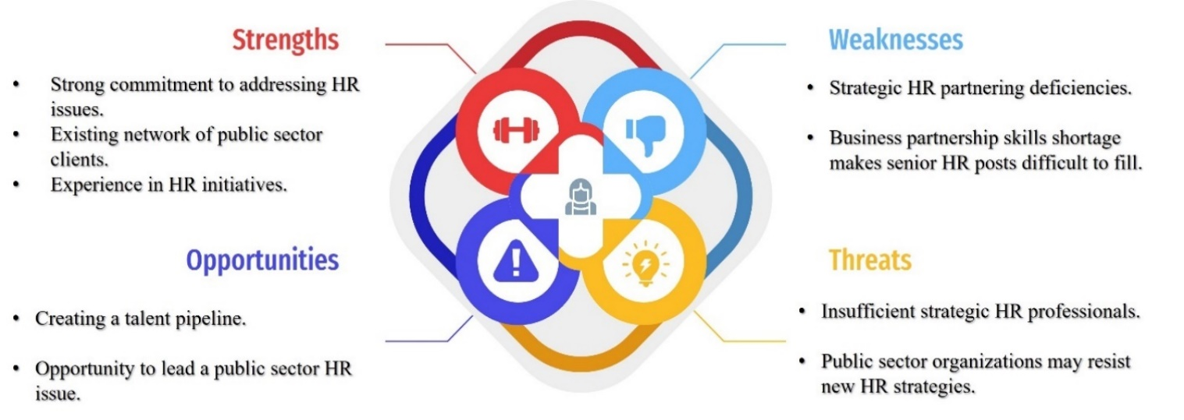
Figure 2 ECC SWOT Analysis Source: Self-created

Strategy Goals and Employee Development
Strategic goals depend on employee development. It entails developing employees' talents, engaging them, and aligning their performance with the company's strategy. An organization's strategic goals depend on how well it develops its workers. HR's role in aligning employee performance with organisational strategy becomes crucial. Use scholarly theories and models to critically evaluate HR's role in employee development (Jacobs and Washington, 2003).

Resource-Based View (RBV) Theory
The RBV theory states that a company's human capital and other internal resources are the foundation of its competitive advantage. Business collaboration is a key strategic ability that is lacking at ECC. Aligning with RBV allows ECC to train its workforce in this area, which will increase the company's talent pool and provide it a long-term advantage in the market. But it's important to question RBV's widespread applicability. Due to its lack of sector-specificity, HRM must take into account sector-specific realities while adopting RBV, including as compliance requirements in the government sector or based on profit goals in the private sector (Madhani, 2010, Kraaijenbrink et al., 2010).

70-20-10 Learning Model
According to the 70-20-10 Learning Model, most of the learning, specifically 70%, is derived from on-the-job experiences. Social learning, which encompasses mentoring and coaching, accounts for 20% of learning, while formal education contributes only 10%. The utilization of this model by ECC has the potential to cultivate strategic HR partnering competencies, emphasizing practical experience and guidance from mentors (Johnson et al., 2018, Joshi, 2018). To get the most out of their training and development efforts and foster a more enthusiastic performance among their staff, several businesses have turned to the 70-20-10 approach.
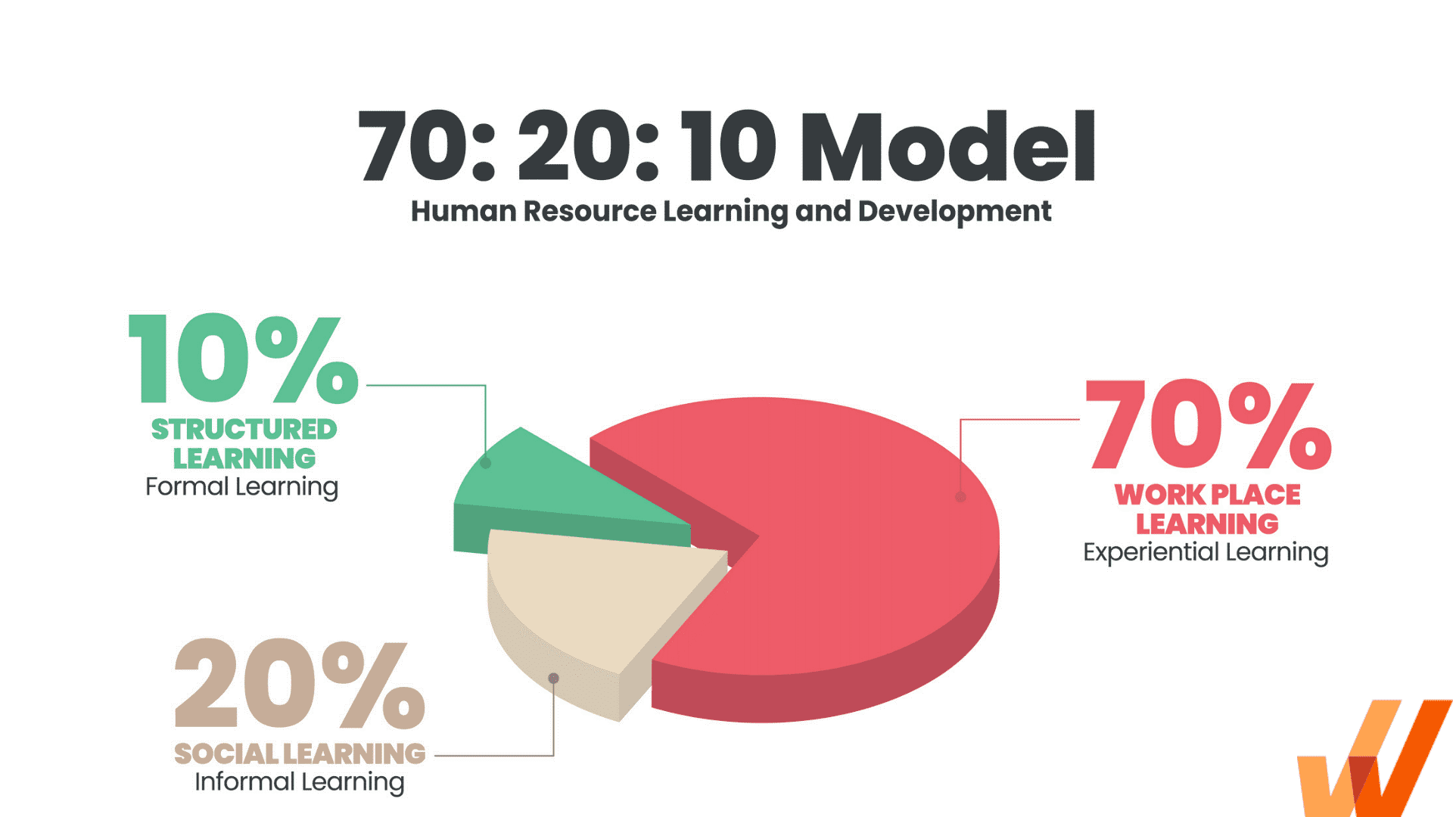
Figure 3 70/20/10 Corporate learning & Development Model Source: (Gupta, 2022)
However, this model's efficacy in ECC must be severely assessed. Public sector rigidity may hinder practicality. The "one-size-fits-all" approach may not meet diverse learning needs, hence a flexible framework that accommodates multiple learning styles and career trajectories is needed. Applying applicable theories and models to build a pool of talent to meet strategic human resources objectives requires careful consideration. Strategic competency development must balance individual demands, sector realities, and organisational culture. RBV, the 70-20-10 Development Approach, PSM, and Organisational Learning Theory offer insightful assistance, but ECC's setting requires critical study. This customized strategy will promote employee development and create an encouraging, engaging, and fulfilling workplace.

HR Strategy and Organisational Climate: A Critical Analysis
The success of an HR strategy is heavily impacted by the organization's climate, or the overall quality of the workplace. Leadership, communication, work-life balance, and employee appreciation are just some of the climate aspects that can help or hurt HR efforts (James and Jones, 1974). We will use the Organisational Climate Measure (OCM), the Theory of Transformational Leadership (TLT), and the Theory of Social Exchange (SET) to provide a critical analysis of these elements. Commitment to one's employer, or "organisational commitment," grows when workers feel appreciated and valued. In reality, climate is the result of a protracted process of gradual accumulation and shaping by a variety of experiences and interactions.
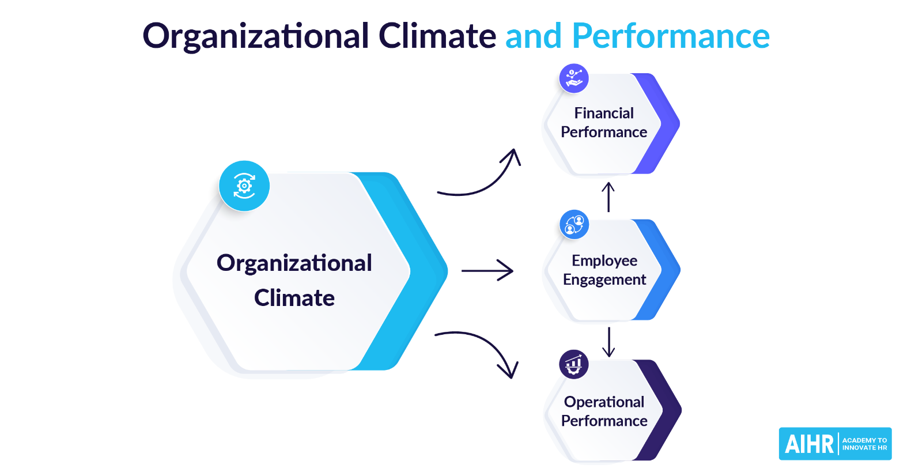
Figure 4 Organizational Climate and Performance Source: (Jay, 2021)

Organizational Climate Measure (OCM) Framework
The OCM is a well-known framework for assessing key elements of work environments, such as freedom, creativity, community, and challenge (Thumin and Thumin, 2011, Schneider et al., 2013). These considerations will have a major impact on how successful ECC's strategy to develop strategic HR capabilities is. An environment that is both stimulating and creative is conducive to education, the acceptance of new responsibilities, and the development of a solid pool of potential employees. The OCM's static nature, however, is called into doubt by the critical analysis. It presumes that the organization's environment will remain constant and stable once it has been formed, which may not be the case. The climate can shift as a result of shifts in leadership, shifts in strategy, or changes in external causes. This means that these possible changes must be taken into account when using the OCM to direct HR strategy.

Transformational Leadership Theory
Leaders that motivate, challenge, and care about their people are shown to have a favorable impact on the work environment and on the success of HR initiatives in the transformational leadership theory (Odumeru and Ogbonna, 2013, Masood et al., 2006). For ECC, leaders of transformation might encourage staff to hone their strategic HR abilities and step into expanded roles. However, a more critical perspective reveals that transformative leadership isn't always the best option. Employees run the risk of becoming dependent on their leader if they look to them for too much motivation and guidance. Therefore, it is important for ECC to make sure that, while employing transformational leadership to foster a positive environment, it does not stifle employees' opportunities for initiative and leadership.

Social Exchange Theory (SET)
According to SET, the atmosphere of an organization can be affected by the norm of reciprocity in interpersonal connections. Employees are more willing to participate, work together, and be dedicated to the success of the company when they believe they are respected, recognized, and treated properly (Cook et al., 2013, Chernyak-Hai and Rabenu, 2018). By using SET, ECC may foster a supportive environment by promulgating equitable policies, highlighting accomplishments, and giving due credit where it's due. This can help provide a fertile setting for staff members to learn HR strategy. One thing to keep in mind while implementing SET critically is that not all interactions are seen as fair, and that discontent and disengagement can result from people's views of injustice. Furthermore, if reciprocity is overemphasized, a transactional culture may develop, which is detrimental to people's sense of intrinsic purpose.

Recommendations
Drawing upon a comprehensive evaluation of diverse theoretical frameworks and their relevance to the specific context of ECC, the ensuing suggestions are posited for the formulation and execution of an efficacious human resources strategy:
- ECC should customize the Resource-Based View, or RBV, and 70-20-10 Learning Framework to meet the strategic HR partnership skills gap. This means providing hands-on experiences and mentoring programs while addressing the public sector's bureaucracy and employees' different learning styles and career pathways.
- ECC should use the PSM theory to assess equitable wages, job advancement, and well-being of workers, which affect employee happiness and performance.
- ECC should encourage a culture of learning and adaptation. To avoid stress, this strategy should be matched with employee well-being.
- ECC should remember that leadership, strategy, and external influences can change organisational climate while adopting the OCM.
- Transformational leadership could encourage ECC staff. It should avoid undermining staff autonomy and self-leadership.
- ECC should follow Social Exchange Theory (SET) and promote fairness, performance, and recognition. However, it should avoid a transactional culture that undermines intrinsic motivation.
- ECC should continually assess its HR strategy against the changing organisational and external environment to ensure their relevance and effectiveness. This could involve gathering employee feedback, tracking effective human resources skills development, and assessing sector developments and best practises.
These suggestions will help ECC close the gap in its strategic HR partnering skills, foster a productive work environment, and advance the company's long-term objectives. These suggestions, however, should be assessed thoroughly and adapted to changing circumstances to ensure their continuous effectiveness, as is the case with any strategy.

Conclusion
In conclusion, there are certain distinct difficulties and advantages associated with human resource management in the public sector. To fill the void in strategic HR partnership abilities at ECC, a number of different theories and models will need to be used with care and consideration. These include the Resource-Based Perspective, the 70-20-10 Learning Approach, including the Public Service Personnel Motivation theory. To add to the importance of HR strategy implementation, creating a positive work environment is essential. Therefore, ECC should take into account the findings of the Organisational Climate Measure, the Transformational Management Theory, and the Social Exchange Theory to ensure a well-rounded strategy that encourages not only the development of strategic skills but also the fulfilment, autonomy, and commitment of the workforce. ECC now has a road map to follow in order to improve its strategic HR competencies and realise its strategic objectives, all thanks to the suggestions presented here. These suggestions, while grounded in theoretical frameworks, will inevitably need to be assessed critically and revised as time goes on to account for new information and shifting conditions. Human resource management in the public sector calls for constant study, flexibility, and sensitivity to the organization's and workers' specific circumstances and requirements.

References
BEATTIE, R. S. & OSBORNE, S. 2007. Human resource management in the public sector, Routledge.
BENZAGHTA, M. A., ELWALDA, A., MOUSA, M. M., ERKAN, I. & RAHMAN, M. 2021. SWOT analysis applications: An integrative literature review. Journal of Global Business Insights, 6, 55-73.
BERNARDIN, H. J. & RUSSELL, J. E. 2006. Human resource management, Tata McGraw-Hill New York.
BROCKBANK, W. & ULRICH, D. 2009. The HR business-partner model: Past learnings and future challenges. People & Strategy, 32, 5-8.
CHERNYAK-HAI, L. & RABENU, E. 2018. The new era workplace relationships: Is social exchange theory still relevant? Industrial and Organizational Psychology, 11, 456-481.
COOK, K. S., CHESHIRE, C., RICE, E. R. & NAKAGAWA, S. 2013. Social exchange theory. Handbook of social psychology, 61-88.
DUPONT, C., FERAUGE, P. & GIULIANO, R. 2013. The impact of corporate social responsibility on human resource management: GDF SUEZ's case. International business research, 6, 145.
GUEST, D. & CONWAY, N. 2011. The impact of HR practices, HR effectiveness and a ‘strong HR system’on organisational outcomes: a stakeholder perspective. The international journal of human resource management, 22, 1686-1702.
GUPTA, D. 2022. The 70-20-10 Model for Corporate L&D [Online]. Available: https://whatfix.com/blog/70-20-10-model/.
HAREL, G. H. & TZAFRIR, S. S. 2001. HRM practices in the public and private sectors: Differences and similarities. Public Administration Quarterly, 316-355.
INDRIS, S. & PRIMIANA, I. 2015. Internal and external environment analysis on the performance of small and medium industries SMEs in Indonesia. International journal of scientific & technology research, 4, 188-196.
JACOBS, R. & WASHINGTON, C. 2003. Employee development and organizational performance: a review of literature and directions for future research. Human resource development international, 6, 343-354.
JAMES, L. R. & JONES, A. P. 1974. Organizational climate: A review of theory and research. Psychological bulletin, 81, 1096.
JAY, S. 2021. What is Organizational Climate? 7 Steps to Improve Yours [Online]. Available: www.aihr.com/blog/organizational-climate/.
JOHNSON, S. J., BLACKMAN, D. A. & BUICK, F. 2018. The 70: 20: 10 framework and the transfer of learning. Human Resource Development Quarterly, 29, 383-402.
JOSHI, M. 2018. Learning: 70-20-10.
KNIES, E., BOSELIE, P., GOULD-WILLIAMS, J. & VANDENABEELE, W. 2017. Strategic human resource management and public sector performance: context matters. Taylor & Francis.
KRAAIJENBRINK, J., SPENDER, J.-C. & GROEN, A. J. 2010. The resource-based view: A review and assessment of its critiques. Journal of management, 36, 349-372.
MADHANI, P. M. 2010. Resource based view (RBV) of competitive advantage: an overview. Resource based view: concepts and practices, Pankaj Madhani, ed, 3-22.
MARLER, J. H. 2012. Strategic human resource management in context: A historical and global perspective. Academy of Management Perspectives, 26, 6-11.
MASOOD, S. A., DANI, S. S., BURNS, N. D. & BACKHOUSE, C. J. 2006. Transformational leadership and organizational culture: The situational strength perspective. Proceedings of the Institution of Mechanical Engineers, Part B: Journal of Engineering Manufacture, 220, 941-949.
ODUMERU, J. A. & OGBONNA, I. G. 2013. Transformational vs. transactional leadership theories: Evidence in literature. International review of management and business research, 2, 355.
RESOURCES, H. 2022. 7 Core Objectives Of HR Management With Smart Goal Examples [Online]. Available: www.snapcomms.com/blog/hr-objectives-smart-goals.
SCHNEIDER, B., EHRHART, M. G. & MACEY, W. H. 2013. Organizational climate and culture. Annual review of psychology, 64, 361-388.
TEOLI, D., SANVICTORES, T. & AN, J. 2019. SWOT analysis.
THUMIN, F. J. & THUMIN, L. J. 2011. The measurement and interpretation of organizational climate. The Journal of psychology, 145, 93-109.
TRUSS, C. 2013. The distinctiveness of human resource management in the public sector. Human resource management in the public sector. Edward Elgar Publishing.
VANHALA, S. & STAVROU, E. 2013. Human resource management practices and the HRM-performance link in public and private sector organizations in three Western societal clusters. Baltic Journal of Management, 8, 416-437.
WOOD, S. 1999. Human resource management and performance. International journal of management reviews, 1, 367-413.

