Engineering Academic Discipline
Motorsport Engineering HND
Title of report: Engine Performance Analysis
Module name and code: Thermodynamics and Combustion. ACHA5011.
Student name: Nia Jenkins
Student number: 2519702
Date of submission: 07/12/2025
Word count: 2378

Table of Contents
Part 1: Cylinder Head and Valve Train Analysis 3
Component Characterisation 3
Piston Motion Analysis 4
Piston position 4
Piston velocity 5
Camshaft and Valve Motion Analysis 6
Valve lift 6
Valve velocity 7
Valve acceleration 8
Jerk 9
Dynamic system assessment 10
Estimating valve float RPM 10
Valve lift and piston position 10
Effect of Lightweight Components on Valve Float RPM 11
Part 2: Flow Analysis and Cylinder Head Performance 12
Flow bench Testing and Data Collection 12
Data analysis and graphs 13
Flow rate 13
Flow rate (l/s/sq) 14
Flow coefficient 15
Integration with Valve Kinematics 16
Flow coefficient 16
Performance Assessment 18
Flow Potential and Tuning Insight 19
References 20

Part 1: Cylinder Head and Valve Train Analysis

Component Characterisation
For this assignment, the Duratec 2L cylinder head was used to analyse piston dynamics and the valve train. The camshaft, valves, valve springs, retainers, and buckets were identified, weighed using a digital scale, and documented for both intake and exhaust sides. The cylinder bore, stroke, and connecting rod length were measured with a micrometer to provide precise dimensional data.

The compression ratio was calculated by measuring the cylinder bore, stroke, and using a clearance volume of 43.2cc, based on a reliable source. Disassembly was performed systematically, with components labelled to ensure accurate reassembly. The compression ratio was determined as the total cylinder volume at Bottom Dead Centre, divided by the clearance volume at Top Dead Centre, providing essential data for thermodynamic analysis.
The technical measurements are highly accurate due to the precision of the tools used. The micrometer, for example, has a resolution of 0.001mm, allowing very precise measurements, while the digital scale measures down to 0.01g, ensuring accurate component weighing. Some human errors can still occur, such as misreading measurements, inconsistent handling, tool movement, or improper component positioning, all of which can affect accuracy. Systematic errors may also arise from component wear or deformation, introducing bias. To minimise these errors, each measurement was repeated three times, and the mean value was taken. Care was also taken to ensure components were correctly positioned before measuring. These steps help ensure the collected data is reliable and suitable for subsequent valve train analysis.

Piston Motion Analysis

Piston position

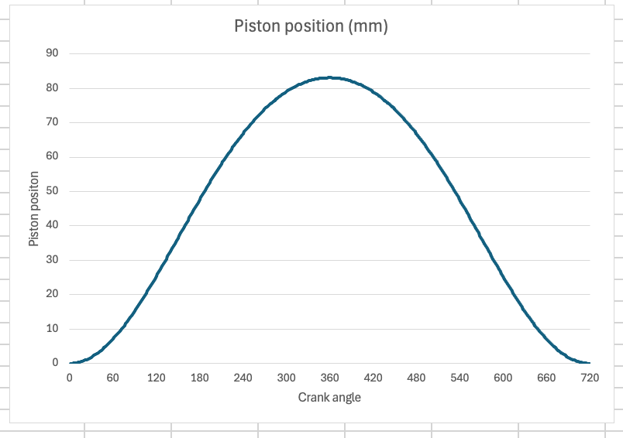
This graph shows piston position plotted against crank angle. The crank angle was calculated by multiplying the measured cam angle by 2, reflecting the 1:2 ratio in a standard four-stroke engine, where the crankshaft completes two revolutions for every one revolution of the camshaft. We can see that the piston moves from 0mm at TDC to the full stroke of 83.1mm at BDC. The curve is non-linear because the piston’s linear motion does not correspond directly to crank angle. The velocity is higher near mid-stroke due to the connecting rod angle, which causes variable piston speed. The piston spends slightly more time near TDC than BDC because the connecting rod is longer than the crank radius, introducing asymmetry in piston motion relative to crank rotation.

Piston velocity
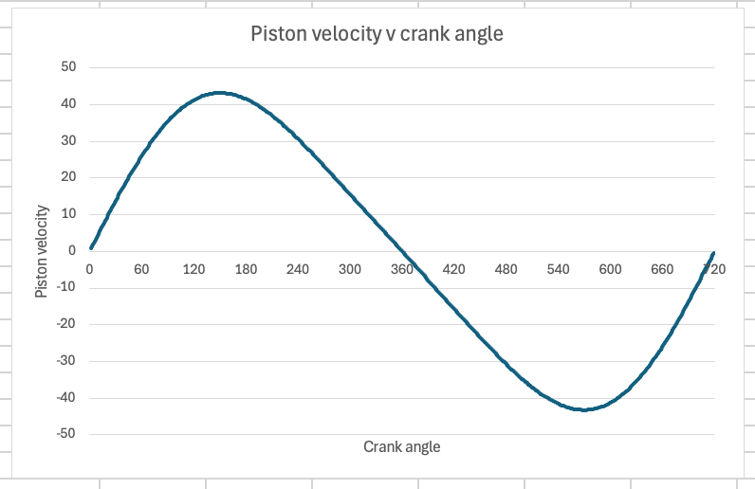
This graph shows piston velocity plotted against crank angle. The velocity is at zero at 0° and 360°, corresponding to TDC and BDC, where the piston changes its direction. Peak velocity occurs near mid-stroke, around 90° and 270°, where the piston moves fastest. The curve is non-linear due to the connecting rod’s angular motion, which causes the piston’s speed to vary throughout the stroke. This graph provides insight into piston motion during compression and expansion strokes, helping to understand engine dynamics and stresses on the valve train.

The mean piston speed is lower than the peak speed because the piston does not move at a constant velocity. It starts at zero at TDC, accelerates to a maximum near mid-stroke, and decelerates back to zero at BDC. The mean speed represents the average velocity over the entire stroke, while the peak occurs only near mid-stroke where the piston moves fastest.

Camshaft and Valve Motion Analysis

Valve lift
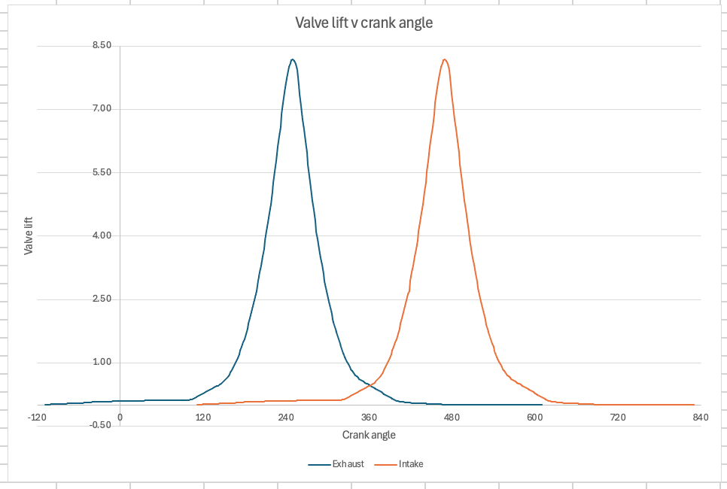
This graph shows the intake and exhaust valve lifts plotted against crank angle, illustrating valve timing and potential overlaps. Cam phasing has been included, with the exhaust phased at -110° and the intake at 110°. The peak of each curve corresponds to the maximum lift of the cam lobe. The intake valve opens before TDC of the compression stroke and closes after BDC, while exhaust valve opens before BDC of the power stroke and closes after TDC of the exhaust stroke. This graph provides insight into valve timing, duration, and any overlap or interference between intake and exhaust valves.

Valve velocity
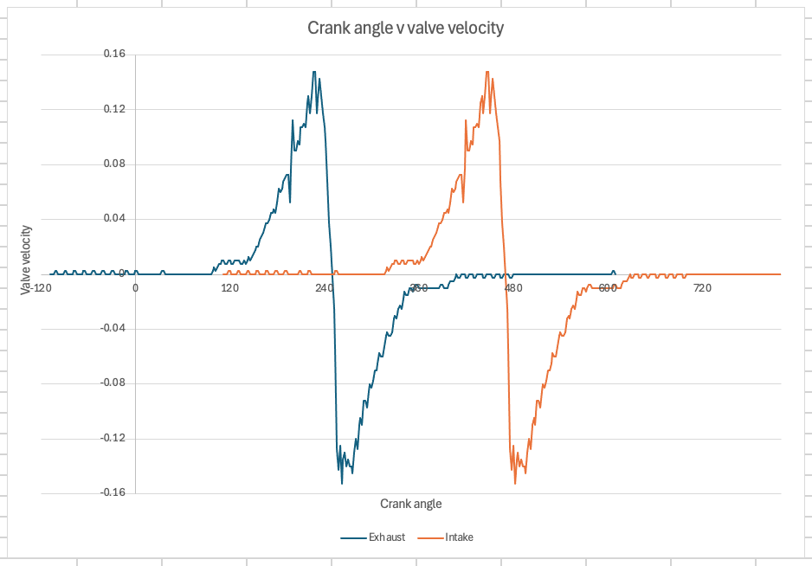
This graph shows valve velocity plotted against crank angle for both intake and exhaust valves, including cam phasing. Velocity is calculated as the rate of change of lift, positive when the valve is opening and negative when closing. Peak velocity occurs approximately midway through valve motion, where the lift curve is steepest, representing the point of fastest valve movement. Peak velocity determines dynamic forces in the valve train, affecting stresses on the valve, spring, and follower, and influencing engine performance. This graph is useful for analysing how quickly the valves open and close, impacting airflow, engine efficiency, and mechanical loads.

Valve acceleration
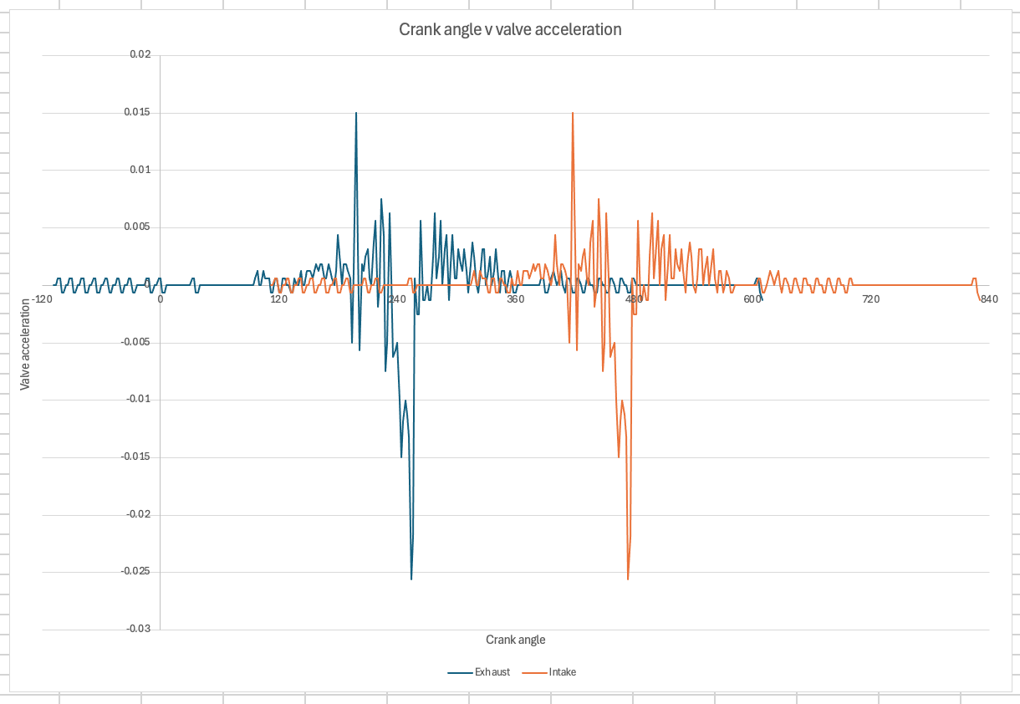
This graph shows valve acceleration plotted against crank angle for both intake and exhaust valves, including cam phasing. Acceleration is the rate of change of valve velocity, positive when velocity increases and negative when it decreases. Peak acceleration occurs where velocity changes most rapidly, typically at the start and end of valve opening and closing. High acceleration values indicate large forces on the valve train, affecting the valve, spring, and follower. Intake and exhaust valves exhibit similar acceleration magnitudes, reflecting comparable lobe profiles, with differences only due to phase shift. This graph helps analyse dynamic loads in the valve train and identifying potential issues such as valve bounce or excessive wear.

Jerk
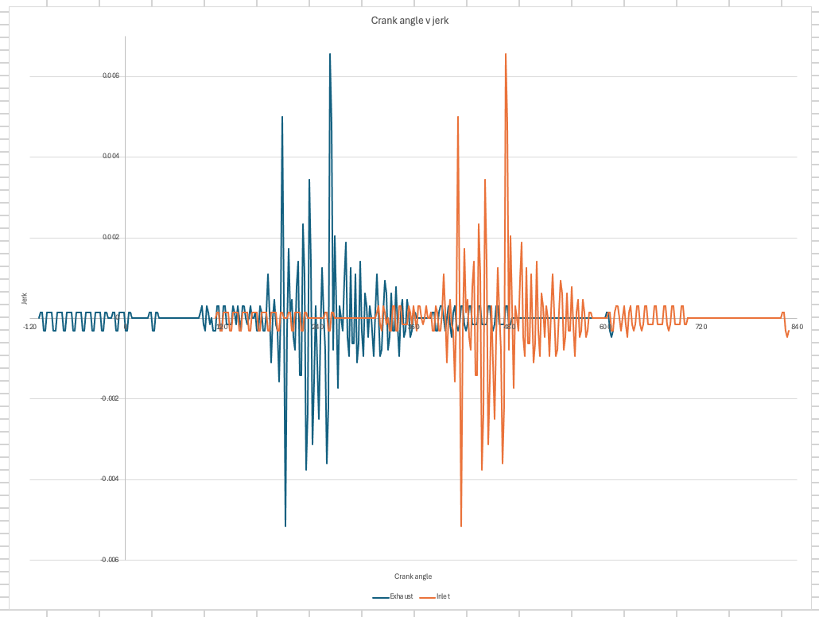
This graph shows valve jerk plotted against crank angle for both intake and exhaust valves, including cam phasing. Jerk is the rate of change of acceleration, representing how abruptly acceleration changes, rather than the valve’s speed. Positive or negative jerk values mainly occur at the start and end of valve opening and closing, where acceleration changes most rapidly. The jerk profiles for both intake and exhaust valves are very similar, indicating nearly identical cam lobe profiles, with differences only arising from cam timing. This graph is important in cam design, as smooth jerk curves reduce mechanical shock, vibration, improving component durability and lifespan.

Dynamic system assessment

Estimating valve float RPM
The effective reciprocating mass of the valve train was calculated by including the valve, retainer, follower, and one-third of the valve spring mass. As the spring characteristics were not measured, a representative spring force of 350N was assumed based on typical 2L naturally aspirated engines. The peak valve acceleration was estimated at 4000m/s². Using the relationship between inertial force and spring force, the onset of valve float was assessed. Although an exact RPM cannot be calculated without time-based acceleration data, this analysis demonstrates how valve train mass and acceleration influence mechanical performance, highlighting why lightweight components can increase the engine’s mechanical rev limit.

Valve lift and piston position
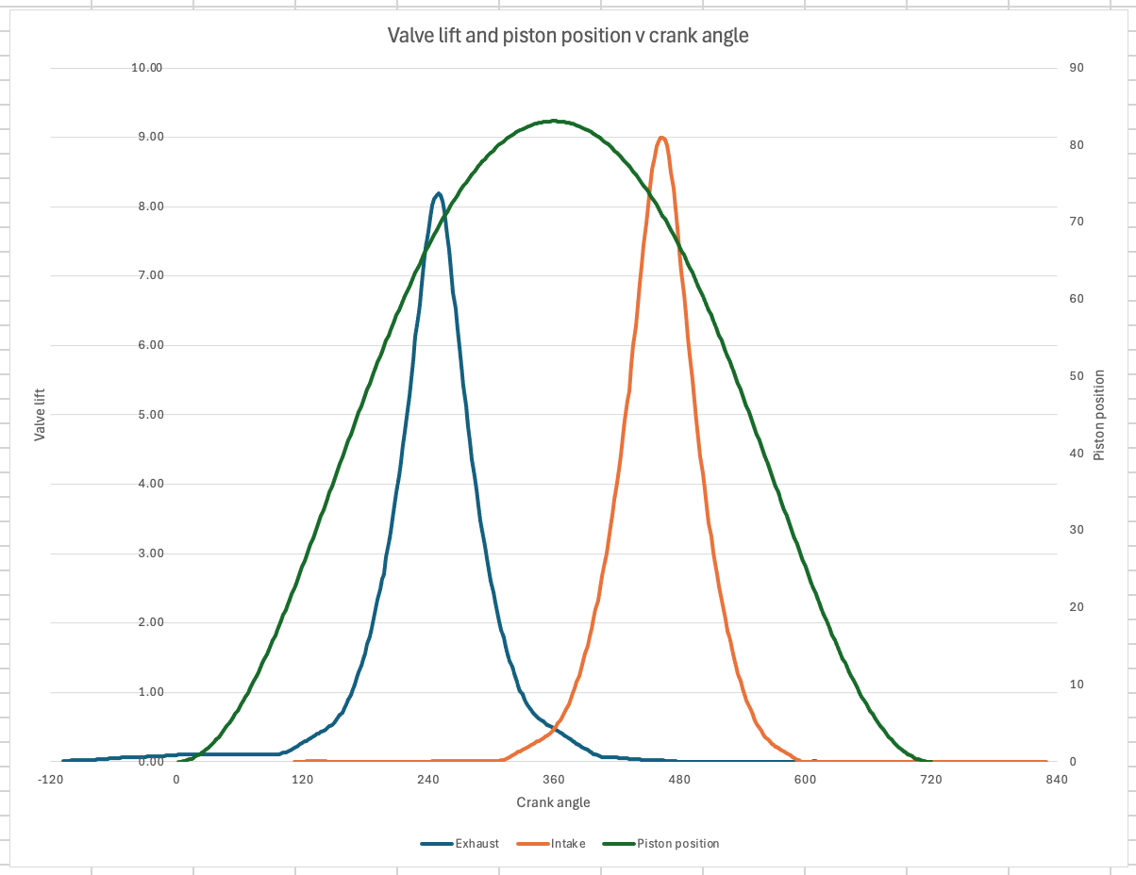
This graph shows crank angle plotted against both valve lift and piston position for the exhaust and intake, including cam phasing. The piston moves smoothly from BDC to TDC, while the exhaust and intake valves open and close according to their respective timing. The exhaust valve opens before BDC of the power stroke and closes after TDC of the exhaust stroke, while intake valve opens before TDC of the compression stroke and closes after BDC of the intake stroke. Valve overlap occurs near the transition between exhaust and intake strokes, but the piston remains clear of both valves, confirming adequate clearance throughout the engine cycle. This analysis demonstrates that the valve train geometry and timing are correctly designed to prevent interference.

Effect of Lightweight Components on Valve Float RPM
The current valvetrain masses are 0.0883 kg for the intake valves and 0.0887 kg for the exhaust valves. Valve float occurs when the valve spring can no longer control the valve at high engine speeds, and the float RPM is highly sensitive to component mass. Calculated float RPM ratios are 0.995 for intake and 0.993 for exhaust, indicating operation near the mechanical limit.
Assuming a spring force of 350 N and a maximum valve acceleration of 4000 m/s², the effective mass closely matches measured component masses. Reducing valve mass to approximately 0.056 kg, through titanium valves, hollow stems, and lightweight retainers, increases float RPM by roughly 25%, achieving the target improvement. This demonstrates that significant RPM gains are achievable through valve train lightweighting.
Practical considerations such as component strength, fatigue life, and manufacturability must still be addressed. Overall, strategic use of lightweight materials provides an effective way to increase both valve float RPM and the engine’s mechanical rev limit.

Part 2: Flow Analysis and Cylinder Head Performance

Flow bench Testing and Data Collection
Flow bench testing was conducted on the Duratec 2 L cylinder head to measure the aerodynamic flow characteristics of both the intake and exhaust ports. Using the workshop Flow bench, volumetric flow rates were recorded across a range of valve lifts, up to full lift, under controlled conditions.
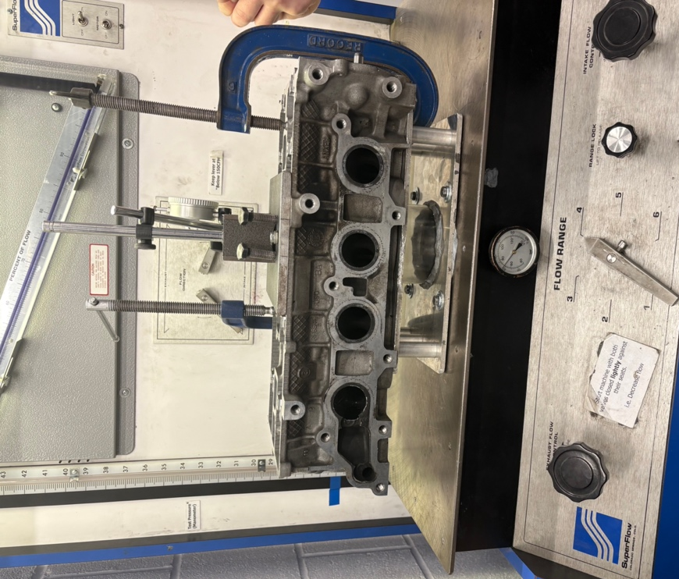
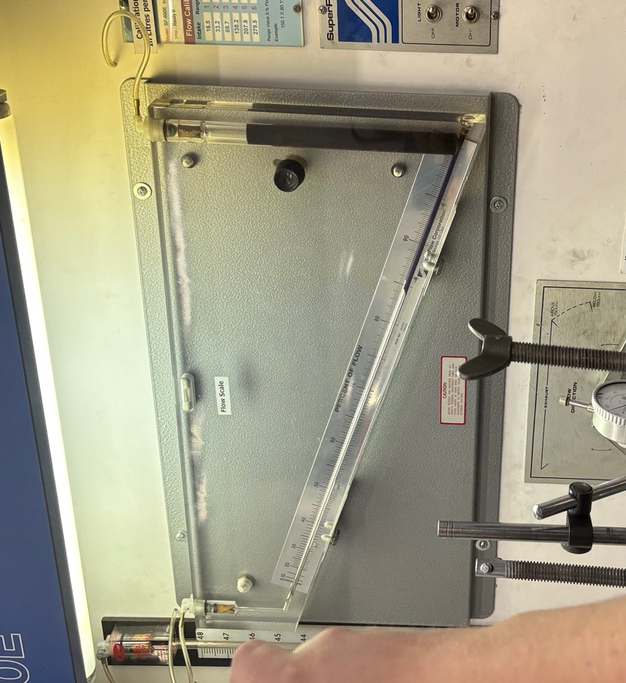
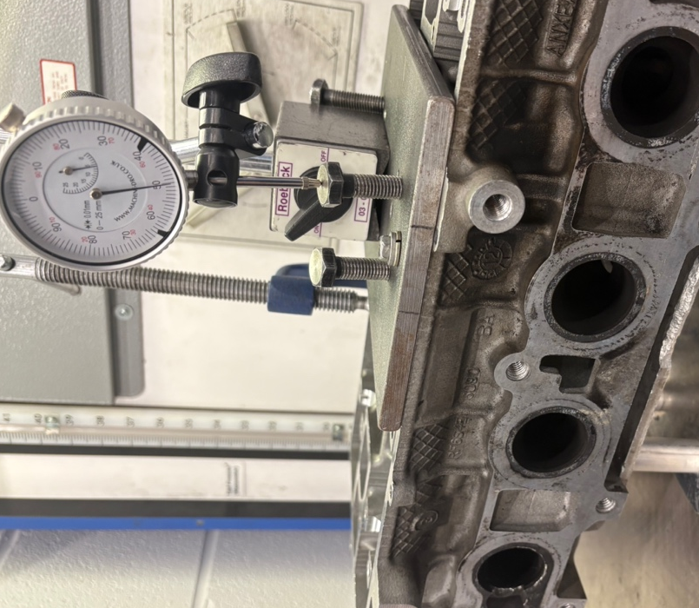
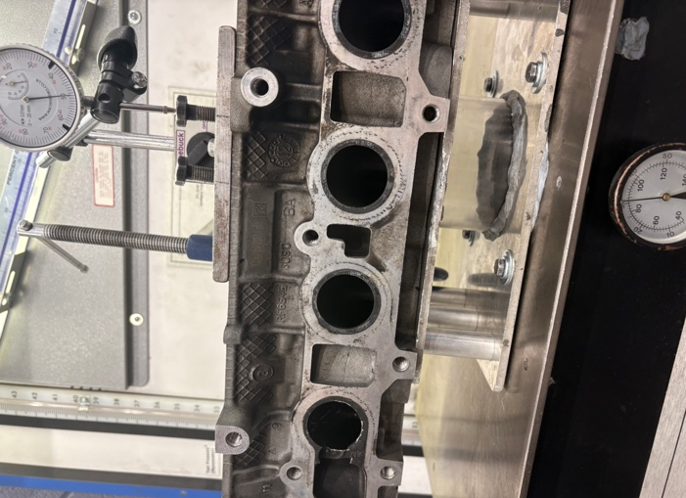

Data analysis and graphs

Flow rate
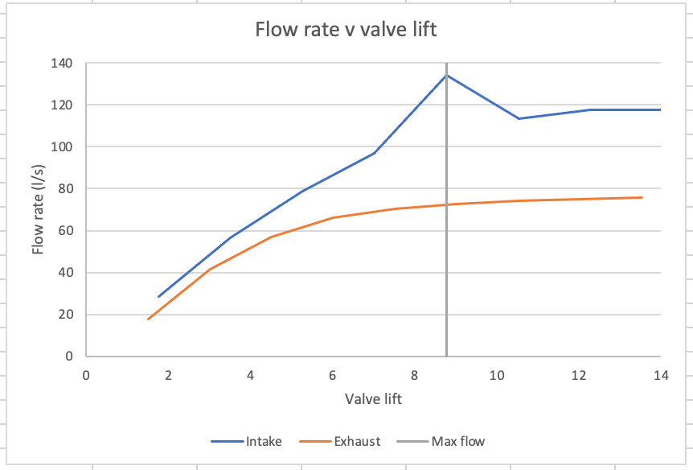
This graph shows the flow rate plotted against valve lift for the cylinder head, with the quarter valve diameter marked for reference. We can see that flow rises rapidly at low lift and slows as lift increases. At the quarter diameter point, the port already draws air efficiently, supporting good low to medium RPM torque. Beyond this, flow plateaus, indicating that further lift produces only minor airflow gains due to port geometry and turbulence. Overall, the head demonstrates effective airflow across the full lift range, with strong early-lift performance and predictable saturation at higher lift, benefiting engine efficiency and peak power potential.

Flow rate (l/s/sq)
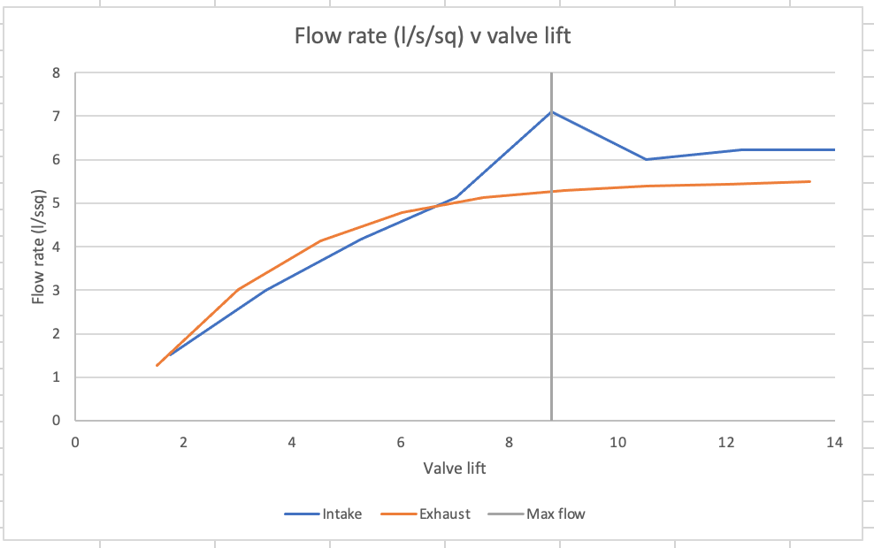
This graph shows the flow rate per unit area plotted against valve lift for both the intake and exhaust valves, with the quarter valve diameter marked for reference. Flow rises rapidly at low lift as the available valve area is effectively used. Around the quarter diameter point, both ports operate efficiently, with most of the valve area contributing to airflow. As lift increases, flow per unit area for the intake continues to rise slightly before plateauing, while the exhaust stabalises earlier. This shows that although total flow increases with lift, additional valve opening is less efficient relative to valve area. The behaviour highlights how port geometry and valve sizing influence airflow efficiency, confirming strong early-lift performance and predictable reductions at higher lifts.

Flow coefficient
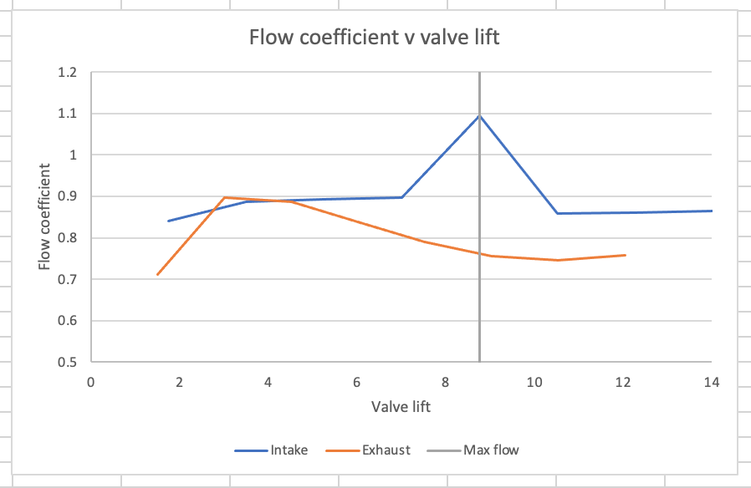

This graph shows the flow coefficient versus valve lift for both intake and exhaust valves. The coefficient rises sharply at low lift before gradually plateauing at higher lift. The intake valve reaches a higher maximum of around than the exhaust, which remains lower and more stable. Plateauing indicates flow saturation, where further lift adds minimal flow as restrictions shift to the surrounding system. The quarter valve diameter lift is marked, showing the point where the valves allow substantial flow before the curves level off. This analysis highlights how the valve controls flow across its lift range and identifies the most effective operating range.

Integration with Valve Kinematics

Flow coefficient
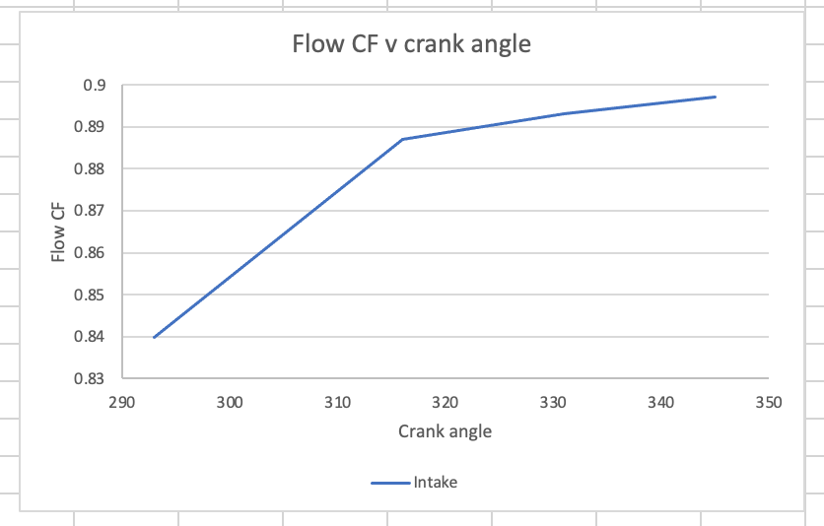

This graph shows the intake valve flow coefficient plotted against crank angle. The coefficient rises sharply at low lift, showing that small increases in valve lift strongly affect airflow. As the valve opens further, the slope decreases, indicating that additional lift produces smaller increases in flow coefficient. This two-stage behaviour highlights how the intake valve controls airflow, which shows an initial sensitive phase with rapid flow response, followed by a less sensitive phase as the valve approaches full lift and flow begins to saturate.

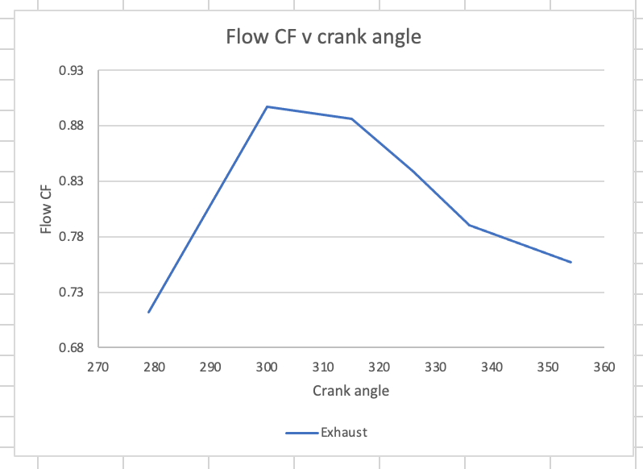

The exhaust valve flow coefficient shows more complex behaviour. It rises steeply at the start, indicating strong influence on exhaust flow, but then decreases in stages as the valve opens further. This suggests that flow becomes progressively restricted, likely due to interactions with the exhaust system or backpressure. Unlike the intake, the exhaust does not plateau. Variations indicate that flow is strongly affected by dynamic system conditions, including pressure waves in the manifold. This highlights the more complex nature of exhaust flow, where valve timing and system dynamics significantly influence the flow coefficient throughout the cycle.

Overall, these plots demonstrate how valve timing and lift govern airflow. The intake shows predictable saturation behaviour, while the exhaust is influenced by dynamic system effects, emphasising the importance of both valve motion and system design in engine breathing performance.

Performance Assessment
The engine speed for maximum power was estimated using:
$$Max RPM= \frac{Engine displacement}{(Mean flow coefficient x Valve diametr)}$$
For the intake valve, a mean flow coefficient of 0.899, combined with the measured intake valve diameter and a 2L (0.002 m³) engine displacement, resulted in a calculated maximum RPM of approximately 63.33. For the exhaust valve, with a mean flow coefficient of 0.798, the estimated maximum RPM is 83.25.
For comparison, the Honda F20C 2L naturally aspirated inline-4 reaches peak power at around 8,300 to 8,600RPM. The large discrepancy highlights the simplifications of the mean flow coefficient method, which assumes a constant coefficient across all valve lifts, idealised valve behaviour, and neglects dynamic effects such as pressure waves, variations in volumetric efficiency, combustion processes, friction, and mechanical constraints. Real engines achieve high RPM and volumetric efficiency through optimised port geometry, cam timing, valve overlap, and other design features.
While the mean flow coefficient method is useful conceptually to link valve geometry and flow to potential engine speed, it is a rough approximation and cannot accurately predict true maximum power RPM. The comparison emphasises the importance of real-world design consideration and the limitations of simplified theoretical models.

Flow Potential and Tuning Insight
The intake and exhaust flow data provide insight into the cylinder head’s tuning potential. The intake flow coefficient rises sharply at low lifts, then flattens as lift increases, showing strong influence at low lift but flow saturation at higher lift. This indicates the head is better suited to a low to mid RPM performance, offering efficient cylinder filling and good torque, rather that sustained high RPM power.
Adding trumpets or a tuned intake manifold could modestly improve flow by smoothing airflow and reducing turbulence, enhancing low to mid RPM performance. However, gains are limited by existing port and valve geometry, and without larger valves or optimised ports, high RPM improvements would be minimal.
Flow saturation at moderate lift highlights real world performance limits, constraining volumetric efficiency and peak power. Comparisons with engines like the Honda F20C, which peaks at 8,300 to 8,600 RPM, show the difference between a high RPM optimised head and this cylinder head.
In summary, the data suggests that the cylinder head is well-suited for torque-oriented, mid-range operation. While intake tuning via trumpets or manifolds could enhance performance modestly, significant gains at high RPM would require redesigning the head to improve flow at higher valve lifts, aligning with the practices observed in high-revving engines.

References
1. Focus Fanatics (2011). Duratec heads. [online]. Available at: https://www.focusfanatics.com/threads/duratec-heads.247823/ . (Accessed: 26/11/2025)
2. Wikipedia (2025). Honda F20C Engine. [online]. Available at: https://en.wikipedia.org/wiki/Honda_F20C_engine . (Accessed: 26/11/2025)

https://www.focusfanatics.com/threads/duratec-heads.247823/
https://en.wikipedia.org/wiki/Honda_F20C_engine

