

Network upgrade in Brackla primary school
by
Josh Bell

Supervisor: Munyaradzi Nicholas Murira

Project submitted as part of the requirements for the award of
BSc (Hons) Computing (stream)
Contents page
DECLARATION

I, Joshua Michael Bell declare that I am the sole author of this Project; that all references cited have been consulted; that I have conducted all work of which this is a record, and that the finished work lies within the prescribed word limits.

This work has not previously been accepted as part of any other degree submission.

Date : 25/08/2022

FORM OF CONSENT

I Joshua Michael Bell hereby consent that my Project, submitted in candidature for the B.Sc.(Hons) Computing (stream) degree, if successful, may be made available for inter-library loan or photocopying (subject to the law of copyright), and that the title and abstract may be made available to outside organisations.

Date : 25/08/2022

Abstract

Brackla primary school were running out of IP addresses and didn’t have enough for their current devices let alone future devices they would like to have. They were also experiencing broadcast traffic issues slowing down the network due to too many devices being in one VLAN. The school's switches and APs were also out of date, resulting in poor network performance and security vulnerabilities. In addition, the squid proxy server for web filtering had to be replaced. A network upgrade was performed by installing a new IP range with a /20 subnet, providing the school with enough IP addresses for current and future devices. This /20 network was divided into VLANs no larger than /23 subnets making the network more manageable and resolving the broadcast traffic issues. New Aruba switches and APs were installed, which improved network performance and added new security features. For the new network, a next-generation firewall was installed, which also functions as a web filtering system, protecting the network and flagging any suspicious user behaviour or malicious packets. Interviews were used to assess project success, and the project was deemed successful.

Table of contents
1 Introduction 7
1.1 Proposed solution 7
1.2 Aim and objectives 8
1.3 Background information - PSBA 8
1.4 Structure of the project 9
2 Literature review 10
2.1 Introduction 10
2.2 Virtual Local Area Networks 10
2.3 Other network upgrade 11
2.4 IPv6 vs IPv4 11
2.5 DHCP starvation attacks 12
2.6 Port security 13
2.7 Firewalls 13
2.8 Broadcast traffic collisions 14
2.9 802.1X Dynamic VLAN Assignment 15
2.10 Security flaws in IoT 16
2.11 Conclusion 16
3 Methodology 17
3.1 Introduction 17
3.2 Research onion 17
3.3 Mendelow’s matrix of stakeholders 19
3.4 Questionnaires 20
3.5 Interview questions 21
3.6 Research methodology 21
3.7 Tools used 21
3.8 Hardware used 22
3.9 Conclusion 22
4 Design 23
4.1 Introduction 23
4.2 Cisco vs Aruba network hardware 23
4.2.1 Vendor decision 23
4.2.2 Network hardware to be replaced 24
4.3 Problems faced in the design stage 26
4.3.1 BT issue 26
4.3.2 Running out of IP addresses 26
4.3.3 Broadcast traffic 26
4.4 Decisions faced in the project 27
4.4.1 IPv4 vs IPv6 27
4.4.2 Choosing a school for the project 27
4.4.3 Minimising downtime 28
4.5 Web filtering 29
4.6 Conclusion 29
5 Implementation 30
5.1 Introduction 30
5.2 DHCP 30
5.2.1 Server configuration 30
5.2.2 DHCP switch configuration 32
5.3 Cisco CLI Analyser used to SSH onto the switch 33
5.4 Switch stacking 35
5.5 VLANs 36
5.6 Port configuration 39
5.7 Wireless Access Points 40
5.7.1 AP dynamic port profile 40
5.7.2 Brackla Wi-Fi networks 41
5.7.3 AP configuration 42
5.7.4 Security 43
5.8 Server monitor 44
5.9 Firewall 45
5.9.1 Web filtering 45
5.10 Conclusion 45
6 Analysis 46
6.1 Introduction 46
6.2 Analysing the data 46
6.3 Conclusion 46
7 Evaluation 47
7.1 Introduction 47
7.2 Was the aim and objectives of the project met 47
7.3 If done again how would the project be done differently 47
7.4 Literature review evaluation 48
8 Conclusions and recommendations 49
8.1 Introduction 49
8.2 Conclusions 49
8.3 Recommendations 50
9 Reflection 53
10 References 54
11 Appendices 56
Appendix A: 56
Appendix B: 56

1 Introduction

​​ All Bridgend County Borough Council schools are currently configured so that all staff and pupil devices on the curriculum network are on one VLAN. This was not an issue when the networks were first set up because there were few devices on the school's network. Previously, each classroom had one PC for the teacher and one or two IT suites for students to use the computers, depending on the size of the school. However, IT has grown exponentially in recent years, and each school now has many more devices. More desktops and laptops have been purchased so that students can use devices without needing to reserve the IT suite. Furthermore, in the last year, some schools have implemented a one-to-one pupil-to-device policy, which means that each student has their own device to work on. As a result, schools are running out of IP addresses on the current IP address design, so a new IP address design must be implemented to accommodate all current devices on the school's network as well as room for future upgrades that the school may desire. Furthermore, schools are experiencing broadcast traffic issues so a new VLAN design must be implemented for each school to reduce the broadcast traffic and make the network more manageable. Although these new VLAN designs must be implemented in all BCBC schools, it would be far too large a project to undertake for the independent project in the time frame provided. As a result, Brackla Primary School was selected to carry out the upgrade. This school consists of one /21 network that has all the school’s end user devices connected to. Brackla Primary School has one device per student, as well as desktop computers and hundreds of tablets, as a result they are running out of IP addresses.

1.1 Proposed solution

BT has assigned the IP address block XX.XX.64.0 /20 to Brackla Primary School. This will be divided into manageable VLAN sizes that will be well-organised and simple to maintain. This number of IP addresses is double what Brackla had previously, allowing for all current devices as well as plenty of room for future devices. All school networks will be properly configured with manageable VLAN sizes in the future, and all school engineers will receive appropriate training. This will allow them to manage the networks and avoid recurring issues caused by having too many devices in one VLAN. To plan this project and design the new network, weekly meetings with the data and networking team and management, as well as meetings with the school's engineer, will be held. This, along with extensive online research, past papers, and other research tools, will contribute to the success of this project.

1.2 Aim and objectives
Aim-
Design and implement a network upgrade for Brackla primary school
Objectives-
- Design VLANs and subnets for wired and wireless network across school
- Configure DHCP server for allocation of IP addresses
- Improve network security
- Improve network performance
- Implement new web filtering system
- Configure firewall policies so that the firewall is working on the new network
- Improve consumer satisfaction

1.3 Background information - PSBA
PSBA is the WAN provider for BCBC, as well as most public sector organisations in Wales, such as local governments, the police, and the NHS. Due to PSBA linking all the BCBC sites together it means that all sites can be managed centrally from one location, which makes it far easier to manage the network. Furthermore, being a part of PSBA comes with many benefits for BCBC, as if multiple public sector organisations want to use the same system the cost of this service being run is much cheaper as the cost is split. This means BCBC have more budget to spend on other areas of the network. An example of this is WCCIS, which is an integrated health and social care system used across Wales by NHS Wales and local government. Moreover, if a shared service goes down then it can be resolved quicker as there are more companies working on it with a shared goal of fixing the issue.

1.4 Structure of the project

This project is divided into nine chapters, each of which contributes to the achievement of the stated aims and objectives. The first chapter of this report is the introduction, which provides a brief explanation of what the project is about and clearly states the project's aims and objectives. The second chapter of the report is the literature review, which focuses on the research done to make the project easier to complete and is a major factor in the project's success. The third chapter is the research methodology, which describes in detail the approach taken to ensure reliable, valid results. The fourth and fifth chapters describe how the project will be delivered and how issues will be resolved when designing and implementing the network upgrade. The analysis of the questionnaires and interviews is covered in the sixth chapter. The seventh chapter is the evaluation, which assesses the project's success and determines whether the aims and objectives were met. The eighth chapter discusses the project's conclusions and recommendations, as well as a summary of the project, outlining future work that will be required after the project is completed. The ninth and final chapter section reflects on what was learned throughout the project and what would be done differently if the project were to be repeated.

2 Literature review

2.1 Introduction

This chapter will include a literature review that will be conducted to establish a familiarity with and understanding of the current research within a network upgrade. To achieve this, the following research databases will be utilised; CORE, science direct and EBSCO. The research terms that will be used are ‘network upgrade’, ‘VLANs’, ‘port security’, ‘IPv6’, ‘IoT’ and ‘DHCP starvation attacks’.

2.2 Virtual Local Area Networks

The following research will be conducted before creating and implementing VLANs in the new network to gain a better understanding of them. This background research will increase knowledge and be extremely beneficial to the project.
Cisco defines a Virtual Local Area Network (VLAN) as a collection of devices on one or more Local Area Networks (LANs) that are configured to communicate as if they were connected to the same wire, even if they are on different LAN segments. [1]. VLANs are based on physical connections, making them extremely adaptable. VLANs define broadcast domains on a layer 2 network; a broadcast domain is the set of all devices that will receive broadcast frames from any device in the set.[1].
A switched LAN, according to Feuzeu et al., is defined as a single broadcast domain. These broadcast frames are sent to all bandwidth-consuming devices. They discovered, however, that a VLAN did not have the same issues because devices only received broadcasts from devices in the same VLAN, rather than the entire network. VLANs were created as an alternative to using routers to limit broadcast traffic. VLANs have several advantages over LANs, including improved performance, security, easier administration, and lower costs [2]. It is extremely beneficial for BCBC to move away from a single LAN and adopt a more modern approach resulting in less broadcast traffic and thus less strain on the network, resulting in improved network performance. VLANs strengthen network security. In a VLAN network environment with multiple broadcast domains, network administrators have control over each port and user. A cyber attacker cannot simply connect their workstation into any switch port and sniff the network traffic using a packet sniffer. The network administrator has control over each port and the resources it is permitted to use. VLANs facilitate the restriction of vulnerable traffic originating within an enterprise department [3].
By reducing both internal and external threats, VLANs improve security. Internally, separating users improves security and privacy by limiting user access to networks that are relevant to their roles. If an outside attacker gains access to one VLAN, they will be restricted to that network due to the boundaries and controls in place to keep it separate from the others [4].

2.3 Other network upgrade

This study examines how other organisations upgrade their networks, examining the methods used to determine what worked and what didn't. As a result, BCBC will be better prepared to carry out the network upgrade.
Tajiri et al. published a paper detailing their Cisco Edge upgrade in 2015. The first step in their research was to "understand the LVHN enterprise network”. They accomplished this by conducting independent research and presentations through the infrastructure team of the company for which they were upgrading the network. This is advantageous because it ensures a better understanding of the network being upgraded. Replicating this approach in this project will provide a better understanding of the school's networks and how they connect back to the data centre. This is particularly important as prior to this project, my role in IT had very limited involvement with the school's networks.[5].
To "thoroughly examine each component of the network," the OSI model was used to deconstruct the layers in use. This was extremely useful in directing the team in determining which "edge switch upgrade" was required [5].

2.4 IPv6 vs IPv4

Research on IPv6 versus IPv4 must be conducted, as all aspects of the network upgrade must be considered.
Milovanov et al published a paper titled "IPv6 building automation solution integration into an IPv4 Network Service Provider infrastructure”. Despite its success, the paper emphasises that IPv4 is not without flaws. Its most notable limitation is the lack of address space. Despite efforts from IT experts worldwide. The last /8 IPv4 address blocks have already been assigned. As a result, the scarcity of IPv4 addresses hampers future growth with technologies such as the Internet of Things (IoT) [6].
Soorty et al published a paper on IPv6 performance using Windows and Linux systems. In this paper, IPv6’s significant improvement over IPv4 was investigated. It is stated that IPv6 will replace IPv4 by addressing the issues of limited addresses, security, and mobility. In addition to addressing these issues, it will introduce new features such as multimedia delivery, QoS, autoconfiguration, security, and mobility enhancements [7].
According to Soorty et al., organisations will have three options. The first option is to continue using IPv4 in internal networks and to communicate across the IPv4 infrastructure using Network Address Translation (NAT) protocol translation. The second option is to perform a complete internal-network IPv6 migration using tunnelling mechanisms such as 6 to 4 Generic Routing Encapsulation and Intra-Site Automatic Tunnelling Addressing Protocol. The last option is to continue to use IPv4 and gradually upgrade to IPv6 while using both protocols to determine which protocol is more beneficial to the needs of the organisation. This deployment strategy provides performance and cost effectiveness [7].
BCBC will decide how to approach IPv6 in the future, and the conclusion of this project will outline what is best for the organisation, when to make the change to IPv6, and how it will be done.

2.5 DHCP starvation attacks

DHCP starvation attacks can be detrimental to a network because they can bring the entire network down if the appropriate defence mechanisms are not in place. Research into how to prevent these attacks is required.

Hubballi et al. published "A closer look into DHCP starvation attack in wireless network." This paper examines DHCP attacks and the best methods for preventing them. Clients use DHCP to automatically configure network parameters such as the default gateway, DNS server, subnet mask, and IP address. Although this protocol is extremely beneficial especially in large networks, it is vulnerable to Denial-of-Service attacks, commonly known as a DHCP starvation attack because it lacks built-in authentication. Open-source tools such as Gobbler and DHCPIG can launch these attacks, making it very easy for someone to carry out this attack. The tools generate many IP requests using MAC address spoofing, and each request is responded by an IP address released by the DHCP server, exhausting the address pool. Although this attack is effective on wired networks, it is not effective against wireless networks.[8].

DHCP starvation attacks are possible due to the lack of built-in authentication in DHCP; however, there are some known detection and mitigation techniques. Port security on switches is one of these methods. Majumdar et al wrote a paper in which they claimed that DHCP starvation attacks can be mitigated by limiting the number of permissible MAC addresses per port on a network switch [9]. When the switch's limit is reached, the port is disabled and an SNMP trap is sent. The second method of prevention is DHCP snooping, which detects differences in MAC addresses in the Ethernet header and CHADDR field of a DHCPDISCOVR message, allowing it to easily prevent the attack [8].

With these three prevention methods active and correctly configured, the network will be much less vulnerable to a DHCP starvation attack. As a result, when performing the network upgrade, these features will be implemented to the network for improved security, which is one of the project's main goals.

2.6 Port security

Port security will be researched to determine if its beneficial to configure on the switches at Brackla Primary School.
Cisco has port security white papers that recommend how to make switches as secure as possible by enabling port security. When the MAC address of the device attempting to access the port differs from any of the MAC addresses specified for that port, port security can be used to block input. Additionally, port security can be used to filter traffic destined for or received from a host based on the host's MAC address. The maximum number of MAC addresses per port can be set, after which the secure MAC addresses can be manually entered or the port can dynamically configure the MAC addresses of the connected devices. If a security violation occurs, the port will be permanently disabled until the security violation is resolved and it is enabled again [10].

2.7 Firewalls

Background research on firewalls will be conducted to gain a better understanding of how they work so that when the firewall is reconfigured for the new network, it will benefit the project.
Zheng et al conducted a paper on ‘dynamic defences in cyber security’ in 2020. They stated correct firewall strategy configuration ensures computer security and plays a role in isolation, preventing unknown security risks, protecting data information security and avoiding the presence of risk information and viruses in the network. Combining firewall and intrusion detection technology is an important direction of current defence technology. The overall optimisation of the current function is promoted by a successful combination of the two. Firewall technology can be effectively used to protect abnormal data in the outside world, allowing the role of security mechanism and security protection to be fully utilised [11].

2.8 Broadcast traffic collisions

Aside from running out of IP addresses, the second most prominent driving force behind this project was broadcast traffic. As a result, it is beneficial to gain a better understanding of what broadcast traffic is.
Munther et al published a study in 2020 detailing ‘supressing broadcast traffic’. Due to the rapid development of technologies and increasing number of hosts, the vulnerability of networks has been exposed. Scalability is one of the biggest issues in networking, resulting from a rapid increase in the number of hosts on networks, resulting in increased broadcast traffic between hosts. Layer 2 broadcast traffic reaches all devices in the same broadcast domain which are devices that are in the same LAN or VLAN. When there are too many devices in one LAN or VLAN, many broadcast messages are sent and received, causing performance issues by slowing down the network [12]. A representation of broadcast traffic can be seen in figure 1.
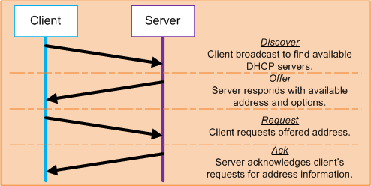

Figure 1: Broadcast traffic [13]

2.9 802.1X Dynamic VLAN Assignment

802.1X authentication is a potential future upgrade that BCBC will implement that no one on the team fully understands currently. Extensive research is required to determine its potential.
IEEE 802.1X Authentication and Dynamic VLAN Assignment with NPS Radius Server is a critical networking component. A user's location cannot be predicted as agile working is a big part of the modern era of working on computers. Tying users to a local VLAN may be beneficial only if they work at the same desk every day; however, while this is the ideal outcome, it is not the most practical [14].
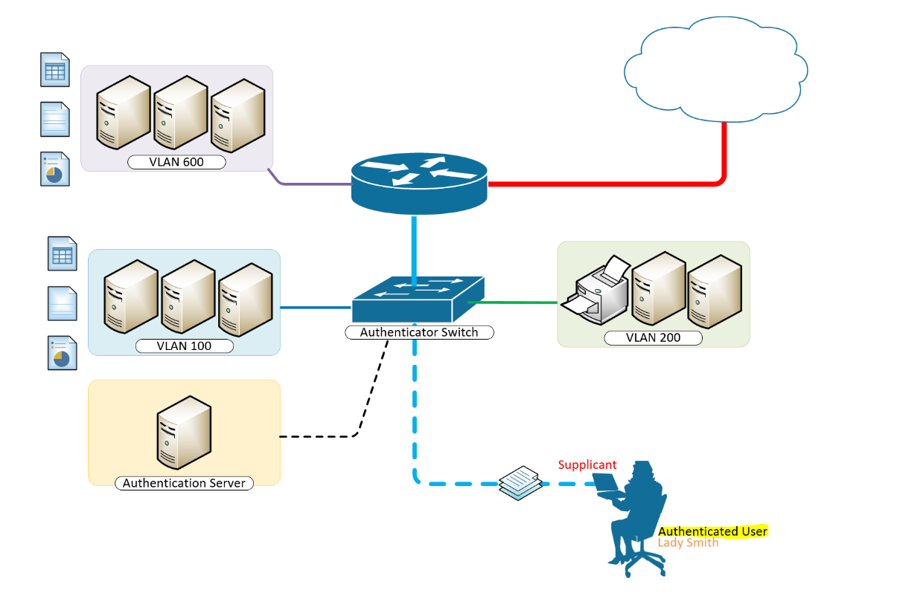

Figure 2: 802.1X example [14]

As illustrated in figure 2, the user wishes to make use of services provided by services on the LAN behind the switch. Based on the user's VLAN membership, there are multiple VLANs with resources available. The user’s laptop is connected to a port on the switch that has 802.1X port authentication control enabled [16].
The laptop must therefore act in a supplicant role. Messages are exchanged between the supplicant (users device) and the authenticator (switch). The authenticator sends the supplicant's credentials to the authentication server for verification, which are the user's Active Directory Account Credentials. The authentication server then informs the authenticator whether the authentication attempt was successful or not, at which point the user is either granted or denied access to the LAN behind the switch [14].

2.10 Security flaws in IoT
Schools across BCBC are constantly looking at IoT devices to better develop technology in their respective school. Although these devices have many advantages, more research is needed to ensure their security.

Sadique et al. published a paper titled "Towards Security on the Internet of Things: Applications and Technological Challenges." This paper discusses the rapid growth of IoT devices and the growing risk of vulnerabilities they can introduce. IoT devices are used in homes, healthcare, businesses, and governments. It was expected that 31 billion devices would be deployed globally by 2020. This rapid rise in devices results in several IoT vulnerabilities. Threats posed by IoT devices include cloning by untrustworthy manufacturers, man in the middle attacks caused by a lack of authentication and authorisation, firmware replacement with malicious code by an attacker and DDoS attacks [15]. Although these threats are serious, the majority are caused by untrustworthy IoT manufacturers who are unreliable and lack appropriate security features. Brackla's devices will be thoroughly researched to ensure that they are of high quality and are secure. Furthermore, they will only be purchased from known manufacturers.

2.11 Conclusion
The research conducted in this chapter will provide information required to gain a better understanding of how to make the network upgrade project a success. This knowledge ranged from how to best plan a project and approach methodology to securing the network from various vulnerabilities and obtaining additional knowledge on areas such as VLANs, IPv6, port security, 802.1X dynamic VLAN assignment and selecting a network vendor that will help in this project and future projects.

3 Methodology

3.1 Introduction

This chapter will provide an overview of the research methodology, philosophy, and data collection methods used. The purpose of this chapter is to present the selected research design using the research onion.
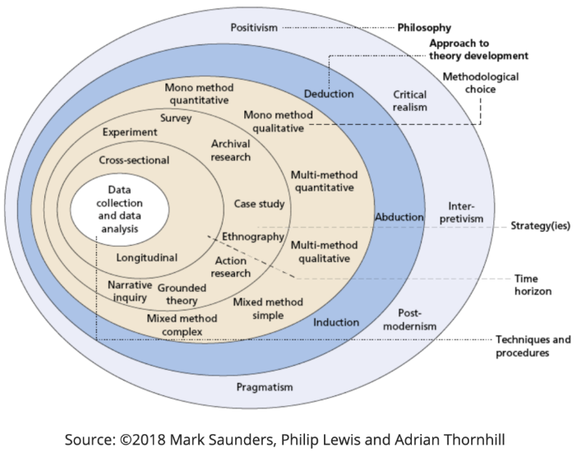

Figure 3: Research onion [16]

3.2 Research onion
Hypothesis – By installing new network hardware and implementing network features the network performance and security of Brackla primary school will be improved.
The research onion model will be utilised to help aid a more organised methodology. The onion will be divided into 6 main layers, seen in figure 3 [17].
Layer 1- Philosophy
Research philosophy consists of ontology, epistemology, and axiology.
The philosophy that will be utilised during this project is interpretivism.
This type of philosophy allows for objective research, focusing on analysing feelings experiences and meaning.

Layer 2- Research Approach
Research approach can be thought of as; inductive vs deductive and qualitative vs quantitative.
The first aspect of the research approach is deciphering between an inductive vs deductive approach.
A deductive approach will be used as existing theory has been gathered in the literature review which provides a starting point to test data against.
This research will focus on a qualitative approach which will include interviews and a questionnaire.
Layer 3- Research Strategy
This layer of the research onion details how, based on the aims of this study, research can be conducted.
An experimental research method will be used. This allows for manipulation of one variable (the network) while observing the change in another variable (user satisfaction).
This will allow testing of existing theories rather than creating new ones. Which is deductive in nature and aligns with the positivist research philosophy.

Layer 4- Choices of methods
Layer 4 of the research onion focuses on the number of data types used within the research there are 3 main types: mono, mixed, and multi-method.
The research of this project will use a mono-method as it will make use of one data type- qualitative.
This method will allow for the objective of ‘improving consumer satisfaction’ to be measured.

Layer 5- Time horizons
Time horizon can be considered as; cross-sectional and longitudinal.
Cross-sectional data will be collected as the data will be gathered at a single point in time.

Layer 6- Data collection and analysis
The methods that will be used for data collection are a questionnaire and interviews.
The questionnaire will consist of 6 questions. It will be anonymous as it allows the respondents to provide a more detail and honest feedback, allowing for representative data.
Interviews will be conducted with the school’s IT engineer, IT co-ordinator and the head network analyst in BCBC.
Questionnaires will be provided to every teacher within the school, including the headteacher and the deputy head. Teacher feedback will be useful as they spend a considerable amount of time using the network and hence will provide well-rounded feedback. The IT engineer is the most knowledgeable person in the school regarding networks, so their opinion is extremely valuable. The headteacher is a high value person so it will be important to obtain their feedback. Pupils will not be included within the sampling population as there will be little interest and likely poor questionnaire completion rates.
The data will be analysed by reviewing questionnaire and interview answers. These answers will deem if the project was a success.

3.3 Mendelow’s matrix of stakeholders

Mendelow’s matrix was used to assist in recognising stakeholders and identify their power and interest. This was used to select who would be suitable to answer interview questions and who to send the questionnaire to. Mendelow’s matrix can be seen in figure 4.
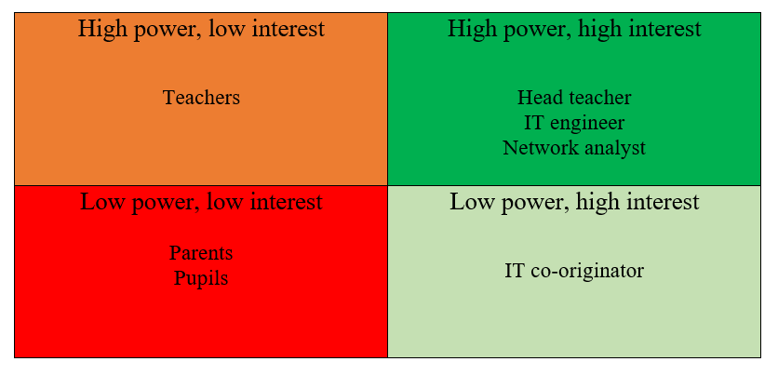

Figure 4: Mendelow’s matrix of stakeholders

3.4 Questionnaires
Figure 5 shows the questionnaire that will be sent to every teacher in the school including the headteacher and the deputy head.
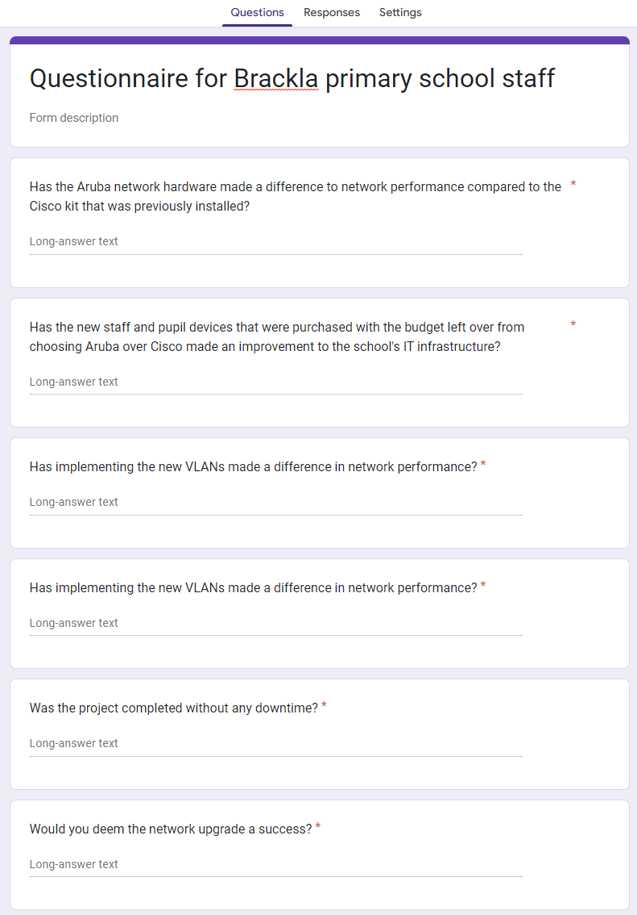

Figure 5: Questionnaire for teachers

3.5 Interview questions
Interviews will be conducted with the IT engineer, who is responsible for resolving any IT issues the school have, the IT co-ordinator, who oversees ordering IT equipment and handing it out as well as basic IT support and BCBC’s network analyst, who works for the corporate side of BCBC but monitors the curriculum network centrally. Although some of the questions will be similar to the questionnaires, an interview allows for more thorough answer and these 3 people have a much better understanding of the network.
Interview questions: [Appendix A]

3.6 Research methodology
The chosen research method is qualitative methodology, this will allow for a much more flexible approach. It allows research to be targeted towards a specific group and thus will gather more meaningful data. Quantitative research will allow for something to be explained that numbers alone are unable to reveal.
However, a qualitative methodology has some downfalls. It’s clear that a self-selective bias may arise. Furthermore, sample size may pose an issue if it’s not a true reflection of the views, for example 500 employees and the sample size is based on 30 employees. Moreover, there may be consciously or unconsciously bias opinions or selective sample that favours an anticipated outcome.

These disadvantages will be worked around by; ensuring the sample size is representative and including only open-ended questions in the questionnaire. In addition, interviews will avoid leading questions.

3.7 Tools used
Various tools will be used to complete the network upgrade. The first of these is Windows Server 2019, this will be used to configure the DHCP pools for the school. There will be a DHCP scope created for each VLAN, and it will be named appropriately to easily identify which VLAN it is a part of i.e., Sch_Brackla_Pupil. A failover server will be configured to avoid downtime if the DHCP server goes down.
Another tool that will be used is an authentication server to SSH onto the switches to configure the VLANs and the port security on the switches. The purpose of the authentication server is added security, making it more difficult for anyone trying to access the switch who shouldn’t be.
Cisco Firepower Manager Centre (FMC) is a physical appliance that manages the firewall. This also includes web filtering policies and other security features such as Intrusion detection systems (IPS) and intrusion prevention systems (IDS).
Configuration for the APs is done through a web browser. From here the Wi-Fi networks can be configured for APs. In Brackla there are three networks that must be configured; the corporate Wi-Fi which is in every primary school, Brackla’s main Wi-Fi and a staff Wi-Fi. Other configuration is undertaken, such as how the IP address is obtained, which VLAN will be accessed and the required security settings.

3.8 Hardware used
The hardware used for this project are switches and APs. These are the backbone of the network that makes everything work. Switches are to connect the wired network and the APs are to connect the wireless network. Brand new switches and APs will be installed for improved network performance.
Servers are needed so that the network can be managed from one central location. PSBA are used to link the school’s network back to BCBC IT.
End user devices such as desktops, laptops and tablets are required for both staff and pupils. These devices will be purchased through a fund provided by the Welsh Government to improve IT in schools. They will also be used by IT to test that the network is working properly before it goes live and pupils return to school, minimising downtime.

3.9 Conclusion
This chapter has detailed the different approaches to methodology, allowing a detailed plan to be made by utilising the research onion. This ensures the research process is smooth, effective and manageable.

4 Design

4.1 Introduction
The following chapter outlines the design stage of the project. During this stage the project requirements were key in the thought process of the design as each requirement must be met. These requirements are to install new switches and APs, design and implement VLANs for the wired and wireless network, configure the DHCP server, improve the networks performance and security, implement a new web filtering system and configure the firewall for the new network.

4.2 Cisco vs Aruba network hardware
The start of the network upgrade was the installation of new switches and APs that were installed in all schools across BCBC to improve network performance. Welsh Government provided BCBC a budget and it was down to BCBC IT, as well as the head teachers and the head of education to come up with the best way of upgrading the network hardware. The decision came down to Cisco vs Aruba. Cisco are the industry standard holding a world market share of 45.4 percent in switches in 2021 compared to HP (Aruba) who had 5.8 percent [18]. Furthermore, all BCBC’s network team have worked with Cisco for over 5 years and are qualified Cisco experts but had no previous experience with Aruba. All the switches and APs in the corporate side of BCBC and BCBC schools were Cisco which made the network easier to manage as it was standardised across the network. However, due to Aruba wanting to break into a market dominated by Cisco a massive discount was given to BCBC due to the size of the project which meant over £1,000,000 would be saved by selecting Aruba.

4.2.1 Vendor decision
The decision was to go with Aruba due to the large amount of money that could be saved. These savings could be used to invest in hundreds of brand-new staff and pupil devices in every school. This would exponentially improve the performance of IT in the school as the previous staff and pupil devices were outdated. Furthermore, the network hardware in the schools was around 7 years old and the recommendation for network hardware is to replace them every 5 years. Having the new Aruba hardware significantly improved network performance due to features such as Wi-Fi6.

4.2.2 Network hardware to be replaced
All the switches and APs in the school had to be replaced with brand new Aruba kit, as well as adding extra APs around the school to improve signal strength and add Wi-Fi in parts of the school where no Wi-Fi existed. The headteacher also requested that external APs be installed so that the gardening club could use their tablets outside which can be seen on figure 6. Figure 6 also shows that APs highlighted in blue are the 20 previous Cisco APs that are to be replaced and the APs highlighted in green and the new ones to be installed. There are 4 external APs and 8 new APs to be installed.

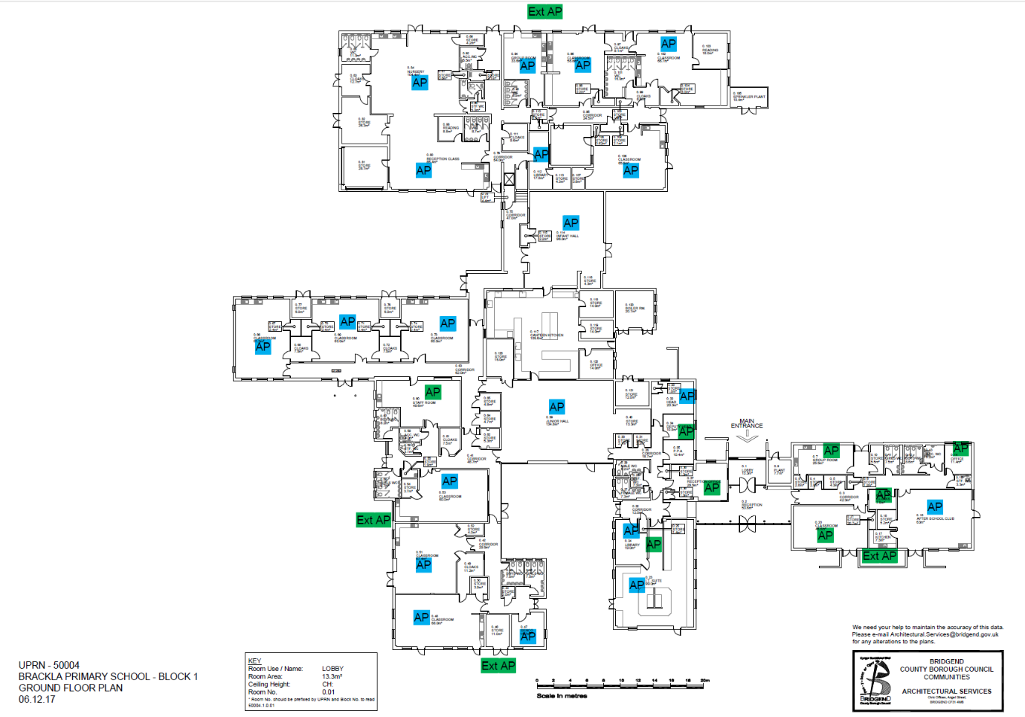
Key:
Blue = existing AP location
Green= new AP to be installed
AP= Wireless Access Point
Ext AP= External Wireless Access Point

Figure 6: AP locations in Brackla primary school

Although there were previously 6 Cisco switches in the school, they were mixed in port sizes. There were three 48 port switches, one 24 port and two 8 port switches. However, the new Aruba switches being installed will be six 48 port switches, adding an additional 104 ports to add new devices to the network. These switches also come with new features, improved security and bandwidth capabilities. Figure 7 shows the locations of the cabinets, and how many switches are in each of them. Each switch is to be a 48 port Aruba CX 6300 switch.

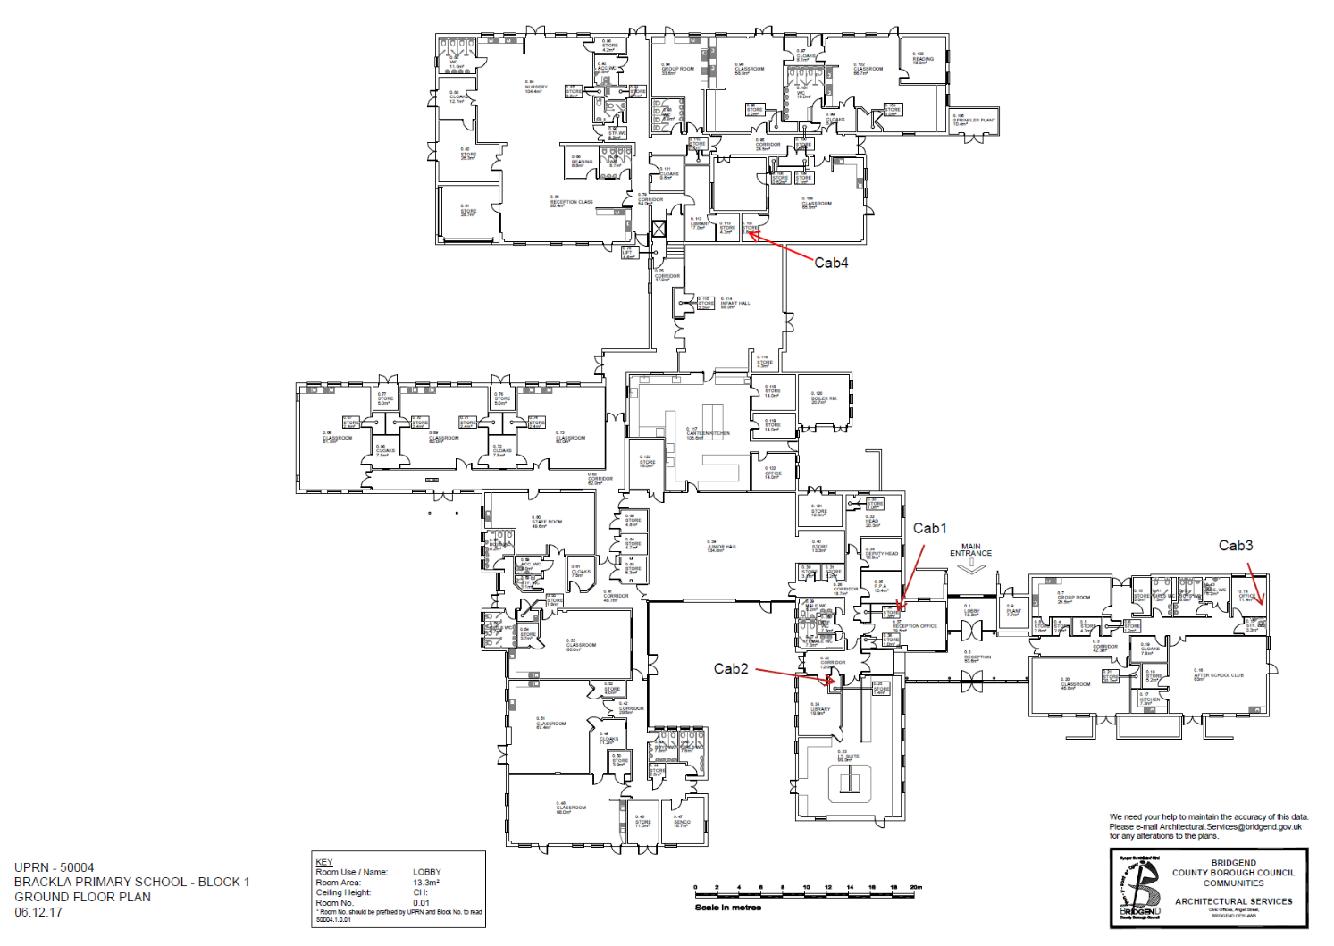
Stacked switches
IP address XX.XX.171.254
6x 48 port Aruba CX 6300 switches

Cabinet 1- Main Admin office – 1x 48
Cabinet 2- Corridor entrance 2x 48
Cabinet 3- Office 1x 48
Cabinet 4- Store room 2x 48

Conclusion

Figure 7: Switch locations in Brackla primary school

4.3 Problems faced in the design stage

4.3.1 BT issue
During the design stage of the project there were many problems that were faced. BT requested £10,000 to put the new IP address range in across all the schools in BCBC. Eventually they brought this down to £6000 but the price was still far too high, considering each school could be done one by one for free. The only downside to this approach was a longer completion rate. As a workaround for the project being delayed, each school was prioritised based on their need for the upgrade to take place. At the top of this list was Brackla primary school as they had run out of IP addresses and needed to expand their network, for this reason this is the school that the project is focused on.

4.3.2 Running out of IP addresses
The main issue that influenced the network upgrade was the lack of IP addresses. The school currently has a /21 network which has 2046 usable IP addresses that is being used as the main VLAN with all the curriculum staff and pupil devices in it. These addresses have run out due to the number of devices that are being added to the network. Each pupil in Brackla has their own Chromebook, there are multiple tablets in the school used for learning applications with their touchscreen feature, there is also a desktop in every classroom and each member of staff who needs access to a device has their own laptop. In addition, there are new technologies that the school are looking to implement to enable the school to run more efficiently. This includes IoT devices than can control the heating around the school, the tills in the canteen being connected to the internet removing the need for paperwork, and guests signing in and out of the school on a tablet. This is just the start of technology in the school and in 5 years there will be even more. Speaking to the school’s IT engineer, he reported that the lack of IP addresses means they have to turn off all unused devises to allow devices in use to have an IP address.
As a result the school needed a larger network to gain more usable IP addresses. Discussions took place with the school’s engineer and BCBC IT on the size of the network. The discussion was between a /20 network and a /19 network. The conclusion was made that a /20 network is double the size of a /21 network, so is suffice for the current school set up, allowing for future expansion. A /19 network would be overkill as there is 8190 addresses which the school would never reach.
Currently if BCBC wanted to add IP addresses, BCBC IT would have to contact BT and request a change to be made. When the /20 network is put into place and the network is configured there will be plenty of spare addresses available for use thus no need to contact BT to make any changes.

4.3.3 Broadcast traffic
Another issue that Brackla and other schools across BCBC are facing is broadcast issues due to all the devices on the network being on one VLAN. These networks were set up a long time ago before VLANs were the standard in most large networks. There were also far fewer devices on the network when it was originally configured. However, most schools across the council are approaching a one-to-one pupil-to-device policy. New devices are constantly being added to the network, such as IoT devices to manage the heating system. There are hundreds of devices in one VLAN in most schools. Broadcast messages are sent out and received by all devices in the VLAN, so the more devices the more traffic there is resulting in performance issues.
BCBC had to create a resolution to this. Fortunately for the schools, BCBC already had previous experience with this issue on the corporate side of the business, so knew what was required. The solution was to implement multiple VLANs for each school, organising them into appropriate groups that not only would resolve this issue but make for easier management of the network. This would allow for different security policies, such as different web filtering policies for staff and pupils.

4.4 Decisions faced in the project

4.4.1 IPv4 vs IPv6

A major decision in the planning stage was whether to upgrade to IPv6 or stick to IPv4. As stated in the literature review, IPv6 brings many benefits, the biggest one being that IPv4 is running out of IP addresses but with IPv6 there is nearly an unlimited amount. IPv6 provides new features such as multimedia delivery, QoS, autoconfiguration, security and mobility enhancements. However, upgrading to IPv6 is a massive project without having to complete the other requirements of this network upgrade. Furthermore, the network team don’t have real life experience with IPv6 so training would be required. There is also a cost implication in upgrading to IPv6 which had not been considered when planning this network upgrade. Moreover, standardisation is important to BCBC IT. When the upgrade to IPv6 happens, it will be completed in all schools and corporate buildings. This will be difficult to manage the same network with some sites being IPv4 and others being IPv6.

4.4.2 Choosing a school for the project
The next stage of the project was to decide which school the upgrade would be implemented in. BCBC must create and implement VLANs in every school across the council estate giving them a new IP address with a larger CIDR. Due to the size of the project and how long it would take to finish every school, it wasn’t feasible to include every school as part of the project. Initially the chosen school was Coleg Cymunedol Y Dderwen, due to it being a very large school and having a different network layout to the rest of the schools. However, BT tried to charge BCBC £10,000 to update the IP address ranges in all 60 schools, requesting to assign a project team to each school rather than logging each school as an individual request. BCBC thought this was extremely excessive and it then took over a month for BT to come back with a new quote of £6000. This was a massive hinderance as it delayed the project an extra month and meant less time to work on the report. Furthermore, BCBC decided £6000 was too expensive so decided to log each school individually which would take longer but would save the council money. Consequently, the school chosen for this project changed as CCYD was not a high priority school who needed the change done straight away. At the top of the priority list was Brackla primary school which is the new chosen school for this project. Due to the primary school’s engineer working both in schools and corporately it meant for better communication.
The next step in planning the project was to communicate with the school’s engineer to find out how big each VLAN would need to be and how many different VLANs are required. Due to how many pupil devices are on the network a /23 network will be required for the wired pupil VLAN and 2 /23 networks will be required for the pupil Wi-Fi VLANs. As each pupil has their own Chromebook which works wirelessly two Wi-Fi VLANs are required, whereas only one pupil VLAN is required for all the pupil desktops around the school, the majority of which are based in two IT computer suites. Furthermore, a /24 network is required for the staff VLAN which any staff device will go into, this VLAN can accommodate wired and wireless devices. A /24 network is also required for the Edu-Infrastructure VLAN which will contain all the printers, scanners servers, etc. In Brackla primary there is a flying start office which BCBC social workers operate out of, and they will be on their own VLAN which will also require a /24 network. The last of the new VLANs required is a /25 network for IoT devices. The designs for these VLANs can be seen below in figure 8. These VLANs were designed from biggest to smallest as it is easier to manage, and it supports future modifications.
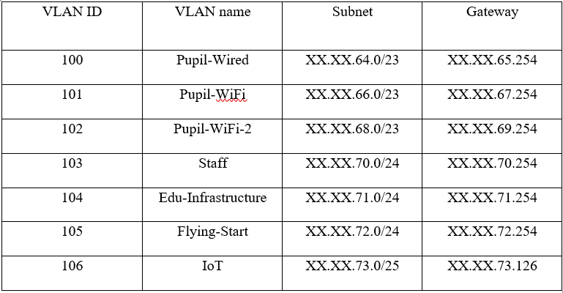

Figure 8: VLANs to be implemented design

4.4.3 Minimising downtime
The next discussion was when to implement the change to minimise downtime. When the school change over to the new IP range the switches need to be configured as well as the firewalls, APs, etc. This means there will be downtime on the network, so scheduling an appropriate time for this change to be done is important as IT in schools in the modern era is crucial. The initial planning focused on when this upgrade would be completed to minimise downtime. Due to the issue with BT delaying the project, the only time the upgrade can be implemented is during the summer holiday when no staff or students are present. This is the perfect time to do the upgrade as there is no pressure to get the network back up and running. However, it will affect the dataset as the questionnaires will not be answered by the teachers. Another obstacle that will be faced is getting a member of staff in to open the building for BCBC staff to gain entry.
Another decision was; implementing the project a section at a time vs all at the same time, to minimise downtime. Research found that splitting a network into smaller sections at a time is very beneficial to make sure everything is working quicker, thus resulting in less downtime. However, this will not be an issue as the upgrade will be implemented in the summer holidays meaning the upgrade can be completed all in one go.

4.5 Web filtering
Previously in Brackla there was a dedicated proxy server that BCBC IT and the school’s IT engineer could configure to block websites and create groups for certain users. However, the new proposed web filtering will be done on the next generation firewall. With this advanced technology web filtering policies can be configured so different VLANs have different policies. Meaning that all staff devices in the staff VLAN will have access to certain websites such as YouTube and social media sites but any device in a pupil VLAN will have these sites blocked.

4.6 Conclusion
During the design stage the network upgrade was planned in detail so it will meet the aims and objectives. The overall design of the network upgrade was done so that the implementation stage could run smoothly.

5 Implementation

5.1 Introduction
The following chapter outlines the steps taken to implement the network upgrade by showing screenshots of the configured switches and APs, as well as screenshots from the DHCP server.

5.2 DHCP

5.2.1 Server configuration
The first step of the implementation was to configure the DHCP server for Brackla making a new scope for every VLAN on the curriculum network, seen in figures 9&10. As shown in figure 11 there was a total of 7 scopes created for each of the 7 VLANs that are to be implemented to the network.
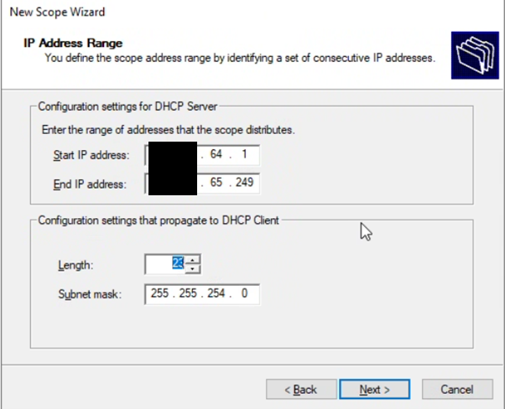
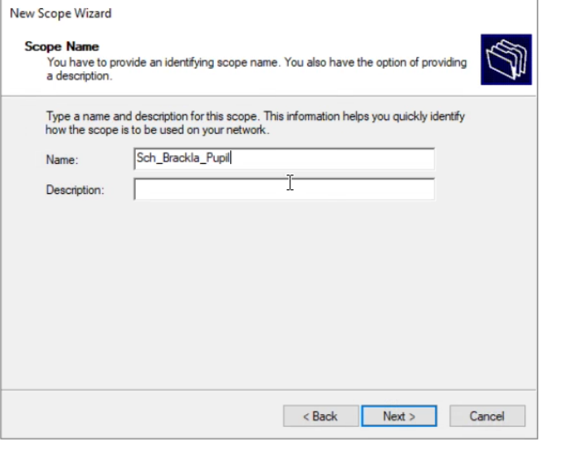

Figure 9: DHCP scope name Figure 10: DHCP scope IP address range
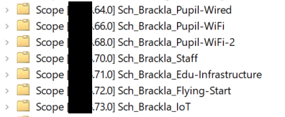

Figure 11: Brackla DHCP scopes

In the configuration of the DHCP sever is a failover. This is in case the server rhubarb goes down then all DHCP services will work on the failover server called custard which will prevent any downtime for DHCP unless both servers go down. To try mitigating both servers going down they are held in different locations. The configuration for the failover can be seen in figure 12.
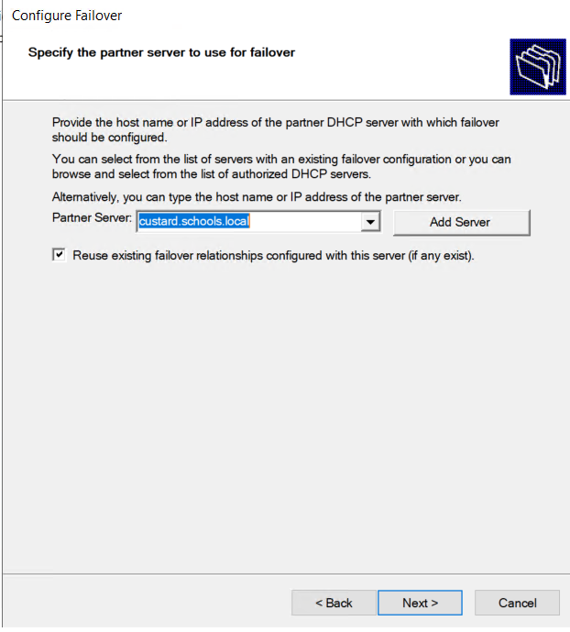

Figure 12: DHCP failover configuration

When configuring the DHCP server a few problems were faced. The first of which is that due to my role in BCBC, being in the support team, I did not have access to the server to configure the DHCP server, as this is a responsibility of the data and networking team. This meant a request had to be made to the head of networking to gain permission. The second issue that was faced was when configuring the DHCP server initially the scopes for every VLAN in Brackla were part of one super scope for the school which can be seen in figure 13. However, when doing testing before going live with the implementation it was found that the super scope was working incorrectly and devices that were supposed to be receiving an IP from one scope were getting them from an incorrect scope. This could be a security risk as a big part of this project is the VLANs and having devices not being able to see parts of the network they do not have access to, and a device being in the wrong VLAN increases the security risk. Furthermore, it could mean that a pupil gets staff web filtering which is a major concern. Due to this issue the decision was made to go back to just scopes and the issue was reported to Microsoft.

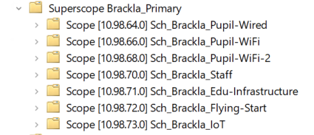

Figure 13: DHCP superscopes

5.2.2 DHCP switch configuration
DHCP is pushed out on the switch though IP helper addresses which can be seen in figure 14. There are two IP addresses which are the server’s rhubarb and custard. Rhubarb is the main DHCP server and custard is the failover in case rhubarb goes down. Having a DHCP server on every VLAN would case many issues and would be very inefficient. With this setup using helper addresses there is only need for two DHCP servers for every school across BCBC.
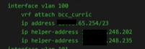

Figure 14: DHCP switch configuration

5.3 Cisco CLI Analyser used to SSH onto the switch
The software that was used to configure the switches was Cisco CLI Analyzer. This allows for the switches to be configured and maintained from the office instead of going to the school as SSH can be used to access the switch remotely. BCBC must put a new IP range in every school across the council which would take months longer if IT were required to attend every school to manually access each switch that had to be configured. This would also cost more due to the fuel costs of driving to each school and the length of time an engineer would have to spend going to each school. Figure 15 shows Cisco CLI being used to SSH onto the Brackla primary switch.
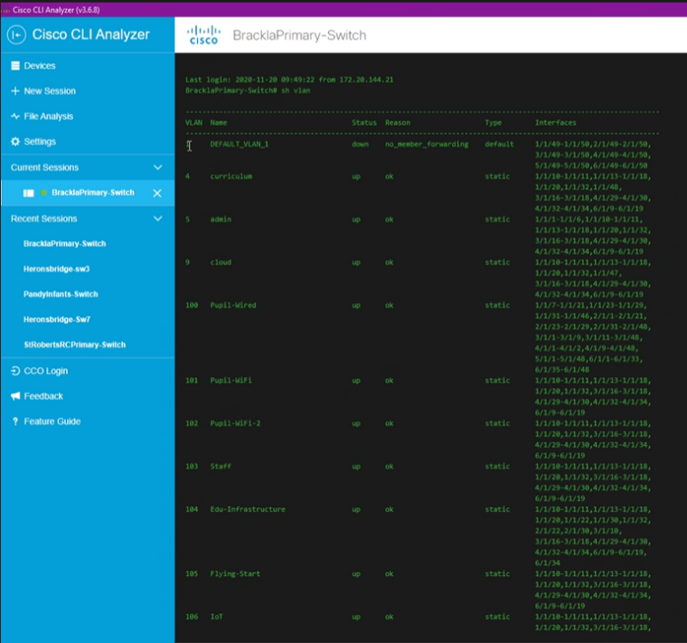

Figure 15: Cisco CLI Analyzer

For security purposes engineers who want to SSH onto a switch must first log into an authentication server which does Terminal Access Controller Access-Control System (TACACS) authentication. If the user logging into the authentication server has appropriate permissions or are in a group with these permissions, then they will have full access to the switch. Other members can have read only privileges such as the service desk and support team who can log onto the switch and view the configurations but not make any changes. The switch configuration for the authentication can be seen in figure 16. There is a local administrator password for the switch that is very complex and only the networking team know. This is in case the network goes down and the switch can’t be accessed remotely through SSH so an engineer needs to visit the site and log in locally with a console cable.
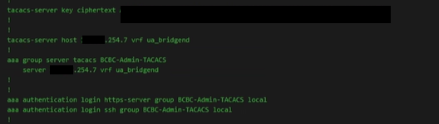

Figure 16: Switch authentication

5.4 Switch stacking
All the switches in Brackla primary school are connected via switch stacking. The switches connected can be seen in figure 17 and the switch topology can be seen in figure 18. This decision was made as it makes for configuring each switch much quicker and ongoing maintenance of the network far easier. With the switch stack, if a new switch needs to be added to the network then the configuration for that switch needs to be very basic, when it is added to the stack it will get the rest of the configuration from there making it much easier and saving time. Furthermore, when a firmware update goes out rather than updates every switch, one firmware update goes out to every switch in the stack. Moreover, if a port needs to be found and the user doesn’t know which switch this port is plugged into then if they give the MAC address of the device plugged into the port this can easily be found. This is due to all the switches being connected so the MAC can easily be located and the appropriate port on the switch can be configured. This is very beneficial to BCBC as some ports in the school needs to be on the corporate network and not the curriculum.
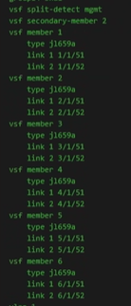

Figure 17: Switches in stack
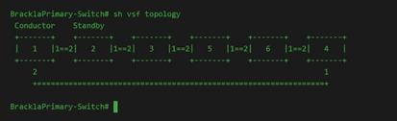

Figure 18: Switch topology

5.5 VLANs
The 3 existing VLANs on the switch are admin, which is the BCBC corporate VLAN used for the admin staff in the school who need to access the corporate network and not the school’s network. This is useful as the corporate Wi-Fi is in every primary school so if IT staff take their laptop to a school their files and programs can easily be accessed. The VoIP VLAN contains all the phones in the school, this is so that the phones have the highest priority on the network as it is such an important service. Although the phones are in their own VLAN the VoIP phone works as a trunk so the phone can be in the VoIP VLAN however, the end user device plugged into the phone will be in the correct VLAN. The last of the existing VLANs already on the switch is the curriculum, previously all the end user devices in the school were in this VLAN. As mentioned, this caused broadcast traffic collision issues and due to it being a singular /21 network the school were running out of IP addresses. At one period the school’s IT engineer had to go round the school turning off devices on the network just to make available DHCP addresses for other devices that needed to be used. The curriculum VLAN is now being used to route the traffic between Brackla and BCBC through PSBA. In the future this VLAN will be changed to a /30 network as the IP address only has a single use as this link between sites and does not need usable addresses.
The next step was to create the new VLANs that had already been designed and had the scopes made in the DHCP server and configured them on the switches. The pupil wired VLAN will contain all the pupil desktops around the school, the majority of which are in the IT suites where the pupils have IT lessons. There are 2 pupil Wi-Fi VLANs due to the sheer number of pupil devices especially since the new chromebooks were purchased. The staff VLAN contains all staff devices desktops and laptops. Edu-infrastructure contains all the schools’ printers and scanners. The IoT VLAN contains IoT devices such as the heating system which can be controlled remotely from anywhere. The flying start VLAN is for flying start staff who are childcare workers. Lastly, the cloud VLAN is for the free cloud Wi-Fi from BT which gives anyone free internet access that requires it. Figure 19&20 shows all the VLANs on the switch including the previous VLANs and the new ones.

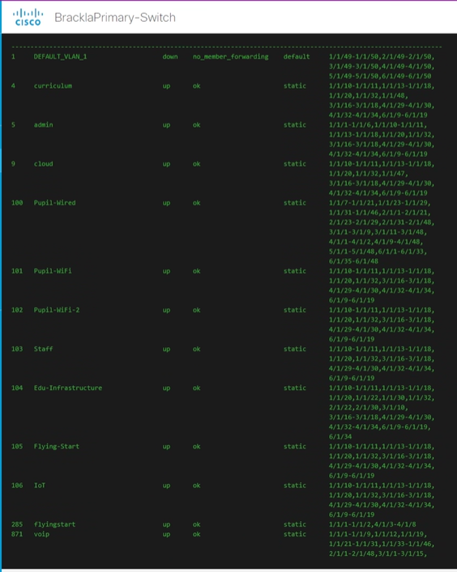

Figure 19: VLANs implemented I
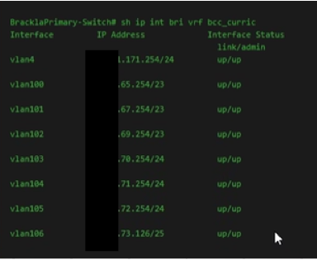

Figure 20: VLANs implemented II

XX.XX.64.0 /20 is the full IP block given to the school by BT which is then split in to VLANs. As a /20 network was chosen for Brackla, there is still massive amounts of room to expand the network. Brackla can go all the way up to XX.XX.79.254 and currently have only gone up to XX.XX.73.126. This gives the school the opportunity to expand their network if they wish over the next few years without having to go to PSBA to request a new IP range. This takes time and as highlighted in this project can incur a potential charge. Figure 21 shows the VLANs and their subnet sizes.
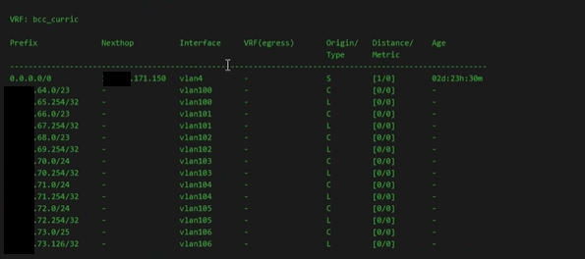

Figure 21: VLANs implemented III

5.6 Port configuration
Figure 22 shows that spanning tree protocol (STP) is enabled on all VLANs, preventing looping within the network. Brackla have had experiences in the past where a user accidentally plugged a VoIP phone into another VoIP phone which caused a loop in the network. However, with this STP switch configuration (which has BDPU-Guard and loop-protect enabled), the switch will shut down any port that is in a loop preventing this issue from happening again. Figure 23 shows spanning-tree bpdu-guard which is configured on every port.
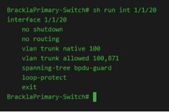
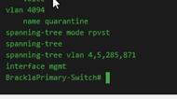

Figure 22: Spanning-tree Figure 23: Spanning-tree bpdu-guard

There are currently no port security features enabled but a demonstration will be conducted in packer tracer suggesting future upgrades to the network.

5.7 Wireless Access Points

5.7.1 AP dynamic port profile
Previously, in schools and in BCBC corporate buildings there were dedicated ports on the switches that APs were plugged into, so they had a specific configuration on the switch. This caused an issue as when engineers were patching in network points, if an AP was previously plugged into an empty port and the engineer patched that port to have an end user device connected. This meant the port had the incorrect configuration for the end user device. However, with dynamic profile that are being pushed out on the new network Link Layer Discovery Protocol (LLDP) will detect on the switch if an AP is plugged in and will apply the AP configuration that has been configured to that port on the switch. If the AP was unplugged, then when an end user device gets plugged back in the port configuration will change, and it will go back to the previous configuration. This saves time having to configure ports every time a new AP needs to be installed, but also mitigates the issue that was previously happening where ports that had previously had APs plugged into them had the incorrect port configuration. Figure 24 shows the configuration a port on a switch gets when an AP is detected.
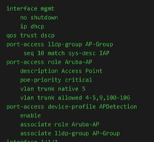

Figure 24: Dynamic port configuration

5.7.2 Brackla Wi-Fi networks
The configuration for the APs is done through a web browser. From here the Wi-Fi networks can be configured for the APs. In Brackla there are three networks that must be configured, these networks can be seen in figure 25. The corporate Wi-Fi which is in every primary school, Brackla’s main Wi-Fi and a staff Wi-Fi. Figure 26 shows the wireless networks and how many devices are connected to each of them. There are currently so few as the screenshot was taken during the summer holiday.
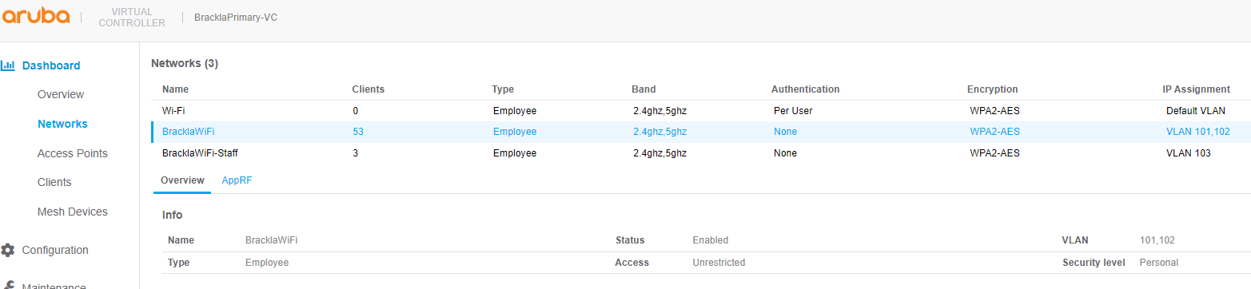

Figure 25: AP wireless networks
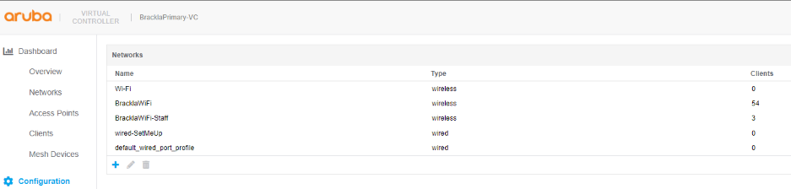

Figure 26: Connected devices

5.7.3 AP configuration
Figure 27 shows the AP configuration for the VLAN settings. In these settings configuration must be done choosing how the AP will have its IP address assigned, and how it will have its VLAN assigned. The configuration for the staff Wi-Fi is to be network assigned, meaning it will get the IP address from the DHCP server. The VLAN assignment is static as this is the configuration for the staff Wi-Fi and VLAN 103 is the staff VLAN, so any device in this VLAN will receive staff policies such as elevated web filtering.
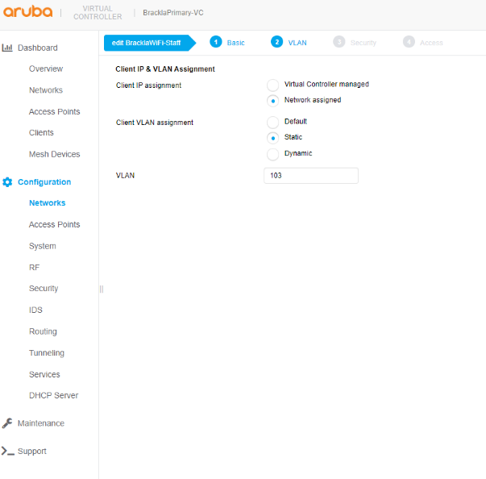

Figure 27: AP VLAN configuration

5.7.4 Security
The next step is security settings which can be seen in figure 28. This is where the security levels are set along with the key management and the password for the router. This section also contains further configurations containing the IEEE standard for fast roaming 802.11r which is turned on. Furthermore, 802.11k is turned on which is an amendment that extends Radio Resource Measurement mechanisms for WLANs. Lastly, 802.11v is configured which allows staff and pupil devices to exchange information about the network topology which is beneficial to the wireless network.
The last configuration page for the APs is access. This allows for access lists to be set on the network however, this has not been configured as it is not required.
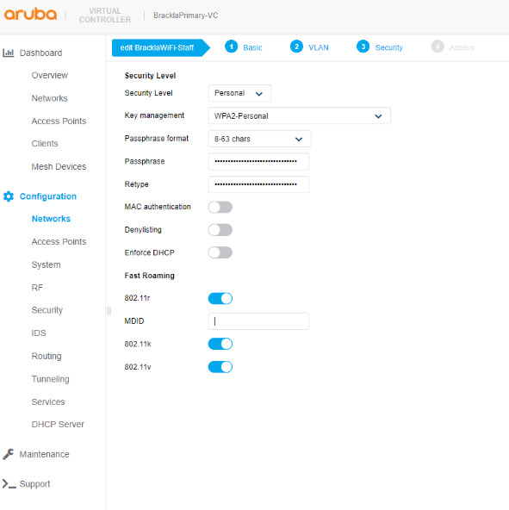

Figure 28: AP security configuration

5.8 Server monitor
Further switch configuration is displayed in figure 29, which includes a server monitor. This is a useful tool to the network team as it shows if any switches or APs go down across the whole council. Although these issues usually get reported by the site, a notification is instantly sent when a network device goes down which means the issue can be resolved quickly. This service also provides further monitoring such as the bandwidth being used by the school. If the school are reporting slow network speeds, then this can be checked so that the school can be advised as to why.
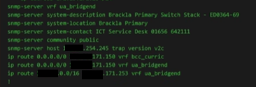

Figure 29: Server monitor

5.9 Firewall
Due to do security implications there cannot be screenshots on the firewall displayed.
The firewall that is used across BCBC on both the corporate network and curriculum is a next generation firewall. This is far more advanced than the previous firewall and comes with a large range of benefits to the security of the network. The previous firewall could only block IP addresses however, the new firewall does deep packet checks at the application layer to assess if the packet is malicious. If anything is detected, this will be flagged and a notification will be sent to IT to review this potential threat. These deeps packet checks are done on every packet which makes the network more secure as it makes any malware or virus extremely hard to go undetected. Furthermore, it detects any suspicious behaviour, for example if a user tried to log onto their laptop from China instead of Wales it would be flagged, and necessary actions can be taken.
As part of the project the firewall had to be reconfigured so that it is working properly with the new IP address range. This has been achieved as the firewall is working properly and the network is secure.

5.9.1 Web filtering
Previously there was a dedicated server for web filtering, however the new firewall does the web filtering as well. This is where the configuration for the VLAN access is done allowing teachers to have access to more websites than the pupil VLANs, such as YouTube. Groups have been configured on the firewall grouping primary schools together, as a lot of the school’s share the same requirements when it comes to web filtering. This saves many hours having to configure web filtering for each school.
As part of the network upgrade these new filtering groups were created and policies were applied to ensure no one could access sites that might contain any malicious content. Furthermore, pupils are kept from seeing inappropriate websites as a result of being in the wrong VLAN. An example of this is if a pupil was in the staff VLAN they could have access to YouTube that isn’t child restricted and watch videos that are not appropriate for them.

5.10 Conclusion
As shown in the figures and text in chapter 5 each part of the network upgrade that was set out at the beginning of the project, stated in the aims and objectives, was implemented.

6 Analysis

6.1 Introduction
Analysis must be completed on the data acquired by interviewing the IT engineer and IT co-ordinator plus BCBC’s network analyst to deem if the project was a success. Valuable data would have been taken from the questionnaires given to every teacher in the school. However, due to the issue with BT, the network upgrade was implemented during the summer holidays. As a result, teachers were unable to answer the questionnaire until after the project deadline. Therefore, the success of the project will be deemed from the interview answers.

6.2 Analysing the data
The 3 people that were interviewed are key stakeholders in Brackla primary school regarding the network and its infrastructure, so their opinion holds value [Appendix B]. As stated in the interviews, all goals that were set out when planning the project upgrade were met. The network performance has been improved due to the switches and Aps being installed, plus Wi-Fi6 features have improved the user experience on staff and pupil devices. With the new IP address range provided to Brackla they are now able to have all their current devices turned on at the same time with plenty of room for future upgrades. Furthermore, the configuration of the firewall and the improved web filtering have improved the schools network security exponentially. Moreover, security has been improved with the implementation of the VLANs segregating parts of the network that users should not have access to. These VLANs have also stopped broadcast traffic issues due to too many devices being in one VLAN. The VLANs have made the network much easier to manage. All these positives, as well as there being no downtime due to the project being done over the summer have contributed to the success of the project. Despite the problem that was faced with BT, overall customer satisfaction has been met resulting in a successful project.

6.3 Conclusion
Due to the network upgrade being implemented in the summer holidays, the datasets that were to be acquired from the teachers in the school were unable to be received before the deadline. This has affected the accuracy of the analysis of the network upgrade. However, on reviewing the interviews from 3 key stakeholders, the project has been deemed a success. This is due to overall improvement of the network performance and security as well as the resolution of the shortage of IP addresses.

7 Evaluation

7.1 Introduction
This chapter examines whether the project's aims and objectives were met, as well as an evaluation of the literature review. It also considers how the project would be done differently if it were done again.

7.2 Was the aim and objectives of the project met
The objectives that were set out at the start of the project were met. New Aruba switches and APs were installed across the school which improved network performance. Network security was also improved, due to the features that these new network devices have in comparison to the previous switches and APs in the school. The IP address range that PSBA supplied was sub netted into appropriate VLAN sizes that resolved the shortage of IP addresses and fixed the issues Brackla was experiencing with broadcast traffic. The DHCP server rhubarb was configured as the main server to assign DHCP addresses across the school. A scope was created for each VLAN on the curriculum network. The DHCP server custard was configured as a failover in case rhubarb went down, minimising downtime. The next generation firewall was also configured which improved network security by flagging any suspicious activity or any malicious packets on the network. This firewall also does the web filtering, which blocks any users going to websites that could be harmful. Furthermore, the web filtering has different policies set for staff and pupils stopping pupils from accessing anything deemed inappropriate. In addition, the firewall and the security policy that is in place ensures all devices on the network are up to date with the latest version of Windows Defender, resulting in improved network security. Data gathered from the interviews suggest that the project was a success as all my objectives have been met and consumers were satisfied. Questionnaires were not able to be used as a useful source of data. Due to the delays with PSBA, the network upgrade was implemented during the summer holidays so the teachers will not be able to complete the questionnaires until after the project deadline. This provides a limited data set which may hinder the validity of the project. A suggestion for a future network upgrade is that 802.1X Dynamic VLAN assignment should be implemented as it will allocate a user into the correct VLAN authenticated from Active Directory, this will make assigning VLANs far easier. Furthermore, in the distant future if a shortage of IP addresses arises again, BCBC can look to implement a IPv6 network which would solve the problem. The aim of designing and implementing a network upgrade for Brackla primary school was met as every objective was achieved and the project was deemed a success by the head teacher and the school’s IT engineer, whose opinions are highly valued.

7.3 If done again how would the project be done differently
If the project was implemented in another school, it would be beneficial for BCBC to request PSBA to provide an IP block for the chosen school. This would allow ample time for completion of the project and avoid standstills in the upgrade. This would in turn provide a larger data set, allowing for questionnaires to be completed, resulting in more reliable data.

7.4 Literature review evaluation
Information gathered during the literature review provided guidance on implementing a network upgrade However, this was not entirely relatable to the network upgrade in this project as the requirements were different to those published.

8 Conclusions and recommendations

8.1 Introduction
This chapter concludes the project for the network upgrade but also has recommendations for future upgrades that the school can look to implement.

8.2 Conclusions
The aim of this project was to complete a network upgrade in Brackla primary school. A literature review was conducted into relevant topics to expand knowledge and help guide the format of the upgrade. The research onion was utilised to systematically design a study to ensure valid and reliable results that encompass the aim and objectives. A thorough design plan was set out to ensure a smooth implementation of the network upgrade. The sections discussed above allowed this upgrade to be successfully implemented without any setbacks, once the issue with BT was resolved. Interviews encompassing open ended questions were conducted among 3 stakeholders to assess the success of the project. This upgrade was deemed a success.

8.3 Recommendations
Although many areas of Brackla’s network were upgraded there is still room for future upgrades. The first recommendation that should be implemented immediately is port security on every switch port in the school, this will prevent anyone from plugging in an unauthorised device into the network. Although it is unlikely that a cyber attacker would physically enter Brackla primary school, it is better to be prepared with port security maximum MAC addresses set to one and port security violation set to shut down. The port would shut down and report that a new device has been plugged in and the MAC address has not been recognised. The configuration for these settings can be seen in a demo lab created in packet tracer in figure 30. Figure 31 shows the ports after they have been configured with port security.

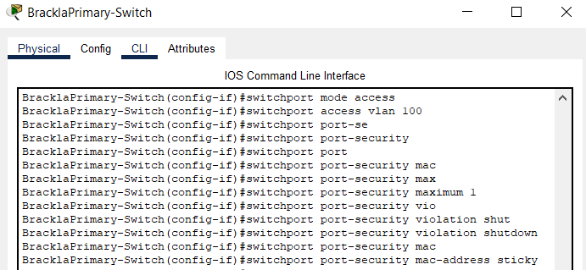

Figure 30: Port security configuration

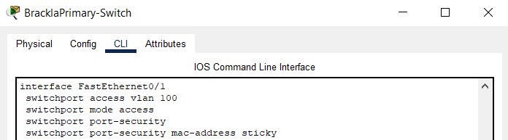
Figure 31: Port security configured

The second recommendation is that DHCP snooping is configured on switches. DHCP Snooping is a layer 2 security technology incorporated into the operating system of a capable network switch that drops DHCP traffic determined to be unacceptable. DHCP Snooping prevents unauthorised DHCP servers offering IP addresses to DHCP clients. The configuration for DHCP was done in a packet tracer lab shown in figures 32, 33 and 34. The recommendation is that DHCP snooping is configured on all switch ports to protect against DHCP starvation attacks.

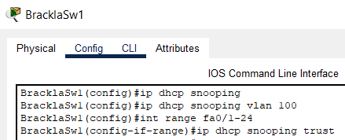

Figure 32: DHCP snooping I
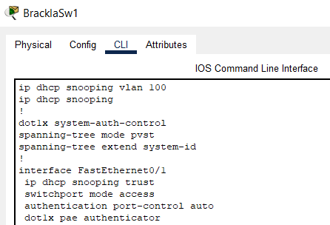

Figure 33: DHCP snooping II

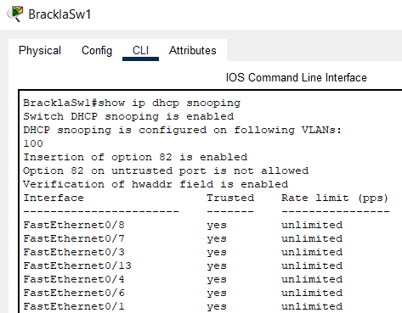

Figure 34: DHCP snooping III

The third recommendation is that IEEE 802.1X Dynamic VLAN assignment is implemented to the network. This assigns authenticated user devices into the correct VLAN from the authentication server, which in BCBC’s case would be Active Directory. This would make managing VLANs easier, as it will be done automatically while also improving security. If a pupil signs into a staff device it will change from the staff VLAN to the pupil VLAN limiting their access. A demonstration was planned for this, but it is not possible to do in packet tracer.

Lastly, a future upgrade to be considered is moving to IPv6. This will prevent the school from ever running out of IP addresses again, while also introducing new features such as multimedia delivery, QoS, autoconfiguration, security, and mobility enhancements. BCBC chose not to implement IPv6 for this project in order to standardise the network across corporate and curriculum, as neither has implemented IPv6. The new network had hundreds of IP addresses left spare after the network upgrade, so this change does not need to be made right away, but it will be made at some point.

9 Reflection

Implementing this project has improved my networking knowledge greatly, which I’m confident will pay dividends in helping me gain a job in networking. Notably it’s provided me with hands on experience configuring switches and APs which I feel is invaluable. Furthermore, it’s provided me with exposure to parts of the network that I have never been given the chance to work on, such as configuring the DHCP server for Brackla. Although I have been taught how to subnet in college and during my degree, real life application of this knowledge has been extremely beneficial to help cement this knowledge and provide experience. I feel a great sense of achievement following the completion of this project, gaining a whole host of personal growth.
I believe I could have performed better if I had been able to select a project on an area outside of work. Due to BCBC policies and the fact I am currently in the support team rather than the networking team, my project options were limited.

10 References
[1]"Configuring VLANs", Cisco. [Online]. Available: https://www.cisco.com/c/en/us/td/docs/switches/datacenter/sw/5_x/nx-os/layer2/configuration/guide/Cisco_Nexus_7000_Series_NX-OS_Layer_2_Switching_Configuration_Guide_Release_5-x_chapter4.html.
[2]T. Feuzeu and B. Cousin, "A New Scheme for Interconnecting LANs with Label Switching Bridges", 2005.
[3]"Benefits of VLANs", NetworkQna. [Online]. Available: http://networkqna.com/benefits-of-vlans/#:~:text=Benefits%20of%20VLANs%201%20Broadcast%20Control%20%3A%20Broadcasts,routers%20costlier%20than%20switches%20.%20More%20items...%20?msclkid=bc508e1eb19f11ecba05bdd339bc8991.
[4]J. Herbst, "VLANs: 5 Types and Benefits - Summit 360", Summit 360. [Online]. Available: https://www.summit360.com/2017/08/30/vlans-types-benefits/?msclkid=74a7852bb1a111eca5bd2e47696b3cf5.
[5]P. Tajiri, "Cisco edge upgrade", 2015.
[6]N. Milovanov and I. Bogomilov, "IPv6 based building automation solution integration into an IPv4 network service provider infrastructure", 2012.
[7]N. Sarkar and B. Soorty, "Evaluating IPv6 in Peer-to-Peer Gigabit Ethernet for TCP using Modern Windows and Linux Systems", International Journal of Business Data Communications and Networking, vol. 9, no. 1, pp. 50-63, 2013. Available: 10.4018/jbdcn.2013010104.
[8]N. Hubballi and N. Tripathi, "A closer look into DHCP starvation attack in wireless networks", Computers &amp; Security, vol. 65, pp. 387-404, 2017. Available: 10.1016/j.cose.2016.10.002.
[9]S. Majumdar, D. Kulkarni and C. Ravishankar, "DHCP Origin Traceback", Distributed Computing and Networking, 2011.
[10]"Configuring Port Security", Cisco. [Online]. Available: https://www.cisco.com/c/en/us/td/docs/switches/lan/catalyst4000/8-2glx/configuration/guide/sec_port.html
[11]Y. Zheng, Z. Li, X. Xu and Q. Zhao, "Dynamic defences in cyber security: Techniques, methods and challenges", Digital Communications and Networks, 2022.
[12]M. Munther, F. Hashim, N. Abdul Latiff, K. Alezabi and J. Liew, "Scalable and secure SDN based ethernet architecture by suppressing broadcast traffic", Egyptian Informatics Journal, vol. 23, no. 1, pp. 113-126, 2022. Available: 10.1016/j.eij.2021.08.001.
[13]"Using Packet Capture to Troubleshoot Client-side DHCP Issues", Cisco Meraki. [Online]. Available: https://documentation.meraki.com/General_Administration/Tools_and_Troubleshooting/Using_Packet_Capture_to_Troubleshoot_Client-side_DHCP_Issues.
[14]"IEEE 802.1X Authentication and Dynamic VLAN Assignment with NPS Radius Server - Expert Network Consultant", Expert Network Consultant. [Online]. Available: https://www.expertnetworkconsultant.com/configuring/ieee-802-1x-authentication-and-dynamic-vlan-assignment-with-nps-radius-server/.

[15]K. Sadique, R. Rahmani and P. Johannesson, "Towards Security on Internet of Things: Applications and Challenges in Technology", Procedia Computer Science, vol. 141, pp. 199-206, 2018. Available: 10.1016/j.procs.2018.10.168.
[16]"Can the ‘research onion’ help your thinking around the philosophical and methodological underpinnings of your SoTL project?", #UofGSoTL. [Online]. Available: https://uofgsotl.blog/2021/07/02/research-onion-sotl-project/.
[17]D. Jansen, "Saunders' Research Onion: Explained Simply (+ Examples) - Grad Coach", Grad Coach. [Online]. Available: https://gradcoach.com/saunders-research-onion/.
[18]"IDC's Worldwide Trackers Show Growth in the Ethernet Switch and Router Markets in Q3 2021", IDC: The premier global market intelligence company, 2021. [Online]. Available: https://www.idc.com/getdoc.jsp?containerId=prUS48502421.

11 Appendices

Appendix A:
Has the Aruba network hardware made a difference to network performance compared to the Cisco kit that was previously installed?
Have the new devices that were purchased with the budget left over from going with Aruba made an improvement to the school’s IT infrastructure?
Has implementing the new VLANs been a success?
Has it resolved the broadcast traffic collision issues the school was experiencing?
Has the schools network security been improved?
Has this project made an improvement to the network performance?
Were there any problems or difficulties faced with this network upgrade?
Was the project completed without any downtime?
Would you deem the network upgrade a success?

Appendix B:
Interview questions and answers
Has the Aruba network hardware made a difference to network performance compared to the Cisco kit that was previously installed?
BCBC network analysist: Yes. Although we didn't have major performance issues previously, the old hardware was out of support and the new kit is a lot newer. The fibre backbone connecting all the switches was also upgraded. From the Wi-Fi side, the new kit supports 802.11ax.
IT engineer: Yes, from the perspective of actually being in the school dealing with day to day calls after around 5 years the Cisco network hardware started to drop in performance. Since the Aruba kit has been installed the teachers have reported a much better experience.
IT co-ordinator: Yes, I used to have to wait much longer for my applications to load. Since the new network hardware has been installed I haven’t had any issues.

Have the new devices that were purchased with the budget left over from going with Aruba made an improvement to the school’s IT infrastructure?
BCBC network analysist: Learners have new devices with better performance that support gigabit networking interfaces and 802.11ax wireless connectivity.
IT engineer: Yes, before these new device were bought for the school some of the devices being used were almost 10 years old so not only was the performance bad but that had some security concerns.
IT co-ordinator: The previous devices were extremely out dated and the new devices have had nothing but good reviews from staff and pupils so definitely.

Has implementing the new VLANs been a success?
BCBC network analysist: Yes, schools now have an expanded capacity for connecting a larger number of devices and room for future growth.

IT engineer: This has been a major success, previously I had to go round the school turning off devices that weren’t being used so that other devices that were being used could get an IP address. Also the web filtering benefits it has come with such as staff and pupils having different web filtering policies has been a huge benefit.

IT co-ordinator: Yes this has been a success and we now have enough IP addresses for all the current devices on the network but also room for upgrades such as implementing new IoT devices.

Has it resolved the broadcast traffic collision issues the school was experiencing?
BCBC network analysist: Better segregation of network traffic reduces the amount of broadcasts in each network segment which this upgrade has done.

IT engineer: Yes, previously we saw performance issues which I believe was related for broadcast collision issues and since we have made the change I have not seen these issues. However, further testing will have to be done when all the kids are back in school.

IT co-ordinator:
I do not know much about these issues so I couldn’t say.

Has the schools network security been improved?
BCBC network analysist: By segregating and better organising the network traffic it has allowed for more refined access control, both locally at each school and on the central firewalls.

IT engineer: Yes, as pupils now can’t see parts of the network they shouldn’t be able to such as the IoT VLAN and also the web filtering which I previously mentioned.
IT co-ordinator: Again, this is not my area but I do see the benefits it has brought.

Has this project made an improvement to the network performance?
BCBC network analysist: Yes with new hardware and better logical organisation of the network.
IT engineer: Yes, due to the new network hardware but massively due to the new staff and pupil devices.

IT co-ordinator: Yes definitely.

Were there any problems or difficulties faced with this network upgrade?
BCBC network analysist:
Other than the initial issue we run into with BT most of the network upgrade was pretty straightforward.
IT engineer: Other than the project being done later than when I was told it would be done and the fact I had to come into the school during the summer holidays no it went pretty straight forward.

IT co-ordinator: No once the issue with BT was resolved it was smooth sailings.

Was the project completed without any downtime?
BCBC network analysist: No major downtime, only very brief blips as devices were moved between VLANs and picked up new DHCP leases.
IT engineer: There would have been if it was during term time but as it was done during the school holidays there was no downtime.
IT co-ordinator: No there wasn’t any downtime as the teachers and pupils were not in the school when it was done.

Would you deem the network upgrade a success?
BCBC network analysist: Yes, the network is now organised much better and the schools have more capacity for their new incoming devices. We have also built in enough capacity for easier future growth.
IT engineer: Yes, the project has been a major success.
IT co-ordinator: Yes definitely we are not able to purchase more devices and look to improve the schools infrastructure.

