Student Name: Tefik Leshkov
Student ID: 2316010
Word count: 974
Project Proposal
Independent Project
LCBB6014

Table of Contents
1) Introduction & Background 2
2) Literature Review 2
3) Theoretical Framework 3
4) Research Methodology 3
5) Expected Contribution 3
6) Limitations 4
7) Proposed Timeframe 4
8) Conclusion 4
9) References 4

1) Introduction & Background
Organisational culture is often described through formal values, mission statements, and strategic messaging (Kummerow and Kirby, 2022). However, culture is more accurately understood through everyday practice: how decisions are made, how people communicate, what behaviours are rewarded, and what employees learn is acceptable within the workplace (Kummerow and Kirby, 2022). In this sense, culture reflects “how things are done here”. Leadership is central to this process because employees frequently interpret organisational priorities through the daily behaviours of managers rather than through official statements alone (Robbins et al., 2019).
This study aims to explore how everyday leadership behaviours shape organisational culture by influencing workplace norms, routines, and employee expectations. The objectives are: first, to examine how organisational culture is expressed through everyday workplace practices; second, to identify the leadership behaviours that influence employee perceptions of acceptable conduct; and third, to analyse how leaders reinforce or alter organisational culture through daily actions and interactions. The main research question is:
How do everyday leadership behaviours shape organisational culture within the workplace?
This topic is important because organisational culture has significant implications for engagement, trust, performance, and consistency of behaviour. Although leaders often communicate desired values, culture is ultimately sustained through repeated actions, decisions, and responses to ordinary situations. The proposed research therefore focuses on the practical and behavioural dimensions of leadership influence.

2) Literature Review
The literature suggests that organisational culture extends beyond surface-level symbolism or corporate messaging. Schein (2010) conceptualises culture as operating across three levels: artefacts, espoused values, and underlying assumptions. This framework is particularly useful because it distinguishes between what organisations claim to value and what is actually embedded in daily behaviour. Similarly, Alvesson (2013) argues that culture is not a static organisational feature but a complex and contested pattern of meaning that influences conduct and interpretation.
Leadership research supports the view that leaders play an important role in shaping these patterns. Yukl (2013) argues that leadership influence operates through both formal and informal mechanisms, including role modelling, behavioural reinforcement, and the communication of priorities. In related work, Bass and Riggio (2006) suggest that leaders shape organisational meaning by aligning values, behaviour, and expectations. However, such perspectives can risk overstating the degree of control leaders possess over culture, particularly where organisational norms are also shaped by history, systems, and employee interpretation.
A particularly important debate concerns the distinction between espoused and enacted culture. Argyris and Schön (1974) show that organisations often present one set of values while operating according to another. In practice, employees may learn more about organisational expectations from how leaders behave in routine situations than from what official policies state. This study builds on that distinction by examining how leadership behaviour functions as a practical mechanism through which organisational culture is reinforced, sustained, or subtly altered.

3) Theoretical Framework
This study will draw primarily on Schein’s (2010) model of organisational culture. The model is appropriate because it enables analysis of culture at both the visible and underlying levels, allowing attention to be paid to the relationship between formal values and everyday practice. It is especially useful for examining how leadership behaviour may influence the translation of espoused values into routine norms.
The study will also be informed by social learning theory (Bandura, 1977). This perspective suggests that individuals learn appropriate behaviour through observation, imitation, and reinforcement. Applied to organisational settings, it implies that employees may infer “how things are done here” by observing what leaders model and normalise. Together, these frameworks provide a coherent basis for analysing how leadership behaviours shape organisational culture through everyday signals and interactions.

4) Research Methodology
This study will adopt an interpretivist philosophy because it seeks to understand how leadership behaviour and organisational culture are conceptualised and represented within existing literature and documentary sources. The research will use an inductive qualitative secondary research design, as this is appropriate for identifying themes, patterns, and meanings without collecting primary data.
Data will be gathered from peer-reviewed journal articles, academic books, and selected organisational and professional sources relevant to leadership and organisational culture. Source selection will prioritise materials that address leadership behaviour, cultural norms, workplace practices, and the relationship between formal values and enacted conduct. The material will be analysed using thematic analysis in order to identify recurring concepts and interpret how leadership behaviours are understood to influence culture.
As no human participants are involved, the ethical risks are limited. However, the study will maintain academic integrity through accurate referencing, careful use of sources, and a clear distinction between documented evidence and the researcher’s interpretation.

5) Expected Contribution
The study’s theoretical contribution lies in synthesising literature on leadership and culture in a way that foregrounds behavioural mechanisms rather than broad generalisations. Its practical contribution is to highlight that culture is shaped not only through strategy statements and value frameworks, but through the repeated conduct of leaders in everyday workplace settings. While policy relevance is likely to be limited, the findings may offer useful insight for leadership development, management training, and organisational efforts to align stated values with lived practice.

6) Limitations
The study is limited by its reliance on secondary sources, which means it will not capture direct employee experience or organisation-specific detail. Existing literature may also reflect selective interpretations of organisational reality. As a result, the findings will be interpretive rather than empirically generalisable.

7) Proposed Timeframe
Weeks 1 to 3 will focus on literature searching and source selection. Weeks 4 to 6 will involve detailed reading and thematic coding. Weeks 7 to 9 will focus on drafting the literature review, theoretical framework, and methodology chapters. Weeks 10 to 12 will be used for refinement, editing, and final submission preparation.
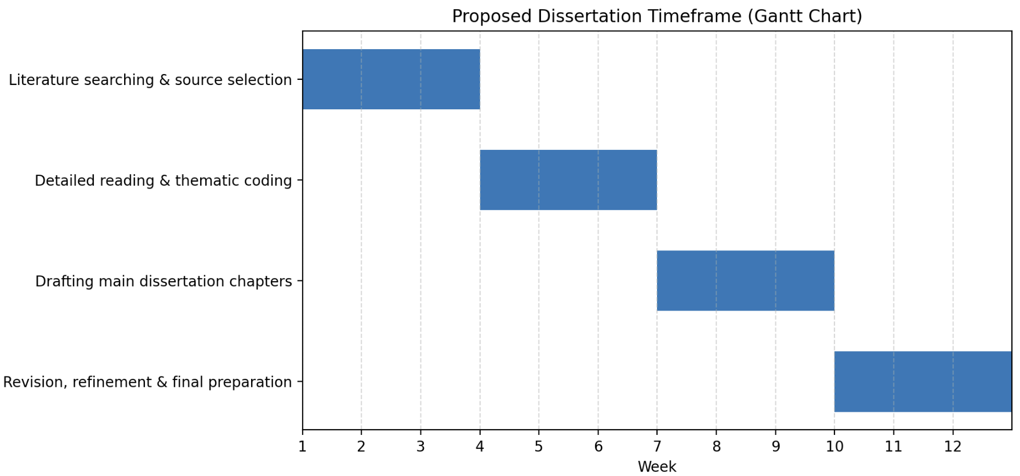

8) Conclusion
This proposal outlines a feasible and academically relevant secondary research study into how everyday leadership behaviours shape organisational culture within the workplace. By focusing on behavioural signals, workplace norms, and the relationship between espoused and enacted culture, the study aims to provide a more grounded understanding of how “how things are done here” is formed and sustained in organisational settings.

9) References
Reference list
Alvesson, M. (2013). Understanding organizational culture. Los Angeles ; London: Sage.
Argyris, C. and Schön, D.A. (1974). Theory in practice: Increasing professional effectiveness. 1st ed. San Francisco, Calif.: Jossey-Bass.
Bandura, A. (1977). Social learning theory. Englewood Cliffs ; London: Prentice-Hall.
Bass, B.M. and Riggio, R.E. (2006). Transformational Leadership. 2nd ed. Psychology Press.
Deal, T.E. and Kennedy, A.A. (2000). Corporate cultures : the rites and rituals of corporate life. New York: Basic Books.
Hatch, M.J. (1993). The Dynamics of Organizational Culture. The Academy of Management Review, [online] 18(4), pp.657–693. doi:https://doi.org/10.2307/258594.
Kummerow, E. and Kirby, N. (2022). Organisational culture : concept, context, and measurement. Singapore: World Scientific.
Martin, J. (2002). Organizational Culture. SAGE Publications.
Robbins, S., Judge, T., Edwards, M., Sandiford, P., Fitzgerald, M. and Hunt, J. (2019). Organisational Behaviour. 9th ed. S.L.: Pearson Education Australia.
Schein, E.H. (2010). Organizational Culture and Leadership. 4th ed. San Francisco: Jossey-Bass.
Smircich, L. (1983). Concepts of Culture and Organizational Analysis. Administrative Science Quarterly, [online] 28(3), pp.339–358. Available at: https://www.jstor.org/stable/2392246.
Yukl, G.A. (2013). Leadership in organizations. 8th ed. Upper Saddle River, N.J.: Pearson.

