

Module Name – Problem Solving and Decisions Making
Student Name – Sean Ferguson
Student No. – 19166821
Lecturer Name – Adesewa Ajayi
Module No. - (BMSW4004_LON)
2000 Words Report

PROBLEM SOLVING AND DECISIONS MAKING IN HEALTH AND SOCIAL CARE

CONTENTS

- Introduction

- Methodology

- NHS

- Problem I: Work Overload

- Problem II: Work related stress

- Problem III: Discrimination

- Conclusion

- References

Introduction

Underpaid and overworked healthcare workers are being pushed to their limits by government funding cutbacks. If the current state of global infections of the Coronavirus continue to rise and overwhelm the health care system, what measures can be taken to strengthen the work force?
This report will demonstrate that the effective use of a strategic problem-solving analysis in the work place can be made in various ways.
First of all, by researching key elements that could affect the morale, the mental health or the work-life balance. The focus of the report will consist of various methods such as the Cause-and-Effect Analysis, the P.E.S.T.E.L Analysis and the 7-step Analysis.

Methodology

After a formal email received by one of my employees was thoroughly analysed, it contained three problems that the employee had been experiencing. It has outlined how these problems have had a negative impact on their social and work life.
Detailed strategies are devised and shown how they can be introduced and developed taking into account economic and welfare requirements.

NHS

The British National Health Service (NHS) has the fifth largest employment rate globally with as many as 1.1m stakeholders in the UK sourced from February 2020, according to the website nuffieldtrust.org.uk.
With government funding cuts this means more working hours for healthcare workers. This creates an added pressure on employees’ social lives and mental health. Mental health issues are “the second most common causes for consultation in primary care”, (Lester et al, 2004).

PROBLEM I)
WORK OVERLOAD

My status is a Healthcare professional, a line manager for a team of nurses in an NHS hospital. Some employees are young and inexperienced whilst some have more training in turn, having confidence when working alone or under pressure.
A young employee contacted me via email detailing three workplace difficulties that they have been experiencing. As the line manager it is my responsibility to ensure a face-to-face meeting is made in order to explore how we may achieve the best possible outcome.
Problem I) explains how, as a younger worker been feeling overwhelmed by the workloads assigned. Furthermore, being less experienced has caused need for extra support to boost their confidence and morale, but haven’t received any.
Appreciation was shown for the email as it installs trust and commitment from senior stakeholders to show recognition and praise. For this problem the Fishbone Method has been created.

The Fishbone Method or Cause and Effect Analysis: The Six Factors
The Kaoru Ishikawa Diagram or the Fishbone diagram is a well-recognised and effective tool designed in the 1960’s by Kaoru Ishikawa to identify and display the characteristics of not just the outcome but the variables that influence that outcome Wong (2011). It ensures optimum quality control searching for the root cause of the problem. The diagram effectively displays the methodical process of the analysis.

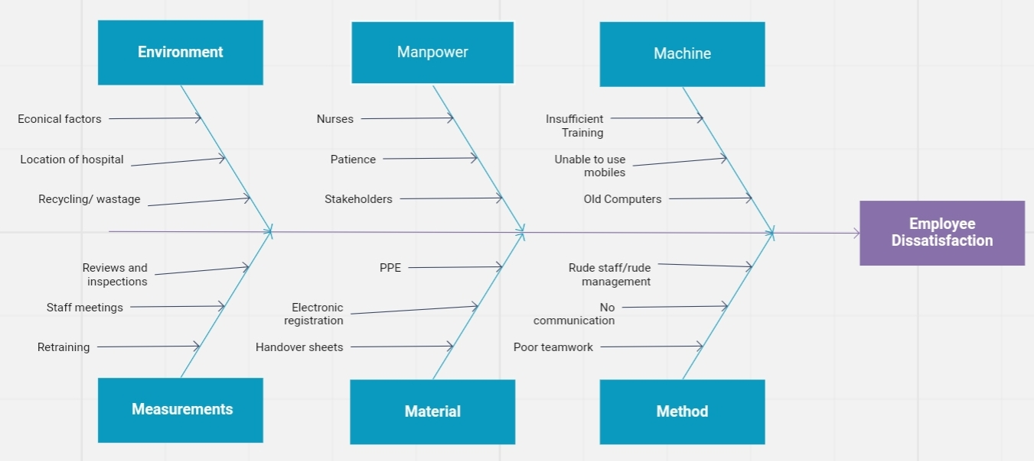 Image 1. Fishbone Diagram
The first step will be to make an investigation into some of the causes that may show how the effects may be controlled.
- Understaffed Management • Inexperienced staff
- Inexperienced management • Insufficient Staff / Supervisors team leadership
- Poor rota supervision • Speaking with other management
- Unprofessionalism

Analysing the collated information from the Fishbone Diagram the steps below will be taken to help improve the current systems and support members of staff:
● Rotas will be reviewed to check shift patterns.

● Ensuring effective communications between myself, supervisors and other stakeholders.

● Integrating effective training for personnel responsible for the rotation of the staff.

● form schedules to methodically give monthly reviews / feedback meetings to staff.

● Weekly and daily briefings and minutes.

Relating factors
The Diagram reflects upon six influencing factors of the workplace problem. Comparing how my employee communicated to me they felt they were overwhelmed with work, which has subsequently been one of the effects. Daily briefings for supervisors and team leaders together where, problems and any related issues can be discussed. Using the interaction between myself and my staff to explain how younger workers were at higher risk to work related stress.
The Fishbone Diagram shows a number of contributing factors but as management there is a necessity to balance between financial resources and how the solution appears to be orientated around being more political to be effective in this problem-solving process.

Results
After using the collated data, a number of potential developments for the problems have been chosen. Looking through my employee`s previous rota`s it was found that they had been working more shifts than anyone in their department, possibly due to lack of attention from responsible staff members. This has been amended and will be revised weekly to ensure it is effectively supervised and does not happen again. It will take place every week throughout the rest of the hospital; Re-evaluations may be made depending on the success. Having less time in this position may contribute to the lack of experience, causing stress. In order to reduce this stress an Apprenticeship Program has been created for anyone who may feel the need to have support from colleagues for reasons like age or experience. This opportunity has been given to my employee.

Meeting Analysis: Personal evaluation
During the meeting with my employee an effective dialog had formed which enforces trust between employee and management creating a more harmonious environment. Face-to- face meetings and interviews are essential for top line stakeholders to show commitment and support. Even though a solution may not be given right away, a description of what will be done and how it will be analysed can then adapted in order to integrate a new system as well as correcting the employee’s problem. After explaining how the Cause-and-Effect Analysis would be an efficient system to use in this situation.

PROBLEM II)
WORK RELATED STRESS

Problem II): the employee states they have worked for the organisation for two years and has been a dependable employee but, unfortunately, work related stress from being overworked has caused them to suffer from severe insomnia. Medical advice has been received in order to monitor the condition and if necessary, to use medication.
In an article by Koplowitz (2019) “younger workers experiencing poor mental health have significant impacts on businesses, this in turn creates a lower interaction at work, feeling unconfident with the employer and having a weakened identity manifesting into underperformance”.
The PESTEL/PESTLE Analysis is an analytical tool for strategic business planning. PESTLE is a strategic framework for understanding external influences on a business or on any project (Zhang et al, 2012).
Problem Solving process uses methodical steps that ensure that problematic situations are rectified and the system that is used is routinely observed.
‘This analysis is searching for a system that can be implemented effectively and also more economical than another solution. Political, Economic, Sociocultural, Technological, Legal and Environmental the analysis formulates different situations based on these factors to develop future predictions and choices creating a more reliving process’ (Alanis, 2018)

PESTEL ANALYSIS
Politically The first step is to the analysis is the create a system that could be integrated and managed as fluid as possible. A solution could be to give all employees free physical and mental health check availability. How could we with the government budget do this?

Economically Is the process going to be cost effective? If the cost of the system equals to more than the amount it would cost to leave the situation then another model will be created. Does the hospital received enough funding for the system introduced? What will be the budget?

Socio-Cultural It means aligning the company policy to respect everyone’s beliefs and values without discrimination. Creating a system with health checks would be equally available to all staff showing professionalism and responsibilities taken on behalf of the employers.

Technological factors may be a big part of workplace stresses, computers and digital devices have been designed to aid you from tablet devices controlling medications and clocking in and making appointments. The health checks could be measures monitored and managed through using technology to show visually analysis reports for anyone seeking assistance that are employed by the NHS. Without technology we would be completely despaired in the modern hospitals. Many lives depend on the technological machines, crucial to survive.

The environment The NHS practices recycling and ensures that the location of hospitals and practices are designed to be environmentally friendly. It also uses a sustainable development unit to measure the carbon emissions/pollution, waste management and water usage.

Legal As an NHS manager it is important to remember that you hold liability for an employee or patient when you take responsibility for them. Their mental health condition could deteriorate and the consequences may have a lasting negative impact. If my employee has communicated to a senior member of staff that they are experience workplace stress anxiety or depression that may affect their social lives then this must be investigated. Anything less could lead to neglect of the professional responsibility.

Conclusions
This method is effective but personally my belief is that it shows more about a business orientated strategy and it seems systematic and methodical but does not show any real solutions as it appears vaguer than the other methods discussed. The Seven-Steps System in the next analysis aims to resolve smaller but more complex problems.

PROBLEM III)
WORKPLACE DISCRIMINATION

Wild et al (2015) discusses the general medical council's survey, which was conducted in 2012 and found that 13% of all medical students have experienced some form of bullying whilst in training. The email detailed how a member of management (Supervisor) has been treating other members of the staff unfairly, discriminating them. Such behaviour created stress and conflict in the workplace, affecting individual’s mental health. `Seven percent of the UK’s health care budget is spent on mental health medication’. Lester et al (2004)

THE SEVEN-STEPS ANALYSIS
The seven-step analysis thoroughly examines the specific cause of the problems in order to efficiently tackle them. This process is methodical, it analyses every aspect of investigating the root cause, finding an appropriate system and then monitoring the progress.

Step 1) Define the problem. This means gathering a clear concept of what the problem is to be able to find a solution. Our problem is employee dissatisfaction working with a senior member. The supervisor has been receiving negative feedback of misconduct.

Step 2) Analyse the feedback. Could this employee be bias to other colleagues or even lying to me? Do I need to speak with other members of the team? Should I move them to work separate shifts?

Step 3) Develop solution: team building activities, daily meetings to optimise communications, creating a better atmosphere by allowing flexible shift patterns and attempt to cross train employees to allow for people that cannot work.

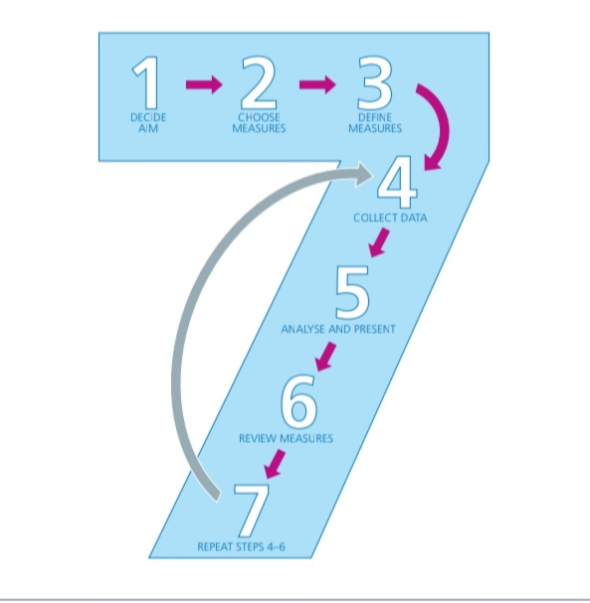
Step 4) Evaluate the best option. As the responsible party for the welfare of my staff it would be suitable to have an investigation into the misconduct. Speaking with all parties involved to create a more accurate image.

Image 2. The Seven-Steps Analys

Step 4) Evaluate the best option. As the responsible party for the welfare of my staff it would be suitable to have an investigation into the misconduct. Speaking with all parties involved to create a more accurate image.

Step 5) Selecting the best option. An email shall be sent to all parties involved; they will each have a slot booked for a meeting to find a resolution.

Step 6) Implementing the solution. Four interviews meetings were made to discuss the issue creating a more accurate image from different points of view. The supervisor communicated that being new in this department has been very stressful and that inexperience has been the primary factor as to the dissatisfied colleagues.
Step 7) Measure the results daily and weekly group meetings will be made to speak about any matters to hand. Fortnightly reviews to management such as team leaders and supervisors of feedback. Paying attention to any negative feedback that may lead back to using step 1.

Conclusion

Many factors should be considered when managing a work place problem, not just indefinite environmental and economic factors but more importantly the mental and physical welfare to the employees of the NHS and healthcare sector.
These methods have now been applied to my working environment, as an NHS manager It has shown how the implementation of one or more of these methods may be able to elevate the health and the welfare conditions in order to maintain a functional working and social life, producing happier workers.

References

- British Journal of General Practice, April 2004 Helen Lester, Jon Glasby and André
- Author links open overlay panel J.R.L.WildH.J.M.FergusonF.D.McDermottS.T.HornbyV.J.GokaniOn behalf ofthe Council of the Association of Surgeons in Training
- Wong Journal of Medical Case Reports 2011, 5:120
- http://www.jmedicalcasereports.com/content/5/1/120
- https://www.thehrdirector.com/business-news/mental-health/younger-employees-likely-suffer-poor-mental-wellbeing4112019/

Strategy Deployment Systems within the UK Healthcare Sector: a case study Shulian Zhang, David Bamford, Claire Moxham, Benjamin Dehe. International Journal of Productivity and Performance Management, 2012

