
Strategic ManagEmenT
LCMB7003
Name - Varsha Chaudhary
Student I'd - 2133119
Lecturer - Charles Oham
Submission Date: January 5, 2023




Executive Summary
Strategic management is a very helpful tool for the organization because it helps in planning and executing the work of the company to achieve its goals and targets. By the use of strategic management, managers become able to analyze every activity at the workplace. It has been analyzed that the concept of strategic management needs that leaders of your organization should introduce new strategies at the workplace so that work culture can be enhanced. It also has been elevated that it provides an effective pathway for the employees to carry out their particular work at job roles. In this report, it has been analyzed how the managers of Nike organizations consider the concept of strategic management.
Different kinds of corporate social responsibility of the organization have been analyzed in this report. Along with that competitive advantage techniques of the organization have been undertaken. There has been an evaluation of the marketing environment of the organization. The organizational structure of the company has also been analyzed. Apart from that various strategic management tools have been analyzed such as SWOT analysis, pestle analysis, etc. Along with that, the value chain analysis and marketing strategies of the organization have been analyzed.

Table of Contents
Executive Summary 1
INTRODUCTION 3
Industry Analysis 4
Key Success Factors of the Company 5
Marketing Environment 7
Strategic Issues 8
ORGANISATIONAL STRUCTURE 8
STRATEGIC MANAGEMENT TOOLS 9
Internal and external Analysis 9
PESTEL analysis 11
Value chain analysis 13
Strategic Choices and Options 15
Action Plan or Recommendations or Strategic Options 16
CONCLUSION 17
REFERENCES 18

INTRODUCTION
Strategic management can be referred to as the ongoing process in which the organization does planning and takes various decisions, and after implementing the plan, the upper level of the organization continuously monitors and analyses the activities of the organization through which they can become able to achieve the goal and target (Ansoff and et al., 2018). Strategic management requires various strategies to constantly change in the organization according to the requirement of the situation, and therefore, management should be strategic, and it is mainly used to provide direction to the plans and policies that have been made by the upper level of the department. It can also be explained that the strategic Management concept is used in the organization through which the organization specifies its goals and targets that they want to achieve shortly. For this particular report, the Nike organization has been undertaken into account. Nike is an American global corporation that is busy designing and developing the sales of footwear and various types of accessories. This organization was founded in the year 1964, and it has its headquarters in the United States. They provide various types of shoes to the customers, such as athletic shoes, sports shoes, casual shoes, etc. In this report, there will be an analysis of the various types of concepts and frameworks that the organization uses to get a competitive advantage. It will be analyzed how the company manages to solve the central issues at the workplace by using various types of theories.
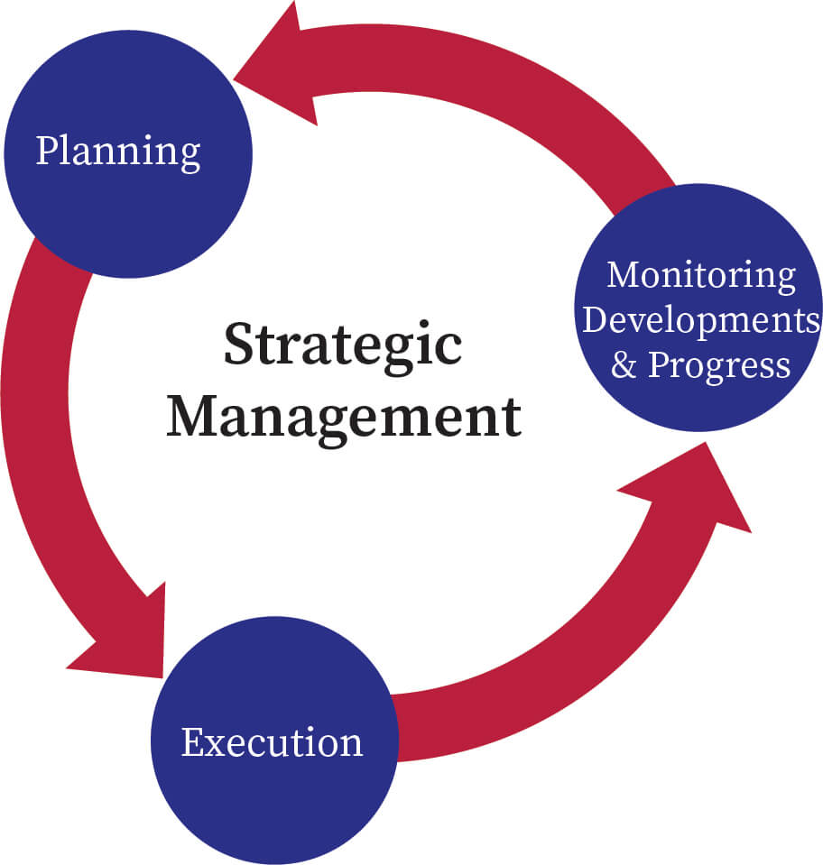
Figure 1: Strategic Management
Source: Bartleby

Industry Analysis/ Strategic Analysis.
Nike Company is from the sportswear Industry. Talking about the products of the Nike organization, they create a wide variety of goods that are differentiated into sports-related categories. They provide track shoes that are meant to be made for running for Nike's earliest offerings to the customer. Since then, the firm has been able to create and sell shoes for a variety of sports, including basketball, cricket, and hockey. In today's time, Nike provides a humongous variety of shoes to customers, and they mainly focus on lighting the weight of the shoes so that customers can feel comfortable after wearing their shoes.


Figure 2: Nike Logo
Source: Encyclopaedia Britannica

One of the main strategies that the upper level of the organization uses is corporate social responsibilities which help the organization fulfil its responsibilities towards society. When Nike was carrying out their operations in the year 2004, they felt that they were overcoming and neglecting the corporate responsibilities that have to be followed in the workplace. After analysing the impact, which was negative way then, the organization implements various types of corporate responsibilities. They became more concerned about the climate change that was being impacted by the industries, and therefore, Nike started to eliminate all those processes of production which cause harmful gases in the air. One of the main problems that organization realizes is that they are dependent upon the use of oil material and fossil fuel energy which extremely creates carbon emission in the year, which ultimately decreases the quality of the environment. Concerning this problem, the organization eliminates the use of fossil fuels, and apart from that, they implement the use of solar plates at the workplace through which they produce electricity and energy. Some of the major responsibilities that the Nike brand carries out are mentioned below:
Environmental corporate responsibility: It can be referred to as the commitment of the organization regarding sustainability and friendly operations. In regards to the Nike organization, they have implemented various strategies to reduce carbon footprints and greenhouse gas emissions through sustainable operations. In the initial stages of the organization, they were using plastic at the workplace, but after analyzing the negative impact of those, they implemented the use of paper bags and eliminated plastic.
Ethical right social responsibility: These corporate responsibilities are undertaken by the Nike organization very seriously because they believe that ethical operations should be carried out at the workplace. It is one of the established shoe brands that are present across the globe, and therefore, they are equal to every person (Nave and Ferreira, 2019). They allow people from different backgrounds and cultures to work with them so that they can maintain good values at the workplace, and it also provides human rights to the individuals.
Economic and corporate responsibility: These are the corporate responsibilities regarding financial support to the community. Please can be referred to as making the financial decision regarding the community welfare. In regards to Nike organization also carry out this corporate social responsibility by donating funds for the girls so that they can come up with unexpected and powerful force to help the community and the world. Now they are contributing to charity with the 1.37 billion dollar charitable gifts. Apart from that, they are also contributing to the growth of children across the world by supporting them in sports and exercise activities.

Key Success Factors of the Company
In comparison to rival brands like Reebok and Puma, Nike has shown to be highly strong. One of the main reasons is brand management because although charging more for the goods, consumers are still willing to pay more for their brands as they are associated with premium quality products that come in a variety of designs. Nike organization becomes able to grow its market across the world because of its strong brand and tough competition in the market. Apart from those, Nike prices are slightly higher than the other brands, but sales of Nike always remain at the top of the chart. Nike organization has a distinct advantage over its competitor. Giving consumers more value and providing high-quality items are two ways to do this. The business has developed better value than its rivals. To give tough competition, and cut-throat competition to the competitors in the market, they use various types of strategies and theories, and one of the main strategies they use is porter's tactics which are helpful for competitive advantage.
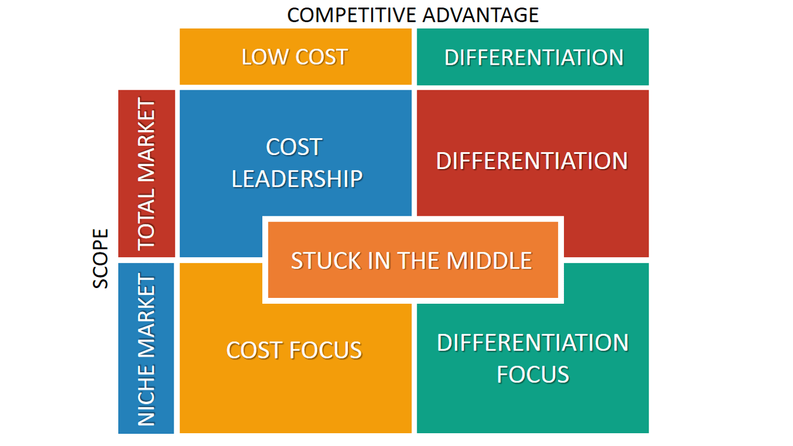
Figure 3 Porter's Generic Model for competitive advantage
Source: Six ads
The upper level of the management department uses porter's generic competitive strategies to stay ahead of their competition in the market. This strategic management method is mentioned below:
Cost leadership: It is the first point of this model in which organizations mainly focus on reducing the cost of the production process through which they can set up the prices for their products and services lower than the market price. There are very sources from which raw materials are being bought at the workplace. Relation to Nike organization faces high costs in the initial stages of their products, but after some time, they analyze the points from which they can cut down the cost of production and raw material (Dagnino, Picone, and Ferrigno, 2021). In today's time, they have collaborated with different kinds of suppliers who sell raw materials to Nike at very reasonable prices. According to the cost, they set up the prices of their shoe products. They mainly believe in cutting down unnecessary costs in the production process, which helps them to give tough competition.
Differentiation: It is the second part of the model in which organizations in the industry focus on producing more valuable products for the buyers. The production department of the organization puts so much more effort into producing unique products than the market so that the needs of the customers can be satisfied to a great extent. In regards to the Nike organization, the key innovative new shoe products according to the wants of the customers through which they stand out from their competition and which helps them to stay strong in the market.
Focus: At this point of the model organization particularly targets a specific group of customers to whom they want to sell their products. In regards to the upper level of Nike organization, they effectively carry out the research and development programs for their potential customers to whom they promote their shoe product. This point of the analysis facilitates the organization to increase its sales by giving cut-throat competition in the market.

Marketing Environment
Nike's marketing approach is a key component of its success. Through various kinds of advertising, it has persuaded consumers to "just do it." Nike has collaborated with well-known athletes through sponsorship deals. It contains a lot of marketing components, like television advertising. Various types of advertisements have been done by the Nike organization, and the first advertisement that they have done is at a marathon in New York. Nike organizations carry out the advertisement process by giving clothing products such as t-shirt shorts to the athletes. One of the major marketing environments they have captured is by collaborating with Michael Jordan, who is a great basketball player. The advertisement done with him has increased the sales of Nike to a very great extent. Till now with Michael Jordan helped the Nike Organization to generate enough revenue.
Apart from that, Nike had to compete fiercely in the market with the businesses like Adidas and Reebok that offer similar goods. Reebok has a large female customer base but when compared to Nike, it often shortens with the marketing strategies. To analyze the marketing environment in the shoe industry, the upper level of the organization is considering the use of the five forces model of competition. They have considered the different aspects of this model through which they become able to analyze the industries' structure and how they can deal with the external forces that affect the business. Implement various kinds of strategies to stay in the competition because the marketing environment is very challenging for the organization as there are very types of competitors present in the market.
The Nike organization has put various types of efforts to balance its production and cost through which they can minimize the power of buyers to bargain with the company (Ansoff, et al., 2018). The administrative level of the organization has made effective relationships with the suppliers through which they do not manipulate the prices of raw materials, and when they increase the raw material prices in advance, they inform the management regarding the prices through which they can accordingly make plans and policies of the financial resources. These types of theories are being applied by the Nike Organization to stay ahead in the competition and to effectively analyze the environment of the market.

Strategic Issues
Superior performance refers to the process of recognizing the level above the standards. To achieve superior performance, Nike has facilitated training and development sessions for the employee. This has helped the company in the attainment of organizational goals and objectives. From the case study, it has been analyzed that Nike has achieved its goal of attaining superior performance with the assistance of competitive positioning as well as value creation. The organization has achieved it through recognition of brand name, advertising, innovation, and creativity in product designing and formulation (Ansoff, et al., 2018). The effective strategic management approach of the company assists it in formulating a competitive edge in the marketplace among numerous competitors. The company also encourage open communication as well as collects regular feedback from the employees as well as a consumer, as it assists the company in gaining a competitive advantage over others in the marketplace. The company also emphasizes reinforcing a positive work environment in the organization. Open communication, as well as an optimistic work environment, helps the employees as well as the organization in building good relationships among the employees.

ORGANISATIONAL STRUCTURE
From the given case study, it can be seen that at the initial stage, the administrative level of the organization was facing challenges to carry out the operational activity effectively. The organization structure was not maintained at the workplace in a proper manner which was proving to be a challenging part for the organization. But after analysing the structural problem, the management department of the organization has decided to organize the work systematically so that employees can easily report to their bosses (Ansoff, et al., 2018). The organizational structure of Nike is Matrix. The company consists of various divisions that are divided into subsidiaries. The organizational structure of Nike majorly focuses on positioning the right people on the right team. In this structure, there is more than one line of reporting managers as it is a combination of two or more different types of organizational structure. In this structure, the worker reports to multiple leaders. In simple words, it can be defined as the process where employees have more than one boss. From the case study, it has been analyzed that with the help of this design, the employees of the organization communicate easily and effectively with each other. This also enhances their productivity and assists them in creating innovative products and services.

STRATEGIC MANAGEMENT TOOLS
The strategic management tool is being used by management to determine the future position of the business organization. There are several advantages of these tools as it increases awareness of the business environment as well as prioritize tasks as per opportunities and threats.

Internal and external Analysis
SWOT analysis
Swot analysis refers to the framework that helps in identifying and analyzing internal factors that affect the functioning and operations of a business enterprise. This analysis also assists the business enterprise in the setting of goals as well as also helps in the formulation, implementation as well as evaluation of these strategies. The SWOT analysis on Nike has been highlighted below-

Figure 4 SWOT analysis (Made by the learner)

Strengths
- Brand awareness and Brand Value- Nike has strong brand awareness as well as brand value. It is one of the known brands all across the globe, and it is memorable, unique, and easy to pronounce. From the case study, it has been analyzed that the symbol of the brand is easily recognized by everyone. The brand value of the company is $42.5 Billion.
- Sustainability- The company also aimed at achieving sustainability. The CEO of the company has addressed that the company will work on the ground of sustainability and will make sure that the functioning of the organization will not affect the environment. It also helps the business in building a competitive advantage and helps the business in making efficient strategic decisions.
- Minimum Manufacturing Cost - As the company produces goods in bulk, the cost of manufacturing is low. From the above case study, it has been evaluated that the company also manufactured its products in foreign nations. This also reduces the manufacturing cost of the enterprise.
Weaknesses
- Weak labor conditions in different countries - The conditions of labor are poor in different countries. It also consists of forced labor, child labor, and lower wages as well as an unpleasant working environment, which are deemed to be unsafe for the labor of the organization.
- Huge Debt- After the analysis of the balance sheet of the company, it has been analyzed that the long-term debt of the company is$ 9.4 billion in the financial year 21, and it is one of the major financial threats for the company (Kim, 2020).
- Lack of Diversification- One of the major weaknesses of the company is the lack of diversification as the company mainly rely on sporting apparel, and after the impact of COVID-19, sports event has been collapsed as well as the crisis discouraged sporting events which led to a huge loss for the organization.

Opportunities
- Digital customer strategy- Nike majorly focuses on its digital business and has closed its physical stores. In the financial year 2021, the brand revenue of the company is 38.7% which comes from its online sales. From the case study, it has been analyzed that the company directly connects with its customers as it assists the company in building a good relationship with the customer with the help of effective strategic management.
- Innovative Products - There are a lot of products that have been produced by Nike, but after analyzing the market trends as well as technological advancement, the company can effectively achieve its goals and objectives and can build a strong position in the marketplace.
- Emerging in New Markets- Nike has its stores in several foreign countries, such as China, Brazil, and India, but the company is also planning to diversify its market in various countries.

Threats
- Enhanced Competition- Nike is one of the dominating brands in the athlete industry, but the emerging brands, as well as competition, have a major threat to the organization as it affects the revenue as well as the profitability of the company. To overcome the competition, the company has designed some innovative products that are being tailored to the needs as well as requirements of the sportspersons.
- Trade Tension- From the case study, it has been analyzed that the major market of business for Nike is China and the U.S. (Ramli, 2021). The revenue and profitability of the company will be affected if the trade tensions between the two nations remain the same.
- Economic uncertainty - Nike has faced lower sales and revenue as a result of the global recession, and it has reduced the sales of the company by 38% (Kim, 2020). If the recession remains constant, it can adversely affect the business.

PESTEL analysis
It refers to the strategic framework that helps in the analysis of external macro-environmental factors that affect the functioning of a business organization. It is the acronym that has been used for Political, Economic, Socio-cultural, Technological, Environmental, and Legal factors. This analysis also assists businesses in making effective strategic decision making. The PESTEL analysis on Nike has been highlighted below-
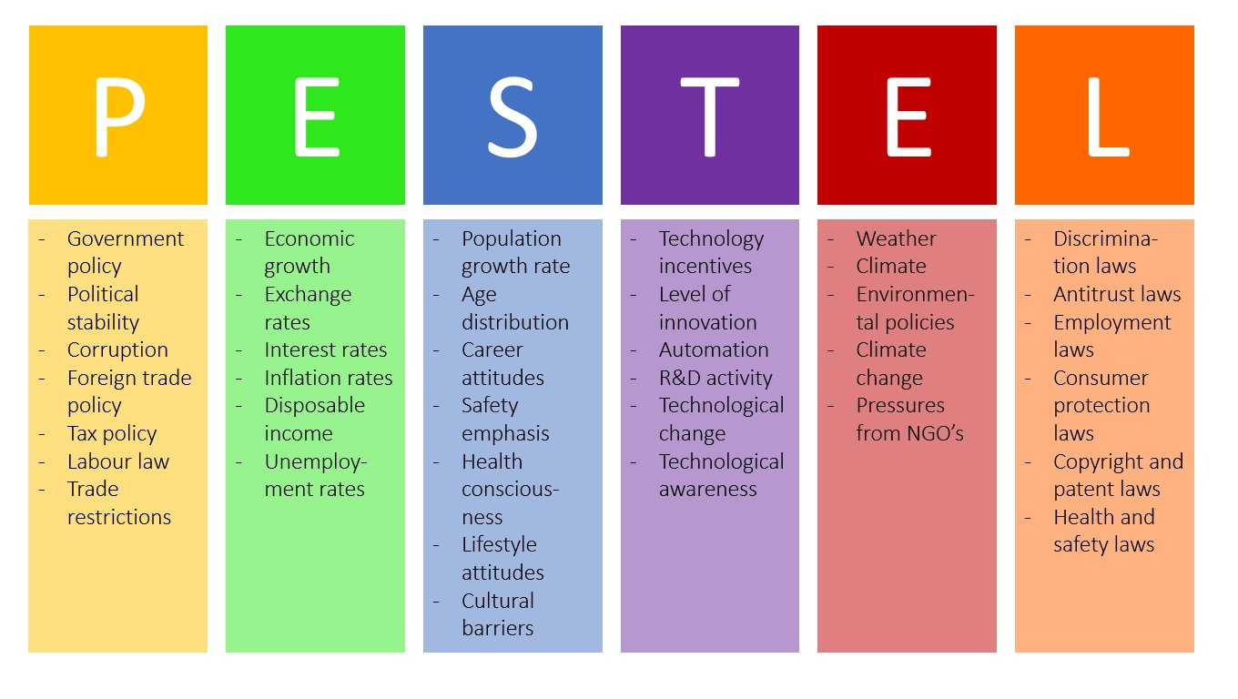
Figure 5: PESTLE Analysis
Source: B2U
- Political factors- It refers to the analysis of government plans and policies that affect a business. These Factors consist of trade disputes, corporate taxation, trade disputes, etc. The company operates its functioning all across the globe, and to run its business efficiently, Nike has to evaluate the government policies and strategies of every nation.
- Economic factors - These refer to the factors that affect the economy as well as the finances of the organization. These factors consist of inflation, employment rates, interest as well as exchange rates, etc. With the above case study, it has been analyzed that Nike has a strong consumer base, and this factor has also affected the purchasing power of the consumer and also assisted the company in building good revenue by creating an overwhelming relationship with the client.
- Socio-cultural factors- These refer to the factors that are related to societal beliefs and norms. These factors consist of Demographic factors, Lifestyle trends, consumer beliefs, and attitudes. Nike is very well known for the changes that have been taking place in the market and society, and it has manufactured its products as per the market trends and policies. This has also helped the company in effectively achieving organizational goals.
- Technological Factors- It refers to the analysis of emerging technologies and technological advancement (Atherton, 2019). These factors consist of automation, cyber security, and technological infrastructure. From the above case study, it has been expressed that Technology is one of the factors that helps Nike in innovating creative products that assist the organization in creating products that help the business in developing brand awareness and brand image.
- Environmental factors – It refers to the process of analyzing the environmental conditions that affect the operations of the business enterprise. This factor consists of climate change, carbon footprints, and scarce resources such as land, water, air, etc. Nike is an environmentally conscious brand and performs all its functions with sustainability. The company makes effective use of renewable energy, and it also mitigates the negative impact of waste and pollution on the environment.
- Legal factors- These refer to the process of evaluating the laws and legalities of different nations. These factors include Licenses and permits, Intellectual Property laws, employment, consumer protection laws, etc. From the case study, it has been evaluated that the company has already dealt with several lawsuits for poor working conditions as well as it has also been dragged to court for patent rights.

Value chain analysis
The value chain analysis was introduced by Michael Porter in 1980. Value chain analysis is a visual tool that helps a business enterprise to analyze the activities of the organization to develop a competitive advantage. It refers to the means of evaluating different activities of the business that helps in creating valuable products and assist the business in choosing activities that add value to gain maximum profit. This analysis has been done through primary as well as support activities. The value chain analysis of Nike has been highlighted below:

Primary activities
The primary activities in the value chain analysis of Nike are directly linked with the creation of delivery of value products. The activities are grouped into five different categories named inbound logistics, operations, outbound logistics, marketing, and sales and service.
- Inbound Logistics –It refers to the process of consisting activities that are related to receiving, warehousing, and management of the inventory of material as well as components. Sustainability, as well as quality, are the reasons behind the success of Nike. The supply chain of the company consists of suppliers, internal delivery, quality check-ups, etc. The company also focuses on environmental safety and pollution reduction.
- Operations- It can be defined as the process of conversion of input into output. It consists of activities that are related to turning raw materials into a finished product. Operations of Nike include the manufacturing of products as well as services. It focuses on the analysis of operations to improve productivity, value creation as well as efficiency.
- Outbound logistics- It consists of activities that are related to distribution, packaging, sorting, and shipping. The outbound logistics of Nike include activities to store and distribute the goods to the consumers. The company has more than 500 factories in various countries that manufacture its products, and then these products are distributed to different markets.
- Marketing and sales - It consists of activities that are related to marketing as well as sales of the product, such as promotion, pricing strategy as well as advertising. From the case study, it has been evaluated that Nike uses effective marketing techniques to attract new consumers as well as to retain existing customers.
- Service- This process consists of activities that include installation, training, repair, quality assurance as well as customer service. After-sales service of Nike plays an important in providing mesmerizing experience to the customer as well as helping businesses in customer retention.

Secondary activities
The secondary activities of the business consist of activities that assist the primary activities in becoming more efficient and help in creating a competitive advantage. These activities are divided into four different categories named Procurement, Technological development, Human resource management, and Infrastructure.
- Procurement – It refers to the activities that are related to sourcing raw materials, machinery, equipment as well as services. Nike's procurement team focuses on managing the process of sourcing the material efficiently and also provides emphasis on sustainability as well as environmental safety.
- Technological development -It refers to the process of activities that are linked to research and development (Tomita, 2022). A critical role is being played by Nike's value chain analysis as it is the leader in innovative sportswear. The company makes efficient use of research and development technologies that are required for market research, product design, and process development.
- Human resource management – It refers to the activities that are related to hiring, recruitment, development, retention as well as payment of employees. Nike is a global company and has over 70000 employees all across the globe, so the company makes different efforts to motivate its employees, such as the provide rewards to the employees as well as encouraging them to work more efficiently.
- Infrastructure - It refers to the activities that are related to overhead and management of the company. Nike is a global organization, and it includes activities such as quality management, financial accounting, legal matters, and strategic management. The value chain of Nike allows the organization to optimize the chain efficiently.

Strategic Choices and Options
A marketing strategy is a long-range plan that is used by an organization to achieve its organizational goals by assessing the needs, tastes, preferences as well as requirements of the consumers. This strategy is used by Nike to identify the target consumer groups and also assist them in the formulation of a strategy that helps in the achievement of marketing objectives. The marketing mix model of Nike has been discussed below –
- Product –Nike mainly deals in sporting apparel. The product strategy of the company is to grow the business through market-based changes. The company has a varied range of products, such as Footwear, Equipment, and Sportswear as well, Accessories, etc. The production department of the organization always believes in providing premium quality shoes to the customers so that they can maintain the brand value of the organization.
- Place –It refers to the marketplace where Nike sells its product. The company sells its product all across the globe via its online, retail as well as company-owned stores. This assisted the company in acquiring more sales and revenue. From the given case study, it can be analysed that river is facing challenges to sell its shoe products across the globe (Diantari and Jokhu, 2021). But they manage to open their stores in different countries in which they provide their shoes. The organization has a website on which customers can make a purchase.
- Price –This element of the marketing strategy consists of Price. The company deals in a niche market, and the company majorly focuses on celebrities as well as high-profile athletes and provides superior quality products at high prices. The company has high sales revenue and also enjoys high-profit margins.
- Promotion –It is one of the essential elements that play an important role in the growth and success of any business enterprise. Nike majorly focuses on advertising to promote its products and services. Apart from advertising, various promotional strategies have been used by Nike, such as Personal selling, public relations, direct marketing as well as sales promotion.

Action Plan or Recommendations or Strategic Options
Value creation refers to the process of setting goals and effectively making effective use of resources. An effective customer support team has been built by the company to assist the customer. This helped the company in creating value among the consumer. This has also assisted the company in attaining profitability as well as also helps in enhancing the growth of the business enterprise. With the assistance of effective strategic management, the company has realized that high-quality, as well as innovative products are being valued by consumers. The organization focuses on the timely delivery of products. From the case study, it has been evaluated that the business enterprise also values its employees and provides them friendly work environment so that they can feel motivated and can work with full efficiency and productivity. The employees are also involved in the decision-making process, and it also helps them in building good relationships with the management and also develops a sense of belongingness among them. Efficient workers in every organization are key to their growth and success. This helps the company to gain a competitive advantage over others in the marketplace.
From the very start, Nike has believed in the image differentiation technique, which facilitates the organization to stand out from their competitors through whom they can enough their brand Image to the customers. The administrative department of the organization always focuses on the company's image because they know that a company can only survive for a longer period in the market when its image is transparent and good in the eyes of the customers. They can create value for their products because they always believe in providing high-quality shoe products to their customers. To create more value for the customers, they keep on doing innovation at the workplace so that they can realize the value of their customers, and apart from the customers, they also value their employees and keep on motivating them at the workplace so that they can produce good results. They also execute award programs at the workplace in which they award those employees of the organization who give their full potential towards the organizational goal, which helps them to create more value at the workplace.

CONCLUSION
From the above report, it can be analysed that there are various benefits of strategic management that a company can get in day-to-day operations. One of the main benefits of the strategies for the workers is that it provides direction to the operational decisions and which facilitate the organization to move in a single direction. It has been analysed in the above report that Nike organization uses various types of strategies through which they become able to solve the central issues that occur while carrying out the activities. The management department of the organization continuously analyses the working of the employees, and they keep on grabbing the opportunities through which they stand out from the competition in the market. In the above report, it has been analysed that various types of tools and models are used by the organization to give direction to the working style of the organization. There has been the valuation of the products of the organization, and along with that, corporate social responsibilities have also been evaluated in how they contribute to society. After that, various marketing strategies of the organization have been analysed, through which they become more competitive. The organizational structure of the organization has also been undertaken into account to find out how Nike organizations carry out their work. At last, it has been analysed how they create value in the lives of customers by providing different kinds of shoe products.

REFERENCES
Ansoff, H. I. et al., 2018. Original Concepts of Strategic Management and the Evolution of Management Systems. In: Implanting Strategic Management. 3 ed. s.l.:Palgrave Macmillan Cham, p. 592. http://doi.org/10.1007/978-3-319-99599-1
Atherton, J., 2019. Social media strategy: A practical guide to social media marketing and customer engagement. Kogan Page Publishers.
Dagnino, G.B., Picone, P.M. and Ferrigno, G., 2021. Temporary competitive advantage: a state‐of‐the‐art literature review and research directions. International Journal of Management Reviews, 23(1), pp.85-115. https://doi.org/10.1111/ijmr.12242
Diantari, N.P.E. and Jokhu, J.R., 2021. The Impact of Instagram as a Social Media Tool on Consumer Purchase Decision on Nike. Jurnal Ilmiah Manajemen dan Bisnis, 7(1), pp.116-127. https://www.neliti.com/publications/459999/the-impact-of-instagram-as-a-social-media-tool-on-consumer-purchase-decision-on
Nave, A. and Ferreira, J., 2019. Corporate social responsibility strategies: Past research and future challenges. Corporate Social Responsibility and Environmental Management, 26(4), pp.885-901. https://doi.org/10.1002/csr.1729
Ramli, A., 2021. Technology Entrepreneurship Project (ENT 600): Nike. https://ir.uitm.edu.my/id/eprint/50634/
Tomita, A., 2022, August. Aligning Digital Transformations with Value Creation Based on International Integrated Reporting. In 2022 Portland International Conference on Management of Engineering and Technology (PICMET) (pp. 1-9). IEEE. https://ieeexplore.ieee.org/abstract/document/9882809/
Nica, I., Chiriță, N. and Ionescu, Ș., 2021. Using KPIs and Dashboard in the analysis of Nike company's performance management. Theoretical & Applied Economics, 28(1).
Thomas, M.B., 2022. Swooshed: How Nike and the City of New York could potentially change the landscape of city branding through apparel licensing agreements. Public Administration Review, 82(6), pp.1186-1191. https://doi.org/10.1111/puar.13519
O'Brien, D., Parent, M.M., Perkins, L., and Gowthorp, L., 2019. Strategic management in sport. Routledge.
Kim, M., 2020. How Phil Knight made Nike a leader in the sports industry: Examining the success factors. Sport in Society, 23(9), pp.1512-1523. https://doi.org/10.1080/17430437.2020.1734329

